Supporting Information
Optimizing Driving Waveforms to Enhance Inkjet Printing Speed
Chao Sui, Wenchao Zhou*
AM³ Lab, 102B Mechanical Engineering Building, University of Arkansas
Fayetteville, Arkansas, 72701, USA; *Corresponding author email: zhouw@uark.edu

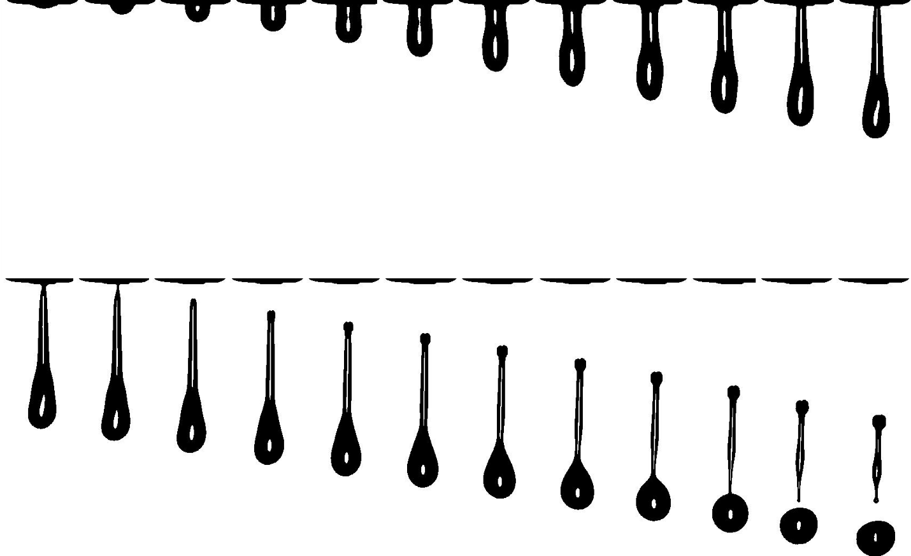
Fig S1. Droplet ejection dynamics and directional stability with satellite formation. High-speed imaging captures the ejection of large-volume droplets accompanied by satellite droplets. Despite the presence of satellites, the main droplet maintains a straight and consistent trajectory along the nozzle axis, as observed across successive frames. This indicates that the inkjet system provides sufficient directional stability and reproducibility for patterning, even at moderate ejection velocities. The directional accuracy is supported by the combined effects of large droplet mass (high inertia), optimized waveform control, and stable fluid properties, which collectively compensate for the lower velocity regime.

S1. Analytical Model Explanation

S1.1 Overview
The analytical model used in this study establishes a physics-informed relationship between the driving waveform and the resulting droplet ejection characteristics in a piezoelectric drop-on-demand (DOD) inkjet system. The model predicts key output quantities such as jetting velocity u(t), filament radius R(t), and printing speed, using waveform parameters as input.

S1.2 Model Assumptions and Conditions
The model is developed under the following simplifying assumptions and operating conditions:
- The ink is Newtonian fluid with constant viscosity, surface tension, and density.
- The nozzle exit is modeled as a cylindrical channel of constant diameter.
- The flow is assumed to be one-dimensional along the ejection direction.
- The fluid is considered incompressible during ejection.
- The flow regime is laminar.
- Ink backflow into the reservoir is neglected.
- Gravitational effects are considered negligible.
- The influence of acoustic wave propagation is assumed to be negligible.
- The voltage applied to the piezoelectric actuator changes at a constant rate.

S1.3 Model Governing Equations
1) Velocity Estimation
The model is based on simplified Navier-stokes equation:
$$ρ\frac{∂u}{∂t}=-\frac{∂P}{∂x}+f+μ\frac{∂^{2}u}{∂x^{2}}-ρu\frac{∂u}{∂x}$$ | (1)
This equation reveals that the temporal acceleration (represented by the left-hand side term) is governed by a combination of four key factors: the pressure gradient, external force, viscous force, and convective inertial force. To model the droplet ejection process more accurately, the entire ejection cycle is divided into several distinct stages based on the characteristic features of each phase. For each stage, the governing equation is derived by applying appropriate approximations to the dominant terms in Equation (1). By integrating both sides of the simplified equation for each stage, the time-dependent velocity profile u(t) can be analytically determined.
2) Jetting Frequency Estimation
The jetting frequency is defined as the inverse of the droplet breakup time, which corresponds to the time interval from the onset of ink motion at the nozzle exit to the moment when the liquid filament pinches off. At pinch-off, the filament radius approaches zero, marking the end of the droplet formation process. To estimate this breakup time, we apply the principle of mass conservation to a control volume at the nozzle exit, yielding an expression for the filament radius R(t) as a function of time. Then the breakup time T_{b} can be obtained. Consequently, the jetting frequency is given by:
$$f=\frac{1}{T_{b}}$$ | (2)
The estimation of the printing speed for one nozzle can be expressed as:
$$W=V*f=πR^{2}\int_{0}^{T_{b}}{u\left(t\right)}dt*\frac{1}{T_{b}}$$ | (3)
Here, V represents the volume of a single droplet, which is obtained by integrating the nozzle exit velocity u(t) over one jetting cycle. $R$ denotes the filament radius at the nozzle exit during ejection, t is time, and $f$ is the ejection frequency (defined as the number of droplets generated per second per nozzle) and equals to the reciprocal of the breakup time (T_{b}).

S2. Flowchart of the surrogate optimization
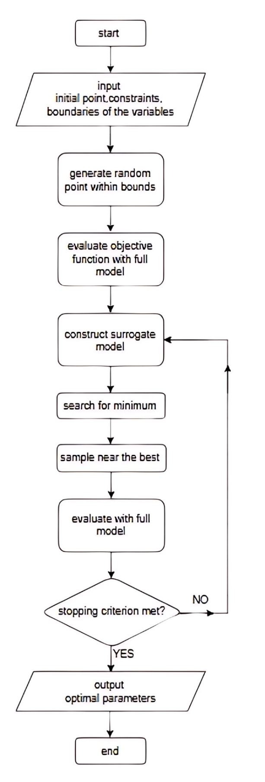
Figure S2 Flowchart of the surrogate optimization process

