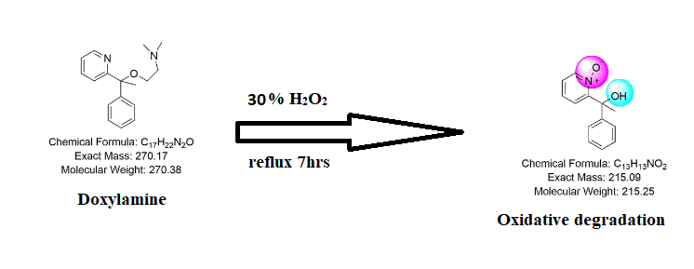

Figure. S1. Schematic diagram of the suggested degradation pathway of DOX.

Figure.S2: LC-Mass spectra of DOX sample showing M.wt .of degradation product

