Figure S1. mPFC pyramidal neurons of susceptible mice display no differences between prelimbic and infralimbic cortex.
(a) Summary plot of input resistance. (b) Summary plot of resting membrane potential. (c) Summary plot of sag ratio. (d) Number of APs elicited by increasing injected current. (e) Summary plot of rheobase. (f) Summary plot of threshold of the 1st action potential. (g) Summary plot of amplitude of the 1st action potential. (h) Summary plot of AHP amplitude. (i) Summary plot of ISIs. (l) Summary plot of ISI coefficient of variation. Not significant p values are not displayed. Data are presented as mean ± SEM.

Figure S2. mPFC pyramidal neurons of resilient mice display no differences between prelimbic and infralimbic cortex.
(a) Summary plot of input resistance. (b) Summary plot of resting membrane potential. (c) Summary plot of sag ratio. (d) Number of APs elicited by increasing injected current. (e) Summary plot of rheobase. (f) Summary plot of threshold of the 1st action potential. (g) Summary plot of amplitude of the 1st action potential. (h) Summary plot of AHP amplitude. (i) Summary plot of ISIs. (l) Summary plot of ISI coefficient of variation. *t test p<0.05. Not significant p values are not displayed. Data are presented as mean ± SEM.

Figure S3. Prelimbic and infralimbic pyramidal neurons of susceptible mice exhibit reduced excitability.
(a) Number of action potentials elicited by current steps in the prelimbic cortex. (b) Number of action potentials elicited by current steps in the infralimbic cortex. ####two-way ANOVA p<0.0001. Data are presented as mean ± SEM.

Supplementary Figure 1

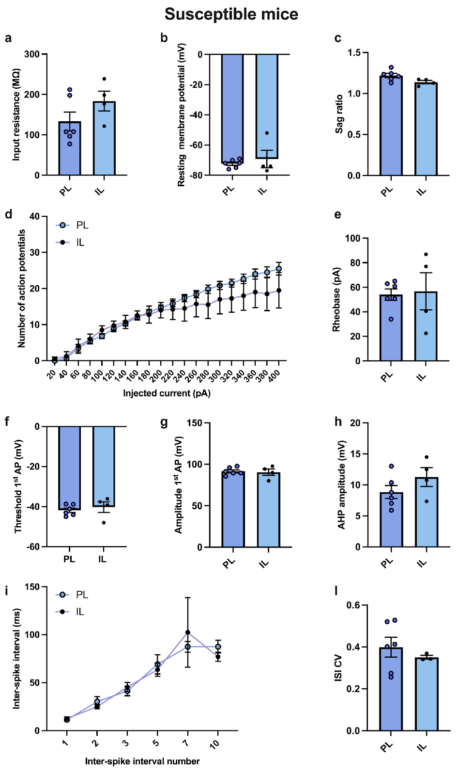

Supplementary Figure 2
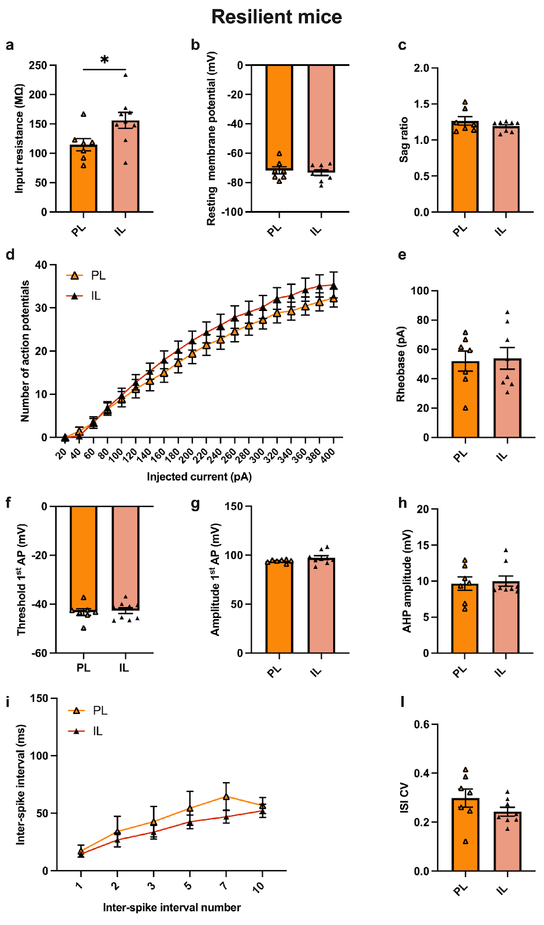

Supplementary Figure 3

