Supplementary Materials
Table S1
Correlation Coefficients between Participants’ Age and Size of Place o Residence and Main Variables in the Study
Variables | Age | Size of place  of residence
Satisfaction with Life | .164** | -.043*
Positive Affect | -.004 | .006
Negative affect | -.355** | -.010
PTSD symptoms intensity | -.270** | .019
The number of lifetime traumatic events | .042* | .020
The number of childhood adverse experiences | -.211** | .091**
The number of childhood positive experiences | .222** | -.036
* p<.05, ** p<.01
Note. For age Pearson correlation coefficients and for size of place of residence Spearman’s correlation coefficients were calculated.
Table S2
Mean Values of Main Variables in the Study in the Group of Females and in the Group of Males
 | Females |  | Males
Variables | M | SD | M | SD | t | p
Satisfaction with Life | 20.21 | 6.37 | 20.79 | 6.48 | -2.14 | .032
Positive Affect | 30.67 | 7.39 | 31.35 | 7.26 | -2.18 | .030
Negative affect | 20.40 | 8.84 | 19.52 | 8.75 | 2.36 | .018
PTSD symptoms intensity | 1.24 | .96 | 1.12 | .92 | 3.13 | .002
The number of lifetime traumatic events | 1.80 | 2.01 | 1.62 | 1.97 | 2.13 | .033
The number of childhood adverse experiences | 1.74 | 2.09 | 1.54 | 2.19 | 2.20 | .028
The number of childhood positive experiences | 7.61 | 2.24 | 7.73 | 2.20 | -1.33 | .183
M – mean value; SD – standard deviation; t – independent sample Student’s t test; p – statistical significance

Table S3
Mean Values of Main Variables in the Study in the Group of Professionally Active Participants and in the Group of Participants Not Professionally Active
 | Professional activity
 | no |  | yes
Variables | M | SD | M | SD | t | p
Satisfaction with Life | 20.47 | 6.41 | 20.48 | 6.44 | -.04 | .972
Positive Affect | 29.60 | 7.20 | 31.75 | 7.31 | -6.68 | .001
Negative affect | 18.76 | 8.45 | 20.67 | 8.93 | -5.01 | .001
PTSD symptoms intensity | 1.09 | 0.91 | 1.24 | 0.96 | -3.51 | .001
The number of lifetime traumatic events | 1.79 | 1.95 | 1.67 | 2.02 | 1.40 | .162
The number of childhood adverse experiences | 1.41 | 1.94 | 1.77 | 2.23 | -3.99 | .001
The number of childhood positive experiences | 7.79 | 2.21 | 7.60 | 2.23 | 1.97 | .049
M – mean value; SD – standard deviation; t – independent sample Student’s t test; p – statistical significance
Table S4
Proportion of Explained Variance for Each Node
Variable | R²
Safe caregiver | .194
Good friend | .208
Comforting beliefs | .171
Liked school | .250
Caring teacher | .224
Good neighbors | .202
Supportive adult | .210
Fun activities | .244
Self-acceptance | .303
Predictable routines | .159
Verbal abuse | .443
Physical abuse | .401
Sexual abuse | .173
Emotional neglect | .440
Physical neglect | .304
Parental separation or divorce | .172
Domestic violence against mother | .343
Substance abuse in household | .256
Mental illness in household | .219
Household member in prison | .151
Satisfaction with life | .478
Positive affect | .378
Negative affect | .580
PTSD symptoms | .575
Life events | .169
Sex | .064
Age | .242

Figure S1
Strength Differences Test Graph
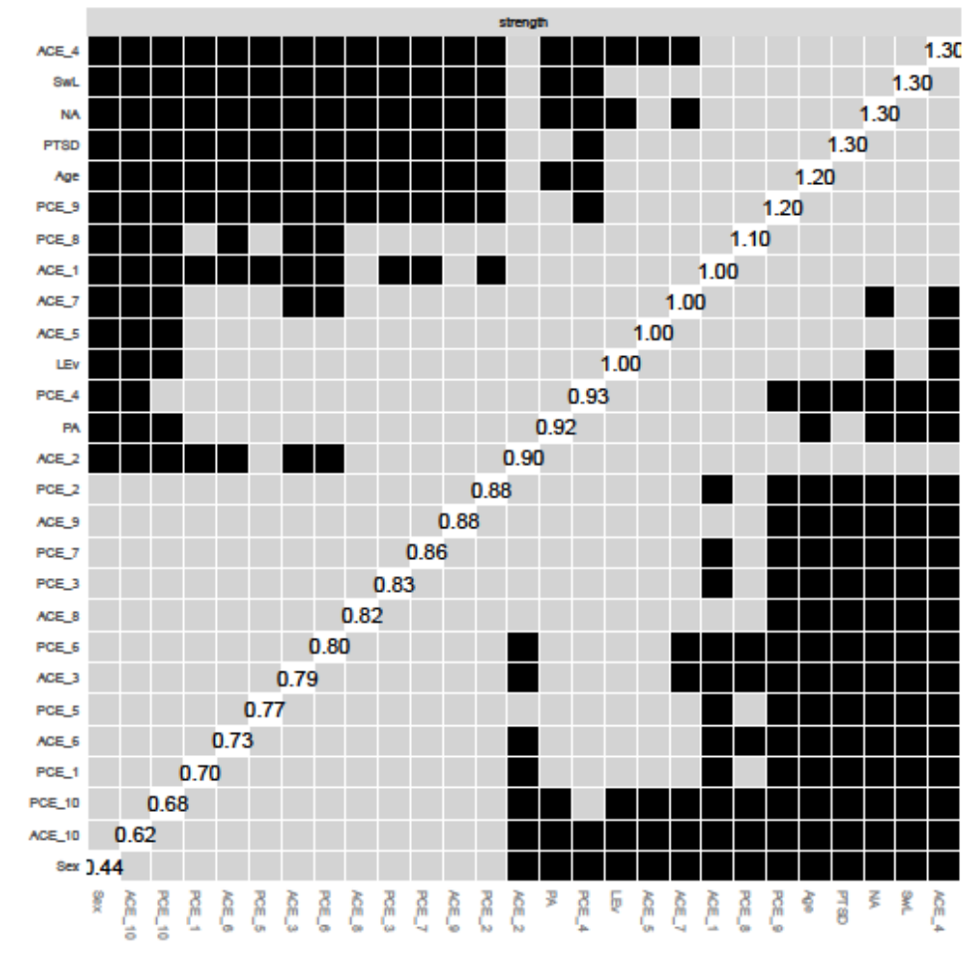
Note. Black squares indicate significance. Grey squares indicate no significance.

Figure S2
Expected Influence Differences Test Graph
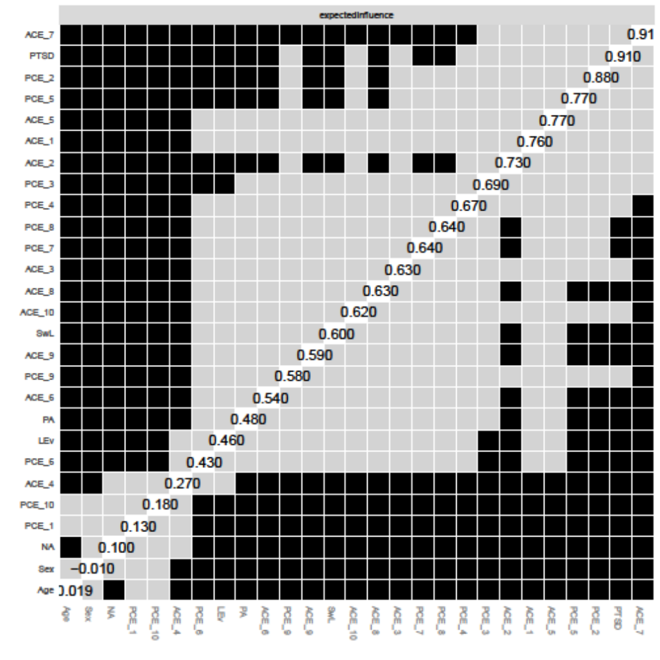
Note. Black squares indicate significance. Grey squares indicate no significance.

Figure S3
Edge Weight Differences Graph
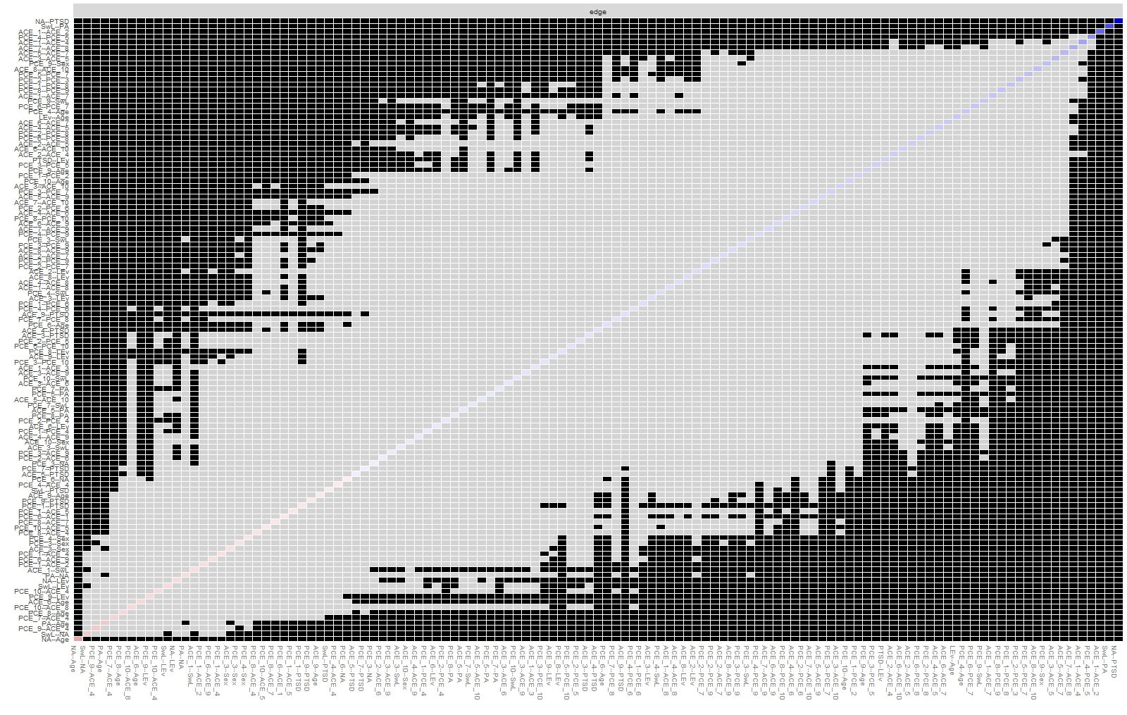
Figure S4
Edge Accuracy Graph
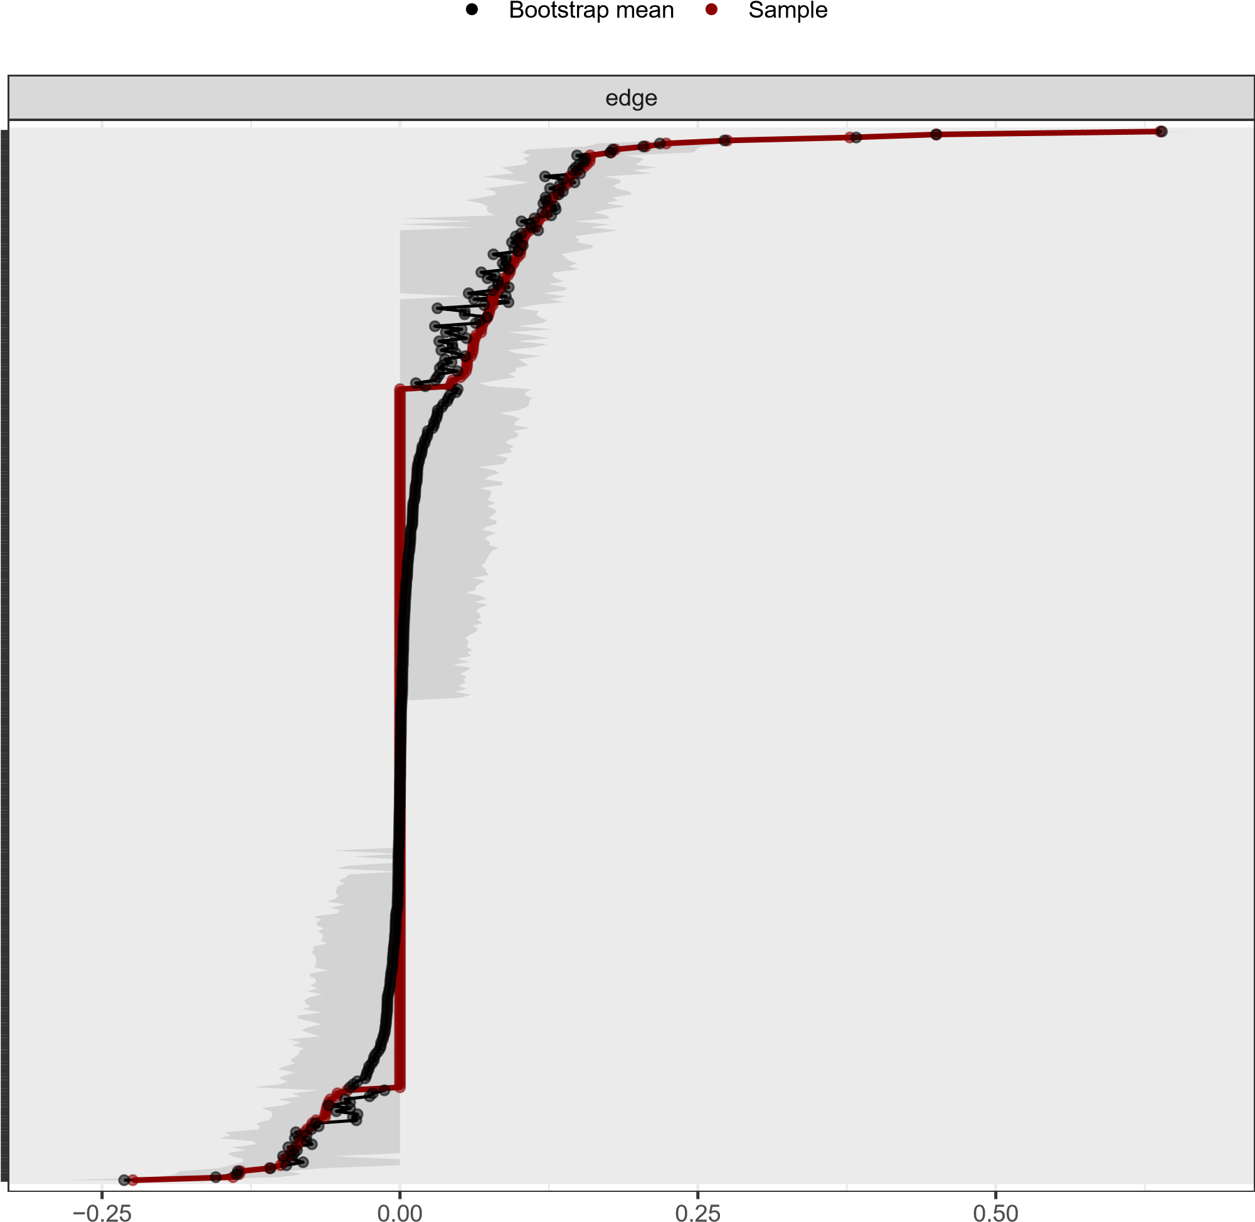

Figure S5
Strength Centrality Stability Graph
−1.0
−0.5
0.0
0.5
1.0
90
%
80
%
70
%
60
%
50
%
40
%
30
%
Sampled cases
Average correlation with original sample
strength

Figure S6
Closeness Stability Graph
