Supplementary Information
Inclusion and exclusion criteria
Participants were required to meet the following criteria for eligibility; normotensive psychedelic-naïve male or female, deemed healthy based on clinical history, physical examination, electrocardiogram (ECG) and laboratory blood tests. They could not consume more than 14 units of alcohol weekly during the study and were required to abstain from alcohol from 24 h before each outpatient visit until the completion of procedures on Day 3. They were also required to abstain from recreational drug use, including psychedelic drugs, until the end of the study and from nicotine while resident in the unit.
Exclusion criteria included the following: acute or chronic illness or infection, history of epilepsy or seizures, history, or family history of malignant hyperthermia and history of serious reaction to any medicine or excipient. Current, or first-degree blood relative with, a serious mental disorder, or history of attempted or completed suicide. Current suicidal ideation as judged by the Columbia-Suicide Severity Rating Scale (C-SSRS) and any major psychiatric disorders as determined by the Mini International Neuropsychiatric Interview. Current, or history of, alcohol or drug abuse or dependence. Nasal obstruction, blockage or symptoms of congestion. Currently taking monoamine oxidase inhibitors. Pregnant or lactating and unwilling to comply with the contraception requirements of the protocol. Positive test for hepatitis B and C or HIV; taken part in another study or lost more than 400 mL blood (e.g. as a blood donor), within the previous 3 months.

Participants’ quotes
The overall map of 5-MeO-DMT experiences is visualized in figure 2. In the following tables (S1-S5) illustrative quotes are provided for key themes described in the main article, for different phases of the experience.

Table S1. Intensity increasing
Themes | Quotes
Rapid change in the intensity of the experience, and in the state of consciousness | “It's the shock: between the states you are in before and the state you're going into,- it's just that the difference is too great. And then your body and your mind are not adjusting fast enough.” -P1, 12mg (s)
Visual effects | "What happened is everything went dark. Then if you put your mind on green field, some colours start to come. I wasn't seeing much, or images of people or things like this. It was more like, hmm… not forms, but colours... It was when it starts to come some light and some colours. It's like you shut down something and then you restart.... It was kind of green. It was green, yellow, red colours. Very mixed colours."-P3, 8mg
Losing control over body | "Not in control is like… I don't know how to describe what it's like. Not like it's not my body. But like I stopped feeling it - the whole thing together. I'm still in control but it's like… I don't know. I don't know how to explain...It's like I'm not thinking, I'm not feeling the body the same way. It's like I'm thinking but also, I'm moving just to test stuff. But I don't have a connection." -P6, 8mg  "I was feeling it more intense and more intense, like I was feeling I'm losing control of my body." -P6, 12mg
Breathing | "At the beginning I had problems to breathe, the experience was so intense, it felt a bit hard to breathe." -P3, 12mg  “I was doing this deep breathing which she [psychedelic monitor] asked me to do. That really helped me... I was focusing only on breathing... It was not easy, but this was like I was distracted, and I was bringing myself back on the breathing. Then I was getting distracted with all this thing going on. And I’ve been holding myself back and focusing on breathing was really helping me.” -P7, 8mg
Letting go or struggling to let go | "For some reason, I couldn't just let myself completely lose control. There was something holding on still." -P1, 8mg
At low doses, peaceful relaxation | “Basically, I started to loosen better and then was it the effect of the waves in my brain is get stronger. But it was still really a peaceful movement, and also relaxed.” -P6, 1mg
At high/medium doses, intense emotions | “In the beginning I was very scared. And then, at the moment I was thrown away into the universe… [pause] I was very relaxed… light. I didn't feel like anything. Because I know I think about lots of things in my head, but in the universe, I didn't think about anything. That's why I was more relaxed or calm, peaceful.” -P3, 6mg  "It got more and more intense and then it was a positive feeling. I felt very happy. I felt like I had a very deep smile on my face. I didn't really have any negative feelings. There's no - I didn't feel any negatives at all really. A comfortable feeling, feeling warm and happy... I just had this overwhelming sort of flood in my body of just had that happy feeling, the joy feeling, and I felt myself have a big smile." -P4, 12mg
Diminishing awareness of both external and internal environment | "I could feel the bed. I could feel if I put my hand and I just opt to not be touching nothing at this moment, so I put my hands to the side I believe to my thighs. I tried just to let go. Be floating around and see what's going to happen after." -P3, 8mg
Feeling elsewhere, not in the dosing room | "It's like you are out in space. You are in the deep ocean… You are just in there and you are floating around because you don't feel nothing around...When you start the colours and you are going, it was a good experience. It's like diving... Scuba diving. It's you in the place where gravity works different... It was just the colours and I was floating around. It was a little bit of the sensation of dissolving yourself or mixing yourself with the ambience. You are sinking in your consciousness, you don't really feel that you have a mass anymore. You are in there. You are inside of your consciousness. You know your body. I felt that mixture of the surroundings and myself. I believe if it was a more quiet place, on this stage I would be connecting very much with my feelings and with my- I believe you connect more with your mind because you are going into your mind. You are deepening. Because I was quite conscious all the time. Would be very nice experience to be having this and let go a little bit more just to dissipate more of those feelings... I remember I was in this sea, let's say… A sea of my mind." -P3, 8mg

Table S2. Peak and plateau
Domain | Themes | Quotes
Emotions | Lower doses: subtle emotional changes | "It was not euphoria… It just that - I'm very relaxed, which is very - it is hard to explain, isn't it? Very mild up, a very mild euphoria. It's a bit - not happier, because I was not unhappy while doing that, but it's just a slight rise in happiness level, but a small time... No, it's just -it was literally just in that moment, just lying there very chilled, I just felt a slight rise in the in the happiness vibe if you like, it's quite hard to explain." -P5, 1mg
 | Higher doses: immense intensity of emotions | “It does something to my emotions. Uncomfortable in the sense of – I haven’t experienced this emotionally before, so it was… [pause] how do I put it into words. I don’t know if it was mentally, but I just remember feeling that I want to get out of this: ‘What is this? What is this feeling?’. It’s almost like a soul experience, it had an effect emotionally on my soul… I couldn’t put into words. I couldn’t explain it. But I knew that it was intense. I knew that I was emotional.” -P6, 6mg  “After I saw the colours and stuff, I had this immense feeling of calmness just come and take over... then it quickly, when I closed my eyes all of that got washed down by a complete calmness and it was very intense in the sense of it was emotions I’ve never felt before... Emotions that I’ve never felt before, it was complete certainty. I’ve never had a feeling of 100%, this is 100%, at peace 100%, tranquillity 100%, it was like emotions taken to another level, you feel it so intense and you’re so sure of it like there’s nothing else. Nothing else is real, like what you’re feeling is real.“ -P2, 12mg
 | Dynamic nature of experience | "It was very intense emotions… I felt a lot of emotions. Well, happy and also I cry there. And I don't know, it wasn't sad. It was just like everything together and so I was smiling and crying at the same time." -P7, 10mg  "I think it was scary, but after it was nice... It was about the intensity of the experience, when you don't have any control about what is happening to the body, this was the scary part of this… I remember that it was a bit in waves, [pause] because at some point I started to be scared again... when I enjoyed it was nice, it was going up and down with my feelings as well. [the feeling of happiness] was strong because I remember smiling. After all these strong feelings that were a bit scary and this fight, I think, I went to stop fighting, and enjoy the trip. It's when you started to feel this happiness, this peace… It was peaceful. It was- I feel happy and scary basically. It was really peaceful and really- I don't know. It was- because I remember my face is smiling at the same time that I have these strong feelings that I had. But, it's scary, peaceful, and happy, those were the three main things." -P3, 12mg
 | Emotional memories | "Not actually seeing it, but feeling it, you know, feeling happy places and things I enjoyed doing. I felt as if they were resonating through me. Certainly, you feel euphoric." -P5, 8mg
Self/Other/Environment | Losing awareness of the surroundings | "Not aware of anything around. I wasn't aware of the sounds of the cars outside. I wasn't aware of the music playing... it was definitely a period where I was not aware of them taking blood pressure measurements, or my temperature, or blood samples." -P4, 12mg
 | Loss of spatial self-consciousness | "The air, and almost forget basically that I'm in a room, inside the room, and lying on the bed. It was more like that I was inside into my brain, and I saw myself as a whole person...I closed my eyes and I saw myself in the whole body that I'm in. It was like a feeling that I'm floating, as I said before, in the universe... But you know that when you're putting the whole body into your body and you know that you're inside your body and you don't feel anything else, just like you're floating. Like if you would be in the big nothing, in the universe, in the darkness, but you still feel comfortable and you know that this is actually the deep calmness to go into... It's floating. Floating in the big universe, into my brain..." -P6, 1mg  “Nothing... It was just pitch black. Pitch black. There were no colours or any variations or nothing like that. It was just pitch black." -P6, 6mg  "I still felt that feeling of a void.. of being in a void…[ if I was to picture it, then it's like a dark void around the shape of my body and my body is just, it's just there… It's like you can feel the rush of the coldness of the atmosphere going past you... it was infinite... It was pure black. There was nothing. It was no beginning or end to it. It was just me, my silhouette in that darkness." -P5, 10mg  “It's very difficult to describe that… You are all over this universe, so it's almost like you are that universe, but at the same time you can see it from outside somehow.” -P5, 12mg (s)
 | One case of perceived external presence | "It's like something is going inside me, inside through air or something and it's coming out, going in and out. It's a strange feeling... It was like some kind of spirit, it was trying to leave me and I'm kind of obsessed because I've been watching Stranger Things lately [laughter]. These two hours, I was like in the series... for a moment I thought, I'm actually a character in the Stranger Things. Some demon is possessing me and he's leaving, but he's coming back. It's like some other person inside me… not a person. It's like some other energy, some force.... No, it was not like a very extreme thing that I totally am disgusted or hated, not that extreme, but it was not a very pleasant experience... Just being possessed by the demon." -P7, 8mg
 | Connection to God | “It felt like God was there. He just pulled you through it. I think something that's holding us attached to reality is definitely a belief. I think having that belief can bring you back to understanding, accepting, and surrendering. You just can hold on to your belief. Because the more you just wander off, it gets a bit wild out there and [you can get lost]… Sorry, faith. I was going to say faith. That something was just what was like a thread between reality and … whatever that was. [I felt him] more like connection rather than presence. It's just a sense of oneness, like you don't feel so separated and connected to something bigger than yourself… Because in that moment, prior to that, I maybe might have felt helpless a bit. It made me feel like I wasn't alone in there. It just felt like I was part of it. Just felt like it was very much inclusive, I think. It didn't just feel, I was part of it.” -P1, 12mg (s)
 | Absence of others in the experience | "I was on my own. There were no people or anything in my trip like my father or something like that, no." -P7, 10mg  "It was the peak time, I was really down [in a sense of going inwards]. I was so into my body that almost I couldn't feel all around me no one. Just me and myself in the universe." -P6, 1mg
 | Connectedness | "I guess it was a feeling of loss. I guess I was sort of feeling like I was reconnecting but also, but also, I guess, feeling, thinking this feeling of waste, of time wasted, life wasted... it was a connection with my mother, it was a very strong sensation of wanting to have my mother, but also of being with her, and actually seeing her briefly as well." -P1, 6mg  "It was a feeling of joyfulness a feeling of connection the golden light was kind of really radiating at this point. It's all one. It's the orgasmic sensation and the breathlessness and the light all together." -P1, 6mg  "I didn't have pictures in my head, but I was feeling very in tune with the universe if that makes sense. I was connected to a higher being other than myself or anything in the room. I was very much in tune with that. That gave me a sense of me being secure and safe and assured that I will be OK. Again, going back to the 100%, I knew 100% I was safe. My brain didn't have to panic or anything. I knew. Emotions I've never felt before." -P2, 12mg  “I felt as if I was being born but with the feeling of ejaculation and feeling it throughout my body. It felt as if I were receiving it, like being the ovaries too. I felt in the womb. It's something that will take months on end [to process]. It was just all encompassing. I do recall at one point feeling this is the female energy, the female form sort of thing. It was duality of man and everything in between.” -P2, 12mg (s)
 | Transcendence of time and space | "I lost sense of time... To be honest, I don't know. I felt timeless." -P7, 10mg
 | Losing sense of self | "You just lose yourself. You don't think yourself as being in physical form... You don't feel as if you are like you're in a body shape type thing, you just feel as if you're part of that white room type thing. It's really weird… I suppose you could describe it like… a floating sensation … you just feel as if you're nothing, but it's nice though....It feels just like you're really drifting away. You're not conscious of anything. You've got no stresses, your brain switched off. You're not thinking about anything. And it's a nice little zone to be in" -P5, 8mg  "I didn't think I had the sensation of myself… I couldn't think about myself as a person, or any particular person. I think I was just experiencing at that level. I think it would have been very difficult to try and think of something in particular, to think of something logical because all I had was just this feeling. It completely takes over everything that you're doing currently" -P4, 12mg  “I was in the middle of everything, but not completely in one piece. It's not being in one piece, it's like being there, but completely dispersed, almost like disappearing or being in all of these objects at the same time. This was a little bit disturbing, but also interesting” -P5, 12mg (s)
 | Medium doses – sense of self, control, disappointment | "I felt a bit of in control at the time. I could generate my will to some memories coming in. It's like you are dreaming but you could control the dream... I was guiding myself... But let's say I mentalize on my sons and then go straight in there. I realized when the colours were starting to come, I could feel something. I could go somewhere... I start to have a little bit of control in it. I could access memories. I could access things, places, people... I feel like daydreaming inside of my mind. I close my eyes, I could assess the memories. I could go for them. It was literally when you dream but you can act inside of your dream. You can choose the things you see." -P3, 8mg  "I was expecting to leave completely my mind. I think that was an expectation too high. I was trying to reach that, and not reaching it was annoying me. I was expecting not to think. Just to let go and just to follow... I feel I was thinking all the time. Yeah. And that bothered me. I was thinking why I'm still thinking." -P6, 8mg
Cognition | Absence of thoughts and worries | To be honest with you, I don't think I was thinking about much at all. I was really [pause]… not focused. I was just taken out of the room and I didn't have any worries. I wasn't thinking about anything, and that was a relief." -P5, 12mg
 | No memory of parts of the experience | "I don't know how long I was not there. I don't remember because I don't have [concept of time]. But, I don't remember for a while anything around me, I don't know where I was." -P3, 12mg  "It's like a dream. The more you're trying to think about it, the more it slips away.” -P5, 12mg  “I don't know if I lost consciousness, but there were times when there were bits missing.” -P1, 12mg (s)
 | Memories | "You could even remember, but you don't remember in that sense because there are lots of feelings together [with memories]. Your feelings are really out... It's like you are outside, seeing something that happened but then you can feel that thing that happened. You remember that thing in the stage of memory, of remembering. But you don't remember just the image. You remember how you felt. You remember! Feelings is something that I really like on this drug because you can reconnect things that you haven't just forgotten. This is really good" -P3, 8mg  "I felt like I had not a vision, but flashback memories, memories I forgot about, childhood memories and I was living them vividly and then all of a sudden I was spinning. I remembered something else. I was living that [memory] and every time it kept changing... It's like I was in those places and when I was kind of… I remember what was said, what we used to do. It's just strange, but without seeing anyone. I felt like I was that child in that place at that time, but I remember what we used to do in those places, what we used to say, who used to come there... Yeah, the environment and I felt like I was that child at that time, and I could hear echoes of my family talking or what we used to, it just came back... Visually I could just see the location and what I could feel... [pause]… It's hard to explain." -P3, 10mg
 | Losing or letting go of control through acceptance and surrender or struggling to let go | "I'm feeling overwhelmed by the situation, I'm struggling. I'm letting go. I'm trying to embrace the process of letting go but it's a struggle to let go and be vulnerable. So, I had to grab onto someone's just because I felt like I was being taken somewhere that I wasn't sure I wanted to go" -P6, 6mg  “We like to control things and life isn't that, so it was like doing the opposite of everything that you know, when you just do something that you normally wouldn't do. That's how it felt. It was unknown, strange, and weirdly blissful… It's acceptance. Before you’re in a state of not knowing, and then you accept the fact that it's OK to not know, it just is a sense of relief, peace, I think… It was hard to accept it at first, then came a sense of relief, like I don't want to control it. I just want to let it be. Just let it be. That's all I was telling myself: ‘Just let it be’." -P1, 12mg (s)
Metacognition | Ineffability | "I'm trying to find descriptive words. I know you said not to try and grab for words, but it just felt surreal, it's a good word, that's probably the most descriptive. It's just something where you felt as if you want it to stay, simple as that. There's no way to describe it really ... this state of trance rather than something that you can experience without doing something to get to that point. It's very hard to describe something that's totally new to you... I say it's very difficult to put into words"-P5, 8mg
 | High doses: metacognitive processes largely absent except when relating to letting go | "If you don't fight it, you will enjoy it. And it was something I had to keep reminding myself because there were moments where it was very intense and I'm like feeling myself clenching up, but it was good."-P2, 12mg
 | Medium/low doses – dual role of experiencer and observer | "Again, I have to talk myself back. So again, same experience, then I calm myself, lay down again... I had to fight it myself in my mind. So, I was again thinking about: “OK, I remember I have to think about something positive.”-P1, 8mg
Sensations | Disappear almost entirely (at high/medium doses) | "It was just pitch black. Pitch black. There were no colours or any variations or nothing like that. It was just pitch black."-P6, 6mg  "I just stopped noticing my body. I think by the time that I thought I was definitely saying 10, I suppose I was kind of out of my body. I think I was just in my head.” -P5, 8mg  "I felt like I I didn't feel anything in my body. Like numbness I would say. Like you getting anaesthesia…I remember just like trying to come out of the bed or somehow I remember I could feel like they tried to push me back or something like that. But it was like I couldn't - I felt it but not really felt it. I don't know how to say. It's like I felt it but from a distance so to say." -P6, 12mg
 | Altered visual perception (medium doses) | "I saw crystals, and they were all moving around me... I remember that I saw some crystals when I closed my eyes. At some point, I opened my eyes again, I don't know why, I can't remember what the reason was, and then when I closed my eyes back, I saw crystals... Pointy, sharp, and blinking. That place, but the crystals were blinking very bright. Bright white colour... They were large, yes... I just remember a dark room, with just loads of big, blinking, shapes of crystals, and it gives a flashing like you have a flashlight, a very bright white colour. So, it was from right, from left, from the bottom, it just kept on flashing." -P1, 8mg  "At first it felt like I was being pulled up into a starry sky. Yeah, I think briefly it felt starry, but then actually it wasn't starry at all. It was all around me. It felt like it was all around... I'd come into this golden light...it's like I'm lying in a field outside early in the morning and there's a golden light I'm sort of seeing. It's kind of like watching dawn, almost but dawn comes from one direction. This was really almost from all directions, but it did feel like it was sort of low... It mostly is just the light, actually, but it would feel like it was low in the ground. It's almost like I could see the ground and it felt like the ground was like a field. Visually, it was overwhelmingly this golden light." -P1, 6mg
 | Synaesthesia-like experiences | "I mean body, no body, it's funny when it's almost like two things happening at the same time. It's like you feel this whiteness. It's like I was feeling this whiteness through my whole body, it doesn't really make sense." -P1, 6mg  "After a while, I started to relate [these colours] with memories. Past memories, recent memories. It was kind of… It's confused because it was everything together at the same time. Like flashes... When images start coming through was when memories started to come up around this... Then it started to come to colours, it went kind of… I started to construct images." -P3, 8mg

Table S3. Decrease of effects
Themes | Quotes
Gradual reduction of effects | "It was on and off until I gradually came back to normal, so it would be on and off, but each time wouldn't be at the same intensity. Or it would at some point go back down." -P6, 12mg
Re-gaining awareness | " I just feel like the sensation, the feelings are getting lower, and lower, and lower till it's just gone everything, and I'm back to my environment." -P6, 1mg
Lingering feelings of connectedness | "I was then turning thoughts to particular individuals again and just seeing them afterwards and stuff like that, more to do with…[pause] I don't know, reuniting with people, a comforting feeling of being back in a place that you like." -P3, 2.5mg  "There may have been a thought about my mom… Because my mom passed away a long time ago. A very long time ago. I think for a split second I was just thinking what it would be like to reunite with her." -P6, 6mg
Regaining agency over mind and body: directing the experience | "’Who am I? How do I relate to others?’, - kind of existential questions. I studied philosophy, so I was like this might be a good time to think about these, because I haven't asked these questions to myself in a long time. And then I was asking myself: ‘Am I happy with what I am doing?’” -P6, 4mg  "Trying to check myself to see if this is really happening, I'm really coming back, am I still alive." -P6, 12mg
Positive emotions: peace, bliss, tranquility, joy | "I was having these on and off feelings, blissful feelings ... It's only for a few seconds so to say. So, it's happening then it's going away and then it would come back after a while. It would be on and off... I think it was like all of the sudden I was like getting this awareness, but I was like, I think I was feeling like a blissful peace." -P6, 12mg
Trying to prolong the experience | "Maybe if I'm thinking properly, I'm trying to put it together, maybe that's when you're trying to get more intense to try and get back to where you were. I'm thinking that could be one possible explanation where you start to realize that it's fading away and you want to feel that again because really the pull is quite intense. You could say it's like an elastic band when you're feeling the tension is slacking and you want to get back to that full tension, that full moment and you know it's slipping away. Maybe that could be the explanation. There is a conscious moment where you try to make decisions and try to say: ‘can we get back there?’" -P5, 8mg
Return of meta-cognition | "Yeah it's not going to happen and then you just give up and then you come back into normal mode. Maybe that's when that happened but… That's the only thing I can think of because like I said there is definitely that moment where you definitely feel it and that's not imagining it or thinking it. It's definitely happening and you're aware of it. A lot of this is, sometimes you're aware, not aware, you're not understanding what you're seeing or doing, but that is like I said a conscious moment. There's two real conscious moments when you're making a decision and that's between letting go and not letting go and then this point here. Those are the two different, distinct moments for me." -P5, 8mg
Feelings of gratitude | "There were these feelings of gratitude... So initially, it was just a sort of a feeling of gratitude, a feeling of appreciation. In fact, I think initially it was appreciation and then gratitude and it was a sort of appreciation for the opportunity to experience this and then there was more of a sort of specific gratitude, which was kind of sort of not it wasn't necessarily gratitude for anything in particular. It was just kind of wanting to be thankful." -P1, 6mg
Feelings of disappointment | "I had such an expectation of what it was meant to be like, I went into it thinking it was gonna be a super psychological and spiritual experience. I'm not a massively spiritual person myself. Definitely not religious, but I thought it would give me that sort of insight, I suppose, but I didn't really get that... Slightly disappointed, I wouldn't say majorly, but I knew ultimately, you're gonna feel different, and it's gonna affect people differently. So, there's no guarantee that you are gonna get this spiritual/psychological phenomena that you're seeking. So, my expectations were kind of realistic in a way. It would have been nice to have gotten that, but we didn't get that, we got something else instead but there was still something nice about that as well. So, disappointment, but not overly... I was also trying to keep that [disappointment] outside of the bubble. Sometimes it would come in, but I didn't really want to be thinking or fixated on why, expected versus the reality of why go up." -P2, 10mg
Becoming aware of the music, following the music | "I remember throughout there was music, and there were sounds, like water sounds, and bird sounds. I could hear this very loud in my head... at some point, I just started listening deeply to this music, I paid a lot more attention to it, what I'm hearing." -P1, 8mg  “I could hear the music and all of a sudden, this music was in my head in the form of a grand piano. And it was like the whole grand piano was in my brain. Well, I can see even now the background of the piano, how things are moving… [And I thought] ‘Maybe now [I will understand music]’. Because I don't have much of a musical sense. I cannot [keep] a rhythm. I thought: ‘Oh, maybe now I will understand how these semi-tones, tones work, because now it's in my head. Now I see why other people can hear this music better than I’.” -P5, 12mg (s)  "I was thinking about the music a lot and the pan pipes - it would make me laugh and make me smile. And there's also a really good harmonica in there somewhere...I love a good harmonica, especially when it's in a rainforest. That's what it sounded like." -P5, 12mg

Table S4. End of effects
Themes | Quotes
Thinking about sharing the experience | "I was thinking: ‘Oh my god, this was crazy. It was beautiful’. And smiling, I was thinking: ‘I just feel very happy. I like that’. Not much of thinking I was away: ‘I wonder how I'm going to explain this?’" -P7, 10mg
Positive emotions | "It's just a mental outlook I suppose, a sense of optimism and just - I'd say probably just like youthful optimism. For me, it's - strangely enough, when I think about certain things from childhood it takes me back to a really happy place and it almost takes me back to the outlook that I had on the world at that time as a naive kid. And that is always quite optimistic and then quite pleasant." -P2, 10mg
Almost back to normal | "OK, now I'm very much aware, I'm back. I feel normal again. It's just that I can feel a slight effect." -P2, 10mg
Disappointed experience was not as expected | "I was waiting for the second dose. I was like wait, are they going to give me another dose? I'm not done here. I feel like there is still more. That's how I was actively thinking. I was thinking there has to be more to this. I think also because it goes with the expectations that came into doing this. I was like: ‘Man, I'm not going to get an opportunity like this’, - because I know about people that this has helped cure all sorts of things. It's not necessarily about mental illness. It's about transformation. It has created transformations... But I want my own experience. I'll be like: ‘hey, guys. I figured it out’. Not everything but just enough sort of thing... I think that's when my disappointment was because I wanted to get whatever it was that people experience. I wanted to be part of that group and be like: ‘Yo, this thing saved my life. It made me think of things and gave me perspectives that I never thought of’. That's what it was... I think I felt underwhelmed, I was a bit disappointed, that those were my thoughts. It didn't get me to the plane that I thought I was going to get to. But I definitely experienced something." -P6, 6mg
Feeling relaxed and calm | "I was feeling peaceful and calm and safe… It was a feeling of just being safe like I said, being calm, being kind of serene. I would say serene is the word I would use." -P1, 4mg

Table S5. Reflections
Themes | Quotes
Desire to repeat the experience or not | "I think that because of me not knowing really what to expect, it didn't start the way - It could start much better. But also, if I would have a little bit more time in this experience, I think I could get much better… I could experience a much better way than I did if it could last a little bit longer maybe."-P1, 8mg  "I do feel like if I was more relaxed and things are started differently - circumstances had been different, I probably would have gotten a different experience of it, which is why I was saying to M [psychedelic monitor] as well, if the opportunity ever came up to do it again, I think I would 100% do it again just to see if I'm - now that I know how it goes, I can go into with a better understanding of how to prepare myself mentally and maybe see if I can just yield a different outcome that way"-P2, 10mg  "I loved it. Like I think I will do it again for sure. Like in a different way. Well, maybe like this, but maybe more like nature. I didn't feel completely [relaxed], like maybe in a different scenario, more connected to nature." -P6, 10mg  "Apart from the first couple of unpleasant terrifying things, it's good. But I don't think I would want to repeat anything... I thought it was interesting, but once it's OK. I don't think I would ever do anything like that. Because it's just very odd. I'm glad I've done it. Like you watch movies. So now I can see how people feel. Yes, I didn't expect to be that intense at the beginning." -P5, 12mg (s)
Feeling changed | "If I would take that joy with me everywhere, I think this experiment have changed my life because it was a joy that it was just, it was very everlasting." -P2, 12mg
Resolutions for the future | "I feel like meditation and things like this could be really beneficial for me just generally and I thought I need to just go away and just think about emotions and think about things that I can do, that can give me good inner peace and balance in life. And after this experience, definitely I might be- I could well be looking into meditation and yoga - these kinds of practices but I've tried these things in the past but never really seriously… Maybe I need to do the test with some brain scans or something. I don't know. I definitely feel different after the experience." -P6, 4mg  "“I wish I was just a better person for my family in general”. That's it. That was my thought process. I didn't come up with any solutions as to how I'd go about it. But I just remember just wishing I was a bit more loving." -P6, 6mg
Difference between expectation and actual experience | "I had such an expectation of what it was meant to be like, I went into it thinking I was gonna be a super psychological and spiritual experience. I'm not a massively spiritual person myself. Definitely not religious, but I thought it would give me that sort of insight, I suppose, but I didn't really get that... Slightly disappointed, I wouldn't say majorly, but I knew ultimately, you're gonna feel different, and it's gonna affect people differently. So, there's no guarantee that you are gonna get this spiritual/psychological phenomena that you're seeking. So, my expectations were kind of realistic in a way. It would have been nice to have gotten that, but we didn't get that, we got something else instead but there was still something nice about that as well. So, disappointment, but not overly." -P2, 10mg  "I expected to have a lot of questions in my head arise as I'm feeling things so I can try and look for answers and stuff, but weirdly enough, no questions, nothing in my head... I would say it exceeded my expectations. I thought of one thing and it happened to be a completely different roller coaster, but it was a very good one." -P2, 12mg
Perceived therapeutic benefit | "It was very scary, but it was positive in a way to let those emotions out, and I think we all have emotions we bottle down, and for me, it seemed to lot of things to come out, and quite a relief in a way to let those feelings out, but it was scary and a bit of a traumatic experience in a little bit in a way as well, so it was a bit of a double edged sword, if that's the right expression... I certainly was feeling a lot of emotion, that was one of the main things from the whole thing. Like after the panic, which is a part of it, yes, the emotions just coming out and thinking about family and reflecting on life as well as reflecting on something, why should it be merely going forward." -P6, 10mg
Feeling safe to discuss past sexual assault | “I had some chats with A [psychedelic monitor] before the experience and then I shared my experience with her, very sad and it was basically sexual assault it happened in my life. And then A [psychedelic monitor] said during the preparation: “Oh, should I tell you like ‘oh, you are safe here’”, - and I said yes, because that made me feel safe.”

QUANTITATIVE ANALYSIS
Parameter Selection for Unsupervised Topic Modeling
UMAP Dimensionality (n_components=5). The 4096-dimensional sentence embeddings were reduced to 5 dimensions using UMAP. This value is a standard and recommended practice within the BERTopic framework, chosen to strike a balance between preserving the semantic structure of the data and ensuring effective clustering. Reducing dimensionality too little (e.g., >10) can impede the performance of density-based clustering algorithms like HDBSCAN due to the “curse of dimensionality,” while reducing it too much (e.g., 2-3) risks collapsing distinct themes into single, less coherent clusters. The 5-dimensional space provides a suitable intermediate representation for identifying meaningful topics in this dataset. The full UMAP parameters used for reproducibility were: n_components=5, n_neighbors=15, min_dist=0.0, metric='cosine', and random_state=42.
HDBSCAN Parameters and Topic Number Determination. The number of topics was not pre-specified but was determined directly by the HDBSCAN algorithm based on the data’s underlying density structure. We used the parameters min_cluster_size=50 and min_samples=50. The min_cluster_size parameter ensures that any identified topic represents a substantial and recurring theme, comprising at least 50 participant utterances. Setting min_samples equal to this value makes the algorithm more conservative, leading to more robust, well-separated clusters and classifying ambiguous points as noise. Importantly, HDBSCAN inherently optimizes for cluster stability, meaning the final set of clusters is chosen because it is the most stable partitioning across the density-based hierarchy. This data-driven approach avoids the need to arbitrarily select the number of clusters a priori.
Final Topic Curation. The HDBSCAN algorithm initially identified a set of raw clusters. A subsequent manual curation step was performed to ensure all final topics were semantically relevant to the phenomenological experience. Clusters representing conversational artifacts (e.g., "Affirmative responses," "Pauses," "I don't know") were removed. This standard post-processing step resulted in the final set of 28 content-relevant topics used for analysis.
Treatment of Outliers. Utterances that HDBSCAN could not assign to any stable cluster were designated as outliers (assigned a topic ID of -1). These utterances represent idiosyncratic statements or noise and do not belong to any coherent, shared theme. As is standard practice, these outliers were grouped under an “Unlabelled” category and were excluded from all quantitative analyses and visualizations of specific topics.
Supervised Topic Modeling
Reference Sentences for Supervised Topic Modeling. The following is the complete list of reference sentences used for the supervised topic modeling analysis described in the Methods section. These sentences represent key experiential themes derived from the qualitative analysis. The dose-dependent trends for a subset of these themes (those showing strict monotonic relationships across dose ranges) are visualized in Figure 6 (main text) and Figure S3 (supplementary materials).
- "I felt a burning sensation in my nose."
- "I noticed strange changes in my body sensations."
- "The effects hit me almost instantly."
- "The intensity of sensations increased very quickly."
- "I felt anxious due to the rapid changes in my consciousness."
- "I felt like I was losing control over my body."
- "I couldn't breathe properly."
- "I had to use breathing exercises to calm myself."
- "I had to think positive thoughts to calm myself."
- "I managed to let go."
- "I relaxed into the experience."
- "The presence of the psychedelic monitor was reassuring."
- "I felt one with the universe."
- "I felt deeply connected to everything."
- "I lost my sense of self."
- "I felt a change in my sense of self."
- "I was very happy."
- "I was very sad."
- "I felt emotions really intensely."
- "I wasn't aware of anything around me."
- "I wasn't aware of my body."
- "I had no idea where I was."
- "I was floating in a void."
- "It's very hard to describe the experience."
- "I felt more connected."
- "I didn't have any thoughts."
- "I don't remember what happened."
- "I struggled to let go and surrender to the experience."
- "I struggled to let go."
- "I could not let go."
- "I completely let go."
- "I had to let go."
- "I surrendered to the experience."
- "I had no sensations at all."
- "I saw geometric patterns."
- "My body felt weightless."
- "It was like I could feel the music through my whole body."
- "The effects diminished gradually, like waves."
- "I started to become more aware of my surroundings."
- "I was filled with gratitude."
- "I was disappointed by the experience."
- "I started to reflect on the experience."
- "Connection and thinking about important people in my life."
- "I started thinking again."
- "I would love to do this again."
- "The experience was very different to what I had imagined it would be like."

Threshold Selection. A cosine similarity threshold of 0.50 was used to determine whether a participant's utterance was semantically related to a predefined reference theme. There is no universal, model-independent threshold for semantic similarity; the optimal value depends on the embedding model, corpus, and specific task. Our choice of 0.50 was based on an exploratory analysis of the similarity score distributions for our reference themes. This value was selected as a moderately conservative cutoff that balances precision and recall: it is high enough to filter out irrelevant or weakly associated utterances (avoiding false positives) but not so high as to exclude genuinely related utterances that use different phrasing from the reference sentence (avoiding false negatives). This data-driven approach is standard practice when applying sentence embedding models like Sentence-BERT and its successors to semantic search and classification tasks.
Figure S1. Average proportion of topics in participant interviews
This bar chart illustrates the average proportion of topics extracted through unsupervised topic modeling of participant interview transcripts. Topics are arranged in descending order of prevalence, with the y-axis showing the average proportion of each topic within individual interviews, calculated by normalizing topic frequencies per participant and then averaging across all participants.
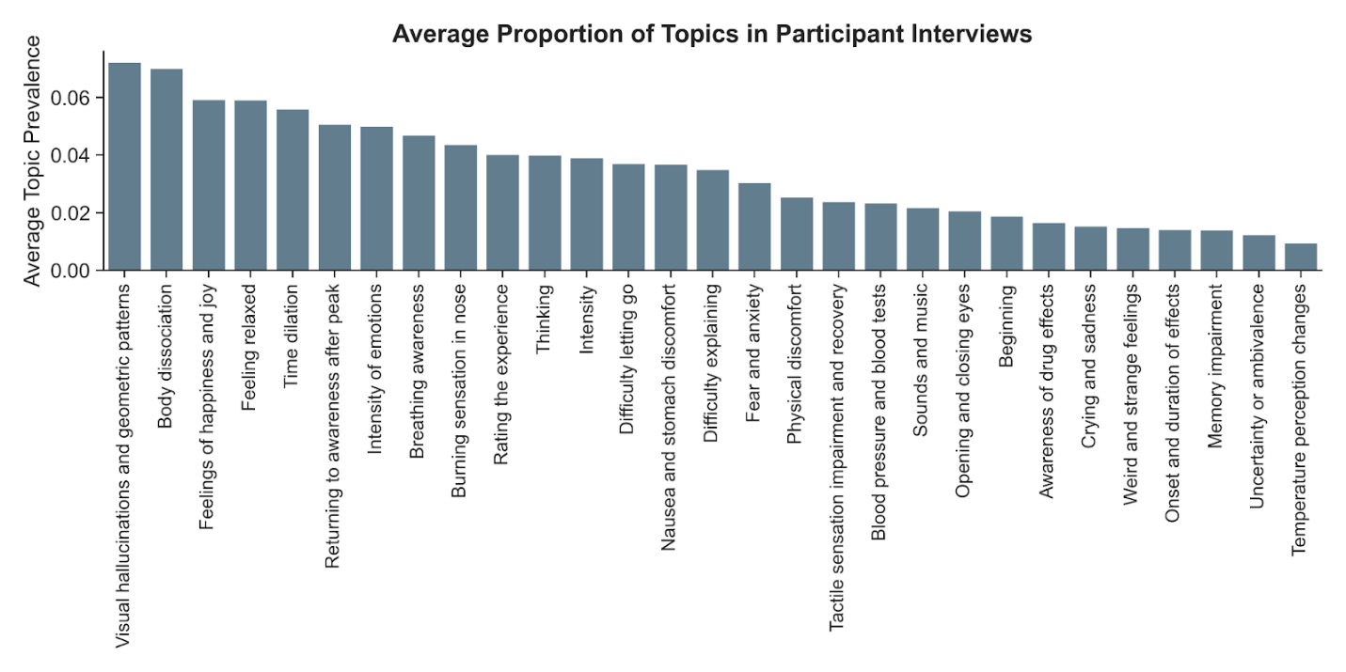
Figure S2. Dynamic topic modelling (evolution of unsupervised topics over time)
These plots show the evolution of distinct experiential themes (topics) over the first 40 minutes following 5-MeO-DMT administration, as revealed by dynamic topic modeling of participant interviews. Each line represents the normalized prevalence of a specific topic, derived from unsupervised analysis of participants' timestamped utterances. Time points were anchored to participants' real-time subjective drug intensity ratings collected during dosing sessions. To better visualize the underlying temporal trends and reduce noise in the prevalence data, the curves representing topic prevalence over time were smoothed using a Savitzky-Golay filter. These smoothed curves allow for easier visual identification of when different experiential themes emerge (rise in prevalence), reach their maximum prominence (peak), and fade (subside) over the course of the acute effects. Comparing the shapes and timing of these curves across topics highlights that different aspects of the experience unfold at varying time scales.

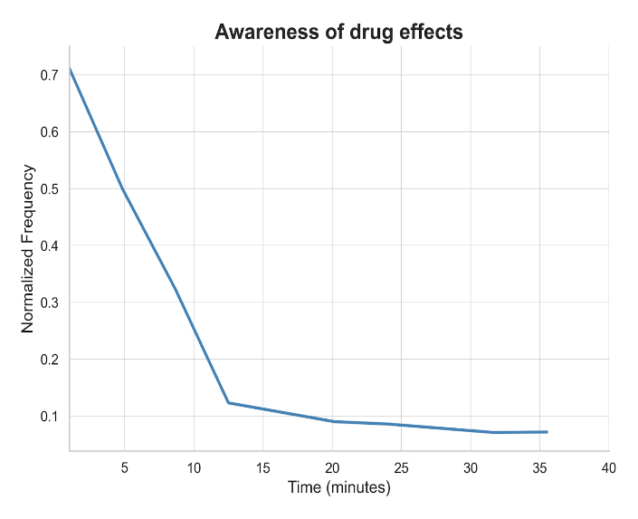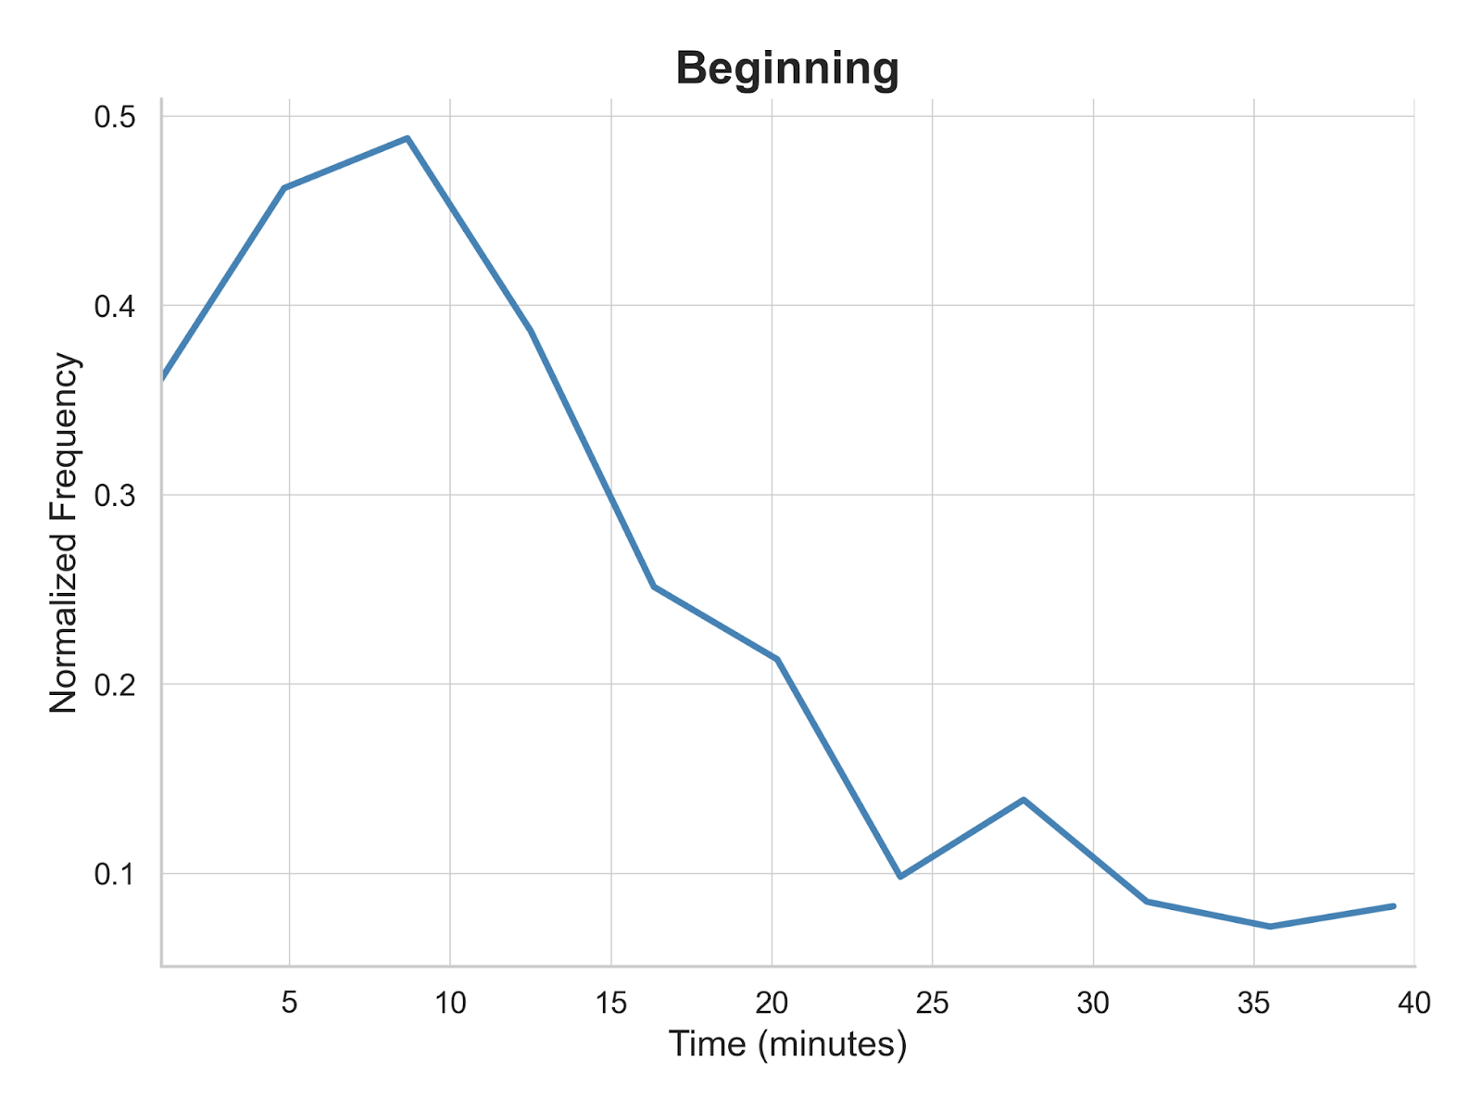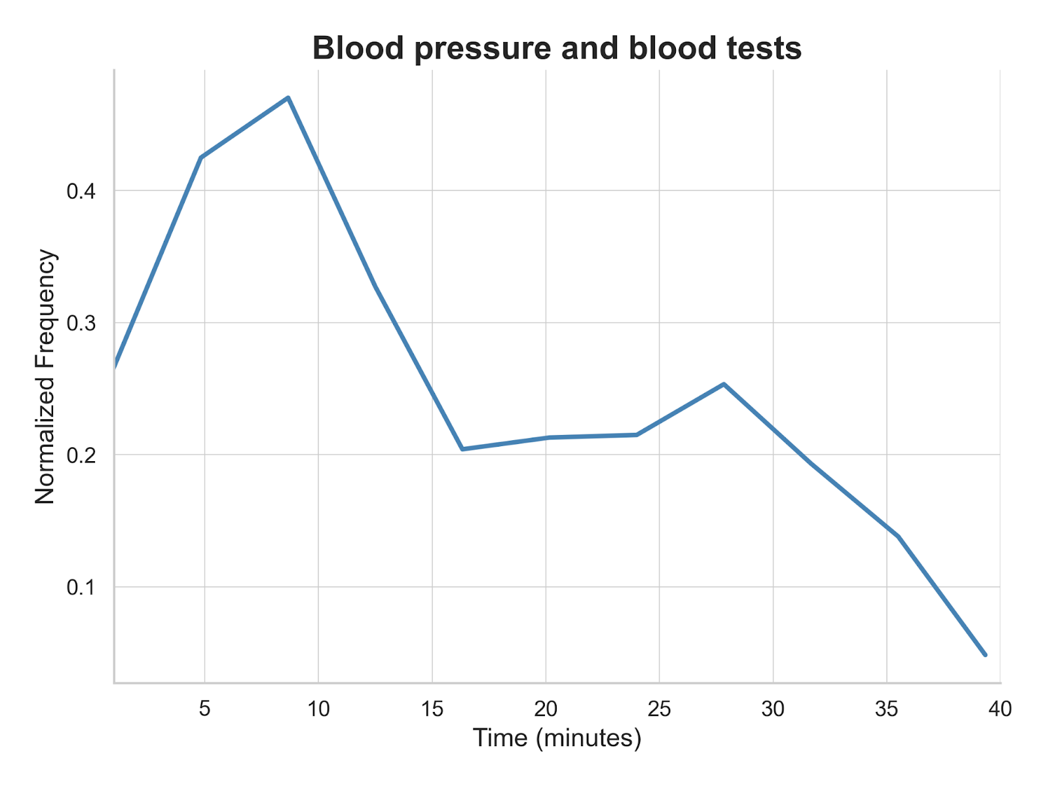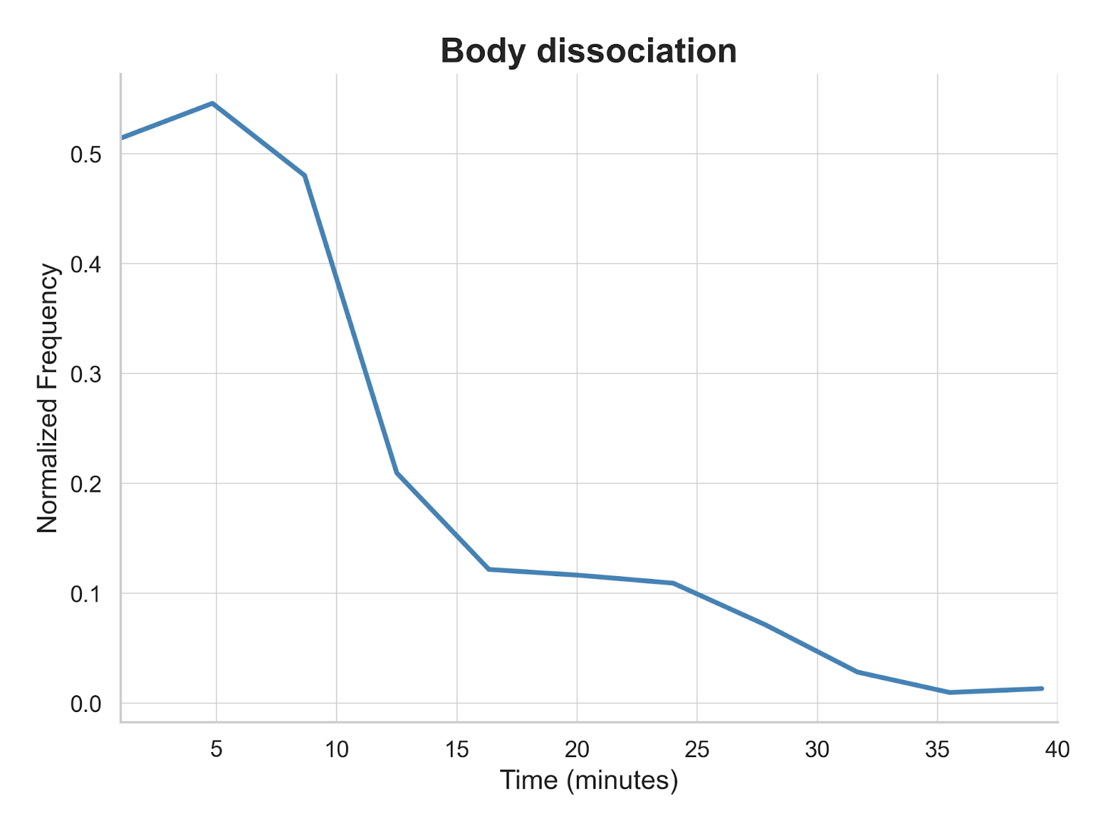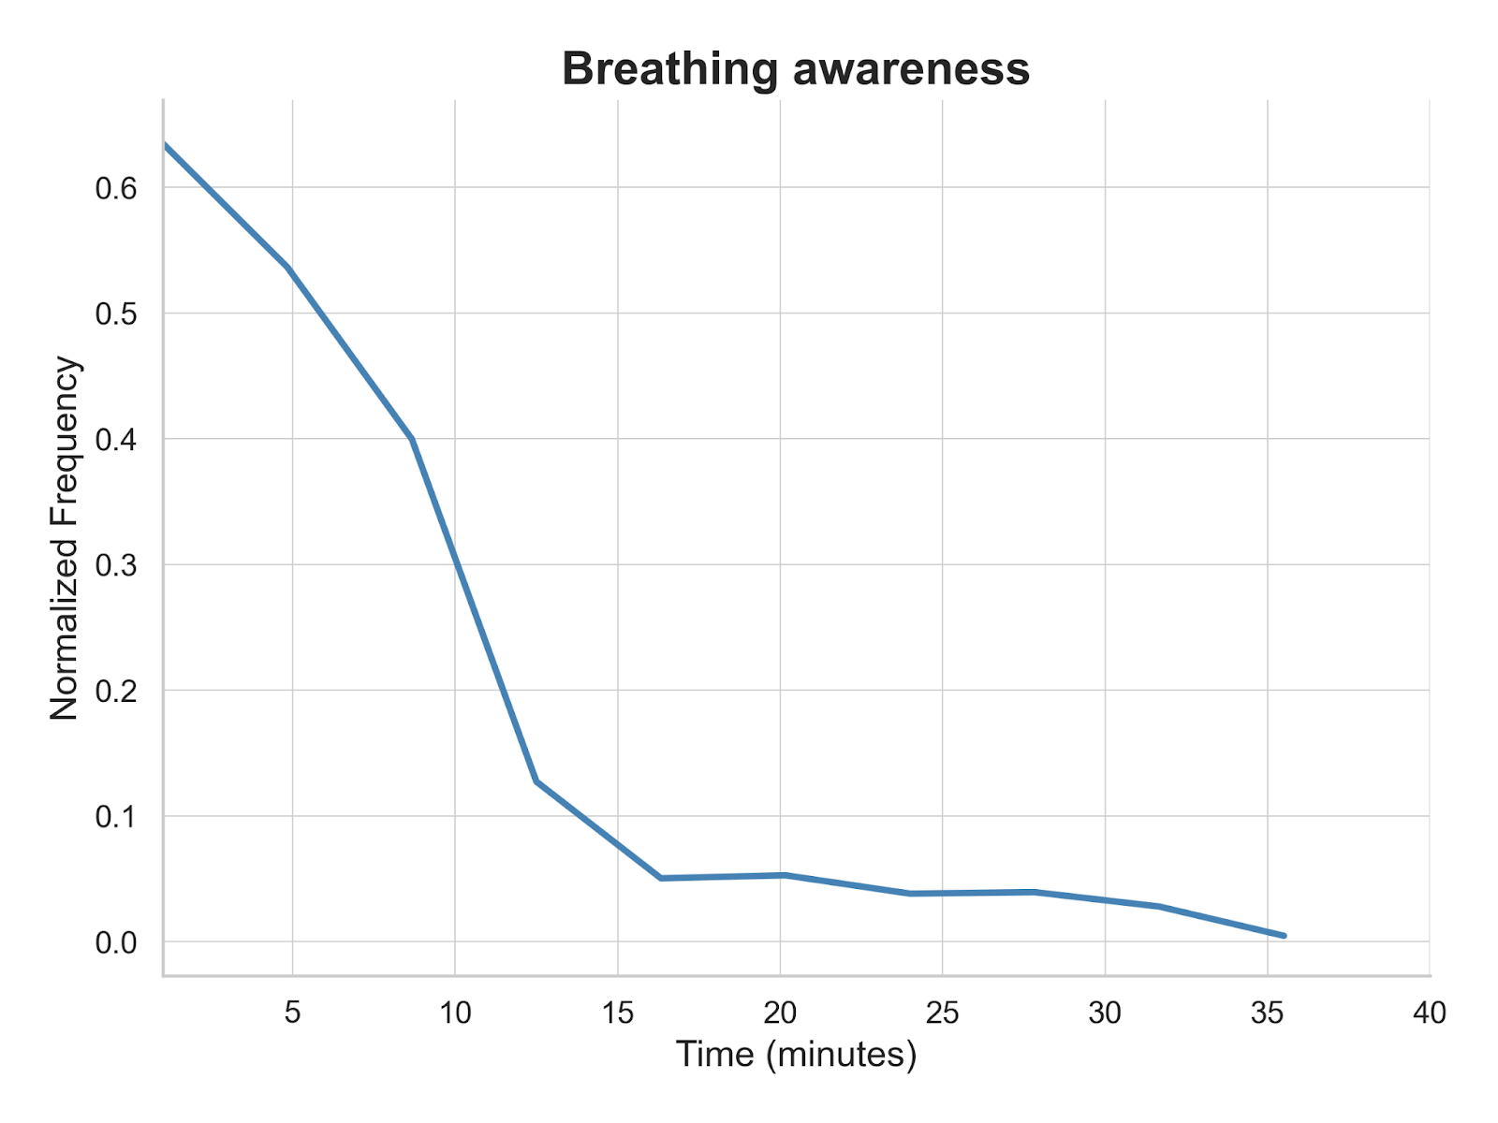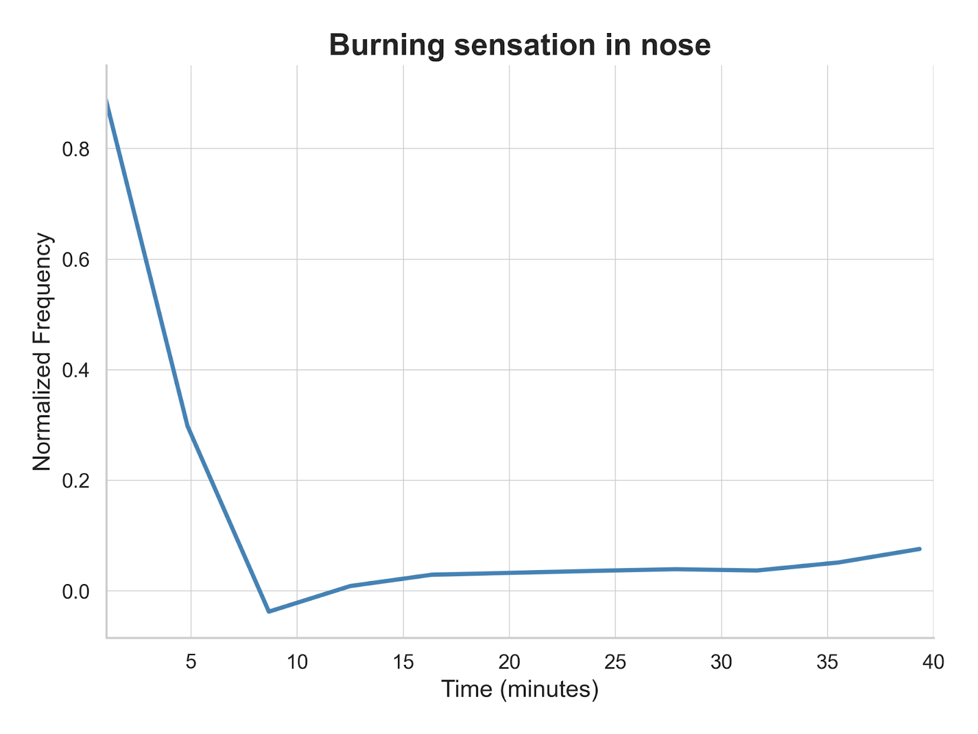

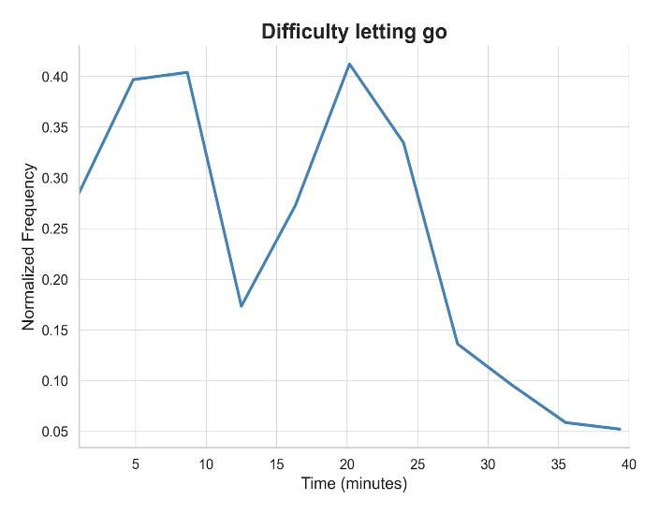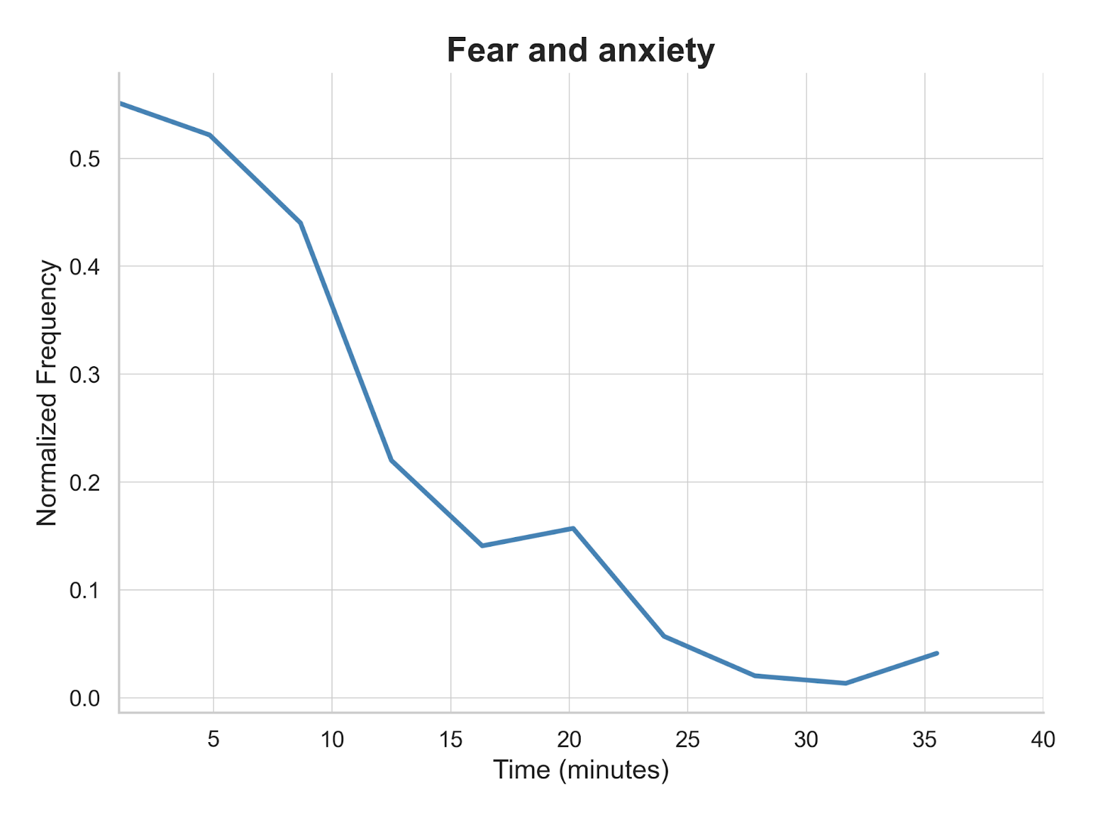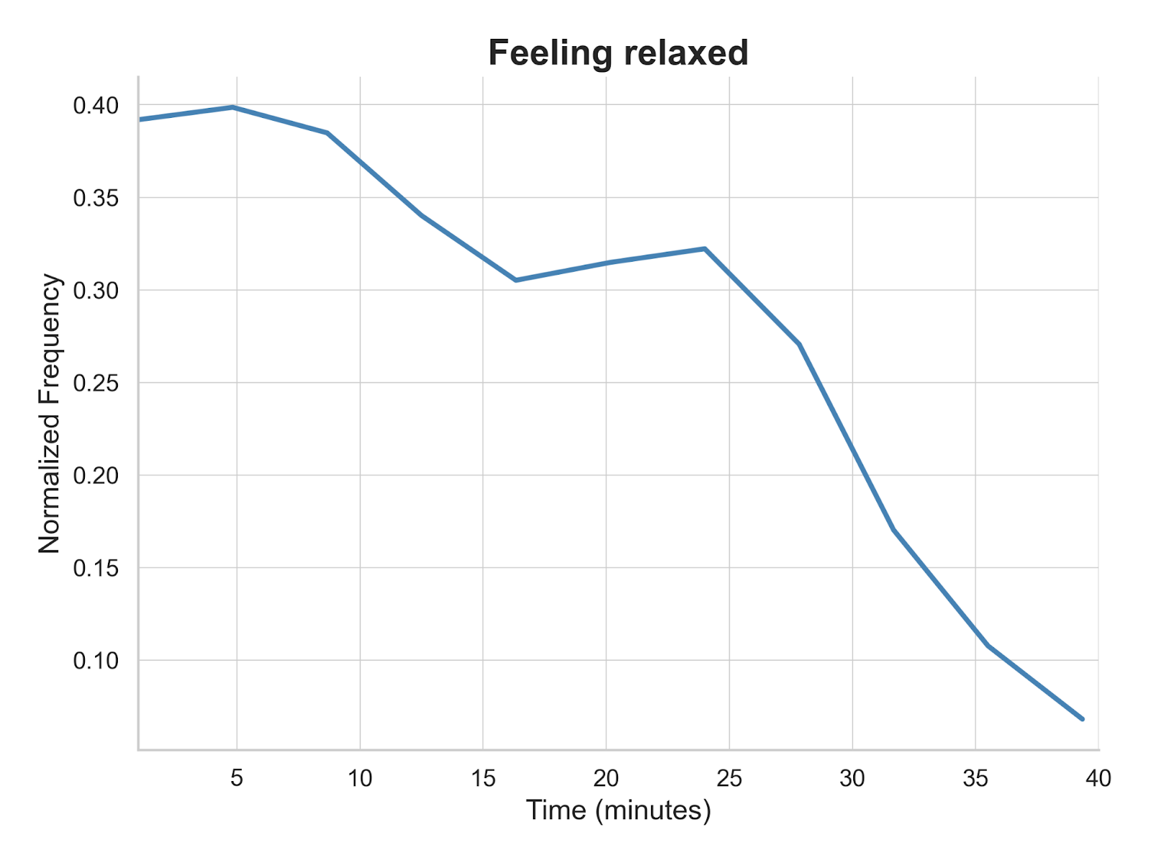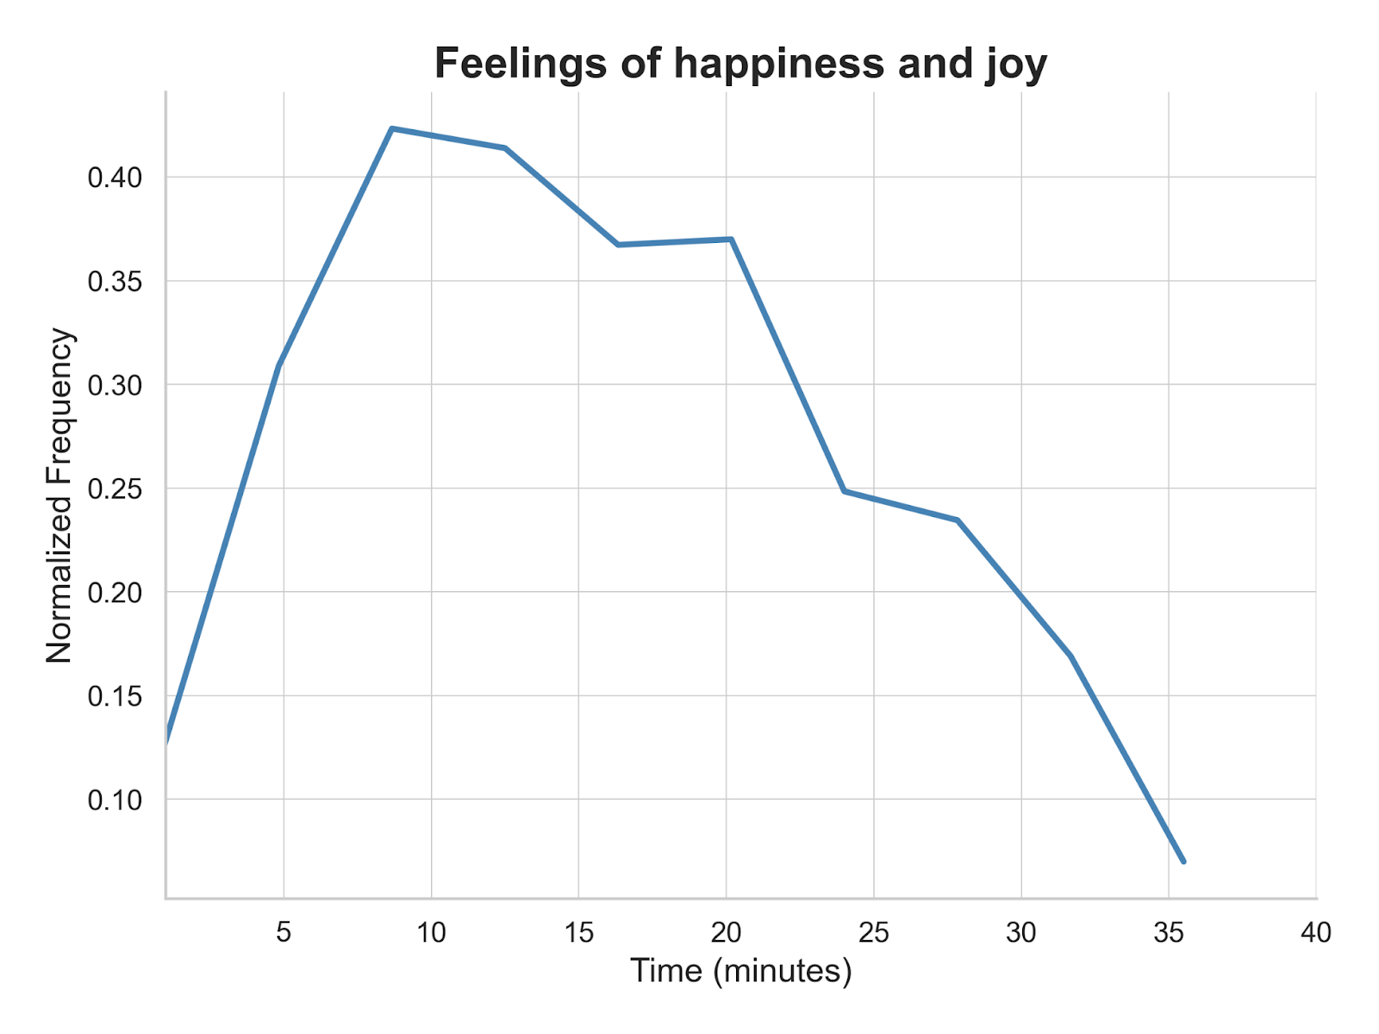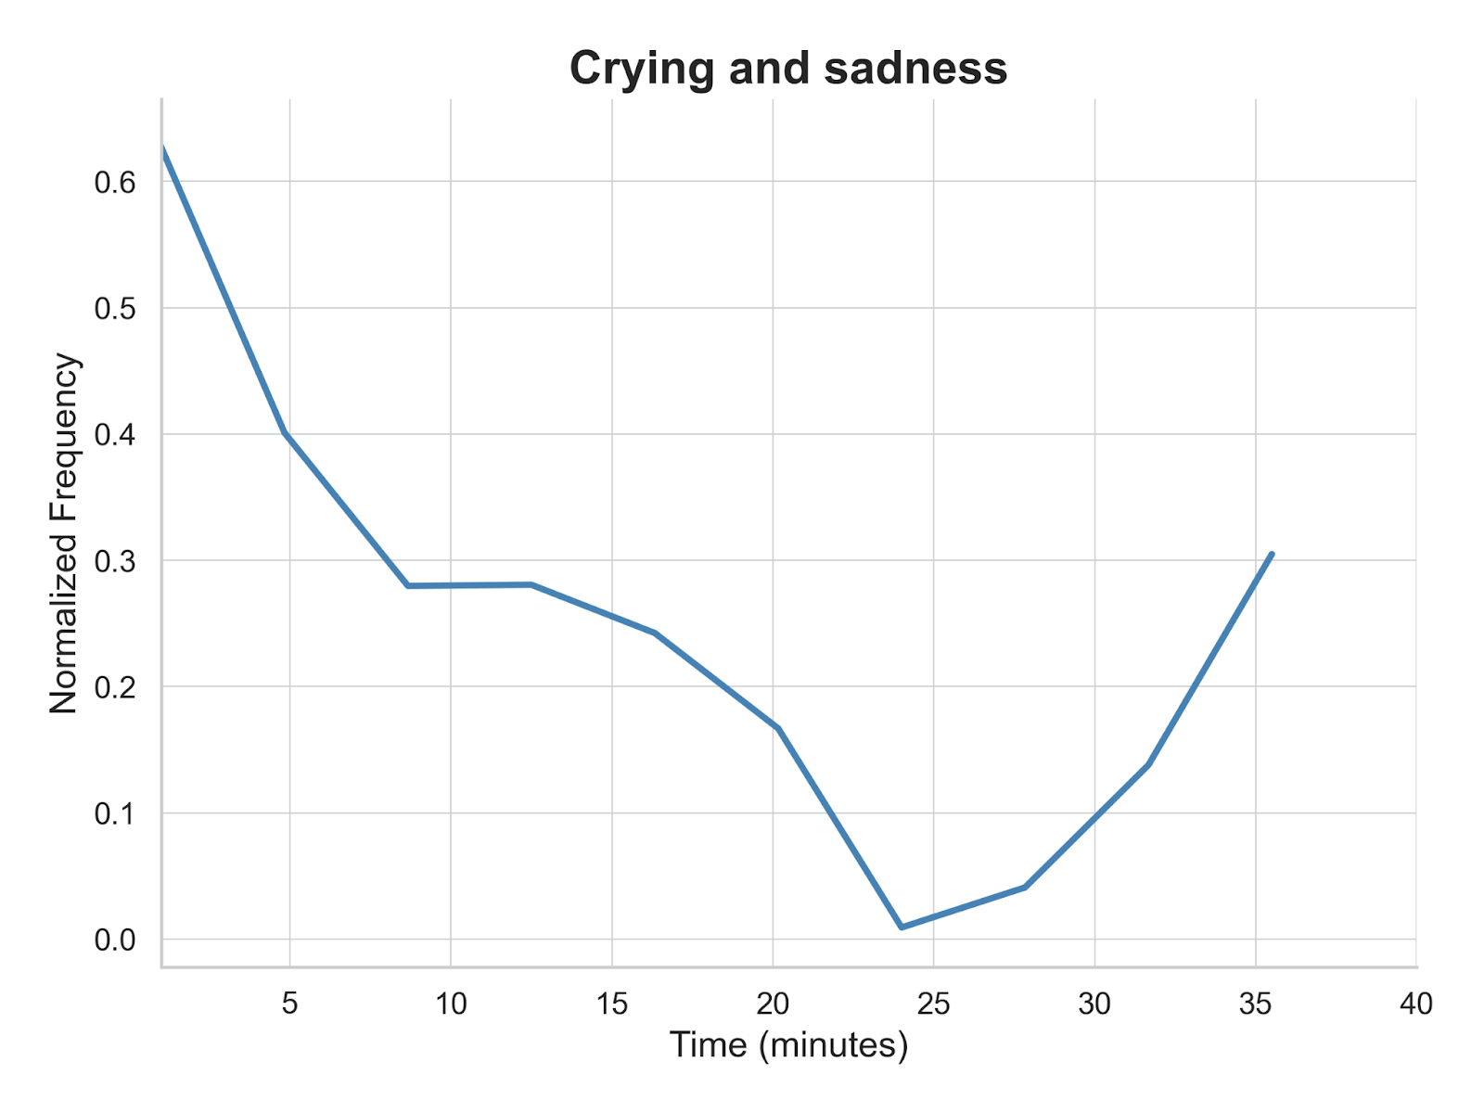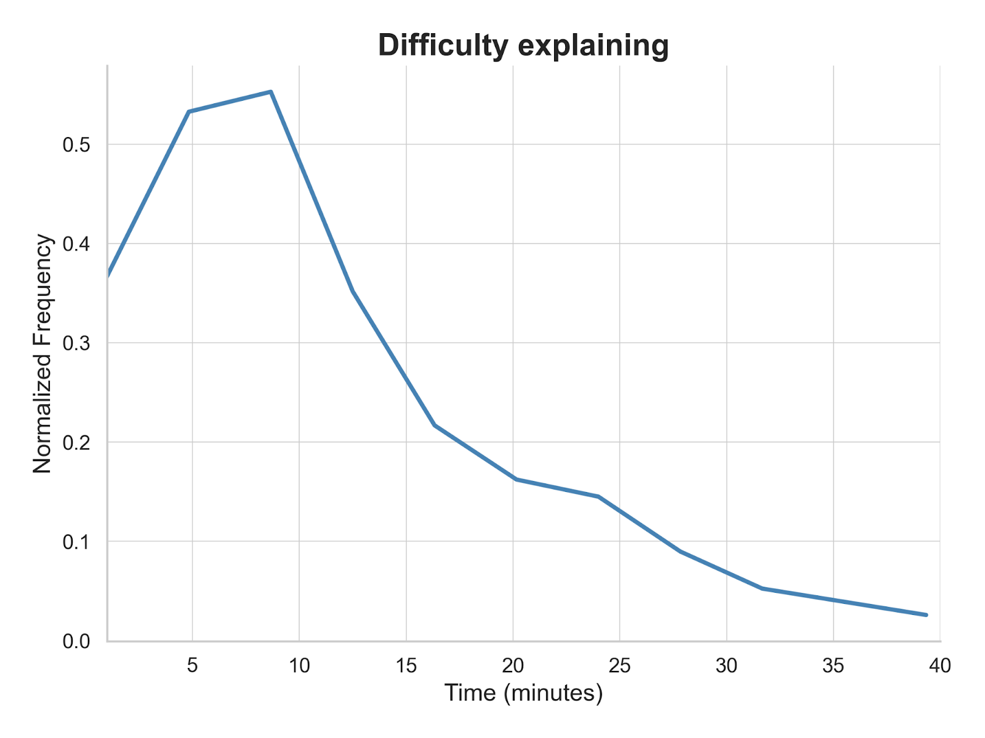

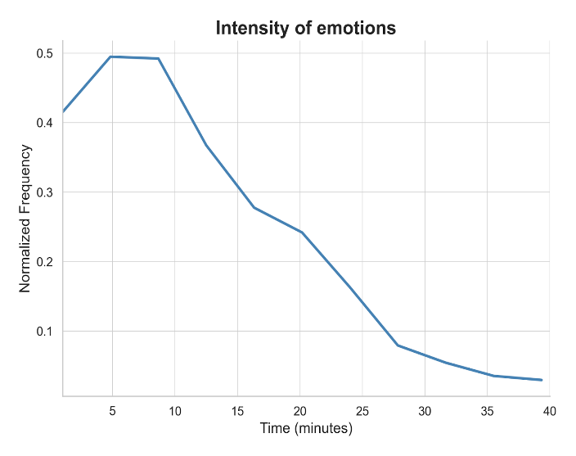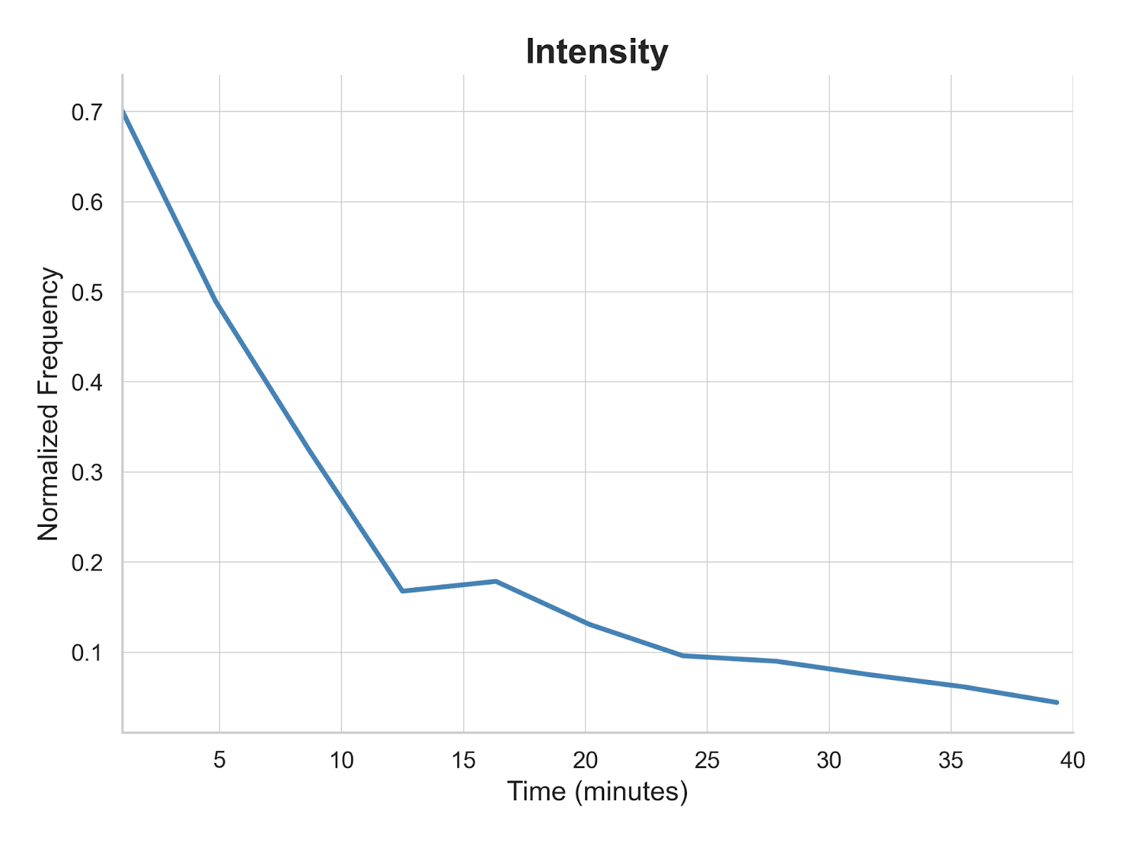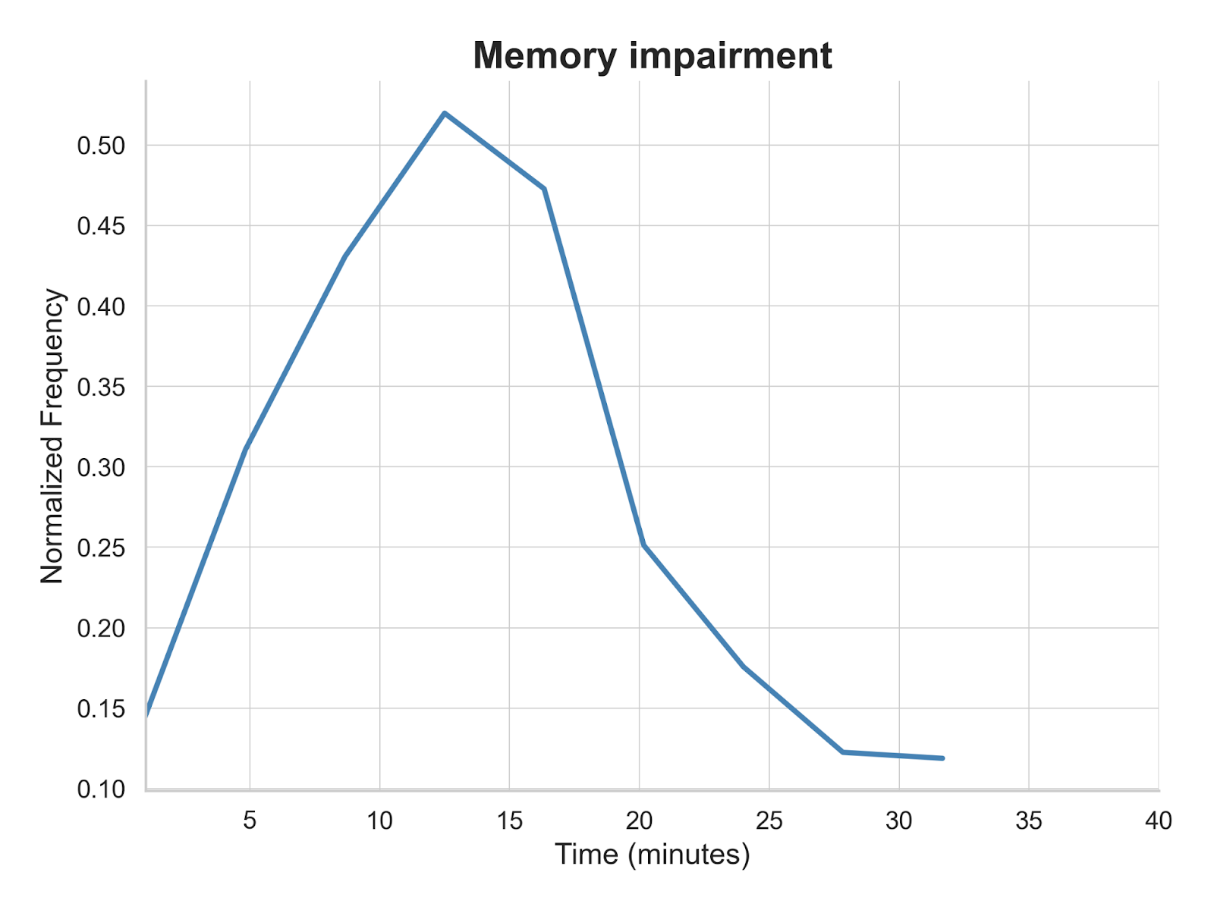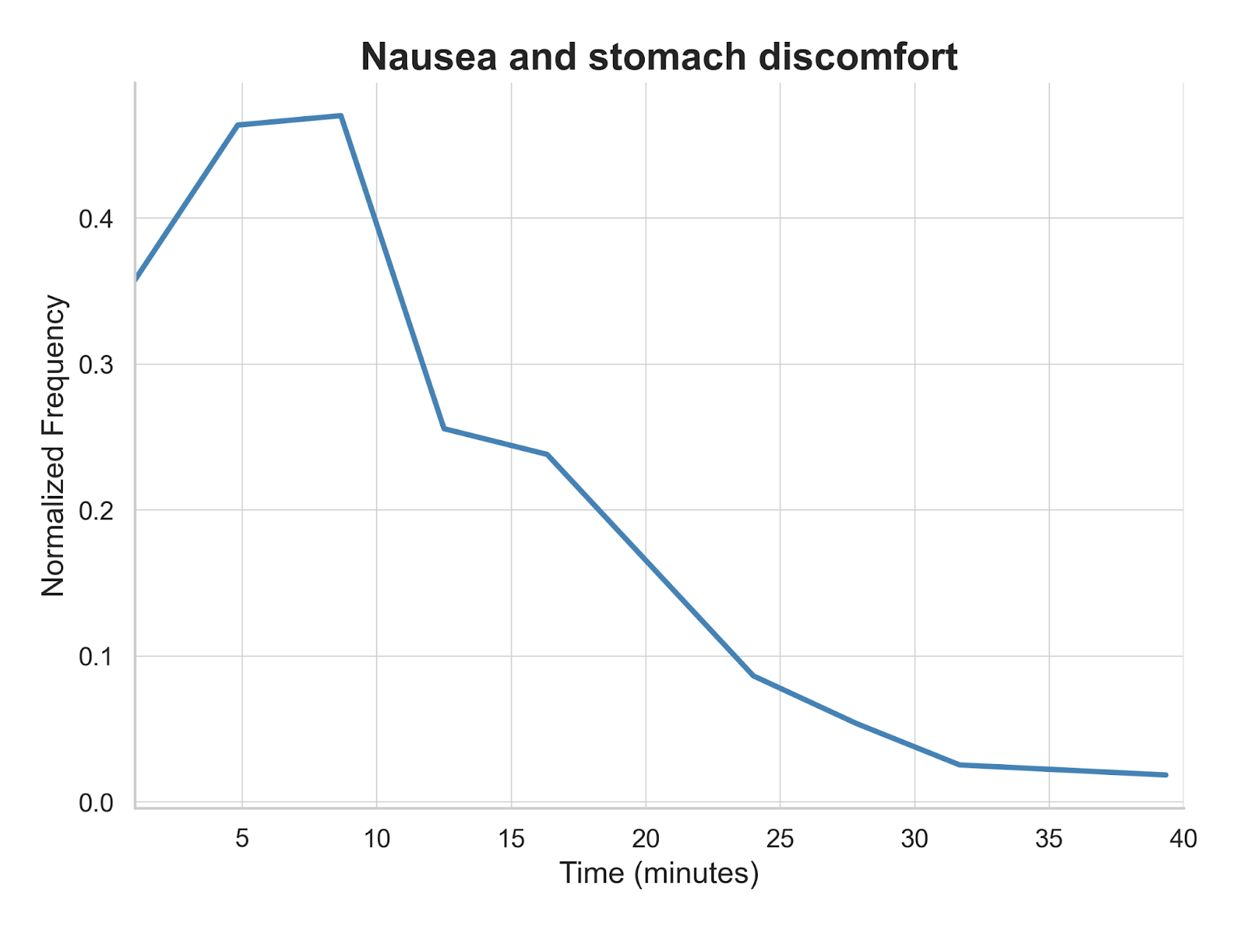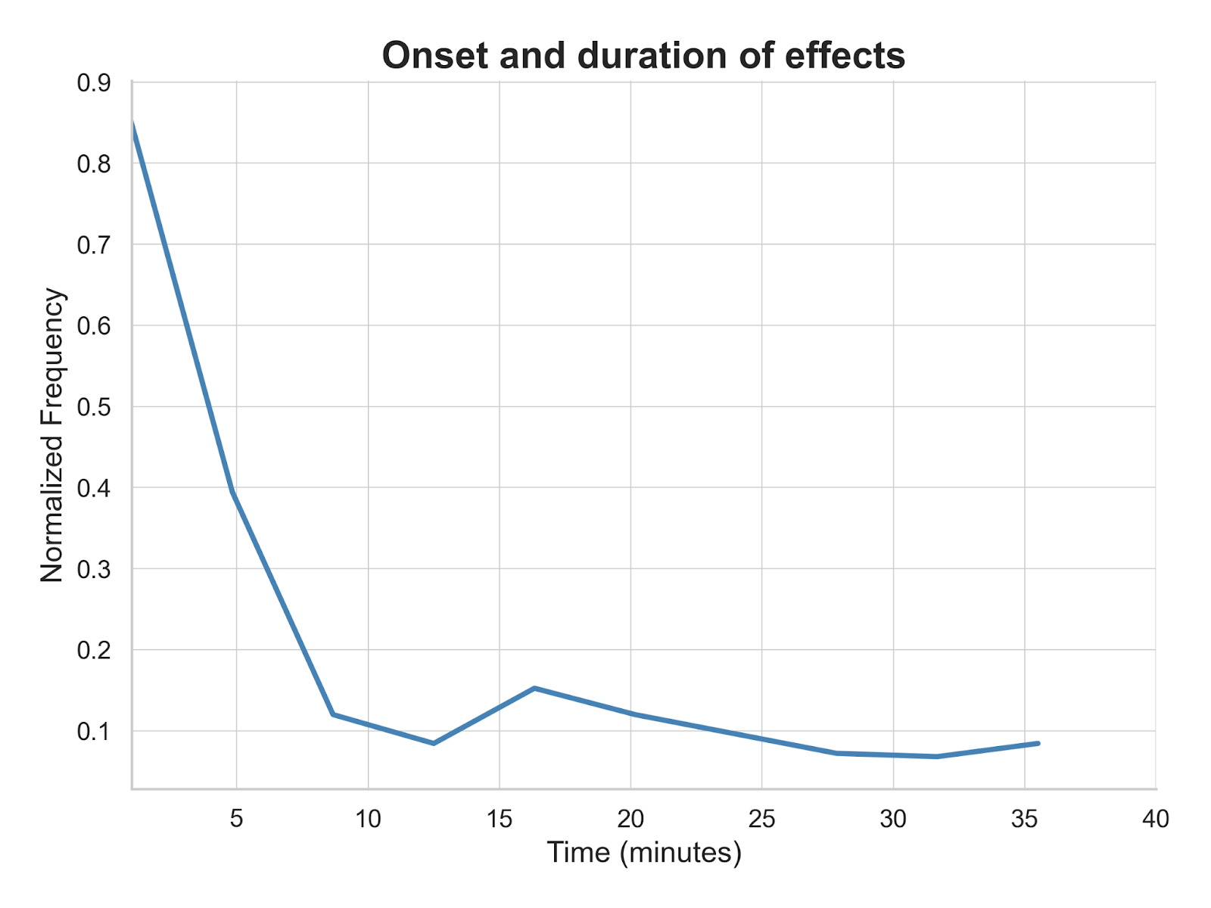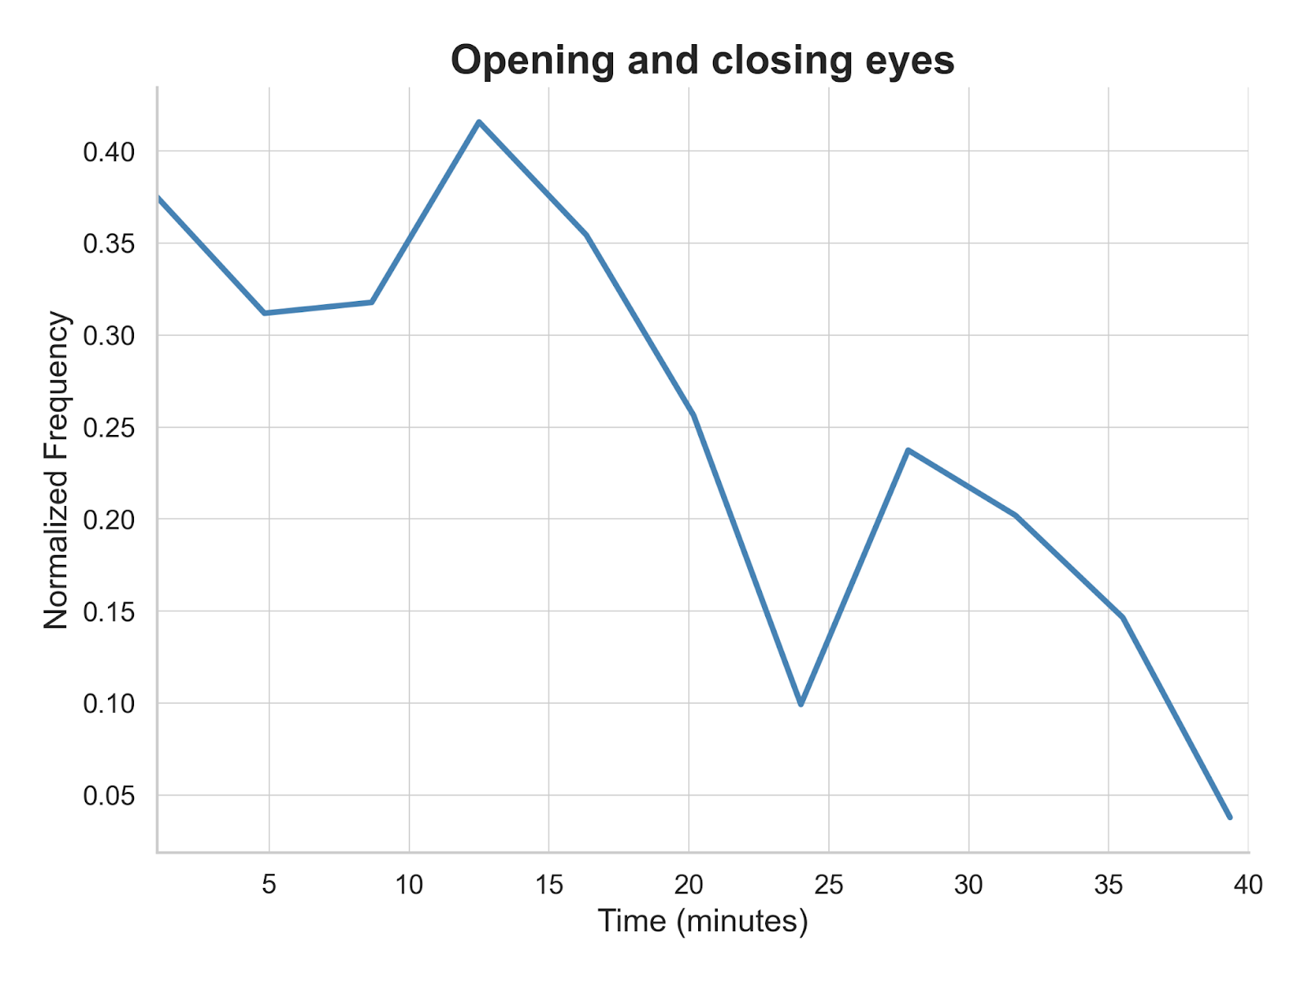

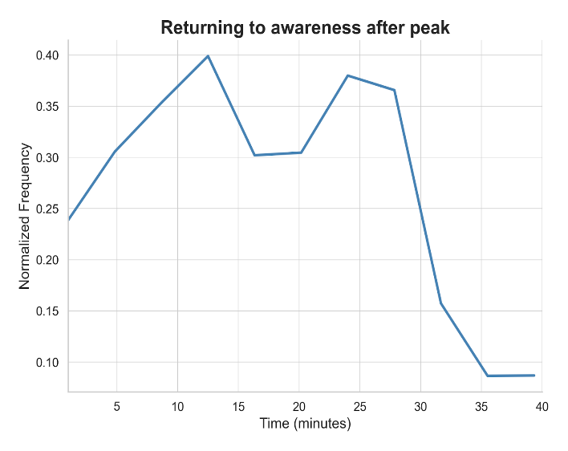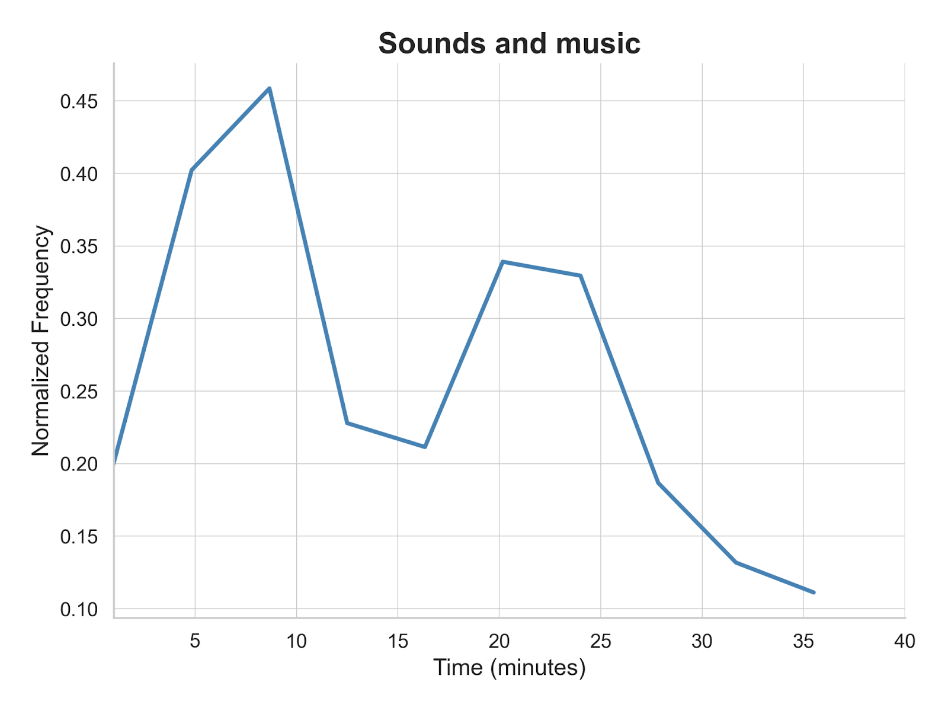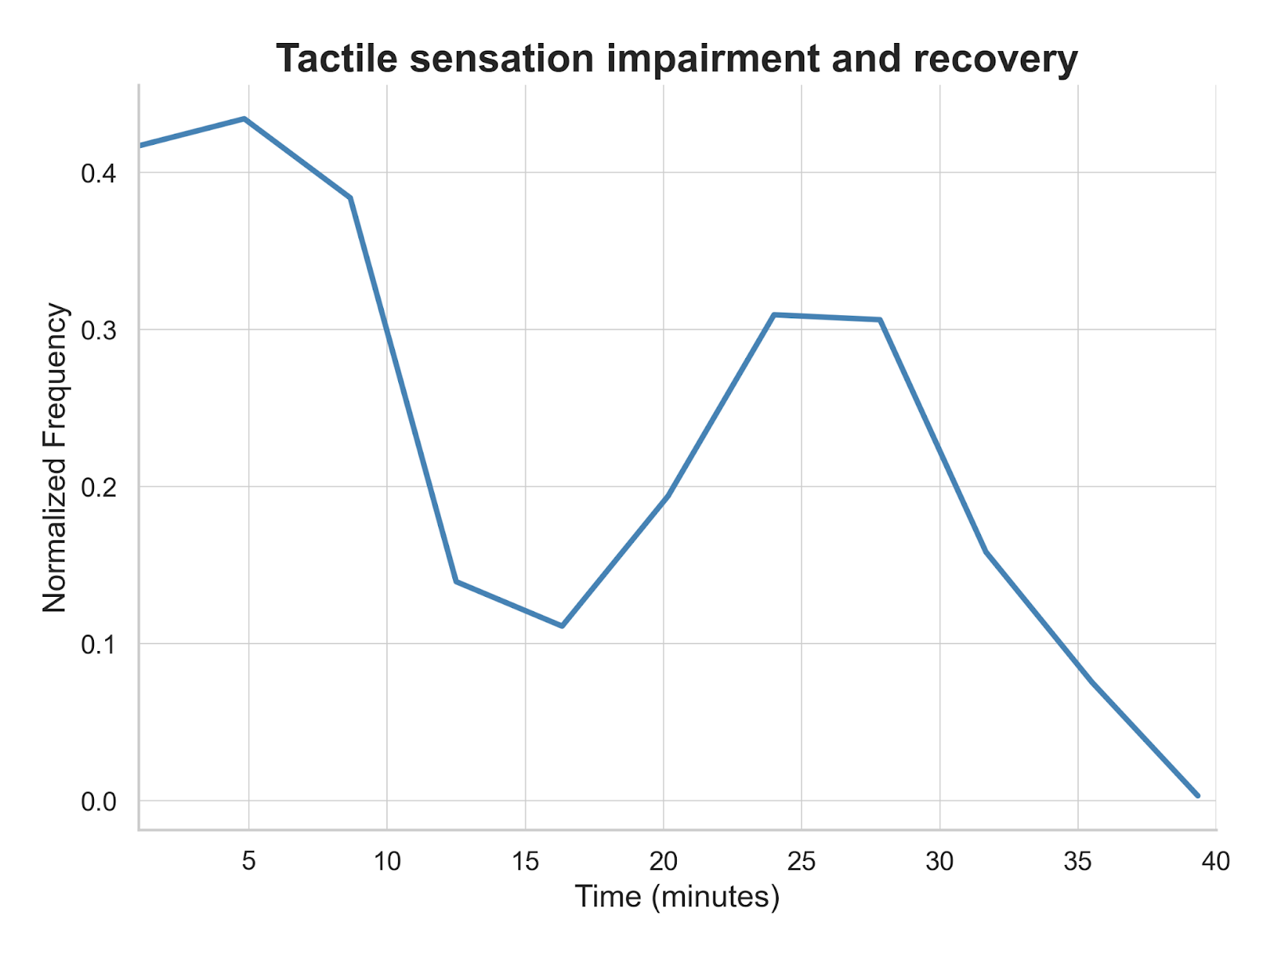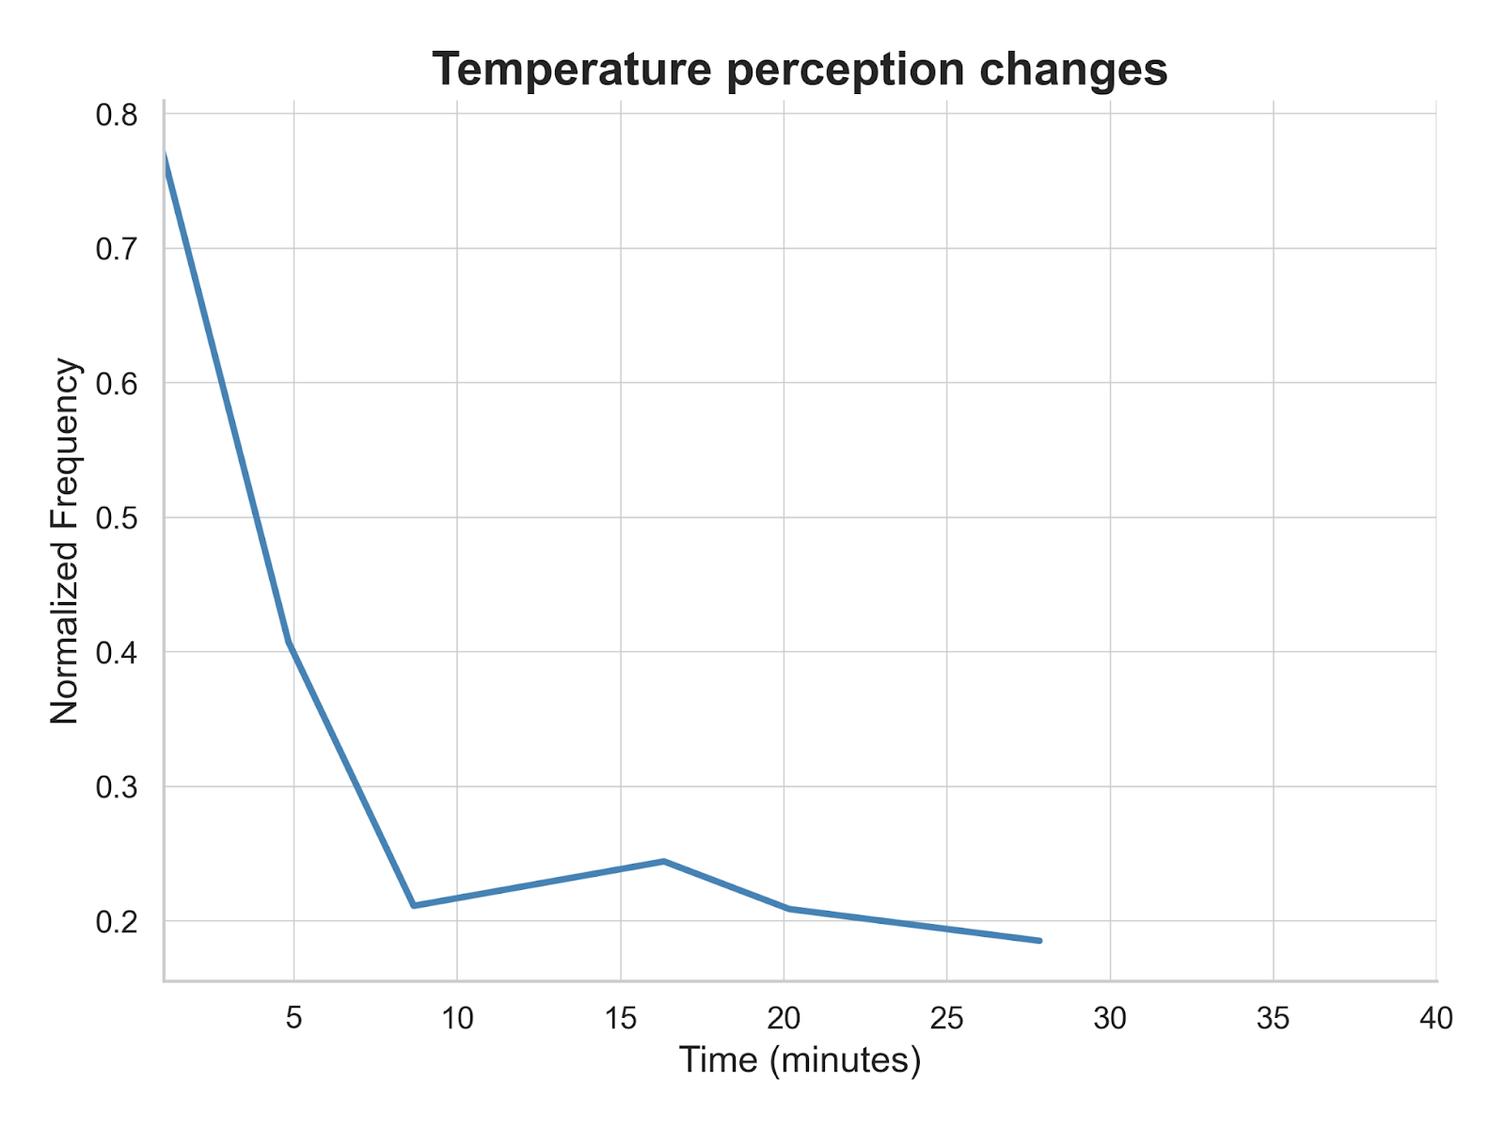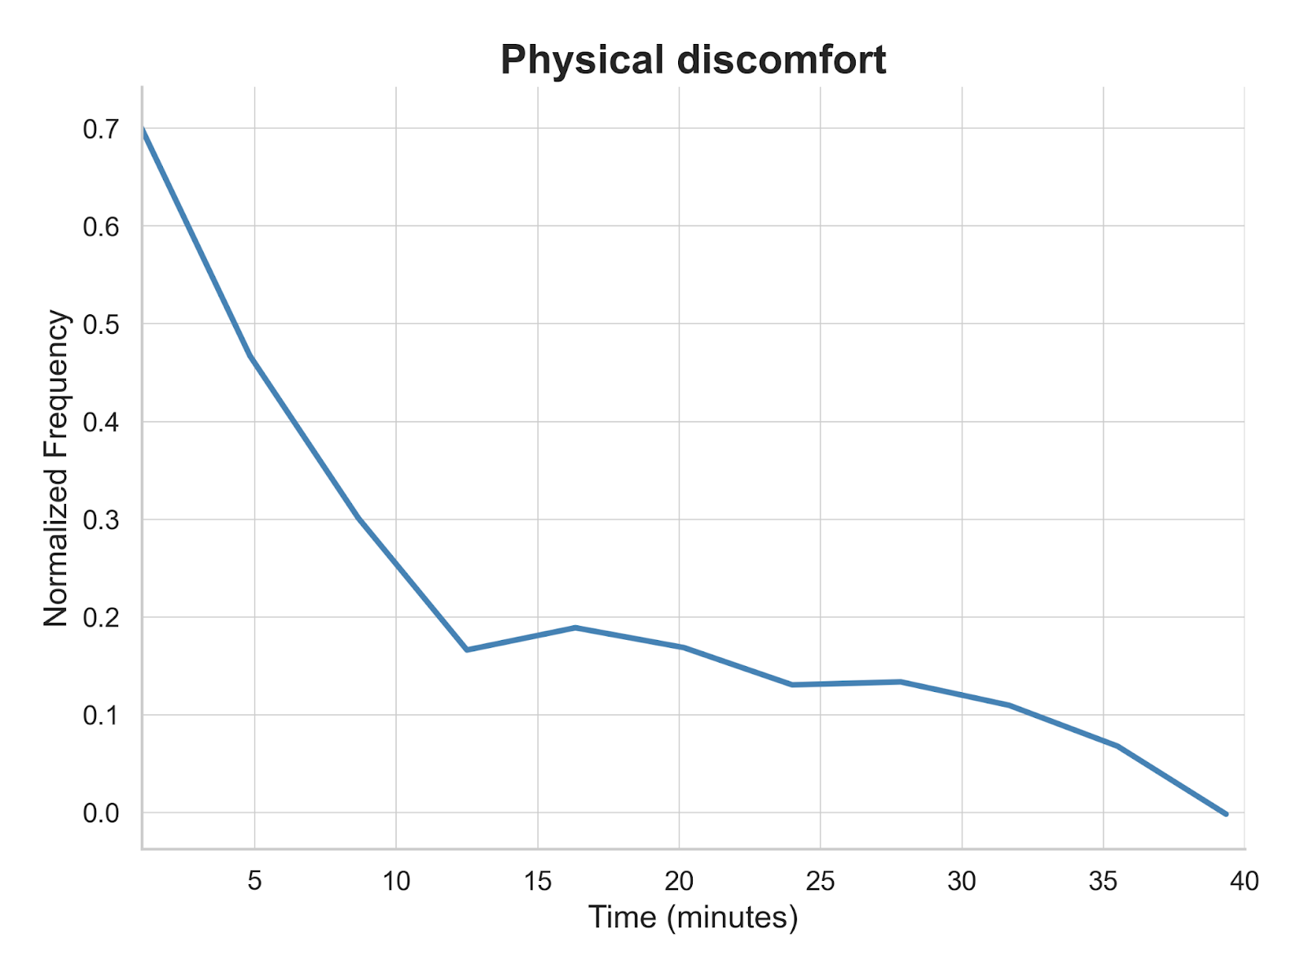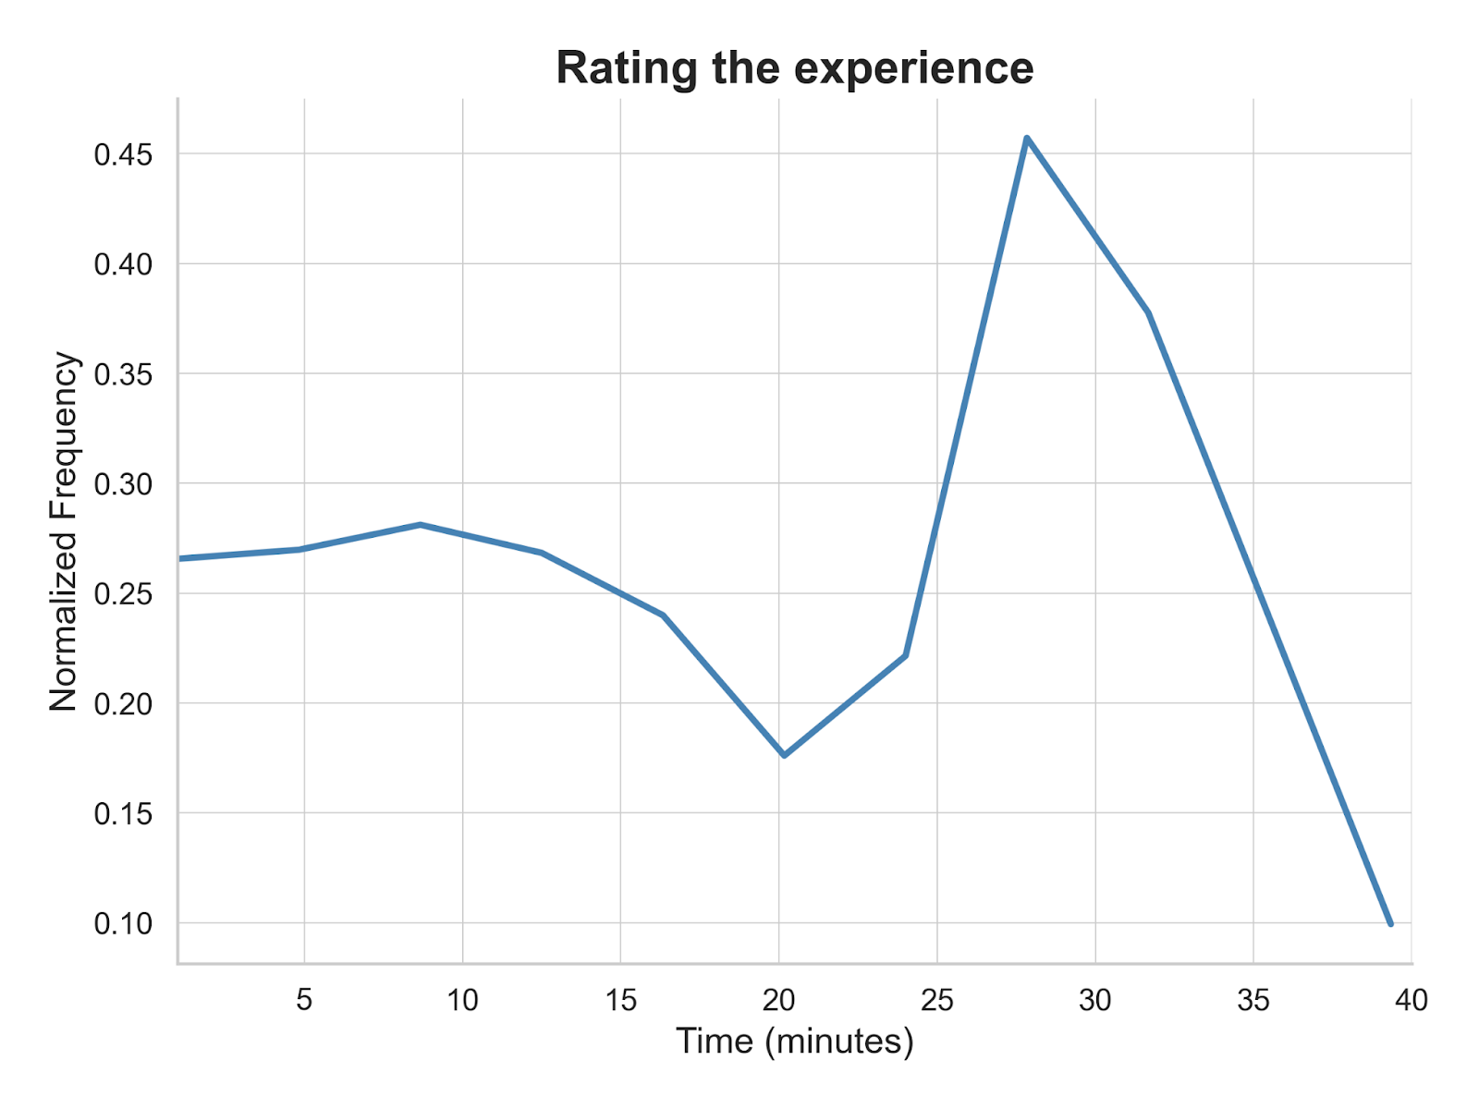

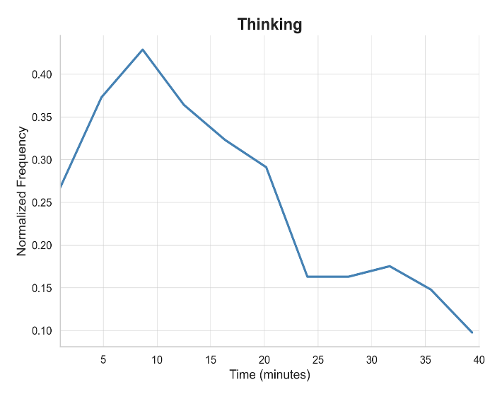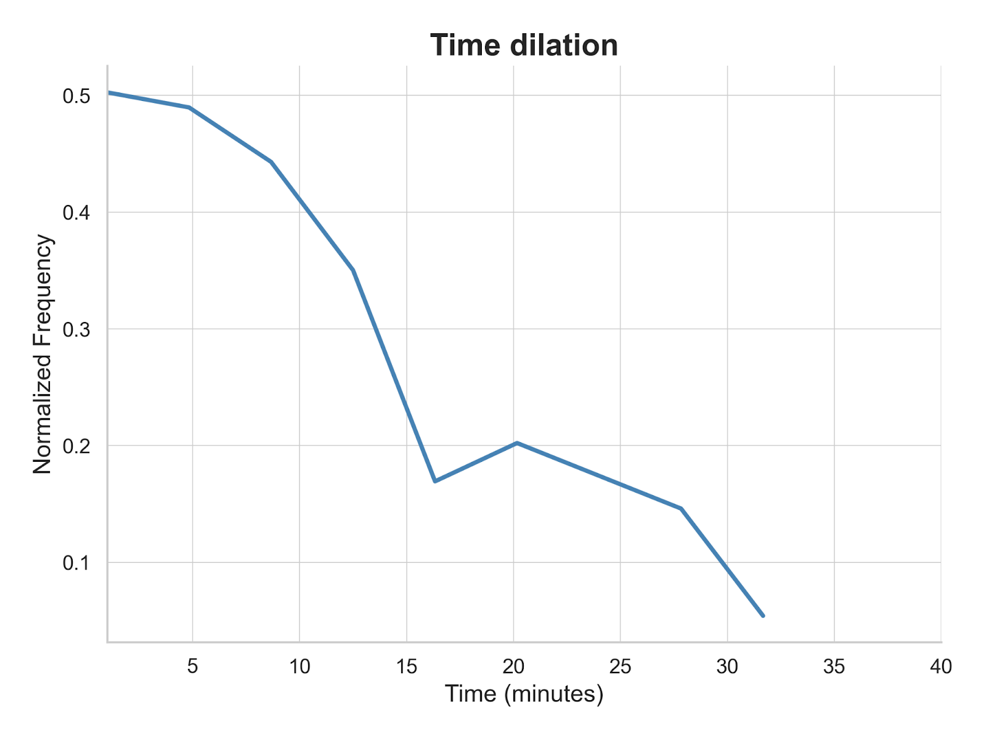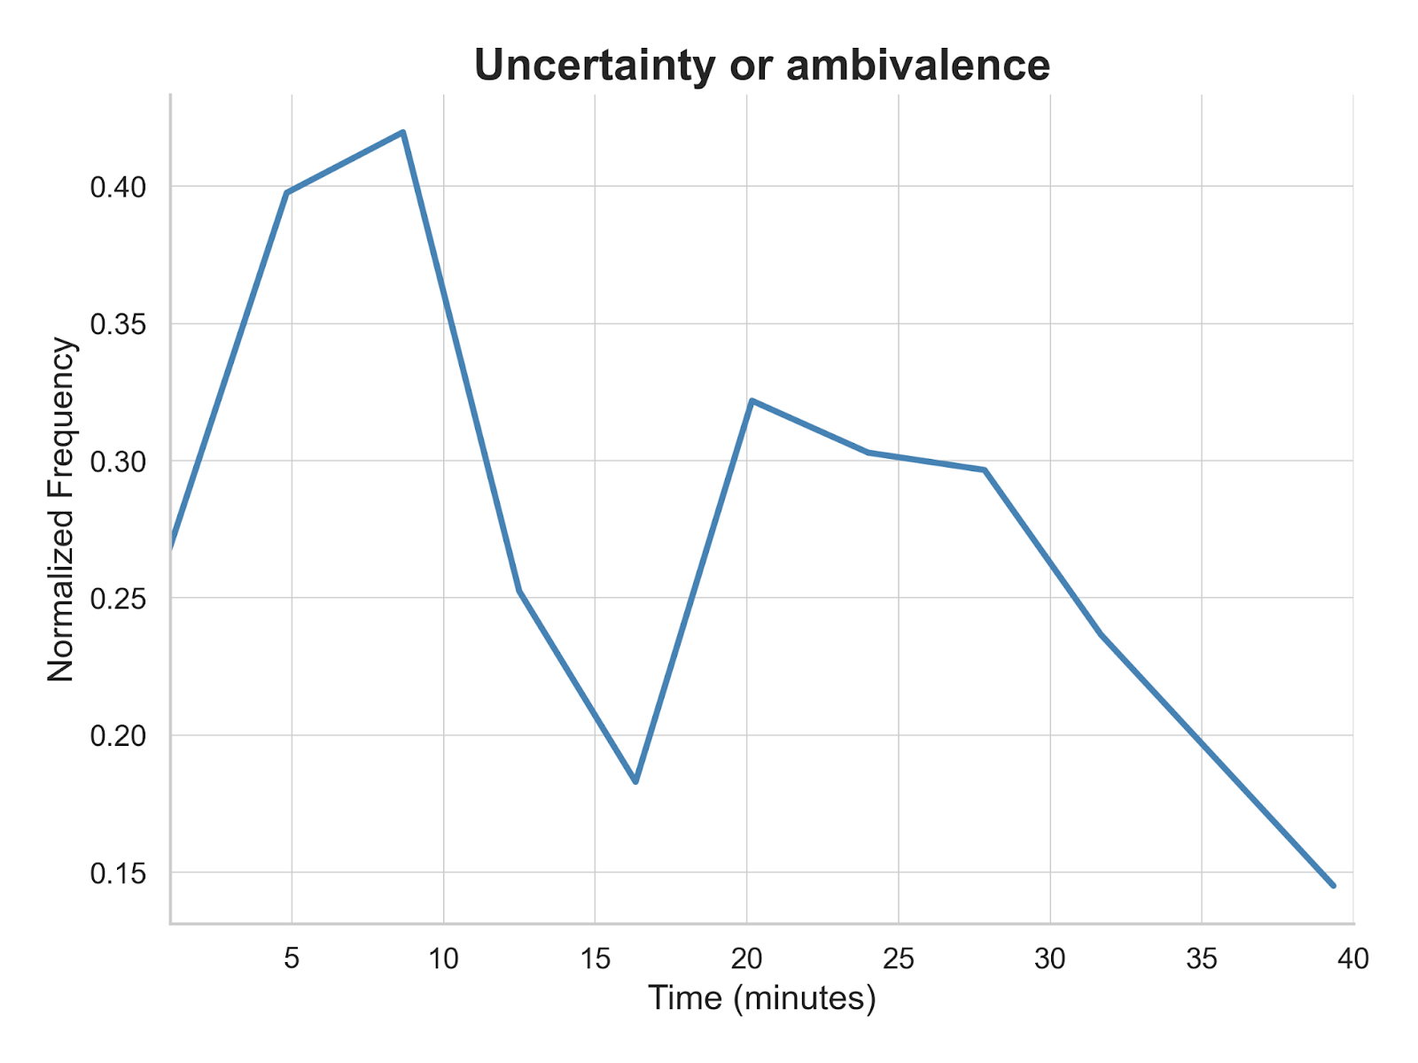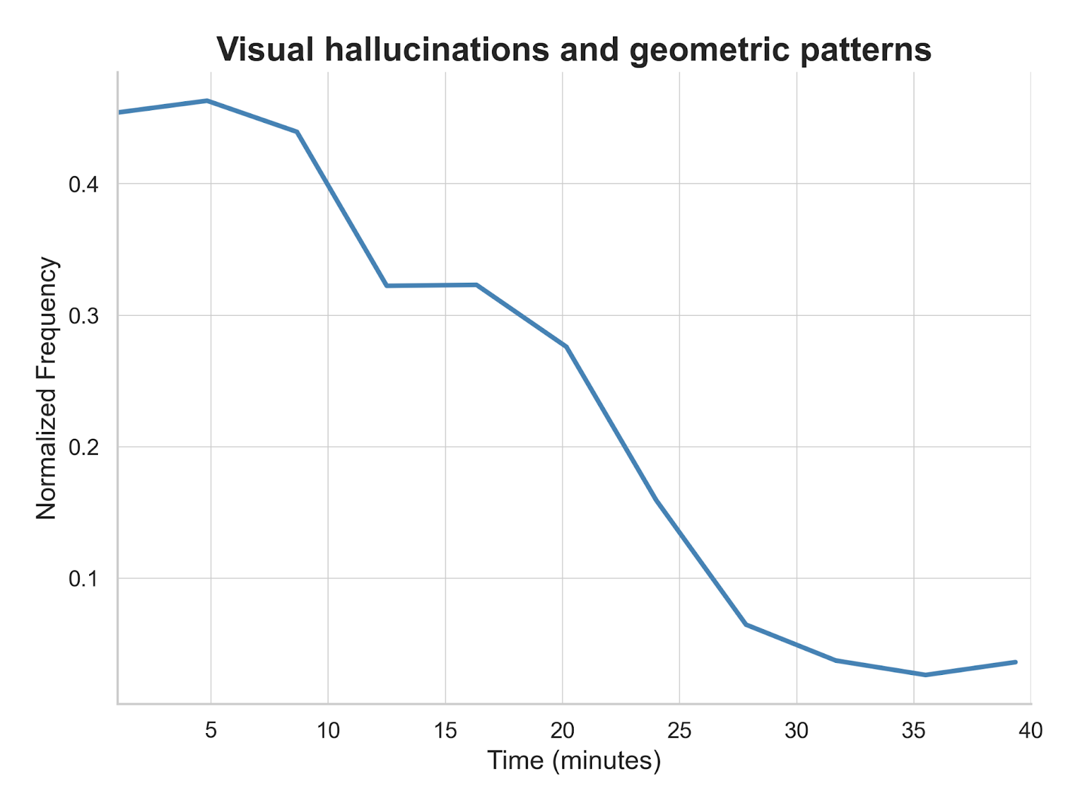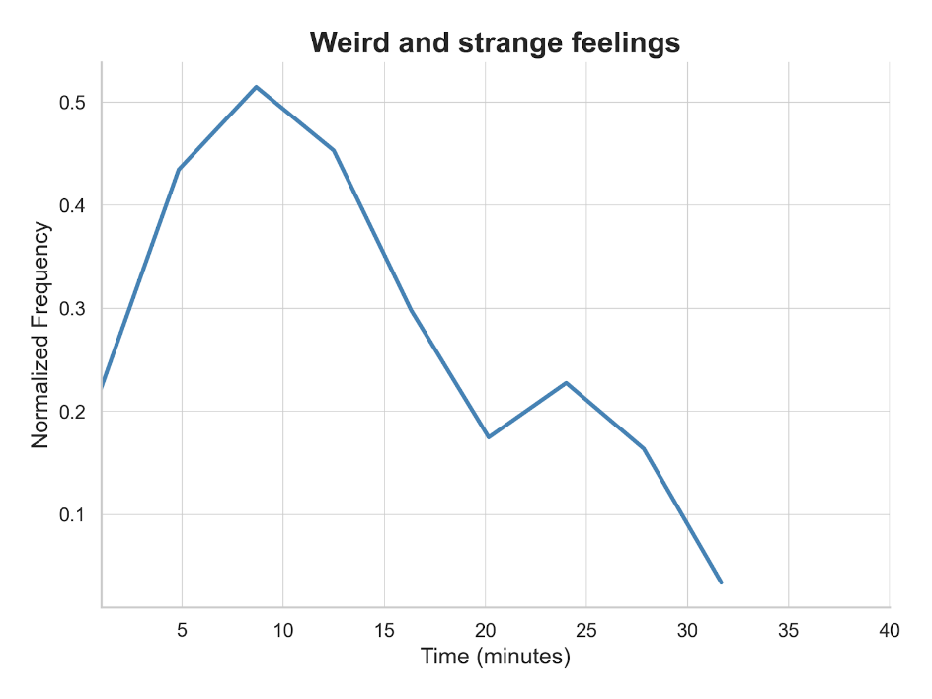

Figure S3. Supervised topic modelling
Line graphs illustrating the dose-dependent relationship between 5-MeO-DMT administration and specific subjective experiences, as derived from supervised topic modeling of participant interviews. The x-axis shows three dose ranges: low (1-4 mg), medium (6-8 mg), and high (10-12 mg). The y-axis shows the average (across participants within each dose range) of participant-level normalized mean cosine similarities (calculated using a threshold of 0.50) between participant utterances and predefined reference sentences, each representing a distinct experiential theme (see Methods: Quantitative analysis for detailed calculation). Only themes exhibiting a strict dose-dependent relationship (consistently increasing or decreasing across dose ranges) are plotted. Note: These trends are presented descriptively. No statistical tests were performed to compare dose groups.
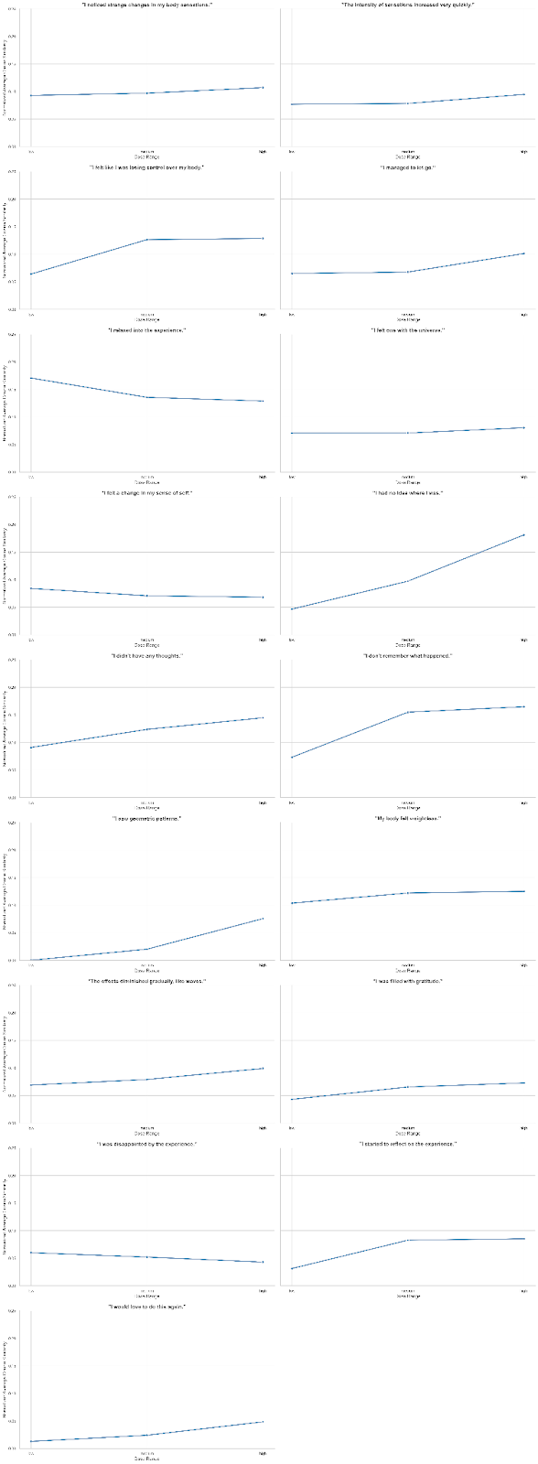

Figure S4. Supervised topic modeling heatmaps for each participant
Heatmaps show normalized average cosine similarity between participant utterances and predefined reference sentences, capturing key themes identified in qualitative analysis. (A) Individual participant responses across all reference sentences, revealing inter-individual variability. (B) Dose-dependent effects, showing average similarities for each dosage group (1, 4, 6, 8, 10, and 12 mg). (C) Dose-range effects, illustrating trends across low (1-4 mg), medium (6-8 mg), and high (10-12 mg) dose ranges. Color intensity indicates the magnitude of similarity, with warmer colors representing higher similarity. A threshold value of 0.50 was applied to focus on strongly related utterances, filtering out weak associations. Cosine similarities above this threshold were normalized to a 0-1 range, enhancing interpretability and allowing for more nuanced comparisons across themes and doses.

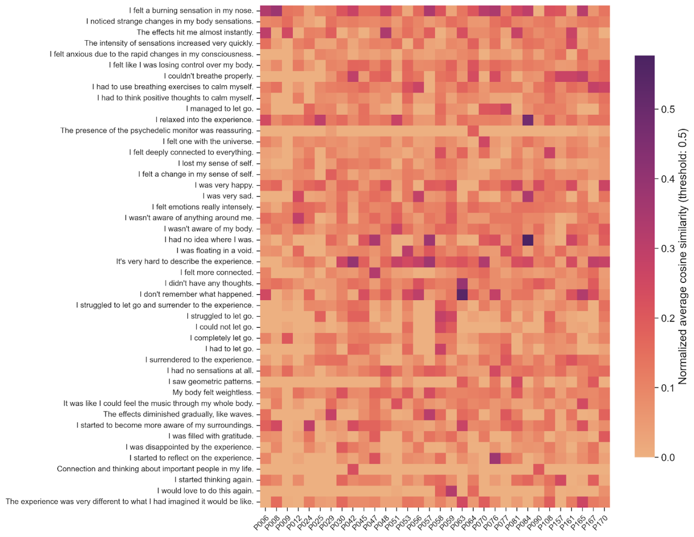
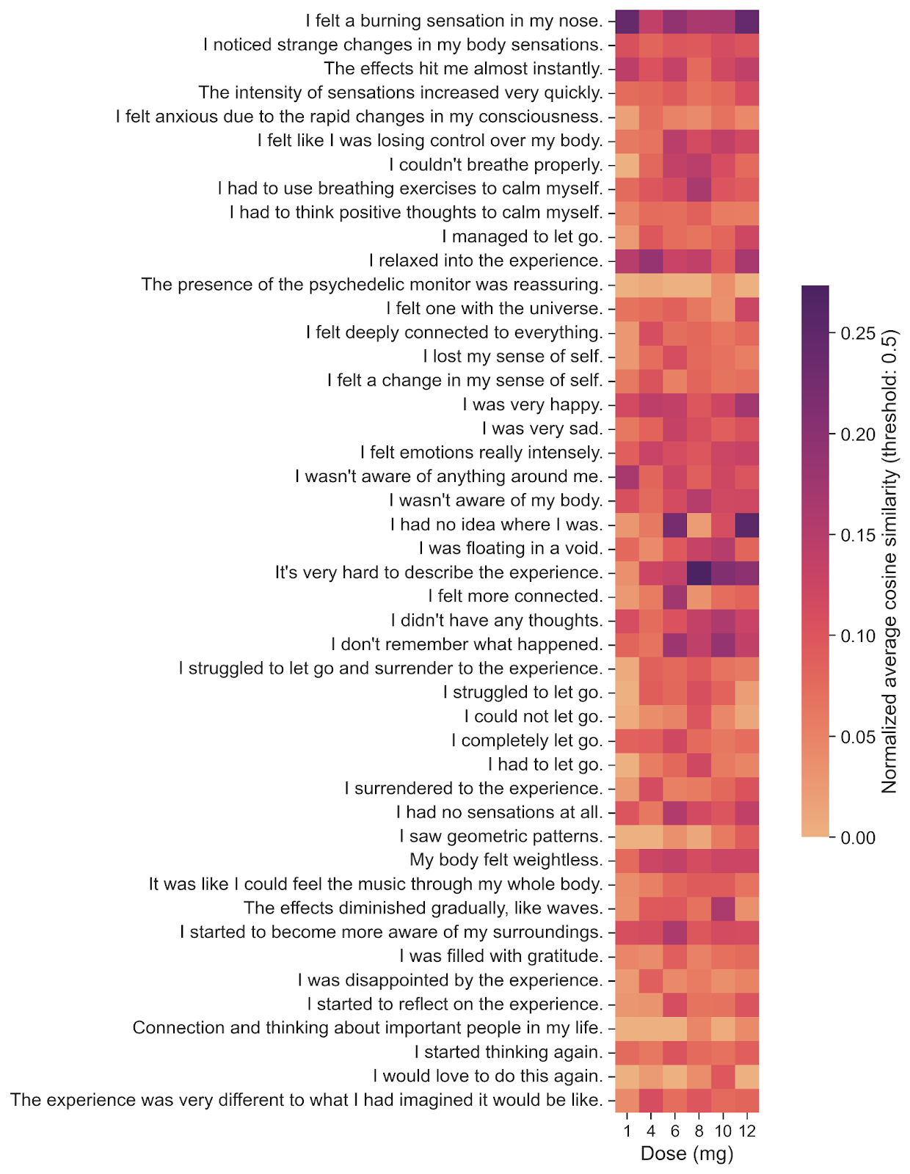
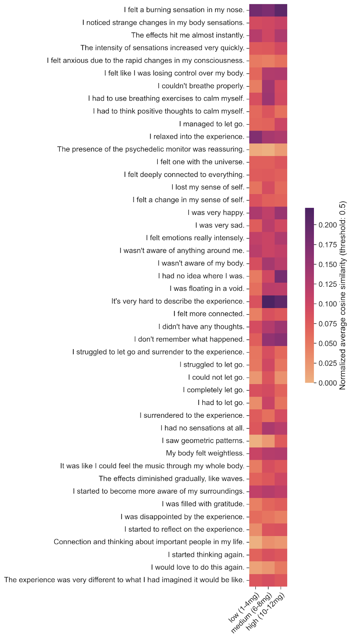
Detailed overview of topic modeling pipelines
Unsupervised Topic Modeling
Libraries & Tools
- sentence-transformers: For generating sentence embeddings.
- UMAP: For non-linear dimensionality reduction.
- HDBSCAN: For density-based clustering of sentences.
- scikit-learn: For term frequency-inverse document frequency (TF-IDF) vectorization.
- BERTopic: As the orchestrating framework for the pipeline.
Parameters
- Embedding Model: nvidia/NV-Embed-v2 (producing 4096-dimensional vectors).
- UMAP Parameters:
  - n_components: 5 (intermediate dimensions for clustering)
  - n_neighbors: 15
  - min_dist: 0.0
  - metric: 'cosine'
- HDBSCAN Parameters:
  - min_cluster_size: 50
  - min_samples: 50
  - metric: 'euclidean'
  - cluster_selection_method: 'eom' (Excess of Mass)
- Vectorizer (for c-TF-IDF):
  - CountVectorizer with English stop words removed.
  - min_df: 2 (words must appear in at least 2 sentences).
  - ngram_range: (1, 2) (considers both single words and two-word phrases).
- Topic Labeling LLM: Llama 3 70B.

Pseudocode
# Pipeline for Unsupervised Topic Modeling

# Step 1: Data Preparation
# Extract all utterances spoken by participants from the transcribed interviews.
corpus = extract_participant_utterances(interview_transcripts)
# Remove conversational artifacts (e.g., "um", "uh", interviewer prompts).

# Step 2: Sentence Embedding
# Convert each sentence into a high-dimensional numerical vector.
embeddings_4096d = embed_sentences(corpus, model="NV-Embed-v2")

# Step 3: Dimensionality Reduction
# Reduce the 4096-dimensional embeddings to a 5-dimensional space to aid clustering.
embeddings_5d = reduce_dimensions_umap(
embeddings_4096d,
n_components=5,
n_neighbors=15,
metric='cosine'
)

# Step 4: Clustering
# Group semantically similar sentences into clusters (topics).
# Sentences not assigned to any cluster are considered outliers.
topic_assignments = find_clusters_hdbscan(
embeddings_5d,
min_cluster_size=50,
min_samples=50
)

# Step 5: Topic Representation and Labeling
# For each identified topic (cluster):
FOR each topic_id in unique(topic_assignments):
# a. Identify the most distinctive words using class-based TF-IDF (c-TF-IDF).
topic_words = calculate_ctfidf(
sentences_in_topic(topic_id),
vectorizer_params={'stop_words': 'english', 'ngram_range': (1, 2)}
)

# b. Generate a concise, human-readable label using a Large Language Model.
representative_sentences = get_most_central_sentences(topic_id)
topic_label = generate_llm_label(
representative_sentences,
top_words=topic_words,
model="Llama 3 70B",
prompt="Generate a short, informative label (<=5 words) for this topic."
)
store_label(topic_id, topic_label)

# Step 6: Temporal Analysis (Dynamic Modeling)
# Link a subset of utterances to specific time points using participants' intensity ratings.
timestamped_utterances = link_utterances_to_timestamps(corpus, intensity_ratings)

# Calculate the frequency of each topic within discrete time bins.
topic_prevalence_over_time = calculate_topic_frequency_per_time_bin(
topic_assignments,
timestamps_of_utterances
)

# Visualize the evolution of topic prevalence over the course of the experience.
plot_dynamic_topics(topic_prevalence_over_time)

Supervised Topic Modeling
Key Libraries & Tools
- sentence-transformers: For generating sentence embeddings.
- NumPy / scikit-learn: For calculating cosine similarity.
Parameters
- Embedding Model: nvidia/NV-Embed-v2.
- Similarity Metric: Cosine Similarity.
- Relevance Threshold: 0.50 (cosine similarity score).
Pseudocode
# Pipeline for Supervised Topic Modeling

# Step 1: Define Reference Themes and Prepare Data
# Create a list of sentences representing the themes of interest.
reference_sentences = [
"I felt one with the universe.",
"I felt anxious due to the rapid changes in my consciousness.",
"I managed to let go.",
# ... and other sentences listed above.
]
corpus = extract_participant_utterances(interview_transcripts)

# Step 2: Embed Corpus and Reference Sentences
# Convert all participant utterances and reference sentences into the same vector space.
corpus_embeddings = embed_sentences(corpus, model="NV-Embed-v2")
reference_embeddings = embed_sentences(reference_sentences, model="NV-Embed-v2")

# Step 3: Calculate Per-Participant Theme Scores
# Initialize a data structure to store scores.
participant_theme_scores = {}

FOR each participant in all_participants:
participant_utterances = get_utterances_for_participant(participant)
participant_embeddings = get_embeddings_for_utterances(participant_utterances)

FOR each reference_embedding, reference_sentence in reference_embeddings:
# a. Calculate cosine similarity between each participant utterance and the reference sentence.
similarities = cosine_similarity(participant_embeddings, reference_embedding)

# b. Filter for relevant utterances by applying the similarity threshold.
relevant_similarities = filter(similarities, where score >= 0.50)

# c. If relevant utterances exist, normalize their scores and compute the mean.
IF relevant_similarities is not empty:
# Normalize scores from [0.5, 1.0] to [0.0, 1.0] to represent theme expression strength.
normalized_similarities = (relevant_similarities - 0.50) / (1.0 - 0.50)
theme_score = mean(normalized_similarities)
ELSE:
# If no utterance meets the threshold, the theme score is 0 for that participant.
theme_score = 0

# d. Store the final score.
store_score(participant, reference_sentence, theme_score)

# Step 4: Aggregate by Dose and Visualize
# Group participants by their assigned dose range (Low, Medium, High).
FOR each dose_range in ["Low", "Medium", "High"]:
participants_in_range = get_participants_in_dose_range(dose_range)

FOR each reference_sentence in reference_sentences:
# Average the theme scores for all participants within the dose range.
scores_for_theme = get_scores(participants_in_range, reference_sentence)
average_score = mean(scores_for_theme)
store_average_score(dose_range, reference_sentence, average_score)

# Plot the average theme scores across dose ranges to identify dose-dependent trends.
plot_dose_dependency(average_scores_by_dose_range)

