Eco-Friendly Micellar HPLC for Metformin and Bisoprolol Analysis in Diverse Matrices: A Green and Blueness Perspective on Drug Purity and Safety
Supplementary material:
Figures

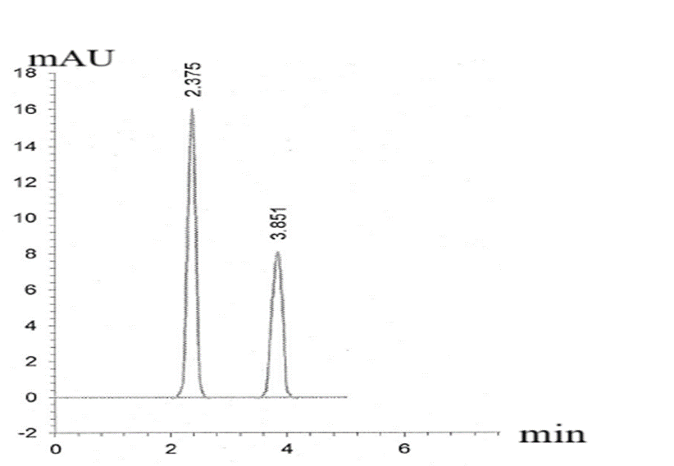
Figure S1: HPLC chromatogram showing prepared pharmaceutical of MET (10 μg/mL) and BISO (10 μg/mL) with retention time are (2.375) and (3.851) respectively.

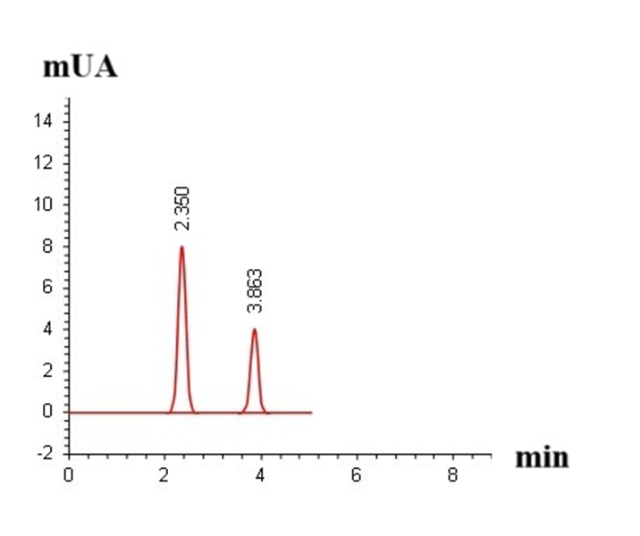

Figure S2: HPLC chromatogram showing separation of mixture of (5 μg/mL) of both MET and BISO in their tablet dosage form with retention time are (2.350) and (3.863) respectively.

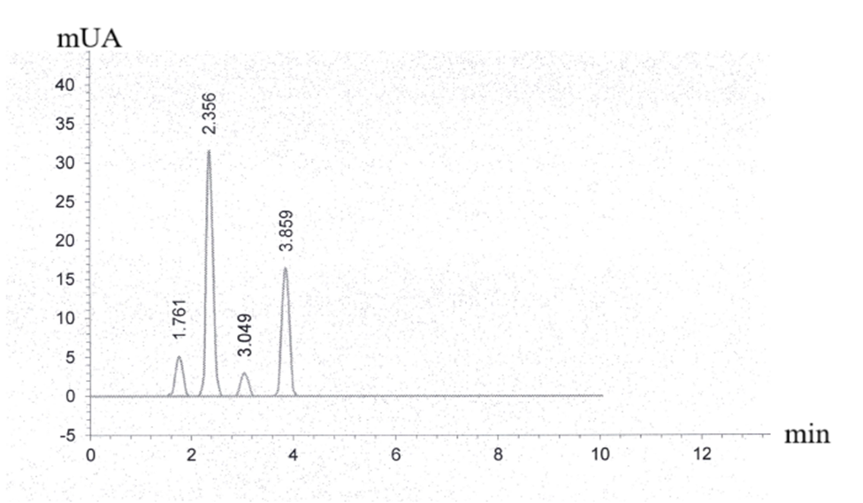
Figure S3: HPLC chromatogram of (10 μg/mL) of each CGD, MET, MLN and BISO with retention time (1.761), (2.356), (3.049) and (3.859) respectively.

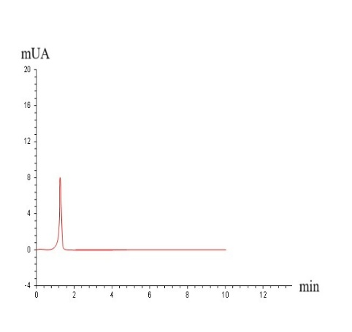
- (b)
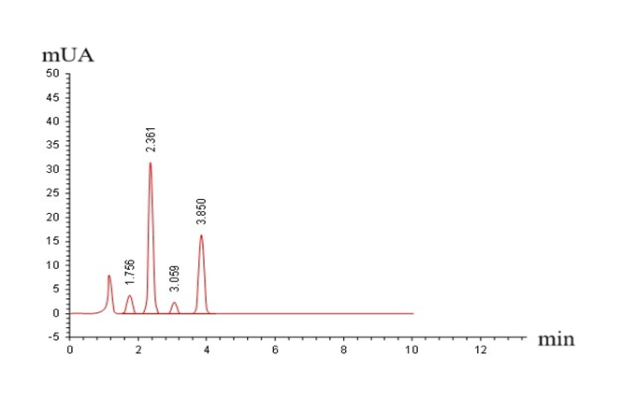

Figure S4: Chromatograms of (a) blank plasma; (b) HPLC chromatogram of (10 μg/ml) of each CGD, MTF, MLN and BISO with retention time (1.756), (2.361), (3.059) and (3.850) respectively in spiked plasma.

