Supplementary Figure 1. GSEA enrichment plots of significantly enriched GO terms in CD4⁺ T cells

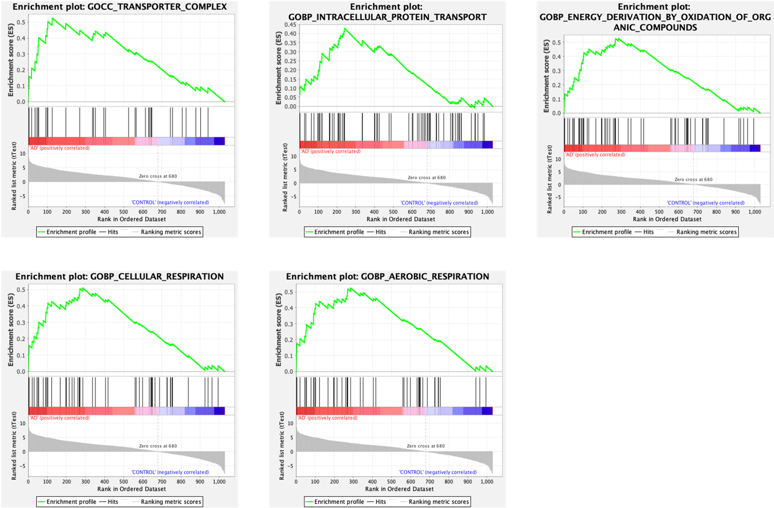

Supplementary Figure 1. Gene Set Enrichment Analysis (GSEA) was performed using the ranked proteomic dataset from CD4⁺ T cells. The plots display five GO terms significantly enriched in the Alzheimer’s disease (AD) group (nominal p < 0.05).

Supplementary Figure 2 GSEA enrichment plots of significantly enriched KEGG pathways in CD4⁺ T cells

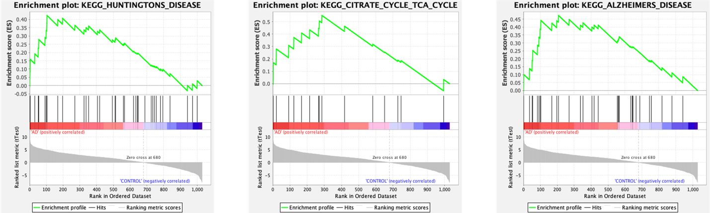

Supplementary Figure 2. Gene Set Enrichment Analysis (GSEA) was performed using the ranked proteomic dataset from CD4⁺ T cells. The plots display KEGG pathways significantly enriched in the Alzheimer’s disease (AD) group (nominal p < 0.05). Pathway data were obtained from the KEGG database. ©2025 Kanehisa Laboratories. Used with permission. (Kanehisa et al., 2025; https://www.kegg.jp/kegg/kegg1.html).

Supplementary Figure 3. GSEA-derived heatmap of top-ranked proteins in CD4⁺ T cells
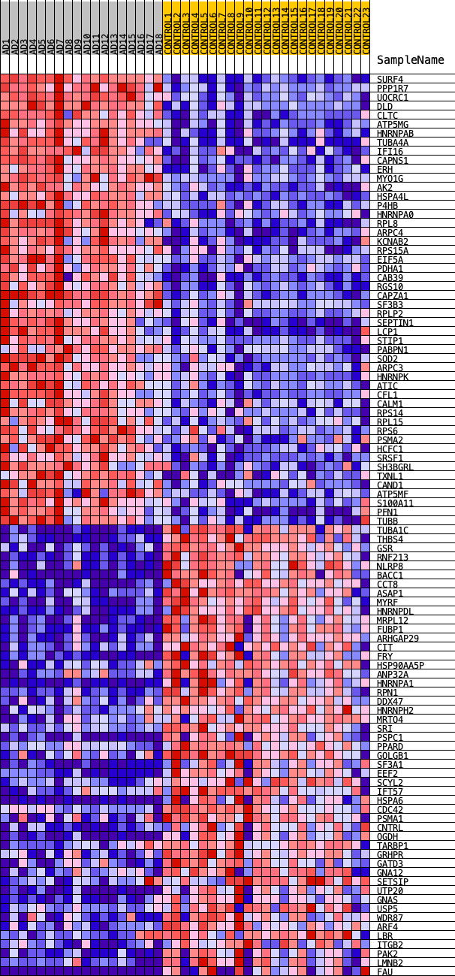
Supplementary Figure 3. The heatmap displays the top 50 GSEA-ranked proteins in CD4⁺ T cells, among which 12 (CCT8, EEF2, EIF5A, HNRNPA1, HNRNPK, RPL8, RPL15, RPLP2, RPS6, RPS14, RPS15A, and SRSF1) were also identified as hub proteins. Red indicates higher expression, and blue indicates lower expression across the samples.

Supplementary Figure 4. GSEA enrichment plots of KEGG and GO analysis for CD8+ T cells
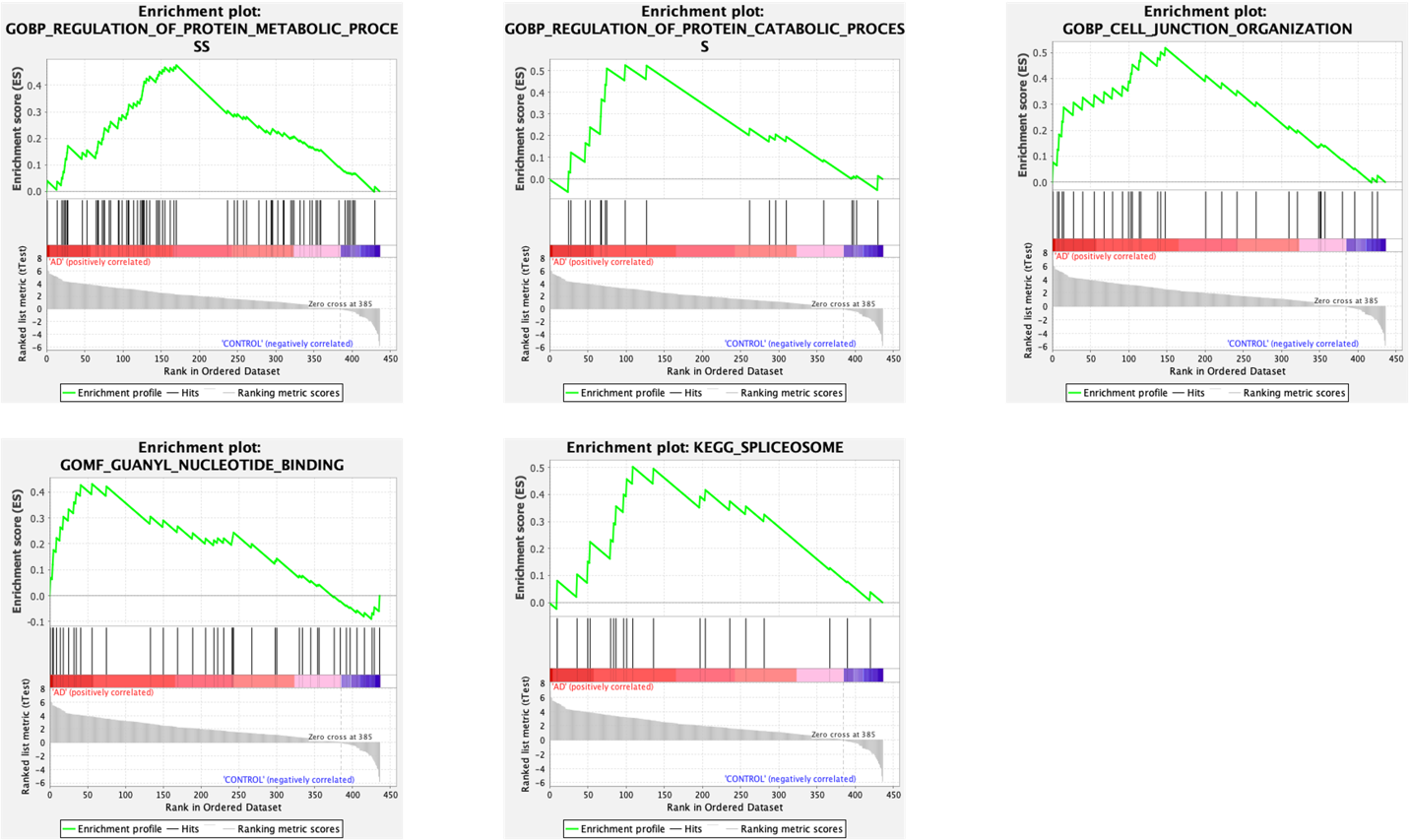
Supplementary Figure 4. Gene Set Enrichment Analysis (GSEA) was performed using the ranked proteomic dataset from CD4⁺ T cells. The plots display KEGG and GO terms significantly enriched in the Alzheimer’s disease (AD) group (nominal p < 0.05). KEGG pathway data were obtained from the KEGG database. ©2025 Kanehisa Laboratories. Used with permission. (Kanehisa et al., 2025; https://www.kegg.jp/kegg/kegg1.html).

Supplementary Figure 5. GSEA-derived heatmap of top-ranked proteins in CD8⁺ T cells
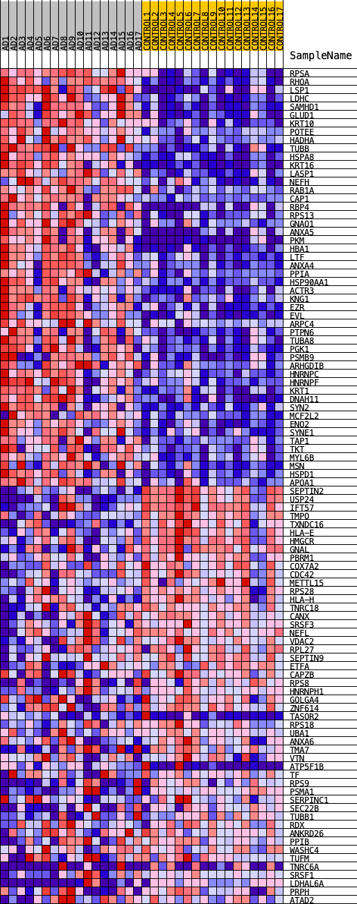
Supplementary Figure 5. The heatmap displays the top 50 GSEA-ranked proteins in CD8⁺ T cells, among which 11 (ENO2, GLUD1, HSP90AA1, HSPA8, HSPD1, LDHC, PGK1, PKM, RHOA, RPSA, TKT) were also identified as hub proteins. Red indicates higher expression, and blue indicates lower expression across the samples.

Supplementary Figure 6. Mitochondrial ROS levels in CD4⁺, CD8⁺, CD14⁺, and CD19⁺ cell subgroups and total cells.

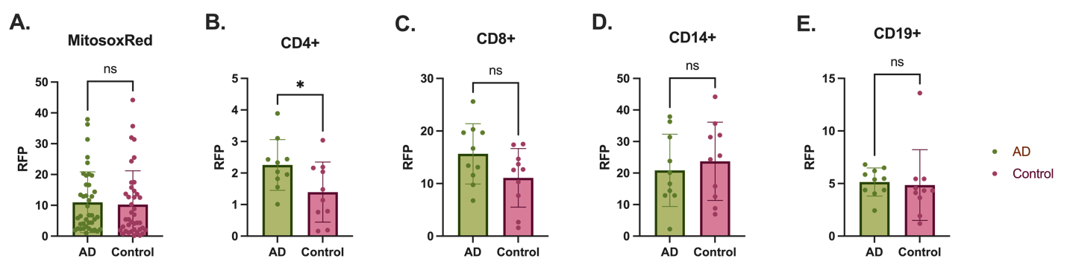

Supplementary Figure 6. Mitochondrial ROS levels in CD4⁺, CD8⁺, CD14⁺, and CD19⁺ cell subgroups and total cells. (A) The graph represents the ROS levels comparison between AD and control with all cell subgroup. (B, C, D, E) AD and control comparison in each cell group ROS levels. Data were analyzed using a two tailed t-test or Mann-Whitney U test depending on data normality. Graphs are presented as mean ﻿± SD. ns: not significant, p < 0.05 (*).

Supplementary Figure 7. JC1 and JC1+ valinomycin results of CD4⁺, CD8⁺, CD14⁺, and CD19⁺ cell subgroups and all subgroups.
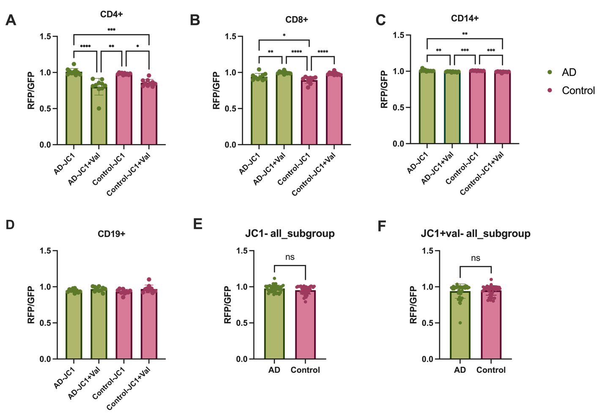

Supplementary Figure 7. JC1 and JC1+ valinomycin results of CD4⁺, CD8⁺, CD14⁺, and CD19⁺ cell subgroups and all subgroups. (A, B, C, D) JC-1 assay results for each cell subset (CD4⁺, CD8⁺, CD14⁺, and CD19⁺), comparing AD and control groups under baseline conditions and following valinomycin treatment. Data were analyzed using Kruskal-Wallis with Dunn's multiple comparisons test or ordinary one-way ANOVA with Tukey's multiple comparisons test. (E-F) The graphs show the JC1 and JC1+valinomycin results for AD and control comparison with all cell subgroups (analyzed with Mann-Whitney U test). Graphs are presented as mean ﻿± SD. ns: not significant, p < 0.05 (*), p ≤ 0.01 (**), p ≤ 0.001(***), p ≤ 0.0001 (****)

Supplementary Figure 8. Valinomycin response in CD4⁺, CD8⁺, CD14⁺, and CD19⁺ cell subgroups.

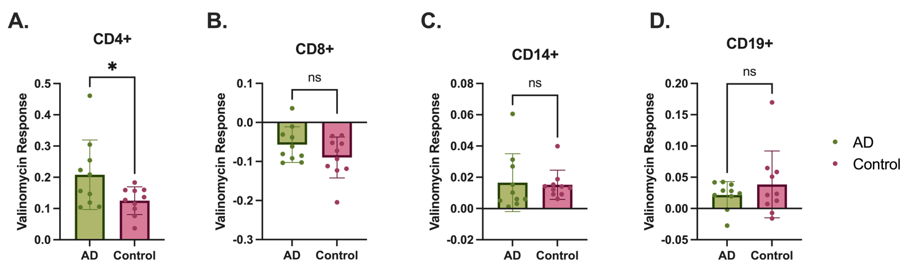

Supplementary Figure 8. Valinomycin response in CD4⁺, CD8⁺, CD14⁺, and CD19⁺ cell subgroups. (A, B, C, D) The valinomycin response was calculated as the difference in the RFP/GFP ratio between valinomycin-treated and untreated conditions. Data were analyzed using a two tailed t-test or Mann-Whitney U test depending on data normality. Graphs are presented as mean ﻿± SD. ns: not significant, p < 0.05 (*).

