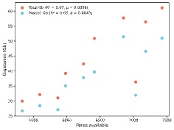

Supplementary Figure 1 | Relationship between flow cell pore availability and sequencing yield. Scatter plot showing sequencing yield (gigabases, Gb) as a function of the number of available pores at the start of each run (n = 10). Each data point represents a sequencing run that included both Whole Genome Sequencing (WGS) and adaptive sampling phases. Total yield (red) and passed yield (blue) are shown. A weak but statistically significant positive correlation (Pearson’s r) was observed for both total (R² = 0.67, p = 0.0036) and passed yield (R² = 0.66, p = 0.0043), indicating that higher pore availability is associated with increased sequencing output.

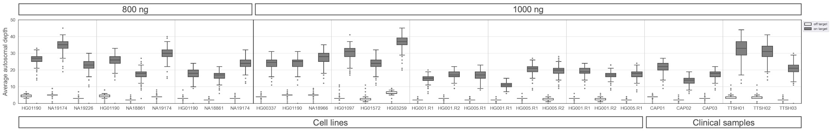
Supplementary Figure 2 | Average autosomal depth of coverage across samples. Boxplots showing the mean depth of coverage for all on- and off-target regions, based on SUP basecalled reads from 3-plex adaptive sampling runs. Samples are grouped by input DNA amount (800 ng and 1000 ng). Boxplots show median, IQR; whiskers extend to 1.5x IQR. Outliers shown as dots.

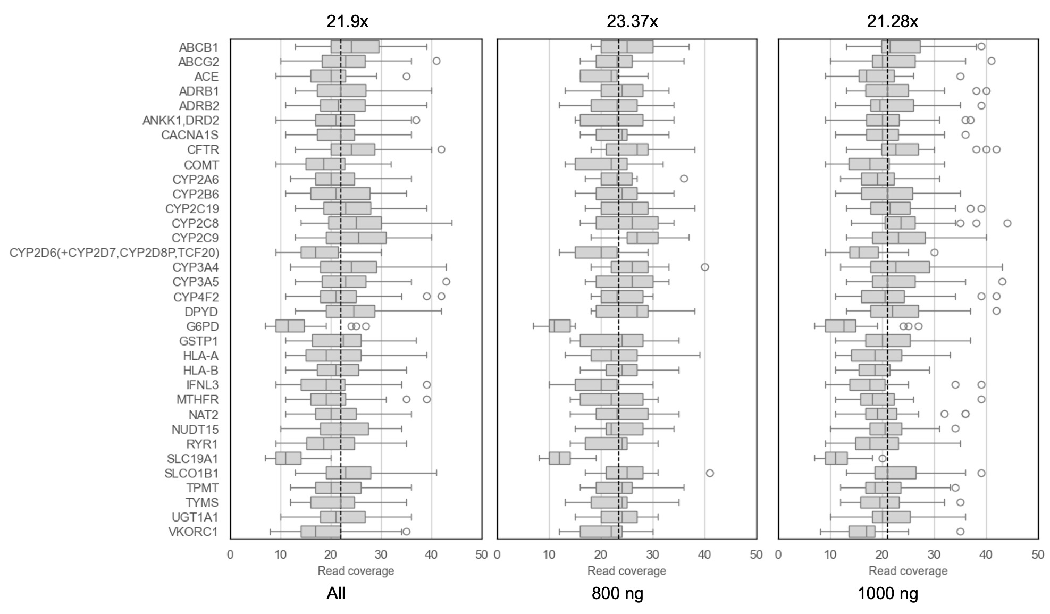
Supplementary Figure 3 | Distribution of read depth in target pharmacogenes.
Boxplots representing the distribution of sequencing read depth for 34 pharmacogenes (PGx) targeted in the panel, using a 3-plex adaptive sampling. The dashed vertical line indicates the mean read depth across all genes (21.9x). Most genes demonstrate consistent coverage, while G6PD and SLC19A1 show notably lower coverage across samples. Outliers are depicted as individual points.

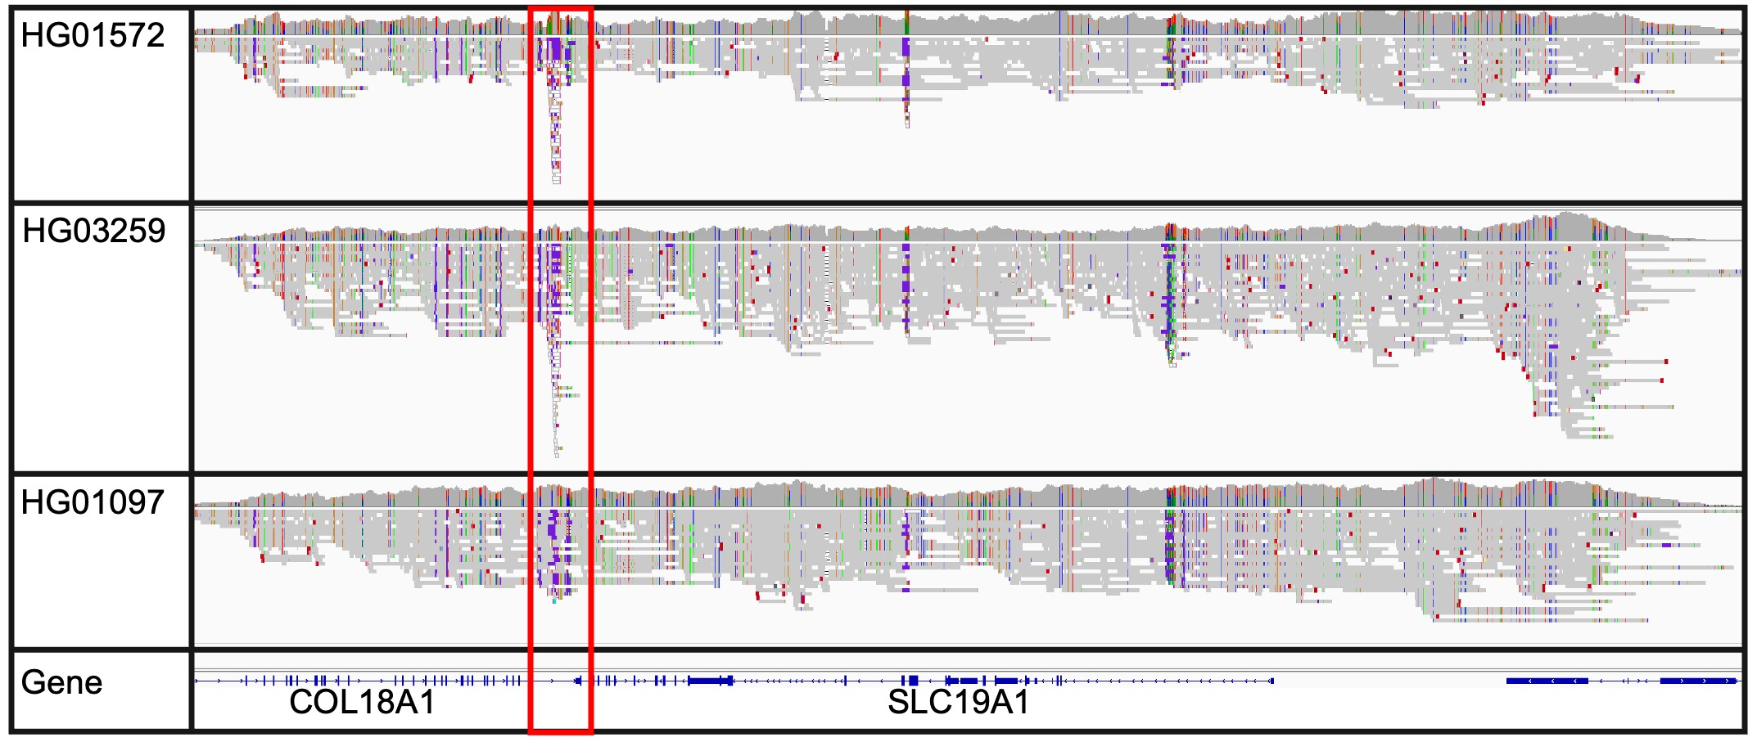

Supplementary Figure 4 | Low-complexity region near SLC19A1. IGV genome browser plot showing read alignments for three samples (HG01572, HG03259, HG01097) from the 3-plex run “1000ng_cell_lines_5”, highlighting a low-complexity within COL18A1, located adjacent to SLC19A1 (red box). The gene tracks at the bottom depict the genomic location of COL18A1 (alpha chain of type XVIII collagen) and SLC19A1. The low-complexity region overlaps with the targeted region for adaptive sampling, and reduces the target coverage for SLC19A1.

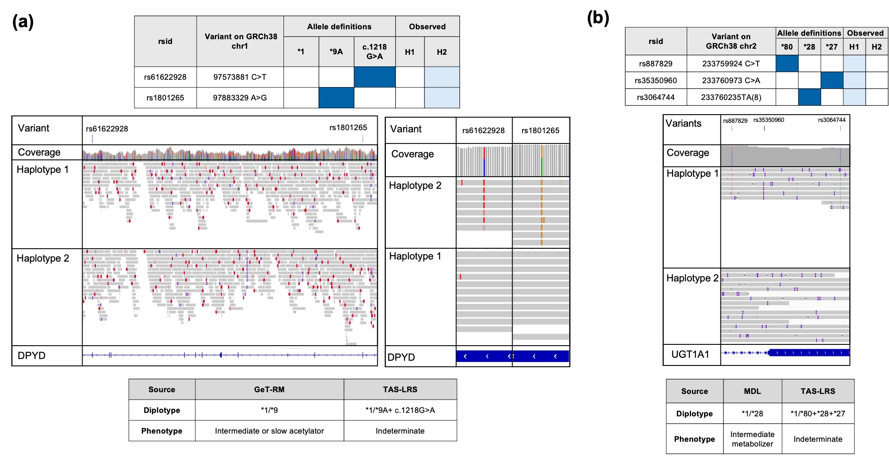

Supplementary Figure 5 | Examples of improved pharmacogene calls enabled by enhanced phasing, novel allele detection, and expanded haplotype coverage. (a) Long-read sequencing enabled phasing of c.85T>C (*9A) and c.1216A>G variants in NA19226. (b) Improved diplotype calling of UGT1A1 in a clinical sample (TTSH_3), where TAS-LRS identified the complex allele *1/*80+*28+*27.

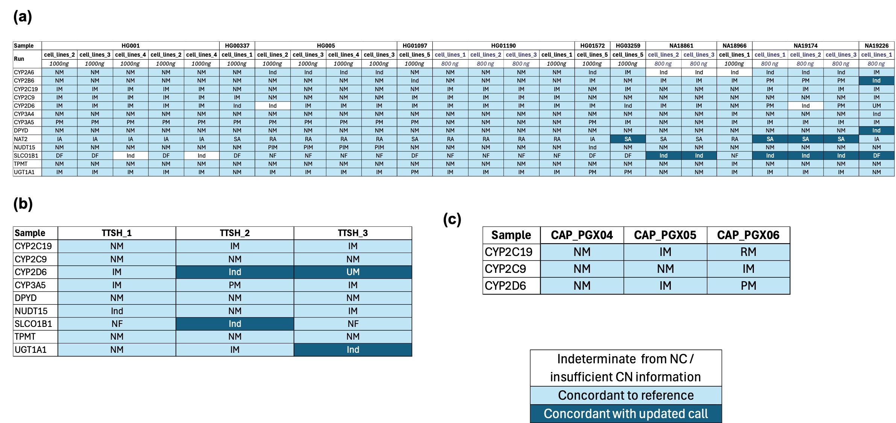
Supplementary Figure 6 | Phenotype concordance in pharmacogenes with complex allele definitions and metabolizer profiles. Results for (a) reference cell lines (n=11), (b) clinical samples from TTSH (n=3) and (c) External Quality Assessment (EQA) samples (n=3) were compared against reference truth sets. Phenotypes were inferred from diplotype calls based on PharmGKB. Phenotypes based on GeT-RM calls were used as the truth set for HG001, HG01190, NA18861, NA18966, NA19174, and NA19226 unless otherwise specified. Phenotype calls for HG00337, HG005, HG01097, HG01572, and HG03259 were based on PyPGx diplotypes from 30x short-read data. For all samples, NUDT15, and UGT1A1 expected phenotypes were based PyPGx diplotypes. Calls matching the expected phenotypes based on the truth set were labelled as concordant, while mismatched calls were considered improved based on IGV read support or consensus across orthogonal methods.

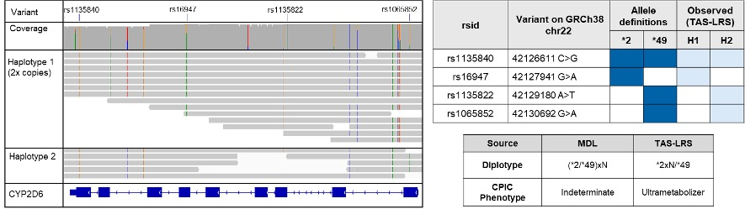

Supplementary Figure 7 | Example of improved CYP2D6 diplotype call leading to refined phenotype classification. IGV genome browser view and variant table for CYP2D6 in sample TTSH_3, showing an example where TAS-LRS resolved a previously unphased copy number change identified by microarrays. This allowed for unambiguous diplotype assignment and a change from 'Indeterminate' to 'Ultrarapid metabolizer' phenotype.

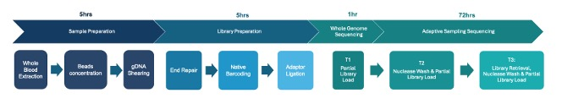
Supplementary Figure 8 | Sample preparation and sequencing workflow for TAS-LRS.
Schematic overview of the laboratory protocol used in the TAS-LRS workflow, optimized for three-sample multiplexing. The process includes four main stages: (i) sample preparation (~5 hours), encompassing whole blood DNA extraction, bead-based concentration, and gDNA shearing; (ii) library preparation (~5 hours), including end repair, native barcoding, and adapter ligation; (iii) an initial whole genome sequencing (~1 hour), during which partial libraries are loaded to assess fragment size and flow cell performance; and (iv) adaptive sampling sequencing (~72 hours), performed in three loading cycles (T1–T3) with nuclease washes and library reloads to maintain active pore utilization.

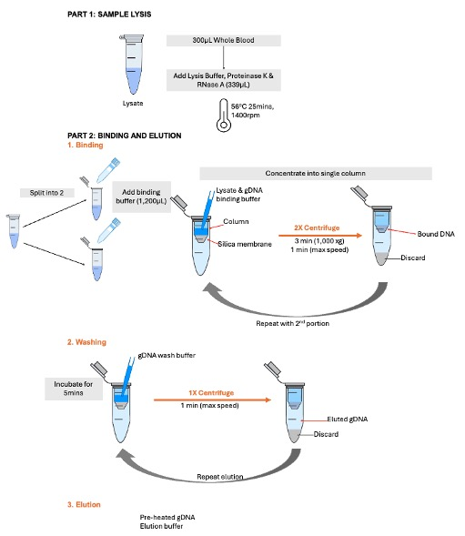

Supplementary Figure 9 | Modified DNA extraction protocol for long-read sequencing.
Workflow illustrating the steps modified from the manufacturer protocol to increase recovery of long DNA fragments from blood. Part 1 shows the lysis step, where a scaled-up lysis mastermix is incubated at 56°C for 25 minutes. In Part 2, lysates are split into two portions, with binding buffer and ethanol added prior to column-based DNA binding. DNA is then pooled onto a single spin column, followed by sequential wash steps (Part 3) and a two-step elution using preheated buffer (Part 4) to maximize recovery. Combined with Solid-Phase Reversible Immobilization (SPRI) bead-based concentration, this protocol delivers concentrated gDNA (>100 ng/µL) from 300 µL of blood input.

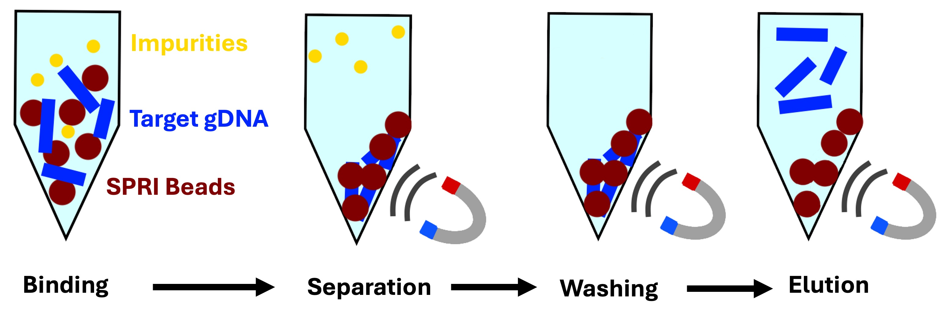
Supplementary Figure 10 | SPRI bead-based concentration of extracted genomic DNA.
Diagram of the bead purification workflow used to concentrate genomic DNA following extraction. DNA binds to SPRI beads (dark red) in the presence of polyethylene glycol (PEG) and salt, while impurities (yellow) remain in solution and are discarded during magnetic separation. Subsequent washing steps remove residual contaminants. In the final elution step, purified high-molecular-weight gDNA (blue) is released from the beads into a low-volume buffer, yielding DNA concentrations exceeding 100 ng/µL suitable for long-read sequencing.

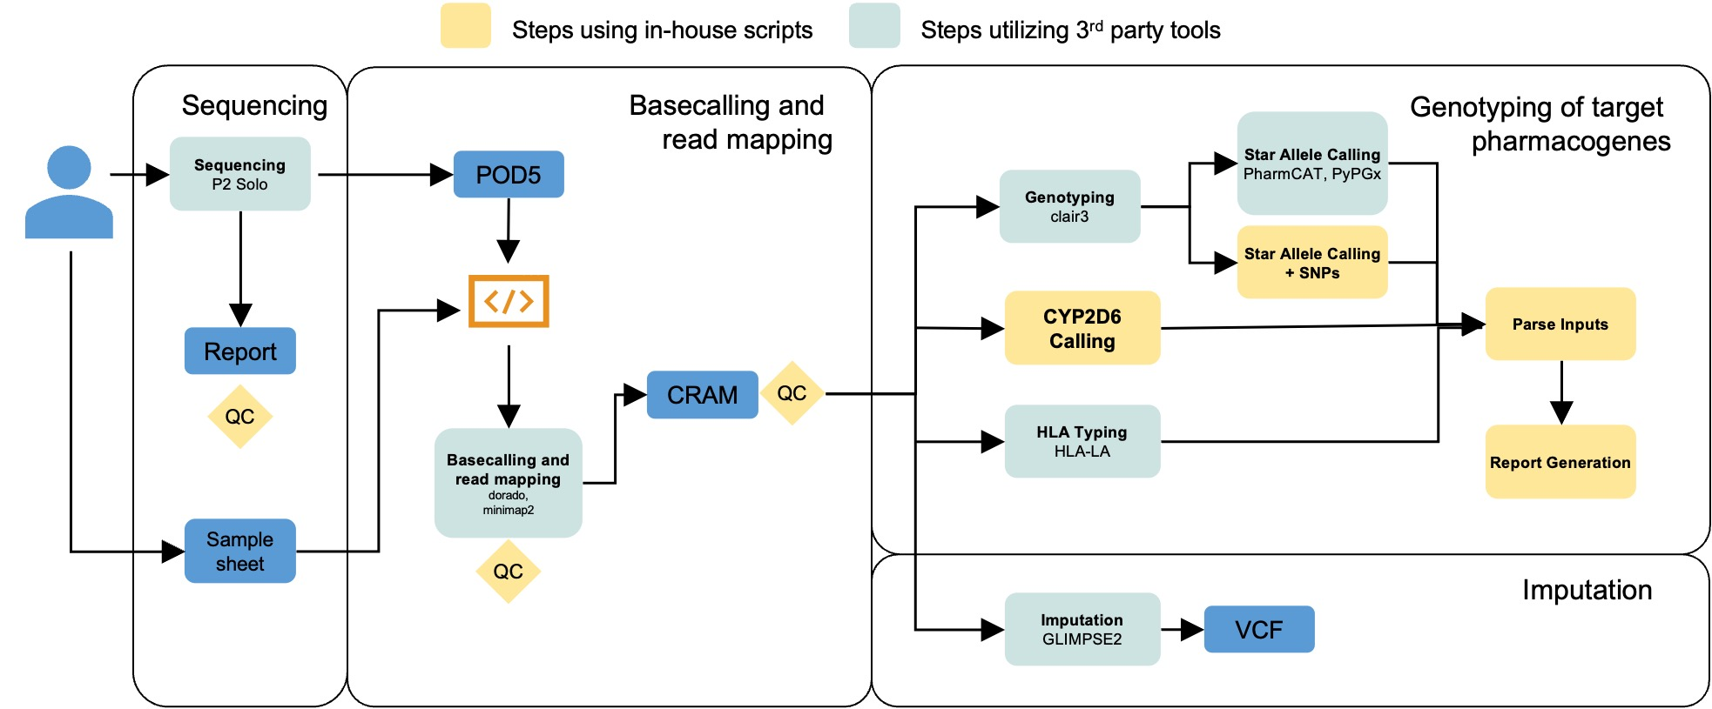

Supplementary Figure 11 | Bioinformatic workflow for pharmacogenomic annotation and genome-wide imputation. Schematic overview of the bioinformatic pipeline, illustrating the steps involved in processing sequencing data for pharmacogenomic analysis. The workflow encompasses sequencing on the ONT P2 Solo platform, basecalling, read mapping, genotyping of target pharmacogenes (including CYP2D6 and HLA typing), and genome-wide imputation using GLIMPSE2. In-house scripts are indicated by orange boxes, while steps utilizing third-party tools are shown in blue. Key file formats - POD5 (raw signal), CRAM (aligned reads), VCF (variant calls) - and quality control (QC) steps are highlighted.

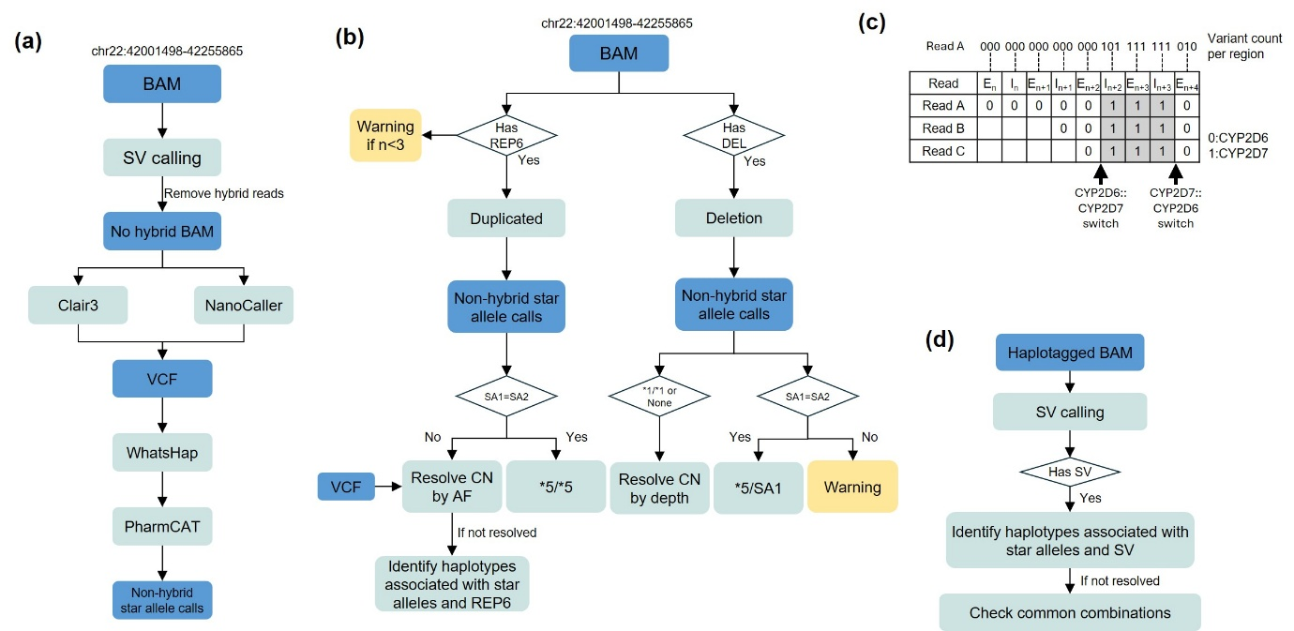

Supplementary Figure 12 | Novel CYP2D6 caller workflow. (a) Schematic outlining the initial variant calling process for CYP2D6, where non-hybrid reads are used as input for Clair3 and NanoCaller, followed by phasing with WhatsHap and diplotype calling with PharmCAT. (b) Heuristic approach for detecting duplications and deletions in CYP2D6, including copy number refinement and resolution of complex allele combinations. (c) Hybrid read identification. For each read, where available, gene-distinguishing variants were used to assign regions of a read as originating from either CYP2D6 or CYP2D7. Switches were then identified by detecting transition points between one gene to another. A hybrid was considered present if the same switch was supported by at least three unique reads. (d) Heuristic for resolving tandem hybrids, involving structural variant (SV) calling and haplotype association to determine hybrid allele composition.

