Supplementary Table 1: Distribution of Dyadic Characteristics of Tuberculosis Cases Stratified by Treatment History, Greater Accra Region, Ghana (2022-2023)
 | Study Population | Mixed Treatment History | Both New Patients | Both Previously Treated | p-value
Dyad Characteristics | 11175 | 2489 | 8515 | 171
Sex (%) |  |  |  |  | <0.001
Male: Female | 4896 (43.8) | 1042 (41.9) | 3784 (44.4) | 70 (40.9)
Male: Male | 5151 (46.1) | 1232 (49.5) | 3828 (45.0) | 91 (53.2)
Female: Female | 1128 (10.1) | 215 (8.6) | 903 (10.6) | 10 (5.8)
Same Age Pair (%) | 3760 (33.6) | 897 (36.0) | 2782 (32.7) | 81 (47.4) | <0.001
Same Religion Pair (%) | 7732 (70.1) | 1622 (65.7) | 6009 (71.7) | 101 (59.1) | <0.001
Same Occupation (%) | 4822 (43.1) | 1115 (44.8) | 3631 (42.6) | 76 (44.4) | 0.152
Same Marital Status (%) | 5550 (49.7) | 1244 (50.0) | 4225 (49.6) | 81 (47.4) | 0.792
Substance Use (%) |  |  |  |  | <0.001
Mixed Status | 5561 (49.8) | 1297 (52.1) | 4180 (49.1) | 84 (49.1)
Neither Use Substances | 3403 (30.5) | 532 (21.4) | 2850 (33.5) | 21 (12.3)
Both Use Substances | 2211 (19.8) | 660 (26.5) | 1485 (17.4) | 66 (38.6)
BMI at Enrollment (%) |  |  |  |  | 0.898
both Normal | 1953 (17.5) | 440 (17.7) | 1485 (17.4) | 28 (16.4)
both Over | 45 (0.4) | 9 (0.4) | 36 (0.4) | 0 (0.0)
mixed Status | 6251 (55.9) | 1370 (55.0) | 4783 (56.2) | 98 (57.3)
both Under | 2926 (26.2) | 670 (26.9) | 2211 (26.0) | 45 (26.3)
Both have Hemoptysis (%) | 6574 (58.8) | 1576 (63.3) | 4875 (57.3) | 123 (71.9) | <0.001
Both have lost weight (%) | 8256 (73.9) | 1710 (68.7) | 6441 (75.6) | 105 (61.4) | <0.001
Both have fever (%) | 1275 (11.4) | 188 (7.6) | 1081 (12.7) | 6 (3.5) | <0.001
Both have severe tiredness (%) | 4851 (43.4) | 1118 (44.9) | 3655 (42.9) | 78 (45.6) | 0.177
Both have BCG Scar (%) | 7381 (66.0) | 1417 (56.9) | 5886 (69.1) | 78 (45.6) | <0.001
Treated for Tuberculosis (%) |  |  |  |  | 0.956
Mixed Status | 2112 (19.4) | 468 (19.1) | 1610 (19.5) | 34 (19.9)
Neither | 120 (1.1) | 28 (1.1) | 91 (1.1) | 1 (0.6)
Both | 8646 (79.5) | 1955 (79.8) | 6555 (79.4) | 136 (79.5)
Both had past two months non-household cough exposure (%) | 630 (5.6) | 155 (6.2) | 465 (5.5) | 10 (5.8) | 0.343
Both had past two months household cough exposure (%) | 153 (1.4) | 45 (1.8) | 105 (1.2) | 3 (1.8) | 0.086
HIV Status (%) |  |  |  |  | <0.001
Mixed Status | 2921 (26.1) | 577 (23.2) | 2310 (27.1) | 34 (19.9)
Both HIV- | 8001 (71.6) | 1870 (75.1) | 5995 (70.4) | 136 (79.5)
Both HIV+ | 253 (2.3) | 42 (1.7) | 210 (2.5) | 1 (0.6)
Occupation (%) |  |  |  |  | <0.001
Unskilled Work | 2926 (26.2) | 726 (29.2) | 2145 (25.2) | 55 (32.2)
Mixed Occupation | 6419 (57.4) | 1385 (55.6) | 4939 (58.0) | 95 (55.6)
Skilled Work | 1830 (16.4) | 378 (15.2) | 1431 (16.8) | 21 (12.3)
Notes: Dyads represent all unique pairs of study participants (N = 11,175) and are stratified by whether both individuals were newly diagnosed, both were previously treated, or pairs had mixed treatment history. Occupation was based on self-reported employment and reclassified intro three categories: skilled (business, clerical worker), unskilled (farming, fishing, tradesman, trader/shop assistant, or other), and unemployed (unemployed, retired, student).

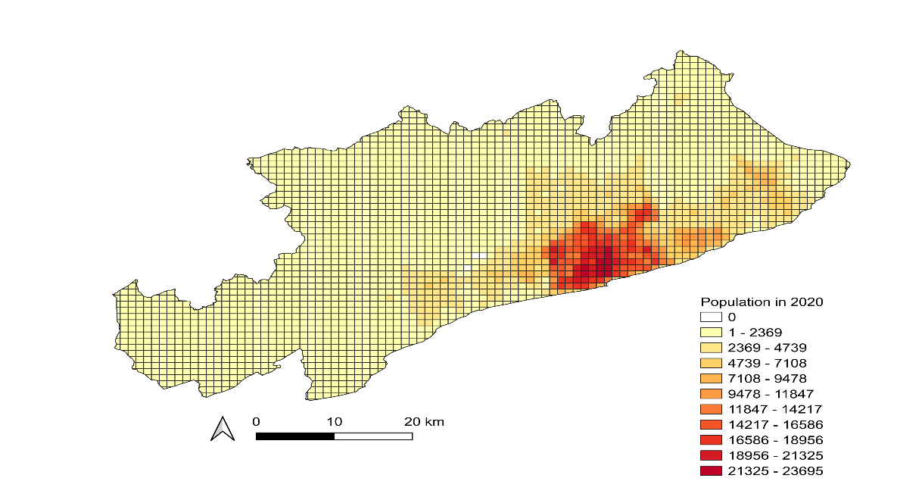
Supplementary Figure 1: Population Density Distribution Across the Study Area, Greater Accra Region, Ghana, 2022 – 2023. The figure shows the estimated population density per 1.5 km² grid cell based on 2020 projections. Darker shades indicate areas of higher population density. Areas with the highest tuberculosis case counts overlapped with areas of highest population density, suggesting that the observed spatial clustering of tuberculosis cases was not solely driven by differences in absolute case numbers across the study area.
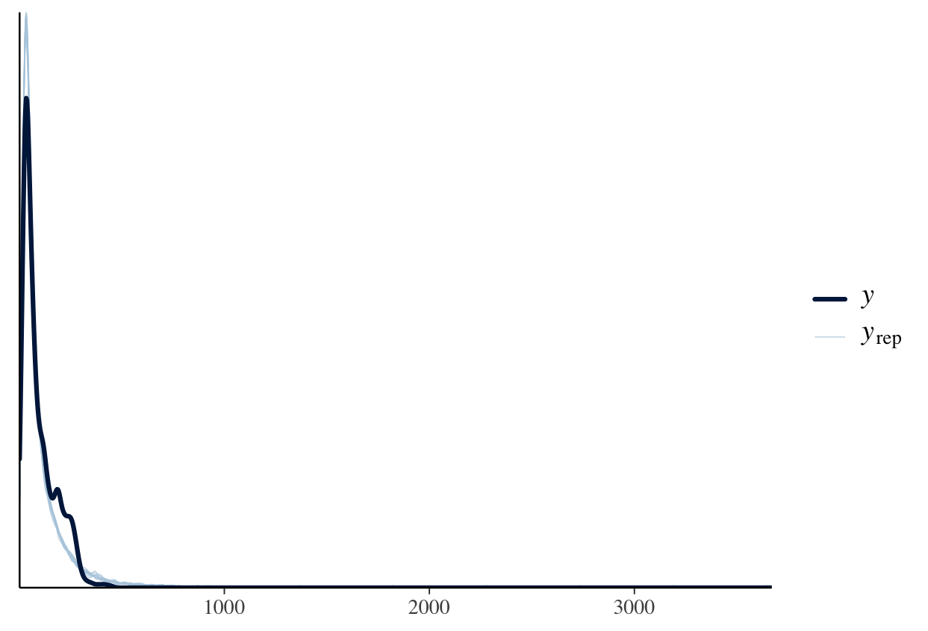

Supplementary Figure 2. Posterior Predictive Check for the Bayesian Gamma Regression Model. Posterior predictive distribution of Euclidean residential distances compared to observed values. The dark line represents the observed distribution of centered and shifted residential distances between TB case pairs. Light gray lines represent 100 simulated datasets drawn from the posterior predictive distribution of the Bayesian gamma regression model. The close alignment between observed and simulated values suggests that the model adequately captures the distributional characteristics of the outcome and provides a good overall fit.

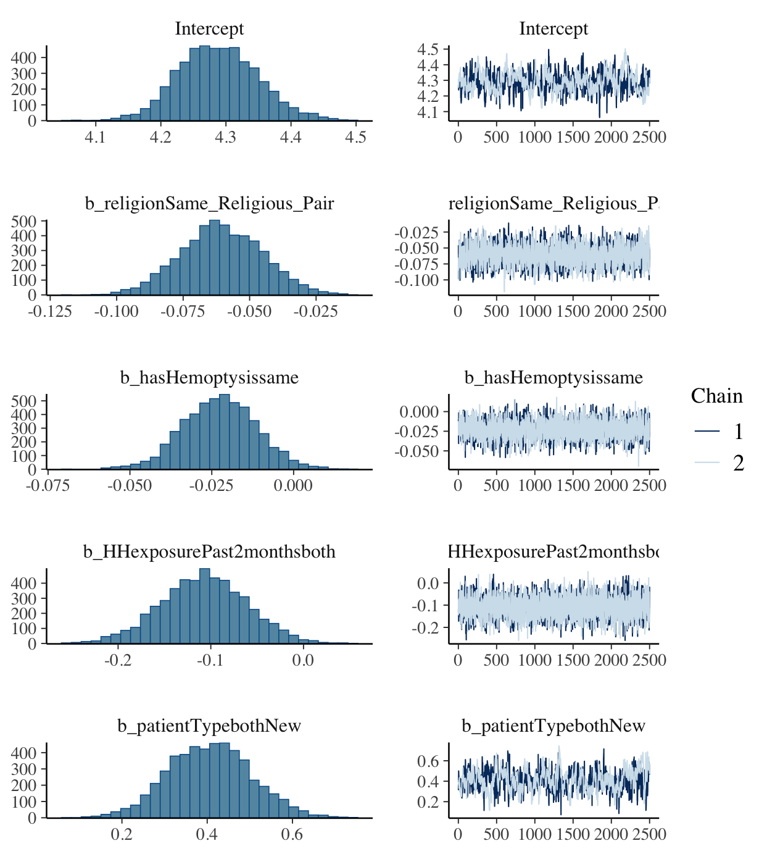
Supplementary Figure 3. Posterior Distributions and Trace Plots for Key Predictors from the Bayesian Gamma Regression Model. Posterior distributions (left panels) and MCMC trace plots by chain (right panels) for the intercept and significant predictors associated with residential proximity among tuberculosis cases. Parameters shown include shared religious affiliation (b_religionSame_Religious_Pair), shared hemoptysis (b_hasHemoptysissame), recent non-household cough exposure (b_HHexposurePast2monthsboth), and patient type (new cases; b_patientTypebothNew). Posterior distributions were approximately normal, and trace plots indicated good mixing and convergence across chains.

