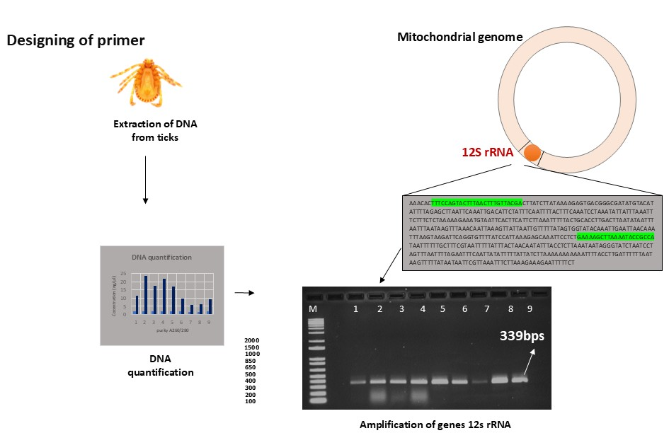
Figure S1: Aligning the different sequences from NCBI data source and designing of primers in the conserved region and extraction of DNA and quantification of DNA and amplification the gene markers by using designed primers 12s rRNA (339bps).

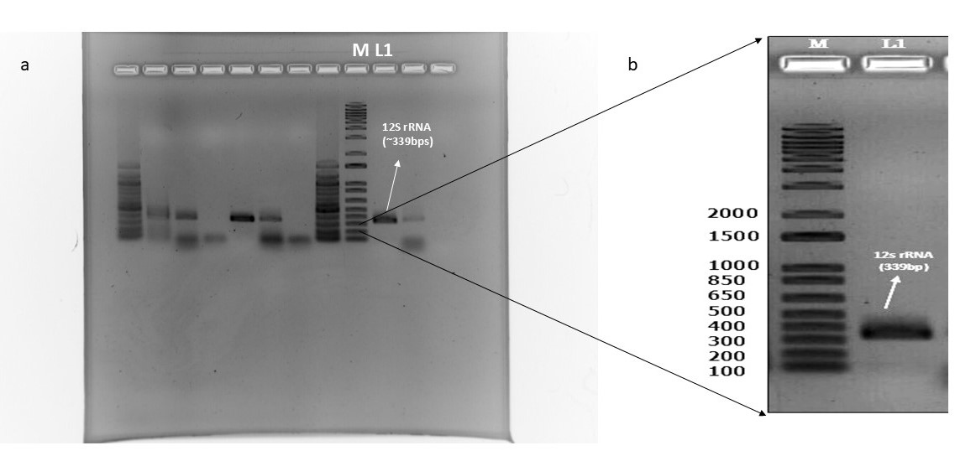
Figure S2: Molecular characterization of 12S rRNA from H. spinigera- a) Uncropped agarose gel carries amplified products from different DNA samples, visualized under UV light (M and L1 in the uncropped gel is maximized to show the 12S r RNA amplification). b) Cropped agarose gel indicating M–1 kb plus DNA marker and L1- 12s rRNA gene (~339 bps). This sample was initially sequenced for the confirmation.
a

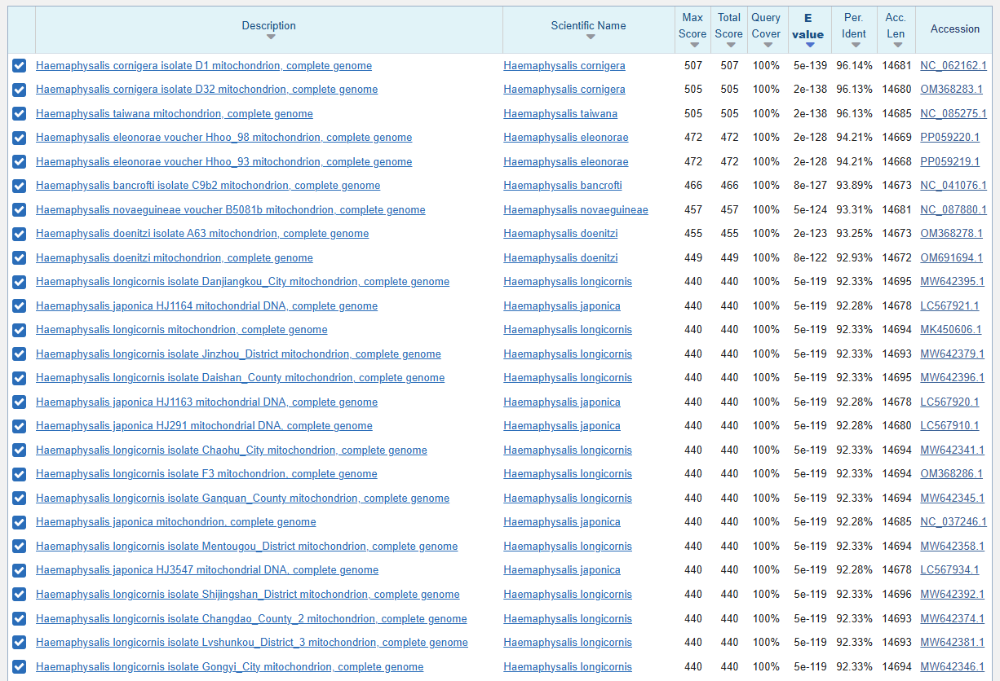
Figure S3: Blast results of 12S rRNA in the NCBI platform.

Figure S4: Phylogenetic tree constructed based on obtained sequence of 12S rRNA sequences from H. spinigera with the retrieved sequences of Haemaphysalis spp. distributed in the other parts of the world and other acarian order individuals, followed by the UPGMA algorithm (500 Bootstrap) of MEGA software.

Figure S5: Phylogenetic tree constructed based on obtained sequence of 12S rRNA sequences from H. spinigera with the retrieved sequences of Haemaphysalis spp. distributed in the other parts of the world and other acarian order individuals, followed by the Neighbour-Joining algorithm (500 Bootstrap) of MEGA software.

