Supplementary Information

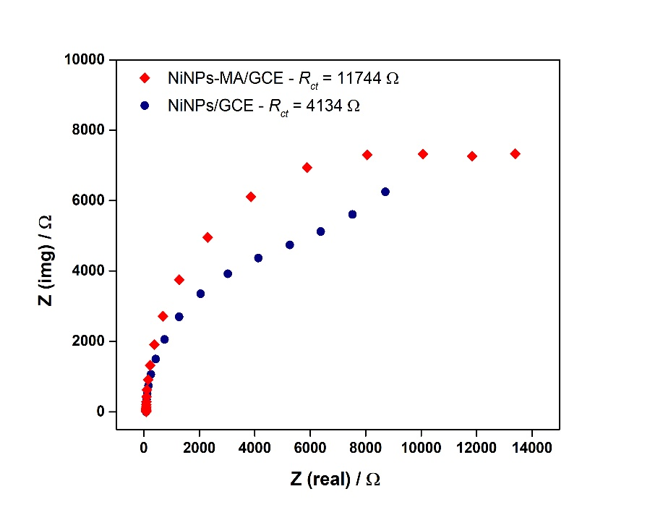
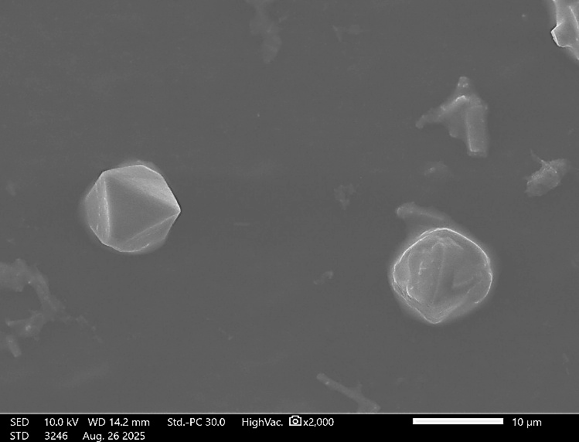
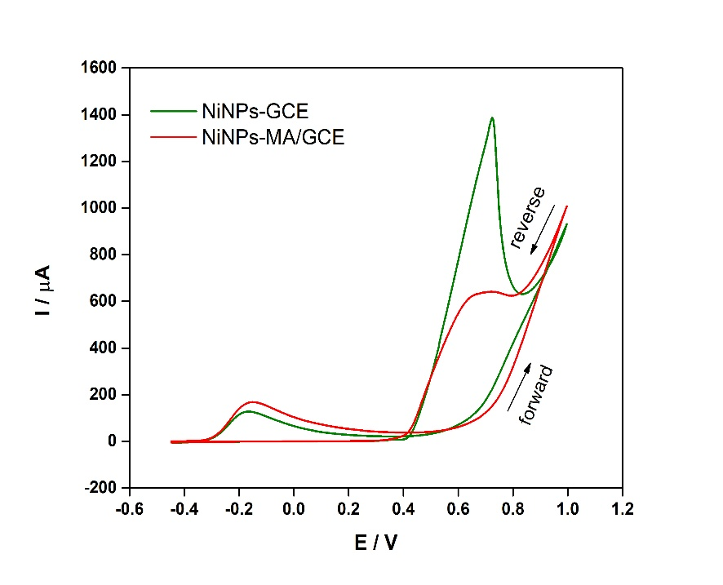
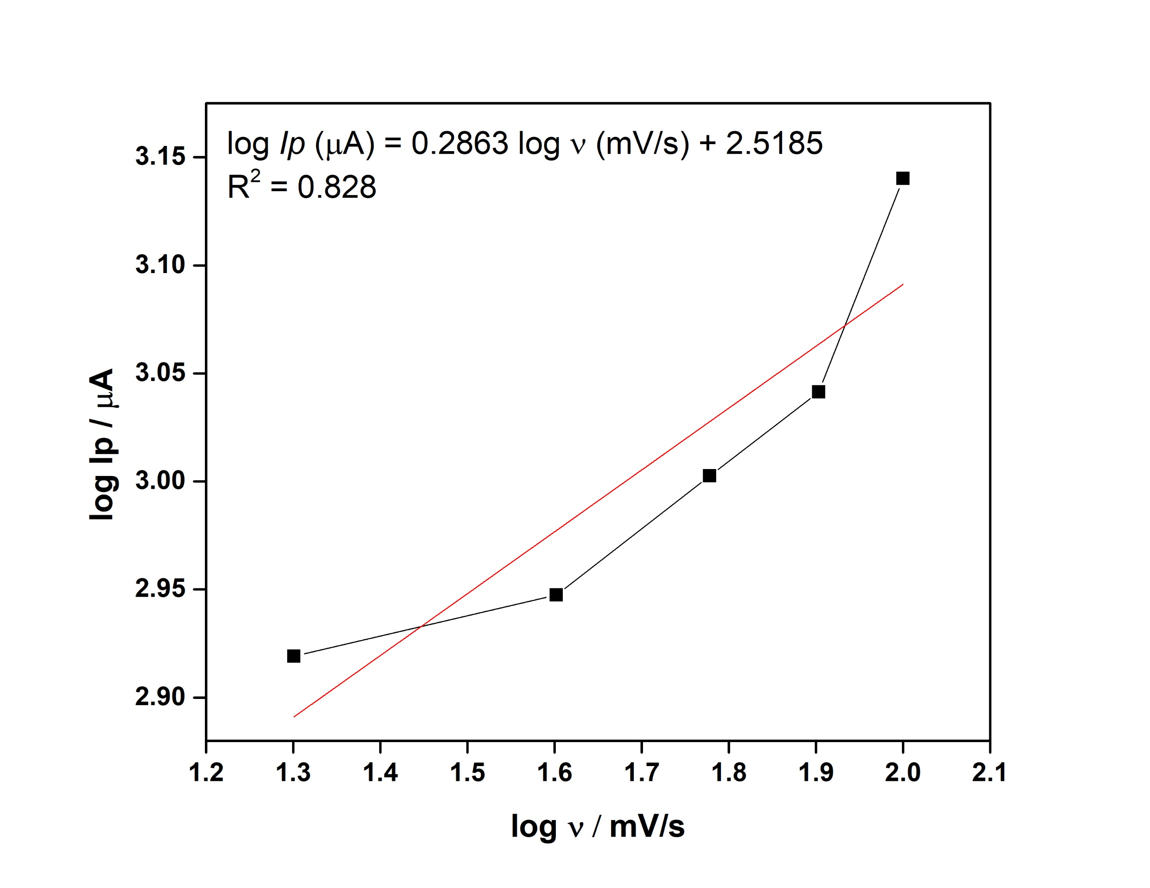
(a)
(b)
(c)
(d)
Figure S1. (a) SEM image of NiNP-MA/GCE at 2,000x magnification (scale bar: 10 µm), (b) Nyquist plot comparison of NiNPs/GCE and NiNP-MA/GCE in 0.1 M NaOH containing 10 µM urea, (c) CV comparison of NiNPs/GCE and NiNP-MA/GCE, and (d) log Ip vs log v plot from CV curves of NiNPs/GCE in 0.1 M NaOH containing 50 µM at different scan rates.

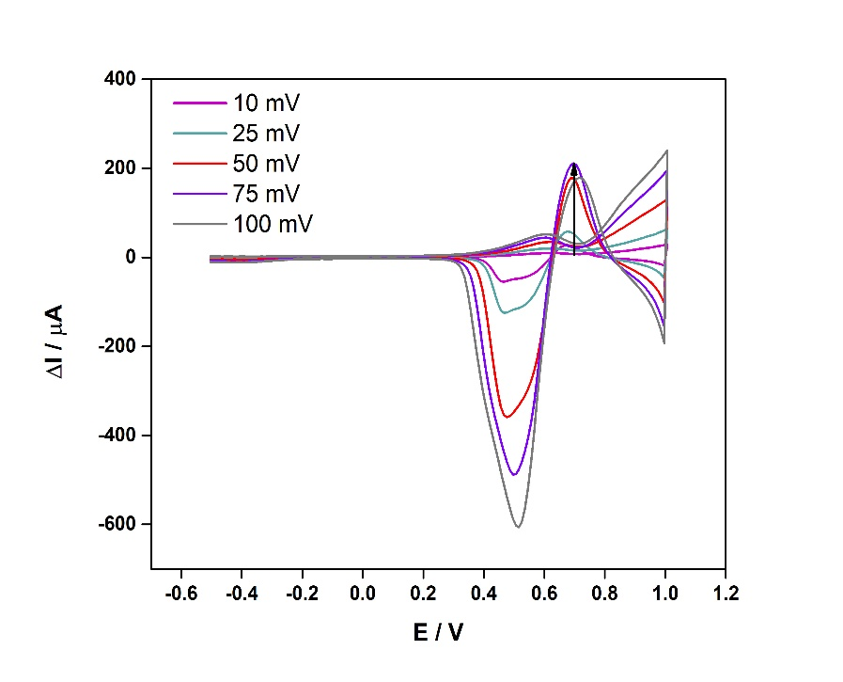
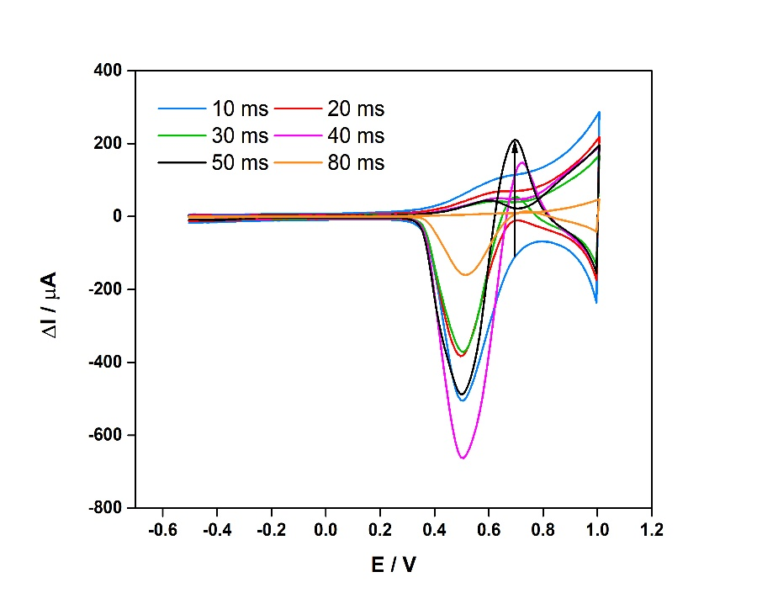
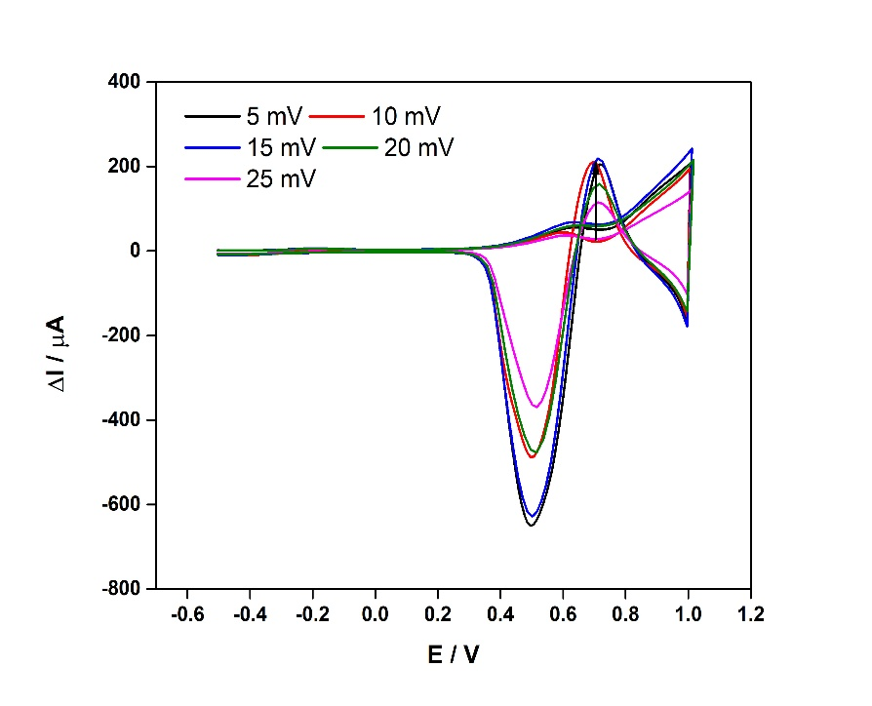
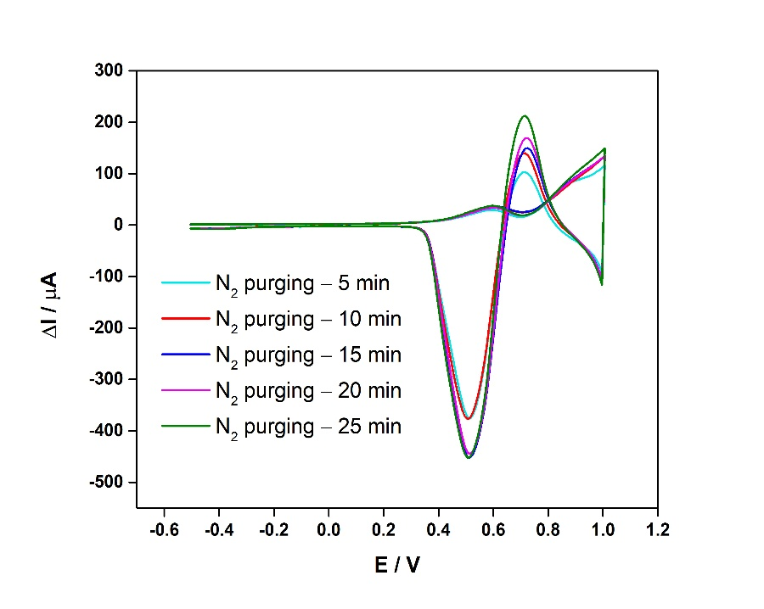
(a)
(b)
(c)
(d)
Figure S2. Effect of (a) pulse height (PH), (b) pulse width (PW), and (c) step height (SH) on the SWV responses of NiNPs/GCE in 10 µM urea in 0.1 M NaOH. (d) Influence of dissolved oxygen on urea sensing as observed by SWV.

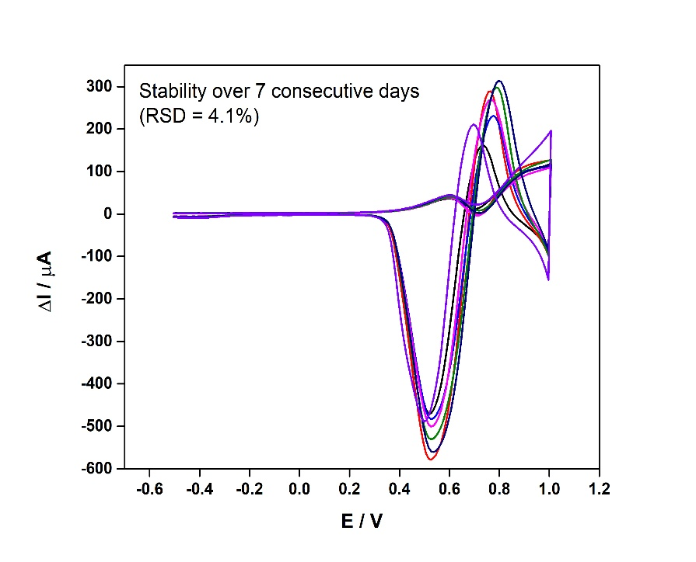
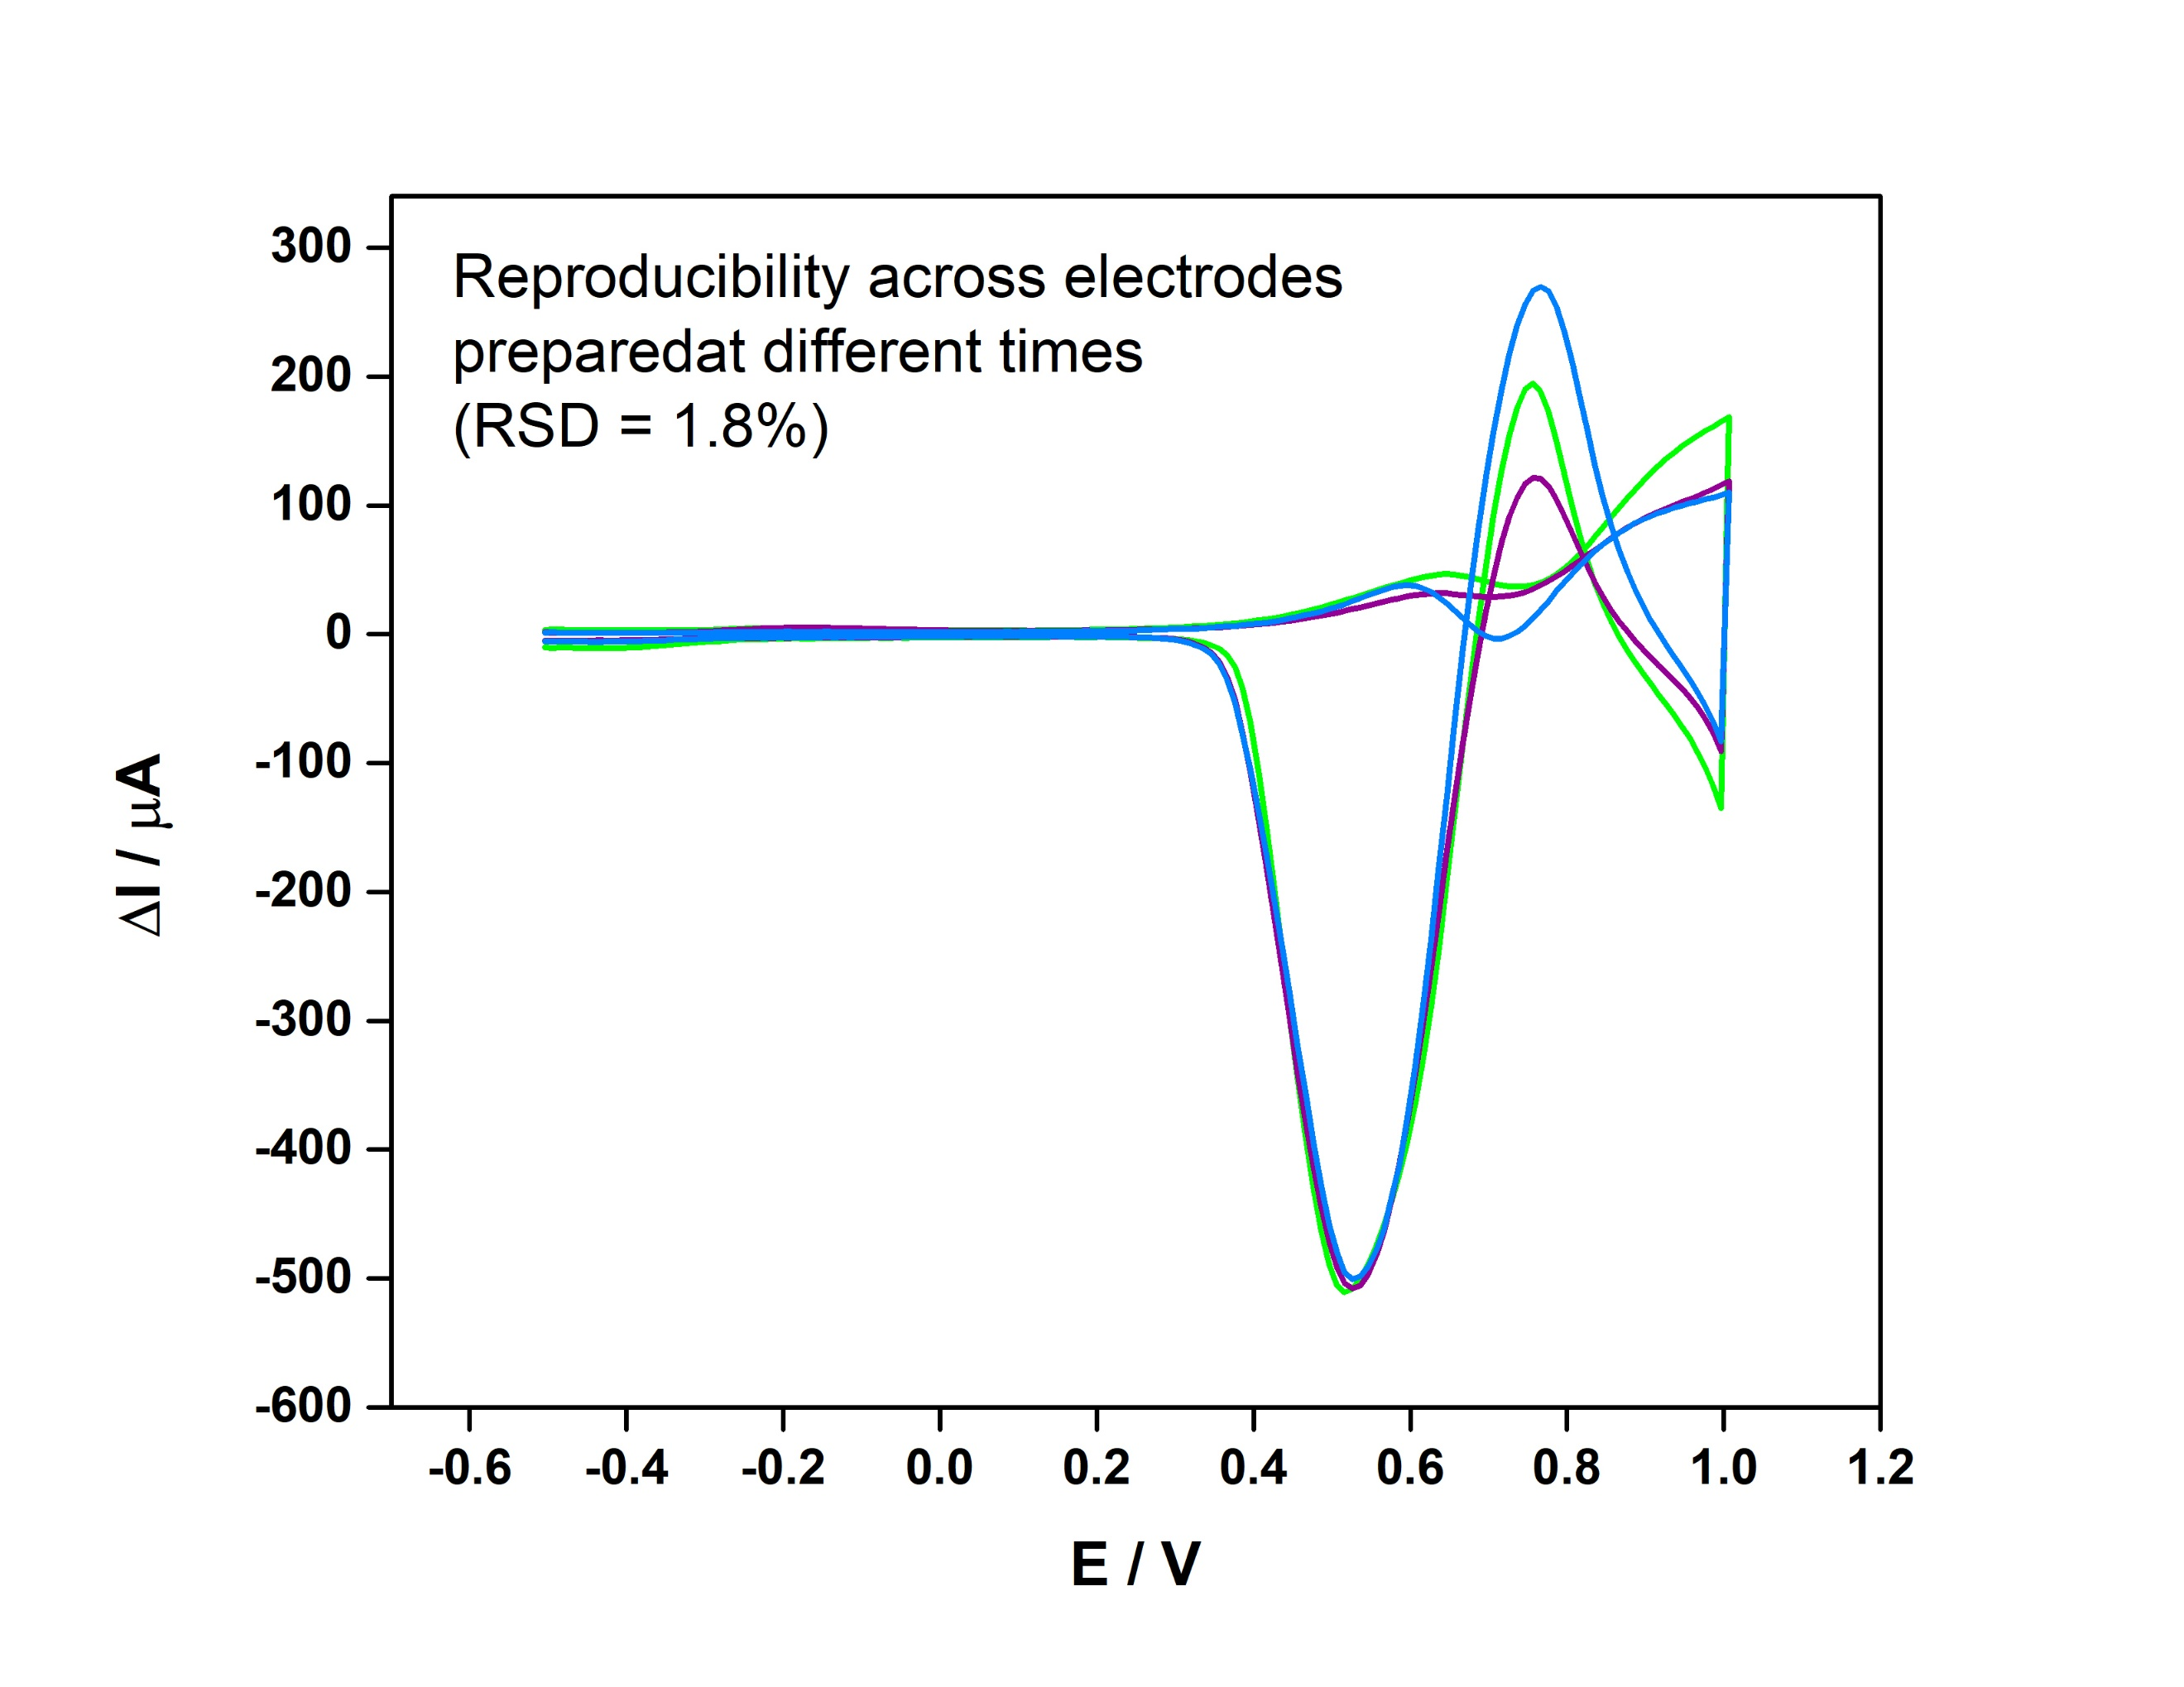
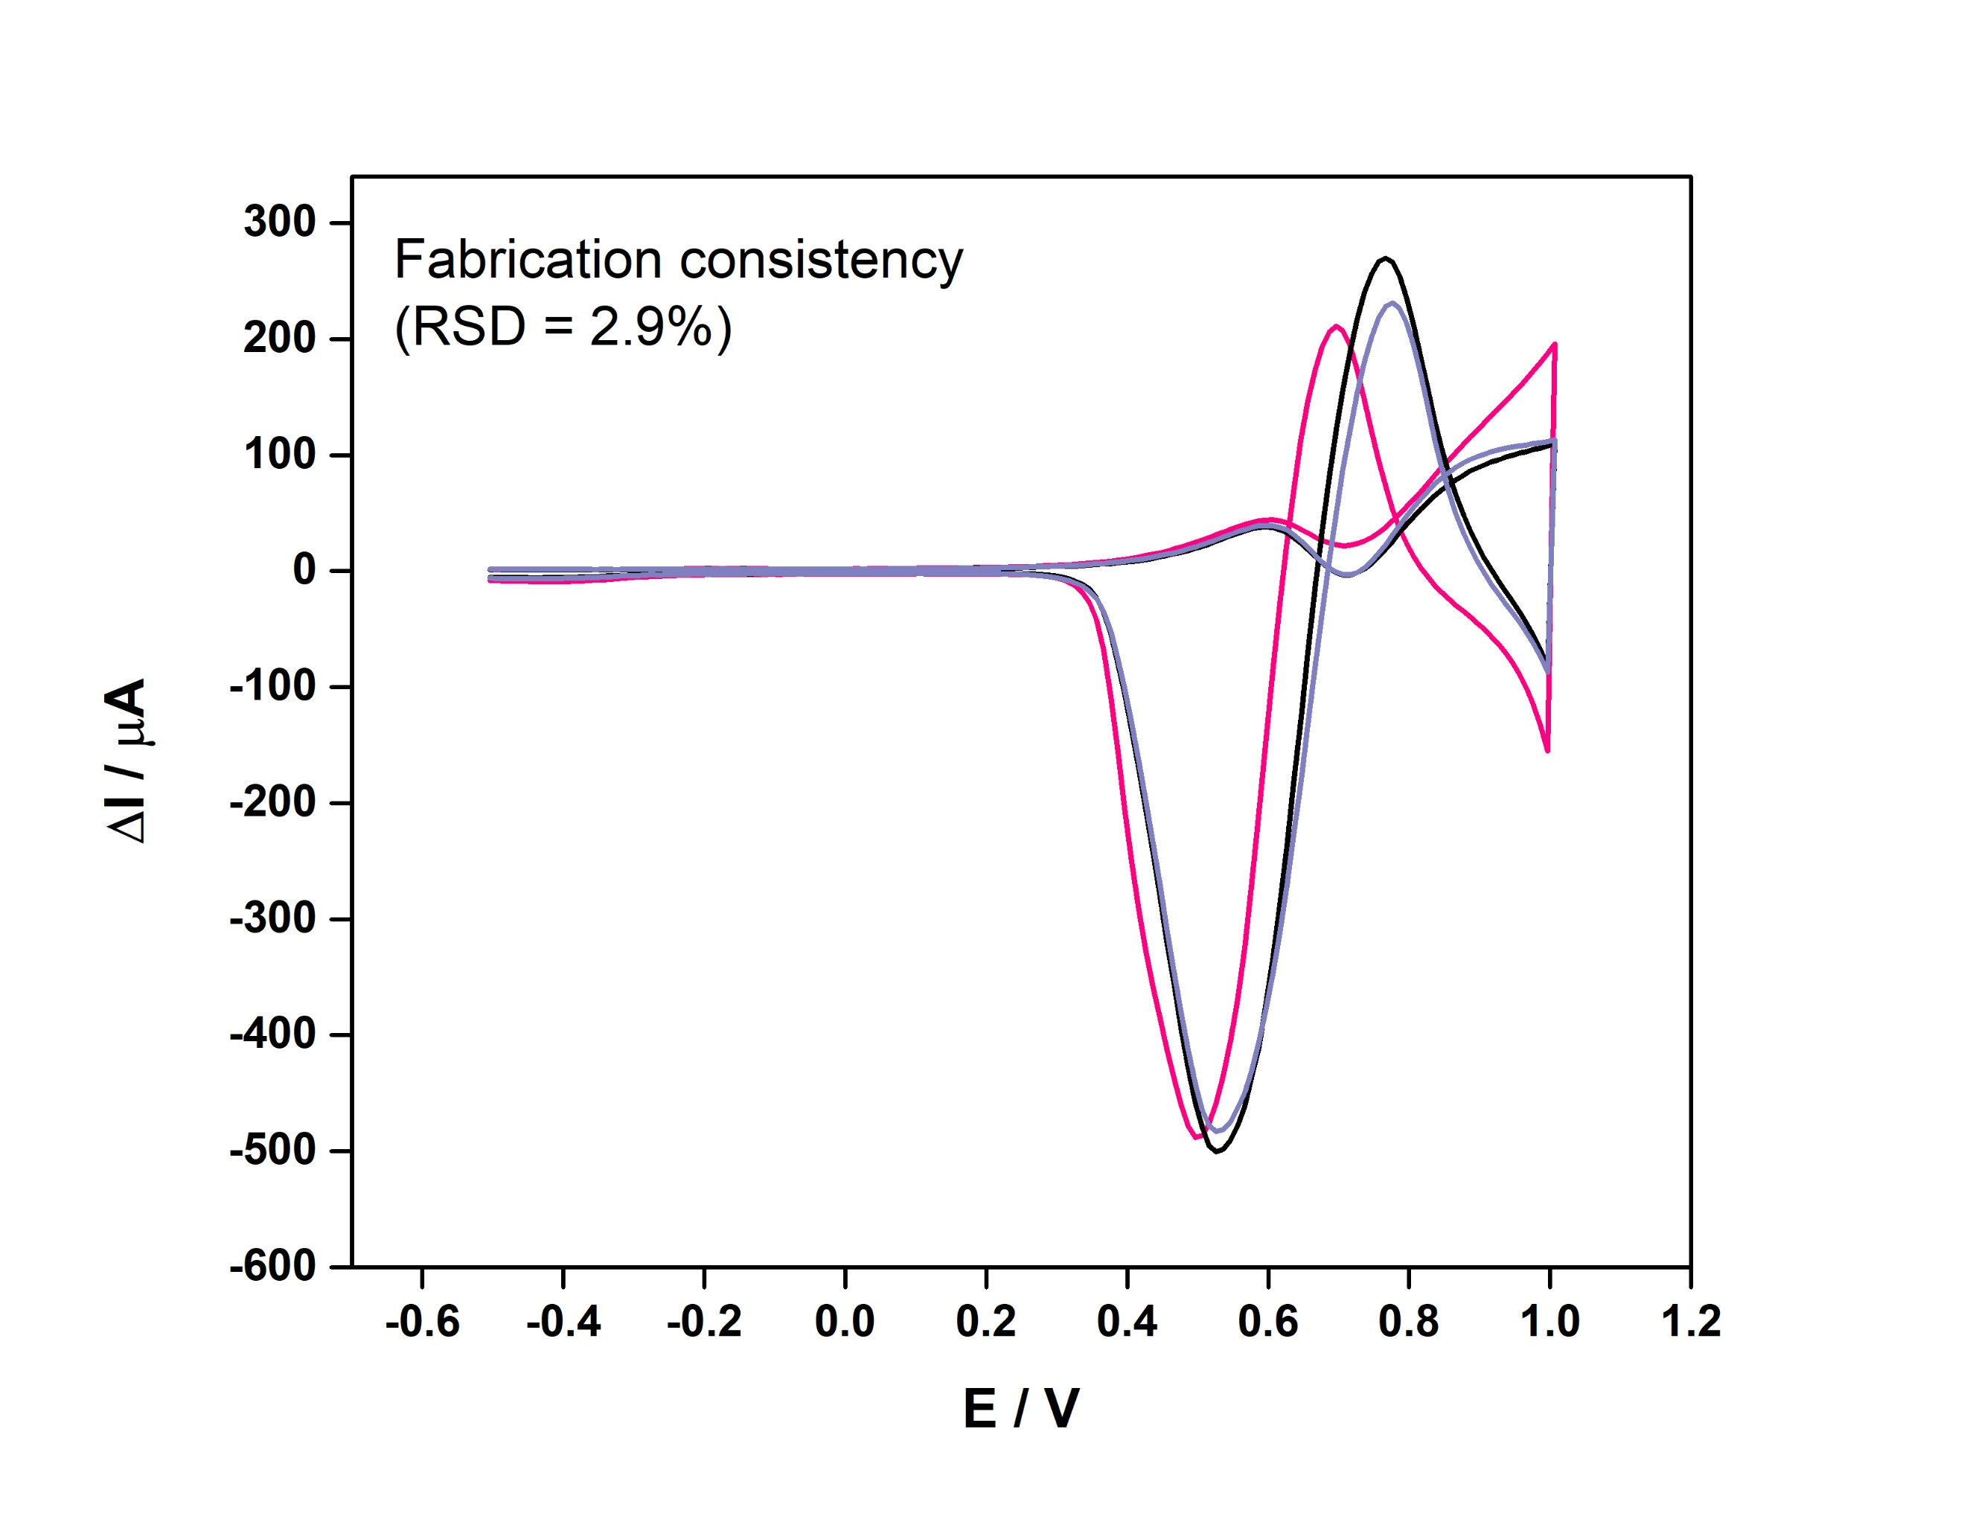
(a)
(b)
(c)
Figure S3. (a) Stability of NiNPs/GCE over 7 consecutive days (RSD 4.1%), (b) reproducibility across different NiNPs/GCE electrodes prepared at different times (RSD = 1.8%), and (c) fabrication consistency of NiNPs/GCE (RSD = 2.9%).

