Fig S1

Body weight (A) and food consumption (B) changes following dosing. C shows kidney weight and body weight ratio comparisons among the 4 groups.

Fig S2

Both KIM1/CREA (A) and NGAL/CREA were significantly higher in the combination group compared with other 3 groups ( p < 0.05, two-way ANOVA).

Fig. S3

In vivo and ex vivo kidney SWE scan comparison (A) and correlation (B)

Fig. S4
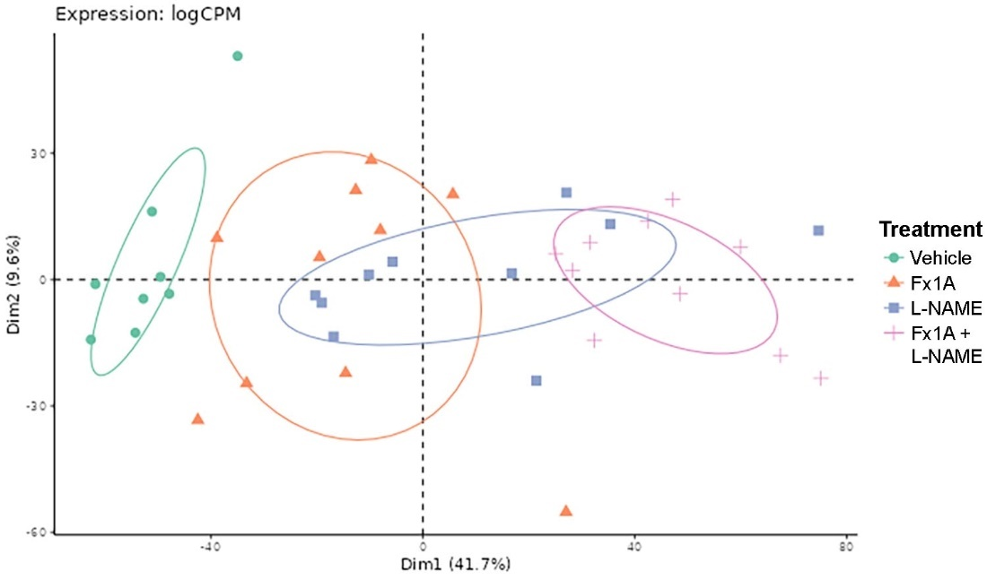
Principal component analysis of gene expression. First component was 41.7%, second component was 9.6%, PC3 only added a few percentage.

Fig S5.
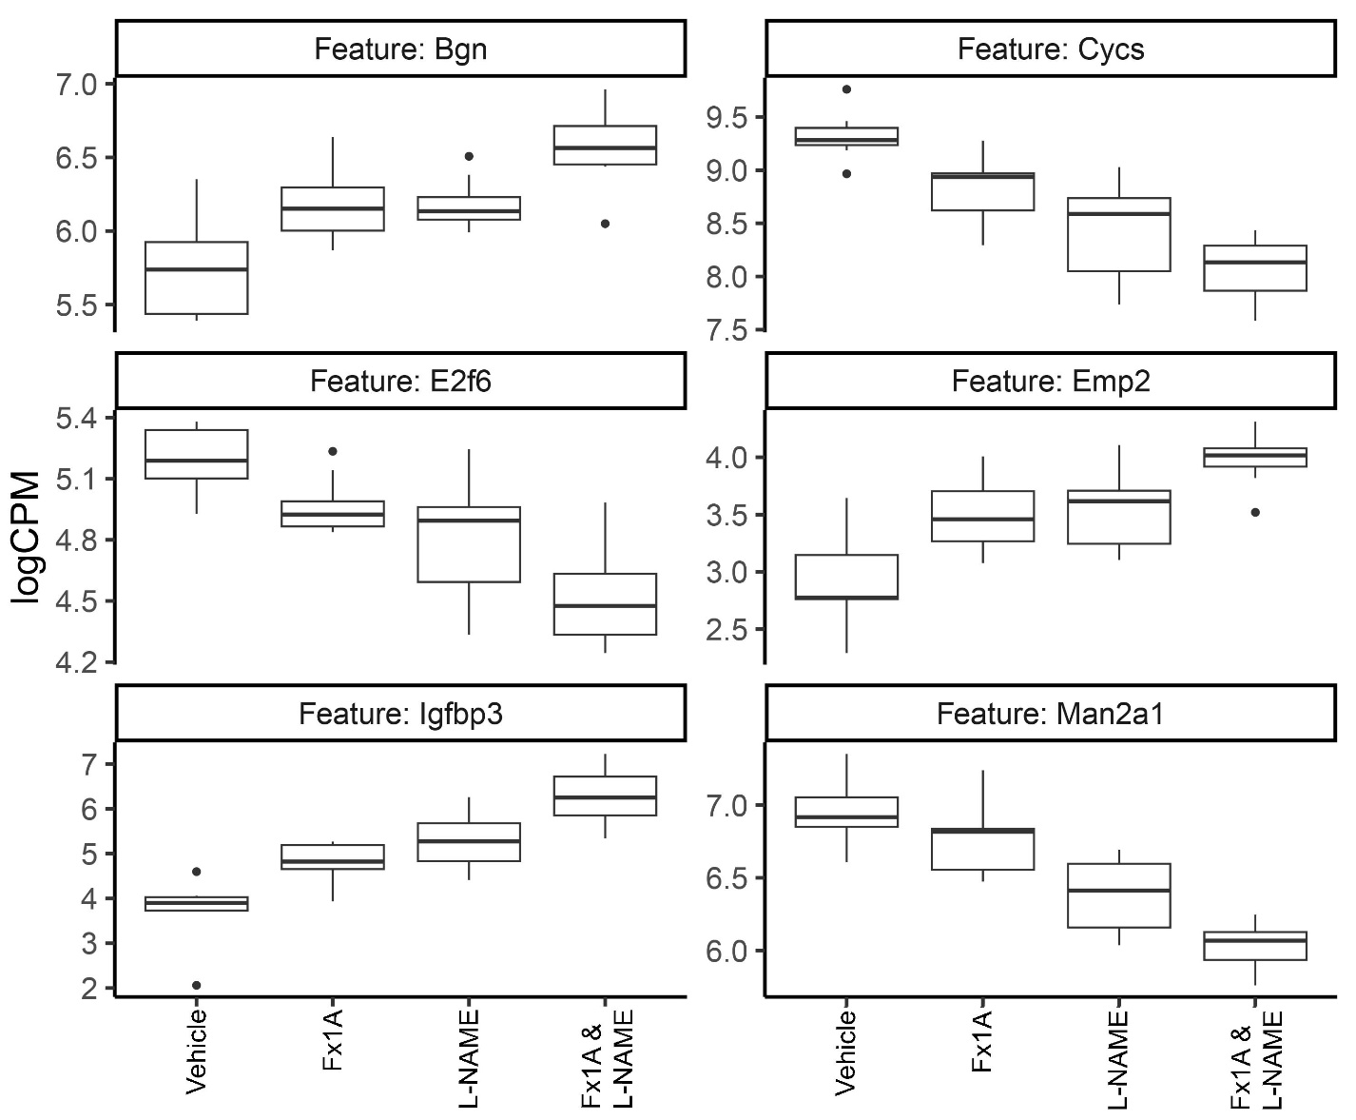
Comparison of top DE genes associated with renal damage.

