Table S1
Number of no omitted trials for each video.
Video stimulus | NT (out of 30) | ASC (out of 23)
Xylophone | 28 | 21
Drums | 28 | 22
Witches | 29 | 19
Sheriff | 28 | 20

Table S2
Median equilibrium probabilities across AOIs for neurotypical gaze patterns in the four trials.
Median Equilibrium Probability in NT group | Adult Activity | Adult Face | Child Activity | Child Face | Object Left | Object Right
Sheriff | 0.02582 | 0.17288 | 0.04068 | 0.54664 | 4.69e-4 | 0.00000
Witches | 0.12615 | 0.41577 | 0.06360 | 0.11043 | 0.00561 | 0.00000
Drums | 0.25877 | 0.17135 | 0.23481 | 0.08380 | 0.00000 | 0.00000
Xylophone | 0.29490 | 0.11327 | 0.32166 | 0.09395 | 0.00811 | 0.00000

Table S3
Distribution of equilibrium probabilities across AOIs for neurotypical gaze patterns in the four trials.
Trial | Kruskal-Wallis |  |  |  | Dwass-Steel-Critchlow-Fligner
Trial | χ² | gdl | p | ε² | Comparison | W | p
Sheriff | 150 | 7 | < .001 | 0.648 | Child Face – Adult Activity | 8.192 | < .001
 |  |  |  |  | Child Face – Adult Face | 6.257 | < .001
 |  |  |  |  | Child Face – Child Activity | 7.555 | < .001
 |  |  |  |  | Child Face – Object Left | -8.915 | < .001
 |  |  |  |  | Child Face – Object Right | -9.362 | < .001
Witches | 165 | 7 | < .001 | 0.689 | Adult Face – Adult Activity | 6.921 | < .001
 |  |  |  |  | Adult Face – Child Activity | -8.656 | < .001
 |  |  |  |  | Adult Face – Child Face | -8.196 | < .001
 |  |  |  |  | Adult Face – Object Left | -9.425 | < .001
 |  |  |  |  | Adult Face – Object Right | -9.517 | < .001
Drums | 171 | 7 | < .001 | 0.739 | Adult Activity – Adult Face | -5.7731 | 0.001
 |  |  |  |  | Adult Activity – Child Activity | -1.7924 | 0.911
 |  |  |  |  | Adult Activity – Child Face | -8.4782 | < .001
 |  |  |  |  | Adult Activity – Object Left | -9.3890 | < .001
 |  |  |  |  | Adult Activity – Object Right | -9.3890 | < .001
 |  |  |  |  | Child Activity – Adult Face | 4.1896 | 0.061
 |  |  |  |  | Child Activity – Child Face | -7.4446 | < .001
 |  |  |  |  | Child Activity – Object Left | -9.3890 | < .001
 |  |  |  |  | Child Activity – Object Right | -9.3443 | < .001
Xylophone | 179 | 7 | < .001 | 0.773 | Adult Activity – Adult Face | -8.368 | < .001
 |  |  |  |  | Adult Activity – Child Activity | 1.001 | 0.997
 |  |  |  |  | Adult Activity – Child Face | -8.830 | < .001
 |  |  |  |  | Adult Activity – Object Left | -9.279 | < .001
 |  |  |  |  | Adult Activity – Object Right | -9.443 | < .001
 |  |  |  |  | Child Activity – Adult Face | 8.478 | < .001
 |  |  |  |  | Child Activity – Child Face | -8.742 | < .001
 |  |  |  |  | Child Activity – Object Left | -9.279 | < .001
 |  |  |  |  | Child Activity – Object Right | -9.443 | < .001

Table S4
Categorization of transition features for both trial groups and corresponding color-coding in the PCA plot.
Sensory Social Routine Trials (Sheriff - Witches) |  | Musical Activities Trials (Drums - Xylophone)
Feature Type | Transition propensity | Feature Type | Transition propensity
Between | Adult Face - Child Face  Child Face - Adult Face | Between | Adult Activity - Child Activity  Child Activity - Adult Activity
From Adult Face | Adult Face - Adult Activity  Adult Face - Child Activity  Adult Face - Object Left  Adult Face - Object Right | From Adult Activity | Adult Activity - Adult Face  Adult Activity - Child Face  Adult Activity - Object Left  Adult Activity - Object Right
From Child Face | Child Face - Adult Activity  Child Face - Child Activity  Child Face - Object Left  Child Face - Object Right | From Child Activity | Child Activity - Adult Face  Child Activity - Child Face  Child Activity - Object Left  Child Activity - Object Right
To Adult Face | Adult Activity - Adult Face  Child Activity - Adult Face  Object Left - Adult Face  Object Right - Adult Face | To Adult Activity | Adult Face - Adult Activity  Child Face - Adult Activity  Object Left - Adult Activity  Object Right - Adult Activity
To Child Face | Adult Activity - Child Face  Child Activity - Child Face  Object Left - Child Face  Object Right - Child Face | To Child Activity | Adult Face - Child Activity  Child Face - Child Activity  Object Left - Child Activity  Object Right - Child Activity

Table S5
Mean transition matrix for the ASC group during the Sheriff trial, showing the mean transition probabilities between AOIs. Rows represent the starting AOIs and columns the target AOIs.
 | Adult Activity | Adult Face | Child Activity | Child Face | Object Left | Object Right
Adult Activity | 0,988284911 | 0,007558004 | 0,00345775 | 0,000380365 | 0 | 0,00031897
Adult Face | 0,012618043 | 0,985061523 | 0,000158276 | 0,000175178 | 3,60179E-05 | 0,001950962
Child Activity | 0,004396584 | 0,00013548 | 0,980160799 | 0,015137672 | 0,000153324 | 1,6141E-05
Child Face | 0,000278552 | 8,44456E-05 | 0,009797022 | 0,98822556 | 0,00160869 | 5,73184E-06
Object Left | 9,1228E-06 | 0,000142877 | 0,000511332 | 0,001679402 | 0,997657267 | 0
Object Right | 0,003127789 | 0,02640129 | 0,000141904 | 4,39209E-05 | 0 | 0,970285096

Table S6
Mean transition matrix for the ASC group during the Witches trial, showing the mean transition probabilities between AOIs. Rows represent the starting AOIs and columns the target AOIs.
 | Adult Activity | Adult Face | Child Activity | Child Face | Object Left | Object Right
Adult Activity | 0,992476676 | 0,004985448 | 0,001774083 | 0,000532968 | 3,74281E-05 | 0,000193397
Adult Face | 0,011534953 | 0,985238918 | 7,40788E-05 | 0,000223853 | 3,32318E-05 | 0,002894966
Child Activity | 0,003715414 | 0,000201662 | 0,987894273 | 0,008105844 | 8,28077E-05 | 0
Child Face | 0,001061575 | 0,000157493 | 0,006864004 | 0,991467115 | 0,000449813 | 0
Object Left | 0,000362941 | 0,000133577 | 0,000138148 | 0,003275428 | 0,996068426 | 2,14805E-05
Object Right | 0,011030444 | 0,006357866 | 2,75081E-05 | 0,000127434 | 6,77757E-05 | 0,982388973

Table S7
Mean transition matrix for the ASC group during the Drums trial, showing the mean transition probabilities between AOIs. Rows represent the starting AOIs and columns the target AOIs.
 | Adult Activity | Adult Face | Child Activity | Child Face | Object Left | Object Right
Adult Activity | 0,995358104 | 0,002116241 | 0,002336725 | 9,22311E-05 | 1,08528E-05 | 8,58458E-05
Adult Face | 0,015980286 | 0,982245311 | 0,000168606 | 0,000191603 | 0 | 0,001414194
Child Activity | 0,002754837 | 8,73158E-05 | 0,994021583 | 0,00306619 | 6,43721E-05 | 5,70252E-06
Child Face | 0,00049968 | 0,000110319 | 0,011252048 | 0,98723236 | 0,000905593 | 0
Object Left | 0,00059978 | 4,0806E-05 | 0,002194073 | 0,001635698 | 0,995529642 | 0
Object Right | 0,001936451 | 0,007602833 | 7,85716E-05 | 0 | 4,28141E-05 | 0,99033933

Table S8
Mean transition matrix for the ASC group during the Xylophone trial, showing the mean transition probabilities between AOIs. Rows represent the starting AOIs and columns the target AOIs.
 | Adult Activity | Adult Face | Child Activity | Child Face | Object Left | Object Right
Adult Activity | 0,995199855 | 0,001874504 | 0,002698527 | 9,01469E-05 | 0 | 0,000136967
Adult Face | 0,017372849 | 0,980123781 | 0,001107595 | 0,000213577 | 2,31212E-05 | 0,001159077
Child Activity | 0,002041352 | 4,61871E-05 | 0,994473825 | 0,003298862 | 0,000139775 | 0
Child Face | 0,000452924 | 0,000239772 | 0,013121008 | 0,985229023 | 0,00090012 | 5,7152E-05
Object Left | 9,04214E-05 | 0,000116333 | 0,001253477 | 0,00522722 | 0,993281948 | 3,06006E-05
Object Right | 0,001471667 | 0,006627731 | 0,000149102 | 0,000219929 | 7,74761E-05 | 0,991454095

Table S9
Mean transition matrix for the NT group during the Sheriff trial, showing the mean transition probabilities between AOIs. Rows represent the starting AOIs and columns the target AOIs.
 | Adult Activity | Adult Face | Child Activity | Child Face | Object Left | Object Right
Adult Activity | 0,984966031 | 0,010557487 | 0,001564032 | 0,00272537 | 6,73034E-05 | 0,000119777
Adult Face | 0,005166914 | 0,99382187 | 0,000174755 | 0,000465189 | 2,95409E-05 | 0,000341731
Child Activity | 0,005628815 | 0,000316325 | 0,980722691 | 0,013318365 | 1,38039E-05 | 0
Child Face | 0,000127395 | 0,000182615 | 0,003218106 | 0,996158123 | 0,000252261 | 6,14995E-05
Object Left | 1,5483E-05 | 4,01497E-05 | 0,002093652 | 0,010590463 | 0,987213313 | 4,69384E-05
Object Right | 0,001766697 | 0,030997136 | 0 | 0,000393825 | 0 | 0,966842342

Table S10
Mean transition matrix for the NT group during the Witches trial, showing the mean transition probabilities between AOIs. Rows represent the starting AOIs and columns the target AOIs.
 | Adult Activity | Adult Face | Child Activity | Child Face | Object Left | Object Right
Adult Activity | 0,992295313 | 0,005504916 | 0,001744843 | 0,00040593 | 3,02495E-05 | 1,87488E-05
Adult Face | 0,004273863 | 0,995171134 | 0,000118832 | 0,000190051 | 8,3788E-06 | 0,000237741
Child Activity | 0,003349444 | 0,000381843 | 0,990037568 | 0,006224377 | 6,76764E-06 | 0
Child Face | 0,00080139 | 0,000510646 | 0,004971934 | 0,993545242 | 0,000170788 | 0
Object Left | 0,00067583 | 0,000469093 | 8,46747E-05 | 0,012954235 | 0,985776986 | 3,91816E-05
Object Right | 0,00032814 | 0,010104111 | 0 | 0 | 9,74738E-05 | 0,989470275

Table S11
Mean transition matrix for the NT group during the Drums trial, showing the mean transition probabilities between AOIs. Rows represent the starting AOIs and columns the target AOIs.
 | Adult Activity | Adult Face | Child Activity | Child Face | Object Left | Object Right
Adult Activity | 0,996943265 | 0,001793493 | 0,001091541 | 0,00012449 | 1,25272E-05 | 3,46845E-05
Adult Face | 0,005656736 | 0,993488009 | 0,000306947 | 0,00016047 | 0 | 0,000387837
Child Activity | 0,001214772 | 8,97146E-05 | 0,996355677 | 0,002312179 | 2,76577E-05 | 0
Child Face | 0,000393653 | 0,000176304 | 0,006737996 | 0,992391909 | 0,000246535 | 5,36029E-05
Object Left | 0,000570326 | 0 | 0,010601857 | 0,001860609 | 0,986850087 | 0,000117121
Object Right | 0,001649154 | 0,019244389 | 8,27041E-05 | 7,41328E-05 | 0 | 0,97894962

Table S12
Mean transition matrix for the NT group during the Xylophone trial, showing the mean transition probabilities between AOIs. Rows represent the starting AOIs and columns the target AOIs.
 | Adult Activity | Adult Face | Child Activity | Child Face | Object Left | Object Right
Adult Activity | 0,997309964 | 0,000975409 | 0,001651125 | 5E-05 | 0 | 1,27977E-05
Adult Face | 0,004609714 | 0,994666764 | 0,000159963 | 0,0003 | 8,62522E-06 | 0,000275233
Child Activity | 0,001219313 | 7,44947E-05 | 0,996885131 | 0,0018 | 4,92385E-05 | 0
Child Face | 0,000460061 | 0,000893009 | 0,00591898 | 0,9917 | 0,001042923 | 5,34426E-06
Object Left | 0,000158407 | 0,000106155 | 0,001201119 | 0,0079 | 0,990552521 | 5,73832E-05
Object Right | 0,006521434 | 0,011378326 | 0 | 0 | 0 | 0,982100241

Table S13
Descriptive statistics and results of the Mann-Whitney U test for all pairwise comparisons of gaze transition propensities across Areas of Interest (AOIs) in ASC and NT children during Sheriff trial. Both uncorrected and FDR-adjusted p-values are reported.
Transition | Group | Mean | Median | SD | Minimum | Maximum |  | Mann-Whitney U
 |  |  |  |  |  |  | Statistics |  | p | FDR p | Effect size
AdultActivity - AdultFace | ASC | 0.00738 | 0.00551 | 0.00553 | 0.00 | 0.01706 | 306 |  | 0.490 | 0.588 | 0.11304
AdultActivity - AdultFace | NT | 0.01021 | 0.00784 | 0.00964 | 0.00 | 0.03547 |  |  | 0.490
AdultActivity - ChildFace | ASC | 3.47e-4 | 0.00000 | 4.89e-4 | 0.00 | 0.00125 | 172 |  | 0.001 | 0.002 | 0.50145
AdultActivity - ChildFace | NT | 0.00263 | 0.00114 | 0.00446 | 0.00 | 0.02000 |  |  | 0.001
AdultFace - AdultActivity | ASC | 0.01262 | 0.01262 | 0.01185 | 0.00 | 0.04343 | 130 |  | < .001 | 0.008 | 0.62319
AdultFace - AdultActivity | NT | 0.00499 | 7.12e-4 | 0.01549 | 0.00 | 0.08408 |  |  | < .001
AdultFace - ChildActivity | ASC | 1.45e-4 | 0.00000 | 2.82e-4 | 0.00 | 8.55e-4 | 292 |  | 0.279 | 0.418 | 0.15362
AdultFace - ChildActivity | NT | 1.69e-4 | 0.00000 | 2.95e-4 | 0.00 | 0.00145 |  |  | 0.279
AdultFace - ChildFace | ASC | 1.60e-4 | 0.00000 | 2.73e-4 | 0.00 | 9.03e-4 | 150 |  | < .001 | 0.005 | 0.56667
AdultFace - ChildFace | NT | 4.83e-4 | 3.69e-4 | 3.61e-4 | 0.00 | 0.00116 |  |  | < .001
AdultFace - ObjectLeft | ASC | 3.29e-5 | 0.00000 | 1.50e-4 | 0.00 | 7.20e-4 | 341 |  | 0.887 | 0.939 | 0.01304
AdultFace - ObjectLeft | NT | 2.86e-5 | 0.00000 | 8.85e-5 | 0.00 | 3.50e-4 |  |  | 0.887
AdultFace - ObectRight | ASC | 0.00178 | 0.00000 | 0.00393 | 0.00 | 0.01637 | 256 |  | 0.051 | 0.083 | 0.25797
AdultFace - ObectRight | NT | 3.30e-4 | 0.00000 | 8.20e-4 | 0.00 | 0.00279 |  |  | 0.051
ChildActivity - AdultFace | ASC | 1.24e-4 | 0.00000 | 2.25e-4 | 0.00 | 8.21e-4 | 301 |  | 0.363 | 0.502 | 0.12754
ChildActivity - AdultFace | NT | 3.06e-4 | 0.00000 | 5.99e-4 | 0.00 | 0.00247 |  |  | 0.363
ChildActivity - ChildFace | ASC | 0.01428 | 0.00525 | 0.01688 | 0.00 | 0.06592 | 332 |  | 0.816 | 0.917 | 0.03913
ChildActivity - ChildFace | NT | 0.01388 | 0.00563 | 0.01331 | 0.00 | 0.04103 |  |  | 0.816
ChildFace - AdultActivity | ASC | 2.74e-4 | 2.27e-4 | 2.70e-4 | 0.00 | 0.00104 | 227 |  | 0.032 | 0.057 | 0.34348
ChildFace - AdultActivity | NT | 1.29e-4 | 9.44e-5 | 1.42e-4 | 0.00 | 5.11e-4 |  |  | 0.032
ChildFace - AdultFace | ASC | 7.71e-5 | 0.00000 | 1.44e-4 | 0.00 | 4.73e-4 | 165 |  | < .001 | 0.002 | 0.52174
ChildFace - AdultFace | NT | 1.82e-4 | 1.70e-4 | 1.20e-4 | 0.00 | 4.99e-4 |  |  | < .001
ChildFace - ChildActivity | ASC | 0.00964 | 0.00800 | 0.01027 | 6.99e-4 | 0.04773 | 127 |  | < .001 | 0.002 | 0.63188
ChildFace - ChildActivity | NT | 0.00311 | 3.76e-4 | 0.00583 | 0.00 | 0.02607 |  |  | < .001
ChildFace - ObjectLeft | ASC | 0.00148 | 1.48e-4 | 0.00493 | 0.00 | 0.02387 | 223 |  | 0.024 | 0.048 | 0.35362
ChildFace - ObjectLeft | NT | 2.44e-4 | 3.77e-5 | 6.63e-4 | 0.00 | 0.00357 |  |  | 0.024
ChildFace - ObjectRight | ASC | 5.23e-6 | 0.00000 | 2.39e-5 | 0.00 | 1.15e-4 | 328 |  | 0.446 | 0.573 | 0.05072
ChildFace - ObjectRight | NT | 5.94e-5 | 0.00000 | 3.26e-4 | 0.00 | 0.00178 |  |  | 0.446
ObjectLeft - AdultFace | ASC | 1.30e-4 | 0.00000 | 3.08e-4 | 0.00 | 0.00146 | 342 |  | 0.961 | 0.960 | 0.00870
ObjectLeft - AdultFace | NT | 4.01e-5 | 4.01e-5 | 7.58e-5 | 0.00 | 3.70e-4 |  |  | 0.961
ObjectLeft - ChildFace | ASC | 0.00167 | 0.00152 | 0.00166 | 0.00 | 0.00599 | 120 |  | < .001 | 0.004 | 0.65362
ObjectLeft - ChildFace | NT | 0.01059 | 0.01059 | 0.01303 | 0.00 | 0.05988 |  |  | < .001
ObjectRight - AdultFace | ASC | 0.02640 | 0.02640 | 0.02254 | 7.39e-4 | 0.11765 | 114 |  | < .001 | 0.003 | 0.66957
ObjectRight - AdultFace | NT | 0.03100 | 0.03100 | 0.01271 | 7.27e-4 | 0.08237 |  |  | < .001
ObjectRight - ChildFace | ASC | 4.39e-5 | 4.39e-5 | 7.95e-5 | 0.00 | 3.95e-4 | 119 |  | < .001 | 0.016 | 0.65507
ObjectRight - ChildFace | NT | 3.94e-4 | 3.94e-4 | 4.01e-4 | 0.00 | 0.00236 |  |  | < .001

Table S14
Descriptive statistics and results of the Mann-Whitney U test for all pairwise comparisons of gaze transition propensities across Areas of Interest (AOIs) in ASC and NT children during Witches trial. Both uncorrected and FDR-adjusted p-values are reported.
Transition | Group | Mean | Median | SD | Minimum | Maximum |  | Mann-Whitney U
 |  |  |  |  |  |  | Statistics |  | p | FDR p | Effect size
AdultActivity - AdultFace | ASC | 0.00467 | 0.00254 | 0.00508 | 1.02e-4 | 0.01733 | 287 |  | 0.302 | 0.41 | 0.16812
AdultActivity - AdultFace | NT | 0.00562 | 0.00305 | 0.00631 | 4.94e-4 | 0.02915 |  |  | 0.302
AdultActivity - ChildFace | ASC | 5.07e-4 | 3.31e-4 | 6.71e-4 | 0.00 | 0.00294 | 266 |  | 0.156 | 0.265 | 0.22899
AdultActivity - ChildFace | NT | 3.92e-4 | 2.43e-4 | 6.06e-4 | 0.00 | 0.00288 |  |  | 0.156
AdultFace - AdultActivity | ASC | 0.01054 | 0.00389 | 0.01529 | 0.00 | 0.06339 | 247 |  | 0.080 | 0.17 | 0.28406
AdultFace - AdultActivity | NT | 0.00438 | 0.00135 | 0.00858 | 3.01e-4 | 0.04134 |  |  | 0.080
AdultFace - ChildActivity | ASC | 6.44e-5 | 0.00000 | 1.09e-4 | 0.00 | 4.30e-4 | 295 |  | 0.331 | 0.41 | 0.14493
AdultFace - ChildActivity | NT | 1.21e-4 | 6.53e-5 | 2.24e-4 | 0.00 | 9.91e-4 |  |  | 0.331
AdultFace - ChildFace | ASC | 2.08e-4 | 1.05e-4 | 2.79e-4 | 0.00 | 9.78e-4 | 332 |  | 0.812 | 0.862 | 0.03913
AdultFace - ChildFace | NT | 1.88e-4 | 1.31e-4 | 2.09e-4 | 0.00 | 8.99e-4 |  |  | 0.812
AdultFace - ObjectLeft | ASC | 2.89e-5 | 0.00000 | 1.10e-4 | 0.00 | 5.13e-4 | 344 |  | 0.972 | 0.972 | 0.00435
AdultFace - ObjectLeft | NT | 8.38e-6 | 0.00000 | 2.60e-5 | 0.00 | 1.03e-4 |  |  | 0.972
AdultFace - ObectRight | ASC | 0.00256 | 3.29e-4 | 0.00828 | 0.00 | 0.04000 | 156 |  | < .001 | 0.007 | 0.54783
AdultFace - ObectRight | NT | 1.36e-4 | 0.00000 | 3.55e-4 | 0.00 | 0.00178 |  |  | < .001
ChildActivity - AdultFace | ASC | 1.75e-4 | 0.00000 | 3.87e-4 | 0.00 | 0.00132 | 290 |  | 0.229 | 0.353 | 0.15942
ChildActivity - AdultFace | NT | 3.82e-4 | 0.00000 | 6.92e-4 | 0.00 | 0.00319 |  |  | 0.229
ChildActivity - ChildFace | ASC | 0.00775 | 0.00537 | 0.00850 | 2.25e-4 | 0.03283 | 328 |  | 0.767 | 0.862 | 0.04928
ChildActivity - ChildFace | NT | 0.00617 | 0.00389 | 0.00565 | 0.00 | 0.02137 |  |  | 0.767
ChildFace - AdultActivity | ASC | 0.00103 | 8.33e-4 | 8.85e-4 | 1.14e-4 | 0.00365 | 237 |  | 0.054 | 0.131 | 0.31304
ChildFace - AdultActivity | NT | 7.52e-4 | 5.85e-4 | 8.07e-4 | 0.00 | 0.00352 |  |  | 0.054
ChildFace - AdultFace | ASC | 1.37e-4 | 0.00000 | 1.99e-4 | 0.00 | 6.13e-4 | 206 |  | 0.009 | 0.038 | 0.40290
ChildFace - AdultFace | NT | 5.11e-4 | 2.85e-4 | 5.91e-4 | 0.00 | 0.00206 |  |  | 0.009
ChildFace - ChildActivity | ASC | 0.00645 | 0.00366 | 0.00645 | 4.66e-4 | 0.02190 | 260 |  | 0.129 | 0.243 | 0.24638
ChildFace - ChildActivity | NT | 0.00513 | 0.00224 | 0.00657 | 0.00 | 0.02709 |  |  | 0.129
ChildFace - ObjectLeft | ASC | 4.32e-4 | 3.12e-4 | 4.62e-4 | 0.00 | 0.00195 | 211 |  | 0.014 | 0.039 | 0.38841
ChildFace - ObjectLeft | NT | 1.92e-4 | 8.28e-5 | 2.58e-4 | 0.00 | 0.00106 |  |  | 0.014
ObjectLeft - AdultFace | ASC | 1.16e-4 | 0.00000 | 1.94e-4 | 0.00 | 7.29e-4 | 205 |  | 0.008 | 0.038 | 0.40580
ObjectLeft - AdultFace | NT | 4.23e-4 | 4.69e-4 | 4.47e-4 | 0.00 | 0.00168 |  |  | 0.008
ObjectLeft - ChildFace | ASC | 0.00293 | 6.12e-4 | 0.00820 | 0.00 | 0.04000 | 292 |  | 0.338 | 0.41 | 0.15362
ObjectLeft - ChildFace | NT | 0.01295 | 0.00282 | 0.04000 | 0.00 | 0.22222 |  |  | 0.338
ObjectRight - AdultFace | ASC | 0.00603 | 0.00386 | 0.00966 | 0.00 | 0.04429 | 211 |  | 0.014 | 0.039 | 0.38841
ObjectRight - AdultFace | NT | 0.01012 | 0.01010 | 0.01712 | 5.52e-4 | 0.09823 |  |  | 0.014
ObjectRight - ChildFace | ASC | 1.11e-4 | 0.00000 | 2.84e-4 | 0.00 | 0.00137 | 210 |  | < .001 | 0.007 | 0.39130
ObjectRight - ChildFace | NT | 0.00000 | 0.00000 | 0.00000 | 0.00 | 0.00000 |  |  | < .001

Table S15
Descriptive statistics and results of the Mann-Whitney U test for all pairwise comparisons of gaze transition propensities across Areas of Interest (AOIs) in ASC and NT children during Drums trial. Both uncorrected and FDR-adjusted p-values are reported.
Transition | Group | Mean | Median | SD | Minimum | Maximum |  |  | Mann-Whitney U
 |  |  |  |  |  |  | Statistics | p |  | FDR p | Effect size
AdultActivity - AdultFace | ASC | 0.00212 | 0.00193 | 0.00197 | 0.00000 | 0.00790 | 293 | 0.461 |  | 0.638 | 0.12144
AdultActivity - AdultFace | NT | 0.00179 | 9.86e-4 | 0.00209 | 2.88e-4 | 0.01027 | 293
AdultActivity - ChildActivity | ASC | 0.00234 | 0.00135 | 0.00239 | 2.56e-4 | 0.00864 | 181 | 0.004 |  | 0.024 | 0.45727
AdultActivity - ChildActivity | NT | 0.00109 | 6.38e-4 | 0.00121 | 1.12e-4 | 0.00524 | 181
AdultActivity - ChildFace | ASC | 9.22e-5 | 0.00000 | 1.25e-4 | 0.00000 | 3.64e-4 | 333 | 0.992 |  | 0.992 | 0.00300
AdultActivity - ChildFace | NT | 1.24e-4 | 0.00000 | 2.05e-4 | 0.00000 | 7.23e-4 | 333
AdultActivity - ObjectLeft | ASC | 1.09e-5 | 0.00000 | 3.60e-5 | 0.00000 | 1.27e-4 | 329 | 0.885 |  | 0.937 | 0.01349
AdultActivity - ObjectLeft | NT | 1.25e-5 | 0.00000 | 3.84e-5 | 0.00000 | 1.55e-4 | 329
AdultActivity - ObjectRight | ASC | 8.58e-5 | 0.00000 | 1.58e-4 | 0.00000 | 6.87e-4 | 238 | 0.024 |  | 0.072 | 0.28786
AdultActivity - ObjectRight | NT | 3.47e-5 | 0.00000 | 1.08e-4 | 0.00000 | 5.05e-4 | 238
AdultFace - AdultActivity | ASC | 0.01598 | 0.00942 | 0.01806 | 0.00000 | 0.07020 | 133 | < .001 |  | 0.018 | 0.60120
AdultFace - AdultActivity | NT | 0.00566 | 0.00127 | 0.01537 | 3.03e-4 | 0.08353 | 133
AdultFace - ChildActivity | ASC | 1.69e-4 | 0.00000 | 3.08e-4 | 0.00000 | 0.00131 | 229 | 0.045 |  | 0.115 | 0.31334
AdultFace - ChildActivity | NT | 3.07e-4 | 2.25e-4 | 3.25e-4 | 0.00000 | 0.00110 | 229
ChildActivity - AdultActivity | ASC | 0.00275 | 0.00143 | 0.00364 | 2.84e-4 | 0.01735 | 236 | 0.074 |  | 0.166 | 0.29235
ChildActivity - AdultActivity | NT | 0.00121 | 7.11e-4 | 0.00130 | 1.95e-4 | 0.00575 | 236
ChildActivity - AdultFace | ASC | 8.73e-5 | 0.00000 | 1.36e-4 | 0.00000 | 5.43e-4 | 324 | 0.850 |  | 0.937 | 0.02849
ChildActivity - AdultFace | NT | 8.97e-5 | 0.00000 | 1.54e-4 | 0.00000 | 5.55e-4 | 324
ChildActivity - ChildFace | ASC | 0.00307 | 0.00121 | 0.00365 | 0.00000 | 0.01271 | 314 | 0.729 |  | 0.936 | 0.05847
ChildActivity - ChildFace | NT | 0.00231 | 0.00107 | 0.00315 | 1.43e-4 | 0.01455 | 314
ChildActivity - ObjectLeft | ASC | 6.44e-5 | 0.00000 | 9.17e-5 | 0.00000 | 2.63e-4 | 262 | 0.094 |  | 0.188 | 0.21439
ChildActivity - ObjectLeft | NT | 2.77e-5 | 0.00000 | 6.37e-5 | 0.00000 | 2.30e-4 | 262
ChildActivity - ObjectRight | ASC | 5.70e-6 | 0.00000 | 2.73e-5 | 0.00000 | 1.31e-4 | 319 | 0.278 |  | 0.5 | 0.04348
ChildActivity - ObjectRight | NT | 0.00000 | 0.00000 | 0.00000 | 0.00000 | 0.00000 | 319
ChildFace - AdultActivity | ASC | 5.00e-4 | 0.00000 | 9.38e-4 | 0.00000 | 0.00415 | 294 | 0.455 |  | 0.638 | 0.11844
ChildFace - AdultActivity | NT | 3.94e-4 | 3.09e-4 | 4.19e-4 | 0.00000 | 0.00169 | 294
ChildFace - ChildActivity | ASC | 0.01125 | 0.00831 | 0.00910 | 0.00118 | 0.03012 | 198 | 0.012 |  | 0.043 | 0.40630
ChildFace - ChildActivity | NT | 0.00674 | 0.00246 | 0.00873 | 3.00e-4 | 0.03366 | 198
ObjectLeft - AdultActivity | ASC | 6.00e-4 | 2.80e-4 | 0.00120 | 0.00000 | 0.00571 | 319 | 0.780 |  | 0.936 | 0.04498
ObjectLeft - AdultActivity | NT | 5.70e-4 | 5.70e-4 | 7.83e-4 | 0.00000 | 0.00386 | 319
ObjectLeft - ChildActivity | ASC | 0.00219 | 0.00174 | 0.00286 | 0.00000 | 0.01268 | 197 | 0.010 |  | 0.043 | 0.40930
ObjectLeft - ChildActivity | NT | 0.01060 | 0.01060 | 0.02043 | 0.00000 | 0.11364 | 197
ObjectRight - AdultActivity | ASC | 0.00194 | 0.00194 | 0.00213 | 0.00000 | 0.00706 | 282 | 0.327 |  | 0.535 | 0.15592
ObjectRight - AdultActivity | NT | 0.00165 | 0.00165 | 0.00228 | 0.00000 | 0.01260 | 282
ObjectRight - ChildActivity | ASC | 7.86e-5 | 0.00000 | 2.05e-4 | 0.00000 | 9.69e-4 | 183 | 0.003 |  | 0.024 | 0.45127
ObjectRight - ChildActivity | NT | 8.27e-5 | 8.27e-5 | 1.41e-4 | 0.00000 | 7.85e-4 | 183

Table S16
Descriptive statistics and results of the Mann-Whitney U test for all pairwise comparisons of gaze transition propensities across Areas of Interest (AOIs) in ASC and NT children during Xylophone trial. Both uncorrected and FDR-adjusted p-values are reported.
Transition | Group | Mean | Median | SD | Minimum | Maximum |  |  | Mann-Whitney U
 |  |  |  |  |  |  | Statistics | p |  | FDR p | Effect size
AdultActivity - AdultFace | ASC | 0.00183 | 8.26e-4 | 0.00200 | 0.00000 | 0.00567 | 295 | 0.484 |  | 0.588 | 0.11544
AdultActivity - AdultFace | NT | 9.75e-4 | 7.25e-4 | 9.42e-4 | 1.13e-4 | 0.00356 | 295
AdultActivity - ChildActivity | ASC | 0.00267 | 0.00195 | 0.00247 | 0.00000 | 0.00988 | 209 | 0.021 |  | 0.057 | 0.37331
AdultActivity - ChildActivity | NT | 0.00165 | 0.00102 | 0.00194 | 4.21e-4 | 0.00846 | 209
AdultActivity - ChildFace | ASC | 8.62e-5 | 0.00000 | 1.61e-4 | 0.00000 | 7.08e-4 | 299 | 0.461 |  | 0.588 | 0.10345
AdultActivity - ChildFace | NT | 5.07e-5 | 0.00000 | 9.46e-5 | 0.00000 | 4.21e-4 | 299
AdultActivity - ObjectLeft | ASC | 0.00000 | 0 | 0.00000 | 0 | 0 | \ | \ |  | \ | \
AdultActivity - ObjectLeft | NT | 0.00000 | 0 | 0.00000 | 0 | 0 | \
AdultActivity - ObjectRight | ASC | 1.31e-4 | 0.00000 | 4.13e-4 | 0.00000 | 0.00197 | 260 | 0.023 |  | 0.057 | 0.22039
AdultActivity - ObjectRight | NT | 1.28e-5 | 0.00000 | 6.89e-5 | 0.00000 | 3.71e-4 | 260
AdultFace - AdultActivity | ASC | 0.01690 | 0.00653 | 0.02623 | 0.00000 | 0.11905 | 149 | < .001 |  | 0.005 | 0.55322
AdultFace - AdultActivity | NT | 0.00461 | 0.00175 | 0.00836 | 4.96e-4 | 0.04150 | 149
AdultFace - ChildActivity | ASC | 0.00106 | 7.48e-5 | 0.00317 | 0.00000 | 0.01534 | 258 | 0.122 |  | 0.216 | 0.22789
AdultFace - ChildActivity | NT | 1.60e-4 | 0.00000 | 2.59e-4 | 0.00000 | 0.00103 | 258
ChildActivity - AdultActivity | ASC | 0.00202 | 0.00153 | 0.00159 | 2.69e-4 | 0.00572 | 212 | 0.025 |  | 0.057 | 0.36432
ChildActivity - AdultActivity | NT | 0.00122 | 6.83e-4 | 0.00142 | 0.00000 | 0.00559 | 212
ChildActivity - AdultFace | ASC | 4.42e-5 | 0.00000 | 7.49e-5 | 0.00000 | 2.69e-4 | 303 | 0.515 |  | 0.588 | 0.09145
ChildActivity - AdultFace | NT | 7.45e-5 | 0.00000 | 1.26e-4 | 0.00000 | 4.97e-4 | 303
ChildActivity - ChildFace | ASC | 0.00324 | 0.00186 | 0.00331 | 0.00000 | 0.01139 | 253 | 0.141 |  | 0.225 | 0.24138
ChildActivity - ChildFace | NT | 0.00177 | 0.00144 | 0.00140 | 1.05e-4 | 0.00551 | 253
ChildActivity - ObjectLeft | ASC | 1.34e-4 | 0.00000 | 2.79e-4 | 0.00000 | 9.99e-4 | 298 | 0.420 |  | 0.588 | 0.10645
ChildActivity - ObjectLeft | NT | 4.92e-5 | 0.00000 | 9.69e-5 | 0.00000 | 3.50e-4 | 298
ChildActivity - ObjectRight | ASC | 0.00000 | 0 | 0.00000 | 0 | 0 | \ | \ |  | \ | \
ChildActivity - ObjectRight | NT | 0.00000 | 0 | 0.00000 | 0 | 0 | \
ChildFace - AdultActivity | ASC | 4.50e-4 | 3.79e-4 | 4.62e-4 | 0.00000 | 0.00128 | 332 | 0.985 |  | 0.985 | 0.00450
ChildFace - AdultActivity | NT | 4.60e-4 | 3.07e-4 | 5.21e-4 | 0.00000 | 0.00168 | 332
ChildFace - ChildActivity | ASC | 0.01298 | 0.00991 | 0.01355 | 5.19e-4 | 0.06497 | 169 | 0.002 |  | 0.008 | 0.49325
ChildFace - ChildActivity | NT | 0.00592 | 0.00263 | 0.00735 | 0.00000 | 0.02696 | 169
ObjectLeft - AdultActivity | ASC | 8.65e-5 | 0.00000 | 1.83e-4 | 0.00000 | 6.88e-4 | 254 | 0.107 |  | 0.214 | 0.23838
ObjectLeft - AdultActivity | NT | 1.58e-4 | 1.58e-4 | 2.78e-4 | 0.00000 | 0.00124 | 254
ObjectLeft - ChildActivity | ASC | 0.00122 | 5.80e-4 | 0.00240 | 0.00000 | 0.01112 | 328 | 0.923 |  | 0.984 | 0.01649
ObjectLeft - ChildActivity | NT | 0.00120 | 0.00120 | 0.00257 | 0.00000 | 0.01384 | 328
ObjectRight - AdultActivity | ASC | 0.00147 | 0.00144 | 0.00272 | 0.00000 | 0.01355 | 136 | < .001 |  | 0.005 | 0.59220
ObjectRight - AdultActivity | NT | 0.00652 | 0.00652 | 0.00849 | 0.00000 | 0.04843 | 136
ObjectRight - ChildActivity | ASC | 1.46e-4 | 7.46e-5 | 3.66e-4 | 0.00000 | 0.00179 | 160 | < .001 |  | 0.005 | 0.52174
ObjectRight - ChildActivity | NT | 0.00000 | 0.00000 | 0.00000 | 0.00000 | 0.00000 | 160

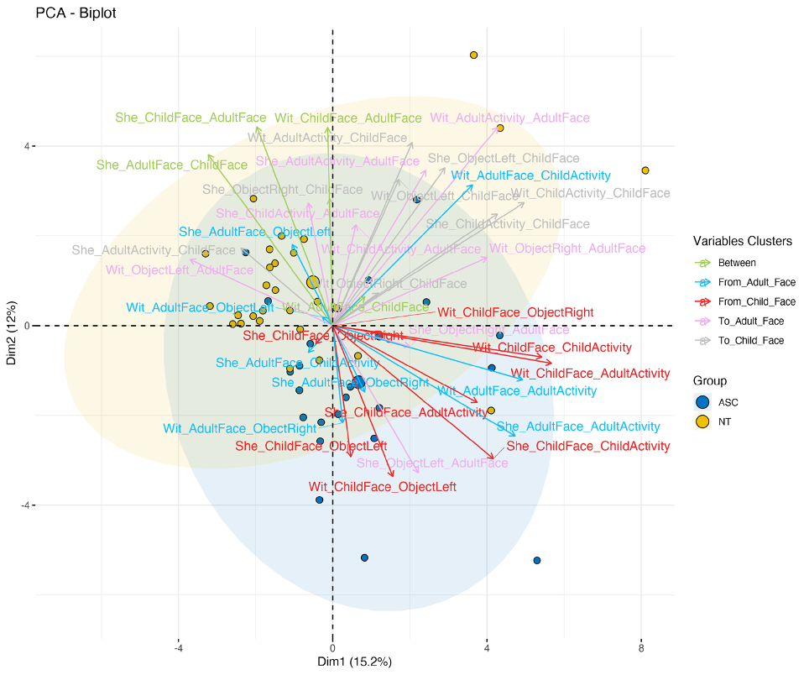
Fig. S1. Scatter plot showing individuals based on the first and second principal components, with concentration ellipses around each group (ASC and NT). Overlaid, a correlation plot displaying the correlation between the first and second principal components, with variables (transition propensities) color-coded based on the categorization. Stimulus videos: Sheriff and Witches.

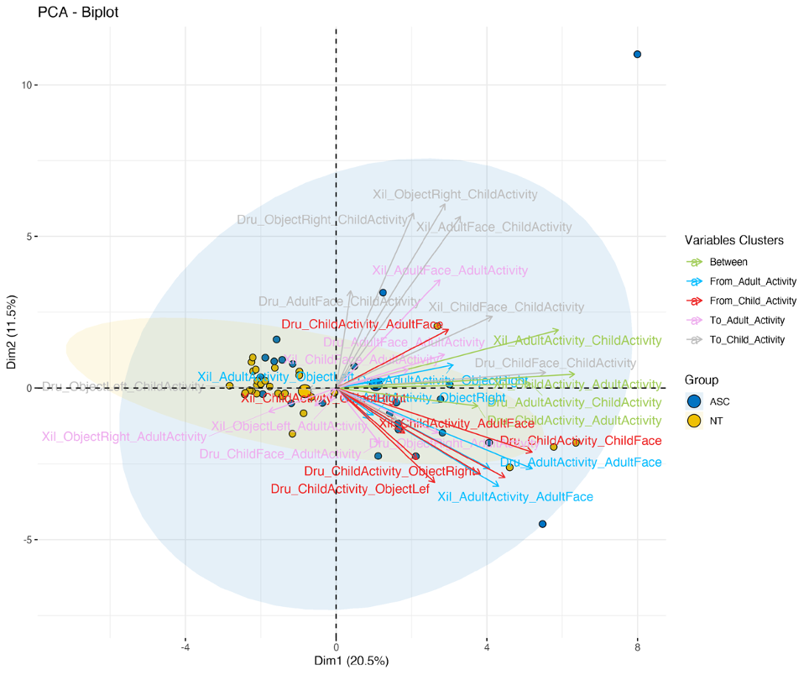

Fig. S2. Scatter plot showing individuals based on the first and second principal components, with concentration ellipses around each group (ASC and NT). Overlaid, a correlation plot displaying the correlation between the first and second principal components, with variables (transition propensities) color-coded based on the categorization. Stimulus videos: Xylophone and Drums.

Figure S3. Top 10 loadings for PC1 (SSRs). The bar plot shows the transitions with the highest contributions to the first principal component during the sensory social routines.
Figure S4. Top 10 loadings for PC2 (SSRs). The bar plot shows the transitions with the highest contributions to the second principal component during the sensory social routines.
Figure S5. Top 10 loadings for PC1 (Musical activities). The bar plot shows the transitions with the highest contributions to the first principal component during the musical activity trials.
Figure S6. Top 10 loadings for PC2 (Musical activities). The bar plot shows the transitions with the highest contributions to the second principal component during the musical activity trials.

