Supplementary Material

- Supplementary Table S1. Relationships between intra-WMH T1w, T2w, FDG or AV45 signals in each brain lobe and regional volumes of WMH in each brain lobe.

- Supplementary Table S2. Relationships between intra-WMH T1w, T2w, FDG or AV45 signals in each brain lobe and the amyloid status (positive/negative).

- Supplementary Table S3. Relationships between the intra-WMH T1w, T2w, FDG or AV45 signal in each brain lobe, and cortical amyloid load (SUVR), adjusted for age (A.), or age and the clinical status (B.).

- Supplementary Figure 1. Relationships between regional intra-WMH T1w signal in each brain lobe and cognition (MMSE).

- Supplementary Figure 2. Relationships between regional intra-WMH T2w signal in each brain lobe and cognition (MMSE).

Supplementary Table S1. Relationships between intra-WMH T1w, T2w, FDG or AV45 signals in each brain lobe and regional volumes of WMH in each brain lobe.

 |  | Volume
 |  | Frontal |  | Parietal |  | Temporal |  | Occipital
 |  | Beta (β) | p-value | Beta (β) | p-value | Beta (β) | p-value | Beta (β) | p-value
Signal | T1w | -0,01 | 0,9170 | -0,09 | 0,26 | -0,17 | <0,05* | -0,08 | 0,31
Signal | T2w | -0,03 | 0,7410 | 0,16 | 0,05 | 0,03 | 0,68 | 0,10 | 0,20
Signal | AV45 | 0,08 | 0,2960 | 0,05 | 0,51 | -0,23 | <0,05* | -0,18 | <0,05
Signal | FDG | 0,38 | <0,05* | 0,61 | <0,05* | 0,25 | <0,05* | -0,05 | 0,57

Standardized Beta and uncorrected p-values from regression linear models adjusted for age are indicated.
* Significant after false discovery rate (FDR) correction for multiple analysis applied for each imaging modality (n=4).

Supplementary Table S2. Relationships between intra-WMH T1w, T2w, FDG or AV45 signals in each brain lobe and the amyloid status (positive/negative).
 |  | T1w |  |  |  |  | T2w
 | Estimate |  | standard errors (SE) |  | p-value | Estimate |  | standard errors (SE) | p-value
Frontal | 0.02 |  | 0.10 |  | 0.31 | -0.04 |  | 0.08 | 0.03
Parietal | 0.06 |  | 0.02 |  | 0.01* | -0.03 |  | 0.02 | 0.04
Temporal | -0.02 |  | 0.03 |  | 0.48 | -0.01 |  | 0.02 | 0.44
Occipital | 0.03 |  | 0.03 |  | 0.27 | -0.03 |  | 0.02 | 0.14
 |  | FDG |  |  |  |  | AV45
 | Estimate |  | standard errors (SE) |  | p-value | Estimate |  | standard errors (SE) | p-value
Frontal | 0.01 |  | 0.01 |  | 0.64 | 0.00 |  | 0.04 | 0.92
Parietal | 0.01 |  | 0.01 |  | 0.61 | -0.03 |  | 0.04 | 0.49
Temporal | 0.01 |  | 0.01 |  | 0.19 | -0.02 |  | 0.04 | 0.64
Occipital | 0.00 |  | 0.01 |  | 0.93 | 0.03 |  | 0.04 | 0.40

Estimates and uncorrected p-values from regression linear models adjusted for age are indicated. When models were also adjusted for the clinical status (cognitively unimpaired versus cognitively impaired), none of the associations were significant (all p values > 0.10).
* Significant after false discovery rate (FDR) correction for multiple analysis applied for each imaging modality (n=4).

Supplementary Table S3. Relationships between the intra-WMH T1w, T2w, FDG or AV45 signal in each brain lobe, and cortical amyloid load (SUVR), adjusted for age (A.), or age and the clinical status (B.).

A. | T1w |  | T2w |  | FDG |  | AV45
 | Estimate | p-value | Estimate | p-value | Estimate | p-value | Estimate | p-value
Frontal | 0.04 | 0.26 | -0.08 | 0.002* | -0.01 | 0.77 | 0.08 | 0.18
Parietal | 0.10 | 0.002* | -0.07 | 0.004* | -0.01 | 0.73 | 0.05 | 0.39
Temporal | 0.02 | 0.56 | -0.06 | 0.04* | 0.00 | 0.91 | 0.06 | 0.26
Occipital | 0.07 | 0.07 | -0.07 | 0.03* | -0.02 | 0.27 | 0.15 | 0.004*
B. | T1w |  | T2w |  | FDG |  | AV45
 | Estimate | p-value | Estimate | p-value | Estimate | p-value | Estimate | p-value
Frontal | 0.04 | 0.39 | -0.07 | 0.02 | -0.02 | 0.41 | 0.17 | 0.02*
Parietal | 0.08 | 0.04 | -0.06 | 0.04 | -0.04 | 0.06 | 0.12 | 0.08
Temporal | 0.05 | 0.28 | -0.03 | 0.32 | -0.02 | 0.22 | 0.20 | 0.002*
Occipital | 0.02 | 0.64 | -0.02 | 0.51 | -0.05 | 0.03 | 0.25 | < 0.001*

Estimates and uncorrected p-values from regression linear models adjusted for age (A), or age and the clinical status (B), are indicated.
* Significant after false discovery rate (FDR) correction for multiple analysis applied for each imaging modality (n=4).

Supplementary Figure 1. Relationships between regional intra-WMH T1w signal in each brain lobe and cognition (MMSE).

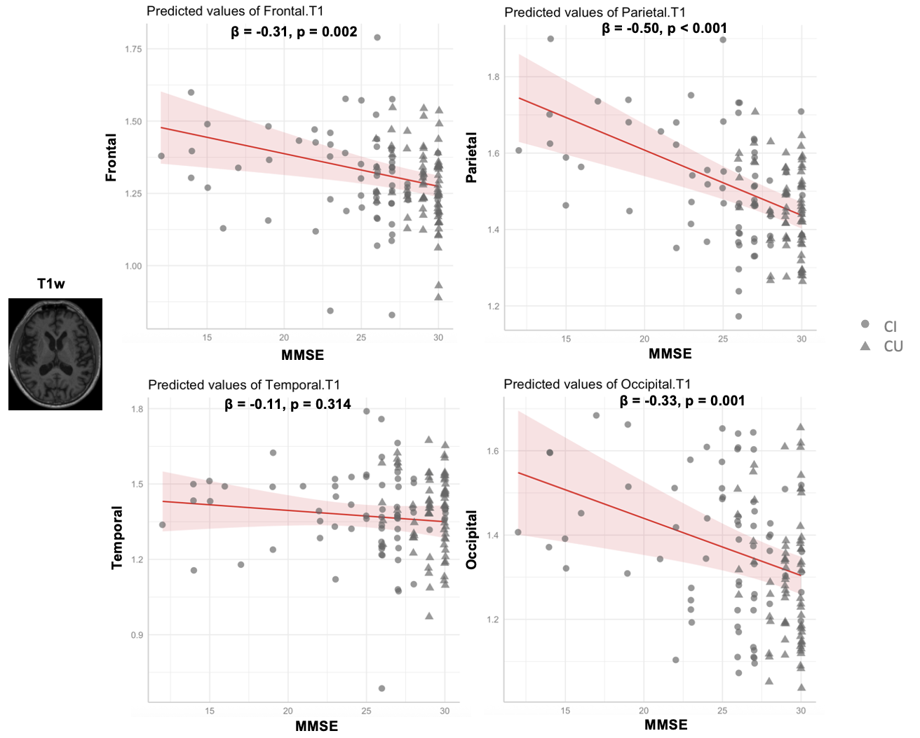

Standardized Beta and uncorrected p-value from regression linear models are indicated, adjusted for age, gender, level of education and clinical status.

Supplementary Figure 2. Relationships between regional intra-WMH T2w signal in each brain lobe and cognition (MMSE).

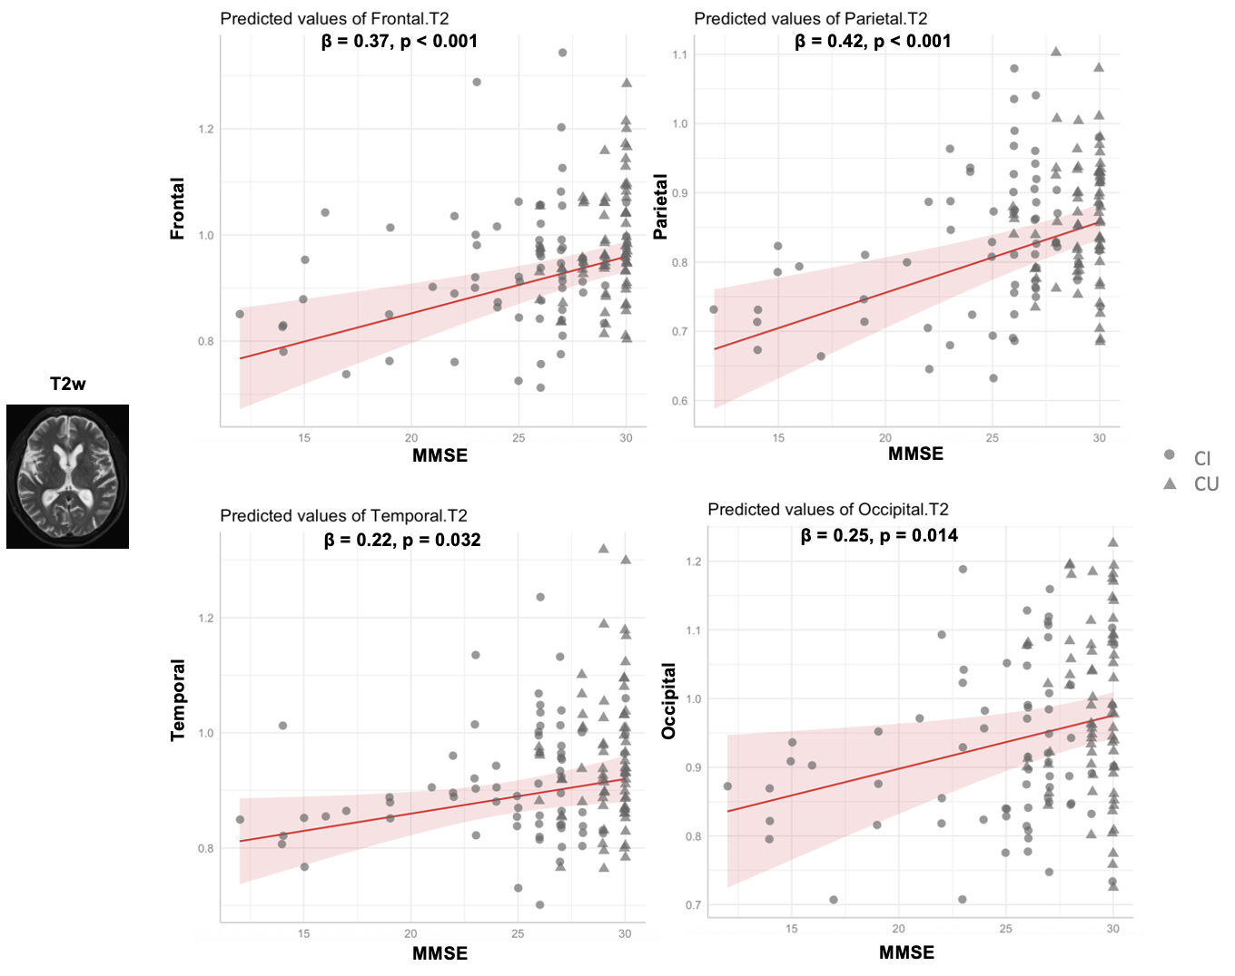

Standardized Beta and uncorrected p-value from regression linear models are indicated, adjusted for age, gender, level of education and clinical status.

