Supplementary
Table S1. Phytochemicals of Hydrastis canadensis and Berberis vulgaris found from Natural Product Activity and Species Source Database (NPASS)
Hydrastis canadensis
Natural Product ID | SMILES
NPC296482 | COc1c(OC)ccc2c1c[n+]1CCc3c(c1c2)cc1c(c3)OCO1.[Cl-]
NPC136330 | O=C(N1CCCCC1)/C=C/C=C/c1ccc2c(c1)OCO2
NPC53069 | COc1ccc2cc3-c4cc5c(cc4CC[n+]3cc2c1OC)OCO5
NPC27887 | O=Cc1c(ccc(c1OC)OC)CC1N(C)CCc2c1cc1OCOc1c2
NPC216459 | COc1c(OC)ccc2c1CN1CCc3c([C@@H]1C2)cc1c(c3)OCO1
NPC138487 | COc1ccc2C[C@@H]3c4cc5c(cc4CCN3Cc2c1OC)OCO5
NPC73020 | CN1CCc2cc3c(cc2[C@@H]1[C@@H]1c2ccc(c(c2C(=O)O1)OC)OC)OCO3
NPC159275 | COc1c(C)c2oc(cc(=O)c2c(c1C)O)c1ccc(cc1)O
NPC54379 | COc1cc2CCN3[C@H](c2cc1O)Cc1c(C3)c(OC)c(cc1)OC
NPC78913 | COc1cc2oc(cc(=O)c2c(c1C)O)c1ccc(cc1)O
NPC14622 | CN1CCc2cc3c(cc2C1[C@@H]1c2ccc(c(c2C(=O)O1)OC)OC)OCO3
NPC477259 | COC1=C(C2=C(CC3C4=CC5=C(C=C4CCN3C2=O)OCO5)C=C1)OC
NPC482982 | Cc1c(c(C)c2c(c(=O)c(c(c3ccc(c(c3)O)OC)o2)O)c1OC)OC
NPC24228 | COc1c(ccc2CC3c4cc5c(cc4CCN3C(=O)c12)OCO5)O
NPC477258 | CC(=O)OC1=C(C2=C(CC3C4=CC5=C(C=C4CCN3C2=O)OCO5)C=C1)OC
NPC167084 | Cc1c(cc(c2c(=O)cc(c3ccc(cc3)O)oc12)O)OC
NPC478985 | COc1cc(ccc1O[C@H]1[C@@H]([C@H]([C@@H]([C@@H](CO)O1)O)O)O)/C=C/C(=O)O[C@@H]1C[C@@](C[C@H]([C@H]1O)O)(C(=O)O)O
NPC170826 | CC[C@H](CC[C@@H](C)[C@H]1CC[C@H]2[C@@H]3CC=C4C[C@H](CC[C@]4(C)[C@H]3CC[C@]12C)O[C@@H]1[C@@H]([C@H]([C@@H]([C@@H](CO)O1)O)O)O)C(C)C
NPC269699 | COc1ccc2cc3-c4cc5c(cc4C(C[n+]3cc2c1OC)O)OCO5
NPC93989 | CN1CCc2cc3c(cc2[C@H]1Cc1ccc(c(c1C=O)OC)OC)OCO3
NPC183485 | COc1ccc2cc3-c4cc5c(cc4CC[n+]3cc2c1OC)OC(O5)[3H]
NPC122483 | Cc1c(c2c(=O)cc(c3ccc(c(c3)O)O)oc2c(C)c1OC)O
NPC308036 | c1cc2c(c[nH]c2cc1Br)CSCCN
 | Berberis vulgaris
NPC78359 | COc1ccc2c3c1O[C@@H]1[C@@]3(CCN(C2)C)C=C[C@@H](C1)O
NPC53069 | COc1ccc2cc3-c4cc5c(cc4CC[n+]3cc2c1OC)OCO5
NPC7715 | COc1cc2CCN([C@H]3c2cc1Oc1c2c(CCN([C@H]2Cc2ccc(Oc4cc(C3)ccc4O)cc2)C)cc(c1O)OC)C
NPC47298 | C/C=C/1[C@H]2C=C(C)C[C@@]1(c1ccc(nc1C2)O)N
NPC4669 | COC1=CC=c2c(C1=O)c[n+]1c(c2)c2cc3OCOc3cc2CC1
NPC49075 | CN1CCc2cc(c3cc2[C@@H]1Cc1ccc(cc1)Oc1cc(ccc1O)C[C@@H]1c2c(CCN1C)cc(c(c2O3)OC)OC)OC
NPC16452 | COc1ccc2cc3-c4cc(c(cc4CC[n+]3cc2c1OC)OC)OC
NPC181796 | CN1CCc2cc(c3cc2[C@@H]1Cc1ccc(cc1)Oc1cc(ccc1O)C[C@@H]1c2c(CCN1C)cc(c(c2O3)O)OC)OC
NPC480593 | c1ccc(cc1)COC(=O)N1CCC[C@H]1C(=O)N1CCC[C@H]1C=O
NPC116007 | COc1ccc2cc3-c4cc5c(cc4CCn3c(=O)c2c1OC)OCO5
NPC251735 | CN1CCc2cc(c3cc2[C@@H]1Cc1ccc(c(c1)Oc1ccc(cc1)C[C@H]1c2c(CCN1C)cc(c(c2O3)OC)OC)O)OC
NPC480591 | CN1CCc2cc(c(c(c2C1)Oc1cc2c(CCN(C)C2Cc2ccc(cc2)O)cc1OC)OC)OC
NPC480590 | CCN(CC)Cc1cc2C[C@@H]3c4c(CCN3C)cc(c(c4Oc3cc4c(CCN(C)[C@H]4Cc4ccc(cc4)Oc(c2)c1O)cc3OC)OC)OC
NPC480592 | CN1CCc2cc(c(cc2C1Cc1ccc(c(c1)Oc1cc(ccc1OC)CC1c2cc(c(cc2CCN1C)OC)O)O)O)OC
NPC200388 | COc1cc(c2c(c1)oc(c1cc(c(cc1O)OC)O)c(c2=O)OC)O
NPC248109 | CN1CCc2cc(c3cc2C1Cc1cccc(c1)Oc1cc(ccc1O)CC1c2c(CCN1C)cc(c(c2O3)OC)OC)OC
NPC199402 | CN1CCc2cc(c3cc2[C@@H]1Cc1ccc(c(c1)Oc1ccc(cc1)C[C@@H]1c2c(CCN1C)cc(c(c2O3)OC)OC)O)OC
NPC117785 | CC(C)CCC[C@@H](C)CCC[C@@H](C)CCC[C@H](C)O
NPC300481 | CC(C)CCC[C@@H](C)CCC[C@@H](C)CCC[C@@H](C)O
NPC480589 | CN1CCc2cc(c(c(c2C1)Oc1cc2c(CCN(C)C2=O)cc1OC)OC)OC

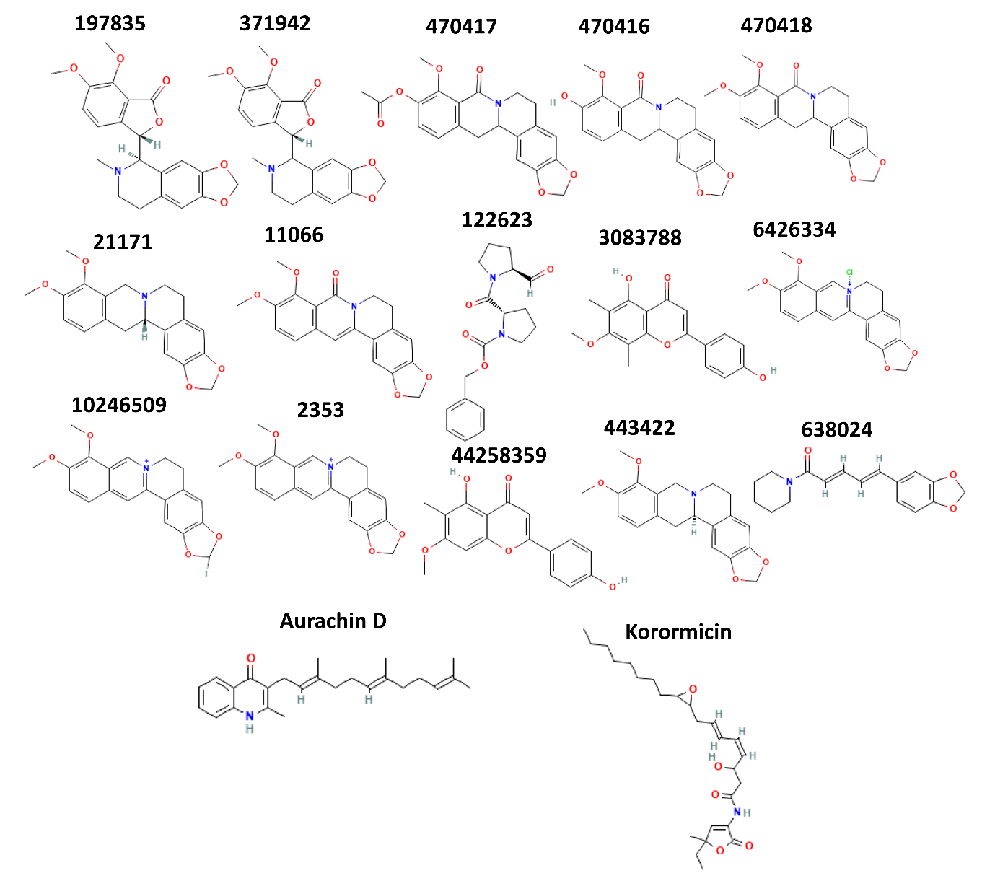
Figure S1. 2D representation of the to 15 compounds after virtual screening

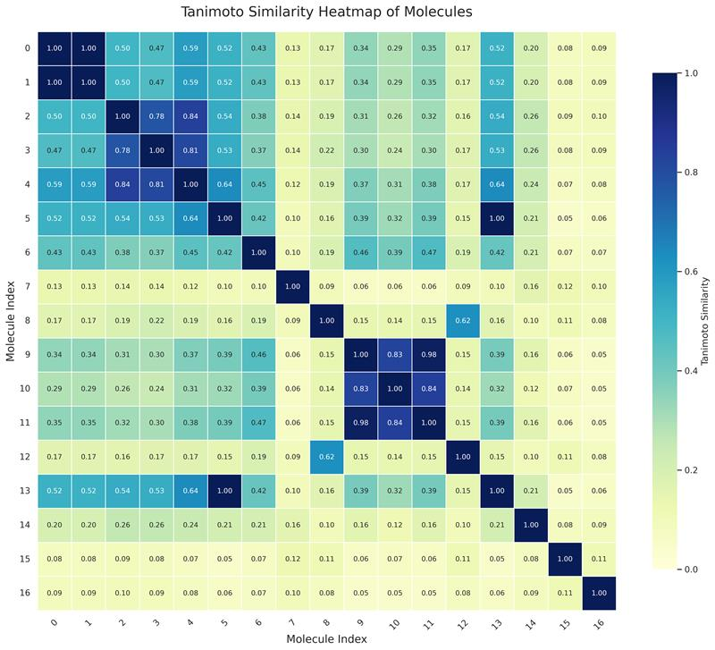
Figure S2. Tanimoto similarity of the to 15 compounds along with the two control compounds after virtual screening

Table S2. InChIKey analysis for the compounds 197835 and 371942
Compound ID | InChI | InChIKey
197835 | InChI=1S/C21H21NO6/c1-22-7-6-11-8-15-16(27-10-26-15)9-13(11)18(22)19-12-4-5-14(24-2)20(25-3)17(12)21(23)28-19/h4-5,8-9,18-19H,6-7,10H2,1-3H3/t18-,19+/m1/s1 | JZUTXVTYJDCMDU-MOPGFXCFSA-N
371942 | InChI=1S/C21H21NO6/c1-22-7-6-11-8-15-16(27-10-26-15)9-13(11)18(22)19-12-4-5-14(24-2)20(25-3)17(12)21(23)28-19/h4-5,8-9,18-19H,6-7,10H2,1-3H3/t18?,19-/m0/s1 | JZUTXVTYJDCMDU-GGYWPGCISA-N

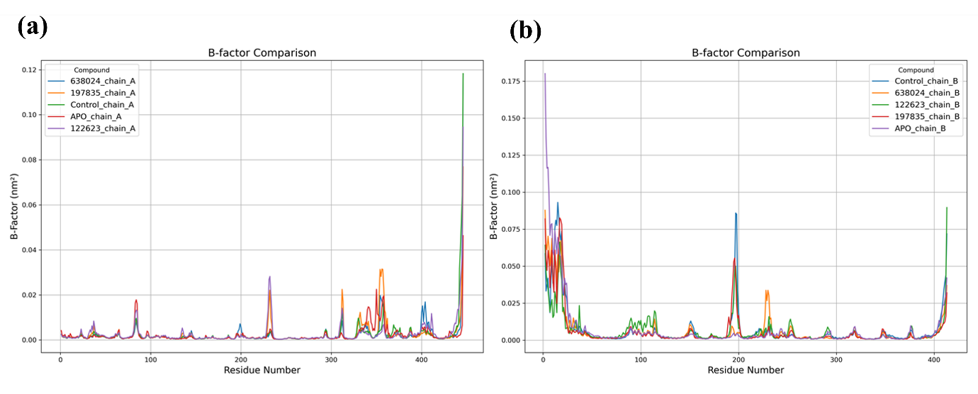
Figure S3. B-factor (atomic fluctuations) of the protein when in apo form and in bound state with Control, 638024, 122623 and 197835

Table S3. Hydrogen bond occupancy for the 300 ns simulation for the selected compounds and control
Residues |  | H-Bond % occupancy | Residues |  | H-Bond % occupancy
 | Control |  |  | 638024
ASP230 | LIG | 0.02 | LEU224 | LIG | 0.007
SER233 | LIG | 20.919 | SER238 | LIG | 0.353
HIS234 | LIG | 0.023 | SER238 | LIG | 0.007
THR236 | LIG | 0.457 | ALA253 | LIG | 0.023
ALA253 | LIG | 0.03 | TYR257 | LIG | 0.813
SER305 | LIG | 0.05 | TYR257 | LIG | 0.027
ILE306 | LIG | 2.403 |  | 197835
ILE306 | LIG | 33.586 | Residues |  | H-Bond % occupancy
ILE306 | LIG | 0.06 | PHE226 | LIG | 0.063
ILE306 | LIG | 2.257 | ALA229 | LIG | 0.09
LEU307 | LIG | 0.153 | ALA229 | LIG | 0.003
LEU307 | LIG | 0.047 | ALA229 | LIG | 0.013
LEU307 | LIG | 0.003 | ASP230 | LIG | 0.003
THR307 | LIG | 3.143 | ASP230 | LIG | 2.37
THR307 | LIG | 27.406 | ASP230 | LIG | 6.06
THR307 | LIG | 0.077 | ASP230 | LIG | 50.018
LIG | TRP241 | 0.003 | ASP230 | LIG | 0.26
LIG | GLY306 | 0.017 | HIS234 | LIG | 0.003
LIG | TRP295 | 1.013 | HIS234 | LIG | 0.013
LIG | ARG297 | 2.547 | THR236 | LIG | 0.097
LIG | ILE298 | 3.02 | THR236 | LIG | 5.35
LIG | ILE298 | 6.64 | TYR257 | LIG | 0.117
 | 122623 |  | TYR257 | LIG | 0.03
Residues |  | H-Bond % occupancy | ALA293 | LIG | 0.03
PHE185 | LIG | 0.007
HIS234 | LIG | 0.02
ALA253 | LIG | 3.703
MET305 | LIG | 10.693
ILE306 | LIG | 0.15
LEU307 | LIG | 8.186

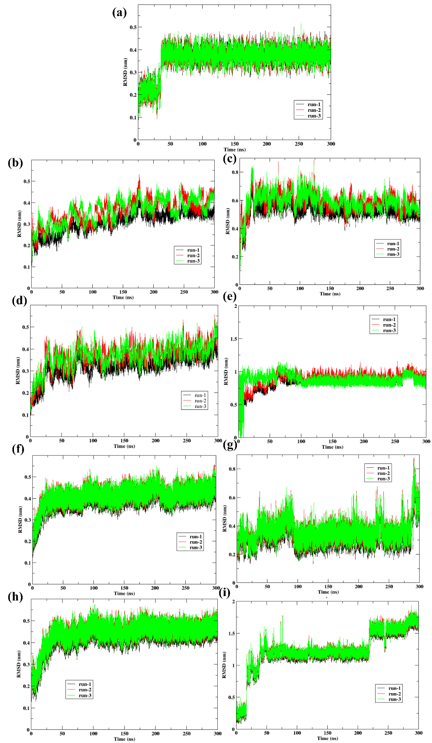
Figure S4. Triplicates of the 300 ns simulation RMSD of the protein of (a) Apo Protein (b) Control (d) 638024 (f) 122623 (h) 197835 and RMSD of ligand of (c) Control (e) 638024 (g) 122623 (h) 197835

