Supplemental Table 1. The primer sequencing used in Real-Time PCR experiments
Gene name | Forward (5’→3’) | Reverse (5’→3’)
mGapdh | AGGTCGGTGTGAACGGATTTG | TGTAGACCATGTAGTTGAGGTCA
mKim-1 | ACATATCGTGGAATCACAACGAC | ACTGCTCTTCTGATAGGTGACA
mIl1-β | GGAGAACCAAGCAACGACAAAATA | TGGGGAACTCTGCAGACTCAAAC
mTgf-β | GCAACAATTCCTGGCGTTACC | CGAAAGCCCTGTATTCCGTCT
mCtgf | GTGCCAGAATGCACACTG | CCCCGGTTACACTCCAAA

Supplemental Figure 1
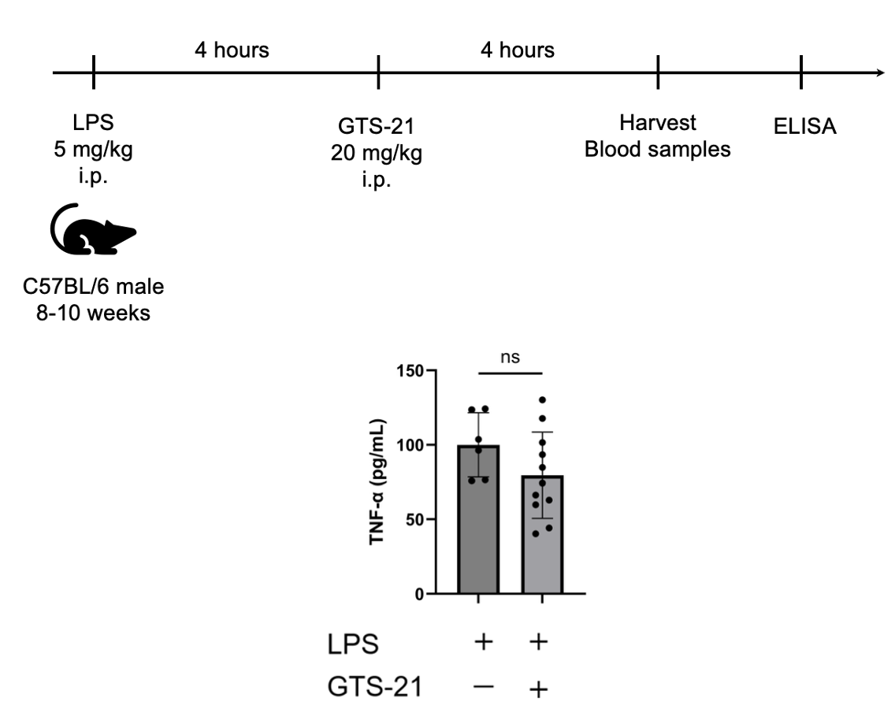

Post-LPS administration of a single dose of GTS-21 did not result in a significant reduction in TNF-α expression.
WT mice were intraperitoneally injected with 5 mg/kg LPS. Four hours later, they received GTS-21 (20 mg/kg) injection (n=6-11 in each group). Eight hours after LPS injection, the mice were euthanized and blood samples were collected. Plasma TNF-α concentrations were analyzed by ELISA. No appreciable change in TNF-α levels was observed in response to GTS-21. (LPS-vehicle and LPS-GTS-21; P=0.122). Data are shown as mean ± SD. Statistical significance was assessed Student’s T-test.

Supplemental Figure 2
Gating strategy for macrophages and CCL2-positive cells in the kidney.
A single-cell suspension was prepared from the whole kidney. Debris was removed using forward scatter (FSC) and side scatter (SSC). After gating on live CD45⁺ cells, macrophages were defined as F4/80 and CD11b double-positive cells. From this population, CCL2-positive cells were further extracted. The numbers in each panel represent the proportion of the gated population in that panel.

Supplemental Figure 3
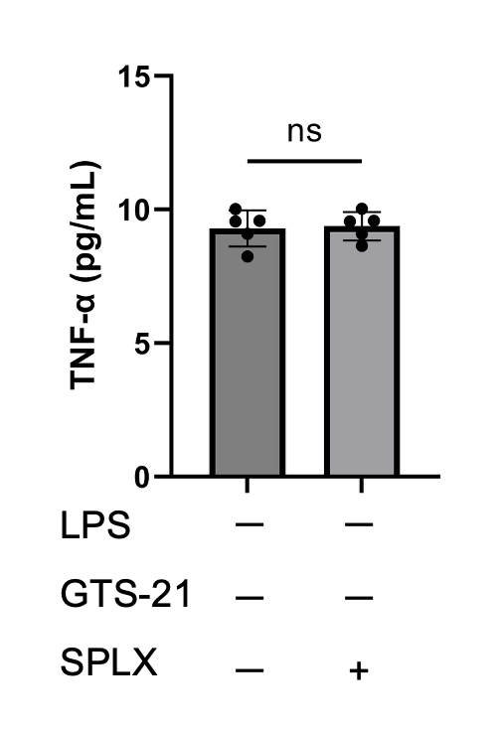

No Impact of Splenectomy on TNF-α Production．
Plasma TNF-α concentrations showed no significant difference with or without splenectomy (p=0.889).
Data are shown as mean ± SD. Statistical significance was assessed using two-tailed Student’s t-test.

Supplemental Figure 4
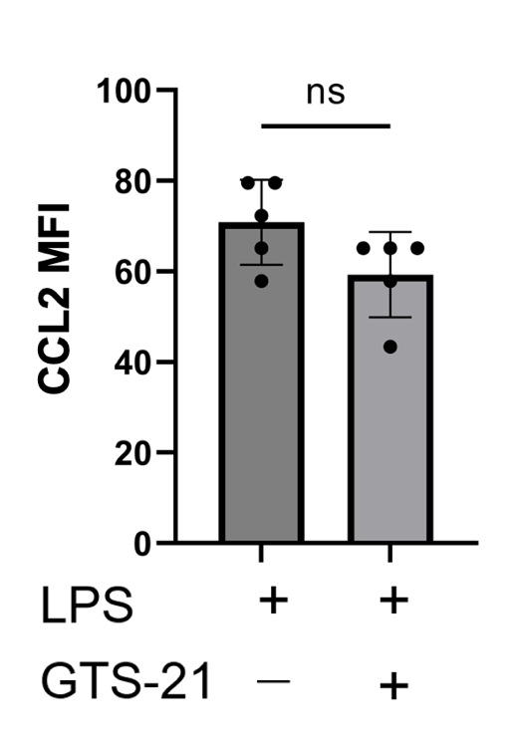

Assessment of Ccl2 expression in splenic macrophages
CCL2 expression in splenic macrophages was evaluated by flow cytometry. Although the median fluorescence intensity of CCL2 tended to decrease with GTS-21 administration following LPS treatment, this difference was not statistically significant (p = 0.0884). Data are shown as mean ± SD. Statistical significance was assessed using two-tailed Student’s t-test.

Supplemental Figure 5
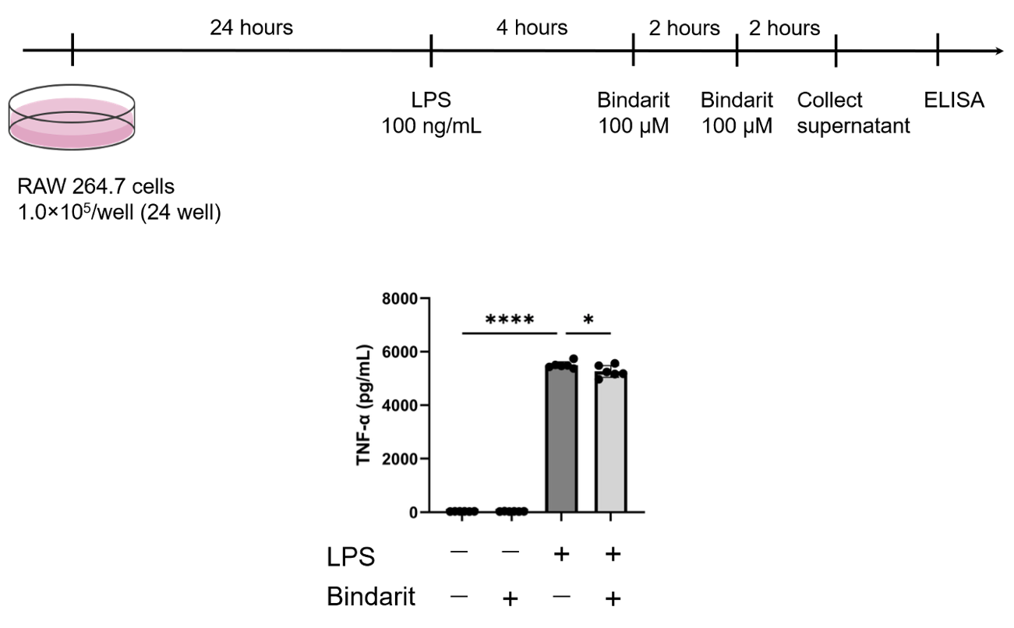
CCL2 inhibitor effectively reduced TNF-α levels following LPS stimulation.
1.0×10⁵ RAW 264.7 cells were seeded in 24-well plates for 24 hours. TNF-α was induced by LPS (100 ng/mL). Four and six hours later, CCL2 inhibitor, Bindarit (100 μM) was administered, and eight hours later, the supernatant was collected. TNF-α concentrations were analyzed by ELISA. The decrease in TNF-α was observed with Bindarit administration (vehicle-vehicle and LPS-vehicle; P<0.0001, LPS-vehicle and LPS-GTS-21; P=0.0462). Data are shown as mean ± SD. Statistical significance was assessed using two-way ANOVA analysis with Tukey’s multiple comparison. *P<0.05, ****P < 0.0001.

