Supplemental Data
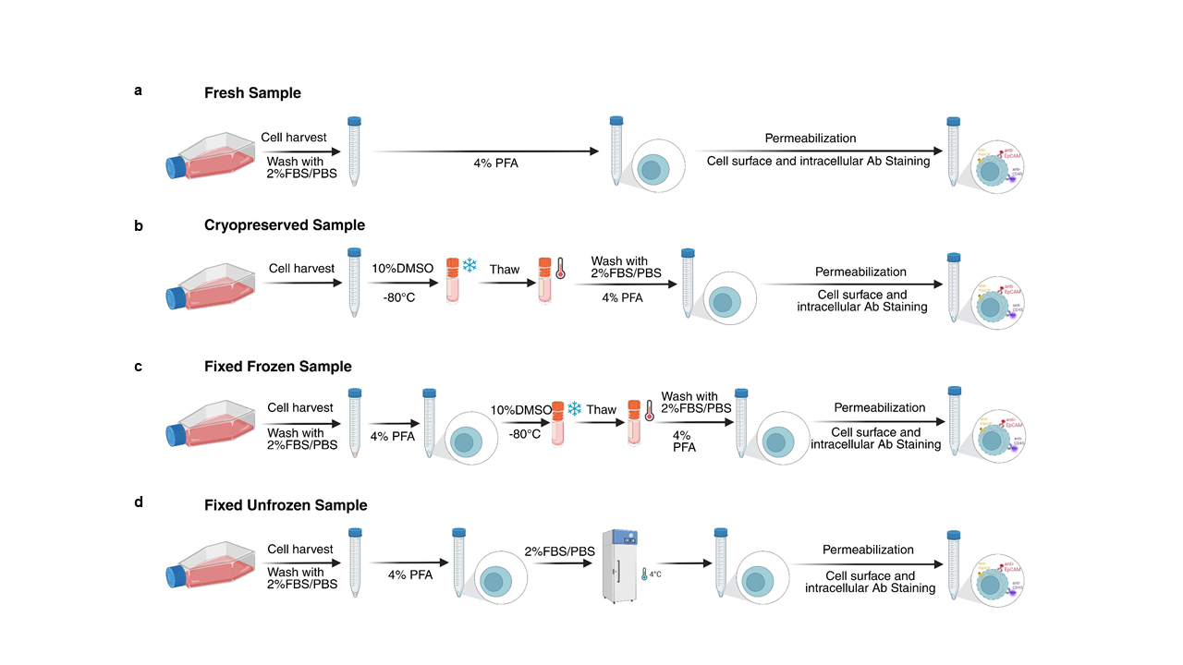Supplemental Figure 1. Workflow of four sample preparation methods. (a) Fresh sample: Cells are harvested, fixed, permeabilized, and simultaneously stained with cell surface and intracellular antibodies. (b) Cryopreserved sample: Cells are harvested, frozen, and stored at -80°C. On the day of analysis, cells are thawed, fixed, permeabilized, and simultaneously stained with cell surface and intracellular antibodies. (c) Fixed frozen sample: Cells are harvested, fixed, frozen, and stored at -80°C. After thawing, cells are permeabilized and simultaneously stained with cell surface and intracellular antibodies. (d) Fixed unfrozen sample: Cells are harvested, fixed, and stored at 4°C. On the day of analysis, cells are permeabilized and simultaneously stained with cell surface and intracellular antibodies.

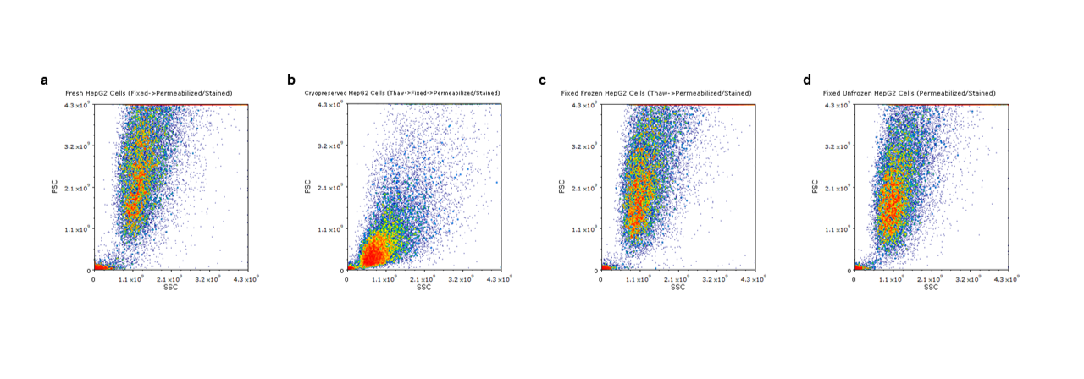
Supplemental Figure 2. Scatter pattern comparison across four sample preparation methods. (a) Fresh HepG2 cells. (b) Cryopreserved HepG2 cells. (c) Fixed frozen HepG2 cells. (d) Fixed unfrozen HepG2 cells.

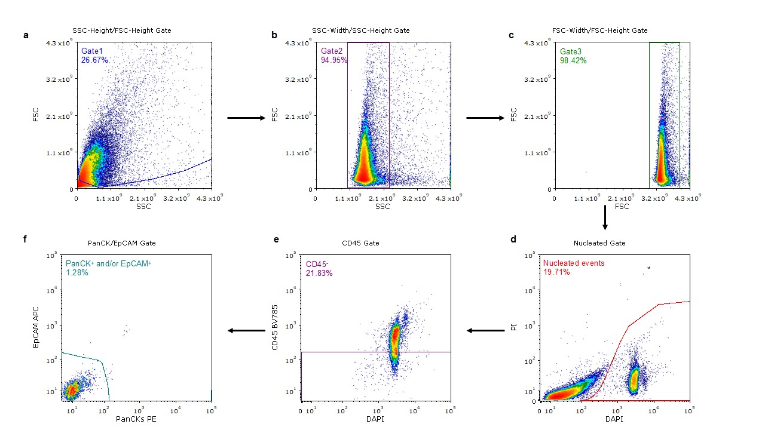
Supplemental Figure 3. Representative sorting strategy on fixed CTC samples from HCC patients. (a - c) Side scatter (SSC) and forward scatter (FSC) gating to identify single cells and exclude cell debris, doublets, or aggregates. (d) Nucleated cells are selected using DAPI gating from FSC/SCC-selected events. (e) CD45 negative nucleated cells are identified using CD45 gating (CD45 threshold established from PMBCs CD45 staining). (f) CTCs are defined as CD45 negative and either PanCK or EpCAM positive or both (CD45⁻/PanCK⁺ and/or EpCAM⁺). EpCAM and PanCK thresholds are determined by HepG2 cells PanCK and EpCAM staining.

Parameters | groups | Median | Min, Max | P value
PanCK⁺ (%) | Serial Staining | 95.48 | 79.98, 96.42 | 0.2000
PanCK⁺ (%) | Simultaneous Staining | 98.09 | 95.00, 99.04 | 0.2000
EpCAM⁺ (%) | Serial Staining | 99.62 | 99.44, 99.82 | 0.1143
EpCAM⁺ (%) | Simultaneous Staining | 99.83 | 99.81, 99.87 | 0.1143
CD45⁻ (%) | Serial Staining | 99.86 | 99.75, 99.96 | 0.0286
CD45⁻ (%) | Simultaneous Staining | 98.96 | 98.79, 99.12 | 0.0286
CD45⁻/PanCK⁺  and/or EpCAM⁺ (%) | Serial Staining | 98.93 | 98.50, 99.36 | >0.9999
CD45⁻/PanCK⁺  and/or EpCAM⁺ (%) | Simultaneous Staining | 98.58 | 98.57, 98.59 | >0.9999
PanCK⁺ MFI | Serial Staining | 532.10 | 313.10, 746.72 | 0.6857
PanCK⁺ MFI | Simultaneous Staining | 510.60 | 358.46, 785.74 | 0.6857
EpCAM⁺ MFI | Serial Staining | 6264.00 | 6154.51, 6431.01 | 0.0286
EpCAM⁺ MFI | Simultaneous Staining | 7234.00 | 7097.50, 7545.07 | 0.0286
PanCK⁺ SI | Serial Staining | 16.34 | 9.30, 28.21 | 0.8571
PanCK⁺ SI | Simultaneous Staining | 18.98 | 15.18, 27.50 | 0.8571
EpCAM⁺ SI | Serial Staining | 226.70 | 187.97, 256.77 | 0.2857
EpCAM⁺ SI | Simultaneous Staining | 262.90 | 219.63, 296.03 | 0.2857
Supplemental Table 1. Comparison of Staining Effect between Serial Staining and Simultaneous Staining using HelpG2 cells.

 | Sample Group – HepG2 Cells
Parameters | Fresh | Cryopreserved | Fixed Frozen | Fixed Unfrozen
PanCK⁺ (%)
Median (Min, Max) | 98.09 (95.00, 99.04) | 98.03 (96.78, 99.13) | 98.58 (97.04, 99.42) | 99.04 (98.68, 99.44)
P value | REF | 0.6857 | 0.4857 | 0.3429
EpCAM⁺ (%)
Median (Min, Max) | 99.83 (99.80, 99.87) | 99.91 (99.50, 99.84) | 99.91 (99.89, 99.94) | 99.94 (99.86, 99.97)
P value | REF | 0.0857 | 0.0286 | 0.0571
CD45⁻ (%)
Median (Min, Max) | 98.96 (98.79, 99.12) | 92.12 (88.86, 95.80) | 89.13 (86.27, 94.03) | 99.15 (98.42, 99.51)
P value | REF | 0.0286 | 0.0347 | 0.8857
CD45⁻/PanCK⁺
and/or EpCAM⁺ (%)
Median (Min, Max) | 98.58 (98.57, 98.59) | 86.34 (82.66, 90.02) | 87.10 (84.51, 89.69) | 98.27 (97.67, 98.87)
P value | REF | 0.3333 | 0.3333 | >0.9999
PanCK⁺ MFI
Median (Min, Max) | 510.60 (358.46, 785.74) | 1339.00 (1302.98, 1485.25) | 309.90 (265.54, 428.06) | 354.00 (327.77, 410.51)
P value | REF | 0.0286 | 0.1143 | 0.3429
EpCAM⁺ MFI
Median (Min, Max) | 7234.00 (7097.50, 7545.07) | 5136.00 (4435.18, 5803.73) | 5975.00 (5228.69, 6845.67) | 6009.00 (5319.91, 6914.53)
P value | REF | 0.0089 | 0.0938 | 0.1349
PanCK⁺ SI
Median (Min, Max) | 18.98 (15.18, 27.50) | 58.65 (55.09, 68.40) | 12.74 (10.34, 17.82) | 14.95 (9.79, 24.17)
P value | REF | 0.0286 | 0.1143 | 0.4571
EpCAM⁺ SI
Median (Min, Max) | 262.90 (219.63, 296.03) | 165.30 (157.54, 165.71) | 140.10 (78.27, 211.33) | 182.40 (109.48, 262.96)
P value | REF | 0.0286 | 0.0286 | 0.3143
Supplemental Table 2. Comparison of Staining Effect Across Four Sample Preparation Methods (fresh, cryopreserved, fixed frozen, and fixed unfrozen) using HepG2 cells.

 | Sample Group - PBMCs
Parameters | Fresh | Cryopreserved | Fixed Frozen | Fixed Unfrozen
CD45⁺ (%)
Median (Min, Max) | 99.68 (99.64, 99.71) | 99.6 (99.53, 99.66) | 99.34 (99.31, 99.36) | 99.33 (99.31, 99.35)
P value | REF | >0.9999 | 0.2427 | 0.1532
CD45⁺ MFI
Median (Min, Max) | 860.60 (810.59, 940.58) | 911.70 (858.39, 965.04) | 895.90 (875.39, 916.49) | 877.00 (847.19, 906.79)
P value | REF | >0.9999 | >0.9999 | >0.9999
CD45⁺ SI
Median (Min, Max) | 38.24 (36.48, 40.00) | 33.35 (31.83, 34.88) | 39.05 (38.15, 39.95) | 35.07 (34.26, 35.88)
P value | REF | 0.3972 | >0.9999 | 0.9183
Supplemental Table 3. Comparison of Staining Effect Across Four Sample Preparation Methods (fresh, cryopreserved, fixed frozen, and fixed unfrozen) using PBMCs.

 | Sample Group – HepG2 Cells
Parameters | Fresh | Fixed Unfrozen 1 wk | Fixed Unfrozen 2 wks | Fixed Unfrozen 3 wks | Fixed Unfrozen 4 wks
PanCK⁺ (%)
Median (Min, Max) | 99.60 (99.19, 99.90) | 99.71 (99.30, 99.88) | 99.72 (99.40, 99.86) | 99.71 (99.48, 99.87) | 99.74 (99.62, 99.86)
P value | REF | 0.7729 | 0.6962 | 0.7811 | 0.6177
EpCAM⁺ (%)
Median (Min, Max) | 99.97 (99.96, 100.00) | 99.97 (99.94, 99.98) | 99.97 (99.95, 100.00) | 99.95 (99.87, 99.99) | 99.95 (99.89, 99.98)
P value | REF | 0.6492 | 0.9046 | 0.4018 | 0.3381
CD45⁻ (%)
Median (Min, Max) | 99.04 (98.65, 99.63) | 98.57 (97.64, 99.11) | 98.93 (98.38, 99.30) | 98.91 (98.51, 99.67) | 99.00 (98.30, 99.53)
P value | REF | 0.3893 | 0.9907 | 0.9831 | 0.9998
CD45⁻/PanCK⁺
and/or EpCAM⁺ (%)
Median (Min, Max) | 97.39 (96.89, 97.89) | 97.94 (93.18, 97.17) | 97.83 (95.73, 98.55) | 97.30 (95.54, 98.77) | 97.93 (95.36, 98.53)
P value | REF | 0.8000 | >0.9999 | >0.9999 | 0.8000
PanCK⁺ MFI
Median (Min, Max) | 637.30 (347.39, 923.73) | 582.70 (389.36, 741.06) | 607.00 (418.73, 704.50) | 701.70 (418.09, 870.42) | 704.90 (638.54, 768.34)
P value | REF | >0.9999 | >0.9999 | >0.9999 | >0.9999
EpCAM⁺ MFI
Median (Min, Max) | 6123.00 (5333.35, 6864.82) | 5981.00 (5679.56, 6950.36) | 5910.00 (5679.56, 6950.36) | 5902.00 (5750.66, 6899.77) | 6822.00 (6262.44, 7274.46)
P value | REF | >0.9999 | 0.4762 | 0.4762 | 0.4762
Auto Fluorescence
Background of PanCK
Median (Min, Max) | 18.40 (17.98, 18.82) | 17.19 (13.11, 21.54) | 17.98 (17.98, 23.58) | 22.54 (19.68, 22.54) | 24.67 (21.54, 27.00)
P value | REF | >0.9999 | >0.9999 | 0.8637 | 0.1636
Auto Fluorescence
Background of EpCAM
Median (Min, Max) | 26.47 (20.59, 32.34) | 28.25 (25.81, 40.54) | 29.55 (27.00, 38.75) | 30.92 (25.81, 40.54) | 33.84 (27.00, 48.56)
P value | REF | >0.9999 | >0.9999 | >0.9999 | 0.7175
Auto Fluorescence
Background of CD45
Median (Min, Max) | 33.98 (30.92, 37.04) | 32.34 (25.81, 33.84) | 35.40 (29.55, 37.04) | 35.40 (32.34, 40.54) | 38.75 (32.34, 46.42)
P value | REF | 0.6071 | 0.7500 | 0.6071 | 0.3214
Supplemental Table 4. Comparison of Staining Effect and Auto Fluorescence Background Across Five Groups (fresh sample and fixed unfrozen sample 1 week, 2 weeks, 3 weeks and 4 weeks) using HepG2 cells.

 | Sample Group
Parameters | Fresh | Fixed Unfrozen | Fixed Frozen | Cryopreserved
50 HepG2 cells spiked Cell Retrieval Rate (%)
Median (Min, Max) | 36.00 (22.00, 46.00) | 26.50 (22.00, 32.00) | 31.00 (26.00, 38.00) | 26.00 (24.00, 32.00)
P value | REF | 0.4981 | >0.9999 | 0.2986
100 HepG2 cells spiked Cell Retrieval Rate (%)
Median (Min, Max) | 47.75 (38.00, 53.00) | 35.75 (27.00, 43.00) | 41.75 (36.00, 48.00) | 23.75 (19.00, 28.00)
P value | REF | >0.9999 | >0.9999 | 0.0349
500 HepG2 cells spiked Cell Retrieval Rate (%)
Median (Min, Max) | 48.70 (42.40, 53.40) | 41.65 (40.80, 43.60) | 41.70 (31.20, 47.80) | 22.87 (19.40, 29.40)
P value | REF | 0.4485 | >0.9999 | 0.011
1000 HepG2 cells spiked Cell Retrieval Rate (%)
Median (Min, Max) | 48.38 (40.80, 59.30) | 42.75 (38.10, 44.80) | 43.60 (38.90, 48.00) | 21.85 (20.00, 25.40)
P value | REF | 0.4145 | 0.5464 | <0.0001
Supplemental Table 5. Comparison of Cell Retrieval Rates (%) Across Four Sample Preparation Method.

Subject ID | Sample type | DNA concentration  TapeStation (ng/ul) | Total CTNNB1 concentration (copy/ul) | CTNNB1
 |  |  |  | Condon 32-37 mutation% | Condon T41A mutation % | Condon S45F mutation %
AK521 | Serum | 0.18 | 88.13 | BLOD | BLOD | BLOD
AK521 | CTC | 89.2 | 303.75 | 1.14%; 1.25% | BLOD | BLOD
AK526 | Serum | 1.19 | 458.75 | BLOD | BLOD | BLOD
AK526 | CTC | 67 | 425 | 0.48%; 1.12% | BLOD | BLOD
Supplemental Table 6. Plasma and CTC DNA concentration and gene mutation detection result. Two biomarker assays were performed, CTNNB1 32-37 droplet digital PCR (ddPCR), CTNNB1 T41A/S45F duplex ddPCR. All assays were performed with at least 1,500 DNA copy input, up to 5000 copies maximum for ddPCR assays. The mutation % shown above are the calculated by the total mutant copies over the total CTNNB1 copies. Samples with positive results were verified in a repeat run as shown above.
BLOD, below limit of detection.

