Supplementary materials
Modelling and Validation of Shock Absorption with Tunable Performance through Liquid Intrusion–Extrusion Cycles

Song Yang^{1#}, Weiwei Zhao^{1#,}*, Yelaman Maksum¹, Victor Stoudenets^{2,}*, Leonid Listovshchyk², Monzer Al Sakka^{3,}*, Yaroslav Grosu^{4,5}*, Yulong Ding¹*

¹ Birmingham Centre for Energy Storage (BCES) & School of Chemical Engineering, University of Birmingham, Birmingham B15 2TT, UK
² Laboratory of Thermomolecular Energetics, National Technical University of Ukraine “Igor Sikorsky Kyiv Polytechnic Institute”, Pr. Beresteiskyi 37, 03056 Kyiv, Ukraine
³ Research Department (Tenneco), Sint-Jorisstraat 4520, 3800 Sint-Truiden, Belgium
⁴ Centre for Cooperative Research on Alternative Energies (CIC energiGUNE), Basque Research and Technology Alliance (BRTA), Alava Technology Park, Albert Einstein 48, 01510 Vitoria-Gasteiz, Spain
⁵ Institute of Chemistry, University of Silesia, 40-006 Katowice, Poland
* Corresponding addresses (y.ding@bham.ac.uk; ygrosu@cicenergigune.com; w.zhao@bham.ac.uk; msakka@driv.com; v.stoudenets@kpi.ua)

# These two authors have equal contributions to this work.

Nomenclature
Symbols
A₀ | Piston displacement amplitude, cm | $$p_{i,e}$$ | Intrusion/extrusion pressure, Pa
D | Dispersion of the values for $p_{i,e}$, Pa | $$ρ_{app}$$ | Apparent density of HLS, g/cm³
f | Piston moving frequency, Hz | v | Overall volume of HLS, cm³/g-m_{s}
F | Hydraulic force, daN | v_{l} | Volume of liquid phase, cm³/g-m_{s}
F₀ | Critical force of intrusion, daN | v_{pore} | Volume of the pores, cm³/g-m_{s}
m_{l} | Mass of nonwetting liquid/water, g | v_{pore,int} | Intruded porous volume, cm³/g-m_{s}
m_{R} | Mass ratio of particles to HLS mixture: m_{s}/(m_{s}+m_{l}), - | v_{b} | Body volume of HLS mixture: v_{l}+v_{s}, cm³/g-m_{s}
m_{s} | Mass of solid particle, g | v_{s} | Volume of solid phase, cm³/g-m_{s}
$$u_{z}$$ | Velocity of piston head, m/s | Δp | Pressure difference, Pa
z | Displacement of piston head, cm | Δv | Volume difference, cm³/g-m_{s}
Abbreviations
CFD | Computational Fluidic Dynamics
HLS | Heterogeneous Lyophobic System
SA | Shock-Absorber

Moving mesh model
Under the action of an external impulse, a piston head within a VD will perform back-and-forth motion around its balance position. This motion is modelled using the arbitrary Lagrangian–Eulerian (ALE) deformed mesh in this study. Three configurations, the material domain Ω₀, spatial domain Ω, and reference domain (or called ALE domain) $\hat{Ω}$, are involved. The material motion can be written by $x^{m}=f\left(X,t\right)$, with denoting the material coordinates $X$ and a function $f\left(X,t\right)$ mapping the body from the material configuration Ω₀ to the spatial configuration Ω. Meanwhile, the ALE domain $\hat{Ω}$ is defined to describe the moving mesh. The position of material points is initialized to be identical to the reference coordinates, namely, $x^{g}=f\left(X,0\right)$, and the mesh motion can be expressed as $x^{m}=\hat{f}\left(x^{g},t\right)$. Hence, one-to-one mappings can be set up between Lagrangian, Euerian and ALE domains as shown in Figure S1.
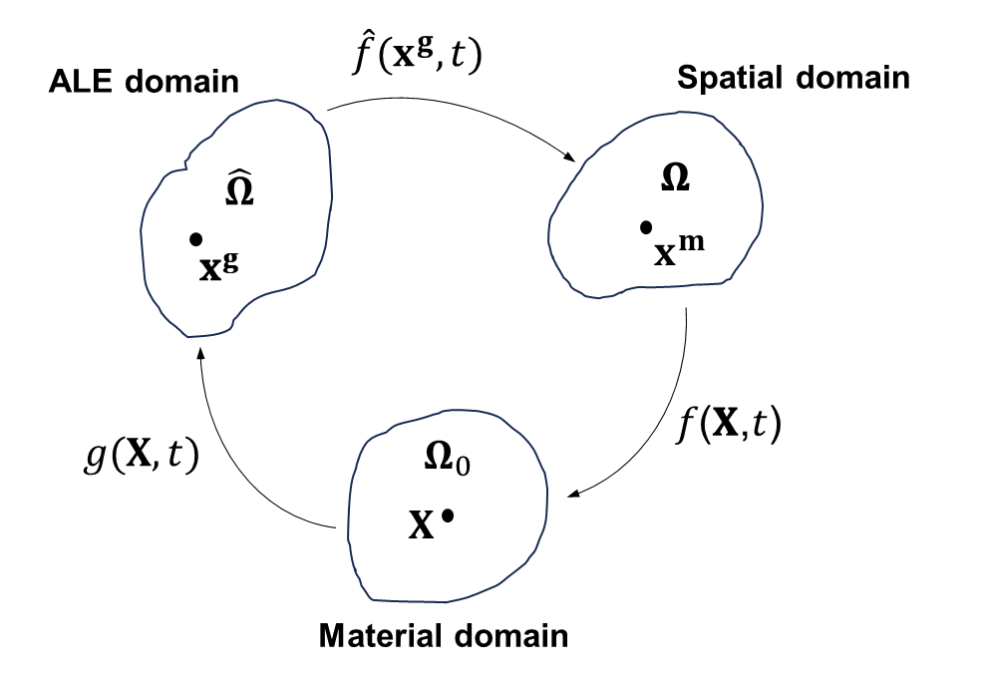
Figure S1. Domains and mapping between Lagrangian, Eulerian and ALE descriptions

The mass and Navier-Stokes equations for fluid flow are formulated and solved in the reference coordinate system where the domain boundaries are fixed. The displacement of mesh is predetermined based on the movement characteristics of a piston head within a VD. Assumed that the piston head follows harmonic motion given by:
$D\left(t\right)=A_{0}\cos\left(2πf∙t\right)$ (eq. S1)
where A₀ and f represent the amplitude and frequency, and t is time. The cosine function is utilised because the initial setting assumes the largest displacement with zero velocity in this simulation.
The mesh domain is separated into three zones, Zone A, Zone B, and Zone C as shown in Figure S2. Zone A refers to the regions within two mobile chambers positioned on either side of the piston head. Therefore, their motion should be synchronized following the same function of D_{A}(t)=D(t). Zone C refers to stationary regions that link valves on one side and the compensation tank on the other side. Zone B is a slender annular channel where the area is compressed and expended along the movement of the piston head. The points adjacent to the piston wall experience the maximum displacement. The displacement of local points gradually diminishes along both sides of the Z-axis, ultimately becoming stationary as they approach the furthest end. Therefore, the motion function for material points within Zone B can be expressed as:
$D_{B}\left(z,t\right)=\frac{\left({t_{p}}/2+l_{A}+l_{B}\right)-z}{l_{B}}×D_{A}\left(t\right)$ (eq. S2)
where l_{B} represents the length for Zone B, l_{A} and l_{C} are the lengths of segments within Zone A and Zone C that are linked to Zone B, t_{p} is the thickness of piston head.
Then, according to the functions of D_{A}(t), and D_{B}(z,t), the moving and deformed meshes in Zone A and Zone B are calculated for every time step. The number of meshes was set to 12,516 to balance accuracy and computational cost.
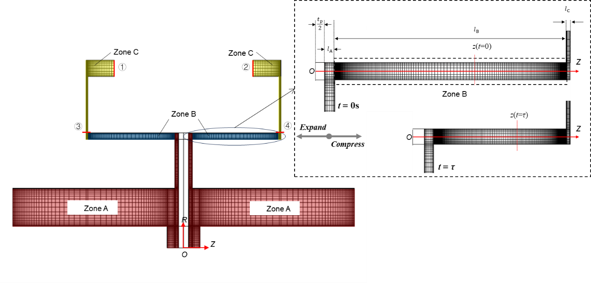
Figure S2. Mesh plot of CFD modelling domain divided into Zone A, moving non-deforming meshes (red region); Zone B, moving and deforming meshes (blue region); Zone C, fixed meshes (yellow region). Scale ratio between R and Z axis is 10: 1. In subfigure, the mech deformation is illustrated while being compressed from the balance position.

Boundary conditions
The 2-D axisymmetric model can be obtained by rotating the plot along Z-axis in Figure S2. The piston head movement can be descripted in eq. S1 as harmonic oscillations with specific amplitude and frequency to imitate the conditions for a vehicle traveling on road surfaces. The boundary conditions and , as shown Figure S2, are set as open boundaries with a zero normal stress f₀, which can be expressed as follows:
$f_{0}=-\left[μ\left(∇\text{u}+{\left(∇\text{u}\right)}^{T}\right)-p\text{I}-\frac{2}{3}μ\left(∇∙\text{u}\right)\text{I}\right]∙n=0$ (eq. S3)
In addition, as mentioned above, the details of the one-way valve and screw are not resolved but depicted using a “screen” modelled as a surface. Specific boundary conditions and are applied to mimic the operational behaviour of two valves. Mass flow is consistent across the screen surface. The influence on the flow field is a loss in the normal momentum component, which can be expressed as follows:
${\left\{ρ_{app}\text{u}∙n\right\}}_{+}={\left\{ρ_{app}\text{u}∙n\right\}}_{-}$ (eq. S4)
$${\left\{ρ_{app}{\left(\text{u}∙n\right)}^{2}+p-n^{T}\left[μ\left(∇\text{u}+{\left(∇\text{u}\right)}^{T}\right)-\frac{2}{3}μ\left(∇∙\text{u}\right)\text{I}\right]∙n\right\}}_{+}=$$
${\left\{ρ_{app}{\left(\text{u}∙n\right)}^{2}+p-n^{T}\left[μ\left(∇\text{u}+{\left(∇\text{u}\right)}^{T}\right)-\frac{2}{3}μ\left(∇∙\text{u}\right)\text{I}\right]∙n\right\}}_{-}+\frac{K}{2}{\left[ρ_{app}{\left(\text{u}∙n\right)}^{2}\right]}_{-}$ (eq. S5)
where subscript + and – refer to the upstream and downstream side of the screen surface. K is the dimensionless resistance coefficient, which parameterizes the magnitude of the drag exerted by the screen on the flow.
The boundary conditions and vary with the value of K. For the screen on the side where the piston is approaching to, K set to a sufficiently high value, to simulate the constrained flow through a one-way valve. On the opposite side where the piston is moving away, K is maintained at the high valve until the hydro-pressure difference across the screen diminishes to a minimal level, at which K is reduced to zero, allowing for unrestricted flow as the one-way valve opens. For example, the value of K for boundary conditions can be given in Table S1.

Table S1. Setting Values for Parameter K on screen boundary condition
Values of K | Conditions
>10⁷ | u_{z} < 0 m/s
>10⁷ | u_{z} > 0 m/s, Δp > 1 kPa
0 | u_{z} > 0 m/s, Δp < 1 kPa

Check Valve Operation
Figure S3 illustrates two status of the check valve during operation in detail. The number of components corresponds with those listed in Figure 1 of the manuscript. Component 9 is a C-type Bourdon tube/spring. When fluid flows from the inner tube to the outer tube, it acts as a barrier, preventing fluid entering through channels 8’. Conversely, when fluid flows from outer tube to the inner tubular space through channels 8’, the C-type Bourdon spring (component 9) compresses due to fluid pressure, allowing the fluid to enter the inner tubular space. This functionality is essential for the operation of check valves. Additionally, adjusting the knob nut (component 10) alters the stiffness of the C-type Bourdon spring, thereby setting an adjustable opening/closing pressure threshold for the check valve.
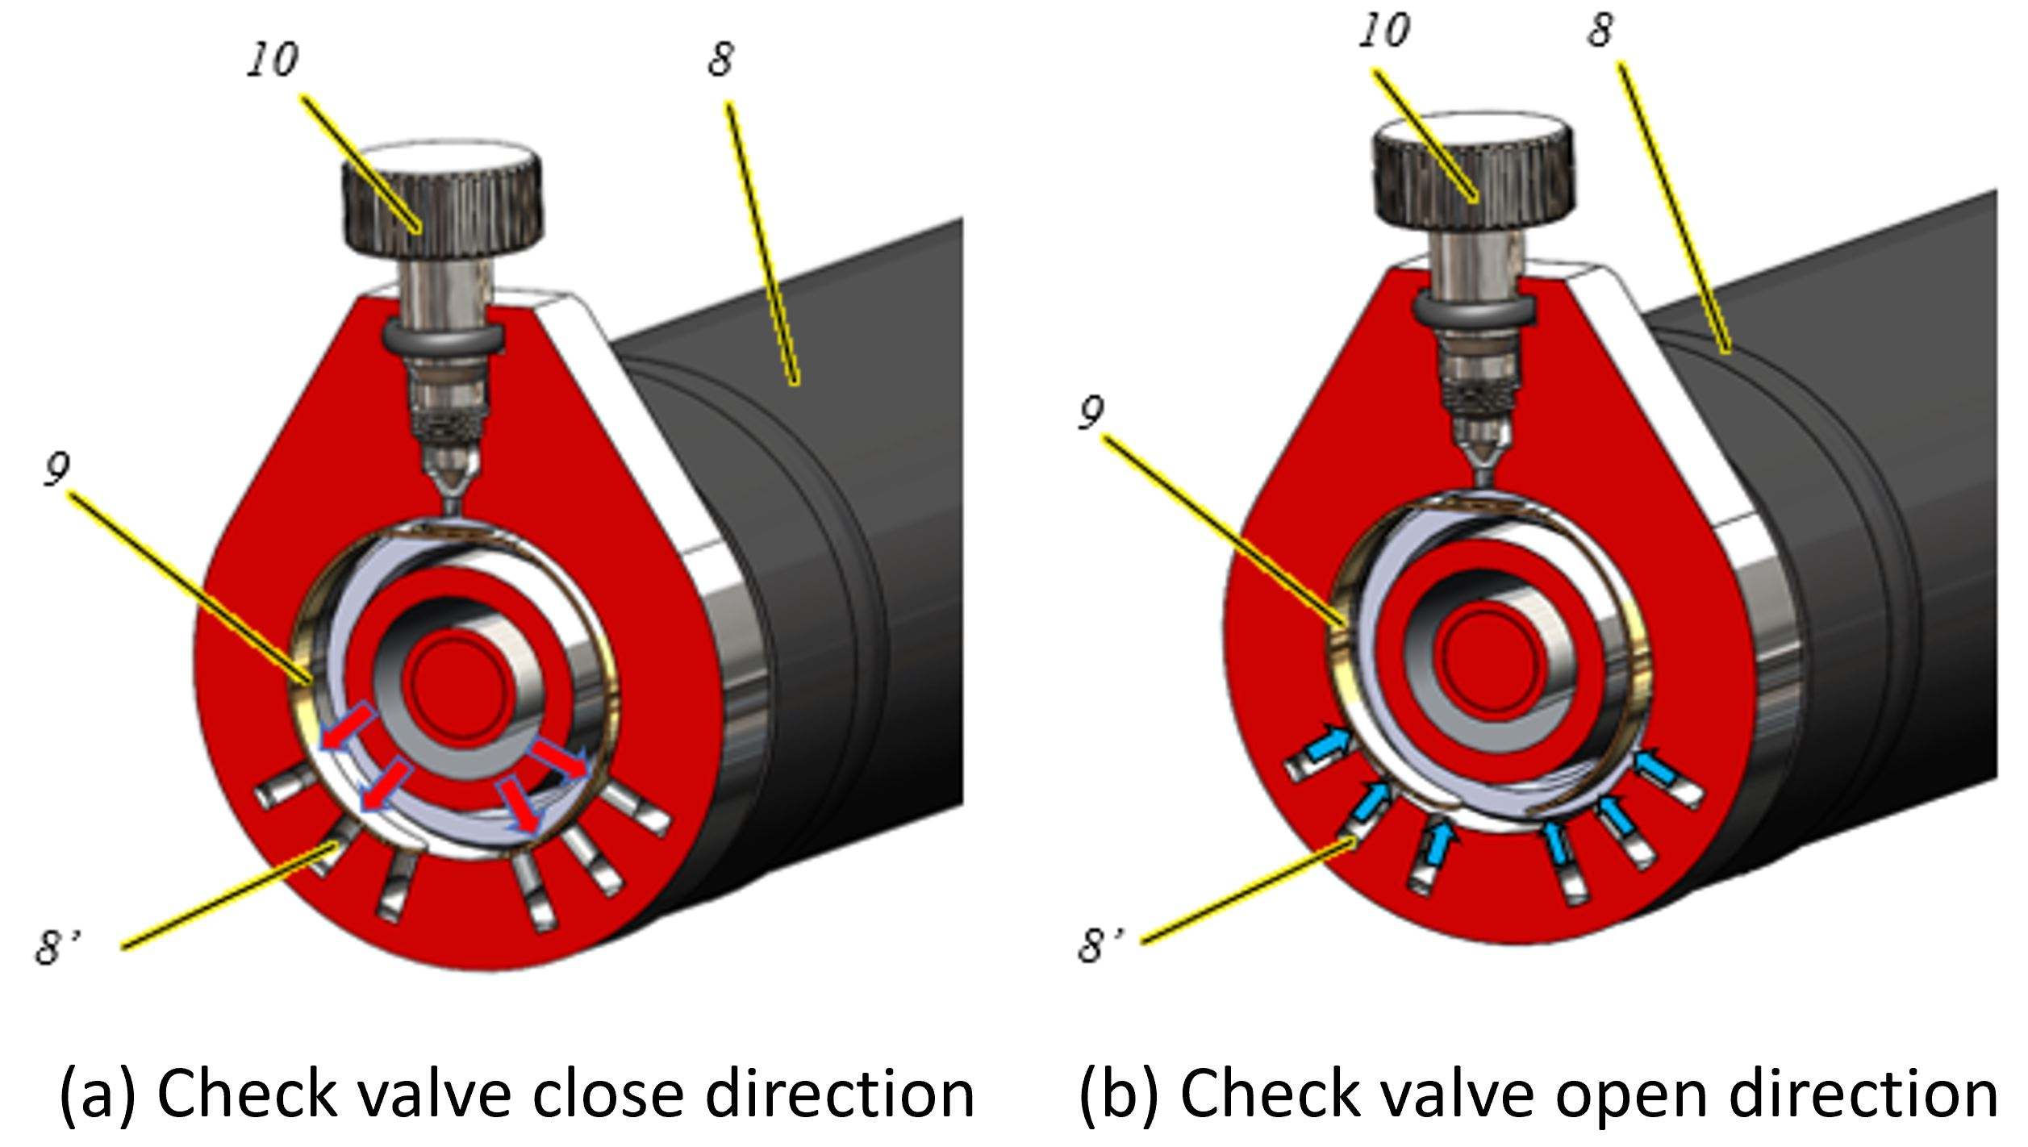
Figure S3. Enlarged picture demonstrating the operation status of the check valve.

Model Verification
To ensure the reliability of the key assumptions, namely, Newtonian fluid approximation and laminar flow behaviour, underlying the CFD model, relevant verification procedures were performed.
A simulation employing a non-Newtonian viscosity model was conducted and compare to the Newtonian reference case. The constitutive relation for generalized non-Newtonian fluids is described by the power-law model [1], commonly used for pseudoplastic industrial polymer fluids, in which viscosity is expressed as a power function of shear rate.
$μ=K{\dot{γ}}^{n-1}$ (eq. S6)
where, $\dot{γ}$ is the shear rate, K is the consistency coefficient set to 0.1 Pa·s^{n}, and n is the rheological index set to 0.42, to represent a concentrated silica gel slurry (~43 wt%) used in this model.
Figures S4 illustrates results of the pressures in upper and lower chambers, p_{Upper}, p_{Lower}, and the pressure difference, Δp, varying over time under a) the Newtonian assumption and b) the non-Newtonian model under, for a frequency of 1 Hz, and a stroke length 40 mm. As expected, discrepancies between the two cases are minimal, supporting the validity of the Newtonian assumption.
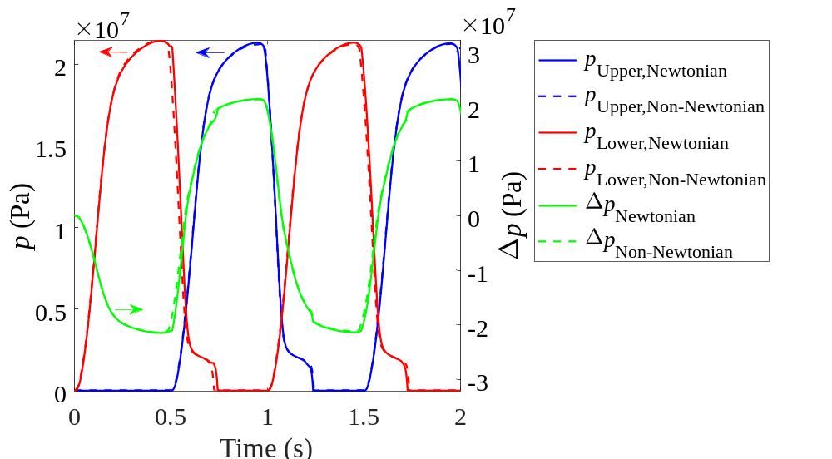
Figure S4. Results of the absolute pressures in the upper and lower chambers and the pressure difference varying over time under (a) the Newtonian assumption with solid line and (b) the non-Newtonian model with dashed line, for f = 1 Hz and X₀ = 40 mm.

The Reynolds number, calculated from Eq. (S7), was evaluated across the operating range. The transient maximum values, Re_{max}, obtained in the joint region between Zone A and Zone B, remains below 3,500 in all cases. The spatially averaged values, Re_{avg}, are low as listed in Table S2. The flow is laminar in Cases 1 – 4 and laminar-dominated in Case 5, justifying laminar treatment across the operating range.
$Re(X,t)=\frac{ρ_{app}(X,t)∙U(X,t)·l_{A}}{μ}$ (eq. S7)

Table S2. Maximum and time-averaged Reynolds numbers across the operating range
Case | f (Hz) | X₀ (mm) | Re_{avg} | Re_{max} | Flow regime
1 | 1.5 | 10 | 2 – 378 | 259 – 600 | Fully laminar
2 | 1 | 20 | 2 – 510 | 277 – 802 | Fully laminar
3 | 1 | 30 | 4 – 774 | 376 – 1198 | Fully laminar
4 | 1 | 40 | 5 – 1055 | 466 – 1622 | Fully laminar
5 | 3 | 30 | 34 – 2399 | 680 – 3485 | Laminar dominated

References
[1] W. Ostwald, Ueber die rechnerische Darstellung des Strukturgebietes der Viskosität, Kolloid-Zeitschrift, 47 (1929) 176-187.

