Supplementary materials
Heavy Metal Accumulation Risk and Source Analysis in Soils of Antimony Mining Areas
Jianyang He^{1,2}, Huimin Zhang¹, Ke Yang^{1,2,3}, Yingmei Li^{1,2}, Li Bao^{1,2}, Liu Gao^{1,2*}, Naiming Zhang^{1,2*}
1 College of Resources and Environment, Yunnan Agricultural University, Kunming, Yunnan 650201, China.
2 Yunnan Soil Fertility and Pollution Remediation Engineering Research Center, Kunming, Yunnan 650201, China.
3 College of Biology and Chemistry, Pu'er University, Pu'er, Yunnan 665000, China.
* Corresponding author:
Dr Liu Gao
E-mail: gaoliu@ynau.edu.cn
Prof. Naiming Zhang
E-mail: zhangnaiming@sina.com

Table S1 Corresponding reference dose (RfD) and slope factors (SF) values of heavy metals in soils in health risk assessment model with Mote Carlo simulator.
Elements | Reference Dose RfD (mg/kg/day) |  |  | Slope Factor SF (mg/kg/day)
Elements | Ingestion | Inhalation | Dermal | Ingestion | Inhalation | Dermal
As | 3.00E-04^{b} | 1.23E-04e | 1.23E-04e | 1.5E+00^{b} | 1.51E+01^{d} | 3.66E+00^{d}
Cd | 1.00E-03ª | 1.00E-05ª | 1.00E-05ª | 6.1E+00^{b} | 6.30E+00ª | n/a
Cr | 3.00E-03ª | 2.86E-05ª | 6.00E-05ª | 8.50E-03^{b} | 4.20E+01ª | n/a
Cu | 4.00E-02ª | 4.02E-02ª | 1.20E-02ª | n/a | n/a | n/a
Pb | 3.50E-03ª | 3.52E-03ª | 5.25E-04ª | 8.50E-03^{c} | n/a | n/a
Sb | 4.00E-04^{g} | n/a | 6.00E-05^{g} | n/a | n/a | n/a
Zn | 3.00E-01ª | 3.00E-01ª | 6.00E-02ª | n/a | n/a | n/a
Abbreviations: N/A-data not available; ª Gu et al. (2017), ^{b} Yang et al. (2019), ^{c} RAIS, (2018), ^{d}Ferreira-Baptista and De Miguel (2005), ^{e} Han et al. (2020), ^{f} Chen et al. (2019), ^{g} (USDE 2021)

Table S2 Input parameters and values in health risk assessment for soil with Mote Carlo simulator.
Description | Parameter | Unit |  | Type | Children |  |  |  |  |  | Adult |  | Reference
Exposure frequency | EF | day/year |  | Triangular (TRI) | 180, 345, 365 |  |  |  |  |  |  |  |  | (Chen et al. 2019)
Soil ingestion rate | R_{ingest} | mg/day |  | Triangular (TRI) | 66, 103, 161 |  |  |  |  | 4, 30, 52 |  |  |  | (Yang et al. 2019)
Skin adherence factor | AF | mg/cm² |  | Lognormal (LN) | LN (0.65, 1.2) |  |  |  |  | LN (0.49, 0.54) |  |  |  | (Chen et al. 2019)
Inhalation rate | R_{inhal} | m³/day |  | Lognormal (LN) | LN (7.19, 1.62) |  |  |  |  |  |  | LN (16.57,4.05) |  | (Chen et al. 2016)
Exposure duration | ED | Year |  | Point | 6 |  | 24 |  |  |  |  |  |  | (MEP 2014)
Average time | AT | day |  | Point | 365×ED (non-carcinogenic); 365×70 (carcinogenic) |  |  |  |  |  |  |  |  | (MEP 2013a)
Particle emission factor | PEF | m³/kg |  | Point | 1.36×10⁹ |  |  |  |  |  |  |  |  |  | USEPA (2011)
Average body weight | BW | kg |  | Lognormal (LN) | LN(37.0, 2.98) |  |  |  | UN(55.7, 68.6) |  |  |  |  | (MEP 2013b)
Exposed skin area | SA | m² |  | Point | 0.23 |  |  | 0.54 |  |  |  |  |  |  | (Li et al. 2022)
Dermal adsorption factor | ABF | - | Point |  |  | 0.001 (non-carcinogenic); 0.01 (carcinogenic) |  |  |  |  |  |  |  |  | (USEPA 2011)
Reference
Chen, H., Teng, Y., Lu, S., Wang, Y., Wu, J., & Wang, J. (2016). Source apportionment and health risk assessment of trace metals in surface soils of Beijing metropolitan, China. Chemosphere, 144, 1002-1011.
Chen, R., Chen, H., Song, L., Yao, Z., Meng, F., Teng, Y., 2019. Characterization and source apportionment of heavy metals in the sediments of Lake Tai (China) and its surrounding soils. Sci. Total Environ. 694, 133819.
Ferreira-Baptista, L. and De Miguel, E. (2005) Geochemistry and risk assessment of street dust in Luanda, Angola: A tropical urban environment. Atmospheric Environment 39(25), 4501-4512.
Gu, Y.G., Lin, Q. and Gao, Y.P. 2017. Metals in exposed-lawn soils from 18 urban parks and its human health implications in southern China's largest city, Guangzhou. Journal of Cleaner Production.163, 164-171.
Han, Q., Wang, M., Cao, J., Gui, C., Liu, Y., He, X., He, Y. and Liu, Y. .2020. Health risk assessment and bioaccessibilities of heavy metals for children in soil and dust from urban parks and schools of Jiaozuo, China. Ecotoxicology and Environmental Safety.191, 110157.
Li, H., Yao, J., Min, N., & Duran, R. (2022). Comprehensive assessment of environmental and health risks of metal (loid) s pollution from non-ferrous metal mining and smelting activities. Journal of Cleaner Production, 375, 134049.
MEP (2013a) Exposure Factors Handbook of Chinese Population ( Adults), Ministry of Environmental Protection ( in Chinese), Beijing.
MEP (2013b) Exposure Factors Handbook of Chinese Population. Ministry of environmental protection of the People's republic of China (in Chinese).
MEP (2014) Technical Guidelines for Risk Assessment of Contaminated Sites, Ministry of Environmental Protection of China (in Chinese).
RAIS, 2018. The Risk Assessment Information System. Toxicity Profiles, Condensed Toxicity Summary for Mercury.
USDE (2021) US Department of Energy. RAIS: The risk assessment information system. Available from: http://rais.ornl.gov Last accessible 30 Sept. 2021.
USEPA (2011) Exposure Factors Handbook: 2011 Edition.
Yang, S., Zhao, J., Chang, S.X., Collins, C., Xu, J., Liu, X., 2019. Status assessment and probabilistic health risk modeling of metals accumulation in agriculture soils across China: A synthesis. Environ. Int. 128, 165-174.

Table S3 Heavy Metal Concentrations at Sampling Sites (mg·kg⁻¹)
Sample Id | Sb  (mg·kg⁻¹) | As  (mg·kg⁻¹) | Cd  (mg·kg⁻¹) | Cr  (mg·kg⁻¹) | Pb  (mg·kg⁻¹) | Zn  (mg·kg⁻¹) | Cu  (mg·kg⁻¹)
KQ-1 | 74.81 | 14.80 | 0.04 | 32.06 | 6.19 | 106.67 | 23.05
KQ-2 | 31.94 | 14.78 | 0.07 | 41.49 | 8.34 | 125.38 | 20.82
KQ-3 | 403.58 | 45.03 | 0.09 | 161.59 | 14.88 | 28.88 | 13.28
KQ-4 | 168.33 | 23.05 | 0.23 | 46.50 | 29.54 | 63.19 | 27.70
KQ-5 | 736.52 | 67.68 | 0.13 | 72.09 | 18.94 | 91.34 | 34.72
KQ-6 | 389.23 | 25.22 | 0.15 | 123.41 | 20.89 | 23.08 | 26.49
KQ-7 | 123.61 | 11.59 | 0.20 | 79.83 | 11.81 | 36.97 | 33.25
KQ-8 | 428.17 | 72.31 | 2.25 | 122.98 | 23.33 | 226.10 | 75.34
KQ-9 | 41.60 | 47.99 | 3.40 | 152.02 | 21.86 | 193.51 | 60.28
KQ-10 | 16.01 | 43.37 | 0.70 | 87.06 | 5.83 | 248.13 | 74.99
KQ-11 | 10.25 | 20.42 | 0.72 | 101.25 | 11.01 | 150.77 | 50.69
KQ-12 | 24.93 | 41.23 | 2.43 | 74.85 | 14.11 | 144.14 | 54.87
KQ-13 | 17.40 | 69.01 | 2.15 | 130.09 | 24.52 | 134.27 | 41.82
KQ-14 | 5.36 | 24.52 | 0.69 | 72.17 | 11.51 | 127.98 | 36.98
KQ-15 | 18.36 | 40.47 | 0.90 | 52.26 | 14.20 | 67.71 | 25.05
KQ-16 | 8.47 | 28.92 | 2.44 | 87.98 | 12.67 | 172.51 | 60.45
KQ-17 | 12.50 | 22.62 | 0.16 | 75.33 | 9.31 | 40.46 | 19.55
KQ-18 | 48.61 | 31.17 | 3.70 | 76.49 | 15.59 | 118.57 | 39.17
KQ-19 | 134.90 | 42.06 | 2.74 | 169.49 | 20.96 | 186.80 | 52.94
KQ-20 | 634.10 | 22.88 | 0.35 | 86.58 | 10.96 | 126.10 | 43.61
KQ-21 | 29.78 | 56.11 | 1.10 | 64.67 | 15.69 | 221.87 | 80.65
KQ-22 | 799.57 | 59.09 | 0.28 | 82.97 | 11.75 | 115.41 | 38.94
KQ-23 | 319.87 | 65.43 | 0.83 | 49.08 | 9.51 | 113.15 | 96.07
KQ-24 | 19.23 | 57.78 | 1.65 | 51.94 | 9.34 | 216.73 | 97.84
KQ-25 | 44.14 | 107.34 | 0.75 | 161.37 | 24.53 | 98.74 | 36.39
KQ-26 | 1958.84 | 122.00 | 0.90 | 212.73 | 31.19 | 112.40 | 47.48
KQ-27 | 1269.23 | 62.87 | 0.55 | 77.93 | 20.44 | 103.82 | 45.00
KQ-28 | 10.36 | 95.84 | 1.78 | 102.13 | 16.38 | 183.46 | 92.19
KQ-29 | 6.73 | 34.61 | 0.50 | 45.24 | 5.89 | 154.10 | 70.85
KQ-30 | 7.75 | 68.82 | 0.43 | 72.81 | 26.16 | 22.12 | 13.09
KQ-31 | 23.77 | 61.29 | 0.23 | 16.49 | 11.42 | 37.17 | 8.25
KQ-32 | 6.45 | 84.81 | 0.33 | 6.26 | 14.76 | 17.88 | 4.84
KQ-33 | 3.99 | 44.68 | 0.48 | 3.53 | 22.38 | 71.38 | 12.67
KQ-34 | 59.35 | 52.23 | 0.77 | 12.63 | 34.80 | 35.77 | 17.52
KQ-35 | 21.53 | 65.56 | 0.39 | 17.58 | 34.56 | 53.84 | 15.36
KQ-36 | 16.96 | 52.08 | 0.36 | 91.38 | 12.61 | 75.92 | 38.11
KQ-37 | 13.34 | 55.18 | 0.52 | 82.85 | 12.57 | 88.36 | 46.36
KQ-38 | 14.21 | 56.97 | 1.25 | 91.03 | 10.78 | 171.49 | 65.38
KQ-39 | 16.91 | 54.10 | 1.00 | 47.38 | 8.96 | 185.82 | 62.44
KQ-40 | 73.87 | 51.57 | 0.86 | 89.86 | 13.06 | 133.49 | 58.80
KQ-41 | 25.28 | 18.96 | 0.92 | 27.46 | 8.95 | 132.70 | 64.04
KQ-42 | 5.50 | 22.87 | 0.53 | 32.85 | 8.03 | 80.50 | 47.51
KQ-43 | 4.29 | 29.49 | 0.48 | 39.61 | 6.98 | 126.47 | 73.30
KQ-44 | 8.57 | 31.57 | 0.39 | 44.30 | 5.54 | 139.83 | 43.85
KQ-45 | 26.18 | 25.30 | 0.64 | 56.43 | 7.78 | 152.81 | 45.64
KQ-46 | 702.44 | 131.61 | 1.26 | 73.29 | 19.51 | 109.85 | 36.44
KQ-47 | 29.11 | 52.58 | 0.50 | 80.84 | 12.93 | 82.32 | 37.46
Table S3 (continued)
Sample Id | Sb  (mg·kg⁻¹) | As  (mg·kg⁻¹) | Cd  (mg·kg⁻¹) | Cr  (mg·kg⁻¹) | Pb  (mg·kg⁻¹) | Zn  (mg·kg⁻¹) | Cu  (mg·kg⁻¹)
KQ-48 | 7.11 | 17.24 | 0.29 | 47.82 | 8.34 | 83.90 | 34.99
KQ-49 | 12.64 | 12.87 | 0.27 | 46.36 | 7.18 | 73.80 | 28.20
KQ-50 | 2.00 | 17.81 | 0.13 | 36.11 | 4.24 | 239.07 | 106.80
KQ-51 | 7.02 | 22.96 | 0.59 | 110.81 | 6.33 | 145.71 | 55.08
KQ-52 | 21.26 | 46.46 | 1.51 | 99.02 | 25.17 | 110.91 | 46.22
KQ-53 | 181.04 | 36.77 | 0.41 | 34.97 | 11.16 | 56.73 | 21.03
KQ-54 | 11.20 | 50.24 | 0.68 | 195.08 | 25.30 | 11.97 | 13.71
KQ-55 | 4.96 | 24.15 | 0.13 | 34.09 | 4.54 | 14.02 | 15.08
KQ-56 | 73.61 | 33.06 | 0.29 | 21.16 | 6.90 | 19.18 | 21.43
KQ-57 | 22.74 | 82.38 | 0.48 | 89.10 | 17.51 | 13.40 | 23.95
KQ-58 | 9.15 | 134.32 | 0.51 | 186.79 | 19.84 | 84.83 | 24.30
KQ-59 | 9.38 | 21.30 | 0.22 | 61.05 | 8.45 | 27.84 | 15.42
KQ-60 | 16.58 | 84.15 | 0.56 | 144.19 | 19.62 | 50.64 | 29.54
KQ-61 | 32.16 | 0.76 | 0.04 | 12.79 | 7.98 | 38.39 | 40.28
KQ-62 | 12.04 | 5.50 | 0.09 | 58.56 | 20.91 | 86.89 | 31.19
KQ-63 | 19.80 | 0.97 | 0.42 | 35.13 | 20.75 | 115.87 | 49.68
KQ-64 | 21.09 | 28.99 | 1.50 | 37.38 | 25.77 | 221.04 | 51.91
KQ-65 | 6.08 | 3.59 | 0.33 | 10.63 | 5.76 | 93.13 | 59.66
KQ-66 | 26.29 | 22.84 | 1.17 | 59.09 | 25.66 | 104.05 | 50.94
KQ-67 | 42.64 | 12.97 | 1.68 | 42.46 | 27.94 | 99.21 | 58.76
KQ-68 | 110.32 | 16.01 | 1.11 | 51.16 | 25.19 | 135.40 | 43.33
KQ-69 | 11.56 | 5.46 | 0.33 | 20.05 | 8.87 | 49.90 | 25.06
KQ-70 | 4.43 | 5.53 | 0.20 | 31.56 | 16.62 | 55.65 | 28.17
KQ-71 | 4.72 | 7.42 | 0.12 | 18.99 | 6.85 | 54.11 | 26.79
KQ-72 | 6.11 | 3.63 | 0.12 | 22.14 | 7.96 | 65.67 | 31.93
KQ-73 | 11.18 | 4.60 | 0.19 | 25.58 | 9.18 | 38.37 | 24.00
KQ-74 | 5.17 | 2.55 | 0.07 | 17.32 | 5.53 | 46.01 | 19.88
KQ-75 | 6.45 | 7.18 | 0.17 | 46.65 | 14.61 | 39.52 | 17.11
KQ-76 | 1.79 | 8.46 | 0.09 | 57.48 | 13.70 | 77.05 | 45.78
KQ-77 | 2.38 | 15.84 | 0.12 | 73.67 | 15.89 | 34.35 | 21.86
ZK | 0.51 | 7.54 | 0.78 | 58.62 | 27.13 | 60.33 | 18.00
KQ-1 to KQ-77 represent sampling sites 1–77 in the mining area, and ZK denotes the standard reference material (GBW07451, GSS-22).
Table S4 Quantitative Index Data
Index | HMs | Mean | Min | Max | SD
I_{geo} | Sb | 5.39 | 11.78 | 0.95 | 2.33
I_{geo} | As | 8.28 | 11.16 | 2.55 | 1.68
I_{geo} | Cd | -3.94 | -0.46 | -7.98 | 1.56
I_{geo} | Cr | 11.08 | 13.66 | 6.53 | 1.27
I_{geo} | Pb | 8.39 | 10.24 | 1.12 | 0.98
I_{geo} | Zn | 12.23 | 14.17 | 9.33 | 1.09
I_{geo} | Cu | 10.08 | 11.69 | 7.06 | 0.88
I_{NI} | - | 9.68 | 13.23 | 2.81 | 3.40
RI | - | 490.48 | 6416.53 | 15.97 | 904.74
EF | Sb | 68.39 | 910.98 | 0.32 | 162.64
EF | As | 3.81 | 50.59 | 0.03 | 6.17
EF | Cd | 4.07 | 23.93 | 0.16 | 3.79
EF | Cr | 1.53 | 15.56 | 0.11 | 1.88
EF | Pb | 0.63 | 4.03 | 0.04 | 0.66
EF | Zn | 1.29 | 4.38 | 0.24 | 0.55
EF | Cu | 3.33 | 22.72 | 0.25 | 3.23
Geo-accumulation index (I_{geo}), Improved Nemerow Integrated Pollution Index (I_{NI}), risk index (RI), Enrichment factors (EF)

Table S5 Comparison of HMs mean concentrations (mgg·kg⁻¹) discovered in this study with those found in other HMs soil studies.
area | Sb (mg·kg⁻¹) | As (mg·kg⁻¹) | Cd (mg·kg⁻¹) | Cr (mg·kg⁻¹) | Pb (mg·kg⁻¹) | Zn (mg·kg⁻¹) | Cu (mg·kg⁻¹) | Reference
Southwest China (Sb mines) | 125.61 | 40.13 | 0.75 | 68.86 | 14.88 | 101.35 | 41.47 | This study
Southwest China (Ba mines) | 2.75 | 29.19 | 4.17 | 64.1 | 30.6 | 242 | 56.8 | (Liu et al. 2022)
Agricultural Soils in Wenzhou | - | - | 0.63 | 73.5 | 106 | 189 | 44 | (Xia et al. 2024)
agricultural soil in Dhaka | - | 20.3 | 14.33 | 1457 | 65.98 | 53.51 | 57.19 | (Bhuiyan et al., 2021)
Construction area | 401.21 | 225.7 | 1.87 | 42.78 | 30.43 | - | - | (Zou et al., 2023)
Arable land area | 365.96 | 225.7 | 1.68 | 41.46 | 28.95 | - | - | (Zou et al., 2023)
Woodland | 119.71 | 86.63 | 1.77 | 41.98 | 304 | - | - | (Zou et al., 2023)
Xikuangshan | 1409.34 | 139.17 | 2.68 | 104.85 | 244.66 | 344.57 | 38.45 | (Wang et al. 2025)
Zhazixi | 1217.05 | 62.78 | 0.02 | 82.15 | 135.88 | 162.89 | 29.02 | Wang et al. 2025)
Banxi | 477.35 | 191.59 | 0.21 | 64.75 | 285.98 | 211.16 | 44.95 | Wang et al. 2025)
northwest of Iran | - | 7.04 | 0.26 | 11.2 | 14.4 | 68.66 | 35 | (Mohammadi et al., 2022
Abandoned As Mining Area | - | 119.51 | 19.21 | 399.27 | 814.78 | 1462.97 | 981.44 | (Huang et al.2025)
northwest Riyadh, Saudi Arabia | 1.08 | 3.78 | 0.25 | 19.97 | 5.08 | 52.16 | 11.36 | (Alarifi et al., 2022)
antimony mines | 3.07 | 85.11 | - | - | 411.02 | - | - | (Čakmak et al., 2025)
Liu, L., Xu, X., Han, J., Zhu, J. M., Li, S., Liang, L., ... & Qiu, G. (2022). Heavy metal (loid) s in agricultural soils in the world’s largest barium-mining area: Pollution characteristics, source apportionment, and health risks using PMF model and Cd isotopes. Process Safety and Environmental Protection, 166, 669-681.
Xia, F., Zhao, Z., Niu, X., & Wang, Z. (2024). Integrated pollution analysis, pollution area identification and source apportionment of heavy metal contamination in agricultural soil. Journal of Hazardous Materials, 465, 133215.
Bhuiyan, M. A. H., Karmaker, S. C., Bodrud-Doza, M., Rakib, M. A., & Saha, B. B. (2021). Enrichment, sources and ecological risk mapping of heavy metals in agricultural soils of dhaka district employing SOM, PMF and GIS methods. Chemosphere, 263, 128339.
Zou, H., & Ren, B. (2023). Analyzing topsoil heavy metal pollution sources and ecological risks around antimony mine waste sites by a joint methodology. Ecological Indicators, 154, 110761.
Wang, X., Deng, R., Wang, C., Xu, R., Hou, B., Zhou, S., ... & Hursthouse, A. (2025). Pollution characteristics, risk assessment and source comparative analysis of potentially toxic elements in soils of three superlarge antimony ore areas in the Zijiang River, Hunan, China. Environmental Pollution, 126701.
Mohammadi, A., Mansour, S. N., Najafi, M. L., Toolabi, A., Abdolahnejad, A., Faraji, M., & Miri, M. (2022). Probabilistic risk assessment of soil contamination related to agricultural and industrial activities. Environmental research, 203, 111837.
Huang, W., Liu, Y., Bi, X., Wang, Y., Li, H., Qin, J., ... & Qiu, R. (2025). Source-specific soil heavy metal risk assessment in arsenic waste mine site of Yunnan: Integrating environmental and biological factors. Journal of Hazardous Materials, 486, 136902.
Alarifi, S. S., El-Sorogy, A. S., Al-Kahtany, K., & Alotaibi, M. (2022). Contamination and environmental risk assessment of potentially toxic elements in soils of palm farms in Northwest Riyadh, Saudi Arabia. Sustainability, 14(22), 15402.
Čakmak, D., Perović, V., Pavlović, D., Matić, M., Jakšić, D., Tanirbergenov, S., & Pavlović, P. (2025). Development of optimisation methods to identify sources of pollution and assess potential health risks in the vicinity of antimony mines. Environmental Geochemistry and Health, 47(3), 73.

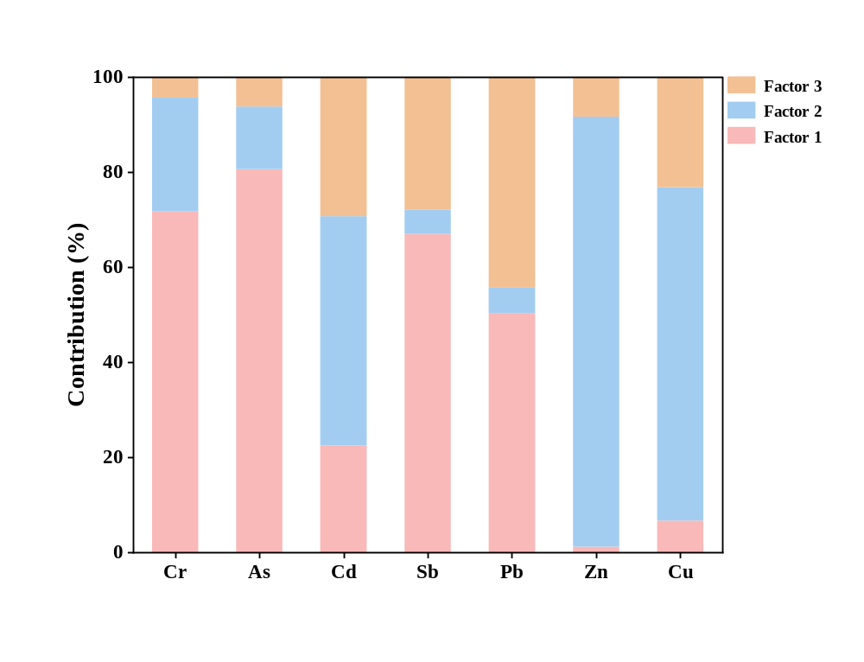
Figure S1. Contribution rates of pollution sources from the APCS-MLR model.
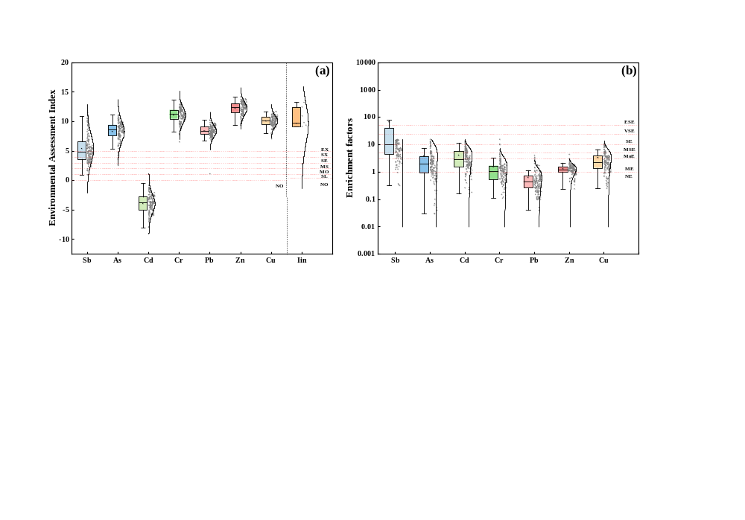
Figure S2. (a) Boxplots of the geo-accumulation index (Igeo) and the improved Nemerow pollution index (INI) for soil samples; (b) Enrichment factors (EF) of individual elements. Footnote: For Igeo and INI: NO, No Pollution; SL, Slight Pollution; MO, Moderate Pollution; MS, Moderate to Severe Pollution; SE, Severe Pollution; SX, Severe to Extreme Pollution; EX, Extreme Pollution. For EF: NE, No Enrichment; ME, Minor Enrichment; MoE, Moderate Enrichment; MSE, Moderately Severe Enrichment; SE, Severe Enrichment; VSE, Very Severe Enrichment; ESE, Extremely Severe Enrichment.

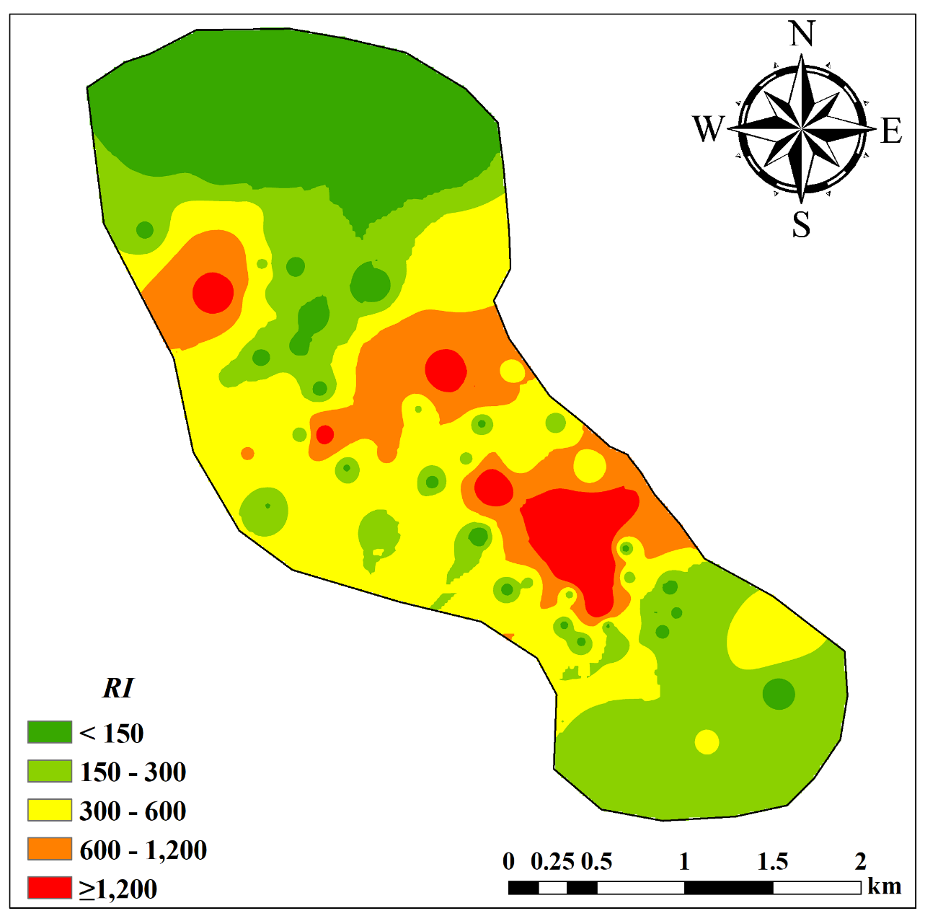Figure S3. Spatial distribution of the potential ecological risk index (RI).
Figure S4 on-carcinogenic risks (HI) and total carcinogenic risks (TCR) for children and adults through different exposure routes. Among them, (a), (b), and (c) represent the non-carcinogenic risks via oral, dermal, and inhalation routes respectively, and (d), (e), and (f) represent the total carcinogenic risks via oral, dermal, and inhalation routes respectively.

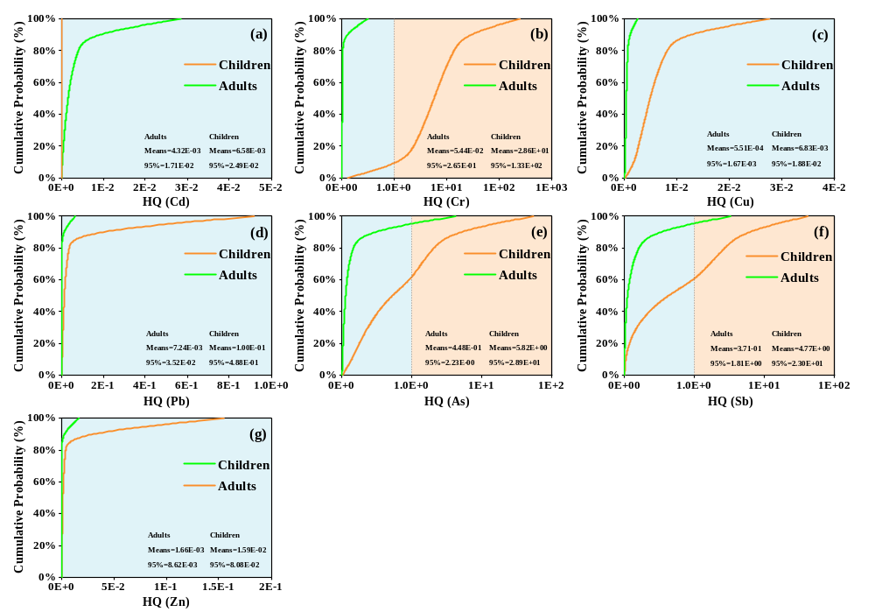 Figure S5. Probability distributions of the hazard quotient (HQ) of human health risks based on the contents. (a) Cd, (b) Cr, (c) Cu, (d) Pb, (e) As, (f) Sb, and (g) Zn.
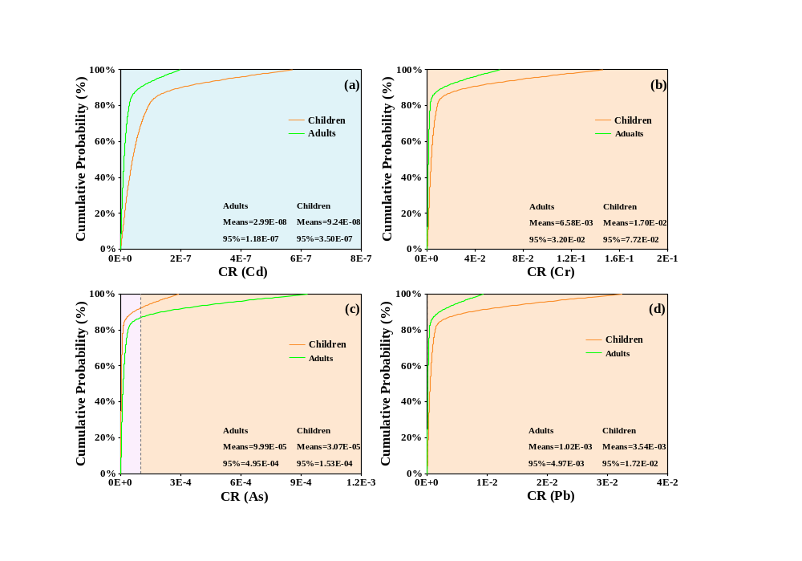
Figure S6. Probability distributions of the carcinogenic risk (CR) of human health based on the contents. (a) Cd, (b) Cr, (c) As, and (d) Pb.
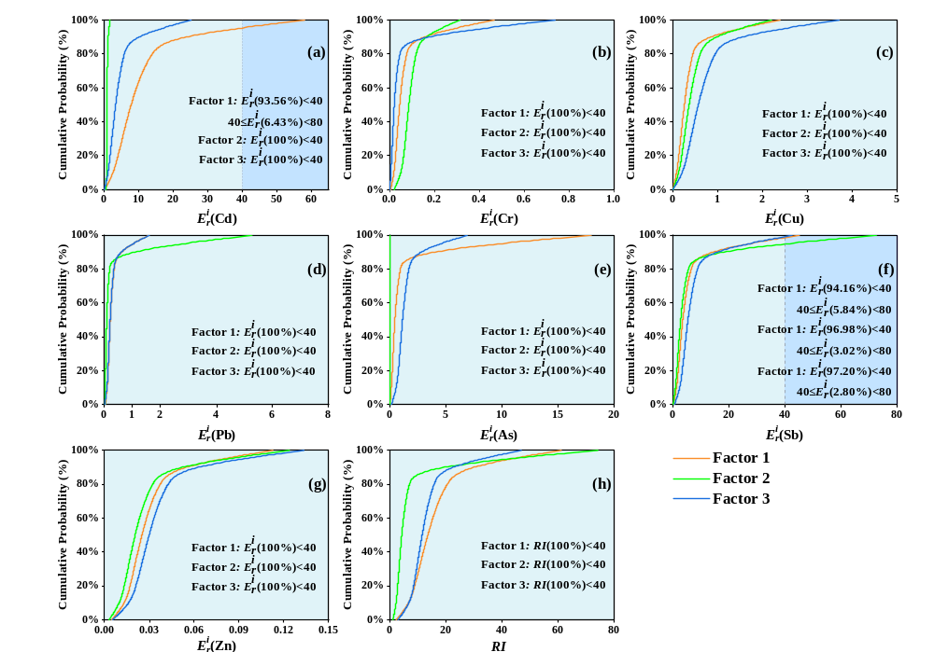Figure S7. Cumulative probability distributions of source-based $E_{r}^{i}$ and RI for soil heavy metals.

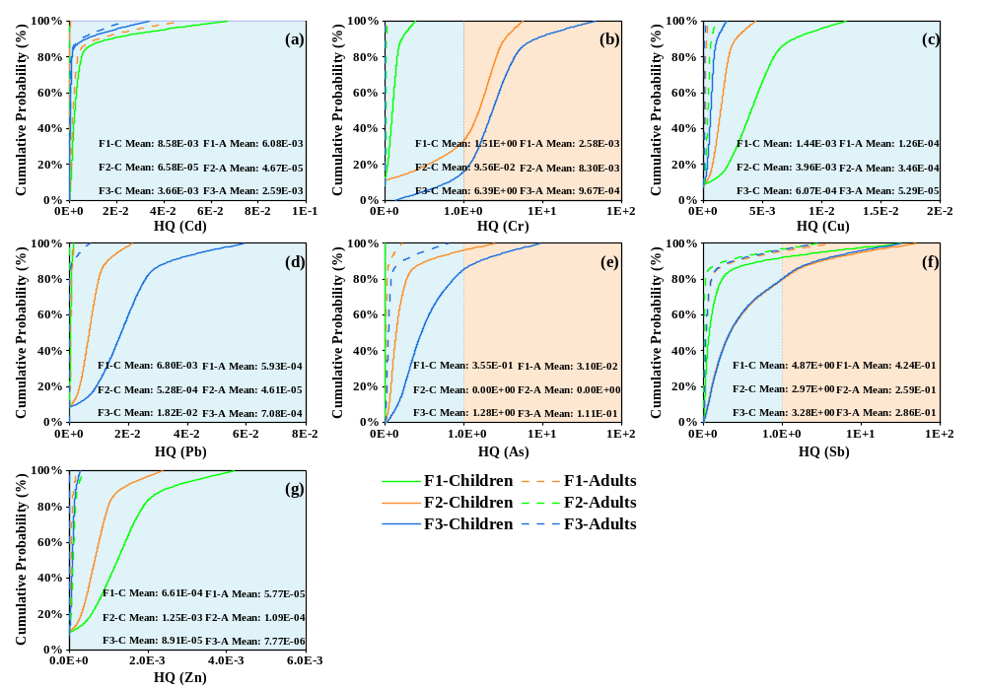Figure S8. Probability distributions of the hazard quotient (HQ) of human health risks based on pollution sources. (a) Cd, (b) Cr, (c) Cu, (d) Pb, (e) As, (f) Sb, and (g) Zn.

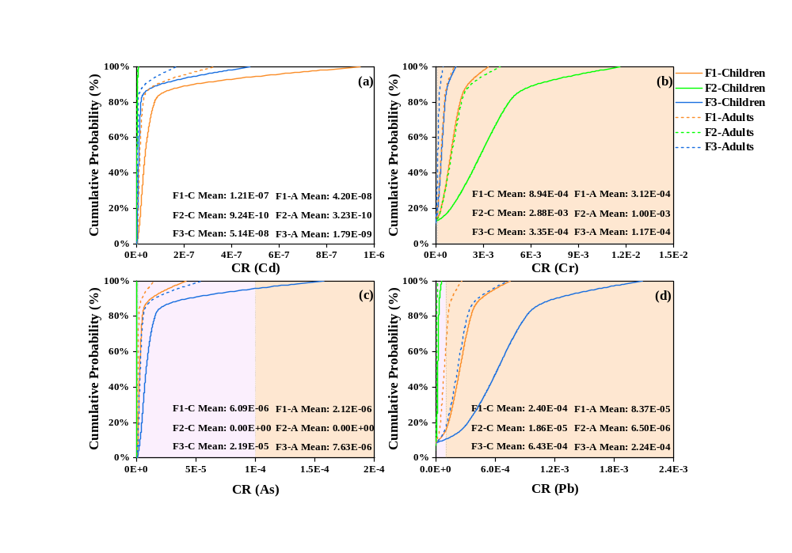
Figure S9. Probability distributions of the carcinogenic risk (CR) of human health based on pollution sources. (a) Cd, (b) Cr, (c) As, and (d) Pb.

