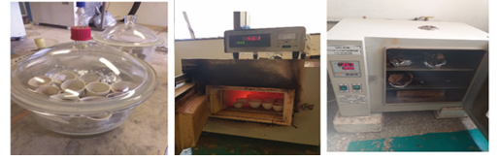

supplementary figure 1: proximate analysis process (discoter, muffle furnce and oven from left to right)

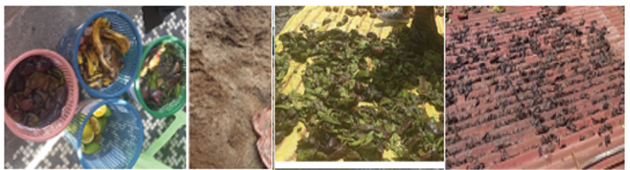
supplementary figure 2: Sample collection from juice house and sugar industry and drying process

supplementary figure 3: Schematic presentation of the briquetting process

