Profiling of Vaginal Microbial Communities in Chilean Women Via self-sampling and full-length 16S rRNA sequencing.

Supplementary Figures
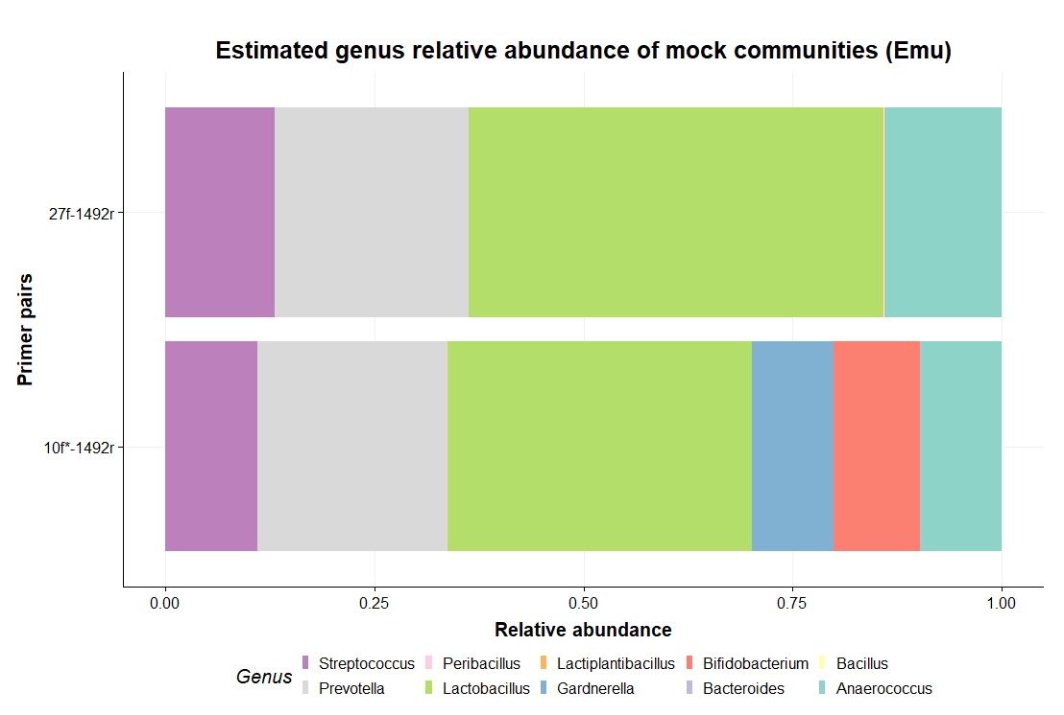
Supplementary Figure 1. Estimated relative genus abundance determined by Emu in the in silico mock communities generated with different primer pairs (27F:5'-AGAGAGTTTGATCMTGGCTCAG-3', 5'-10F*:RGTTYGATYCTGGCTCAG-3', 1492R:5'-TACGGYTACCTTGTTACGACTT-3')
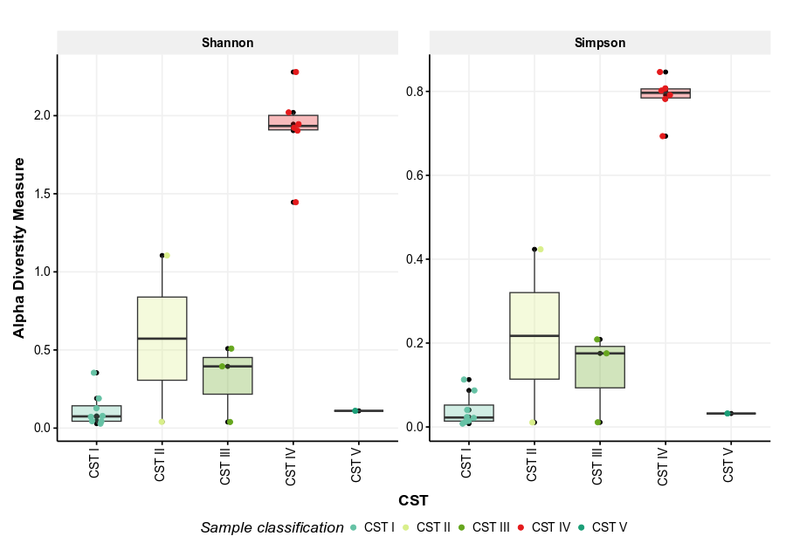

Supplementary Figure 2. Alpha diversity indices (Shannon and Simpson) calculated at the bacterial genus level in vaginal samples. Boxplots represent genus-level diversity in vaginal samples, grouped according to previously determined community state types (CSTs). CSTs include: CST I (L. crispatus-dominant), CST II (L. gasseri-dominant), CST III (L. iners-dominant), CST IV (high bacterial diversity), and CST V (L. jensenii-dominant). The x-axis displays the different CSTs, where each point represents an individual sample. The y-axis indicates alpha diversity, measured using Shannon and Simpson indices.

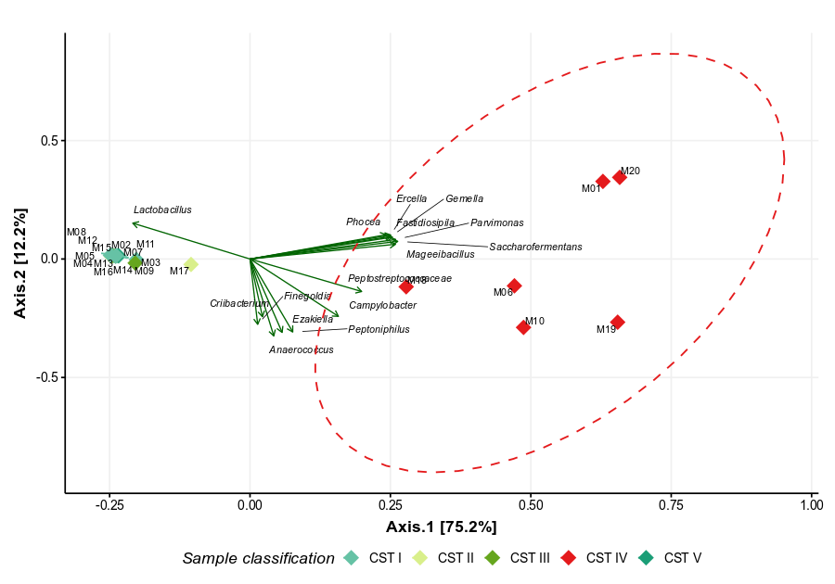
Supplementary Figure 3. Beta Diversity Analysis by PCoA Based on Bray-Curtis Distance at the Genus Level. The graph represents the Bray-Curtis distances of vaginal samples analyzed at the genus level. Each sample is color-coded according to its previously determined community state. All samples classified as CST IV were grouped to add an ellipse (red dashed line). PCA loadings are represented as arrows labeled with the corresponding genera, displaying only the 15 most contributing taxa. The X-axis represents the first principal component, while the Y-axis represents the second principal component.

Supplementary Tables
Larger tables are available in the supplementary excel file.

Supplementary Table S1. Participant characteristics based on demographic, health, and lifestyle questionnaire. The table provides an overview of the results obtained from the questionnaire on the health and lifestyle characteristics of the participants, including their age, contraceptive methods, hygiene practices, recent antibiotic use, stress levels, alcohol consumption, smoking habits, and dietary preferences.

Supplementary Table S2. Conditions of the PCR cycles to amplify the bacterial 16S rRNA gene.
PCR | Temperature | Time | Cycles
Initial denaturation | 95 °C | 1 min | 1
Denaturation | 95 °C | 20 secs | 30
Alignment | 55 °C | 30 secs | 30
Extension | 65 °C | 2 mins | 30
Final extension | 65 °C | 5 mins | 1
Storage | 4 °C | ∞

Supplementary Table S3. Estimated species relative abundance (Emu) of in silico generated mock communities with different primer pairs. The table shows the results of the estimated relative abundances of the in silico mock communities done with different primer pairs. Pairs include 27F-1492R and 5'-10F*:-1492R.
Supplementary Table S4. Relative abundances of the top ten most abundant genera across all analyzed vaginal 16S samples. The table presents the estimated abundances assigned by Emu for each sequenced sample, displaying only the top ten genera. Remaining genera are grouped as "Others." The “Not defined” category corresponds to a specific Peptostreptococcaceae bacterium oral taxon 929.
Supplementary Table S5. Relative abundances of the top ten most abundant species across all analyzed vaginal 16S samples. The table presents the species-level estimated abundances assigned by Emu for each sequenced sample, displaying only the ten most abundant species across all samples. Remaining species are grouped as "Others."
Supplementary Table S6 Alpha diversity statistics analysis at genus level by groups.
Group | Mean Shannon | SD Shannon | Mean Simpson | SD Simpson
I | 0.117 | 0.109 | 0.040 | 0.039
II | 0.573 | 0.753 | 0.217 | 0.292
III | 0.314 | 0.245 | 0.132 | 0.106
IV | 1.920 | 0.270 | 0.787 | 0.051
V | 0.110 | - | 0.032 | -

Supplementary Table S7. Principal Component Analysis (PCA) results based on Bray-Curtis distance at the genus level. This table contains the principal component (axis) scores for each sample at genus level.
Supplementary Table S8. Principal Component Analysis (PCA) genus level loadings. This table contains the principal component scores of the loadings corresponding to each taxa at genus level.
Supplementary Table S9. Principal Component Analysis (PCA) results based on Bray-Curtis distance at the species level. This table contains the principal component (axis) scores for each sample at species level.
Supplementary Table S10. Principal Component Analysis (PCA) species level loadings. This table contains the principal component scores of the loadings corresponding to each taxa at species level.
Supplementary Table S11. Alpha diversity statistics analysis at species level grouped by community states.
CST | Mean_Shannon | SD_Shannon | Mean_Simpson | SD_Simpson
CST I | 0.373 | 0.224 | 0.157 | 0.126
CST II | 0.624 | 0.791 | 0.222 | 0.290
CST III | 0.900 | 0.147 | 0.476 | 0.102
CST IV | 2.42 | 0.182 | 0.851 | 0.0336
CST V | 0.138 | - | 0.0383 | -

