Supplementary file. 1
(Network and Pathway diagram of BP, CC, MF)
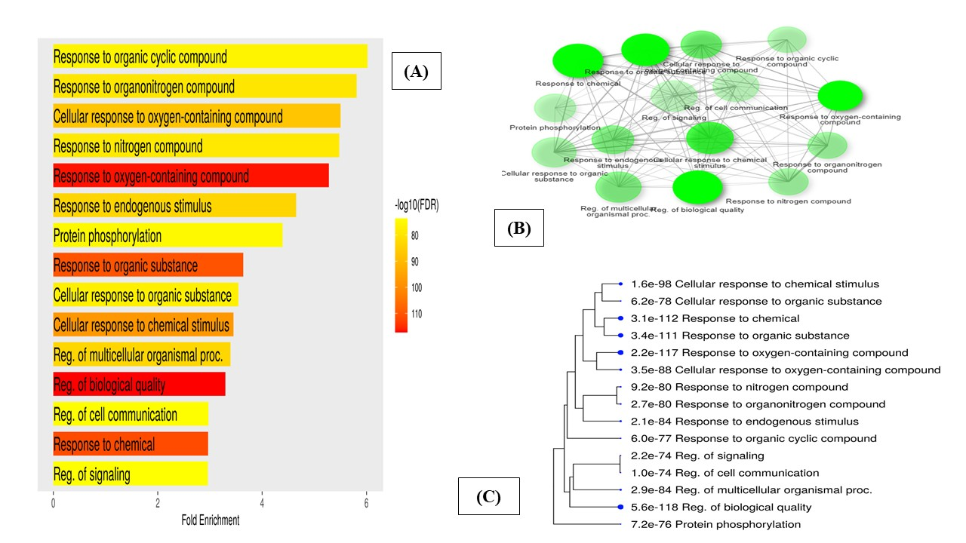

Figure S1: (A) BP Pathway depicted as a lollipop plot. (B) Interaction network between BP Pathways (C) A hierarchical clustering tree representing these pathways and shared genes.

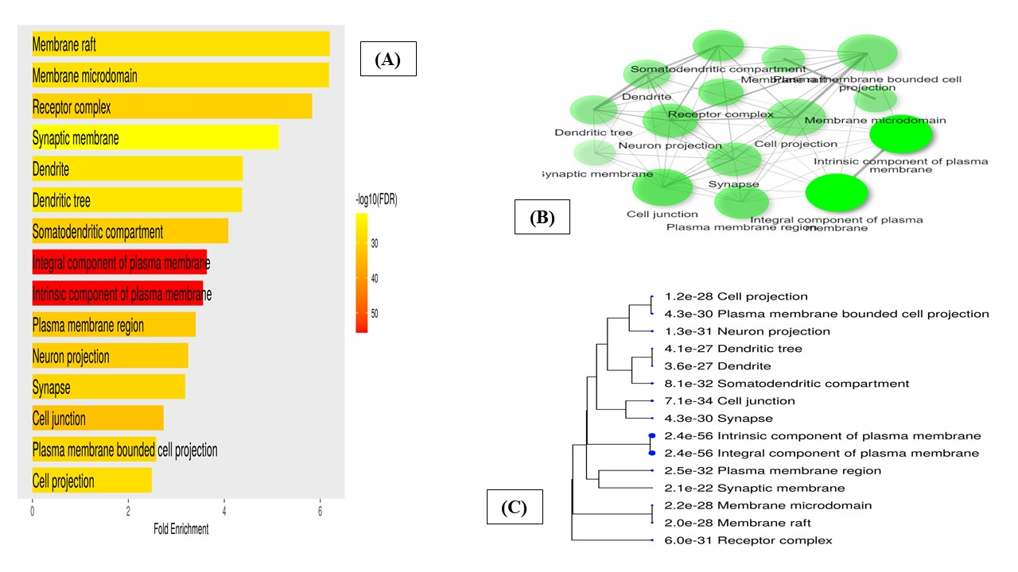Figure S2: (A) CC Pathway depicted as a lollipop plot. (B) Interaction network between CC Pathways (C) A hierarchical clustering tree representing these pathways and shared genes.

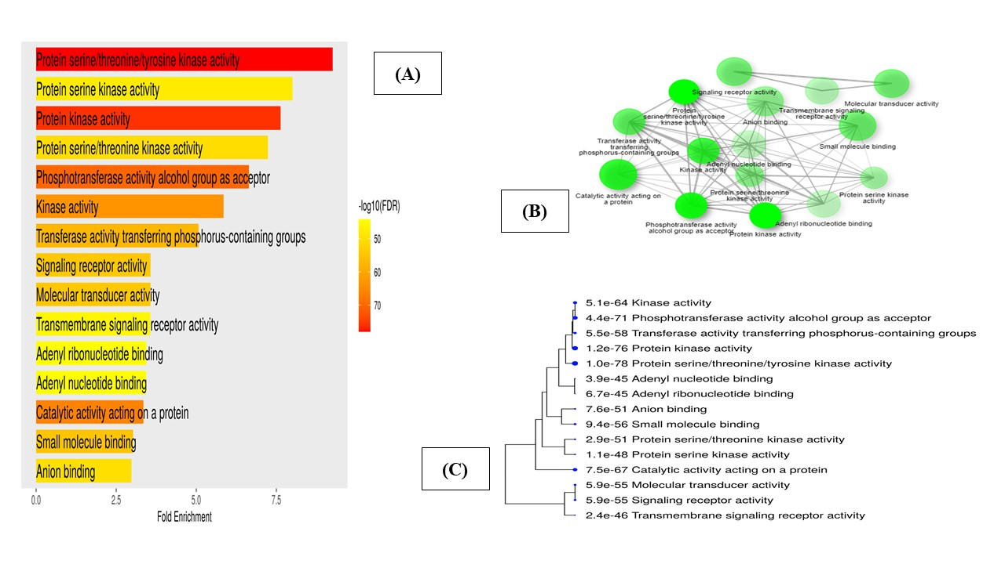
Figure S3: (A) MF Pathway depicted as a lollipop plot. (B) Interaction network between MF Pathways (C) A hierarchical clustering tree representing these pathways and shared genes.

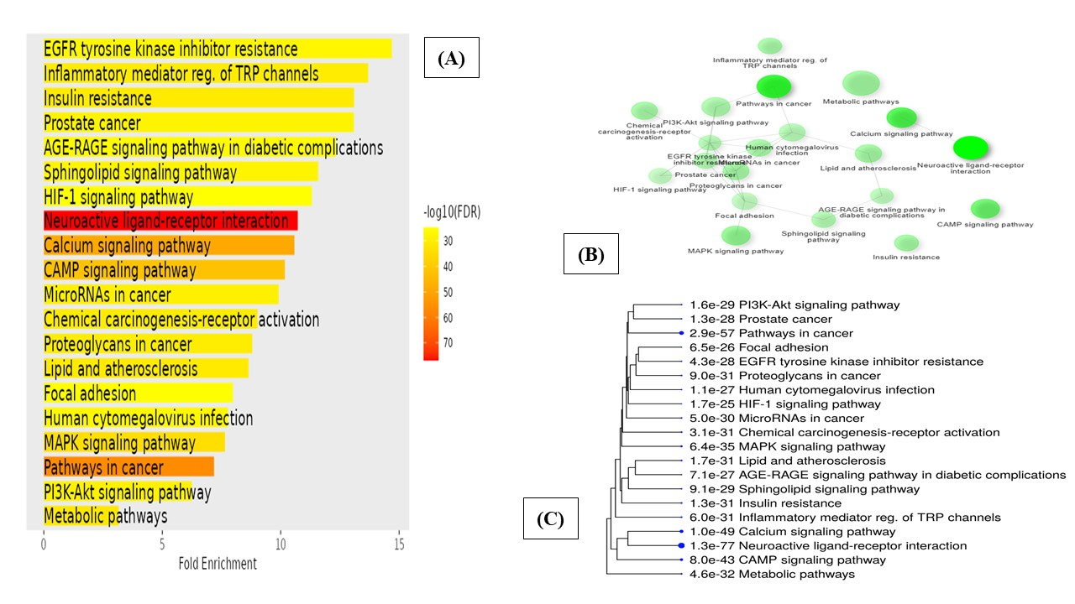
Figure S 4: (A) KEGG Pathway depicted as a lollipop plot. (B) Interaction network between KEGG Pathways (C) A hierarchical clustering tree representing these pathways and shared genes.

