Supplementary file. 3
(Active site prediction)
The CASTp online server was employed to identify potential active site pockets within two target proteins, Epidermal Growth Factor Receptor Tyrosine Kinase (EGFR-TK) and AKT1. For EGFR-TK, a specific pocket located in chain A and comprising the amino acid residues ASP783, ASN784, GLN958, ARG962, MET963, HIS964, LEU977, MET978, ASP979, GLU980, GLU981, ASP982, MET983, ASP984, and VAL986 was selected for virtual screening, as these residues are known to participate in binding with AQ4 (Erlotinib), a well-characterized inhibitor of EGFR-TK, thereby ensuring biological relevance for docking studies.
Similarly, in AKT1, a predicted pocket encompassing residues LYS14, ARG15, GLY16, GLU17, TYR18, LYS20, ARG25, PHE27, LEU28, LYS30, THR34, ILE36, GLY37, TYR38, LYS39, GLU40, PRO42, GLN43, ASP44, VAL45, GLU49, ALA50, PRO51, LEU52, ASN53, ASN54, PHE55, SER56, ALA58, GLN59, CYS77, LEU78, GLN79, TRP80, THR81, THR82, VAL83, ILE84, GLU85, ARG86, THR87, PHE161, ASN199, VAL201, LEU202, SER205, ARG206, HIS207, LEU210, THR211, ALA212, LEU213, SER216, PHE217, GLN218, LEU223, CYS224, PHE225, MET227, TYR263, LEU264, LYS268, VAL270, VAL271, TYR272, ARG273, ASP274, LYS276, ASN279, ILE290, THR291, ASP292, PHE293, GLY294, CYS296, LYS297, GLU298, LEU316, GLU319, VAL320, ASP323, ASN324, ASP325, TYR326, GLY327, ARG328, ALA329, PRO388, LYS389, GLY393, GLY394, GLY395, SER396, and ASP398 was selected, as it contains residues known to interact with IQO, a well-characterized inhibitor of AKT1, thus representing a biologically relevant site for molecular docking and virtual screening analyses.

Figure S1 The binding site of EGFR-TK protein. A Active site area and B Active amino acid residue (Highlighted)

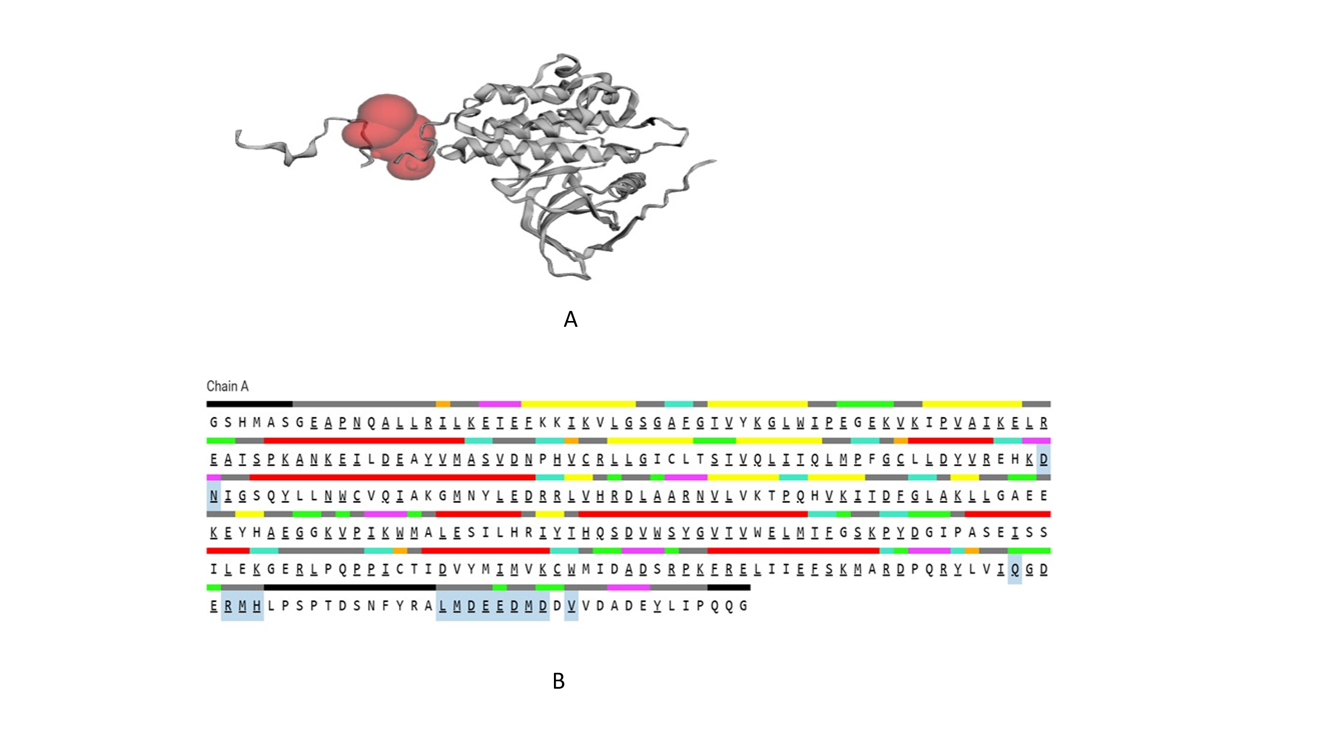

Figure S2 The binding site of AKT1 protein. A Active site area and B Active amino acid residue (Highlighted)

