Supplementary analyses

Supplementary analysis 1: Confusion pattern.
The frequencies of the different responses for each emotional category and for each face gender are shown in Figure SA1. These frequencies are also reported in Table SA1 together with the mean ratings for the arousal and valence dimensions and the median response times.
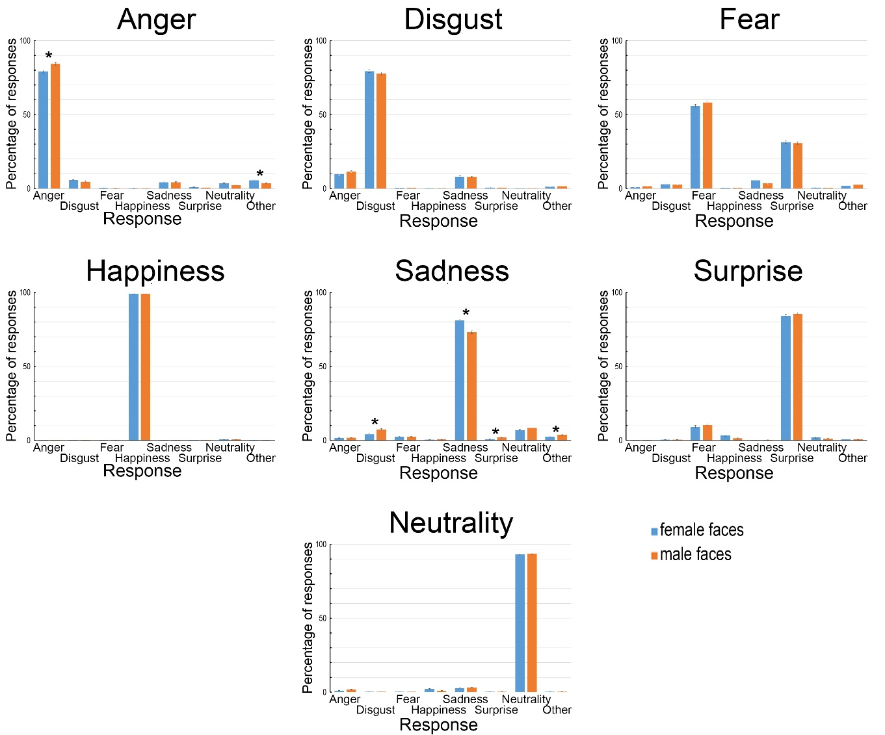
Figure SA1: Frequencies of the different responses (in %) according to expression and face gender (*: significant difference between female and male faces).
To assess whether certain types of confusion were more frequent for certain emotion categories, we performed by-item analyses, data for arousal ratings, valence ratings, and response percentages for each category, which were averaged across participants for each picture. Owing to the low frequency of some responses, nonparametric Friedman ANOVAs were performed for each emotion category (anger, disgust, fear, happiness, sadness, surprise, and neutrality), with Response (eight categories: the seven emotion categories plus “other”) as the within-item factor. Analyses were conducted first including the expected response and then excluding it to determine whether the expression effect was still significant for the other (incorrect) responses. These analyses revealed that the main effect of Response was significant for each expression (lowest p value: χ²(7) = 1721.29, N = 482, p < .0001; for surprise: χ²(7) = 688.16, N = 140, p < .0001). As illustrated in Figure SA1 (see also Table SA1), the expected response was always given more frequently than other responses, as anticipated. When the expected response was removed from the analysis, the main effect of Response remained significant for all categories (lowest p value: χ²(6) = 318.40, N = 482, p < .0001; for surprise: χ²(6) = 358.70, N = 140, p < .0001). For anger, the responses “disgust”, “sadness”, and “other” were more frequent than “neutrality”, which in turn was more frequent than “fear”, “happiness”, and “surprise”. For disgust, the response “anger” was more frequent than “sadness”, which was more frequent than other responses. For fear, the response “surprise” was very frequent, followed by “sadness”, “disgust” and “other”. The less frequent responses were “happiness” and “neutrality”. For happiness, “neutrality” was chosen more frequently than any other response. For sadness, participants most often responded with “neutrality”, followed by “disgust”, then “other”, “fear”, “anger”, “surprise”, and “happiness”. Surprise was confused with “fear” and, to a lesser extent, “happiness”. For neutrality, “sadness” was the most frequent incorrect response, followed by “anger”, “happiness”, and then other responses.
Table SA1: Response frequencies according to the modeled expressions. The mean arousal and valence ratings as well as the median RTs are reported for information purposes.
 | RESPONSE
MODELED EXPRESSION | Angry | Disgust | Fear | Happiness | Sadness | Surprise | Neutrality | Other
Anger  arousal  valence  median RT | 81.7%  4.2  -1.5  1432 | 5.2%  3.9  -1.3  3297 | 0.3%  3.8  -1.6  7452 | 0.2%  3.4  -0.4  5853 | 4.3%  3.9  -1.4  2914 | 0.7%  3.4  -0.7  6028 | 3.1%  3.4  -0.9  2603 | 3.6%  3.7  -0.8  5068
Disgust  arousal  valence  median RT | 10.5%  4.8  -2.0  1910 | 78.5%  4.7  -1.9  1416 | 0.5%  4.5  -1.9  3578 | 0.3%  4.3  -0.8  2099 | 7.9%  4.7  -2.0  2463 | 0.7%  4.1  -1.2  4595 | 0.3%  3.9  -1.2  2512 | 1.2%  4.3  -1.3  4888
Fear  arousal  valence  median RT | 1.2%  4.9  -1.4  2686 | 2.8%  4.7  -1.3  2688 | 57.1%  5.2  -1.6  1857 | 0.5%  5.2  -0.9  2952 | 4.5%  4.3  -1.4  3081 | 31.0%  4.8  -1.2  2367 | 0.6%  4.3  -0.9  2527 | 1.9%  4.3  -0.9  6189
Happiness  arousal  valence  median RT | 0.0%  4.3  2.3  733 | 0.1%  3.3  1.6  1066 | 0.1%  4.1  1.0  1429 | 98.9%  4.4  2.2  984 | 0.1%  4.4  1.5  3094 | 0.0%  5.2  2.5  3842 | 0.7%  3.9  1.7  1165 | 0.0%  4.3  1.0  7643
Sadness  arousal  valence  median RT | 1.7%  3.2  -1.3  3285 | 5.7%  3.7  -1.3  3066 | 2.5%  3.6  -1.3  3603 | 0.6%  3.6  -1.0  2056 | 77.1%  3.5  -1.4  1521 | 1.5%  3.2  -0.9  3247 | 7.7%  2.8  -0.8  2112 | 3.0%  3.3  -0.9  5570
Surprise  arousal  valence  median RT | 0.1%  4.0  -0.2  1116 | 0.4%  5.0  -1.0  2146 | 9.8%  4.8  -0.7  1974 | 2.3%  5.1  0.6  1910 | 0.2%  3.2  -0.4  2837 | 84.8%  4.6  -0.3  1417 | 1.5%  3.7  -0.7  3687 | 0.6%  3.5  -0.2  4979
Neutrality  arousal  valence  median RT | 1.4%  1.8  -0.5  2286 | 0.2%  1.8  -0.1  5308 | 0.1%  2.1  -0.3  3361 | 1.6%  1.8  0.2  1818 | 2.8%  1.9  -0.3  2540 | 0.3%  1.7  -0.2  21668 | 93.3%  1.5  0.0  1086 | 0.3%  1.9  0.4  4818

The effect of Face gender was investigated separately via Student’s t tests for each response type and category, with Bonferroni correction applied for multiple comparisons (α = .05/8 responses by image = .00625). The main effect of Face gender was significant for the expression of anger, with the participants recognizing anger more frequently in male faces than in female faces (T(480) = 2.89, Cohen’s d = 0.26, p = .004). Conversely, the participants responded “other” more frequently for female faces than for male faces (T(480) = 3.30, Cohen’s d = 0.30, p = .001). In contrast, sadness was more frequently correctly recognized in female faces than in male faces (T(480) = 4.12, Cohen’s d = 0.37, p < .0001); conversely, the participants responded more frequently “disgust” (T(480) = 3.51, Cohen’s d = 0.32, p = .0005), “surprise” (T(480) = 3.15, Cohen’s d = 0.29, p = .0017), or “other” (T(480) = 3.03, Cohen’s d = 0.28, p = .0026) for male faces than for female faces.

Supplementary analysis 2: Comparison of our results with those of the KDEF validation study (Goeleven, De Raedt, Leyman, & Verschuere, 2008).
A validation study was performed for part of the KDEF database (Lundqvist, Flykt, & Öhman, 1998) by Goeleven et al. (2008). They assessed the first front-view shots of the 70 models (N = 490) by asking 272 female psychology students aged 18--39 years (M = 21.1, SD = 2.1) to categorize the different pictures according to 8 possible responses (anger, disgust, fear, happiness, sadness, surprise, neutral, and “?”). The participants were also asked to rate the intensity and arousal of the images. Each picture was rated by 64 participants. Goeleven et al. (2008) reported only unbiased hit rate accuracy scores (Hu) for 490 pictures in the database.
We have therefore computed the unbiased hit rate accuracy scores in our study for the same 490 pictures, and we contrasted the means with those of the validation study by calculating Student's t tests to assess differences. We also computed Cronbach's alphas to assess the congruency across pictures for the participants in the two studies. These analyses were performed first for the full set of pictures (N = 490) and then for each emotional category (N = 70). The mean unbiased accuracy scores are reported in Table SA1, together with the analysis results.
Table SA2: Unbiased hit rate accuracy scores (Hu) and standard deviations (SDs) in our study and in the validation study for the KDEF (Goeleven et al., 2008).
 | Present study  _____________ |  | Validation study (KDEF)  _____________ |  | Student t tests  _____________ |  | Cronbach’s alpha and 95% confident interval (CI)  _______________________
 | Mean  ______ | SD  ____ | Mean  ______ | SD  ____ | T  _____ | P  ____ | α  _______ | 95% CI  ____________
All pictures | 0.68 | 0.25 | 0.57 | 26,7 | 11,59 | ^{<.0001} | .83 | .803-.862
Anger | 0.76 | 0.18 | 0.61 | 0.22 | 7,36 | ^{<.0001} | .77 | .634-.854
Disgust | 0.65 | 0.19 | 0.57 | 0.27 | 3,22 | ^{<.0020} | .71 | .558-.817
Fear | 0.31 | 0.19 | 0.29 | 0.20 | 1,22 | ^{.2283} | .84 | .74-.90
Happiness | 0.95 | 0.65 | 0.89 | 0.15 | 3,53 | ^{<.0008} | .45 | .233-.615
Sadness | 0.58 | 0.24 | 0.50 | 0.21 | 3,94 | ^{<.0002} | .83 | .729-.895
Surprise | 0.64 | 0.15 | 0.59 | 0.17 | 2,55 | ^{<.0131} | .68 | .496-.805
Neutrality | 0.84 | 0.13 | 0.56 | 0.24 | 9,89 | ^{<.0001} | .45 | .186-.633

Overall, our participants outperformed those in the validation study, both for all images and for each expression, with the exception of fear. The overall difference was 10.3% on the corrected index, ranging for emotional expressions from 4.8% for sadness to 15.3% for anger. Neutrality exhibited an even greater difference of 27.5%. The difference between the two studies can be explained by a number of factors. First, the conditions under which our study was performed were different: our participants completed the study tasks at their own pace at home and were exposed to a larger number of items and models. This may have enabled them to train more intensively as the study progressed, helping them detect relevant facial actions. They were also more often exposed to several expressions of the same model, whereby they saw all the expressions twice. In particular, this may have made it easier for our participants to perceived the difference between a neutral face (where the model produced no intense facial activity) and an expressive face (where most models deliberately emphasized such activity). Another possible explanation is that the images were edited in the validation study, with participants seeing faces only from the forehead line to approximately halfway up the chin. In our study, participants saw the whole head as well as the neck and upper shoulders. They may thus have benefited from additional clues about the emotion being modeled (e.g., jaw shape or head position).
This difference in accuracy did not prevent a good level of overall agreement between participants in the two studies, as indicated by Cronbach's alpha (overall Cronbach’s α = .83). This high level of agreement was found for each expression considered separately (ranging from .68--0.84), with the notable exceptions of happiness and neutrality (Cronbach α =0.45 in both cases). For happiness, this can be explained by the ceiling effect generally caused by this expression, which reduces variability between items and hinders the statistical observation of agreement. For neutrality, the low agreement mirrors the discrepancy in accuracy.

Supplementary analysis 3: Comparison of our results with those of the FACES validation study (Ebner, Riediger, & Lindenberger, 2010).
Ebner et al. (2008) performed a validation study asking a group of 154 raters (52 young, 51 middle-aged, and 51 older) to determine the facial expression of the pictures in their database, with forced choice among the following categories: angry, disgusted, scared, happy, sad, and neutral. Each participant completed the task for (all or part of) one of the shots (the first or the second). On average, each picture was evaluated by 11 raters in each age group (range: 8--14). The authors provide the percentages of correct recognition at their database site, as well as other evaluations of perceived age, attractiveness, distinctiveness and trustworthiness (see https://faces.mpdl.mpg.de/imeji/). To study the consistency between their participants' responses and our own, we contrasted the mean percentage of correct responses by performing Student's t tests (to assess differences) and Cronbach's alpha tests (to assess congruency), first for the full set of pictures (N = 2052) and then for each emotional category separately (N = 342). We considered only the scores of the young participants in the Ebner et al. study (2010), whose ages matched those of our group. The results are summarized in Table SA3 below.
Table SA3: Percentages and standard deviations (SDs) for correct recognition in our study and in the validation study for FACES (Ebner et al., 2010).
 | Present study  _____________ |  | Validation study (FACES)  _____________ |  | Student t tests  _____________ |  | Cronbach’s alpha and 95% confident interval (CI)  _______________________
 | Mean  ______ | SD  ____ | Mean  ______ | SD  ____ | T  _____ | P  ____ | α  _______ | 95% CI  ____________
All pictures | 82.0 | 20.5 | 80.9 | 16.5 | 3.35 | ^{<.0009} | .80 | .778-.812
Anger | 80.1 | 20.0 | 81.3 | 13.9 | 1.64 | ^{.1009} | .81 | .772-.843
Disgust | 79.0 | 18.7 | 68.0 | 18.2 | 15.84 | ^{<.0001} | .88 | .847-.90
Fear | 63.1 | 19.9 | 80.5 | 11.3 | 16.52 | ^{<.0001} | .51 | .415-.59
Happiness | 99.3 | 2.1 | 96.6 | 3.3 | 14.06 | ^{<.0001} | .42 | .30-.525
Sadness | 77.5 | 21.0 | 72.9 | 18.7 | 6.80 | ^{<.0001} | .89 | .865-.911
Neutrality | 93.1 | 11.1 | 85.9 | 11.5 | 15.63 | ^{<.0001} | .85 | .818-.881

Overall, our participants were slightly more accurate than those in the validation study, with some discrepancies according to categories: there was no difference for anger, but our participants were more accurate by 2.6% for happiness, 4.7% for sadness, 7.2% for neutrality, and 11% for disgust. However, they were 17.4% less accurate for fear. The better performance can be explained by the conditions in our study that favored correct categorizations, notably the fact that our participants were exposed to more faces and thus benefited from more intense and varied training with prototypical expressions. This seemed to favor disgust in particular, which must be distinguished from anger. The sharp decrease in accuracy for fear is explained in part by the fact that our participants could choose the "surprise" response, unlike those in the validation study. They largely did so in more than 25% of the cases (Figure SA1), leading to the sharp drop in “fear” responses.
Despite these differences in accuracy, agreement between participants in the two studies, as measured by Cronbach's alpha, was good overall (i.e., over the entire set: Cronbach’s α = .80) and for most expressions separately (i.e., lower Cronbach’s α = .81), with two notable exceptions: fear (Cronbach’s α = .51) and happiness (Cronbach’s α = .42). For fear, the lower agreement can probably be explained by the same reasons as the difference in accuracy: the introduction of the “surprise” response in our study. For happiness, the lower agreement can be explained by the fact that both studies exhibit a ceiling effect, with most images at or near 100% of correct responses. In fact, almost all the participants agreed that nearly all smiles were happy emotions.
References:
Ebner, N. C., Riediger, M., & Lindenberger, U. (2010). FACES—A database of facial expressions in young, middle-aged, and older women and men: Development and validation. Behavior Research Methods, 42, 351-362.
Goeleven, E., De Raedt, R., Leyman, L., & Verschuere, B. (2008). The Karolinska directed emotional faces: a validation study. Cognition and emotion, 22(6), 1094-1118.
Lundqvist, D., Flykt, A., & Öhman, A. (1998). The Karolinska Directed Emotional Faces - KDEF, CD ROM from Department of Clinical Neuroscience, Psychology section, Karolinska Institutet, ISBN 91-630-7164-9.

