Supplementary Information

Multi-phase modelling of potential drivers for the range expansion of the golden jackal (Canis aureus)

Hanna Bijl, Gergely Schally, Miklós Heltai, Arsalan Emami-Khoyi, Sándor Csányi

Table S1 Estimated regression coefficients (Est), standard errors (SE), z-values and p-values for the binomial GLMM (presence–absence) across all five periods with added AIC values. Significant predictors are highlighted in bold.
 | 1997–2001 (AIC 428) |  |  |  | 2002–2006 (AIC 795) |  |  |  | 2007–2011 (AIC 2641)
 | Est | SE | z-value | Pr(>|z|) | Est | SE | z-value | Pr(>|z|) | Est | SE | z-value | Pr(>|z|)
(Intercept) | -14.07 | 1.21 | -11.61 | <2e-16 | -12.81 | 0.84 | -15.33 | <2e-16 | -9.26 | 0.51 | -18.07 | < 2e-16
Red deer harvest | 1.03 | 0.49 | 2.11 | 0.04 | 0.36 | 0.47 | 0.78 | 0.43 | 0.69 | 0.30 | 2.29 | 0.02
Roe deer harvest | -0.80 | 0.60 | -1.33 | 0.18 | -0.46 | 0.41 | -1.11 | 0.27 | -0.41 | 0.20 | -2.03 | 0.04
Wild boar harvest | 0.16 | 0.60 | 0.26 | 0.79 | 0.83 | 0.57 | 1.46 | 0.14 | 0.80 | 0.26 | 3.02 | 0.002
Broad-leaved forest | 0.62 | 0.83 | 0.76 | 0.45 | 0.49 | 0.51 | 0.95 | 0.34 | 0.52 | 0.30 | 1.75 | 0.08
Coniferous forest | 0.34 | 0.81 | 0.42 | 0.68 | -0.21 | 0.80 | -0.27 | 0.79 | -0.62 | 0.45 | -1.36 | 0.17
Mixed forest | -0.34 | 0.92 | -0.37 | 0.71 | 0.45 | 0.71 | 0.63 | 0.53 | 0.43 | 0.40 | 1.07 | 0.28
Water bodies and wetlands | -0.25 | 0.84 | -0.30 | 0.77 | 0.08 | 0.29 | 0.29 | 0.78 | 0.19 | 0.25 | 0.77 | 0.44
European hare harvest | 0.44 | 0.37 | 1.20 | 0.23 | -0.09 | 0.54 | -0.18 | 0.86 | -0.08 | 0.22 | -0.35 | 0.73
Red fox hunting bag | -0.05 | 0.42 | -0.11 | 0.91 | 0.20 | 0.29 | 0.68 | 0.50 | -0.03 | 0.16 | -0.19 | 0.85
Elevation | -1.85 | 1.29 | -1.44 | 0.15 | -2.06 | 1.06 | -1.94 | 0.05 | -1.65 | 0.46 | -3.57 | < 0.001
Human population | 0.04 | 0.41 | 0.11 | 0.92 | -0.04 | 0.40 | -0.09 | 0.93 | 0.19 | 0.28 | 0.68 | 0.50

 | 2012–2016 (AIC 4351) |  |  |  | 2017–2021 (AIC 3657)
 | Est | SE | z-value | Pr(>|z|) | Est | SE | z-value | Pr(>|z|)
(Intercept) | -1.10 | 0.58 | -1.91 | 0.06 | 3.40 | 0.30 | 11.43 | < 2e-16
Red deer harvest | 0.84 | 0.19 | 4.30 | < 0.001 | 1.32 | 0.21 | 6.16 | < 0.001
Roe deer harvest | -0.44 | 0.15 | -2.88 | 0.004 | 0.01 | 0.15 | 0.05 | 0.96
Wild boar harvest | 0.87 | 0.18 | 4.95 | < 0.001 | 0.63 | 0.14 | 4.48 | < 0.001
Broad-leaved forest | 0.51 | 0.21 | 2.49 | 0.01 | 0.44 | 0.23 | 1.90 | 0.06
Coniferous forest | -0.47 | 0.26 | -1.82 | 0.07 | -0.38 | 0.23 | -1.63 | 0.10
Mixed forest | 0.57 | 0.26 | 2.19 | 0.03 | -0.21 | 0.23 | -0.92 | 0.36
Water bodies and wetlands | 0.42 | 0.16 | 2.69 | 0.007 | 0.17 | 0.14 | 1.16 | 0.24
European hare harvest | -0.16 | 0.15 | -1.06 | 0.29 | 0.23 | 0.14 | 1.62 | 0.10
Red fox hunting bag | 0.40 | 0.12 | 3.34 | < 0.001 | 0.74 | 0.12 | 6.25 | < 0.001
Elevation | -1.96 | 0.25 | -7.78 | < 0.001 | -1.80 | 0.25 | -7.16 | < 0.001
Human population | 0.02 | 0.13 | 0.14 | 0.89 | 0.49 | 0.52 | 0.94 | 0.35

Table S2 Estimated regression coefficients (Est), standard errors (SE), t-values and p-values for the robust LMM (abundance) across all five periods with added AIC values. Significant predictors are highlighted in bold.
 | 1997–2001 (AIC 4785) |  |  |  | 2002–2006 (AIC 9833)
 | Est | SE | t(df = 5216) | p-value | Est | SE | t(df = 5216) | p-value
(Intercept) | -6.89e-15 | 0.03 | -2.49e-13 | > 0.999 | -4.68e-14 | 0.04 | -1.11e-12 | > 0.999
Red deer harvest | 0.28 | 0.07 | 4.09 | <0 .001 | 0.34 | 0.06 | 5.31 | < 0.001
Roe deer harvest | -0.08 | 0.03 | -2.36 | 0.018 | -0.13 | 0.02 | -8.08 | < 0.001
Wild boar harvest | -0.10 | 0.05 | -2.09 | 0.036 | 7.58e-03 | 0.03 | 0.30 | 0.763
Broad-leaved forest | 0.04 | 0.03 | 1.70 | 0.089 | 0.03 | 0.01 | 3.23 | 0.001
Coniferous forest | 2.46e-03 | 7.75e-03 | 0.32 | 0.751 | -0.03 | 0.03 | -1.20 | 0.232
Mixed forest | -0.04 | 0.01 | -2.88 | 0.004 | -5.39e-04 | 0.02 | -0.03 | 0.976
Water bodies and wetlands | -0.03 | 0.01 | -3.30 | < 0.001 | -0.02 | 0.01 | -1.66 | 0.098
European hare harvest | -0.03 | 6.68e-03 | -4.31 | < 0.001 | 0.04 | 0.02 | 1.75 | 0.080
Red fox hunting bag | 0.03 | 0.03 | 0.99 | 0.322 | -0.02 | 0.03 | -0.65 | 0.516
Elevation | -0.13 | 0.03 | -4.29 | < 0.001 | -0.22 | 0.05 | -4.42 | < 0.001
Human population | -1.15e-03 | 1.40e-03 | -0.82 | 0.411 | -8.51e-03 | 1.35e-03 | -6.31 | < 0.001

 | 2007–2011 (AIC 24381) |  |  |  | 2012–2016 (AIC 33397)
 | Est | SE | t(df = 5216) | p-value | Est | SE | t(df = 5216) | p-value
(Intercept) | -8.32e-15 | 0.04 | -1.97e-13 | > 0.999 | -2.06e-13 | 0.08 | -2.50e-12 | > 0.999
Red deer harvest | 0.43 | 0.03 | 15.46 | < 0.001 | 0.27 | 0.02 | 14.90 | < 0.001
Roe deer harvest | -0.17 | 0.03 | -5.04 | < 0.001 | -0.27 | 0.04 | -6.40 | < 0.001
Wild boar harvest | -0.04 | 0.02 | -1.54 | 0.123 | 0.14 | 0.08 | 1.62 | 0.104
Broad-leaved forest | 0.07 | 0.02 | 2.78 | 0.006 | 0.15 | 0.02 | 7.14 | < 0.001
Coniferous forest | -0.07 | 8.11e-03 | -8.84 | < 0.001 | -0.09 | 0.01 | -7.58 | < 0.001
Mixed forest | 0.02 | 0.01 | 1.66 | 0.096 | 0.06 | 0.01 | 4.10 | < 0.001
Water bodies and wetlands | -0.03 | 0.01 | -2.45 | 0.014 | -0.03 | 7.44e-03 | -3.58 | < 0.001
European hare harvest | 2.66e-03 | 6.36e-03 | 0.42 | 0.676 | 0.05 | 0.02 | 2.15 | 0.032
Red fox hunting bag | -0.06 | 0.02 | -3.67 | < 0.001 | 0.02 | 0.02 | 1.14 | 0.256
Elevation | -0.28 | 0.05 | -5.41 | < 0.001 | -0.38 | 0.07 | -5.62 | < 0.001
Human population | -0.02 | 6.08e-03 | -2.98 | 0.003 | -0.03 | 3.38e-03 | -8.68 | < 0.001

 | 2017–2021 (AIC 42838)
 | Est | SE | t(df = 5216) | p-value
(Intercept) | -1.82e-14 | 0.05 | -3.44e-13 | > .999
Red deer harvest | 0.05 | 0.05 | 0.98 | 0.329
Roe deer harvest | -0.39 | 0.05 | -7.97 | < 0.001
Wild boar harvest | 0.27 | 0.03 | 8.78 | < 0.001
Broad-leaved forest | 0.22 | 0.03 | 8.22 | < 0.001
Coniferous forest | -0.08 | 0.01 | -6.45 | < 0.001
Mixed forest | 0.01 | 5.73e-03 | 2.31 | 0.021
Water bodies and wetlands | -0.05 | 5.69e-03 | -8.71 | < 0.001
European hare harvest | 0.10 | 6.95e-03 | 14.83 | < 0.001
Red fox hunting bag | 0.11 | 0.03 | 3.74 | < 0.001
Elevation | -0.43 | 0.04 | -11.06 | < 0.001
Human population | -0.01 | 2.50e-03 | -5.29 | < 0.001

Table S3 Estimated regression coefficients (Est), standard errors (SE), t-values and p-values for the robust LMM (relative abundance) across all five periods with added AIC values. Significant predictors are highlighted in bold.
 | 1997–2001 (AIC -20903) |  |  |  | 2002–2006 (AIC -21399)
 | Est | SE | t(df = 5100) | p-value | Est | SE | t(df = 5108) | p-value
(Intercept) | 4.11e-06 | 0.02 | 1.95e-04 | > 0.999 | 2.54e-05 | 0.04 | 7.22e-04 | > 0.999
Red deer harvest/hunter | 0.28 | 0.13 | 2.11 | 0.035 | 0.58 | 0.15 | 3.83 | < 0.001
Roe deer harvest/hunter | -0.07 | 0.05 | -1.41 | 0.160 | -0.24 | 0.03 | -7.57 | < 0.001
Wild boar harvest/hunter | -0.07 | 0.07 | -0.96 | 0.335 | -0.08 | 0.05 | -1.61 | 0.108
Broad-leaved forest | 0.09 | 0.06 | 1.54 | 0.123 | 0.05 | 0.02 | 3.22 | 0.001
Coniferous forest | -0.02 | 0.01 | -1.29 | 0.198 | -0.03 | 0.02 | -1.18 | 0.240
Mixed forest | 0.02 | 0.03 | 0.75 | 0.454 | 0.01 | 0.02 | 0.68 | 0.497
Water bodies and wetlands | -0.02 | 7.35e-03 | -2.94 | 0.003 | -8.70e-03 | 0.02 | -0.56 | 0.576
European hare harvest/hunter | -2.57e-03 | 0.01 | -0.22 | 0.826 | 0.03 | 0.02 | 1.46 | 0.144
Red fox hunting bag/hunter | -6.82e-03 | 0.02 | -0.31 | 0.753 | -0.05 | 0.07 | -0.76 | 0.448
Elevation | -0.13 | 0.06 | -2.07 | 0.039 | -0.17 | 0.04 | -4.19 | < 0.001
Human population | 4.22e-03 | 6.29e-03 | 0.67 | 0.502 | -2.69e-03 | 1.69e-03 | -1.60 | 0.111

 | 2007–2011 (AIC -5203) |  |  |  | 2012–2016 (AIC 6794)
 | Est | SE | t(df = 5101) | p-value | Est | SE | t(df = 5105) | p-value
(Intercept) | 2.48e-05 | 0.03 | 7.53e-04 | > 0.999 | 6.26e-05 | 0.06 | 1.07e-03 | > 0.999
Red deer harvest/hunter | 0.64 | 0.10 | 6.59 | < 0.001 | 0.23 | 0.04 | 5.55 | < 0.001
Roe deer harvest/hunter | -0.34 | 0.04 | -8.79 | < 0.001 | -0.38 | 0.13 | -2.91 | 0.004
Wild boar harvest/hunter | 0.05 | 0.08 | 0.59 | 0.554 | 0.49 | 0.25 | 1.96 | 0.050
Broad-leaved forest | 0.08 | 0.02 | 3.39 | < 0.001 | 0.12 | 0.02 | 7.28 | < 0.001
Coniferous forest | -0.06 | 0.02 | -3.34 | < 0.001 | -0.06 | 6.14e-03 | -9.23 | < 0.001
Mixed forest | 0.02 | 9.81e-03 | 2.46 | 0.014 | 0.04 | 0.01 | 3.01 | 0.003
Water bodies and wetlands | -0.02 | 8.57e-03 | -2.70 | 0.007 | -0.03 | 0.02 | -1.82 | 0.069
European hare harvest/hunter | 4.71e-03 | 8.26e-03 | 0.57 | 0.568 | 0.07 | 0.04 | 1.59 | 0.112
Red fox hunting bag/hunter | 0.09 | 0.05 | 1.80 | 0.072 | 0.15 | 0.06 | 2.40 | 0.016
Elevation | -0.22 | 0.02 | -11.12 | < 0.001 | -0.36 | 0.10 | -3.70 | < 0.001
Human population | 7.55e-03 | 0.01 | 0.64 | 0.524 | -0.03 | 4.22e-03 | -6.12 | < 0.001

 | 2017–2021 (AIC 16901)
 | Est | SE | t(df = 5112) | p-value
(Intercept) | -4.23e-06 | 0.01 | -3.53e-04 | > 0.999
Red deer harvest/hunter | 0.18 | 0.05 | 3.32 | < 0.001
Roe deer harvest/hunter | -0.38 | 0.06 | -6.34 | < 0.001
Wild boar harvest/hunter | 0.50 | 0.10 | 4.90 | < 0.001
Broad-leaved forest | 0.06 | 0.03 | 2.05 | 0.040
Coniferous forest | -0.09 | 0.01 | -6.88 | < 0.001
Mixed forest | 0.02 | 0.01 | 2.05 | 0.040
Water bodies and wetlands | -0.07 | 0.01 | -5.61 | < 0.001
European hare harvest/hunter | 0.03 | 0.02 | 1.34 | 0.181
Red fox hunting bag/hunter | 0.37 | 0.08 | 4.55 | < 0.001
Elevation | -0.28 | 0.02 | -14.46 | < 0.001
Human population | 6.84e-03 | 0.01 | 0.59 | 0.554

Table S4 Estimated regression coefficients (Est), standard errors (SE), t-values and p-values for the robust LMM (density) across all five periods with added AIC values. Significant predictors are highlighted in bold.
 | 1997–2001 (AIC -43250) |  |  |  | 2002–2006 (AIC -38122)
 | Est | SE | t(df = 5216) | p-value | Est | SE | t(df = 5216) | p-value
(Intercept) | -5.27e-15 | 0.03 | -1.90e-13 | > 0.999 | 3.05e-16 | 0.04 | 7.19e-15 | > 0.999
Red deer harvest density | 0.28 | 0.07 | 4.21 | < 0.001 | 0.34 | 0.06 | 5.66 | < 0.001
Roe deer harvest density | -0.08 | 0.03 | -2.43 | 0.015 | -0.13 | 0.02 | -8.54 | < 0.001
Wild boar harvest density | -0.09 | 0.05 | -2.02 | 0.044 | 0.02 | 0.03 | 0.52 | 0.600
Broad-leaved forest | 0.04 | 0.02 | 1.72 | 0.085 | 0.03 | 0.01 | 2.99 | 0.003
Coniferous forest | 2.21e-03 | 7.80e-03 | 0.28 | 0.777 | -0.03 | 0.03 | -1.24 | 0.214
Mixed forest | -0.04 | 0.01 | -2.93 | 0.003 | 1.41e-04 | 0.02 | 7.88e-03 | 0.994
Water bodies and wetlands | -0.03 | 0.01 | -3.34 | < 0.001 | -0.02 | 0.01 | -1.76 | 0.078
European hare harvest density | -0.03 | 6.91e-03 | -4.14 | < 0.001 | 0.04 | 0.02 | 1.76 | 0.079
Red fox hunting bag density | 0.03 | 0.03 | 0.97 | 0.332 | -0.02 | 0.03 | -0.69 | 0.493
Elevation | -0.14 | 0.03 | -4.4 | < 0.001 | -0.23 | 0.05 | -4.43 | < 0.001
Human population density | -1.35e-03 | 1.43e-03 | -0.95 | 0.344 | -8.36e-03 | 1.41e-03 | -5.93 | < 0.001

 | 2007–2011 (AIC -23648) |  |  |  | 2012–2016 (AIC -14637)
 | Est | SE | t(df = 5216) | p-value | Est | SE | t(df = 5216) | p-value
(Intercept) | 3.57e-14 | 0.04 | 8.38e-13 | > 0.999 | -1.55e-13 | 0.08 | -1.88e-12 | > 0.999
Red deer harvest density | 0.44 | 0.03 | 14.33 | < 0.001 | 0.28 | 0.02 | 14.90 | < 0.001
Roe deer harvest density | -0.17 | 0.03 | -5.12 | < 0.001 | -0.26 | 0.04 | -6.24 | < 0.001
Wild boar harvest density | -0.04 | 0.02 | -1.58 | 0.115 | 0.13 | 0.08 | 1.58 | 0.113
Broad-leaved forest | 0.07 | 0.02 | 2.75 | 0.006 | 0.15 | 0.02 | 7.08 | < 0.001
Coniferous forest | -0.07 | 8.17e-03 | -8.79 | < 0.001 | -0.09 | 0.01 | -7.56 | < 0.001
Mixed forest | 0.02 | 0.01 | 1.53 | 0.126 | 0.06 | 0.01 | 3.86 | < 0.001
Water bodies and wetlands | -0.03 | 0.01 | -2.56 | 0.011 | -0.03 | 0.01 | -3.83 | < 0.001
European hare harvest density | 2.35e-05 | 6.67e-03 | 3.51e-03 | 0.997 | 0.05 | 0.02 | 2.22 | 0.044
Red fox hunting bag density | -0.05 | 0.02 | -3.45 | < 0.001 | 0.02 | 0.02 | 0.99 | 0.322
Elevation | -0.29 | 0.05 | -5.47 | < 0.001 | -0.38 | 0.07 | -5.64 | < 0.001
Human population density | -0.02 | 6.05e-03 | -2.97 | 0.003 | -0.03 | 0.003 | -8.64 | < 0.001

 | 2017–2021 (AIC -5131)
 | Est | SE | t(df = 5216) | p-value
(Intercept) | -1.10e-14 | 0.05 | -2.09e-13 | > 0.999
Red deer harvest density | 0.06 | 0.05 | 1.12 | 0.262
Roe deer harvest density | -0.39 | 0.05 | -7.85 | < 0.001
Wild boar harvest density | 0.28 | 0.03 | 9.44 | < 0.001
Broad-leaved forest | 0.21 | 0.03 | 7.97 | < 0.001
Coniferous forest | -0.08 | 0.01 | -6.82 | < 0.001
Mixed forest | 9.01e-03 | 6.31e-03 | 1.43 | 0.153
Water bodies and wetlands | -0.05 | 5.82e-03 | -9.11 | < 0.001
European hare harvest density | 0.10 | 6.73e-03 | 15.18 | < 0.001
Red fox hunting bag density | 0.10 | 0.03 | 3.62 | < 0.001
Elevation | -0.43 | 0.04 | -10.85 | < 0.001
Human population density | -0.01 | 2.37e-03 | -6.06 | < 0.001

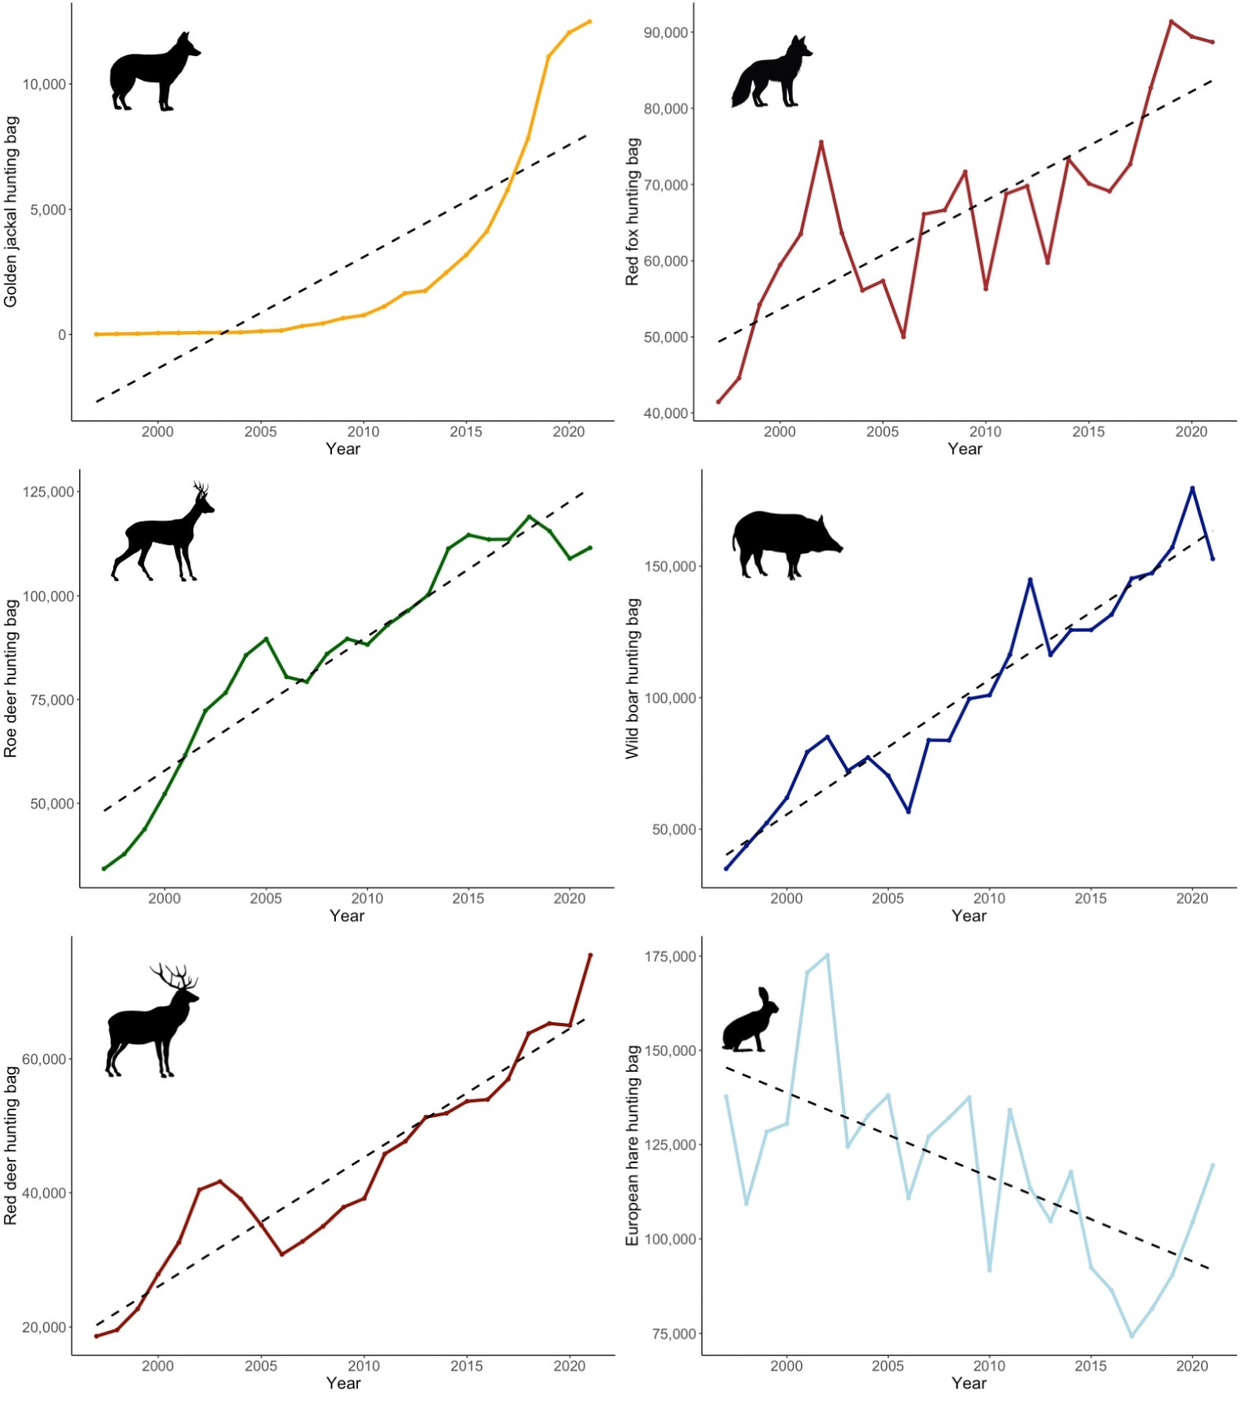
Figure S1 Hunting bag changes of the golden jackal, red fox, roe deer, wild boar, red deer, and European hare in Hungary from 1997–2021.

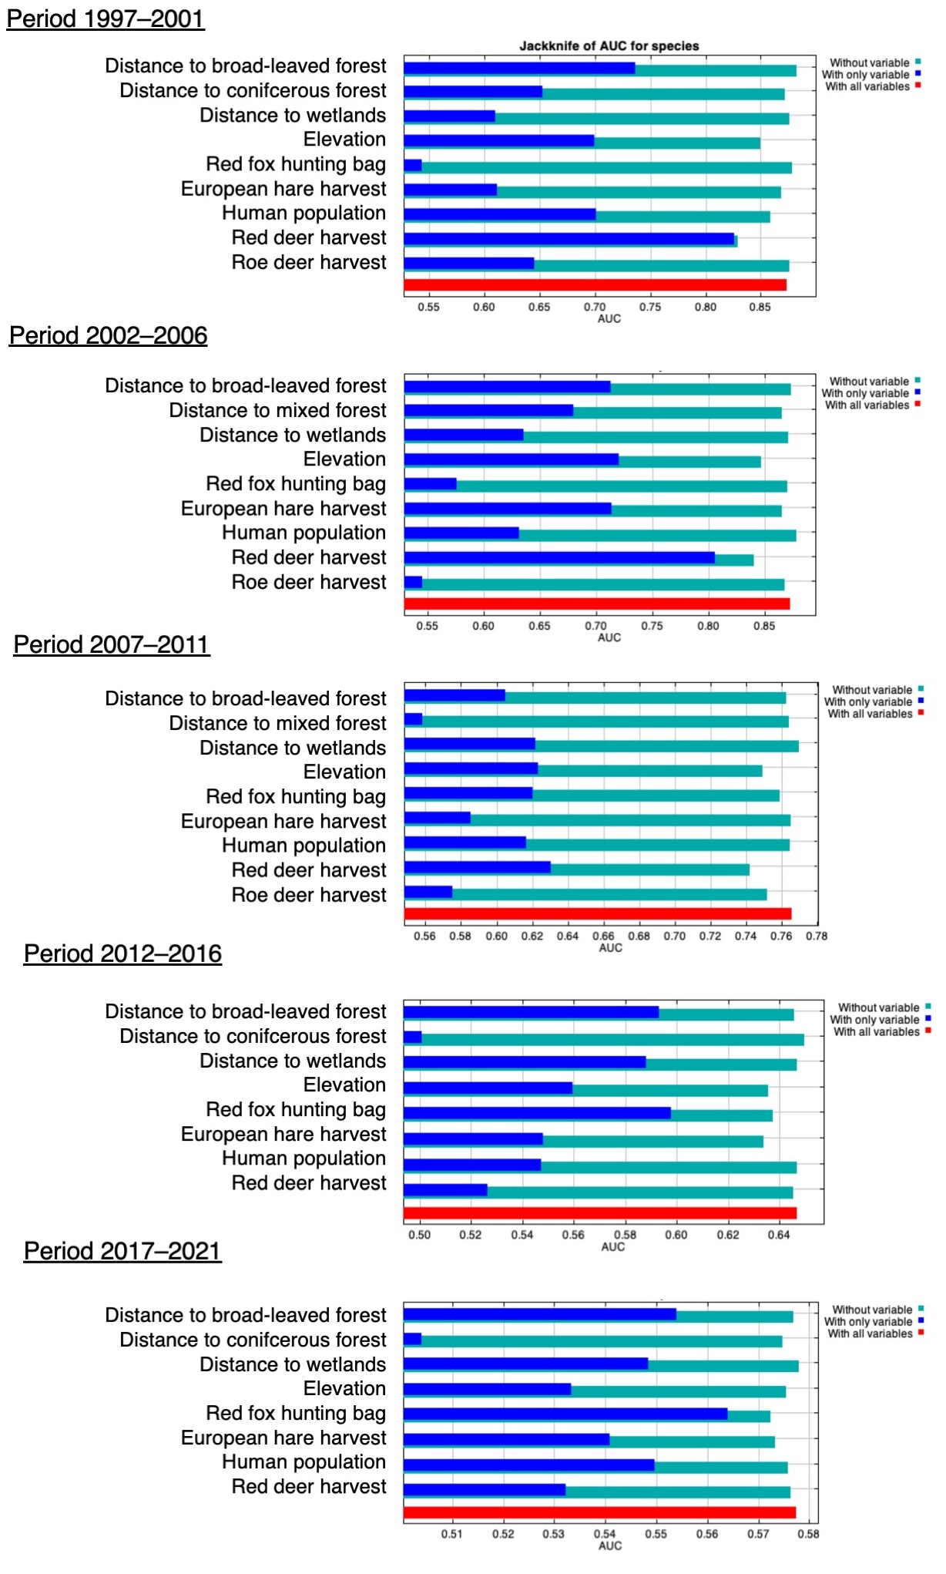
Figure S2 Results of the jackknife test of variable importance using AUC on test data across all five time periods.

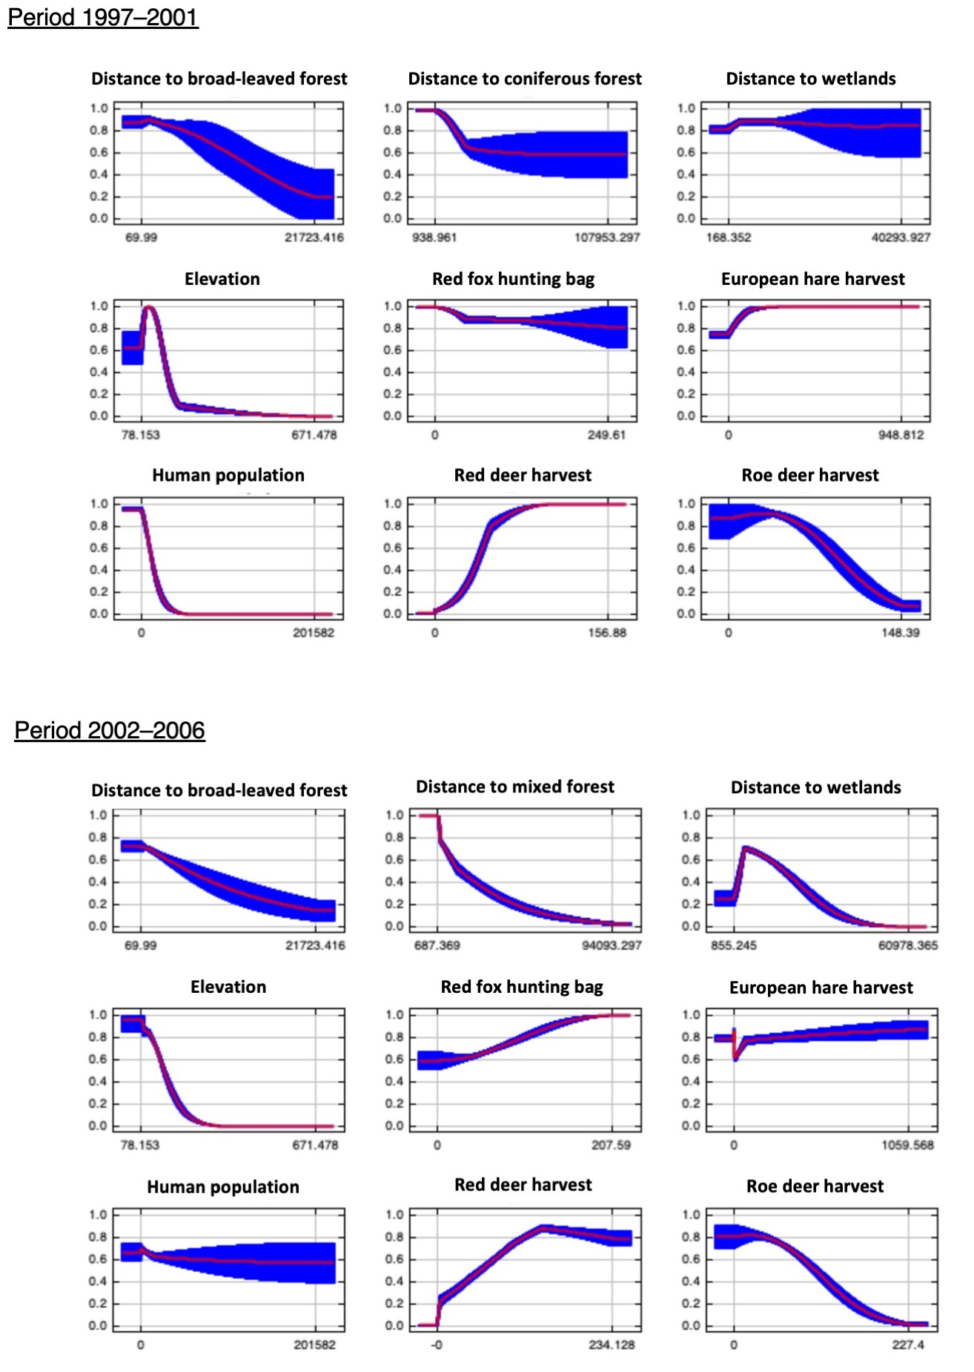
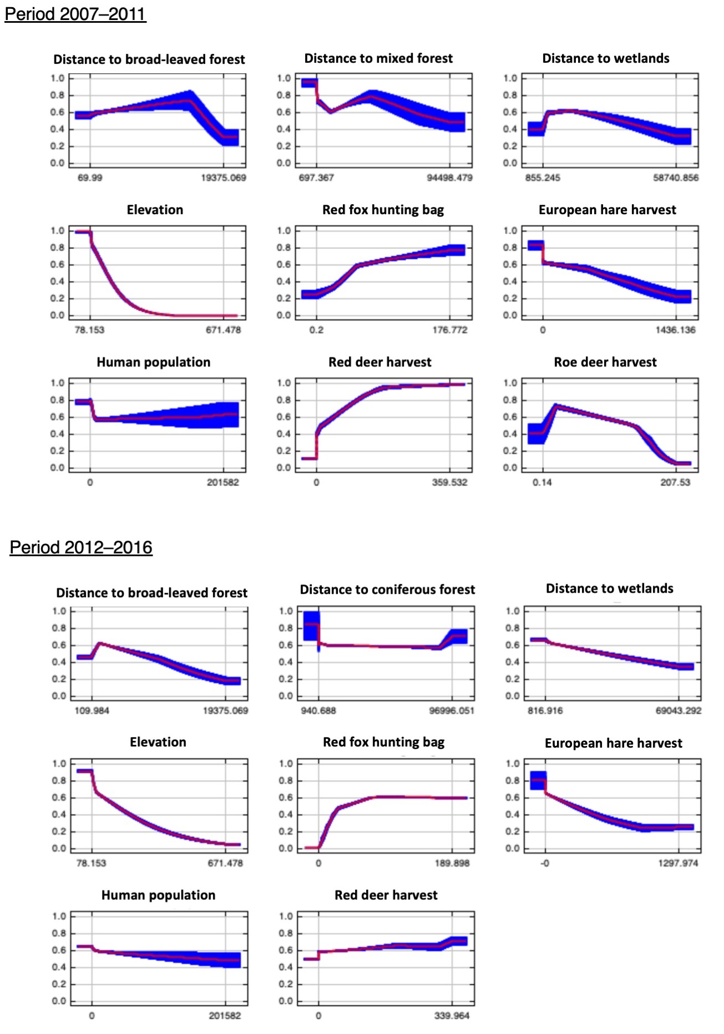
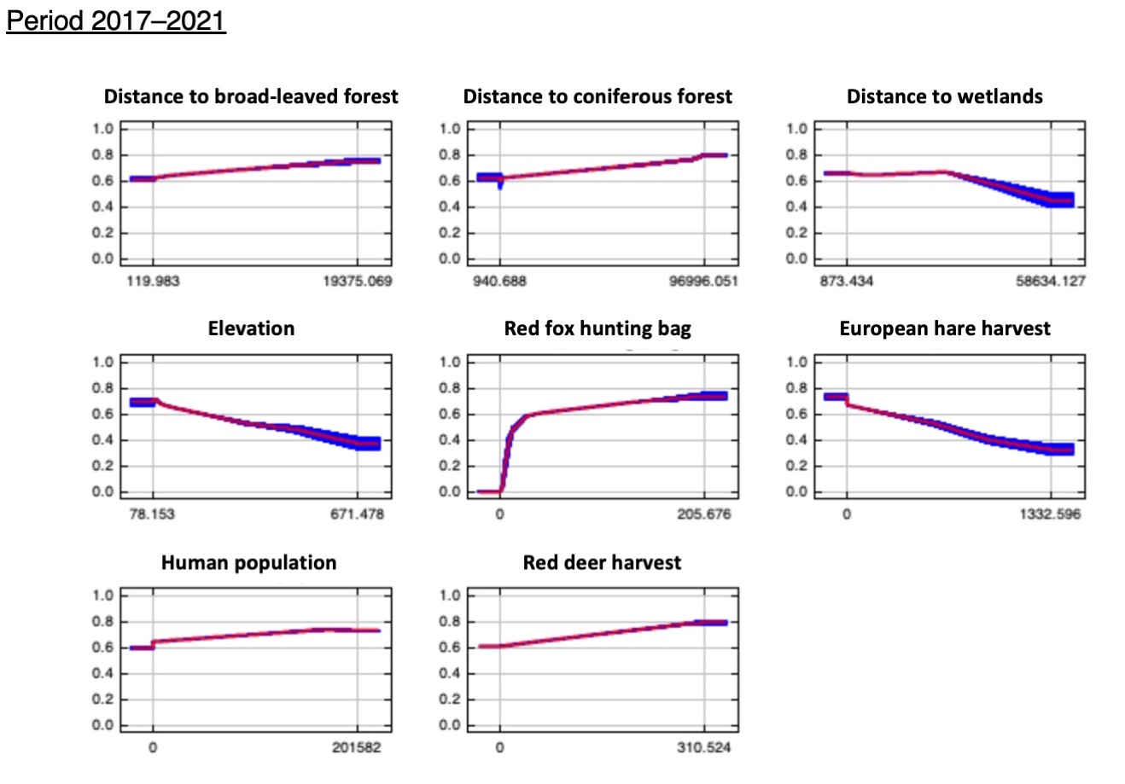
Figure S3 Response curves of the predicted probability of jackal presences with the mean response of the 10 replicates and the standard deviation across all five time periods.

