Supplementary Figures

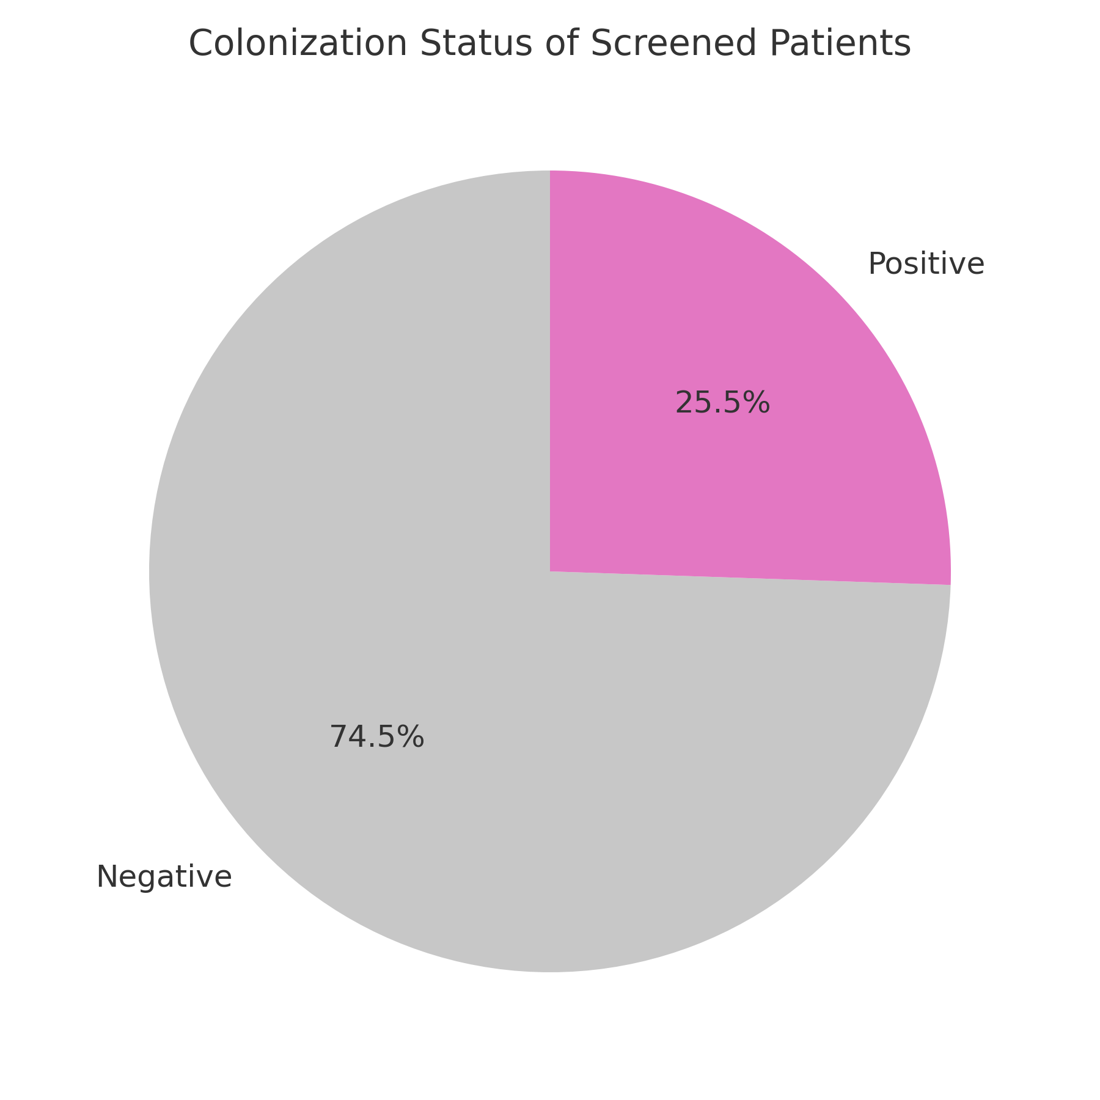
Supplementary Figure 1. Colonization status of collected swabs (swab-level analysis).

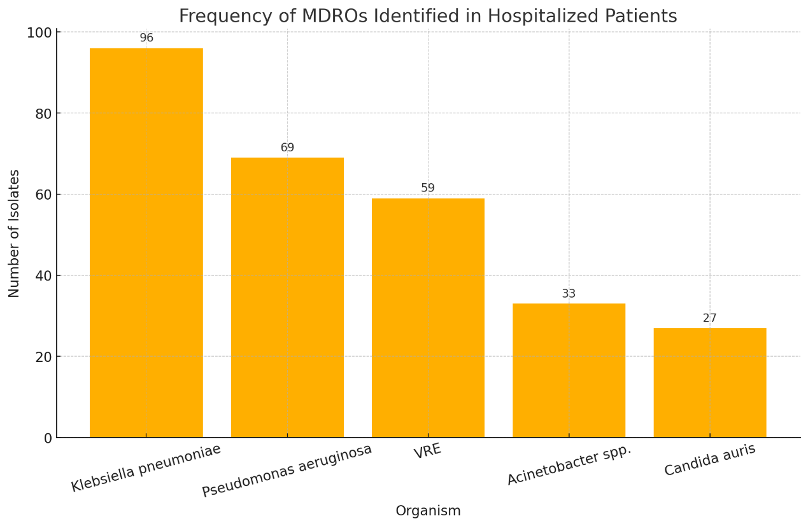
Supplementary Figure 2. Frequency of multidrug-resistant organisms (MDROs) identified during active surveillance.

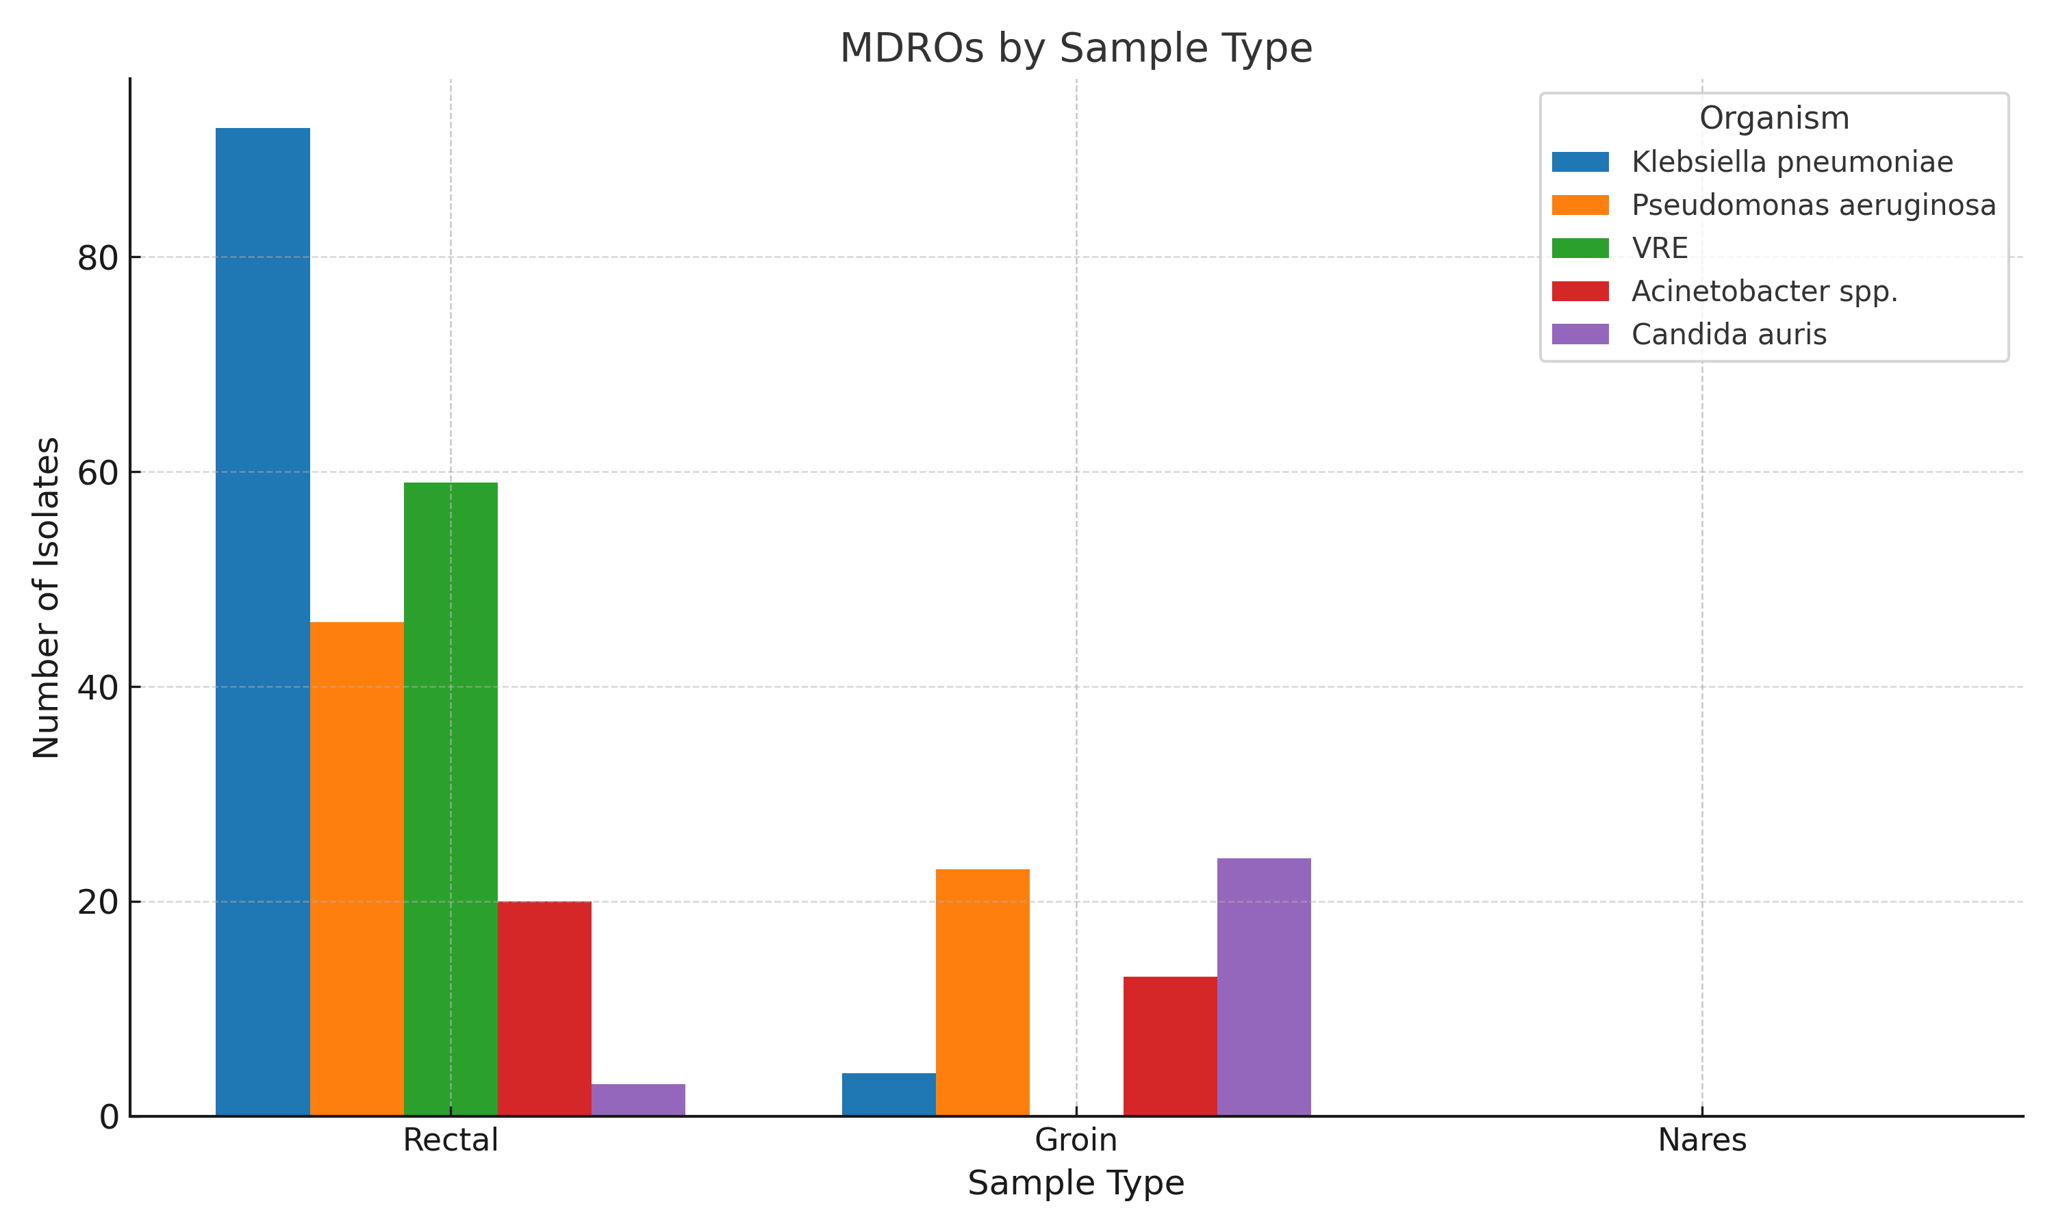

Supplementary Figure 3. Distribution of MDROs by sample type. Grouped bar chart illustrating the number of MDROs isolated from rectal, groin, and nasal swabs. Rectal swabs accounted for the majority of isolates, particularly in the case of K. pneumoniae, VRE, and P. aeruginosa. C. auris was predominantly recovered from groin swabs.

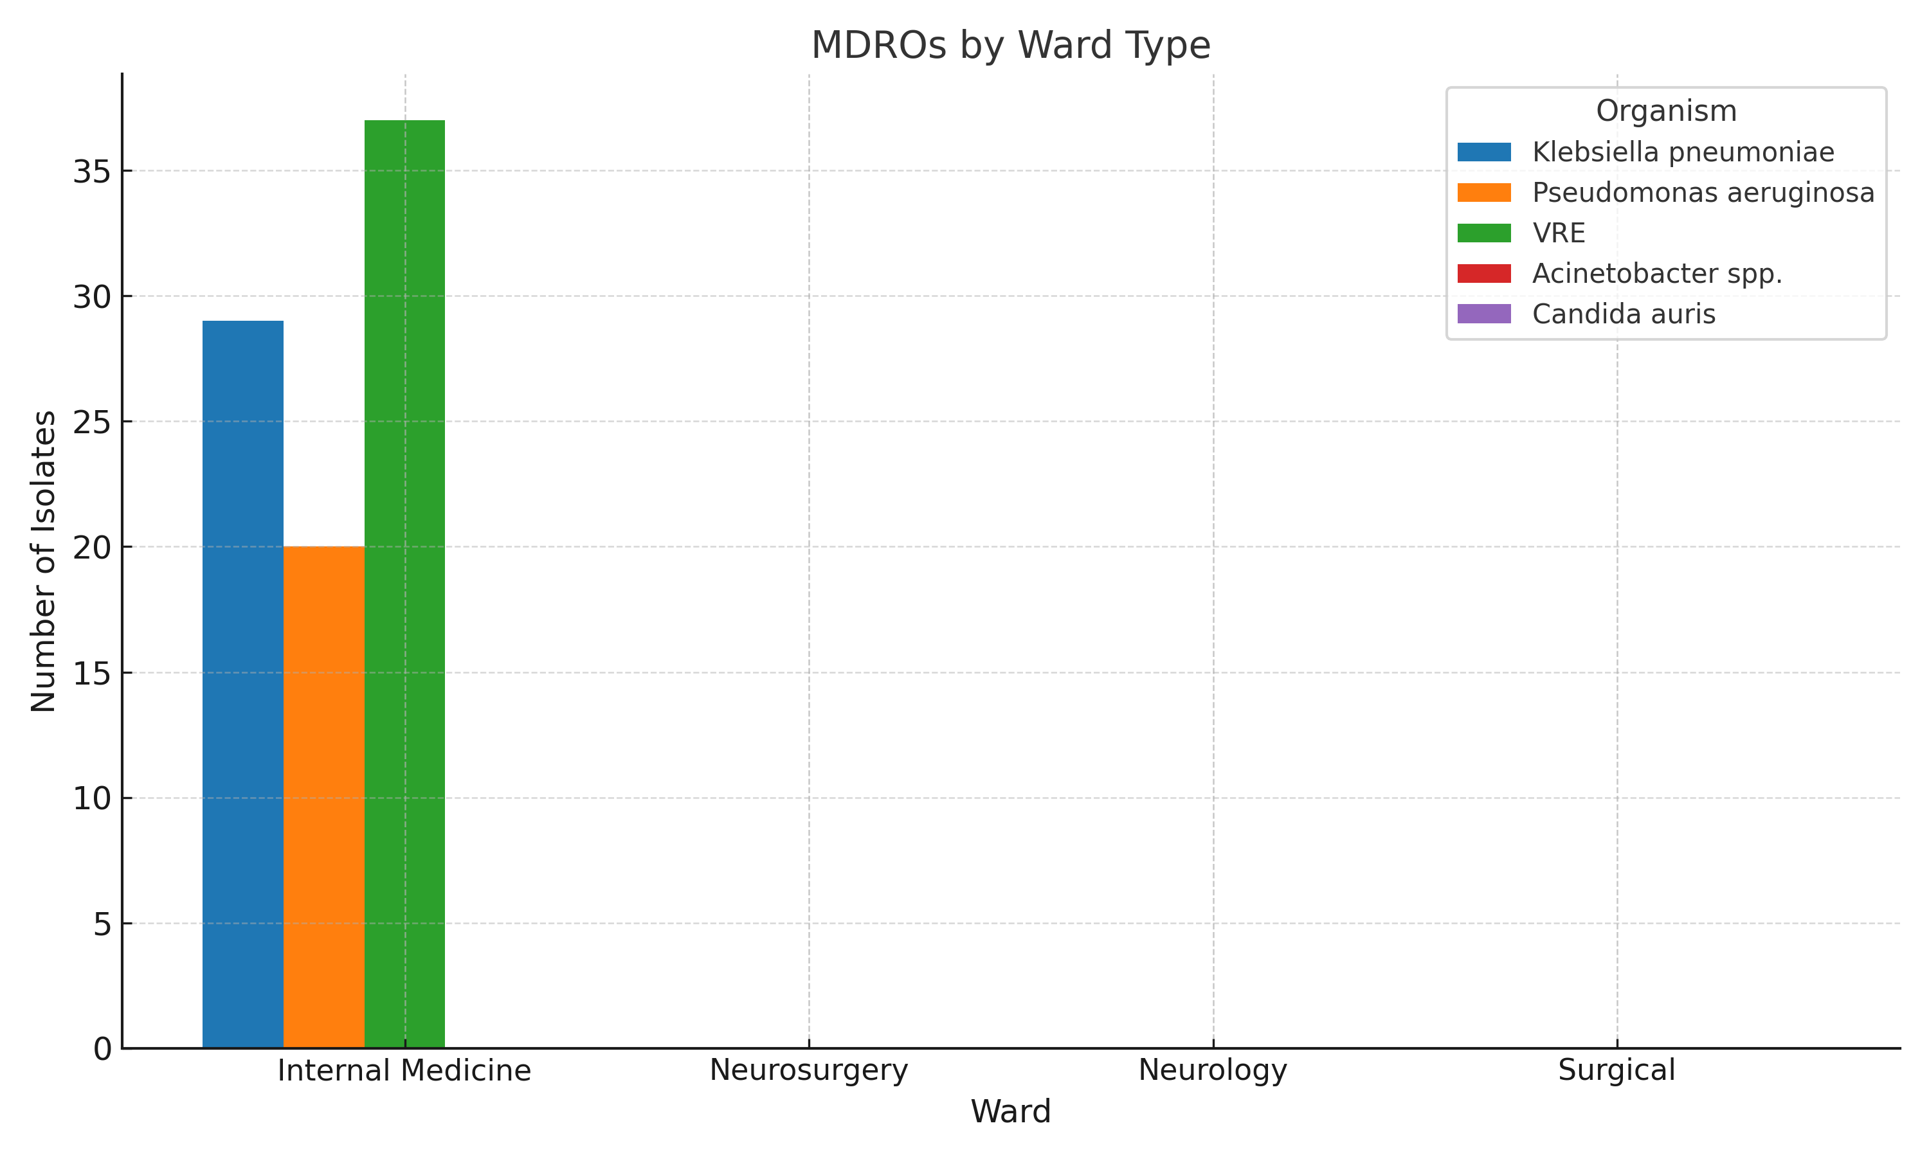
Supplementary Figure 4. MDRO distribution across hospital wards.

