Table S1. Comparisons of laboratory indicators and vital signs within 24 hours of ICU admission in all cohorts.
 | MIMIC-III | MIMIC-IV | P value
Laboratory test (Within 24h)
Albumin (Min, g/dL) | 2.75 ± 0.62 | 2.78 ± 0.64 | 0.544
Albumin (Max, g/dL) | 2.87 ± 0.61 | 2.93 ± 0.68 | 0.113
Total Bilirubin (Min, mg/dL) | 3.16 ± 4.73 | 2.68 ± 4.28 | 0.064
Total Bilirubin (Max, mg/dL) | 3.88 ± 5.27 | 3.23 ± 4.86 | 0.027
Creatinine (Min, mg/dL) | 1.19 ± 1.18 | 1.19 ± 1.03 | 0.979
Creatinine (Max, mg/dL) | 1.42 ± 1.35 | 1.47 ± 1.34 | 0.407
Hematocrit (Min, %) | 28.29 ± 5.95 | 28.24 ± 6.45 | 0.87
Hematocrit (Max, %) | 34.16 ± 5.60 | 32.24 ± 6.19 | <0.001
Hemoglobin (Min, g/dL) | 9.52 ± 2.01 | 9.17 ± 2.15 | 0.001
Hemoglobin (Max, g/dL) | 11.30 ± 1.94 | 10.46 ± 2.08 | <0.001
Platelets (Min, 10³/μL) | 191.41 ± 135.63 | 181.48 ± 122.62 | 0.138
Platelets (Max, 10³/μL) | 236.84 ± 153.87 | 218.40 ± 132.05 | 0.013
WBC (Min, 10³/μL) | 10.70 ± 8.51 | 11.25 ± 7.65 | 0.191
WBC (Max, 10³/μL) | 13.96 ± 10.15 | 15.51 ± 12.47 | 0.007
INR (Min) | 1.43 ± 0.66 | 1.46 ± 0.49 | 0.371
INR (Max) | 1.87 ± 2.27 | 1.70 ± 0.90 | 0.079
PT (Min, sec) | 15.35 ± 3.77 | 15.87 ± 5.32 | 0.029
PT (Max, sec) | 17.99 ± 9.61 | 18.54 ± 9.70 | 0.284
PTT (Min, sec) | 32.74 ± 13.79 | 32.99 ± 14.95 | 0.741
PTT (Max, sec) | 47.26 ± 31.43 | 44.34 ± 30.31 | 0.078
Glucose (Min, mg/dL) | 109.46 ± 32.70 | 114.16 ± 36.92 | 0.009
Glucose (Max, mg/dL) | 174.91 ± 79.68 | 178.84 ± 88.22 | 0.362
Glucose (Mean, mg/dL) | 138.21 ± 41.99 | 143.31 ± 51.23 | 0.033
Lactate (Min, mmol/L) | 2.39 ± 2.08 | 2.55 ± 2.55 | 0.293
Lactate (Max, mmol/L) | 4.33 ± 3.69 | 4.10 ± 3.94 | 0.334
Vital signs (Within 24h)
Heart Rate (Min, bpm) | 76.07 ± 17.30 | 76.75 ± 18.34 | 0.455
Heart Rate (Max, bpm) | 109.32 ± 20.01 | 110.85 ± 22.56 | 0.159
Heart Rate (Mean, bpm) | 90.92 ± 16.62 | 91.79 ± 17.64 | 0.322
SBP (Min, mmHg) | 91.64 ± 18.69 | 90.05 ± 17.99 | 0.09
SBP (Max, mmHg) | 144.63 ± 25.24 | 143.87 ± 22.70 | 0.542
SBP (Mean, mmHg) | 116.21 ± 17.90 | 114.95 ± 16.76 | 0.155
DBP (Min, mmHg) | 45.23 ± 12.41 | 48.81 ± 12.37 | <0.001
DBP (Max, mmHg) | 82.71 ± 16.92 | 90.10 ± 19.81 | <0.001
DBP (Mean, mmHg) | 61.68 ± 10.50 | 65.07 ± 11.42 | <0.001
MBP (Min, mmHg) | 59.05 ± 14.65 | 60.34 ± 14.89 | 0.086
MBP (Max, mmHg) | 103.20 ± 28.56 | 103.95 ± 24.17 | 0.585
MBP (Mean, mmHg) | 77.78 ± 11.77 | 78.54 ± 11.71 | 0.208
Respiratory Rate (Min, bpm) | 12.67 ± 3.86 | 12.56 ± 4.04 | 0.593
Respiratory Rate (Max, bpm) | 27.30 ± 6.40 | 29.64 ± 7.25 | <0.001
Respiratory Rate (Mean, bpm) | 19.20 ± 4.25 | 19.87 ± 4.21 | 0.002
Temperature (Min, °C) | 36.08 ± 0.76 | 36.44 ± 0.54 | <0.001
Temperature (Max, °C) | 37.37 ± 0.78 | 37.29 ± 0.65 | 0.028
Temperature (Mean, °C) | 36.74 ± 0.64 | 36.84 ± 0.41 | 0.001
Spo2 (Min, %) | 91.50 ± 8.60 | 90.58 ± 7.68 | 0.028
Spo2 (Max, %) | 99.33 ± 1.52 | 99.20 ± 1.48 | 0.081
Spo2 (Mean, %) | 96.83 ± 2.87 | 96.20 ± 2.61 | <0.001

Table S2. Performance of the prediction models using all features (with SMOTE).
Model | AUROC | AUPRC | Optimal  Threshold | Accuracy | F1 Score
Internal test
Logistic Regression | 0.857  (0.793, 0.919) | 0.713  (0.578, 0.833) | 0.561 | 0.827  (0.775, 0.879) | 0.694  (0.577, 0.789)
Random Forest | 0.888  (0.822, 0.937) | 0.772  (0.650, 0.880) | 0.430 | 0.850  (0.792, 0.902) | 0.717  (0.604, 0.812)
LightGBM | 0.893  (0.836, 0.939) | 0.773  (0.644, 0.877) | 0.230 | 0.850  (0.792, 0.902) | 0.729  (0.619, 0.817)
XGBoost | 0.858  (0.789, 0.921) | 0.727  (0.592, 0.842) | 0.324 | 0.850  (0.792, 0.902) | 0.717  (0.597, 0.810)
External test
Logistic Regression | 0.822  (0.781, 0.858) | 0.706  (0.644, 0.763) | 0.524 | 0.785  (0.754, 0.814) | 0.644  (0.587, 0.695)
Random Forest | 0.849  (0.815, 0.879) | 0.702  (0.633, 0.759) | 0.610 | 0.808  (0.779, 0.835) | 0.561  (0.494, 0.627)
LightGBM | 0.819  (0.780, 0.853) | 0.670  (0.599, 0.733) | 0.977 | 0.792  (0.763, 0.821) | 0.463  (0.390, 0.537)
XGBoost | 0.802  (0.766, 0.840) | 0.649  (0.577, 0.712) | 0.950 | 0.785  (0.756, 0.815) | 0.568  (0.502, 0.632)

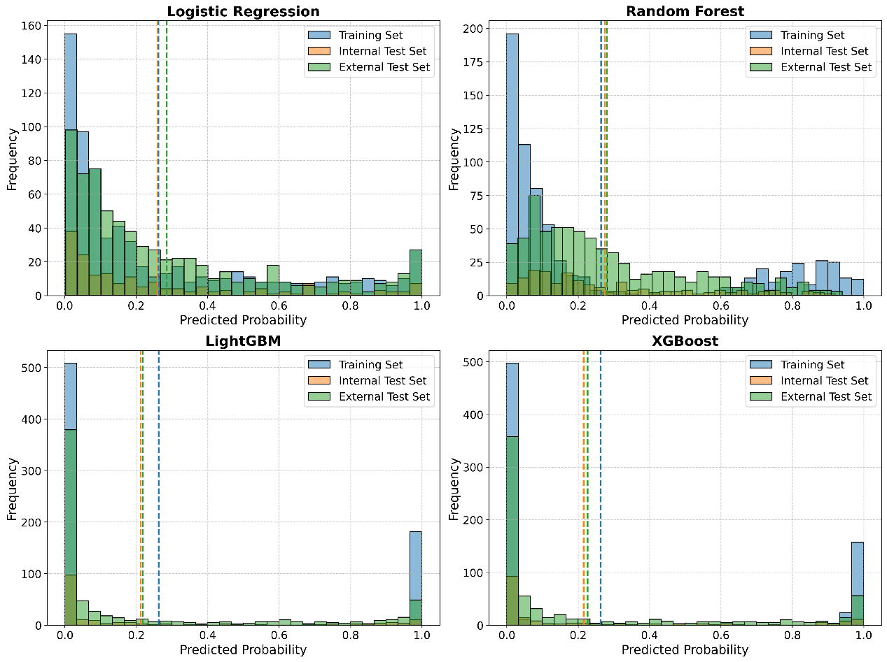
Figure S1. Distribution of predicted probabilities for the training set, internal test set, and external test set.

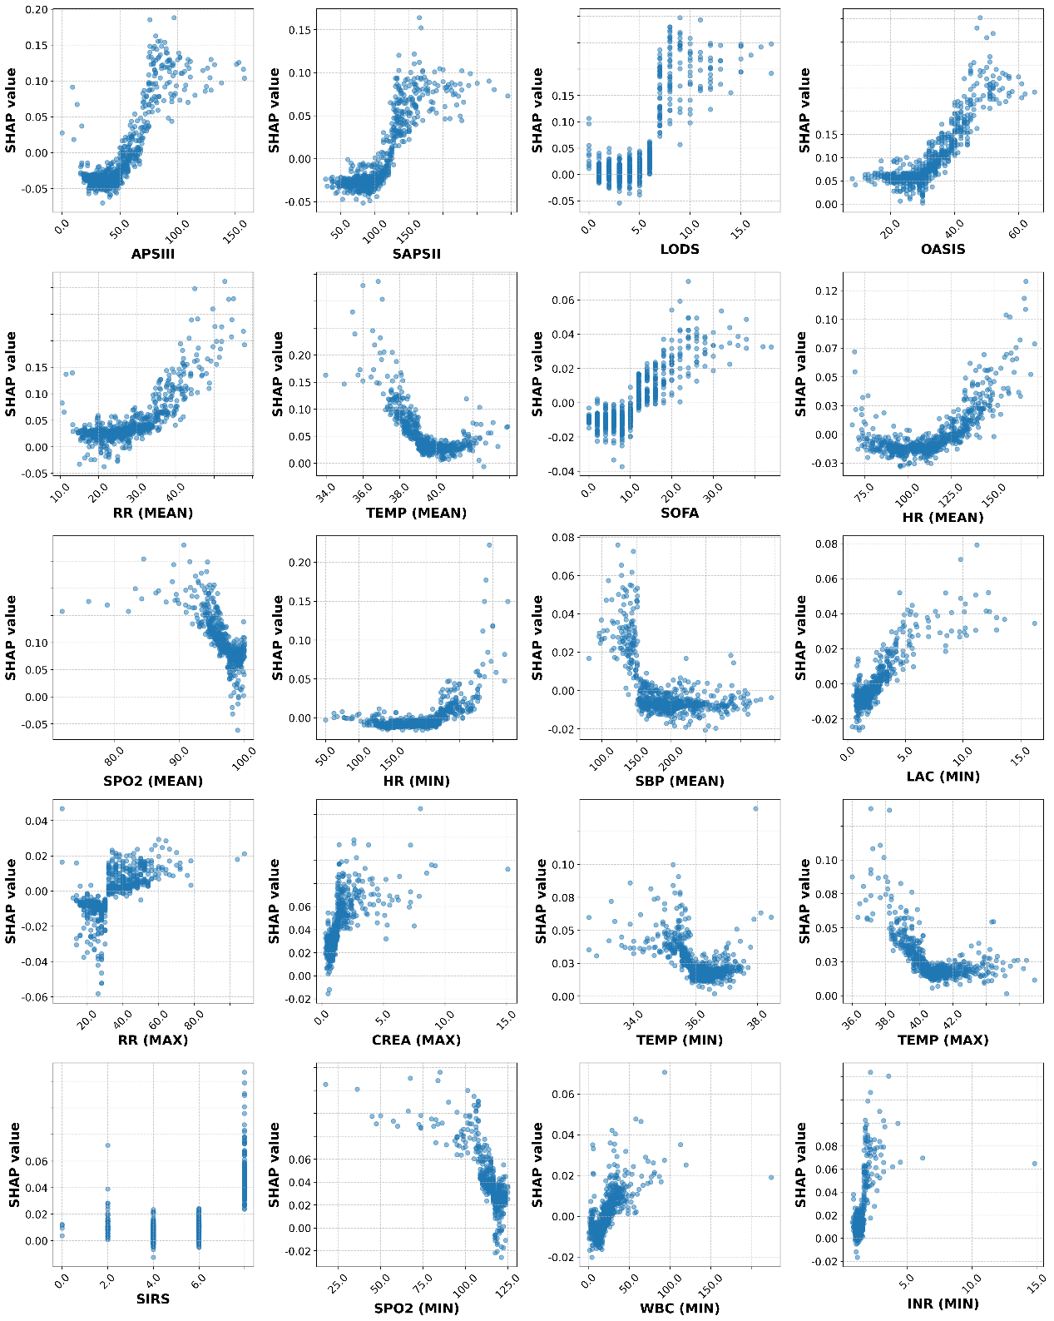
Figure S2. Scatter plots showing the relationship between feature values and SHAP values for the top 20 features in the training set.

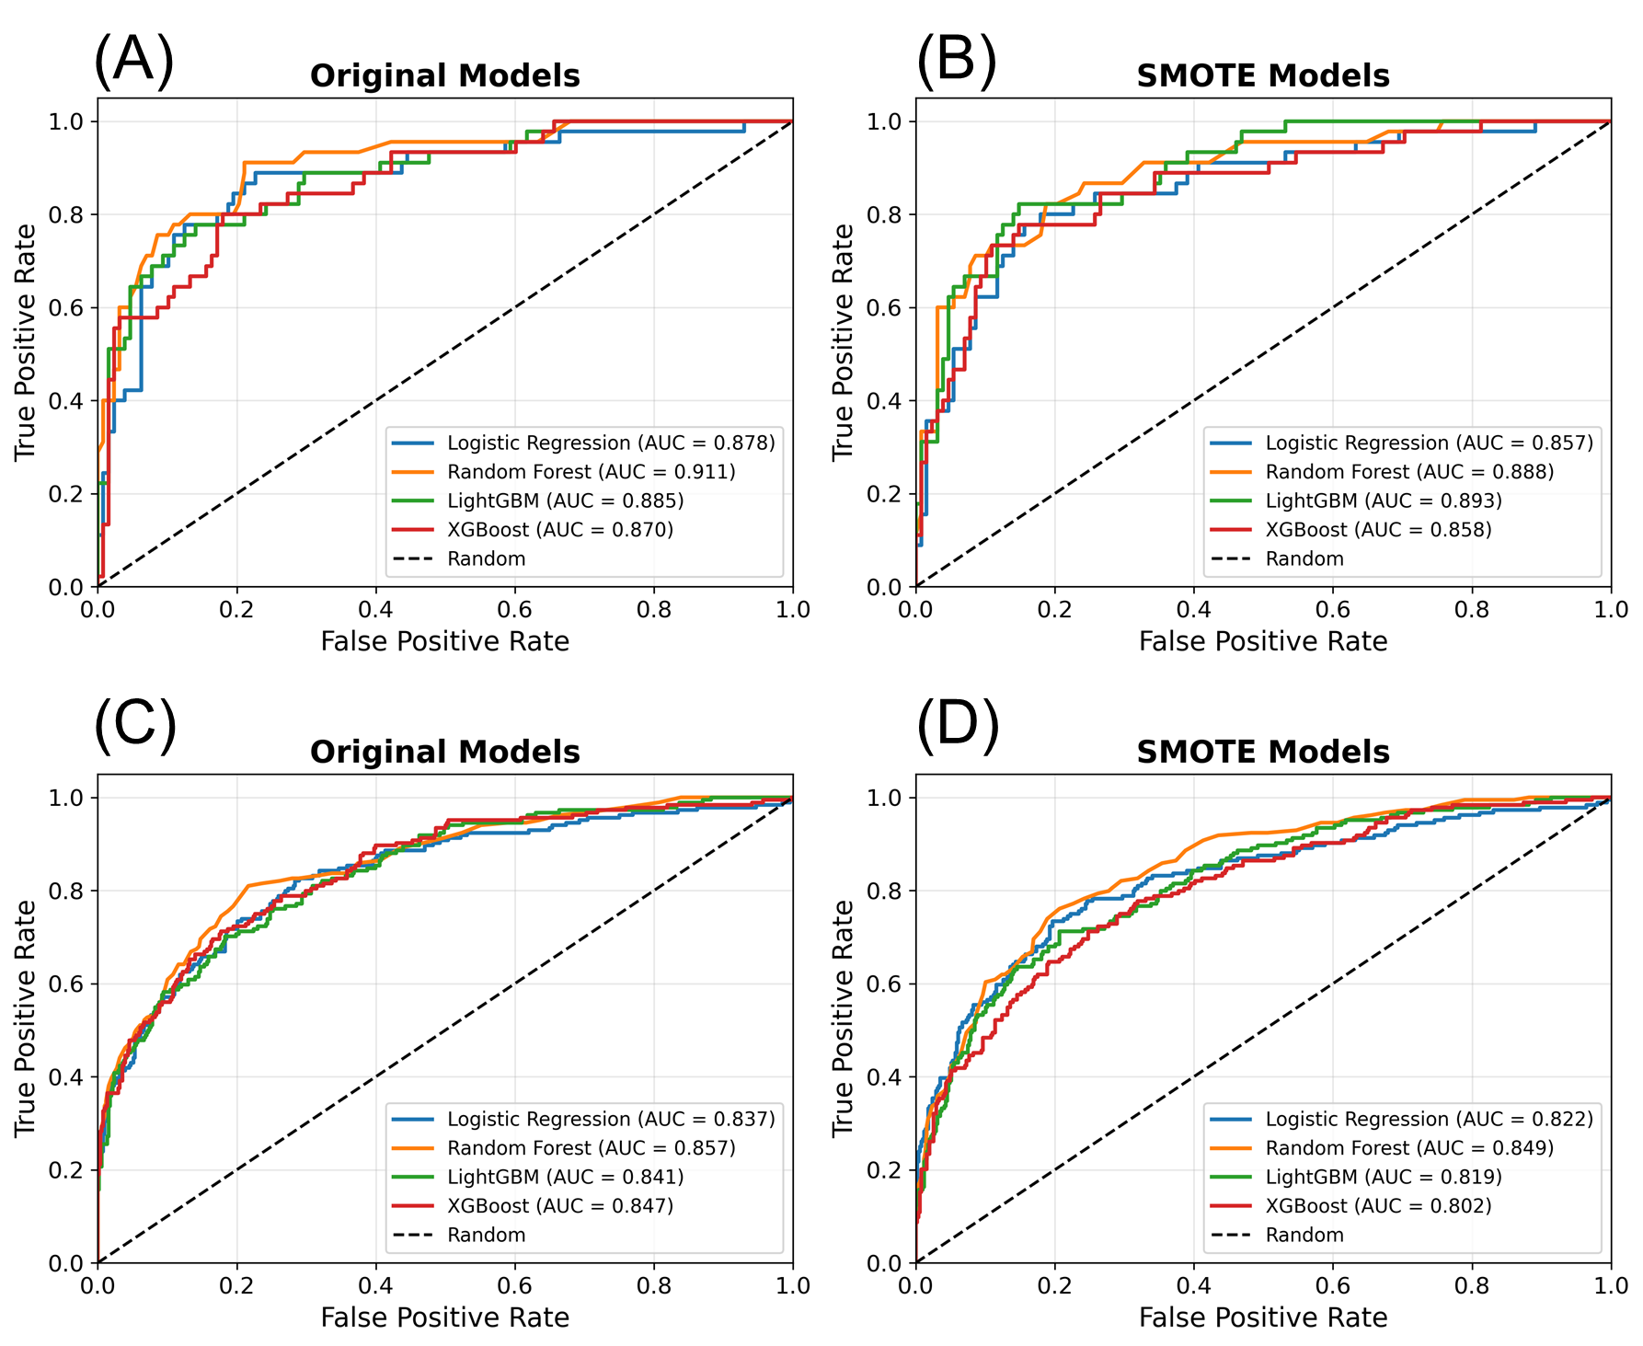
Figure S3. Receiver operating characteristic (ROC) curves of the four machine learning models (Logistic Regression, Random Forest, LightGBM, and XGBoost) before and after applying SMOTE for both internal and external validation sets. AUC indicates area under the ROC curve.

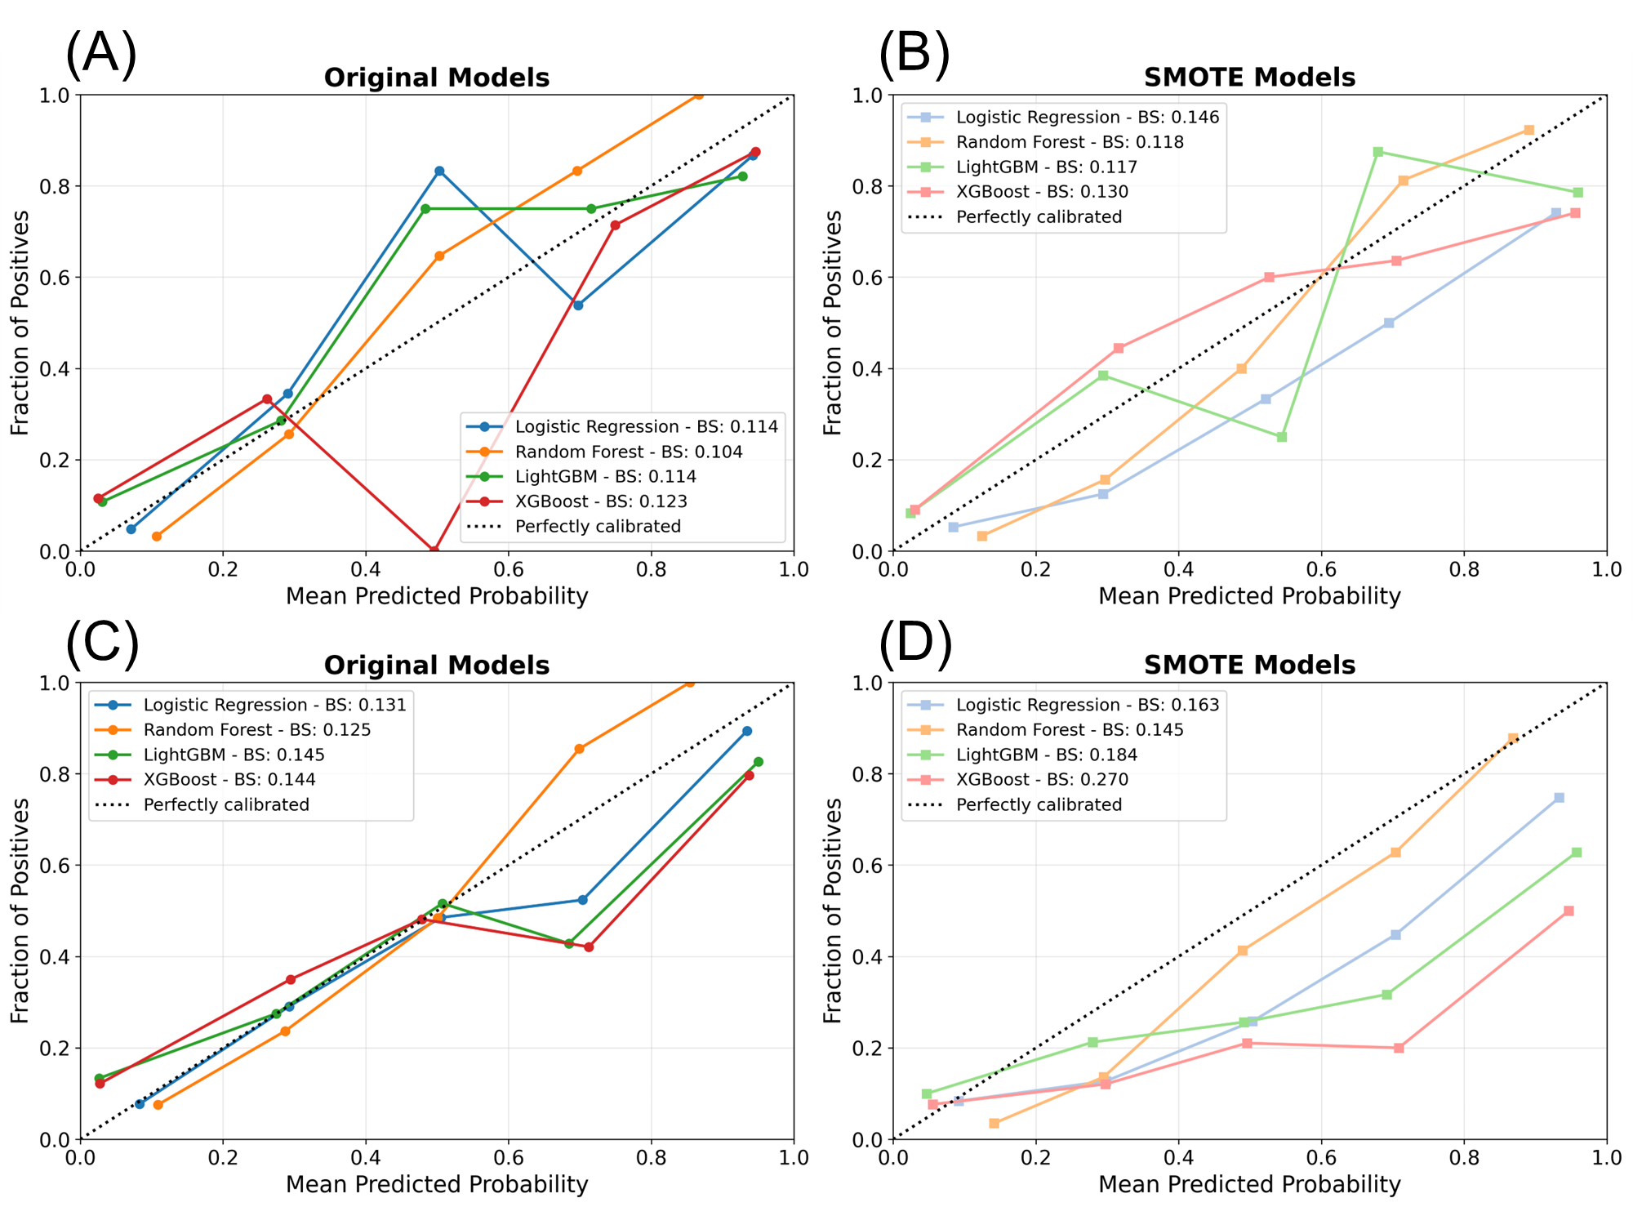
Figure S4. Calibration curves of the four machine learning models (Logistic Regression, Random Forest, LightGBM, and XGBoost) before and after applying SMOTE for both internal and external validation sets. BS indicates Brier Score.

