Supplementary material: 1
UKB study participants
(n= 502,408)

Consent withdrawn
& missing data
(n=4513)

Included
(n= 497,895)

Diabetes
(n=26,206)
No diabetes
(n=471,689)

Stroke
(n=5367)
MI
(n=2250)
Angina
(n=1958)
ESRD
(n=303)
Stroke
(n=771)
ESRD
(n=875)
Angina
(n=9220)
MI
(n=9198)

Figure 1: Flowchart of selection of study participants

Figure 2: Mean age of Myocardial infarction, angina, stroke, ESRD and diabetes diagnosis.
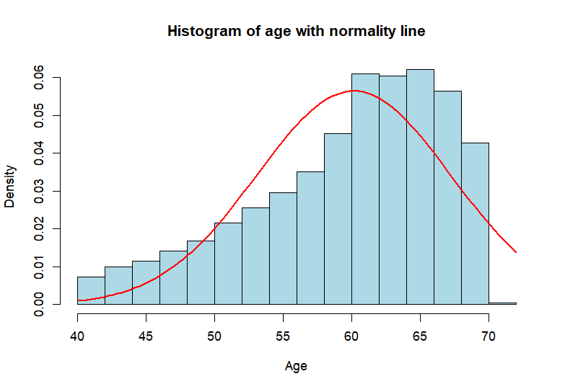

Figure 3: Histogram of age

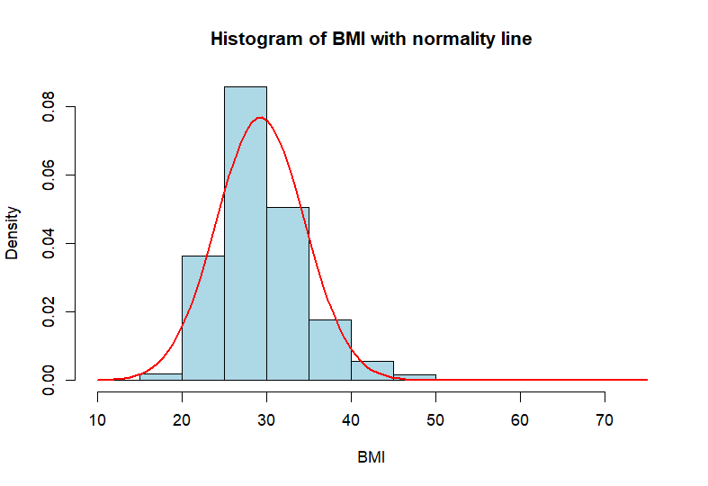
Figure 4: Histogram of BMI
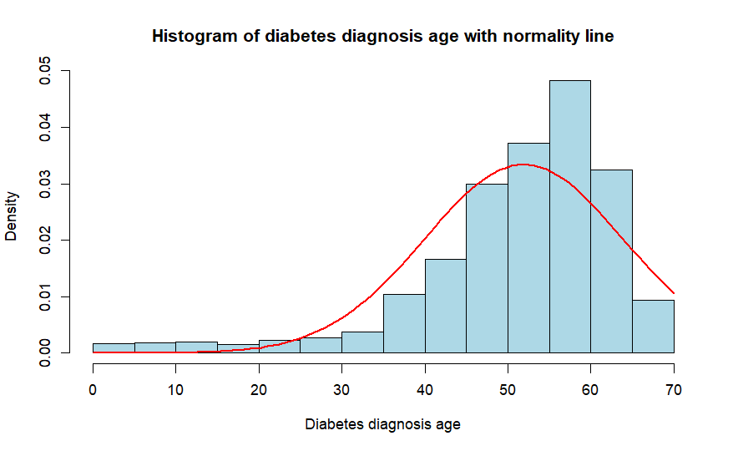
Figure 5: Histogram of diabetes diagnosis age

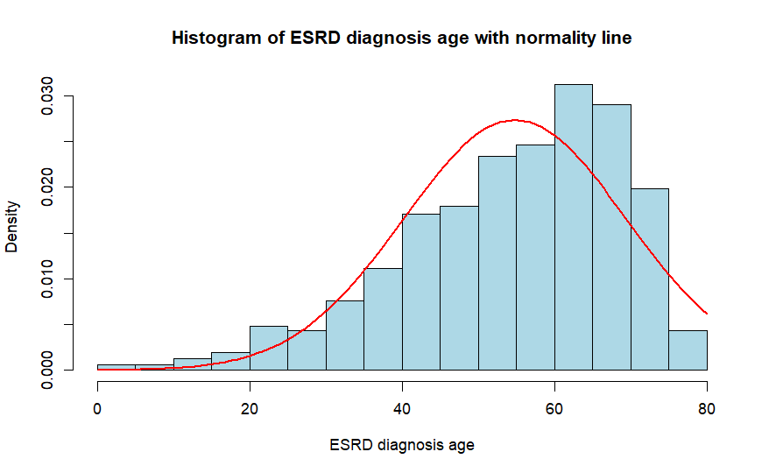
Figure 6: Histogram of hypertension diagnosis age

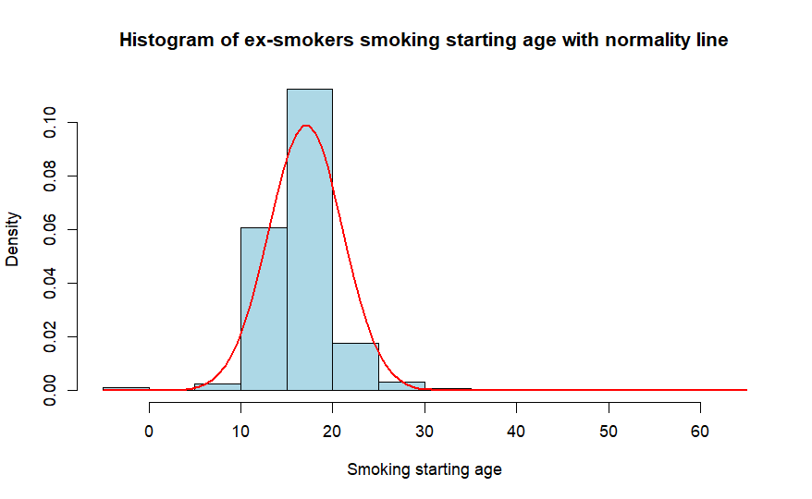
Figure 6: Histogram of ex-smokers smoking starting age

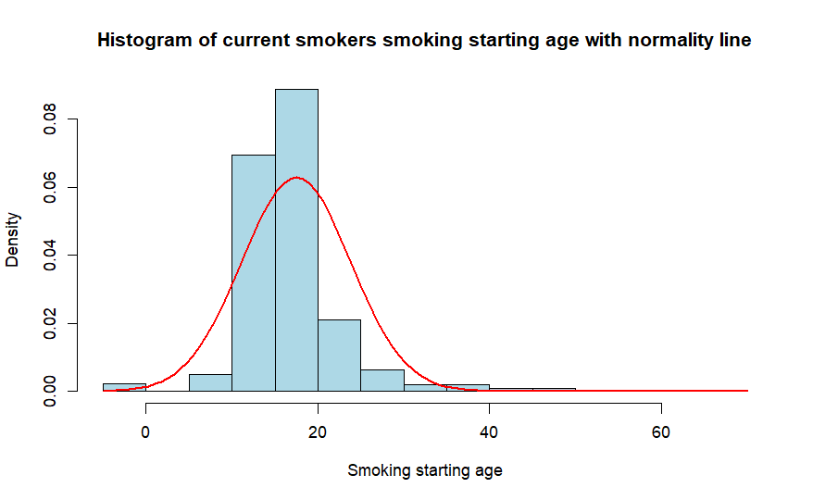
Figure 8: Histogram of current smokers smoking starting age

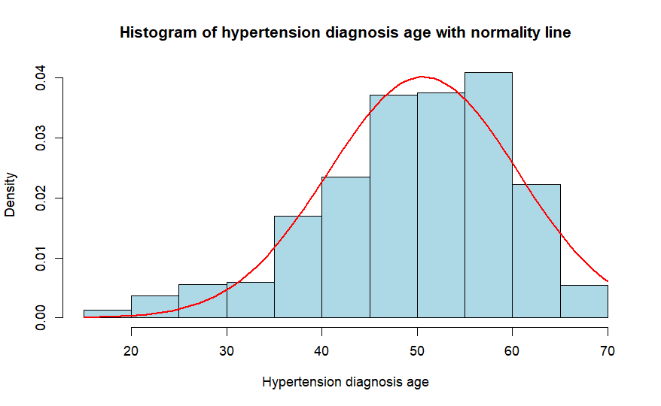
Figure 9: Histogram of hypertension diagnosis age

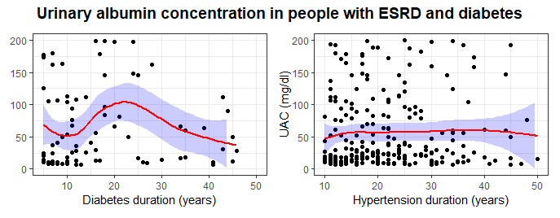
Figure 10: UAC values in people with diabetes and ESRD based on the duration of diabetes and hypertension

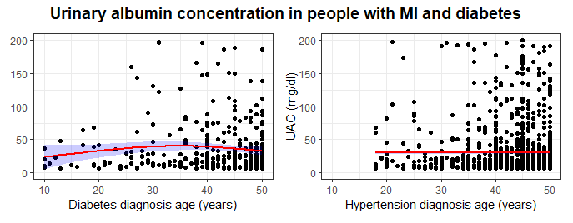
Figure 11: UAC values in people with diabetes, hypertension and myocardial infarction
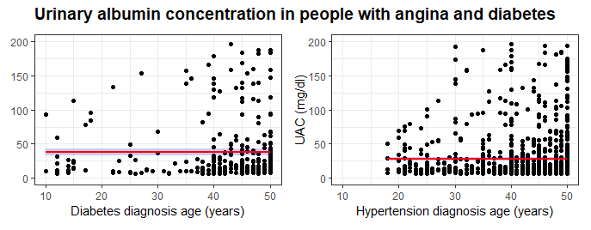
Figure 12: UAC values in people with diabetes and angina based on diabetes and hypertension diagnosis age

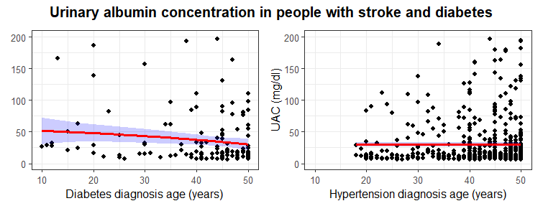
Figure 13: UAC values in people with diabetes and stroke based on diabetes and hypertension diagnosis age
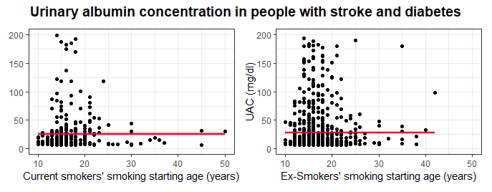
Figure 14: UAC values in people with diabetes and stroke based on smoking starting age

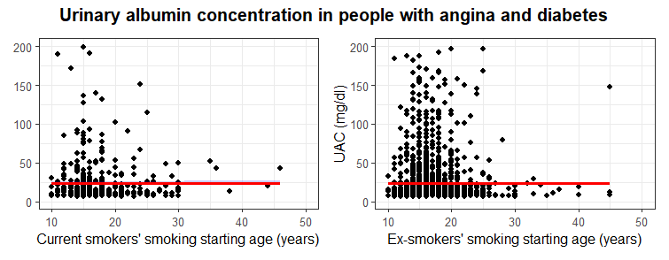
Figure 15: UAC values in people with diabetes and angina based on smoking starting age

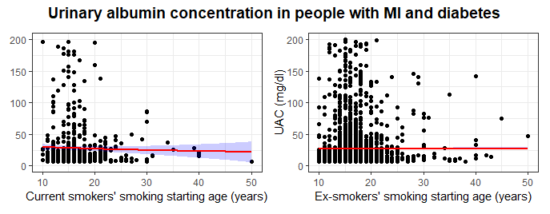
Figure 16: UAC values in people with diabetes and MI based on smoking staring age

Supplementary material 2: Missing data analyses

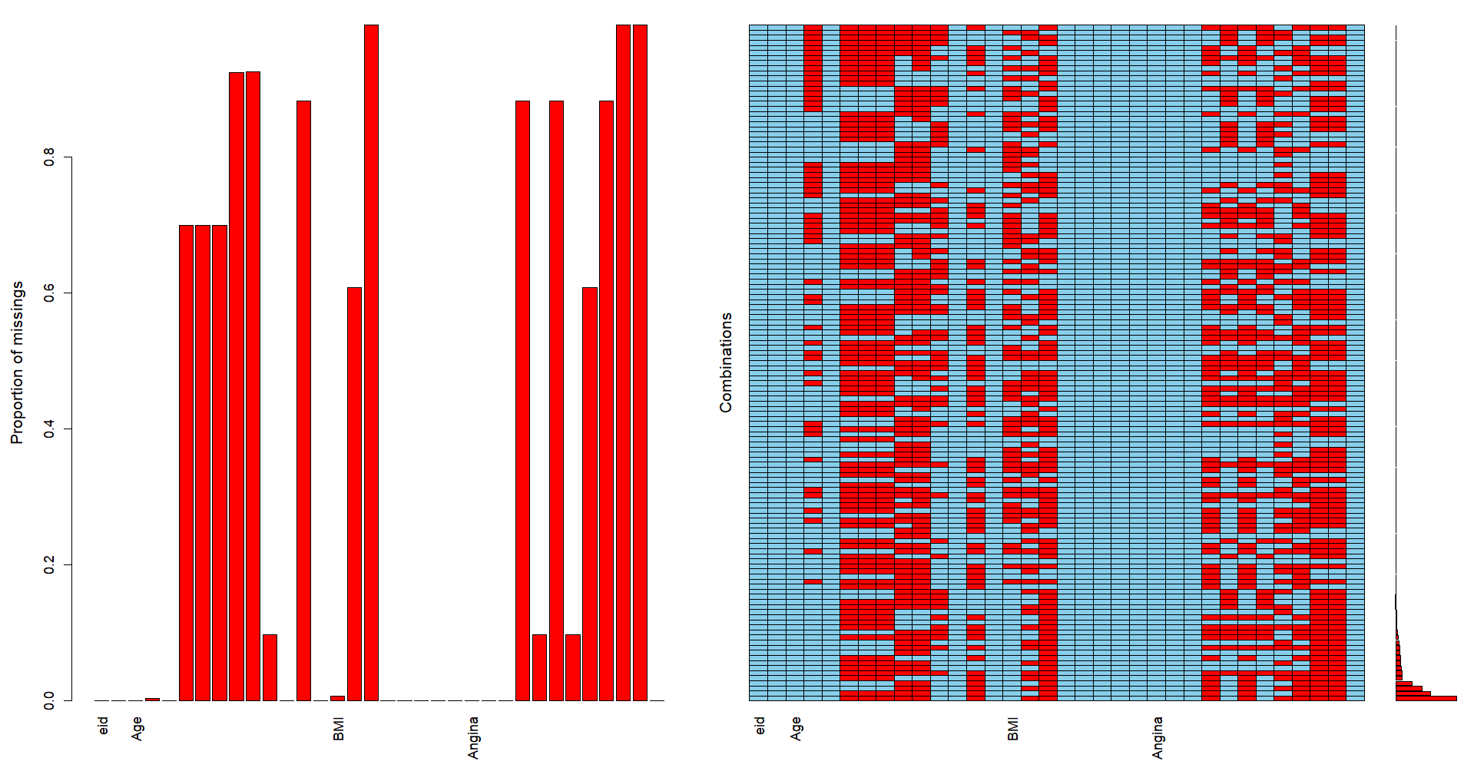
Figure 17: Multiple Imputation by Chained Equation (MICE) plot showing random distribution of missing data
Supplementary material 3: Concordance with the assumption of logistic regression
Independence of observations (Durbin-Watson Test)
Test results:
- DW statistic: 1.9989
- p-value: 0.4776
- Alternative hypothesis: True autocorrelation is greater than 0 (positive autocorrelation)
Interpretation:
- DW statistic:
The DW statistic ranges from 0-4
- A value near 2 suggests no autocorrelation
- A value significantly less than 2 suggests positive autocorrelation
- A value significantly greater than 2 suggests negative autocorrelation
Here the DW statistic is 1.9989, which is very close to 2, indicating little or no autocorrelation.
- p-value:
- The p-value (0.4776) is greater than common significance levels (e.g., 0.05 or 0.01), meaning that there is insufficient evidence to reject the null hypothesis.
- The null hypothesis is that there is no autocorrelation.

Conclusion:
- The Durbin-Watson test does not indicate significant autocorrelation in the residuals of the model.
- The residuals appear to be independent, suggesting that the assumption of no autocorrelation is likely to satisfied.

Multicollinearity (Variance Inflation Factor - VIF)
Test results:
Independent variable | Generalised VIF | Degree of freedom (DF) | GVIF^(1/2*DF)
DM diagnosis age group | 1.012 | 3 | 1.00
Sex | 1.029 | 1 | 1.01
Albuminuria diagnosis age group | 1.029 | 2 | 1.00

VIF values:
- Close to 1 indicates no multicollinearity.
- Between 1 and 5 suggests low to moderate multicollinearity.
- Above 5 indicate significant multicollinearity

Interpretation:
Generalised VIF of all three independent variables and the reciprocals are close to 1 suggests negligible multicollinearity.
Conclusion:
- VIF test shows that the models meet the logistic regression assumption of multicollinearity

Supplementary materials 4: UK Biobank codes
Data-Field – (Data used for this study - Instance 0)
Age diabetes diagnosed - Data-Field 2976
Diabetes diagnosed by doctor - Data-Field 2443
Medication for cholesterol, blood pressure, diabetes, or take exogenous hormones - Data-Field 6153
ESRD outcomes - Resource 8319
Age high blood pressure diagnosed - : Data-Field 2966
Age started smoking in current smokers - : Data-Field 3436
Age started smoking in former smokers - : Data-Field 2867
Age stopping smoking - : Data-Field 22507
Vascular/heart problems diagnosed by doctor - : Data-Field 6150

