Supporting Information
Hyperplastic Growth, Not Hydrostatic Distension, in Endolymphatic Hydrops in Humans Challenges the Classic View of Meniere’s Disease

Corey Bryton, Diana M. Correa, David Bächinger, Valentin Fankhauser, Nicole Kamber, MengYu Zhu, Jennifer T. O’Malley, Tyler T. Hickman, Paula Robles-Bolivar, Steven D. Rauch, Andreas H. Eckhard

Corresponding author:
Andreas H. Eckhard
Email: andreas_eckhard@meei.harvard.edu

This PDF file includes:
Supporting text (discussion)
Figures S1 to S5
Table S1 to S2
SI References

Supporting discussion
Origins of hypercellularity in hydropic epithelia.
The 4- to 7-fold increase in epithelial cell counts we observed in hydropic Reissner’s membrane (RM) and saccular membrane (SM) strongly suggests that intrinsically increased epithelial proliferation (hyperplasia) is the primary source of these additional cells. Ideally, this would be validated by e.g. demonstrating an increase in mitotic figures in hydropic epithelia compared to controls. However, several biological and methodological limitations inherent to our archival postmortem tissue specimens precluded such a mitotic index analysis. First, EH expansion likely follows saturating kinetics, meaning that specimens from late-stage disease—the stage represented by most of our archival material—exhibit approximately the same degree of maximal EH expansion. Consequently, the proliferation index in hydropic epithelia, presumably already low in the early, dynamic phase of EH development, has likely declined further, or even ceased entirely, by this late stage, making the presence of mitotic figures a relatively unlikely event. Second, the fact that our archival collection contains only every 10th tissue section (meaning only 10% of the total epithelium could be examined), combined with the historical choice of cross-sectional angles optimized to visualize the flat epithelium en face, further limits the chance of detecting mitotic figures.
While less likely, alternative biological mechanisms underlying the increased cell counts in hydropic epithelia include mesenchymal-epithelial transition (MET, [1]), where mesenchymal cells from the perilymph-facing surface of the RM and SM would adopt epithelial characteristics. However, the baseline mesenchymal cell numbers we quantified in RM and SM from control specimens (data not shown) are insufficient by a factor of 102 (data not shown) to account for the observed 4- to 7-fold cell increase in hydropic epithelia. Another possibility is bone marrow-derived cells or other cells migrating and transdifferentiating into epithelial cells [2]. However, such cell migration patterns should be readily apparent given the exposed, free-floating configuration of RM and SM within fluid spaces, but was not observed by us, particularly not in early-stage EH. Therefore, while other possibilities cannot be fully excluded, intrinsic epithelial proliferation (hyperplasia) remains the most plausible explanation for the observed hypercellularity. Definitive determination of the underlying mechanism will require in vivo animal studies employing lineage tracing and proliferation markers to distinguish between proliferation and other potential processes.
Cell spacing in hydropic epithelia.
The weak but significant correlation between cell spacing (internuclear distance) and epithelial length we observed in both Reissner's membrane (RM) (r² = 0.12, r = 0.35, p < 0.0001) and the saccular membrane (SM) (r² = 0.32, r = 0.57, p < 0.0001) (Figs. 3D and 3E) presents some interpretive uncertainty. Most likely this result is attributable to a methodological artifact. Specifically, with increasing EH severity, the expanding RM and SM epithelia come into closer proximity, and eventually abut, the surrounding tissues. In our digital image analysis workflow, this phenomenon ultimately resulted in increased pixel information noise (cell nuclei more challenging to delineate for machine-learning algorithm from surrounding tissue components), occasionally leading to missed nuclei, and artificially inflating cell spacing measurements. Consistent with this hypothesis, increase in cell spacing was most evident in the most severe EH cases upon visual inspection by the investigators. Other potentially relevant biological factors to consider that could lead to an increase in cell spacing are fluid pressure—via passive mechanical cell distension as proposed by the old model—and hypertrophy—via active increase in cytoplasm volume and membrane surface. While our findings challenge the concept of pressure as a primary pathological driver of EH, specifically refuting previously alleged pressure-induced epithelial ruptures, pressure may nonetheless play a role as an “intermediary”. In our model, disturbed fluid homeostasis (resulting from osmotic and fluid volume shifts due to endolymphatic sac dysfunction) leads to pressure changes that transduce this imbalance into a mechanical stimulus. This stimulus, in turn, may trigger the compensatory response, analogous to the effects of increased blood load in the heart [3] and urine load in the kidney [4]. Hypertrophy (increased cell size, membrane surface area, and gene expression contributing to functional compensation [5]), often synergistic with hyperplasia, represents another potential contributor to increased cell spacing. Our model explicitly considers for the first time hypertrophy as a possible phenomenon in hydropic inner ear epithelia. Hypertrophy, via increase in cytoplasm volume and membrane surface are, could potentially show up as elongated cells, leading to the same morphological changes (increased cell spacing) traditionally attributed to pressure-induced mechanical distension. However, inherent limitations in our use of postmortem tissue precluded definitive demonstration of hypertrophy in this study. Consequently, histological analysis alone cannot distinguish between passive pressure effects and active cell hypertrophy.
Mechanisms and sites of primary inner ear injury in secondary EH.
Secondary EH is typically diagnosed histopathologically when inner ear symptoms (not necessarily MD symptoms) and EH are observed alongside other conditions that affect the inner ear, including labyrinthitis, autoimmune diseases, and temporal bone trauma, and others [6]. While some of these conditions directly impact the ES—for example, temporal bone fractures disrupting the vestibular aqueduct [7], focal fibrous dysplasia [8], or meningiomas [9] destroying or compressing the ES—others likely exert their pathomechanistic effects at different inner ear sites, potentially involving diffuse or even sub-light microscopic damage. Consequently, the inner ear, including the ES, may even appear histologically unremarkable in some instances. Within our novel model of EH as a compensatory hyperplastic response to inner ear injury, we propose—analogous to chronic kidney disease, which can arise from a host of insults (inflammatory, traumatic, toxic, genetic)—that various agents can damage different and/or multiple cellular sites critical for inner ear homeostasis, all leading to the same (histologically) observable compensatory response: hyperplastic EH formation. Whether this response is also consistent at the molecular level requires further investigation. This model not only redefines EH as an active participant in the pathogenesis of these inner ear conditions, moving it beyond its previous label as a mere epiphenomenon [10], but also identifies EH as a unifying response to major injury of inner ear homeostatic functions, suggesting a common pathogenic mechanism shared by MD and other seemingly disparate inner ear conditions.

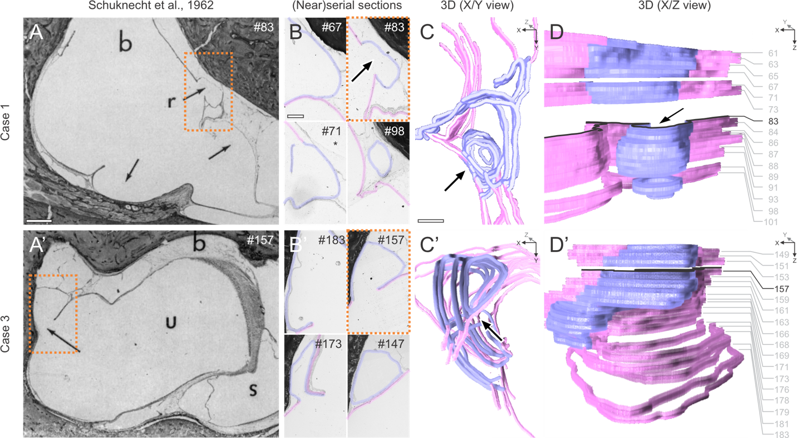
S1 Fig. Reinterpretation of previously reported "ruptures" in hydropic epithelia. (A, A′) Original images from [11]; reproduced with permission from SAGE Publishing) showing areas within hydropic epithelia previously interpreted as ruptures (arrows) in two MD patient temporal bones. (B, B′) Adjacent tissue sections from these archival specimens (64 and 67 years old) were retrieved, mounted, digitized, and segmented. Alleged rupture sites (light blue) and neighboring epithelial regions (pink) were reconstructed in 3D (680 μm and 800 μm depth, respectively). (C, C′, D, D′) X/Y projections (C, C′; arrows indicate alleged ruptures) and Z/Y projections (D, D′) reveal no evidence of epithelial discontinuity but rather puckering and outfolding. Scale bars: (A, A′), 500 μm; (B, B′), (C, C′), 200 μm.
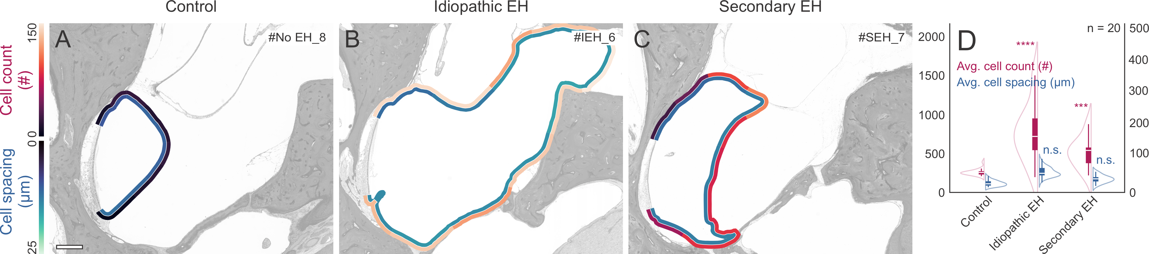
S2 Fig. Saccular membrane (SM) epithelial cell counts and cell spacing were quantified in specimens from control (EH-negative), idiopathic EH, and secondary EH groups. (A–C) Heatmaps overlaying SM show cell counts (outer heatmaps) and cell spacing (inner heatmaps) per 10% membrane segment. (D) Group averages for cell counts and cell spacing. **** P < 0.0001, *** P < 0.001, n.s. = not significant. Scale bar, 500 μm.

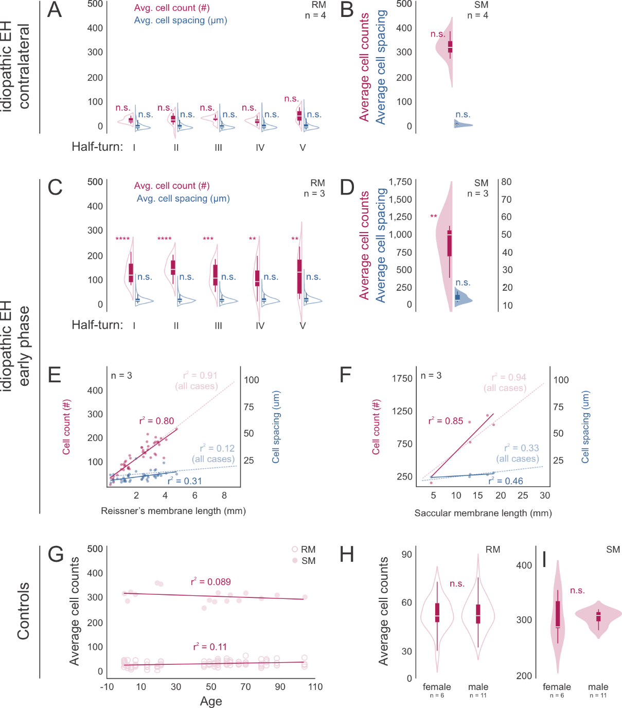
S3 Fig. Cellularity in contralateral ears of MD patients, early-stage idiopathic EH, and controls (EH-negative). (A, B) In donors with unilateral idiopathic EH and a clinical history of MD, contralateral (no MD, no EH) ears show RM (A) and SM (B) cell counts and cell spacing in each cochlear half-turn that are not significantly different from the no EH control group (Fig. 2A′, SI Appendix, Fig. S3D). (C, D) Early-stage idiopathic EH (clinical MD) donors, exhibiting episodic symptoms and milder EH, show RM (C) and SM (D) cell counts and cell spacing. (E, F) Cell counts and cell spacing are plotted against membrane length in RM (E) and SM (F), with the entire idiopathic EH cohort (all cases combined) shown for comparison. (G) In individuals without EH or documented inner ear disease (controls), correlations of average RM/SM cell counts with donor age (gestational week 28 to 104 years) are shown. (H, I) Distribution of average cell counts as a function of sex. **** P < 0.0001, *** P < 0.001, ** P < 0.01, n.s. = not significant.
S4 Fig. Machine-learning (ML) model training, validation, and data analysis workflow. (A– E′′) To train our U‐Net‐based ML model for segmenting epithelial cell nuclei in Reissner’s membrane (RM) and the saccular membrane (SM), we manually annotated nuclei in both membranes from a range of archival human inner ear specimens covering over 40 years of storage. This broad timespan led to variability in H&E staining intensity and tissue artifacts (e.g., yellowing mounting media, fading HE staining). Hence, we curated two separate training datasets—one comprising more recent specimens and the other encompassing older, more artifact-prone specimens—to ensure robust model performance (E–E′′). (F–G) Model validation was carried out on an independent heterogeneous dataset of RMs. Three investigators manually labeled >1,200 nuclei, serving as ground truth. A custom Python script employed a heuristic nearest‐neighbor approach to match centroid coordinates between the ML‐based segmentation and the investigator annotations, generating confusion matrices for matched and unmatched nucleus counts (F). The model yielded high precision, recall, F1 scores, and accuracy when compared to each investigator, reflecting a close match to human expert segmentation (G). (H– N′′) After training, the ML model was applied to each cross‐sectioned RM (H) and SM (analogous method was applied, therefore not shown here) in the study dataset. Each membrane outline (RM outlined yellow, I) and its adjacent endolymph space (blue, I) were traced. To count only epithelial nuclei directly bordering to the endolymph space, the latter was “dilated” (kernel size of 19 px; K, blue arrows). Dust or minute artifacts were removed if they had fewer than 10 pixels (yellow in M), and elongated mesenchymal nuclei were excluded if they exceeded a Feret diameter of 10 µm (green in M). This filtration in particular helped avoid double-counting multiple epithelial nuclear rows in tangentially sectioned membranes (especially in hydropic areas), confining the analysis to a single row of epithelial nuclei (N–N′′). (O–R) We exported the centroid (X/Y) coordinates of counted epithelial nuclei as .csv files for subsequent analysis (O). A custom Python script identified the start and end centroids (e.g., limbal to strial edges for RM) and reordered the coordinates into a path (P). Each RM or SM segment was then subdivided into 10 equal subsegments, and for each subsegment we calculated the average number of cell nuclei (cell counts) and their average cell spacing (Q). These values, averaged over three microscope images per specimen and over entire study groups, were visualized as heatmaps that were overlaid on the original microscope images to show spatial patterns of cell density (R). Scale bars: (E–E′′, N–N′′), 20 µm.
Fig. S5. Negative control and γENaC immunolabeling in cochlear and saccular membranes. (A) Negative control (primary antibody omitted) in basal cochlear duct of case IEH-6 (non-hydropic left ear) showing RM (arrowheads) without signal. (B) H&E-stained saccule from the same case with artifactual displacement of SM (arrowhead); black dotted line marks its normal position. (C) γENaC immunolabeling of the same SM showing intense, continuous staining; (C′) contralateral hydropic SM with similar staining. Scale bars: (A) 200 µm; (B) 100 µm; (C, C′) 50 µm.

S1 Table. Medical record data associated with human temporal bone specimens.

Study group | Case # | Age  (years) | Sex | Otological diagnosis | Time from diagnosis to death (years) | Specimen side | ES pathology
EH-negative (control) | No EH_1 | 0 * | Unknown | None | N.a. | R | None
EH-negative (control) | No EH_2 | 0.003 | M | None | N.a. | R | None
EH-negative (control) | No EH_3 | 1.83 | M | None | N.a. | R | none
EH-negative (control) | No EH_4 | 3.75 | M | None | N.a. | L | None
EH-negative (control) | No EH_5 | 6.37 | M | None | N.a. | R | None
EH-negative (control) | No EH_6 | 13 | F | None | N.a. | L | None
EH-negative (control) | No EH_7 | 19 | F | None | N.a. | R | None
EH-negative (control) | No EH_8 | 21 | F | None | N.a. | R | None
EH-negative (control) | No EH_9 | 46 | F | None | N.a. | R | None
EH-negative (control) | No EH_10 | 49 | F | None | N.a. | L | None
EH-negative (control) | No EH_11 | 52 | M | None | N.a. | R | None
EH-negative (control) | No EH_12 | 54 | M | None | N.a. | L | None
EH-negative (control) | No EH_13 | 59 | F | None | N.a. | R | None
EH-negative (control) | No EH_14 | 61 | M | None | N.a. | R | None
EH-negative (control) | No EH_15 | 66 | F | None | N.a. | L | None
EH-negative (control) | No EH_16 | 70 | M | None | N.a. | L | None
EH-negative (control) | No EH_17 | 79 | M | None | N.a. | L | None
EH-negative (control) | No EH_18 | 82 | F | None | N.a. | L | None
EH-negative (control) | No EH_19 | 88 | M | None | N.a. | R | None
EH-negative (control) | No EH_20 | 104 | M | None | N.a. | R | None
Idiopathic EH | IEH_1 | 58 | M | Bilateral MD | 26 (R, L) | R + L | Degeneration
Idiopathic EH | IEH_2 | 65 | F | Bilateral MD | 6 (R, L) | R + L | Hypoplasia
Idiopathic EH | IEH_3 | 71 | M | Right MD | 11 | R | Degeneration
Idiopathic EH | IEH_4 | 81 | M | Bilateral MD | 24 (L)  26 (R) | R + L | Hypoplasia
Idiopathic EH | IEH_5 | 85 | M | Right MD | 20.5 | R | Hypoplasia
Idiopathic EH | IEH_6 | 87 | F | Right MD | 15 | R | Hypoplasia
Idiopathic EH | IEH_7 | 90 | M | Left MD | 38 | L | Hypoplasia
Idiopathic EH | IEH_8 | 91 | F | Bilateral MD | 51 (R, L) | R + L | Hypoplasia
Idiopathic EH | IEH_9 | 94 | M | Bilateral MD | 30 (R, L) | L | Hypoplasia
Idiopathic EH | IEH_10 | 96 | M | Bilateral MD | 69 (R, L) | R + L | Hypoplasia
Idiopathic EH_early stage | IEH_11_early stage | 13 | F | Right MD | 10 | R | Degeneration
Idiopathic EH_early stage | IEH_12_early stage | 58 | M | Right MD | 8 | R | Hypoplasia
Idiopathic EH_early stage | IEH_13_early stage | 68 | F | Left MD | 6 | L | Hypoplasia
Idiopathic EH_contralat. | IEH_3.2_contralat. | 71 | M | Right MD | N.a. | L | None
Idiopathic EH_contralat. | IEH_5.2_contralat. | 85 | M | Right MD | N.a. | L | None
Idiopathic EH_contralat. | IEH_6.2_contralat. | 87 | F | Right MD | N.a. | L | None
Idiopathic EH_contralat. | IEH_7.2_contralat. | 90 | M | Left MD | N.a. | R | None
Secondary EH | SEH_1 | 23 | F | Labyrinthitis | N.a. | R | None
Secondary EH | SEH_2 | 40 | M | Von Hippel-Lindau (ES tumor) | N.a. | L | None
Secondary EH | SEH_3 | 56 | M | Cholesteatoma with erosive labyrinth fistula, post-surgical | N.a. | R | None
Secondary EH | SEH_4 | 62 | F | Cogan’s syndrome | N.a. | R | None
Secondary EH | SEH_5 | 63 | M | AIED | N.a. | L | None
Secondary EH | SEH_6 | 69 | M | Idiopathic SNHL | N.a. | R | None
Secondary EH | SEH_7 | 74 | F | Otosclerosis | N.a. | L | None
Secondary EH | SEH_8 | 75 | M | Neurofibromatosis type 2 (schwannoma VIII) | N.a. | R | None
Focal EH | fEH_1 | 76 | F | Idiopathic SNHL | N.a. | L | None
Focal EH | fEH_2 | 78 | M | Idiopathic SNHL | N.a. | L | None
Focal EH | fEH_3 | 91 | F | Idiopathic SNHL | N.a. | R | None
(ES, endolymphatic sac; SNHL, sensorineural hearing loss; AIED, autoimmune inner ear disease; MD, Meniere’s disease; R, right specimen; L, left specimen; n.a., not applicable; * pre-natal case, gestational age 28 weeks).

S2 Table. Audiometric data associated with human temporal bone specimens.
 |  | Pure tone thresholds (air conduction)
Study Group | Case # | 250 Hz | 500 Hz | 1000 Hz | 2000 Hz | 4000 Hz | 8000 Hz | WRS (%)
Idiopathic EH | IEH_1 | 60 | 70 | 70 | 65 | 70 | 75 | 44
Idiopathic EH | IEH_2
Idiopathic EH | IEH_3 | 65 | 65 | 60 | 65 | 75 | 75 | 84
Idiopathic EH | IEH_4 | 40 | 45 | 50 | 30 | 50 | 45 | 52
Idiopathic EH | IEH_5 | 50 | 50 | 40 | 30 | 60 | 75 | 60
Idiopathic EH | IEH_6 | 90 | 90 | 95 | 80 | 90 | 105 | CNT
Idiopathic EH | IEH_7 | 105* | 115* | 120 | 115 | 120* | 105* | CNT
Idiopathic EH | IEH_8 | 25 | 25 | 25 | 55 | 70
Idiopathic EH | IEH_9
Idiopathic EH | IEH_10 | 90 | 100 | 85 | 85 | 90 | 95
Idiopathic EH  _early stage | IEH_11_early stage | 90 | 85 | 90 | 60 | 45 | 55
Idiopathic EH  _early stage | IEH_12_early stage | 60 | 50 | 40 | 45 | 50 | 70 | 92
Idiopathic EH  _early stage | IEH_13_early stage | 70 | 70 | 80 | 80 | 50 | 70*
Idiopathic EH  _contralat. | IEH_3.2_contralat. | 20 | 20 | 25 | 15 | 40 | 45 | 100
Idiopathic EH  _contralat. | IEH_5.2_contralat. | 10 | 15 | 15 | 20 | 35 | 55 | 92
Idiopathic EH  _contralat. | IEH_6.2_contralat. | 15 | 25 | 15 | 25 | 30 | 40 | 100
Idiopathic EH  _contralat. | IEH_7.2_contralat. | 5 | 5 | 5 | 5 | 65 | 80 | 94
Secondary EH | SEH_1 | 80 | 65 | 70 | 70 | 90 | 90 | 36
Secondary EH | SEH_2 | 65 | 70 | 75 | 60 | 60 | 100* | 48
Secondary EH | SEH_3 |  | 110 | 95 | 100 | 115*
Secondary EH | SEH_4
Secondary EH | SEH_5 | 85* | 95 | 100 | 95 | 100*
Secondary EH | SEH_6 | 75 | 70 | 80 | 90 | 120*
Secondary EH | SEH_7 | 90 | 90 | 85 | 100 | 80 | 55
Secondary EH | SEH_8 | 45 | 40 | 40 | 25 | 45 | 60 | 40
Focal EH | fEH_1 | 90 | 110 | 110 | 110 | 110 | 110 | 0
Focal EH | fEH_2 | 55 | 75 | 100 | 115* | 115*
Focal EH | fEH_3 | 45 | 50 | 40 | 40 | 65 | 95
(WRS, word recognition score; CNT, could not test; *, maximum tolerance level reached without obtaining a threshold. Gray-shaded cells indicate data not available).

Supporting information references
- Youssef KK, Nieto MA. Epithelial–mesenchymal transition in tissue repair and degeneration. Nat Rev Mol Cell Biol. 2024;25:720-39.
- Herzog EL, Chai L, Krause DS. Plasticity of marrow-derived stem cells. Blood. 2003;102:3483-93.
- Kudoh S, Yamazaki T, Hayakawa M, et al. Mechanical stretch induces hypertrophic responses in cardiac myocytes of angiotensin II type 1a receptor knockout mice. J Biol Chem. 1998;273:24037-43.
- Schnaper HW. Remnant nephron physiology and the progression of chronic kidney disease. Pediatr Nephrol. 2014;29:193-202.
- Tamori Y, Deng WM. Compensatory cellular hypertrophy: the other strategy for tissue homeostasis. Trends Cell Biol. 2014;24:230-7.
- Ferster APO, Cureoglu S, Keskin N, Paparella MM, Isildak H. Secondary Endolymphatic Hydrops. Otol Neurotol. 2017;38:774-9.
- Bachinger D, Chien W, Sahyouni R, et al. Clinical Imaging Findings of Vestibular Aqueduct Trauma in a Patient With Posttraumatic Meniere's Syndrome. Front Neurol. 2019;10:431.
- Weiss NM, Alhabib SF, Wagner KJ, et al. Meniere's Syndrome Associated With Fibrous Dysplasia of the Temporal Bone. Otol Neurotol. 2023;44:e445-8.
- Morshed RA, Zada G, Clark AJ, et al. Posterior petrous face meningiomas presenting with Ménière's-like syndrome: a case series and review of the literature. J Neurosurg. 2022;136:441-8.
- Merchant SN, Adams JC, Nadol JB Jr. Pathophysiology of Meniere's syndrome: are symptoms caused by endolymphatic hydrops? Otol Neurotol. 2005;26:74-81.
11.Schuknecht HF, Benitez JT, Beekhuis J. Further observations on the pathology of Meniere's disease. Ann Otol Rhinol Laryngol. 1962;71:1039-53.

