Figure 2

1-5637-circ_nc | 2-5637-circ_0003266
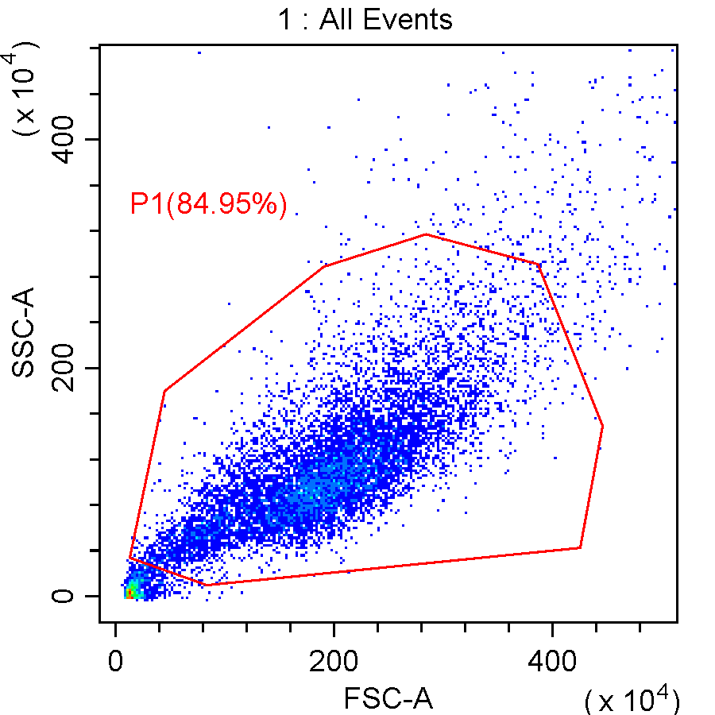 | 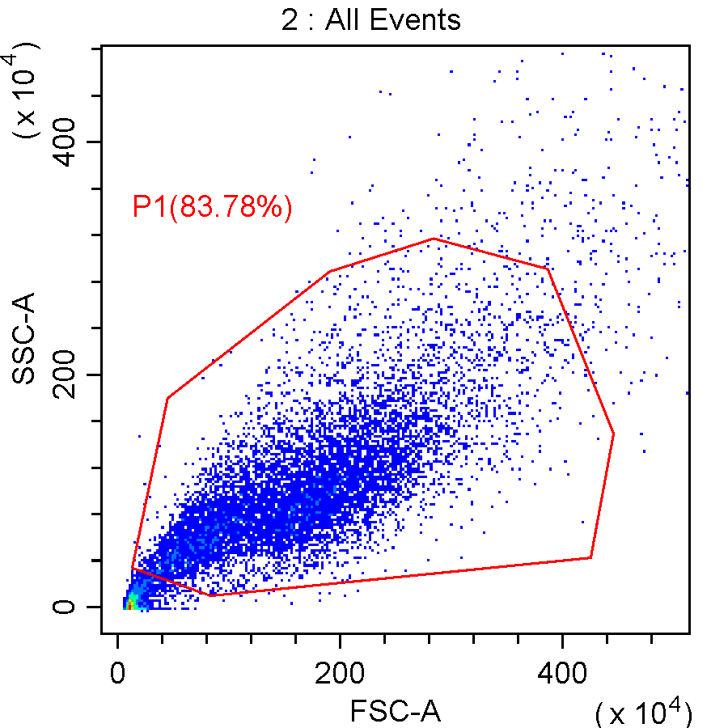
3-T24-circ_nc | 4-T24-circ_0003266
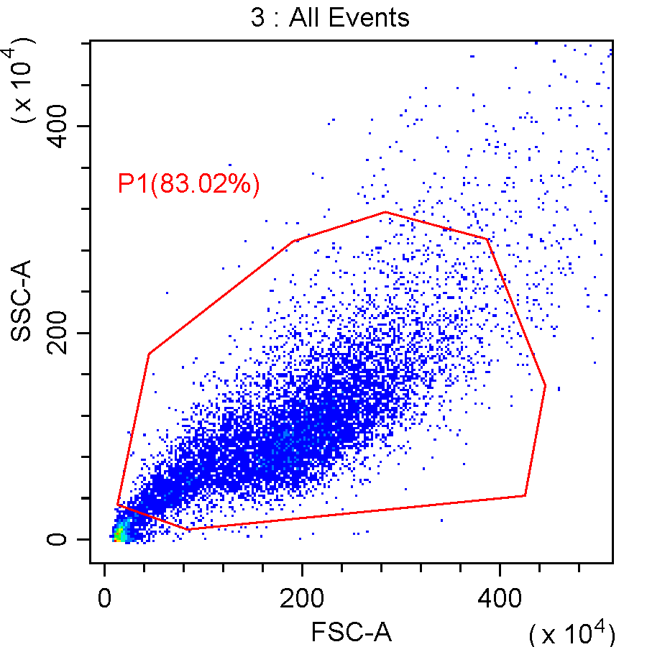 | 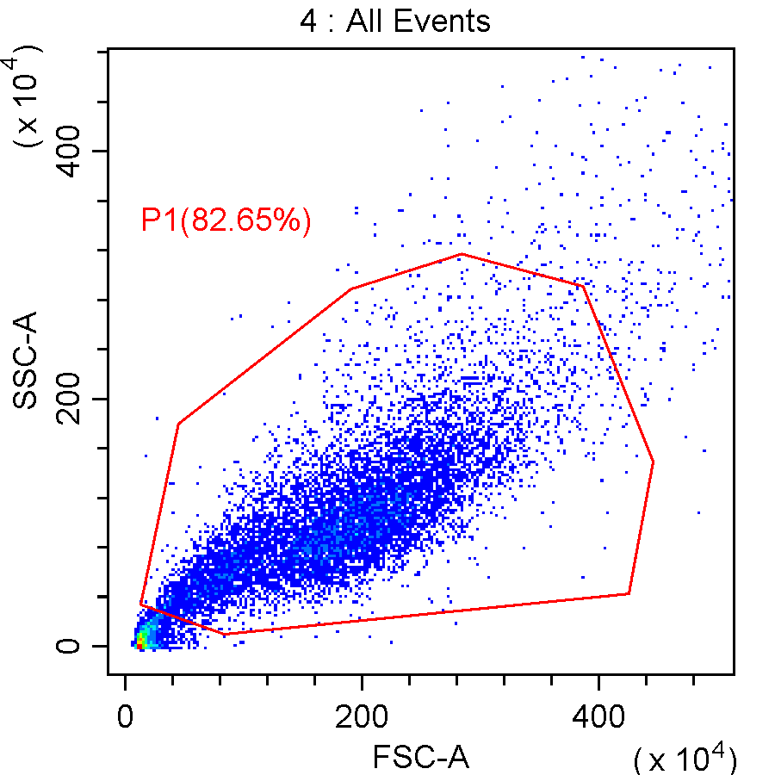
Figure 4

1-5637-circ_nc+nc mimic | 2-5637-circ_0003266+nc mimic
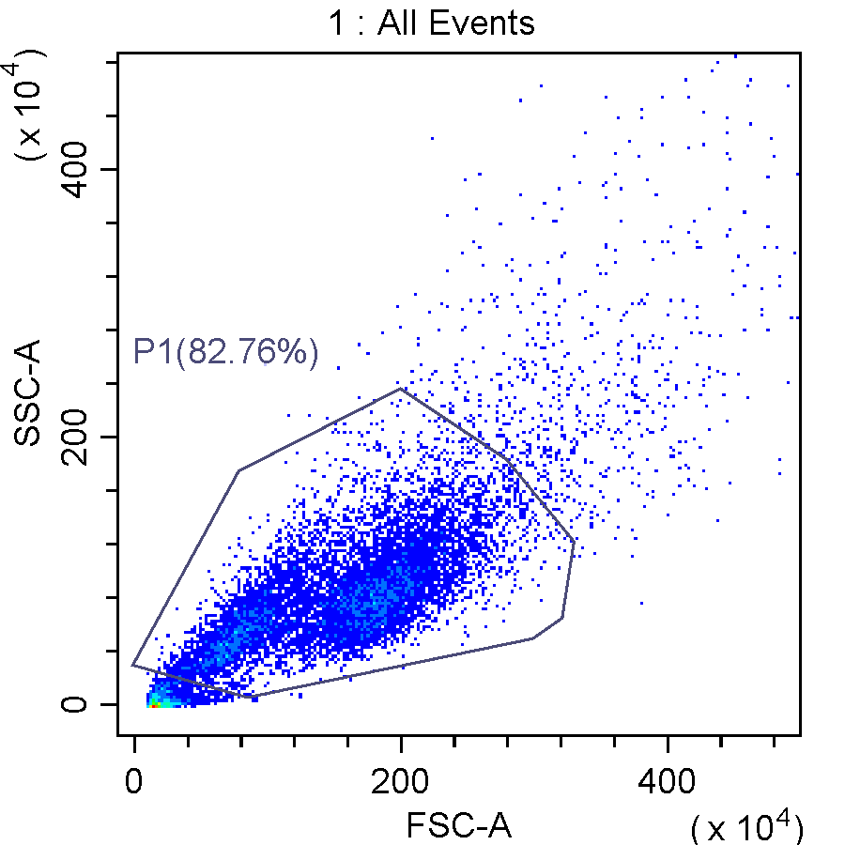 | 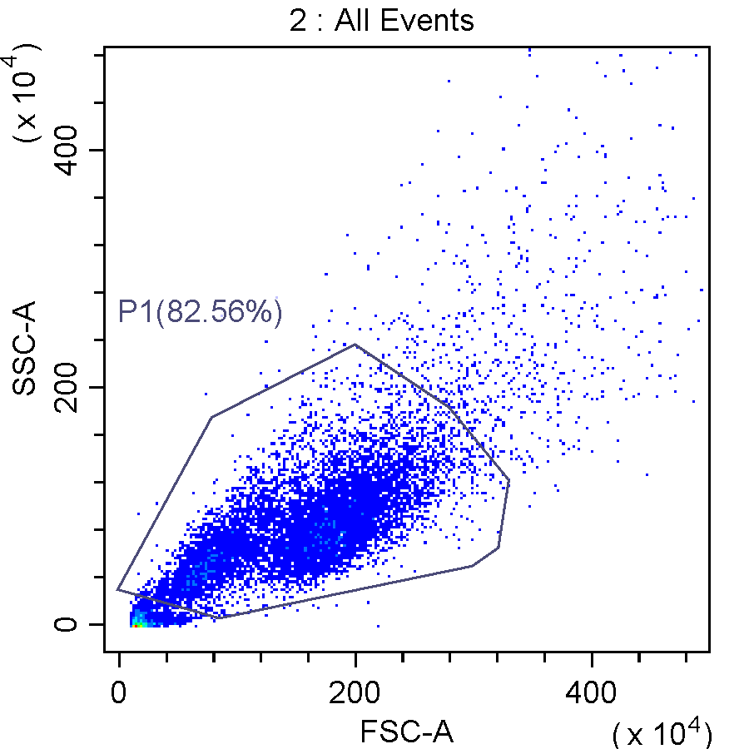
3-5637-circ_nc+miR-503-5p mimic | 4-5637-circ_0003266+miR-503-5p mimic
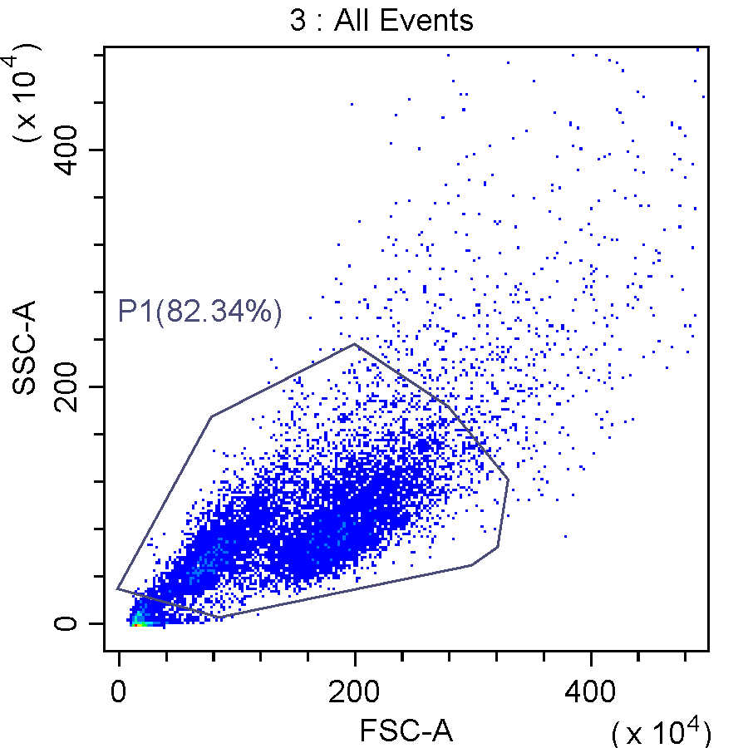 | 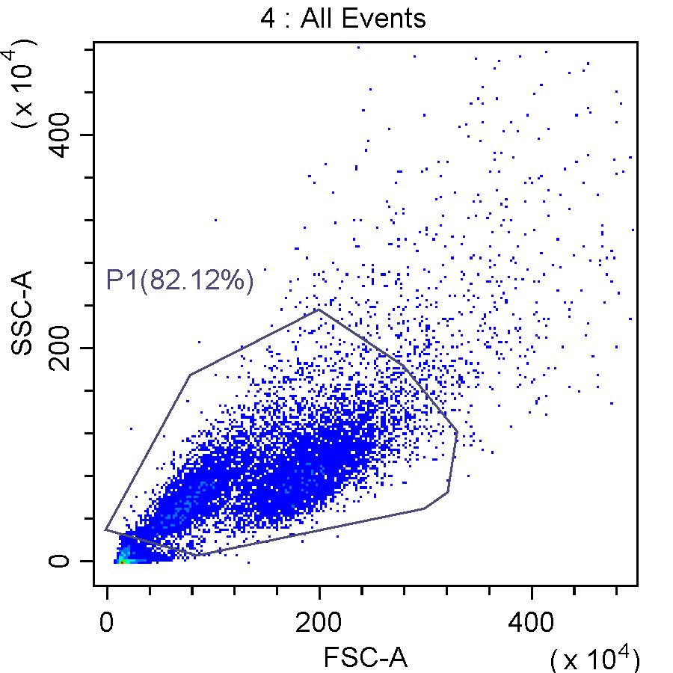
5-T24-circ_nc+nc mimic | 6-T24-circ_0003266+nc mimic
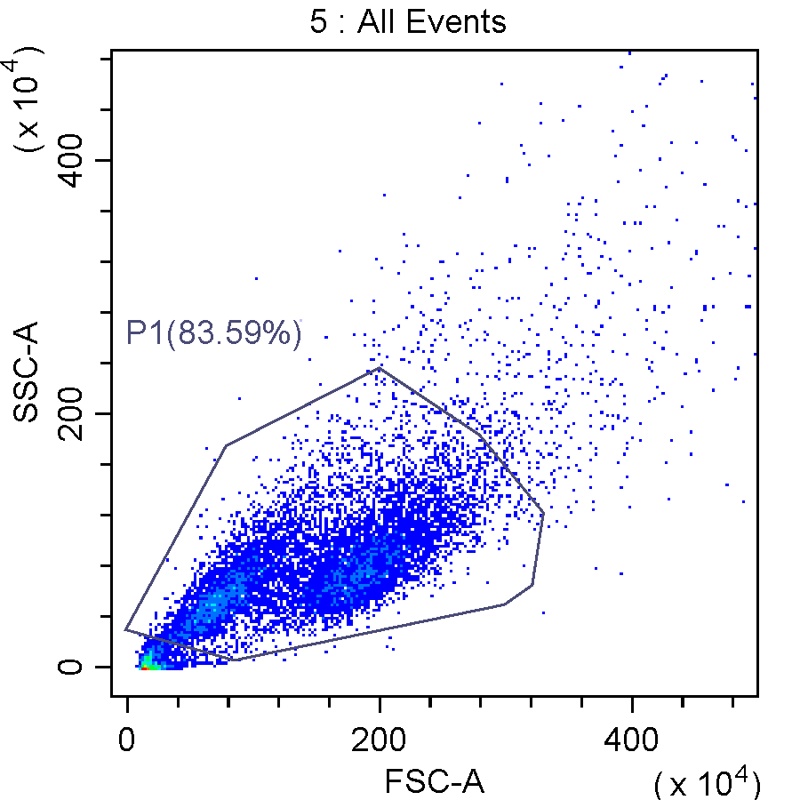 | 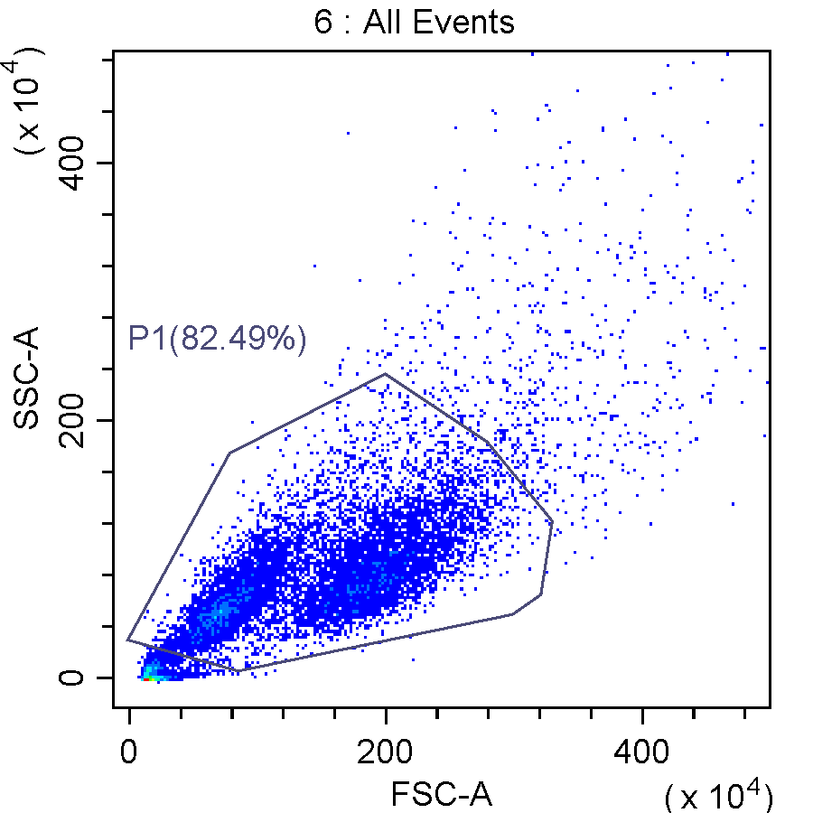
7-T24-circ_nc+miR-503-5p mimic | 8-T24-circ_0003266+miR-503-5p mimic
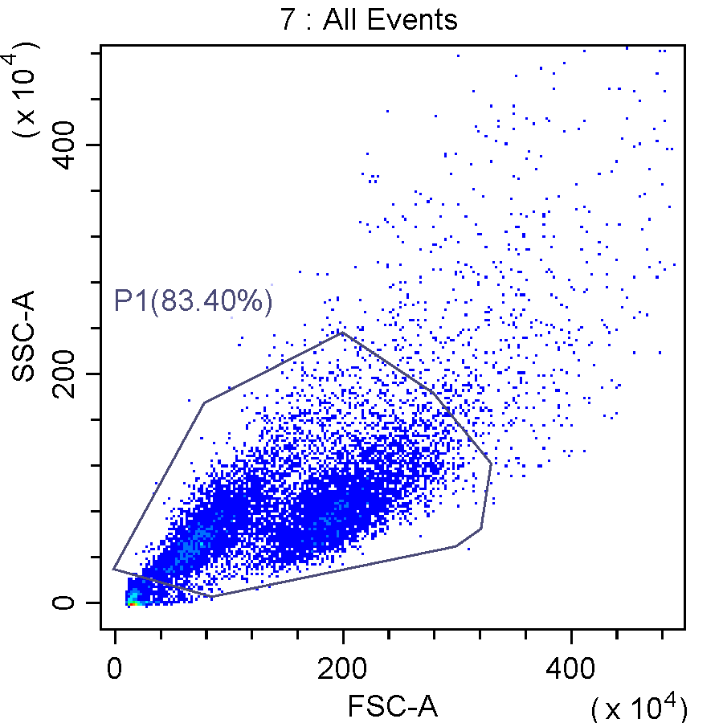 | 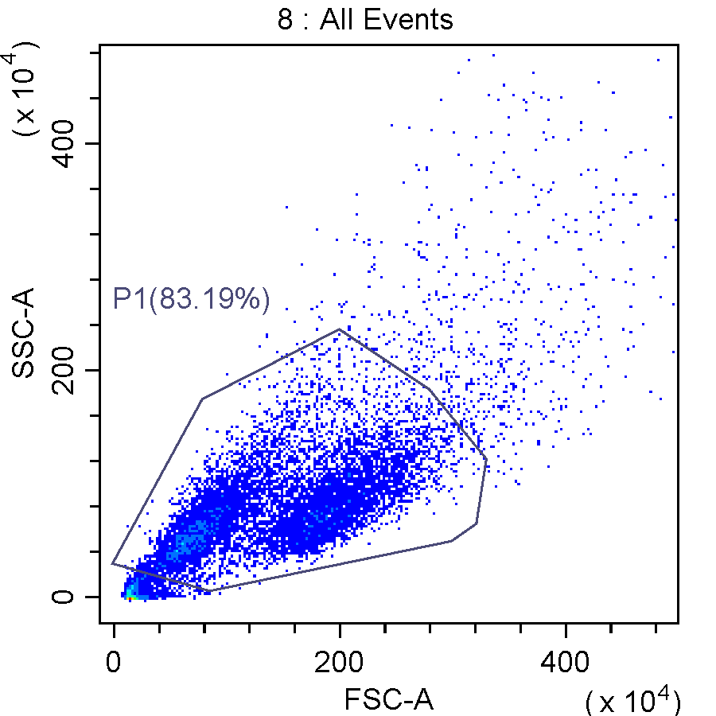
Figure 6

1-5637-nc inhibitor | 2-5637-miR-503-5p inhibitor
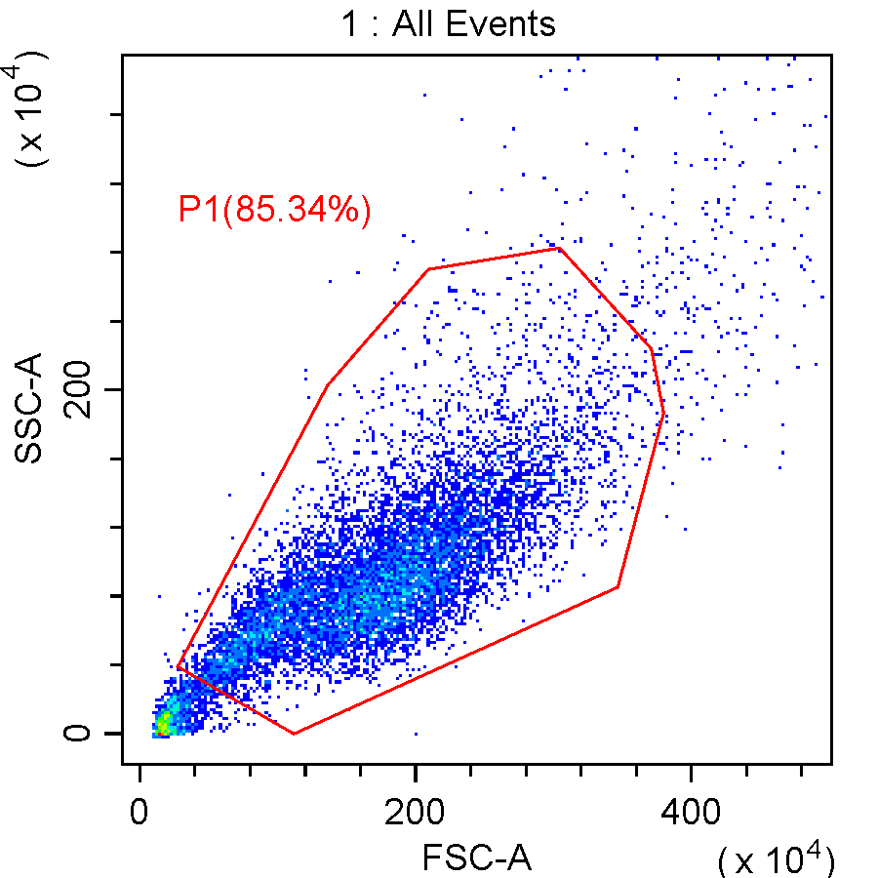 | 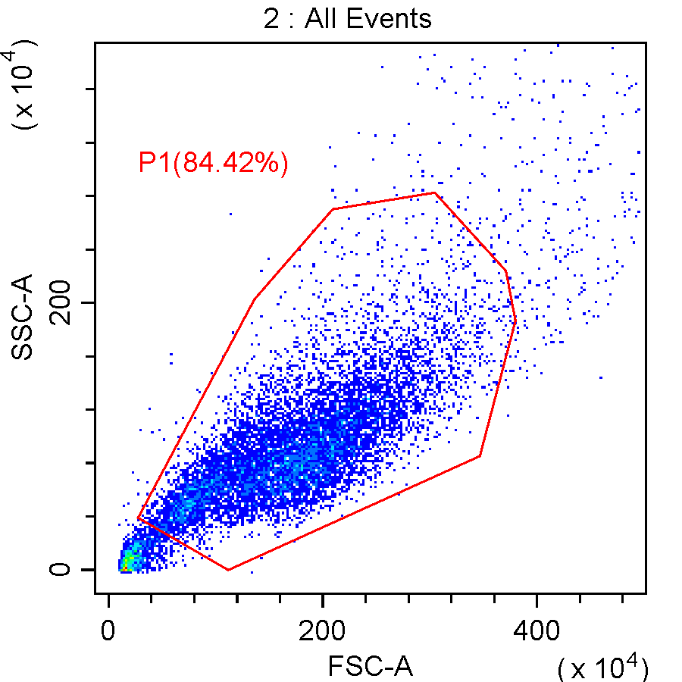
3-5637-miR-503-5p inhibitor+sh-nc | 4-5637-miR-503-5p inhibitor+sh-SMAD7
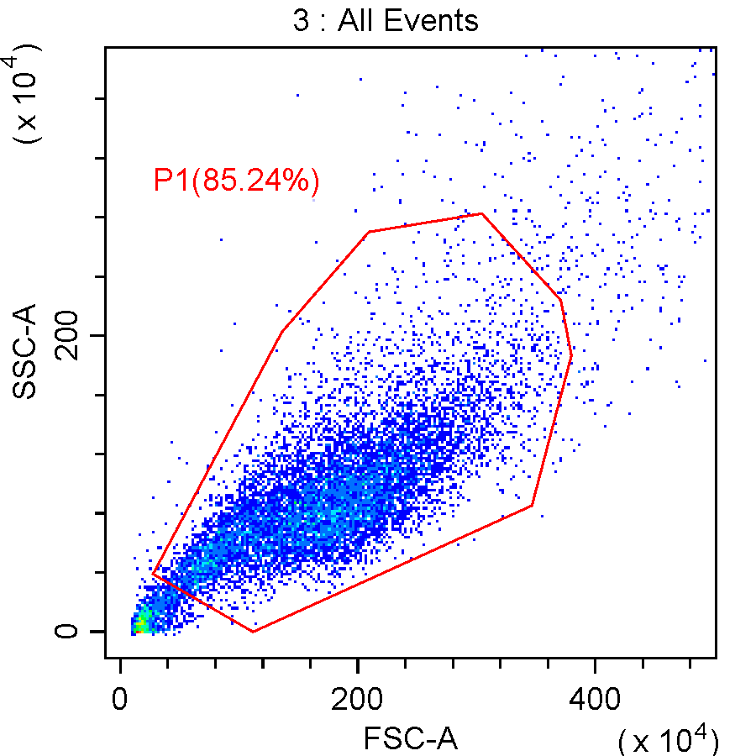 | 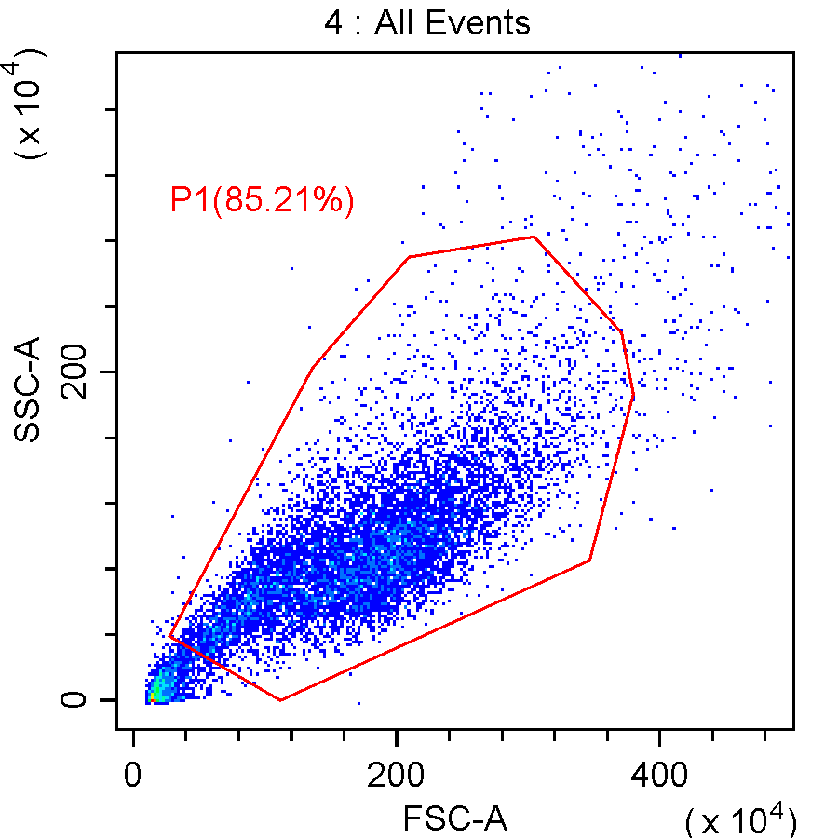
5-T24-nc inhibitor | 6-T24-miR-503-5p inhibitor
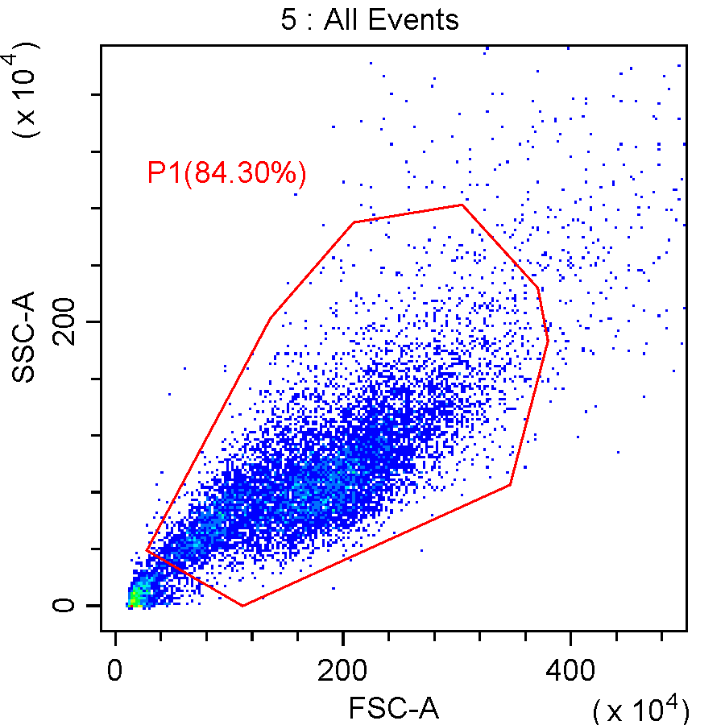 | 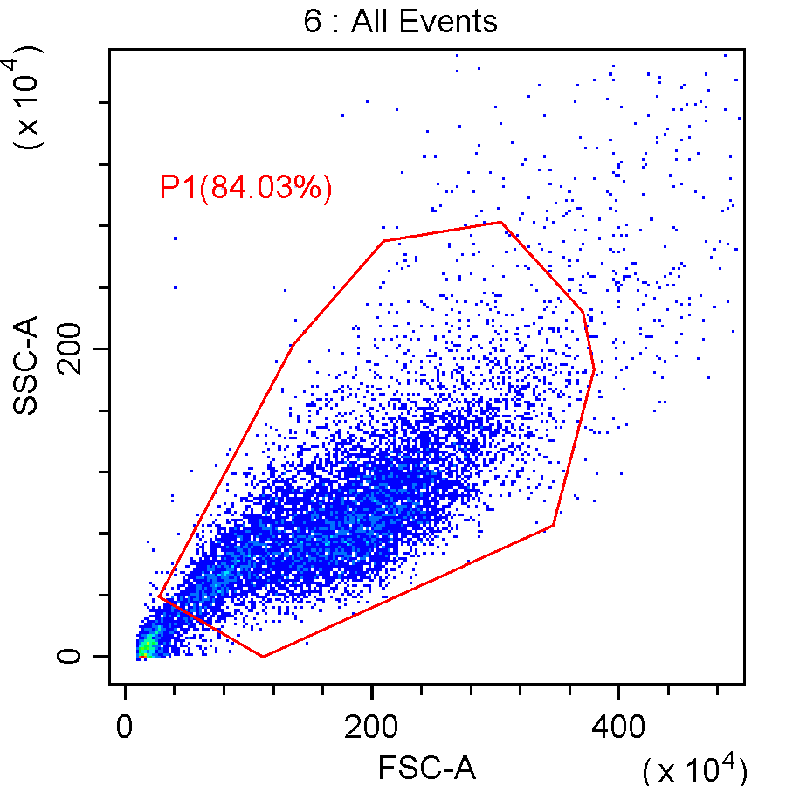
7-T24-miR-503-5p inhibitor+sh-nc | 8-T24-miR-503-5p inhibitor+sh-SMAD7
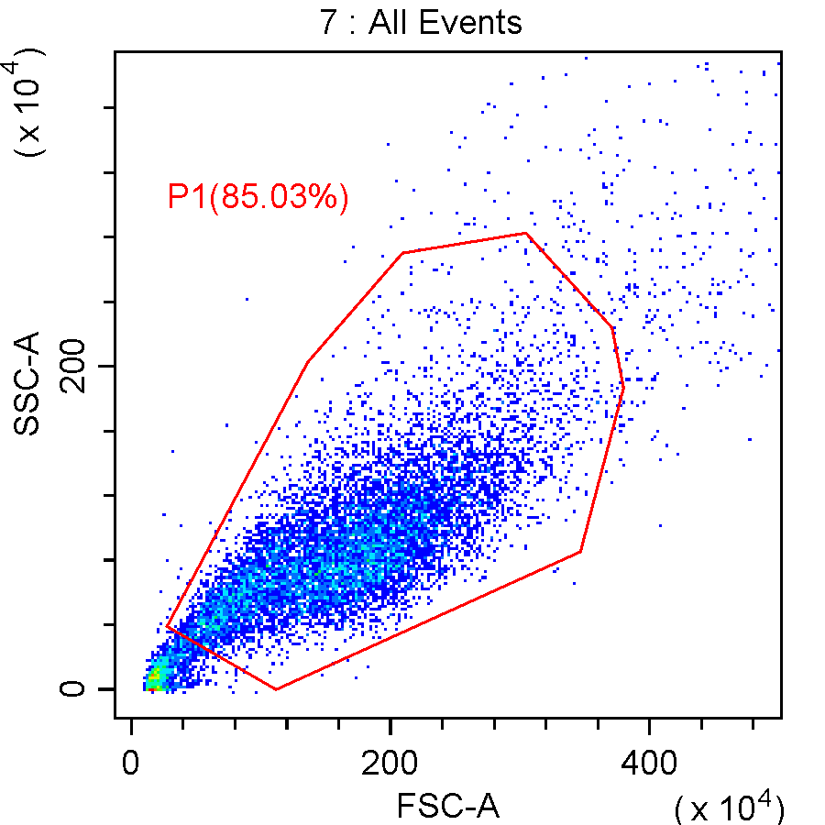 | 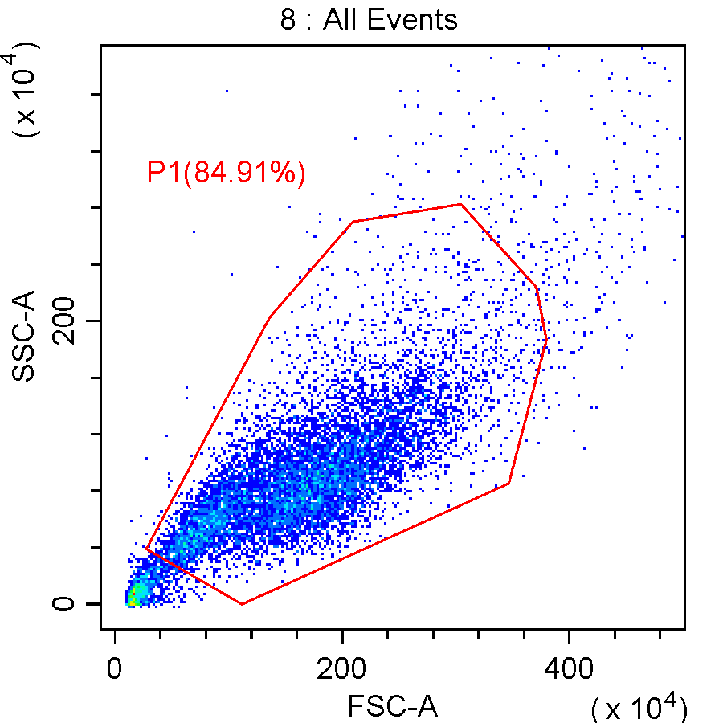
Figure 8

1-5637-vector | 2-5637-SMAD7+vector
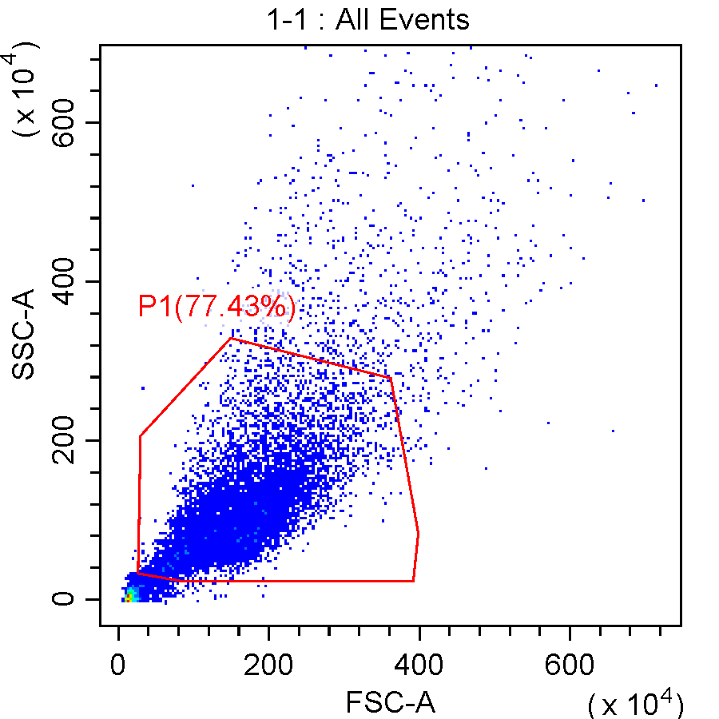 | 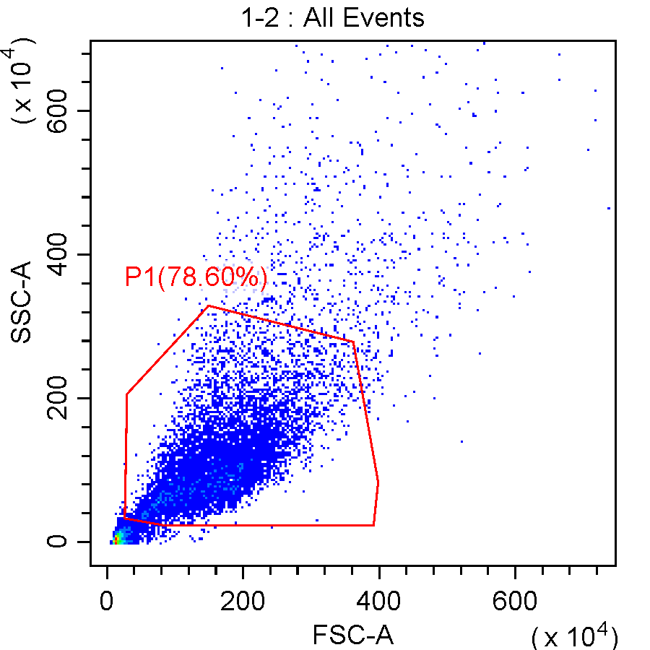
3-5637-SMAD7+TGF-β | 4-T24-vector
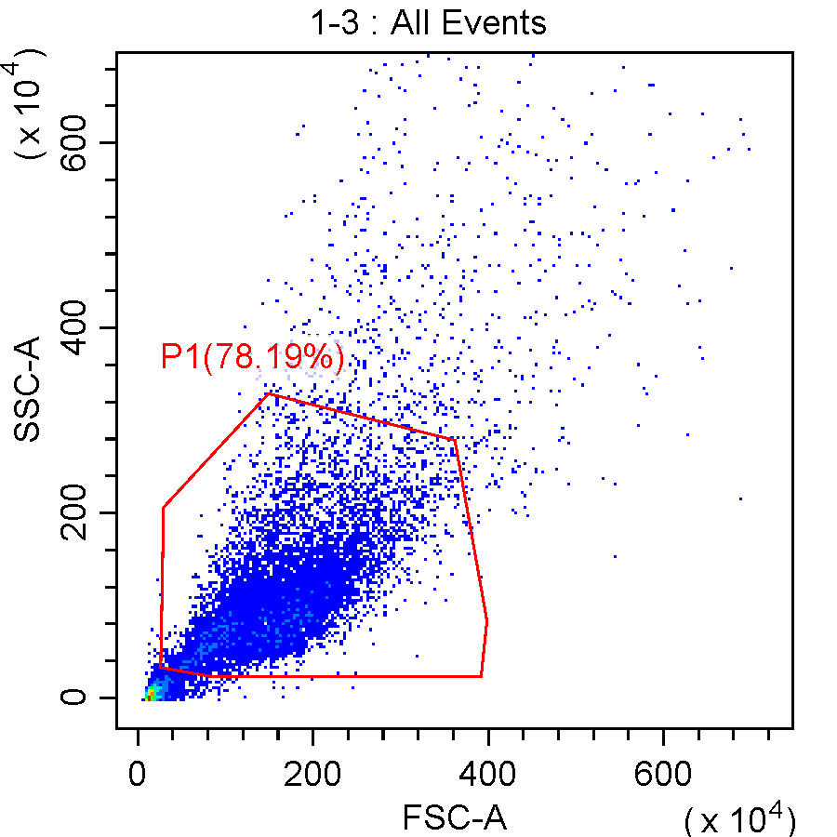 | 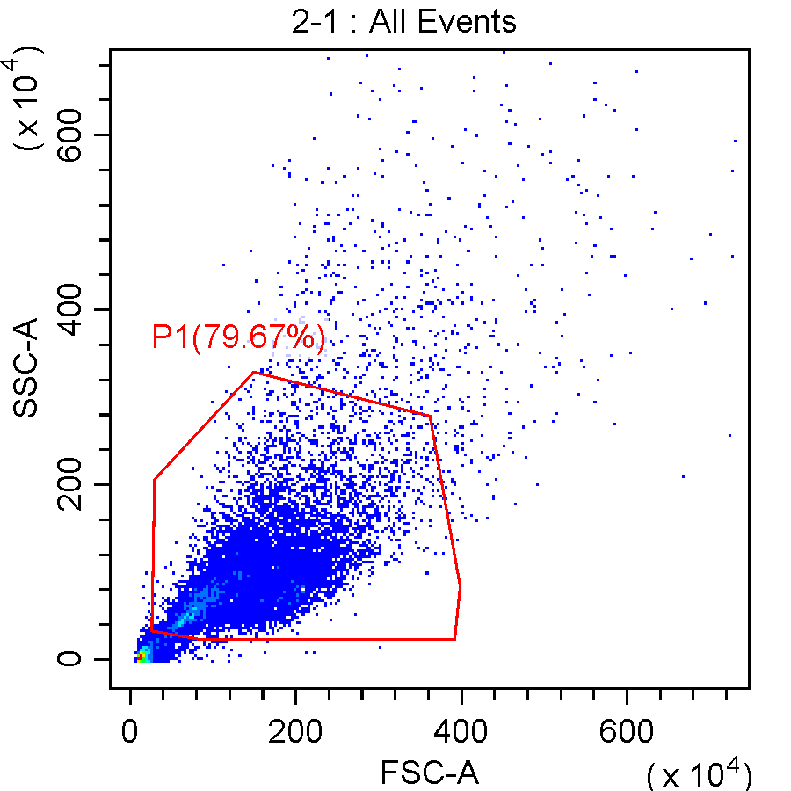
5-T24-SMAD7+vector | 6-T24-SMAD7+TGF-β
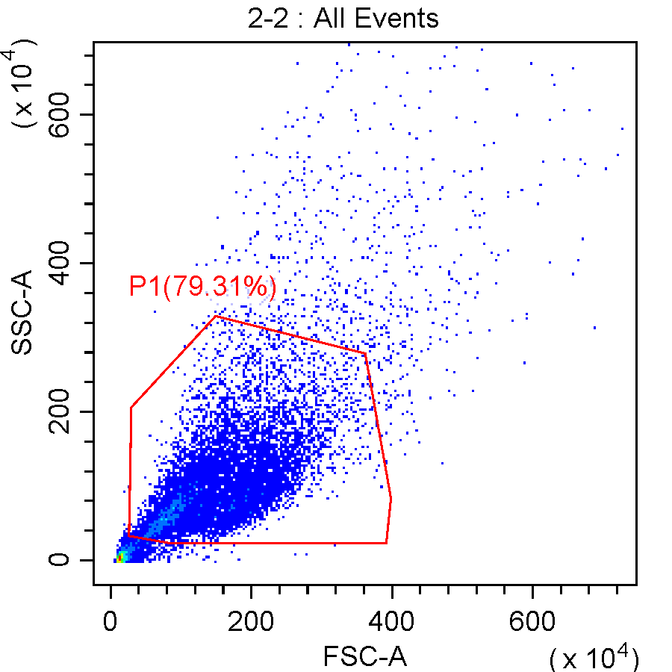 | 