Western Blot Images

Figure7A | 5637 |  | T24
Figure7A | sh-nc | sh-SMAD7 | sh-nc | sh-SMAD7
SMAD7
50kDa
TGF-β
44kDa
p-SMAD2
58kDa
SMAD2
60kDa
p-SMAD3
50kDa
SMAD3
50kDa
ACTB
42kDa

Figure7B | 5637 |  |  | T24
Figure7B | Input | IP:IgG | IP:SMAD7 | Input | IP:IgG | IP:SMAD7
SMAD7  50kDa | 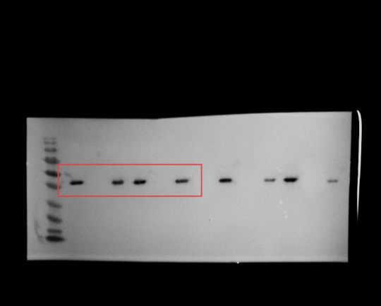
TGF-β  44kDa | 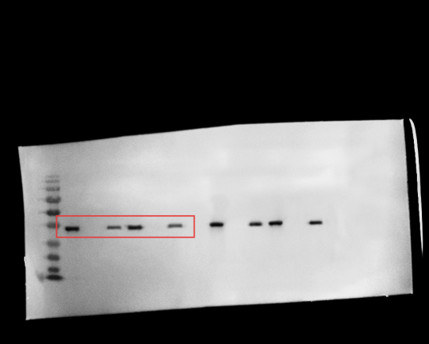

Figure7C | 5637 |  |  | T24
Figure7C | Input | IP:IgG | IP:TGF-β | Input | IP:IgG | IP:TGF-β
SMAD7  50kDa | 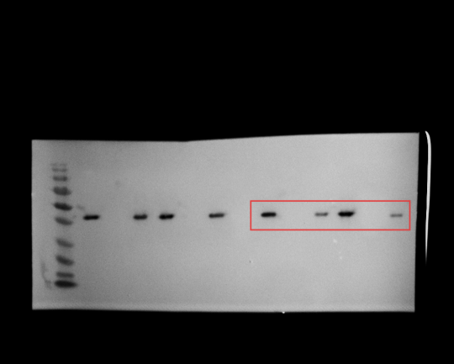
TGF-β  44kDa | 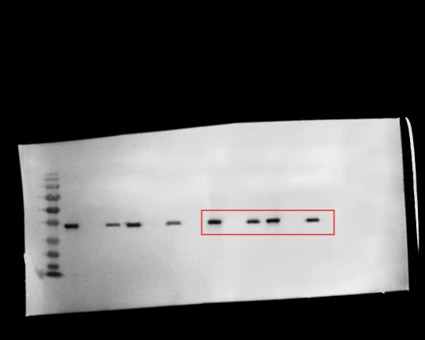

Figure9H | Lv-nc | Lv-circ_ 0003266
SMAD7
50kDa
TGF-β
44kDa
p-SMAD2
58kDa
SMAD2
60kDa
p-SMAD3
50kDa
SMAD3
50kDa
ACTB
42kDa

