Supplementary Materials
Association of air pollutions and systemic inflammation with early Cardiovascular-Kidney-Metabolic syndrome among middle-aged and elderly adults: a cross-sectional study from CHARLS
Xuanming Xu ^{1,#}, Lian Tang ^{2,#}, Yutong Kang ¹, Jing Liang ¹, Wenqi Geng ¹, Yajie Wang ^{1,*}
1. Department of Clinical Laboratory, Beijing Ditan Hospital, Capital Medical University, Beijing 100015, China
2. Department of Neurology, Beijing Tiantan Hospital, Capital Medical University, Beijing, China
# These authors equally contributed to this work
* Corresponding author

Directory
Fig. S1 The flowchart of the study participant selection process
Fig. S2 Maps of the 3-year average concentrations of PM_{2.5}, PM₁₀, SO₂, NO₂, O₃ and CO
Detailed definition and staging of CKM
Table S1 Methods for evaluating CKM stages
Table S2 Specific definitions of various diseases
Fig. S3 Association of PM_{2.5}, PM₁₀, SO₂, NO₂, O₃ and CO with early CKM incidence in CHARLS 2015 by RCSs
Fig. S4 ORs (95% CIs) of CKM associated with a SD increment of air pollutants, stratified by age, sex, residence and smoking status
Fig. S5 Effect modification between CRP and 3-year average concentration of air pollutions on CKM syndrome
Fig. S6 Association between CRP and CKM syndrom by levels of air pollutants
Fig. S7 Association between air pollutants and CKM syndrom by percentiles of CRP
Table S3 Person correlation coefficients of 3-year average air pollutant concentrations
Table S4 Deviation analysis of the association between air pollution and CKM
Table S5 Sensitivity analysis of using 1 year and 2-year average concentration of air pollutants in the association between air pollution and CKM
Table S6 Sensitivity analysis of using 1-year concentration of air pollutants in the association between CRP and CKM, and its modification effects in association of air pollution and CKM
Table S7 Sensitivity analysis of using 2-year average concentration of air pollutants in the association between CRP and CKM, and its modification effects in association of air pollution and CKM
Table S8 Sensitivity analysis by additional adjustment for regional categories in the association between air pollution and CMK
Table S9 Sensitivity analysis by additional adjustment for regional categories in the association between CRP and CKM, and its modification effects in association of air pollution and CKM
Table S10 Sensitivity analysis by excluding participants who had relocated in the association between air pollution and CKM
Table S11 Sensitivity analysis by excluding participants who had relocated in the association between CRP and CKM, and its modification effects in association of air pollution and CKM
Table S12 Sensitivity analysis by using two-pollutant model with adjustment for O₃

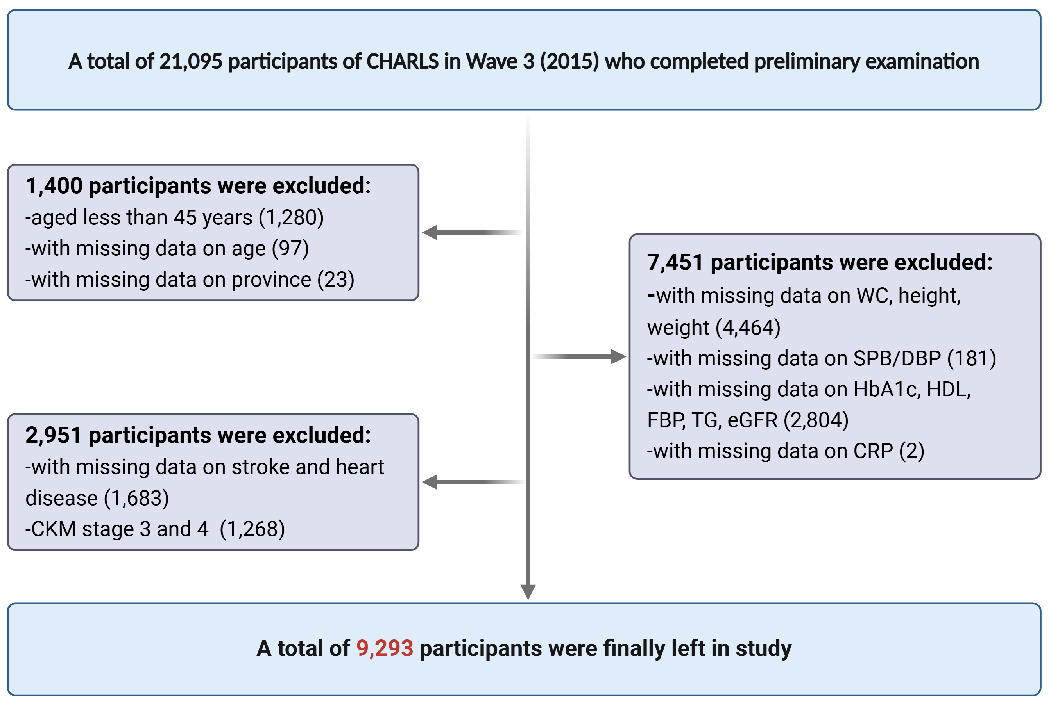
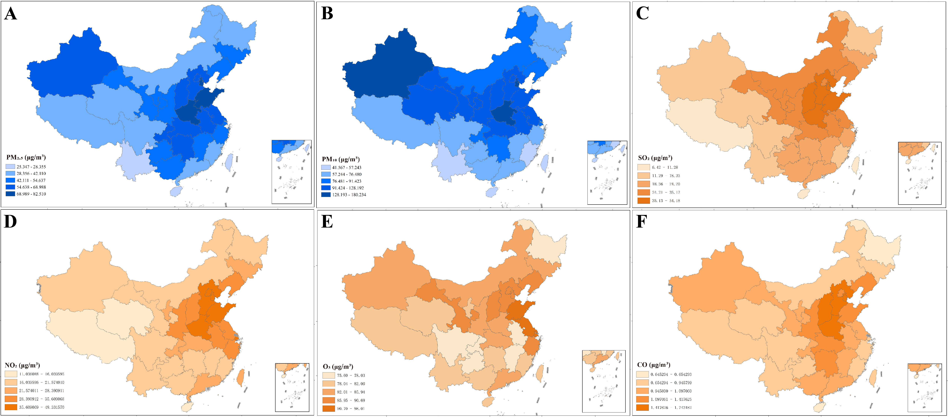
Fig. S1 The flowchart of the study participant selection process.
Fig. S2 Maps of the 3-year average concentrations of (A) PM_{2.5}, (B) PM₁₀, (C) SO₂, (D) NO₂, (E) O₃ and (F) CO.

Detailed definition and staging of CKM
The classification of CKM syndrome is delineated various stages based on specific risk factors and underlying health conditions.
Stage 0 indicates the absence of CKM risk factors, characterized by normal BMI, glycemic control, blood pressure, and lipid profiles, alongside the absence of CKD or CVD.
Stage 1 is marked by the presence of components associated with overweight, abdominal obesity or metabolic dysfunction, without the presence of other metabolic risk factors or CKD. BMI ≥25 kg/m² (Asian ≥23 kg/m²), waist circumference ≥88/102 cm in women/men (Asian ≥80/90 cm in women/men), fasting blood glucose ≥100-124 mg/dl or HbA1c between 5.7% and 6.4%.
Stage 2 identifies individuals with established CKM risk factors, especially who exhibit signs of hypertriglyceridemia (≥135 mg/d), hypertension, metabolic syndrome (MetS), diabetes or CKD. Hypertension is identified in patients who report a history of high blood pressure or exhibit a baseline SBP ≥130 mmHg or DBP ≥80 mmHg. Particularly, the diagnostic criteria of MetS for Chinese is based on the Joint Interim Societies by WC classifications [1, 2]. And individuals with a history of diabetes or those undergoing treatment for diabetes are classified based on FBG levels, with a threshold of 7.0 mmol/L (126 mg/dL) or HbA1c ≥6.5%, indicating the presence of diabetes. Furthermore, CKD is diagnostic in individuals with the eGFR ≤60 ml/min and confirmed through criteria.
Stage 3 represents a critical phase where metabolic dysfunction is linked with the onset of CVD, manifesting in conditions like subclinical atherosclerotic cardiovascular disease (ASCVD) or heart failure (HF). Diagnostic criteria at this level include imaging characteristics and elevated biomarkers, such as NT-proBNP and hs-troponin [3].
Stage 4 denotes advanced metabolic dysfunction with severe implications for cardiovascular health, including evident CVD [coronary heart disease (CHD), HF, stroke, peripheral artery disease and atrial fibrillation]. Notably, Stage 4a represents no kidney failure, while Stage 4b indicates kidney failure present.

Table S1 Approach to evaluating CKM stages
CKM stages | Threshold for CKM syndrome conditions
Stages 0 | Absence of risk factors for CKM syndrome, including normal body mass index (BMI), waist circumference (WC), blood glucose, systolic blood pressure (SBP), diastolic blood pressure (DBP), lipid levels, renal function, and no evidence of cardiovascular disease (CVD).
Stages 1 | Any of the three criteria is met:  (1) BMI ≥23 kg/m²  (2) WC ≥80/90 cm in Asian female/male  (3) Prediabetes  All criteria are met:  (1) SBP <130 mmHg and DBP <80 mmHg without self-reported diagnosis of hypertension or use of antihypertensive medications.  (2) HDL-C <50/40 mg/dL in female/male  (3) TG <150 mg/dL  (4) eGFR ≥60 ml/min/1.73m² and without self-reported diagnosis of CKD  (5) No Subclinical CVD and clinical CVD
Stages 2 | Any of the five criteria is met:  (1) Hypertriglyceridemia  (2) Hypertension  (3) Diabetes  (4) Metabolic syndrome  (5) eGFR：30-60 ml/min/1.73m² and/or with self-reported diagnosis of CKD  All criteria are met：  (1) No Subclinical CVD and clinical CVD
Stages 3 | Any of the eight criteria is met:  (1) BMI ≥23 kg/m²  (2) Waist circumference ≥80/90 cm in Asian female/male  (3) Prediabetes  (4) Hypertriglyceridemia  (5) Hypertension  (6) Diabetes  (7) Metabolic syndrome (MetS)  (8) eGFR：30-60 ml/min/1.73m² and/or with self-reported diagnosis of CKD  Any of the two criteria is met:  (1) eGFR <30 ml/min/1.73m²  (2) Subclinical CVD  The criterion is met：  (1) No clinical CVD
Stages 4 | Clinical CVD  Any of the five criteria is met:  (1) Coronary heart disease (CHD)  (2) Heart failure (HF)  (3) Stroke  (4) Peripheral artery disease  (5) Atrial fibrillation  Classification:  (1) 4a: no kidney failure  (2) 4b: present kidney failure
Abbreviation: CKD: chronic kidney disease; TC: total cholesterol; HDL: high-density lipoprotein cholesterol; LDL: low-density lipoprotein cholesterol; eGFR: estimated glomerular filtration ratio; TG: triglyceride.
Table S2 Specific definitions of various diseases
Prediabetes | Fasting blood glucose ≥100-124 mg/dL or HbA1c ≥5.7%-6.4% and without self-reported diagnosis of diabetes, use of hypoglycemic medications
Diabetes | Fasting blood glucose ≥125 mg/dL or HbA1c ≥6.5% or self-reported diagnosis of diabetes, use of hypoglycemic medications
Hypertension | SBP ≥130 mmHg or DBP ≥80 mmHg or self-reported diagnosis of hypertension or use of anti-hypertensive medications
CKD | Any of the two criteria is met：  (1) Self-reported history of chronic kidney disease  (2) eGFR < 60 ml/min/1.73m²
Hypertriglyceridemia | Triglycerides ≥135 mg/dL
Metabolic syndrome | Meet any three or more of the five:  (1) Waist circumference ≥80/90 cm in female/male.  (2) HDL<50/40 mg/dL in female/male.  (3) Triglycerides ≥150 mg/dL.  (4) Elevated blood pressure (SBP ≥130 mmHg or DBP ≥80 mmHg and/or use of anti-hypertensive medications)  (5) Fasting blood glucose ≥100 mg/dL
Subclinical CVD | Any of the two criteria is met:  (1) Very high-risk CKD in KDIGO classification: eGFR <30 ml/min/1.73m².  (2) Framingham risk score ≥21.5/21.6 in female/male
Clinical CVD | Any of the two criteria is met:  (1) Participants were asked "Have you been told by a doctor that you have been diagnosed with a heart disease, including angina, heart attack, congestive heart failure, and other heart problems?"  (2) "Have you been told by a doctor that you have been diagnosed with a stroke?"

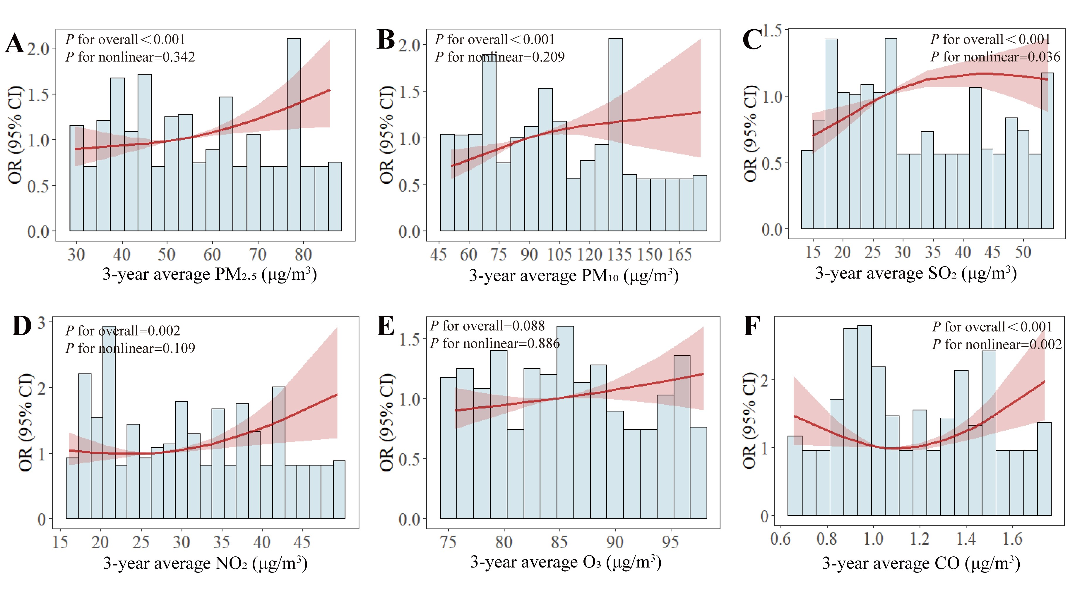
Fig. S3 Association of PM_{2.5} (A), PM₁₀ (B), SO₂ (C), NO₂ (D), O₃ (E) and CO (F) with early CKM incidence in CHARLS 2015 by RCSs. The models were adjusted for age, sex, residence, education status, marital status, smoking status, drinking status, cooking fuel use, arthritis disease, digeste disease, lung disease and liver disease.
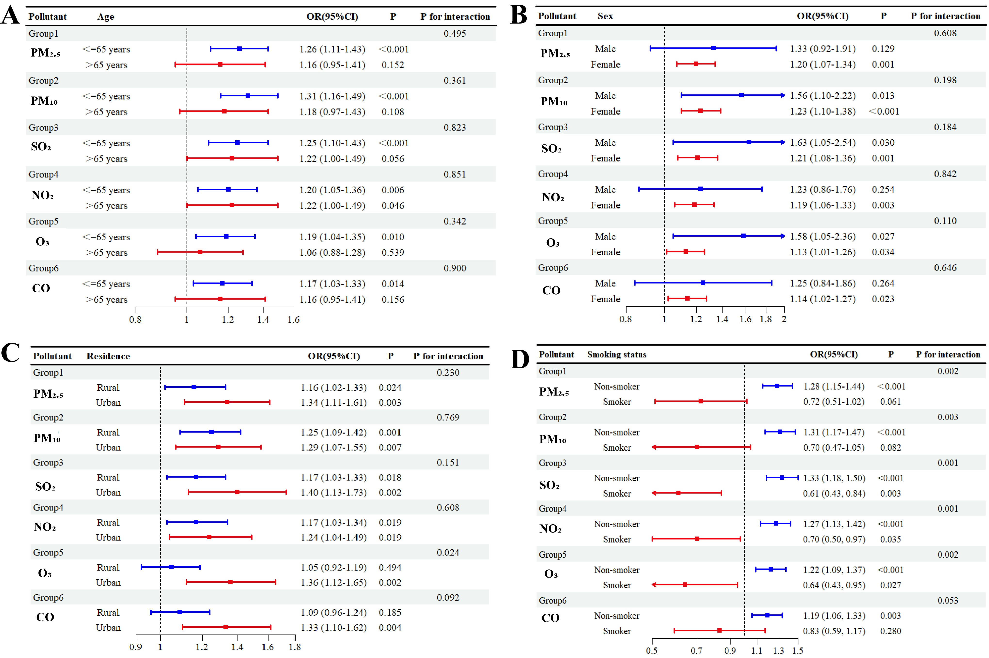
Fig. S4 ORs (95 % CIs) of CKM associated with a SD increment of air pollutants, stratified by age (A), sex (B), residence (C) and smoking status (D).
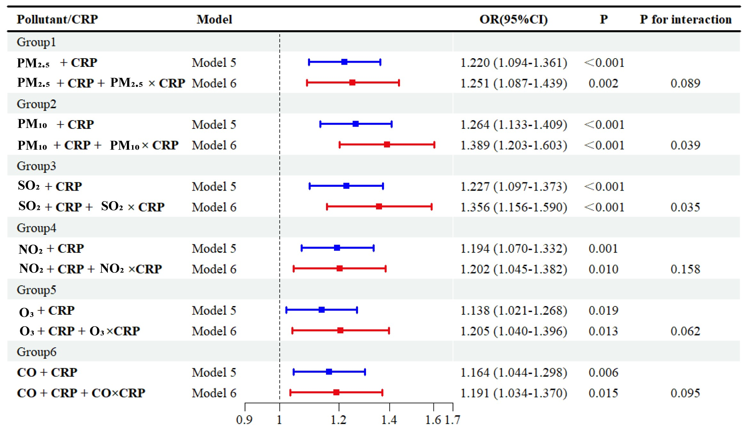
Fig. S5 Effect modification between CRP and 3-year average concentration of air pollutions on CKM syndrome.
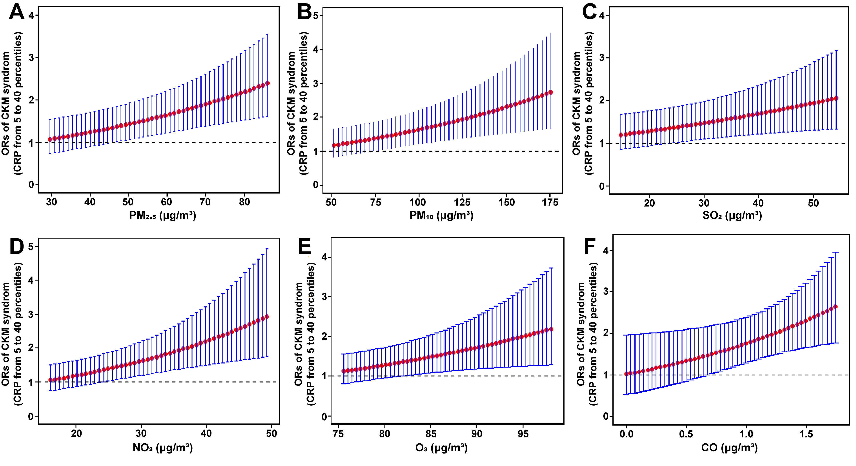
Fig. S6 Association between CRP and CKM syndrome by levels of air pollutants: OR values in CKM syndrom, and 95% confidence intervals, per increments of CRP from the 5th to the 40th percentile, for different concentrations of PM_{2.5} (A), PM₁₀ (B), SO₂ (C), NO₂ (D), O₃ (E) and CO (F).
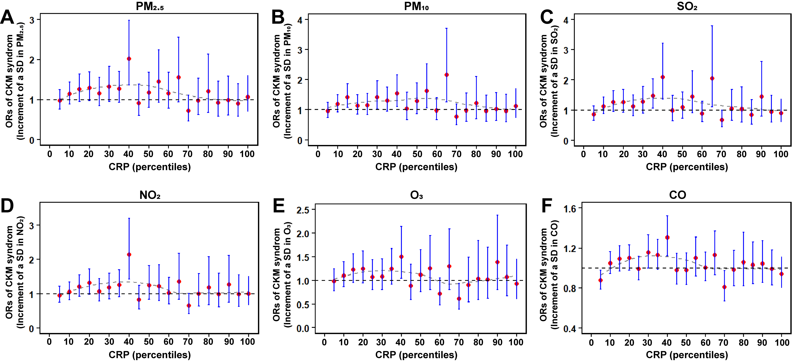
Fig. S7 Association between air pollutants and CKM syndrome by percentiles of CRP: OR values in CKM syndrom, and 95% confidence intervals, per SD increments of PM_{2.5} (A), PM₁₀ (B), SO₂ (C), NO₂ (D), O₃ (E) and CO (F), for different percentiles of CRP distributions.
Table S3 Person correlation coefficients of 3-year average air pollutant concentrations.
Air pollution | PM_{2.5} | PM₁₀ | SO₂ | NO₂ | O₃ | CO
PM_{2.5} | 1
PM₁₀ | 0.903 ** | 1
SO₂ | 0.846 ** | 0.856 ** | 1
NO₂ | 0.906 ** | 0.803 ** | 0.858 ** | 1
O₃ | 0.586 ** | 0.645 ** | 0.727 ** | 0.719 ** | 1
CO | 0.766 ** | 0.740 ** | 0.828 ** | 0.741 ** | 0.513 ** | 1
Abbreviations: PM_{2.5,} particle with aerodynamic diameter ≤2.5 μm; PM₁₀, particle with aerodynamic diameter ≤10 μm; SO₂, sulfur dioxide; NO_{2,} nitrogen dioxide; O₃, ozone; CO, carbonic oxide. * P <0.05; ** P <0.01; ***P <0.001
Table S4 Deviation analysis of the association between air pollution and CKM.
Air pollutant | NULL |  |  | Residual |  | MCFadden R²
Air pollutant | Deviance | df |  | Deviance | df | MCFadden R²
PM_{2.5} | 10795 | 9292 |  | 10538 | 9280 | 0.163
PM₁₀ | 10795 | 9292 |  | 10535 | 9280 | 0.165
SO₂ | 10795 | 9292 |  | 10537 | 9280 | 0.164
NO₂ | 10795 | 9292 |  | 10539 | 9280 | 0.162
O₃ | 10795 | 9292 |  | 10541 | 9280 | 0.161
CO | 10795 | 9292 |  | 10540 | 9280 | 0.161
Table S5 Sensitivity analysis of using 1 year and 2-year average concentration of air pollutants in the association between air pollution and CKM.
Air pollutants |  | 1-year average |  |  |  | 2-year average
Air pollutants | Mean  (µg/m³) | OR and 95%CI | P |  | Mean  (µg/m³) | OR and 95%CI | P
PM_{2.5} | 47.20 | 1.232 (1.105, 1.373) | <0.001 *** |  | 51.29 | 1.216 (1.091, 1.354) | <0.001 ***
PM₁₀ | 81.94 | 1.275 (1.143, 1.422) | <0.001 *** |  | 88.93 | 1.267 (1.136, 1.413) | <0.001 ***
SO₂ | 25.29 | 1.243 (1.110, 1.391) | <0.001 *** |  | 28.57 | 1.231 (1.100, 1.377) | <0.001 ***
NO₂ | 26.26 | 1.201 (1.077, 1.338) | <0.001 *** |  | 27.53 | 1.184 (1.062, 1.320) | 0.002 **
O₃ | 83.33 | 1.202 (1.078, 1.340) | <0.001 *** |  | 84.30 | 1.153 (1.035, 1.286) | 0.010 *
CO | 1.06 | 1.150 (1.032, 1.281) | 0.012 * |  | 1.11 | 1.155 (1.036, 1.286) | 0.009 **

Table S6 Sensitivity analysis of using 1-year concentration of air pollutants in the association between CRP and CKM, and its modification effects in association of air pollution and CKM.
Models | CRP-CKM |  |  |  |  | Air pollution-CKM |  |  |  |  | P_{inter}
Models | OR and 95%CI |  |  | P |  | OR and 95%CI |  |  | P
Model 4
CRP | 1.207 (1.126, 1.295) | <0.001*** |  |  |  | — | — |  |  | —
Model 5
PM_{2.5} + CRP | 1.209 (1.127, 1.297) | <0.001*** |  |  |  | 1.241 (1.112, 1.385) | <0.001***
PM₁₀ + CRP | 1.205 (1.124, 1.291) | <0.001*** |  |  |  | 1.274 (1.143, 1.422) | <0.001***
SO₂ + CRP | 1.204 (1.124, 1.291) | <0.001*** |  |  |  | 1.240 (1.107, 1.389) | <0.001***
NO₂ + CRP | 1.209 (1.128, 1.297) | <0.001*** |  |  |  | 1.211 (1.086, 1.351) | <0.001***
O₃ + CRP | 1.207 (1.125, 1.293) | <0.001*** |  |  |  | 1.200 (1.077, 1.338) | <0.001***
CO + CRP | 1.208 (1.126, 1.295) | <0.001*** |  |  |  | 1.154 (1.034, 1.287) | 0.010 *
Model 6
PM_{2.5} + CRP + PM_{2.5} × CRP | 1.219 (1.133, 1.313) | <0.001*** |  |  |  | 1.291 (1.118, 1.491) | <0.001*** |  |  | 0.075*
PM₁₀ + CRP + PM₁₀ × CRP | 1.241 (1.149, 1.342) | <0.001*** |  |  |  | 1.410 (1.218, 1.633) | <0.001*** |  |  | 0.033**
SO₂ + CRP + SO₂ × CRP | 1.233 (1.142, 1.331) | <0.001*** |  |  |  | 1.370 (1.165, 1.612) | <0.001*** |  |  | 0.035**
NO₂ + CRP + NO₂ × CRP | 1.212 (1.128, 1.303) | <0.001*** |  |  |  | 1.227 (1.066, 1.414) | 0.005 ** |  |  | 0.218
O₃ + CRP + O₃ × CRP | 1.232 (1.142, 1.329) | <0.001*** |  |  |  | 1.312 (1.130, 1.523) | <0.001*** |  |  | 0.042**
CO + CRP + CO × CRP | 1.208 (1.125, 1.296) | <0.001*** |  |  |  | 1.158 (1.004, 1.326) | 0.043 * |  |  | 0.302
Model 4, a univariate model that included only CRP; Model 5, both CRP and each air pollutant were incorporated as independent variables; Model 6, an interaction model that included CRP, an air pollutant, and their interaction (CRP × air pollutant). *P <0.05; **P <0.01; ***P <0.001 for the association of CRP/air pollution and CKM. *P <0.10; **P <0.05 for interactions of CRP and air pollution.

Table S7 Sensitivity analysis of using 2-year average concentration of air pollutants in the association between CRP and CKM, and its modification effects in association of air pollution and CKM.
Models | CRP-CKM |  |  |  |  | Air pollution-CKM |  |  |  | P_{inter}
Models | OR and 95%CI |  |  | P |  | OR and 95%CI |  |  | P
Model 4
CRP | 1.207 (1.126, 1.295) | <0.001*** |  |  |  | — | — |  |  |  | —
Model 5
PM_{2.5} + CRP | 1.210 (1.128, 1.298) | <0.001 *** |  |  |  | 1.227 (1.100, 1.368) | <0.001 ***
PM₁₀ + CRP | 1.207 (1.126, 1.295) | <0.001 *** |  |  |  | 1.268 (1.137, 1.414) | <0.001 ***
SO₂ + CRP | 1.205 (1.124, 1.292) | <0.001 *** |  |  |  | 1.231 (1.101, 1.377) | <0.001 ***
NO₂ + CRP | 1.210 (1.128, 1.297) | <0.001 *** |  |  |  | 1.196 (1.072, 1.334) | 0.001 **
O₃ + CRP | 1.207 (1.126, 1.295) | <0.001 *** |  |  |  | 1.155 (1.036, 1.288) | 0.009 **
CO + CRP | 1.208 (1.126, 1.295) | <0.001 *** |  |  |  | 1.159 (1.039, 1.292) | 0.008 **
Model 6
PM_{2.5} + CRP + PM_{2.5} × CRP | 1.217 (1.131, 1.309) | <0.001*** |  |  |  | 1.264 (1.098, 1.456) | 0.001 ** |  |  |  | 0.080*
PM₁₀ + CRP + PM₁₀ × CRP | 1.241 (1.149, 1.342) | <0.001*** |  |  |  | 1.400 (1.218, 1.618) | <0.001 *** |  |  |  | 0.034**
SO₂ + CRP + SO₂ × CRP | 1.234 (1.143, 1.332) | <0.001*** |  |  |  | 1.361 (1.160, 1.597) | <0.001 *** |  |  |  | 0.035**
NO₂ + CRP + NO₂ × CRP | 1.212 (1.127, 1.302) | <0.001*** |  |  |  | 1.207 (1.048, 1.388) | 0.009 ** |  |  |  | 0.146
O₃ + CRP + O₃ × CRP | 1.224 (1.137, 1.319) | <0.001*** |  |  |  | 1.239 (1.066, 1.440) | 0.005 ** |  |  |  | 0.052*
CO + CRP + CO × CRP | 1.211 (1.127, 1.300) | <0.001*** |  |  |  | 1.183 (1.027, 1.361) | 0.020 * |  |  |  | 0.099*

Table S8 Sensitivity analysis by additional adjustment for regional categories in the association between air pollution and CMK.
Air pollutants | Regional variable was not adjusted |  |  | Regional variable was adjusted
Air pollutants | OR and 95% CI | P-value |  | OR and 95% CI | P-value
PM_{2.5} | 1.209 (1.085, 1.346) | <0.001 *** |  | 1.269 (1.121, 1.437) | <0.001 ***
PM₁₀ | 1.263 (1.134, 1.408) | <0.001 *** |  | 1.294 (1.153, 1.452) | <0.001 ***
SO₂ | 1.227 (1.098, 1.372) | <0.001 *** |  | 1.297 (1.143, 1.473) | <0.001 ***
NO₂ | 1.182 (1.060, 1.317) | 0.003 ** |  | 1.294 (1.129, 1.483) | <0.001 ***
O₃ | 1.135 (1.019, 1.265) | 0.021 * |  | 1.271 (1.100, 1.470) | 0.001 **
CO | 1.160 (1.041, 1.292) | 0.007 ** |  | 1.174 (1.045, 1.321) | 0.007 **

Table S9 Sensitivity analysis by additional adjustment for regional categories in the association between CRP and CKM, and its modification effects in association of air pollution and CKM.
Models | CRP-CKM |  |  |  |  | Air pollution-CKM |  |  |  |  | P_{inter}
Models | OR and 95%CI |  |  | P |  | OR and 95%CI |  |  | P |  | P_{inter}
Model 4
CRP | 1.207 (1.126, 1.295) | <0.001*** |  |  |  | — | — |  |  | —
Model 5
PM_{2.5} + CRP | 1.209 (1.127, 1.297) | <0.001*** |  |  |  | 1.279 (1.128, 1.450) | <0.001***
PM₁₀ + CRP | 1.204 (1.123, 1.291) | <0.001*** |  |  |  | 1.291 (1.148, 1.450) | <0.001***
SO₂ + CRP | 1.203 (1.122, 1.290) | <0.001*** |  |  |  | 1.290 (1.135, 1.466) | <0.001***
NO₂ + CRP | 1.208 (1.127, 1.296) | <0.001*** |  |  |  | 1.304 (1.136, 1.496) | <0.001***
O₃ + CRP | 1.205 (1.124, 1.292) | <0.001*** |  |  |  | 1.264 (1.093, 1.463) | 0.002**
CO + CRP | 1.207 (1.125, 1.295) | <0.001*** |  |  |  | 1.175 (1.045, 1.323) | 0.007**
Model 6
PM_{2.5} + CRP + PM_{2.5} × CRP | 1.214 (1.129, 1.306) | <0.001*** |  |  |  | 1.310 (1.124, 1.527) | <0.001*** |  |  | 0.090*
PM₁₀ + CRP + PM₁₀ × CRP | 1.238 (1.146, 1.337) | <0.001*** |  |  |  | 1.417 (1.221, 1.646) | <0.001*** |  |  | 0.038**
SO₂ + CRP + SO₂ × CRP | 1.231 (1.141, 1.329) | <0.001*** |  |  |  | 1.425 (1.201, 1.691) | <0.001*** |  |  | 0.033**
NO₂ + CRP + NO₂ × CRP | 1.209 (1.126, 1.299) | <0.001*** |  |  |  | 1.310 (1.114, 1.541) | 0.001** |  |  | 0.268
O₃ + CRP + O₃ × CRP | 1.217 (1.131, 1.309) | <0.001*** |  |  |  | 1.332 (1.118, 1.587) | 0.001** |  |  | 0.061*
CO + CRP + CO × CRP | 1.211 (1.127, 1.300) | <0.001*** |  |  |  | 1.203 (1.037, 1.396) | 0.015* |  |  | 0.092*

Table S10 Sensitivity analysis by excluding participants who had relocated in the association between air pollution and CKM.
Air pollutant | Participants who had changed their address were included |  |  | Participants who had changed their address were excluded
Air pollutant | OR and 95% CI | P-value |  | OR and 95% CI | P-value
PM_{2.5} | 1.209 (1.085, 1.346) | <0.001 *** |  | 1.211 (1.079, 1.360) | 0.001 **
PM₁₀ | 1.263 (1.134, 1.408) | <0.001 *** |  | 1.278 (1.136, 1.437) | <0.001 ***
SO₂ | 1.227 (1.098, 1.372) | <0.001 *** |  | 1.252 (1.108, 1.413) | <0.001 ***
NO₂ | 1.182 (1.060, 1.317) | 0.003 ** |  | 1.197 (1.064, 1.348) | 0.003 **
O₃ | 1.135 (1.019, 1.265) | 0.021 * |  | 1.142 (1.014, 1.285) | 0.028 *
CO | 1.160 (1.041, 1.292) | 0.007 ** |  | 1.184 (1.051, 1.332) | 0.005 **

Table S11 Sensitivity analysis by excluding participants who had relocated in the association between CRP and CKM, and its modification effects in association of air pollution and CKM.
Models | CRP-CKM |  |  |  |  | Air pollution-CKM |  |  |  | P_{inter}
Models | OR and 95%CI |  |  | P |  | OR and 95%CI |  |  | P
Model 4
CRP | 1.178 (1.097, 1.265) | <0.001*** |  |  |  | — | — |  |  |  | —
Model 5
PM_{2.5} + CRP | 1.180 (1.099, 1.268) | <0.001*** |  |  |  | 1.219 (1.085, 1.371) | <0.001***
PM₁₀ + CRP | 1.177 (1.096, 1.264) | <0.001*** |  |  |  | 1.280 (1.138, 1.438) | <0.001***
SO₂ + CRP | 1.177 (1.096, 1.264) | <0.001*** |  |  |  | 1.252 (1.110, 1.413) | <0.001***
NO₂ + CRP | 1.181 (1.100, 1.268) | <0.001*** |  |  |  | 1.208 (1.072, 1.362) | 0.002**
O₃ + CRP | 1.179 (1.098, 1.266) | <0.001*** |  |  |  | 1.143 (1.015, 1.287) | 0.027*
CO + CRP | 1.178 (1.097, 1.265) | <0.001*** |  |  |  | 1.186 (1.052, 1.336) | 0.005**
Model 6
PM_{2.5} + CRP + PM_{2.5} × CRP | 1.186 (1.102, 1.277) | <0.001*** |  |  |  | 1.254 (1.085, 1.448) | 0.002** |  |  |  | 0.083*
PM₁₀ + CRP + PM₁₀ × CRP | 1.209 (1.117, 1.309) | <0.001*** |  |  |  | 1.393 (1.201, 1.616) | <0.001*** |  |  |  | 0.042**
SO₂ + CRP + SO₂ × CRP | 1.215 (1.122, 1.317) | <0.001*** |  |  |  | 1.410 (1.190, 1.671) | <0.001*** |  |  |  | 0.028**
NO₂ + CRP + NO₂ × CRP | 1.185 (1.101, 1.275) | <0.001*** |  |  |  | 1.228 (1.061, 1.422) | 0.006** |  |  |  | 0.108
O₃ + CRP + O₃ × CRP | 1.189 (1.103, 1.280) | <0.001*** |  |  |  | 1.199 (1.028, 1.400) | 0.021* |  |  |  | 0.070*
CO + CRP + CO × CRP | 1.189 (1.104, 1.281) | <0.001*** |  |  |  | 1.250 (1.075, 1.454) | 0.004** |  |  |  | 0.065*

Table S12 Sensitivity analysis by using two-pollutant model with adjustment for O₃.
Air pollutants | Single-pollutant model |  |  | Two-pollutant model with adjustment for O₃
Air pollutants | OR and 95% CI | P-value |  | OR and 95% CI | P-value
PM_{2.5} | 1.209 (1.085, 1.346) | <0.001 *** |  | 1.219 (1.065,1.364) | 0.009**
PM₁₀ | 1.263 (1.134, 1.408) | <0.001 *** |  | 1.291 (1.124,1.482) | <0.001***
SO₂ | 1.227 (1.098, 1.372) | <0.001 *** |  | 1.257 (1.077,1.468) | 0.004**
NO₂ | 1.182 (1.060, 1.317) | 0.003 ** |  | 1.194 (1.070,1.332) | 0.046*
CO | 1.160 (1.041, 1.292) | 0.007 ** |  | 1.120 (0.988,1.269) | 0.077

References
1. Alberti, K.G.M.M., P. Zimmet, and J. Shaw, The metabolic syndrome—a new worldwide definition. The Lancet, 2005. 366(9491): p. 1059-1062.
2. Hou, J., et al., Long-term exposure to ambient air pollution attenuated the association of physical activity with metabolic syndrome in rural Chinese adults: A cross-sectional study. Environment International, 2020. 136: p. 105459.
3. Ndumele, C.E., et al., Cardiovascular-Kidney-Metabolic Health: A Presidential Advisory From the American Heart Association. Circulation, 2023. 148(20): p. 1606-1635.

