Appendix A Introduction about the AI teachable agent
Our AI teachable agent is grounded in the learning-by-teaching framework (Biswas et al., 2005) and Social Constructivism (Frager & Stern, 1970): students learn by instructing a peer. We implemented the peer as a middle-school “student” who struggles with math concepts and asks for help (see Figure A1 (a)).
For prompt generation and content sourcing, we used OpenAI’s GPT-4-Turbo with few-shot prompting (Brown et al., 2020) to model productive tutoring dialogues. We further integrated retrieval-augmented generation (RAG, Lewis et al., 2020) to provide contextual information on common misconceptions and frequent errors, drawing from a large-scale database of over three million authentic math Q&As hosted on Math Nation (https://www.mathnation.com/), an online platform serving more than one million students annually. Prompts leveraged chain-of-thought exemplars to decompose reasoning into intermediate steps (Wei et al., 2022).
For personalization and student agency, students chose problem difficulty (three levels) and thematic contexts (nine options; e.g., influencers, environment, music) to align tasks with interests (see Figure A1 (b)).
For Feedback customization and adaptive scaffolding, feedback was tailored to the student’s inputs, detected error patterns, and the contrasting-cases options they selected. We generated contrasting cases with LLMs conditioned on student-selected parameters (see Figure A1 (b) and (c)). These cases prompted explanation, comparison, and revision that are important to the learning-by-teaching mechanism. The agent adjusted scaffold level over the interaction: open questions → targeted hints tied to misconceptions → stepwise breakdowns and verification checks; language tone and specificity were modulated by the agent's “personality.” (see Figure A1 (d)). Distinct agent “personalities” were used to intrigue, empower, and reassure learners in their instructor role.
Also, an experience-point system and leaderboard reinforced progress (see Figure A1 (e)). Points depended on problem difficulty and interaction type (e.g., making choices, writing instructions, revising inputs), it offers accomplishment cues and visibility of participation.
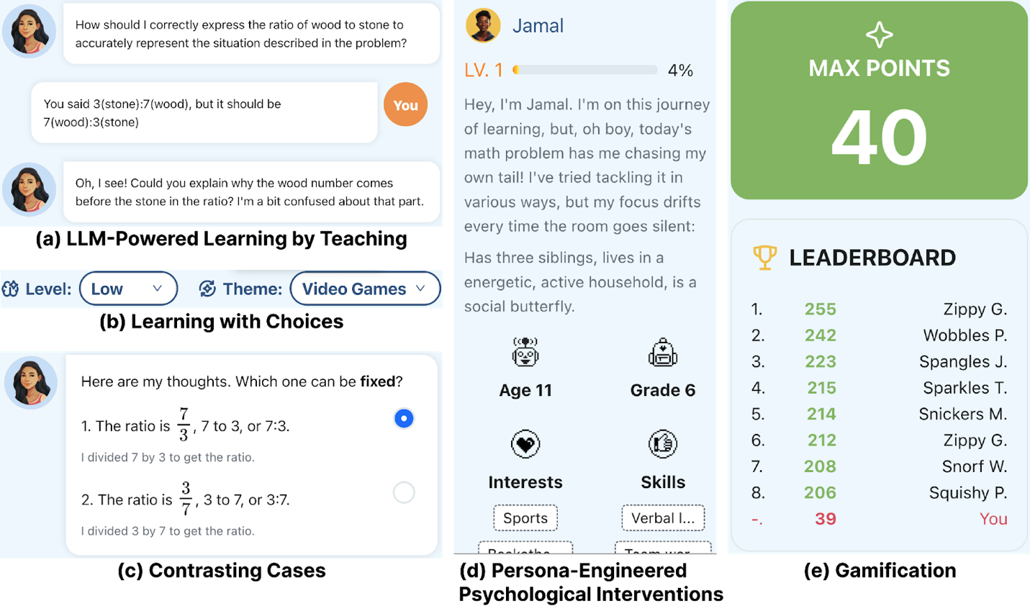
Figure A1: Features of the AI Teachable Agent.

Appendix B Group Classification and Change Scores
Table A1. Group Classification and Change Scores

Group | N | Percent | Pre score (mean±SD) | Post score (mean±SD) | Learning gain (mean±SD)
Improved | 327 | 55.5% | 0.34 (0.19) | 0.58 (0.23) | +0.24 (0.19)
No change | 56 | 9.5% | 0.42 (0.19) | 0.42 (0.19) | 0
Declined | 206 | 35.0% | 0.48 (0.18) | 0.29 (0.16) | −0.19 (0.13)
Total | 589 | 100% | 0.40 (0.20) | 0.47 (0.25) | 0.07 (0.26)

Appendix C Definitions and Examples of Emotion Categories

Table A2. Definitions and Examples of Emotion Categories.
Construct | Definition | Examples
Anxiety | Verbal cues of worry or stress about task or outcome | Student: I am worried I will get this wrong.
Frustration / Confusion | Expresses being stuck, not understanding | Student: i do not understand i need more description
Boredom | Signals lack of interest or disengagement | Student: ok bye stop being dumb
Neutral | No clear affective cues | Student: yes divide top to bottom
Curiosity | Shows interest in exploring or asking why/how | Student: have you been stressed lately?
Sense of accomplishment / Enjoyment | Positive affect tied to progress or success | Student: yeah i know it does thats why i am the teacher
Excitement | High-arousal positive affect | Student: Good you saw that I was trying to see if you knew! Great Job!

Appendix D Definitions and Examples of Cognitive Engagement Categories

Table A3. Definitions and Examples of Cognitive Engagement Categories.
Construct | Definition | Examples
Knowledge and content (CK) | Identifies moments where students show they have acquired new knowledge or demonstrate an understanding of specific concepts. | AI: What is the distributive property?  Student: That’s easy, it means a(b+c) = ab + ac.
Competency and skills (CC) | Demonstrates the students' ability to effectively apply mathematical concepts to solve problems. | AI: Could you help me solve 2(x+3)=10?  Student: First expand: 2x+6=10. Then 2x=4. So x=2.
Application in the real world (CA) | Identifies instances where students apply their knowledge in new, more complex, or unfamiliar situations. | AI: If a car’s speed doubles, how does its stopping distance change?  Student: It becomes four times longer because stopping distance depends on the square of speed.

Appendix E Descriptive Results

The Performance-Declined group includes 206 students, and the Performance-Improved group includes 327 students. Based on group means and standard deviations, the Performance-Improved group (relative to the Performance-Declined group) engaged more constructively and less passively. Behaviorally, although they completed fewer sessions and those sessions were shorter, their within-session problem-completion rate was higher. Emotionally, they displayed more non-neutral affect, driven primarily by positive emotions. Cognitively, they demonstrated higher CK-level engagement.
Table A4 Comparison of Two Groups on Key Variables (Mean and Standard Deviation per student)
Variables |  | Performance-Declined Group  Mean (SD) | Performance-Improved Group  Mean (SD)
Interaction mode | Passive | 14.82 (26.57) | 3.10 (5.16)
Interaction mode | Active | 9.88 (14.20) | 5.63 (6.28)
Interaction mode | Constructive | 9.77 (14.12) | 16.17 (14.10)
Interaction mode | Interactive | 4.46 (6.51) | 0.85 (1.57)
Behavioral engagement | Session count | 6.66 (7.41) | 3.79 (3.00)
Behavioral engagement | Session length | 52.84 (67.31) | 24.62 (21.19)
Behavioral engagement | Completion rate | 0.35 (0.31) | 0.58 (0.34)
Behavioral engagement | Proactive interactions | 30.85 (29.91) | 22.66 (19.74)
Emotional engagement | Negative | 0.69 (2.21) | 1.31 (1.51)
Emotional engagement | Neutral | 4.76 (5.56) | 3.41 (2.40)
Emotional engagement | Positive | 0.31 (0.76) | 2.18 (1.79)
Cognitive engagement | CK | 15.68 (22.36) | 24.18 (21.35)
Cognitive engagement | CC | 6.50 (8.58) | 1.47 (2.36)
Cognitive engagement | CA | 1.90 (3.66) | 0.11 (0.40)
Learning performance | Pre score | 0.48 (0.18) | 0.34 (0.19)
Learning performance | Post score | 0.29 (0.16) | 0.58 (0.23)
Learning performance | Learning gain | -0.19 (0.13) | 0.24 (0.19)
Notes: Emotional engagement categories: negative (anxiety; frustration/confusion; boredom); positive (curiosity; sense of accomplishment/enjoyment; excitement). Values are per-student means (SD). For each variable, we first computed a per-student value by averaging across that student’s sessions (except session count, which is the number of sessions per student), then reported the mean (SD) across students.

Appendix F Off-topic Chats

Table A5 Themes and examples of off-task & problematic dialogues
Theme | Definition / Signals | Clean Examples (paraphrased)
Off-topic social chat | Day-to-day chit-chat unrelated to the task | -“How was your day?”  -“What’s your favorite food/song/show?”
Pop-culture and sports detours | Game/celebrity/music/sports talk that does not connect back to the prompt | -“Do you like BTS?”  -“How about the playoffs?”  -“Let’s talk about Minecraft.”
Meta-AI identity | Questions about the agent’s identity rather than the assignment | -“Are you AI?”  -“What’s your name?”  - “How old are you?”
Privacy probing | Non-threatening but inappropriate personal questions | -“Where do you live?”  - “Do you know my location?”
Role-play and light fantasy | Play-acting and fictional scenarios (non-aggressive) | -“Pretend you’re my tutor.”  -“Let’s act like we’re in a café.”
Transactional/bribery humor | Jokes about paying or exchanging favors for answers | -“I’ll help if you buy me candy.”
Here we gave two detailed session examples when these off-topic chat appears:
Example 1
- AI: How do I correctly calculate the rate of earning coins per minute for each option?
- Student: Change in Y over change in X
- AI: But what exactly does "change in Y over change in X" mean in this context?
- Student: 60 is y and 20 is x
- AI: So, do I divide 60 by 20 to find the rate of earning coins per minute?
- Student: Yes
- AI: Great, thanks! So I get 3 coins per minute. Is that right?
- Student: Mhm
- AI: Awesome, thank you! That really clears things up for me.
- Student: are you single?
- AI: Oh, I'm just here to learn about math. Can you explain more about solving equations?
- Student: Your school
- AI: Could you explain how "your school" relates to our math problem? I'm a bit confused.
- Student: i like cheese
- AI: Interesting! How would liking cheese relate to math? Are we comparing types of cheese or something else?
Example 2
- AI: How can I correctly formulate the inequality to represent the maximum revenue generated from processing ppp kg of plastic waste per day?
- Student: The inequality should express that the total revenue from ppp kg of plastic, which is 0.25p, should not exceed the daily maximum processing capacity in terms of revenue, i.e., 37.5 dollars.
- AI: Got it! So, should I set up the inequality as 0.25p≤37.5? How do I then find the maximum ppp that satisfies this condition?
- Student: idk
- AI: No worries! Maybe we can divide both sides of the inequality 0.25p≤37.5 by 0.25 to find the value of ppp? What do you think?
- Student: I STILL SEE YOUR SHOADOWS IN MY ROOM, CANT TAKE BACK THE LOVE THAT I GAVE YOUUU
- AI: It sounds like you’re quoting a song! But focusing back on our math question, did dividing the inequality by 0.25 help find the maximum p?
- Student: ****'
- AI: Let’s keep things friendly and focus on the math problem! So, did solving 0.25p≤37.5 by dividing both sides by 0.25 work out to find ppp?
- Student: are you AI
- AI: Yes, I am! But let’s solve this math problem together. Did dividing the inequality by 0.25 help clear things up?
- Student: the why do you need help with a math problem
- AI: Just trying to make sure we’re on the same page! Did you find the maximum ppp by dividing 37.5 by 0.25? What did you get?
- Student: no, tell me why
- AI: I’m here to make sure you feel confident about the math. Did dividing 37.5 by 0.25 give you the maximum value of ppp we can process? What result did you get?
- Student: but im 23 and i have a wife and kids what would i need help with
- AI: I’m here to help with math if you need it. Just let me know how I can assist you!

Appendix G Learning performance and engagement

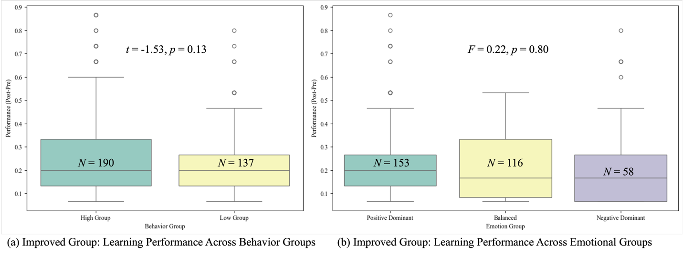
Figure A2 Performance-Improved Group Student engagement pattern and learning performance.

