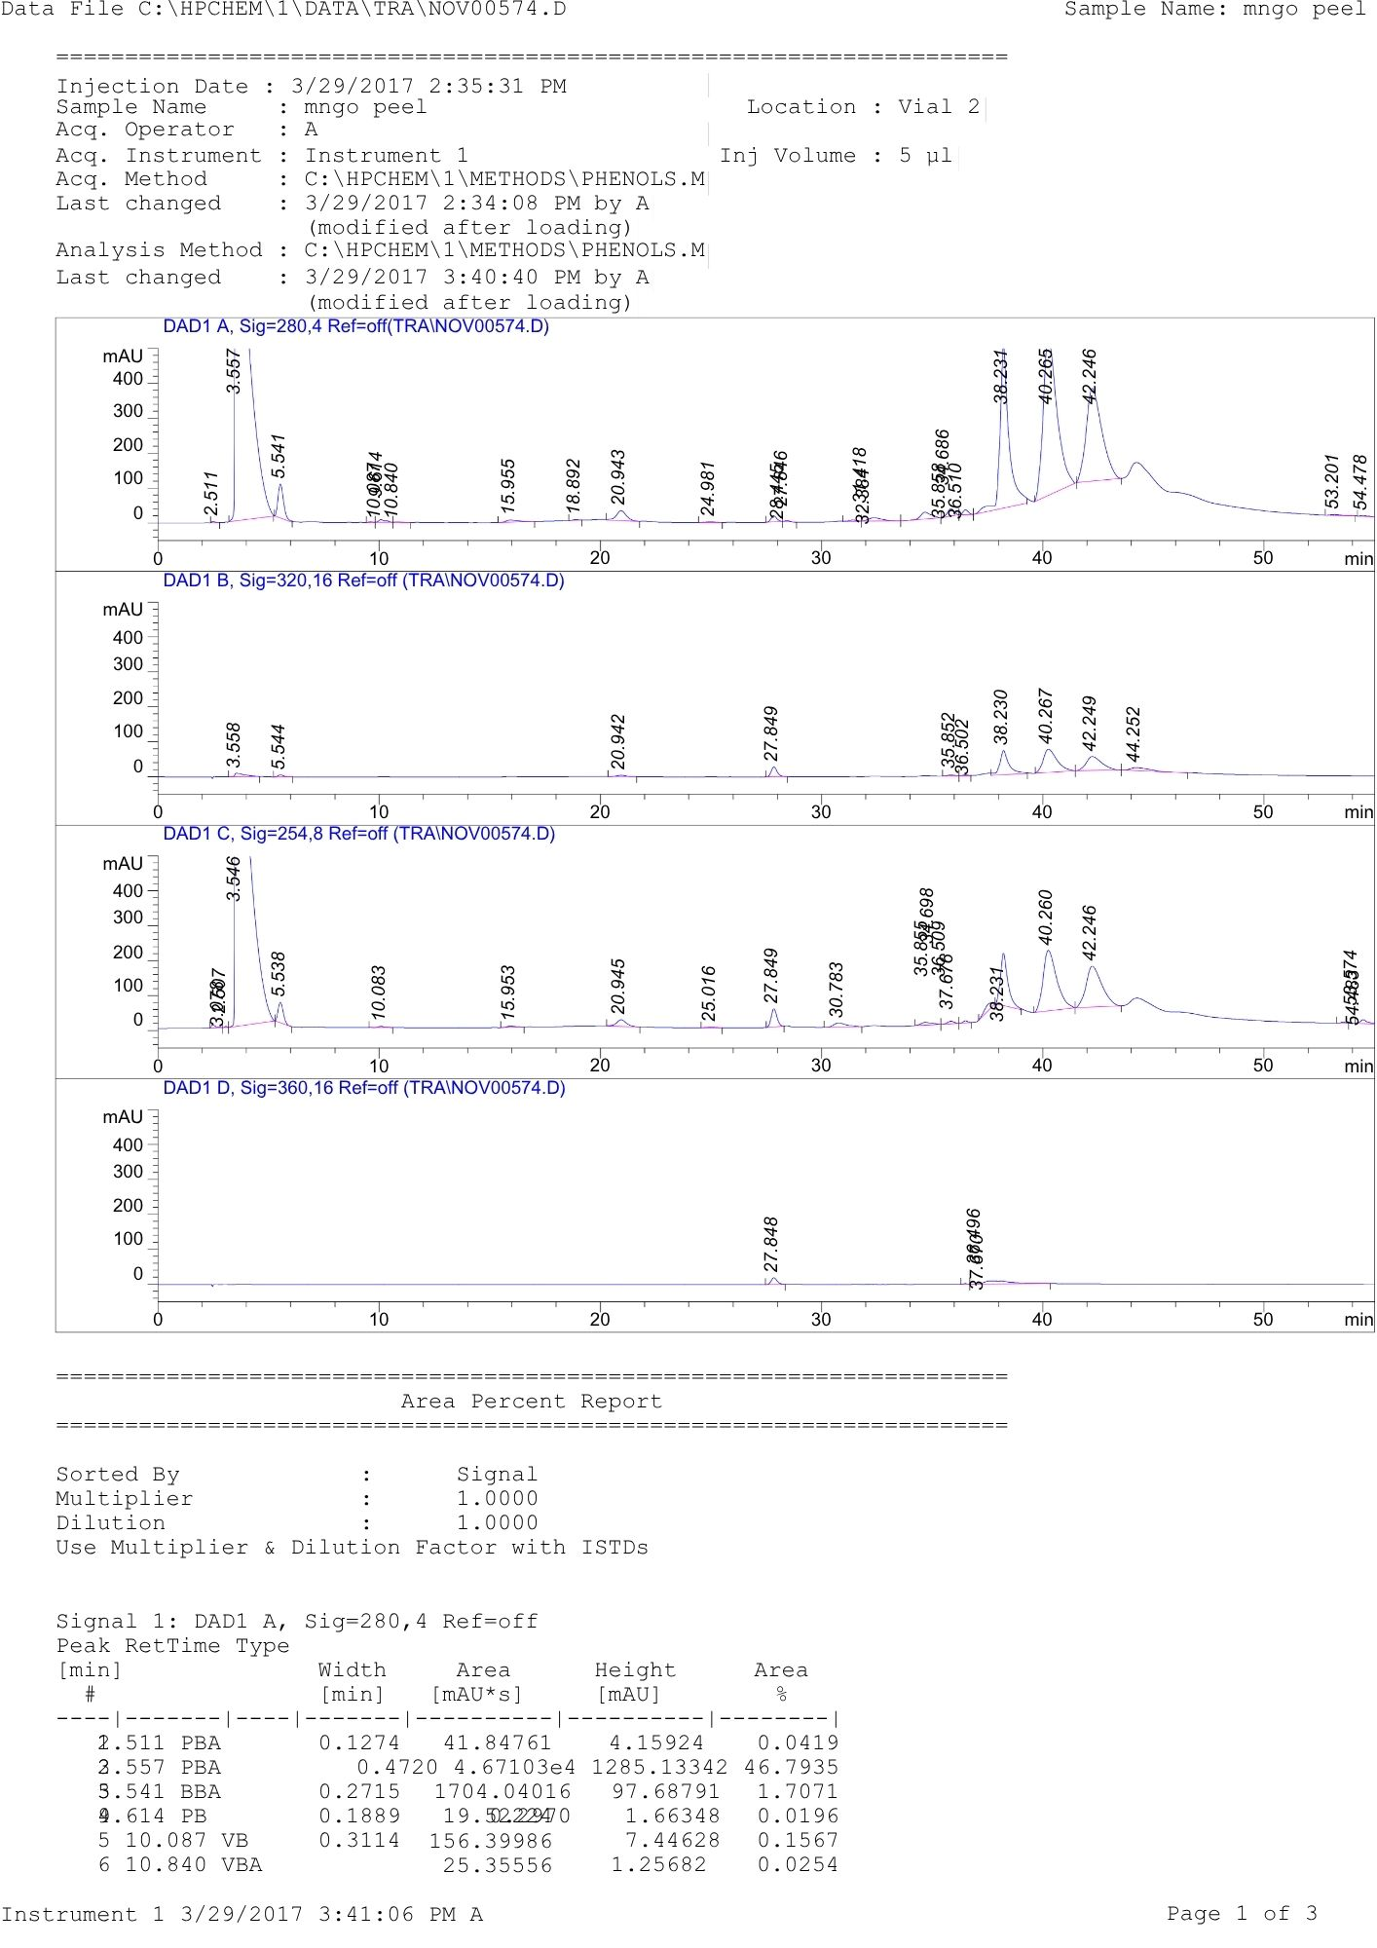
Fig. S1. HPLC chromatogram showing the phenolic profile of flaxseed extract after 5 days of germination. Peaks correspond to identified phenolic compounds as determined by retention times and standards.

Table S1. ANOVA for the selected factorial model and Fit Statistics

ANOVA |  |  |  | Fit statistics for the model
Responses | F-value | p-value | Model | R2 | Adjusted R2 | Predicted R2 | Adeq. precision
TPC | 838.94 | < 0.0001 | factorial | 0.999 | 0.9983 | 0.992 | 95.09
TFC | 1124.79 | < 0.0001 | factorial | 0.999 | 0.9987 | 0.991 | 106.60

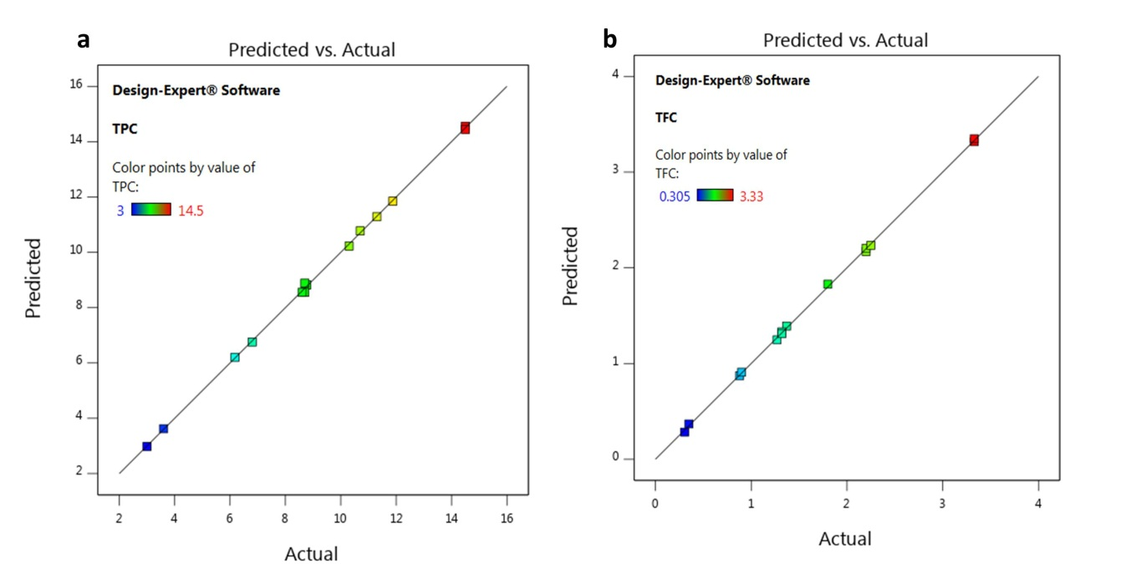

Fig. S2. Predicted vs. actual value graphs for (a) TPC and (b) TFC.

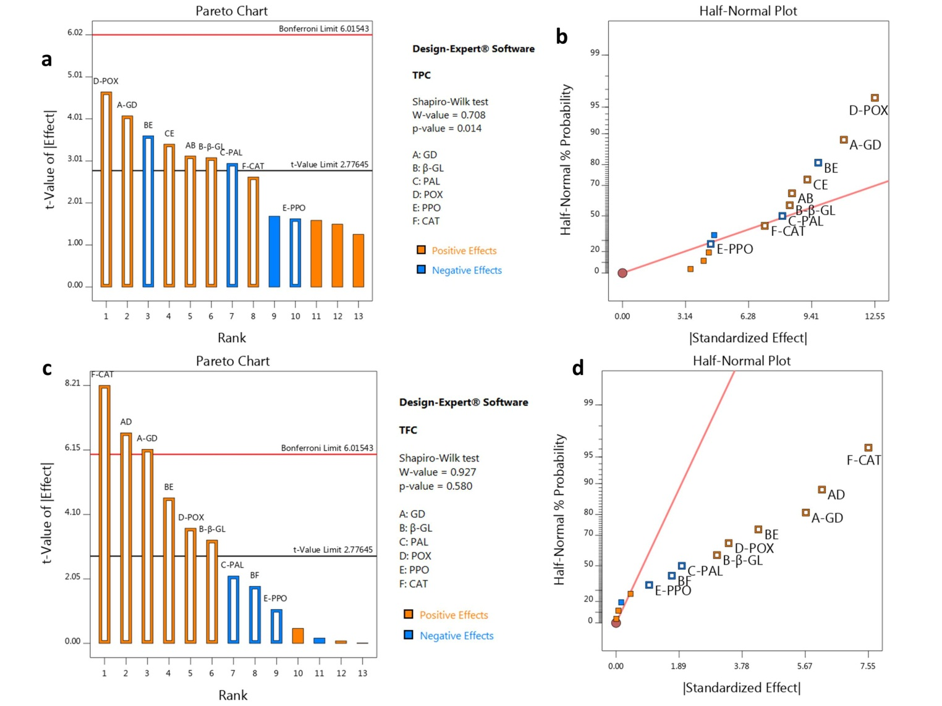

Fig. S3. Pareto charts illustrate the impact of various factors on TPC (a) and TFC (c). Factors that exert a positive influence are represented in orange, whereas those with a negative influence are depicted in blue. Additionally, half-normal charts display the effects of enzymes as variables on TPC (b) and TFC (d).

 | Intercept | GD  (A) | β-GL  (B) | PAL  (C) | POX  (D) | PPO  (E) | CAT  (F) | AB | AD | BE | CE
Regression coefficients (TPC) | 10.180 | 5.505 | 2.354 | -1.602 | 2.381 | -2.671 | 1.54298 | 4.409 |  | -5.831 | 5.809
p-values  F- values |  | 0.015  16.65 | 0.036  9.50 | 0.0421  8.68 | 0.0097  21.63 | 0.179  2.65 | 0.058  6.88 | 0.035  9.76 |  | 0.0226  13.01 | 0.0271  11.61
Regression coefficients (TFC) | 1.068 | 2.841 | 0.929 | -0.268 | 0.579 | -0.4177 | 0.938 |  | 1.973 | 1.650
p-values  F- values |  | 0.0035  38.10 | 0.0304  10.77 | 0.0993  4.57 | 0.0215  13.41 | 0.3423  1.16 | 0.0012  67.33 |  | 0.0026  44.83 | 0.0098  21.42
Table S2: ANOVA results of factorial models and regression coefficients for enzymes associated with the biosynthesis or liberation of total phenolic and flavonoid contents. Statistically significant variables are indicated in bold (P < 0.05).

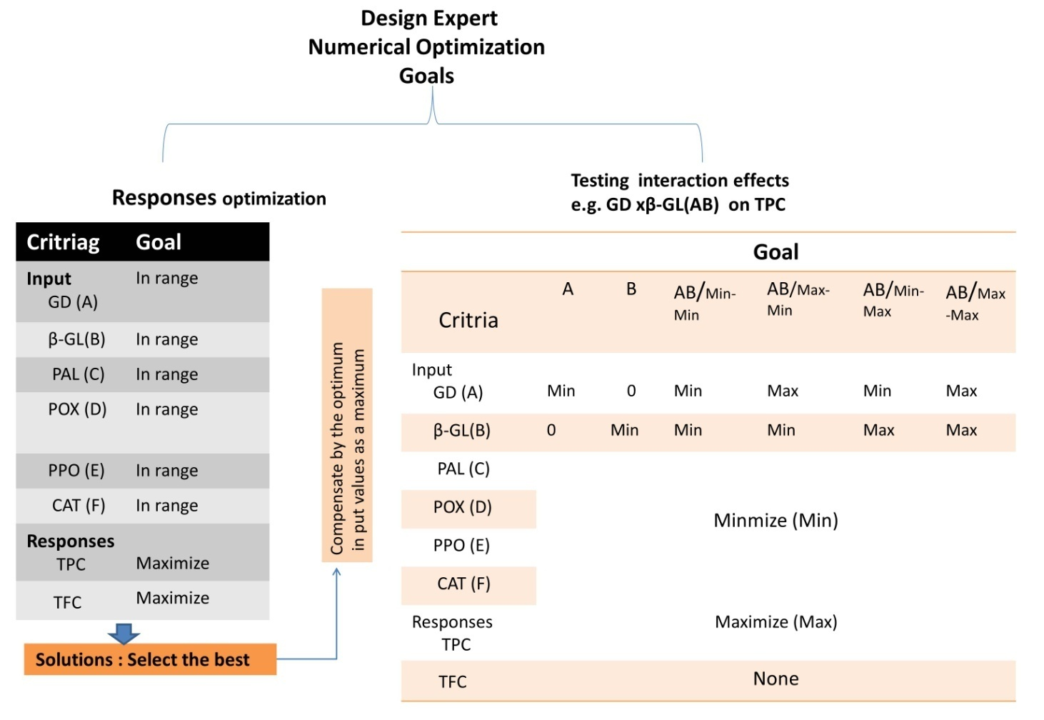

Fig S4: Diagram for numerical optimization approaches

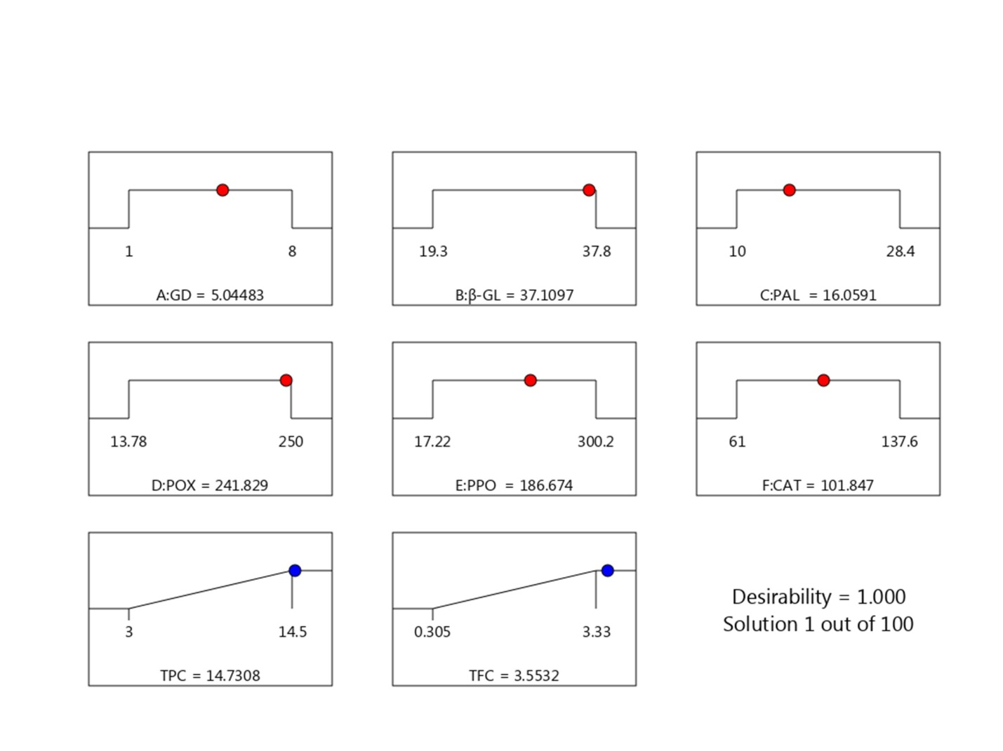
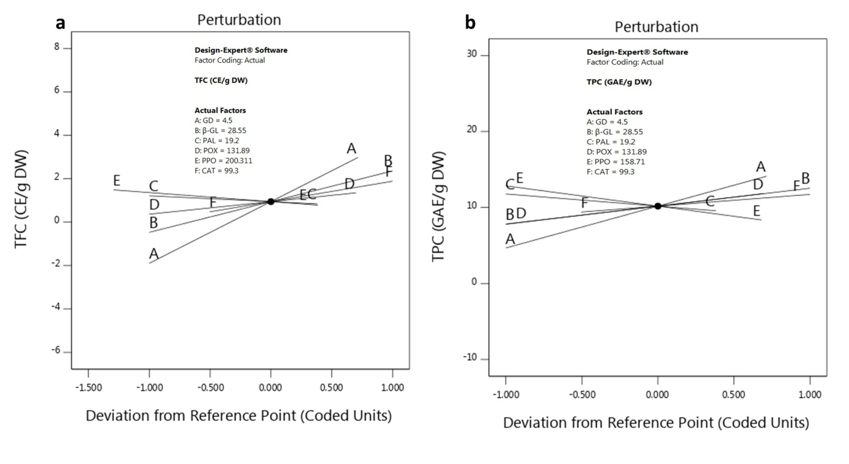

Fig.S5. Desirability ramp plots for the factors influencing the maximum production of TPC and TFC in flax sprouts.

Table S3. presents the maximum levels of phenolic and flavonoid compounds produced by the Flax seeds during the germination process, along with the actual and predicted niche parameters associated with their production. *Relative error (%) is calculated using the formula: [(experimental value - predicted value)/experimental value] x 100.
Measurement | Parameters |  |  |  |  |  | Responses |  | Desirability
Measurement | GD (day) | β-GL  (U/g seed) | PAL (U/g seed) | POX  (U/g seed) | PPO  (U/g seed) | CAT  (U/g seed) | TPC (mg GAE/g | TFC  (mg CE/g) | Desirability
Actual | 5 | 22.27 | 15.25 | 215.5 | 240.66 | 192.13 | 14.5 | 3.33 | 1
Predicted | 5.044 | 37.1 | 16.05 | 241.09 | 186.6 | 101.84 | 14.7 | 3.55 | 1
*Relative error% |  |  |  |  |  |  | 1.38 | 6.6 | 1

 | TPC
 | GD xβ-GL(AB) |  |  |  |  |  | PAL × PPO (CE)
 | Individual GD | Individual β-GL | Combination |  |  |  | individual  PAL | Individual  PPO | Combination
GD (A) | 1  Min | 0 | 1  Min | 5  Min | 1  Min | 5  Max | Min
β-GL (B) | 0 | 19.3  Min | 19.3  Min | 19.3  Min | 37.1  Max | 37.1  Max
PAL(C) | Min |  |  |  |  |  | 16.05  Min | 0 | 10  Min | 16.05  Max | 10  Min | 16.05  Max
PPO (E) |  |  |  |  |  |  | 0 | 17.22  Min | 17.22  Min | 17.22  Min | 186.6  Max | 186.6  Max
Yielded TPC | 1.64 | 1.25 | 3 | 4.92 | 5.8 | 7.2 | 3.6 | 4.2 | 7 | 5.7 | 7.9 | 9.9
desirability | 0.84/1 | 1 | 0.94 | 0. 9 | 0.89 | 0.75 | 0.805 | 0.836 | 0.9 | 0.83 | 0.73 | 0.7
 | TFC
 | GD × POX (AD) |  |  |  |  |  | β-GL × PPO (BE)
 | individual  GD | individual  POX | Combination |  |  |  | individual  β--GL | individual  PPO | Combination
GD (A) | 1  Min | 0 | 1  Min | 5  Max | 1  Min | 5  Max | Min
POX (D) | 0 | 13.78  Min | 13.78  Min | 13.78  Min | 241.8  Max | 241.8  Max
β-GL (B) | Min |  |  |  |  |  | 19.3  Min | 0 | 19.3  Min | 19.3  Min | 37.1 | 37.1
PPO (E) |  |  |  |  |  |  | 0 | 17.22  Min | 17.22  Min | 186.6  Max | 17.22 | 186.6
Yielded TFC | 0.72 | 0.86 | 1.25 | 1.9 | 1.87 | 2.7 | 0.33 | 0.9 | 1.0 | 1.76 | 2.2 | 2.73
desirability | 0.74 | 0.8 | 0.6 | 0.74 | 0.99 | 0.9 | 0.88 | 0.85 | 0.95 | 0.82 | 0.85 | 0.91
Table S4: Interacting factors in changing concentrations varying TPC and TFC response. Min: minimum; Max: maximum concentrations

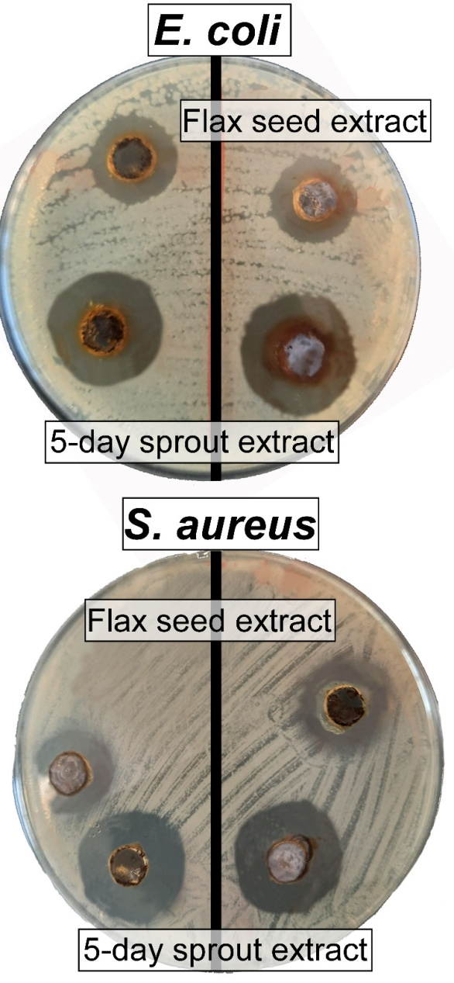

Fig S6. Inhibition zone diameters of dry flaxseed and 5-day sprout extracts against human-pathogenic E. coli and S. aureus using the agar well diffusion method.

