Supplementary File for “Normative Data for IGF-1 and IGFBP-3 and their determinants in Healthy Adult Males from India: the INDIIGo Study”
Running title: Normative data for IGF-1 and IGFBP-3 from India

Authors: Ravi Shah¹, Dipika Bansal², Pulkit Rastogi³, Suchet Sachdev⁴, Nagita Devi⁵, Ratti ram Sharma⁴, Naresh Sachdeva¹, Arun Agrawal⁶, Liza Das^{1,7}, Philippe Chanson⁸, Pinaki Dutta^{1*}
Supplementary Table 1: Detailed Inclusion and exclusion criteria for the INDIIGo study
Inclusion Criteria:  - Apparently healthy adult males of age 20-65.9 years  - Willing to provide written informed consent | Exclusion Criteria:  Medical History of:  - Chronic liver diseases  - Chronic renal diseases  - Cancer or malignancy  - Cardiovascular disease, Chronic congestive cardiac failure  - Pulmonary disease  - Malabsorption  - Uncontrolled Psychiatric disease  - Neurological diseases such as:  - History of subarachnoid hemorrhage  - Traumatic brain injury  - Tubercular meningitis  - Any other disease likely to affect the GH-IGF1 axis  Endocrine disorders:  - Uncontrolled diabetes mellitus  - Improperly treated thyroid disease  - Pituitary disorders  - Hypogonadism  Clinical examination and Biochemical abnormalities:  - BMI ≤ 18.5 kg/m² or ≥ 27.5 kg/m²  - Moderate to severe anemia (hemoglobin <11 g/L)  - Serum albumin below the lower limit of normal  - Alanine transaminase or Aspartate transaminase levels more than twice the upper limit of normal  - Estimated Glomerular Filtration Rate (eGFR) ≤ 60 ml/min/1.73 m²  - Abnormal TSH >4.2 mcIU/mL  - Random plasma glucose >200 mg/dL  - HbA1c >7%  Medication Use:  - Steroids  - Antiandrogens  - Antiestrogens  - Diuretics  - Enzymatic inducers such as:  - Rifampicin  - Phenytoin  - Carbamazepine  - Efavirenz  - Nevirapine  - Griseofulvin  - Mitotane  Lifestyle Factors:  - Current smokers (more than 100 cigarettes in lifetime and at least once a month)  - Alcohol consumption (more than 2 drinks/day or 30 g alcohol per day)  - Substance abuse  Infectious disease:  - Recent (< 1 week) uncontrolled intercurrent disease  - Chronic infectious diseases such as:  - HIV  - Hepatitis  - Tuberculosis

Supplementary Table 2 Reference range of biochemical parameters included in our study.
Biochemical Parameter | Reference range (RR)
Hb (g/dL) | 12-18
S. Creatinine (mg/dL) | 0.5-1.2
ALT (U/L) | 2-41
AST (U/L) | 2-40
Albumin (g/dL) | 3.4-4.8
HbA1c (%) | <5.7
Testo (nmol/L) | 9.9-27.8
TSH (mclU/mL) | 0.27-4.2
T4 (mcg/dL) | 4.8-12.7
Hb = Hemoglobin, ALT= Alanine Transmainase, AST = Aspartate Transaminase, HbA1c = Hemoglobin A1c, TSH = Thyroid Stimulating Hormone, T4 = thyroxine, IGF-1 = Insulin-like Growth Factor-1

Results
Supplementary Table 3 Baseline characteristics of subjects.
 | Total |  | Included |  | Excluded |  | RR
 | Median | IQR | Median | IQR | Median | IQR
Age (years) | 42.18 | 22.98 | 41.29 | 23.58 | 44.88 | 20.39 | 20-65
Height (cm) | 168.00 | 9.00 | 168.00 | 9.00 | 168.00 | 10.00
Weight (kg) | 71.00 | 14.30 | 71.00 | 13.80 | 73.60 | 14.23
BMI (kg/m2) | 25.51 | 3.96 | 25.31 | 4.13 | 26.35 | 3.43 | 18.5-23.5
Hb (g/dL) | 14.40 | 1.60 | 14.50 | 1.60 | 13.80 | 2.08 | 12-18
S. Creatinine (mg/dL) | 0.84 | 0.19 | 0.84 | 0.18 | 4.80 | 0.44 | 0.5-1.2
ALT (U/L) | 29.70 | 21.50 | 29.00 | 19.90 | 0.83 | 0.21 | 2-41
AST (U/L) | 25.90 | 11.20 | 25.60 | 10.60 | 38.15 | 50.68 | 2-40
Albumin (g/dL) | 4.85 | 0.41 | 4.86 | 0.41 | 30.00 | 24.33 | 3.4-4.8
HbA1c (%) | 5.50 | 0.90 | 5.40 | 0.60 | 6.80 | 2.28 | <5.7
Testo (nmol/L) | 14.30 | 7.40 | 14.50 | 7.40 | 13.10 | 7.91 | 9.9-27.8
TSH (mclU/mL) | 2.05 | 1.51 | 2.01 | 1.42 | 2.55 | 3.18 | 0.27-4.2
T4 (mcg/dL) | 6.96 | 1.84 | 6.94 | 1.81 | 7.16 | 2.21 | 4.8-12.7
IGF-1 (ng/ml) | 176.00 | 89.00 | 181.00 | 90.00 | 148.50 | 84.75

BMI = Body Mass Index, Hb = Hemoglobin, ALT= Alanine Transmainase, AST = Aspartate Transaminase, HbA1c = Hemoglobin A1c, TSH = Thyroid Stimulating Hormone, T4 = thyroxine, IGF-1 = Insulin-like Growth Factor-1

Supplementary Table 4 Distribution of subjects across socioeconomic strata and intake sufficiency as per Modified Kuppuswamy scale 2019

Modified Kuppuswamy Scale | Frequency | Percentage | Intake sufficiency (%)
Didn’t Disclose | 52 | 3.55 | 79%
Upper | 137 | 9.35 | 83.3%
Upper Middle | 419 | 28.61 | 80.6%
Lower Middle | 356 | 24.35 | 82.9%
Upper Lower | 460 | 31.42 | 84.9%
Lower | 40 | 2.72 | 59.7%

Supplementary Table 5 Multiple Linear regression analysis for factors responsible for variation in serum IGF-1.
Model | Unstandardized Coefficients |  | t | Significance | 95% Confidence Interval
 | Beta | Standard error |  |  | Lower Bound | Upper Bound
(Constant) | 251.96 | 58.15 | 4.33 | <0.001 | 137.89 | 366.04
Age (yrs) | -3.01 | 0.25 | -12.05 | <0.001 | -3.49 | -2.52
Modified  Kuppuswamy Class | -5.82 | 1.92 | -3.04 | 0.002 | -9.57 | -2.06
BMI (kg/m²) | 0.49 | 1.074 | 0.46 | 0.648 | -1.62 | 2.60
Fat (%) | 0.07 | 0.34 | 0.21 | 0.838 | -0.60 | 0.737
Hb (g/dL) | 1.60 | 1.52 | 1.05 | 0.294 | -1.39 | 4.58
eGFR (ml/min/1.73m²) | -0.38 | 0.21 | -1.81 | 0.071 | -0.78 | 0.03
ALT (U/L) | -0.61 | 0.126 | -4.87 | <0.001 | -0.86 | -0.37
AST (U/L) | 0.13 | 0.16 | 0.80 | 0.423 | -0.19 | 0.45
Alb (g/dL) | 18.05 | 6.93 | 2.60 | 0.009 | 4.44 | 31.65
T (nmol/L) | 0.19 | 0.37 | 0.50 | 0.616 | -0.54 | 0.908
TSH (mcIU/mL) | -0.38 | 0.74 | -0.52 | 0.606 | -1.84 | 1.07
T4 (mcg/dL) | 4.55 | 1.33 | 3.44 | <0.001 | 1.96 | 7.15
HbA1c (group) | -8.22 | 3.9 | -2.06 | 0.040 | -16.07 | -0.38

For the model, R² = 0.221, adjusted R2 = 0.214, Standard error= 77.8
BMI= Body Mass Index, Hb = Hemoglobin, eGFR= estimated Glomerular Filtration Rate, ALT = Alanine Transaminase, AST= Aspartate Transaminase, Alb = serum albumin, T = testosterone, TSH = Thyroid Stimulating Hormone, HbA1c= Hemoglobin A1c

Based on the regression analysis, Predicted IGF-1 (ng/ml) = 251.967 – 3 * Age (yrs.) – 5.8 * Modified kuppuswamy class – 0.6 * ALT (U/L) + 18 * S. Albumin (g/dL) -8.22* HbA1c group + 4.5 * Plasma T4 (mcg/dL)
Supplementary Table 6 Multiple linear regression analysis for factors responsible for variation in serum IGFBP-3
Model | Unstandardized Coefficients |  | t | Significance | 95% Confidence Interval
 | Beta | Standard error |  |  | Lower Bound | Upper Bound
(Constant) | 3278.88 | 1266.06 | 2.59 | 0.01 | 795.03 | 5762.73
Age (yrs) | -44.79 | 5.08 | -8.81 | <0.001 | -54.76 | -34.81
Modified Kuppuswamy Class | -61.90 | 38.49 | -1.61 | 0.108 | -137.41 | 13.62
BMI (kg/m²) | 16.61 | 22.70 | 0.73 | 0.464 | -27.92 | 61.13
Fat (%) | -6.23 | 6.85 | -0.91 | 0.364 | -19.67 | 7.22
Hb (g/dL) | 59.47 | 33.98 | 1.75 | 0.080 | -7.19 | 126.17
eGFR (ml/min/1.73m²) | 1.67 | 4.39 | 0.38 | 0.703 | -6.93 | 10.27
ALT (U/L) | -3.52 | 3.88 | -0.91 | 0.365 | -11.12 | 4.09
AST (U/L) | 6.69 | 5.99 | 1.12 | 0.265 | -5.07 | 18.45
Alb (g/dL) | 147.04 | 142.37 | 1.03 | 0.302 | -132.28 | 426.35
T (nmol/L) | -9.25 | 7.66 | -1.21 | 0.227 | -24.28 | 5.77
TSH (mcIU/mL) | 40.23 | 43.31 | 0.93 | 0.353 | -44.75 | 125.20
T4 (mcg/dL) | 60.75 | 27.12 | 2.24 | 0.025 | 7.54 | 113.96
HbA1c (group) | -19.44 | 163.24 | -0.12 | 0.905 | -339.69 | 300.811

For the model, R² = 0.170, adjusted R2 = 0.161, Standard error= 1449.7

BMI= Body Mass Index, Hb = Hemoglobin, eGFR= estimated Glomerular Filtration Rate, ALT = Alanine Transaminase, AST= Aspartate Transaminase, Alb = serum albumin, T = testosterone, TSH = Thyroid Stimulating Hormone, HbA1c= Hemoglobin A1c

Based on the above regression analysis, Predicted IGFBP-3 (ng/ml) = 3278.88 – 44.8 * Age (yrs.) + 60.75 * Plasma T4 (mcg/dL)
Supplementary Table 7 Studies reporting normative data of serum IGF-1 in adults done by Roche Elecsys® electrochemiluminescence immunoassay analyzer (ECLIA) assays
Study | Year of publication | Journal | Country | Included number of males | Age group
Present Study | 2024 | Present journal | India | 1271 | 20-65.9
Sabbah et al. (10) | 2021 | Endocr Connect | France | 463 | 18-89.0
Hörenz et al. (11) | 2022 | Journal of Clinical Endocrinology & Metabolism | German (predominantly) | 2504 (in reference cohort) | 19-80.9

Supplementary Figure 1 Initial study design and plan of conduct of study

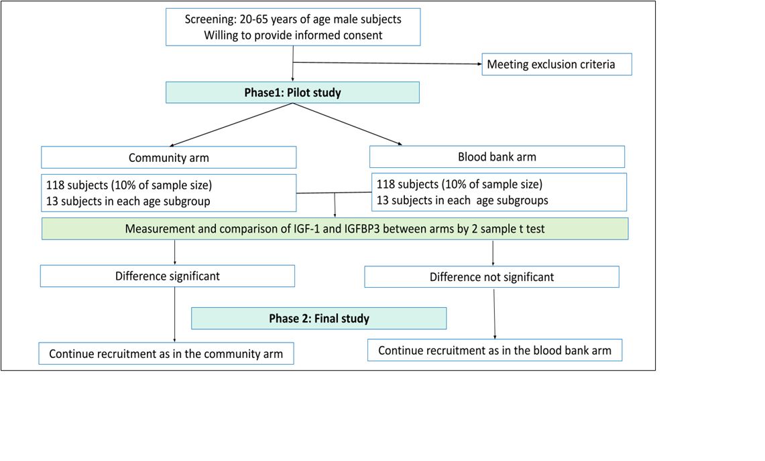
Supplementary Figure 2 Comparison of age-wise median IGF-1 of our population with reference data provided by manufacturer (p<0.001)
