The overlapping impacts of heat and COVID-19 on mortality: A time-series analysis

Endale Alemayehu Ali^{a*}, Raf Aerts^{b,c}, Bert Vaesª, Charlotte Scheerens^{a,e}, Simon Gabriël Beertenª, Elisa Duarte^{d}, Gijs Van Pottelberghª
ªDepartment of Public Health and Primary Care, KU Leuven, Kapucijnenvoer 33, 3000 Leuven, Belgium
^{b}Division Ecology, Evolution and Biodiversity Conservation, KU Leuven, 3001 Leuven, Belgium
^{c} Health Impact Assessment, Sciensano, Juliette Wytsmanstraat 14, 1050 Brussels, Belgium
^{d}I-BioStat, Data Science Institute, Hasselt University, Campus Diepenbeek, Diepenbeek, Belgium
^{e}Department of Public Health and Primary Care, Ghent University, 9000 Ghent, Belgium

Supplementary results

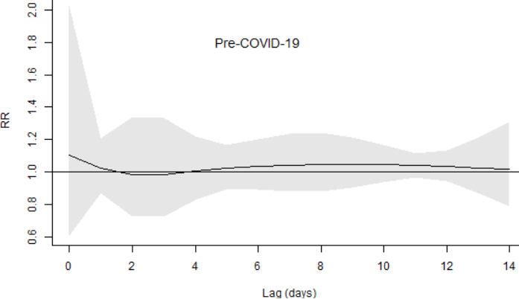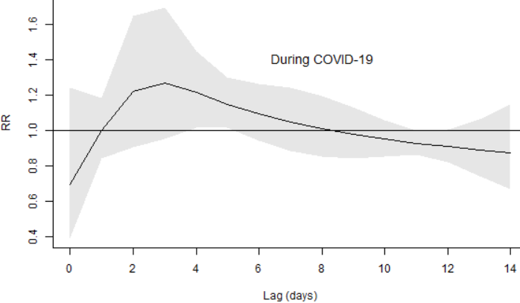
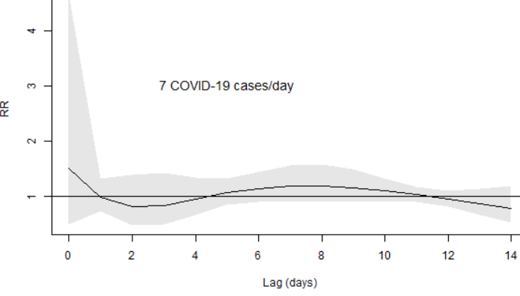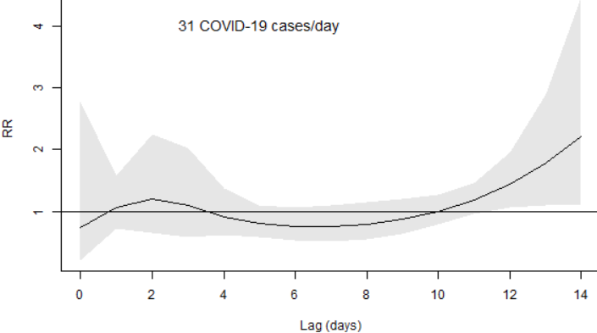
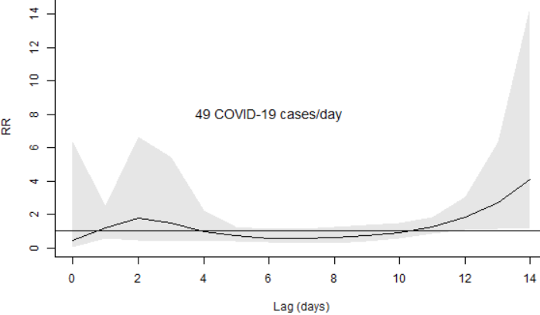
Figure S1: The lag-response association of minimum temperature (at P99: 22.6 °C)
and mortality using a binary interaction approach (top panel) and linear interaction approach (middle and bottom panel)

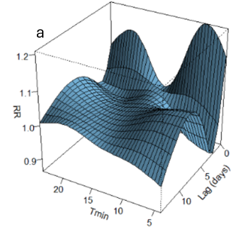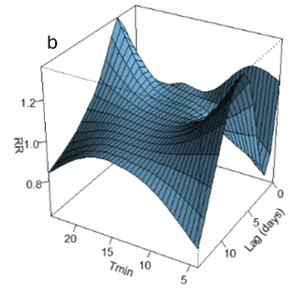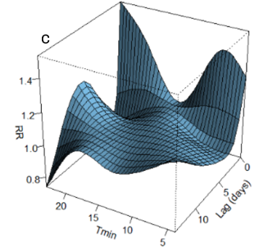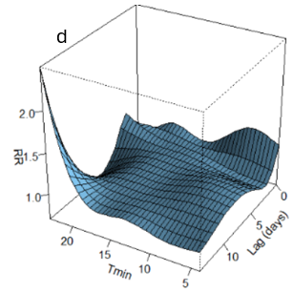
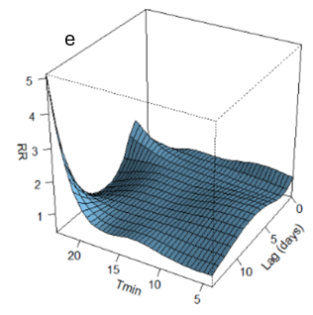
Figure S2: The 3d (exposure-lag-response) plots, estimated based on binary approach (e: before COVID-19 and b: during COVID-19) and
linear approach (a: low COVID-19 intensity, b: mild COVID-19 intensity, and c: high COVID-19 intensity)

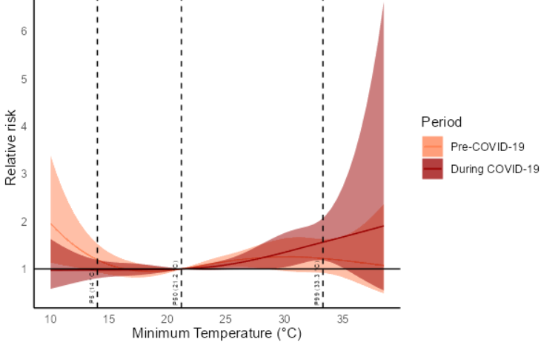
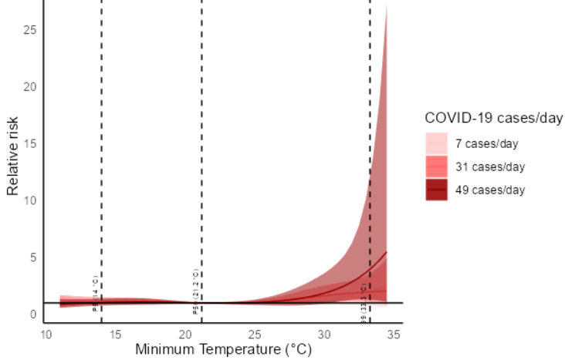
Figure S3: Cumulative (lag 0-14 days) RR for the association between daily maximum temperature and all-cause mortality, estimated for pre- and during-COVID-19 periods (top panel ) and levels of daily COVID-19 transmission intensity (bottom panel). The vertical dashed lines represent the 1st, 50th, and 99th percentiles of maximum temperatures. Shaded areas represent the 95% confidence intervals of the estimates.

Table S1: Cumulative RRs (lag 0-14 days) of all-cause mortality associated with extreme heat (99th (33.3 °C ) vs 50th (21.2 °C) percentile of maximum daily temperature), estimated for pre- COVID-19 and during-COVID-19 periods using a binary interaction approach, and under varying COVID-19 intensity levels (low, mild and high) using a linear interaction approach.
Exposure | Binary interaction approach |  | Linear interaction approach
Exposure | Pre-COVID-19 | During-COVID-19 | Low COVID-  19 intensity | Mild COVID-19 intensity | High COVID-19 intensity
Exposure | RR (95% CI) | RR (95% CI) | RR (95% CI) | RR (95% CI) | RR (95% CI)
Tmin | 1.07 (0.72, 1.58) | 1.55 (1.18, 2.02) | 1.18 (0.64, 2.18) | 1.95 (1.03, 3.70) | 3.57 (1.10, 11.61
Tmax | 1.25 (0.94, 1.64) | 1.58 (1.20, 2.09) | 1.27 (0.73, 2.19) | 1.83 (1.03, 3.28) | 2.92 (0.99, 8.66)

Table S2: Comparison of heat-related mortality risks before and during the COVID-19 period and across varying COVID-19 intensity levels. For both approaches, pairwise z-tests were performed. *indicates statistical significance at 5% level of significance.
Model approach | COVID-19 status | Z-test | p-value
Binary interaction | During-COVID-19 vs pre-COVID-19 | 1.97 | 0.049
Linear interaction | Mild vs low | 1.68 | 0.09
Linear interaction | High vs low | 2.35 | 0.02*
Linear interaction | High vs mild | 3.49 | 0.0005*

