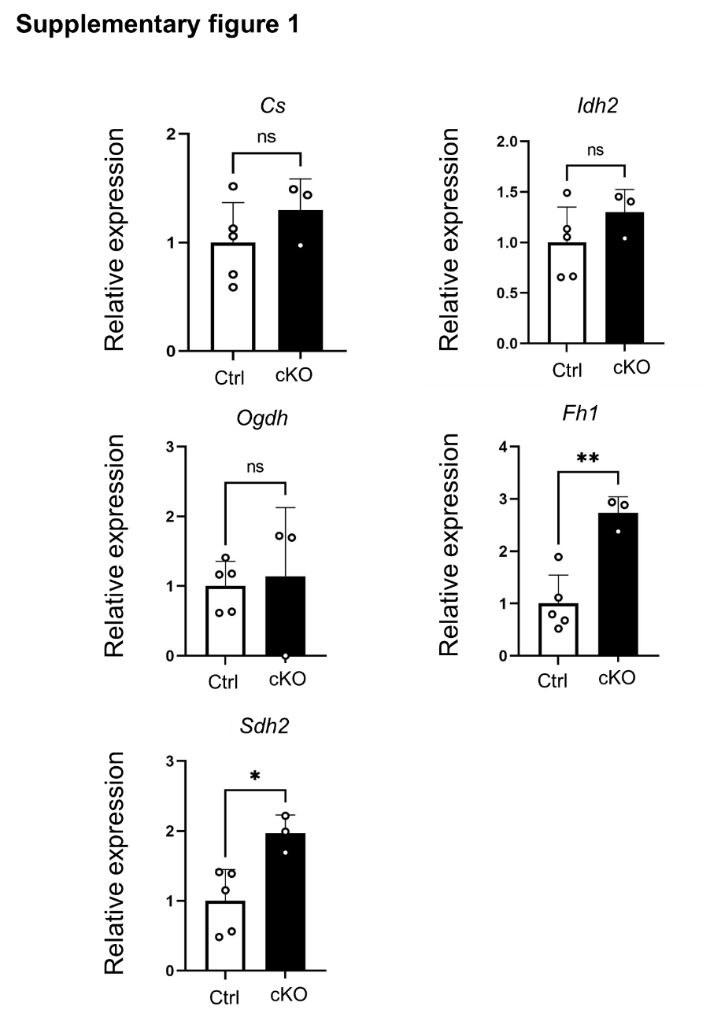
RT-qPCR analysis was performed using RNA extracted from hind limb muscles of E18.5 control (Ctrl) and Aco2 cKO embryos.
The relative mRNA expression levels of Cs, Idh2, Ogdh, Sdha, and Fh1 were quantified. Sdha and Fh1 were significantly upregulated in Aco2 cKO mice compared with controls, whereas Cs, Idh2, and Ogdh showed no significant differences. Data are presented as mean ± SD (Ctrl: n = 5, cKO: n = 3). Statistical significance was assessed by a two-sided t-test (*p < 0.05; *p < 0.01).

