- Remnant cholesterol and body mass index jointly associate with cardiometabolic multimorbidity with mediation analysis in CHARLS a prospective cohort study
- Jiaxin Li¹⁺, Mingxue Fan²⁺, Mingyue Yang¹⁺, Wei Huang¹, Wenjing Shi¹, Daowen Zhang¹, Weiwei Zhu¹, Cancan Liu¹, Nannan Xu¹, Huijun Zhang¹ and Kuanlu Fan^{1*}
¹ Department of Endocrinology, The Second Affiliated Hospital of Xuzhou Medical University, Xuzhou, China
² ﻿Xuzhou Clinical Academy of Xuzhou Medical University, Xuzhou, China
⁺Jiaxin Li, Mingxue Fan and Mingyue Yang contributed equally to this work and share first authorship.
* Correspondence: E-mail: fan17751991828@163.com

Table S1 Covariate selection rationale and multicollinearity diagnostics
Variable | Rationale for inclusion | GVIF^(1/(2×Df)) | Decision
RC | Primary exposure (lipid metabolism indicator) | 1.02 | Kept
BMI | Primary exposure (adiposity indicator) | 1.09 | Kept
age | Fundamental demographic confounder | 1.14 | Kept
sex | Fundamental demographic confounder | 1.34 | Kept
residence | Socio-environmental factor | 1.04 | Kept
Marital | Socio-economic factor | 1.06 | Kept
education | Socio-economic factor | 1.05 | Kept
smoke | Lifestyle behavior | 1.22 | Kept
drink | Lifestyle behavior | 1.15 | Kept
Hypertension | Clinical comorbidity relevant to CMM | 1.06 | Kept
﻿treatment for dyslipidemia | Clinical comorbidity relevant to CMM | 1.04 | Kept
GVIF^(1/(2×Df)) represents the generalized variance inflation factor adjusted for degrees of freedom. All adjusted GVIF values were < 2.0, indicating no significant multicollinearity.

Table S2 Combined analysis of RC and BMI based on inflection points derived from restricted cubic spline models.
character | Unadjusted |  | Adjusted
character | OR(95%CI) | P value | OR(95%CI) | P value
Q1 (Low RC & Low BMI) | Ref | — | Ref | —
Q2 (Low RC & High BMI) | 2.48 (1.83,3.35) | <0.0001 | 2.09 (1.52,2.86) | <0.0001
Q3 (High RC & Low BMI) | 1.49 (1.07,2.08) | 0.02 | 1.44 (1.03,2.02) | 0.03
Q4 (High RC & High BMI) | 3.20 (2.42,4.22) | <0.0001 | 2.41 (1.80,3.24) | <0.0001
P for trend | <0.0001 | — | <0.0001 | —

Adjusted for age, sex, residence, marital status, education, smoking, drinking, hypertension, and dyslipidemia treatment. Cut-off values (RC = 18.6 mg/dL; BMI = 23.1 kg/m²) were derived from RCS inflection points.

Table S3 Additive interaction between residual cholesterol (RC) and body mass index (BMI) on cardiometabolic multimorbidity (CMM) risk
Measure | Estimate (95% CI) | p-value
RERI (Relative excess risk due to interaction) | 0.31 (−0.78 to 1.40) | 0.577
AP (Attributable proportion due to interaction) | 0.08 (−0.48 to 0.65) | 0.773
S (Synergy index) | 0.06 (−0.41 to 0.52) | 0.812

Note:
Estimates were derived from multivariable logistic regression models including an interaction term (RC_high × BMI_obese). RC_high and BMI_obese were defined as values ≥ the sample median and ≥ 28 kg/m², respectively. Covariates included age, sex, residence, marital status, education, smoking, drinking, hypertension, and dyslipidemia treatment.
95% confidence intervals were estimated using the delta method.
RERI > 0, AP > 0, and S > 1 indicate a positive additive interaction between RC and BMI on CMM risk.

Figures S1 Distribution of remnant cholesterol (RC) before and after data cleaning using the interquartile range (IQR) method
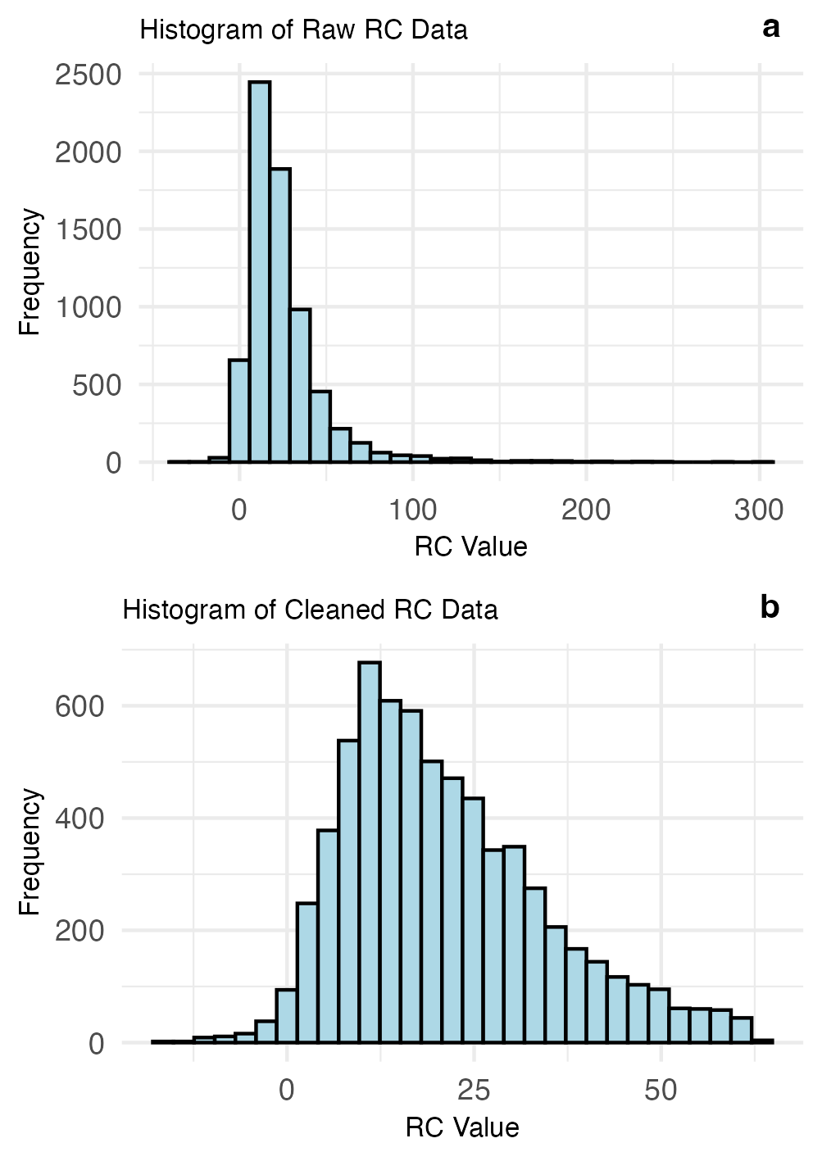
Histogram of remnant cholesterol (RC) before and after data cleaning using the interquartile range (IQR) method. The raw RC data were right-skewed, and the cleaned RC data approximated a normal distribution.

Figures S2 Violin and box plots of cleaned remnant cholesterol (RC) across BMI-related subgroups
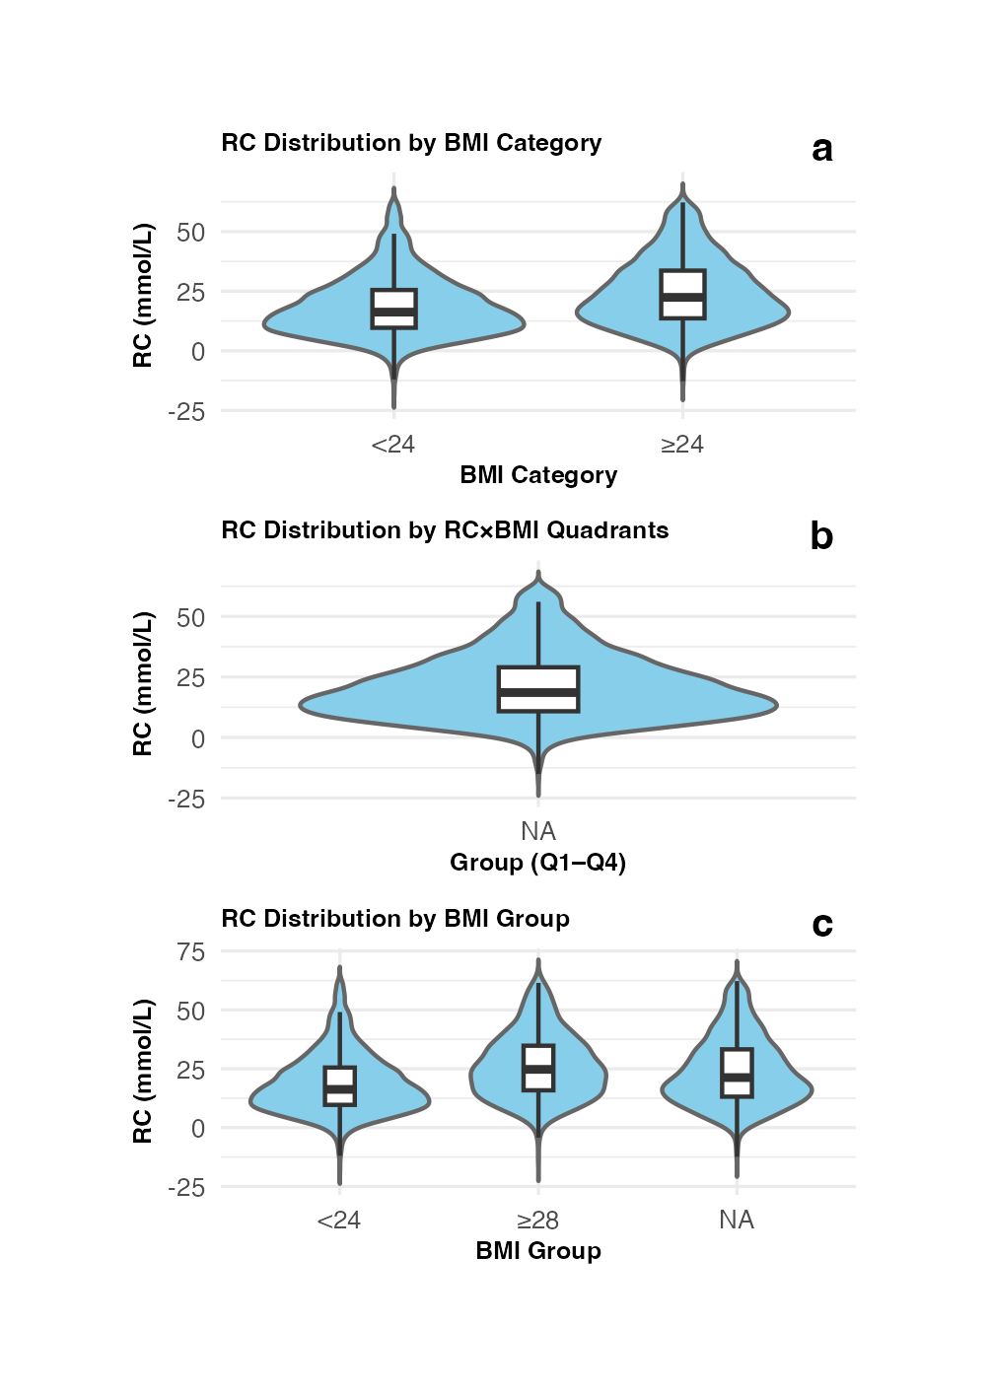
Violin and box plots of cleaned RC data showing the distribution of RC according to (a) BMI categories (<24 vs ≥24), (b) combined RC×BMI quadrants (Q1–Q4), and (c) BMI groups (<24, 24–28, ≥28). RC values exhibited a mildly right-skewed distribution across all groups.
Table S4 Subgroup analysis for the effect of RC and BMI on the risk of CMM
Group | Unadjusted |  | Adjusted
Group | 95%CI | P | 95%CI | P
Subgroup 1
RC<median & BMI<24 | ref |  | ref
RC<median & BMI≥24 | 2.11(1.44,3.10) | <0.001 | 2.17(1.46,3.23) | <0.001
RC≥median & BMI<24 | 1.32(0.92,1.90) | 0.13 | 1.33(0.92,1.91) | 0.13
RC≥median & BMI≥24 | 2.8(2.00,3.92) | <0.0001 | 2.81(1.98,3.98) | <0.0001
p for trend |  | <0.0001 |  | <0.0001
Subgroup 2
RC<median & BMI<24 | ref |  | ref
RC<median & BMI≥24 | 2.37(1.31,4.28) | 0.004 | 2.28(1.24,4.18) | 0.01
RC≥median & BMI<24 | 1.41(0.81,2.45) | 0.22 | 1.42(0.81,2.48) | 0.22
RC≥median & BMI≥24 | 2.42(1.39,4.23) | 0.002 | 2.32(1.31,4.13) | 0.004
p for trend |  | 0.01 |  | 0.02
Adjusted: age, sex, residence, Marital, education, smoke, drink, Hypertension.
Subgroup 1: among 5396 participants without treatments for hypertension or dyslipidemia at baseline;
subgroup 2: among 3980 participants without treatments for hypertension or dyslipidemia at baseline or during follow-up.

Table S5 Baseline characteristics of included (Q1) and excluded (Q2) participants at baseline (CHARLS 2011–2018).
variable | Total  (n=19752) | Q1  (n=6646) | Q2  (n=13106) | P value
age | 61.76 ± 10.40 | 65.43 ± 8.89 | 59.89 ± 10.62 | <0.0001
sex |  |  |  | <0.01
female | 10440(52.86) | 3617(54.42) | 6823(52.06)
male | 9312(47.14) | 3029(45.58) | 6283(47.94)
Marital |  |  |  | <0.0001
Married | 16815(85.13) | 5472(82.34) | 11343(86.55)
Non-Married | 2937(14.87) | 1174(17.66) | 1763(13.45)
education |  |  |  | <0.0001
Higher education | 426(2.16) | 61( 0.92) | 365(2.78)
Secondary school | 6388(32.34) | 1814(27.29) | 4574(34.90)
No formal education | 8543(43.25) | 3313(49.85) | 5230(39.91)
Primary school | 4395(22.25) | 1458(21.94) | 2937(22.41)
residence |  |  |  | <0.0001
rural | 11788(59.68) | 4505(67.79) | 7283(55.57)
urban | 7964(40.32) | 2141(32.21) | 5823(44.43)
smoke |  |  |  | <0.0001
no | 19064(97.62) | 6501(98.83) | 12563(97.00)
yes | 465(2.38) | 77(1.17) | 388(3.00)
DM |  |  |  | 0.50
no | 17139(87.62) | 5806(87.39) | 11333(87.74)
yes | 2422(12.38) | 838(12.61) | 1584(12.26)
Hypertension |  |  |  | <0.0001
no | 12305(64.12) | 3921(59.00) | 8384(66.83)
yes | 6887(35.88) | 2725(41.00) | 4162(33.17)
dyslipidemia |  |  |  | 0.05
no | 15249(78.38) | 5156(77.58) | 10093(78.79)
yes | 4207(21.62) | 1490(22.42) | 2717(21.21)
Heart disease |  |  |  | <0.0001
no | 15724(80.55) | 5185(78.02) | 10539(81.86)
yes | 3796(19.45) | 1461(21.98) | 2335(18.14)
stroke |  |  |  | <0.01
no | 18256(92.65) | 6104(91.84) | 12152(93.05)
yes | 1449(7.35) | 542(8.16) | 907(6.95)
CMM |  |  |  | 0.74
no | 17919(92.68) | 6164(92.78) | 11755(92.63)
yes | 1415(7.32) | 480(7.22) | 935(7.37)
RC | 25.81 ± 24.58 | 21.00 ± 13.53 | 37.23 ± 37.70 | <0.0001
BMI | 23.65 ± 3.87 | 23.43 ± 3.83 | 24.59 ± 3.92 | <0.0001
Values are presented as mean ± standard deviation for continuous variables or n (%) for categorical variables.
Q1 represents participants included in the final analytic sample (n = 6,646); Q2 represents those excluded due to missing data on RC, BMI, CMM, or covariates (n = 13,106). P-values were calculated using t-test or χ² test, as appropriate.

