Chrysanthemum morifolium extract improves Metabolic Dysfunction-Associated Fatty Liver Disease by regulating lipid metabolism
Wenjing Yu ¹, Jun Qiu ¹, Yonghu Chen ¹, Xianhua Che ^{1*}, Xuezheng Li ^{1.*}
¹ College of Pharmacy, Yanbian University Hospital, Yanbian University, Yanji, 133002, P.R. China

Wenjing Yu: sunshineywj2024@163.com
* Corresponding author:
Prof. Dr. Xuezheng Li
E-mail: xzli@ybu.edu.cn
College of Pharmacy, Yanbian University Hospital, Yanbian University, Yanji, 133002, P.R. China
Tel: +86-15526771896
Supplementary Figure 1
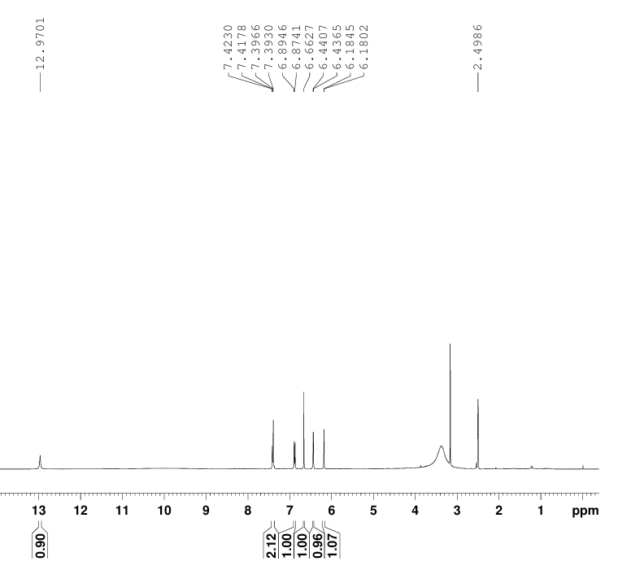
Supplementary Figure 1. The ¹H-NMR spectrum of Luteolin (LU) in DMSO-d₆ (400 MHz)
Supplementary Figure 2
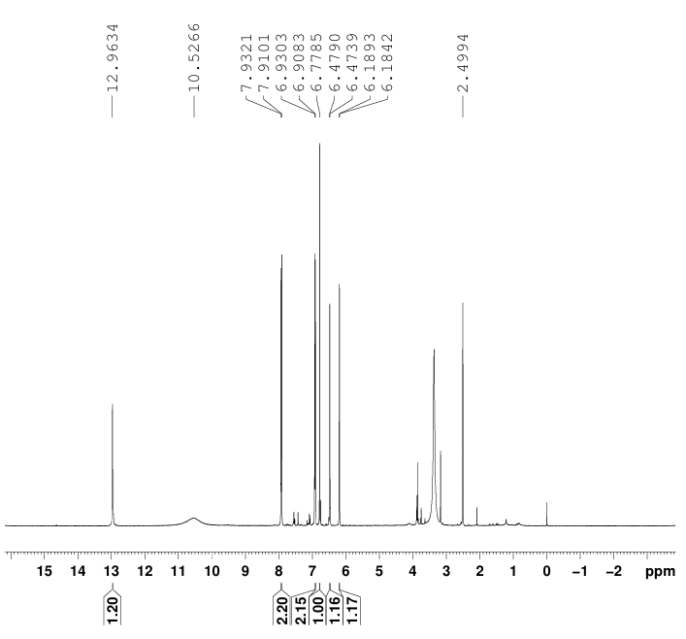
Supplementary Figure 2. The ¹H-NMR spectrum of Apigenin (AP) in DMSO-d₆ (400 MHz)

Supplementary Figure 3
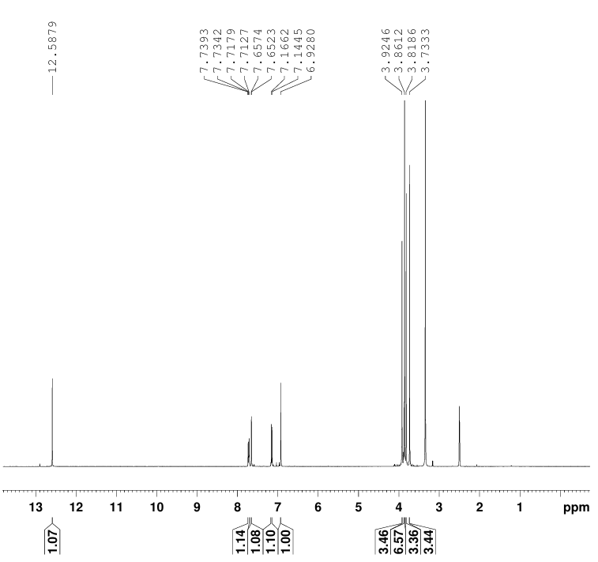
Supplementary Figure 3. The ¹H-NMR spectrum of Artemisetin (AR) in DMSO-d₆ (400 MHz)
Supplementary Figure 4
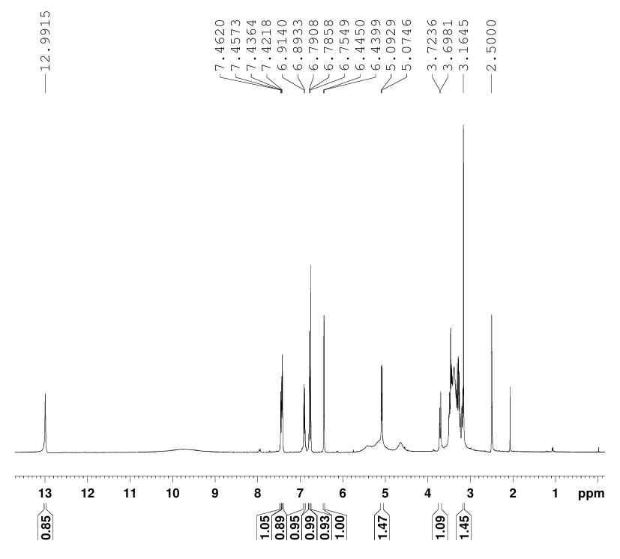
Supplementary Figure 4. The ¹H-NMR spectrum of Luteolin-7-O-β -D-glucopyranoside (LU-glu)
in DMSO-d₆ (400 MHz)

Supplementary Figure 5
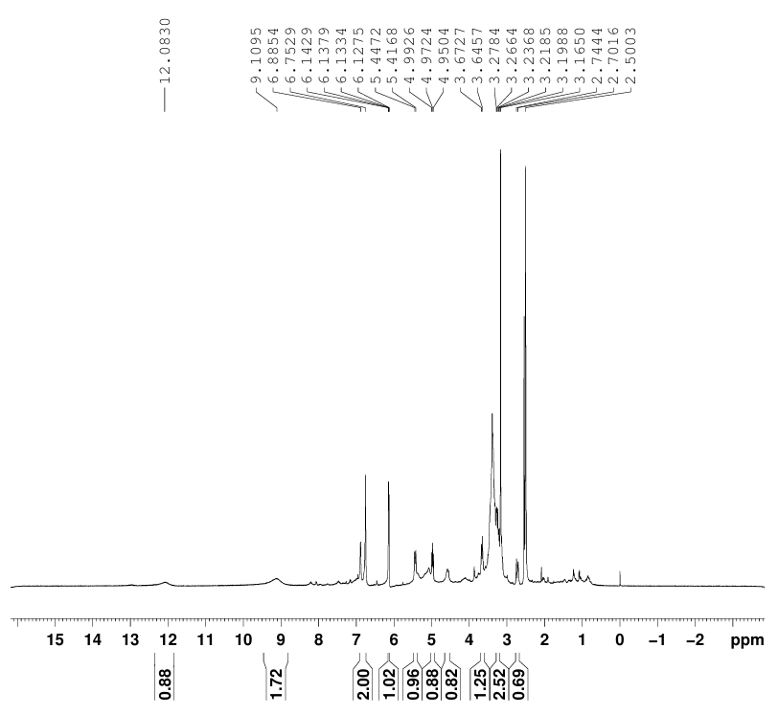
Supplementary Figure 5. The ¹H-NMR spectrum of Eriodictyol-7-O-β-D-glucopyranoside(ER-glu)
in DMSO-d₆ (400 MHz)
Supplementary Figure 6
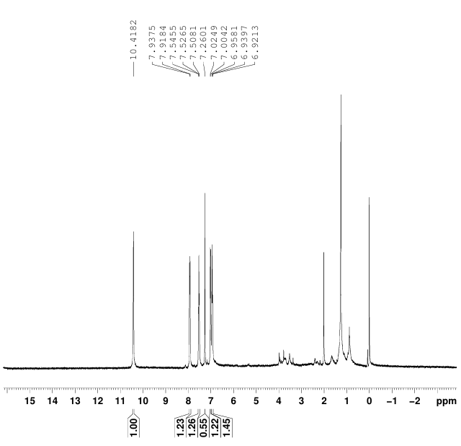
Supplementary Figure 6. The ¹H-NMR spectrum of Salicylic acid (SA) in CDCI₃ (400 MHz)

