Supplementary Information

Results

Identification of causal genes in patient
To identify potential causal genes, clinical SNP microarray testing performed on the patient and both parents had revealed multiple regions of de-novo copy number variation, including both gains and losses on the q-arm of chromosome 19 in the affected child. Additional genetic evaluations were performed on a research basis to further investigate the 19q12 copy number variation (CNV) and identify causative gene candidates which may be related to her clinical presentation. This included Optical Genome Mapping to further characterize the large structural variations in 19q12; long-read Whole Genome Sequencing (10X Genomics Linked Reads) to identify breakpoints and sequence potentially involved genes; and RNA sequencing of lymphocytes to evaluate relative gene expression. Optical genome mapping showed changes in various regions of the q12 arm of chromosome 19 (Table S1). OGM in the region spanning 27,904,110-31,334,862 showed that at least one uninterrupted copy of every gene existed. This region encodes genes AC005394.2, UQCRFS1, POP4, C19orf12 and CCNE1. Genomic segments 5 and 6, spanning genes URI1 and ZNF536, were found to be inverted and duplicated and deleted, respectively. Finally, genomic segment 10 encodes TSHZ3 and is deleted. While URI1 has no clear disease association, both ZNF536 and TSHZ3 have been implicated in autism spectrum disorder.

Methods

Imaging

Plates were imaged using the Opera Phenix at 20x magnification with 5 vertical Z-stacks 1um apart to capture both neurites and cell body clusters. Images were analyzed using Perkin Elmer Harmony software (v5.1) to determine live/dead status and confirm neuronal classification. Analysis was based on manual training of an integrated mask program to detect differences between live and dead cells, as well as neuronal or neural precursor cells. Metrics trained for included nuclear size, nuclear roundness and intensity of both DAPI and NeuO fluorescence (Fig. S5).

DRUG-seq

Detection and removal of sparse genes
For each compound/concentration - DMSO pair used for differential expression analysis, a sparsity metric was defined for each gene. The sparsity was calculated as the fraction of wells in which the gene was not detected. The sparsity for each gene follows a trimodal distribution (Figure S3).
A Gaussian mixture model was used to fit the distribution using a mixture of 3 separate Gaussian functions. Genes with a sparsity greater than the mean + standard deviation of the middle Gaussian were removed.

Figures

Figure S1
(A) Immunocytochemistry (ICC) image from PerkinElmer Opera Phenix illustrating DAPI-stained nuclei (blue), overlaid with Ki-67 stain (yellow). Ki-67+ nuclei show yellow overlay, contrasting with Ki-67- nuclei, which only show DAPI staining and retain the blue color. Ki-67+ nuclei represent nuclei still capable of undergoing proliferation. The ratio of Ki-67+ to Ki-67- nuclei in a given cell population decreases as Neuron Progenitor Cells (NPCs) undergo neuronal maturation. (B) Manually trained mask in PerkinElmer Harmony image analysis software allows for the distinction between two populations, in this case Ki-67+ and Ki-67- nuclei. Nuclei that only retain the DAPI stain are marked in red as Ki67- nuclei, while nuclei that are Ki-67+ are highlighted in green. Measurements such as fluorescence intensity of both DAPI and Ki-67 are used to train the mask. Adjustments have been made to the mask sensitivity to ensure the most accurate readout of Ki-67- and Ki-67+ nuclei, though some variability is noted. This variability is accounted for by analyzing multiple randomly selected distinct areas (images above are one distinct area within a well) of each well before determining the mean Ki-67+ population for each well, normalized to the number of total live nuclei per well.
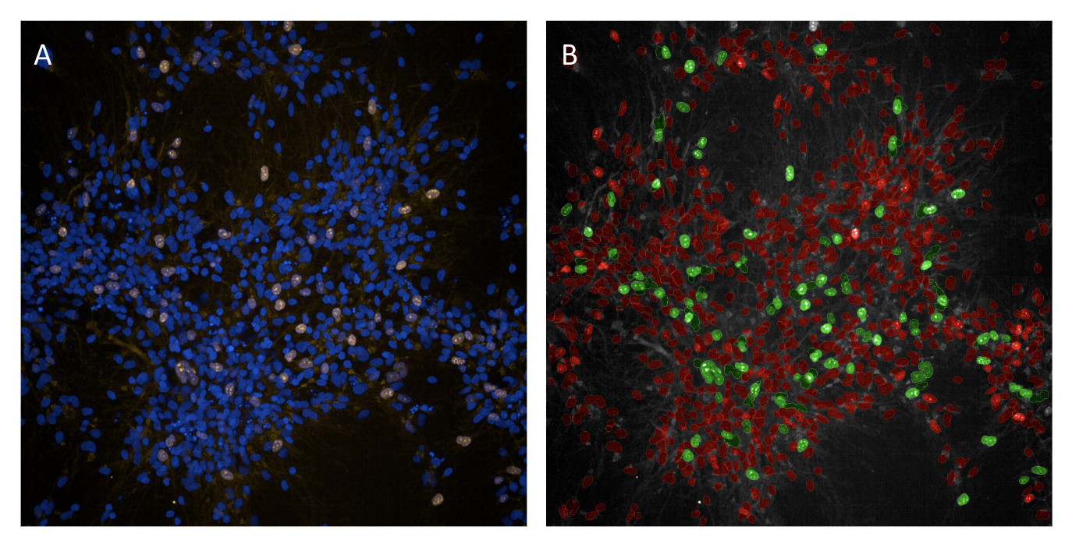

Figure S2
Heatmaps showing normalized enrichment score of additional neurogenesis pathways in patient-derived vs. a parental control line as a function of neuron maturation stage (iPSC, NPC, day 7, day 14 and day 20 neurons). Inset numbers show magnitude of normalized enrichment score). Redder and greener colors show lower and higher activity, respectively, in patient-derived compared to a parental control line. The combined p-value for each pathway across the timepoints was calculated using the Fisher Test and all pathways were significant (p-value < 0.05).

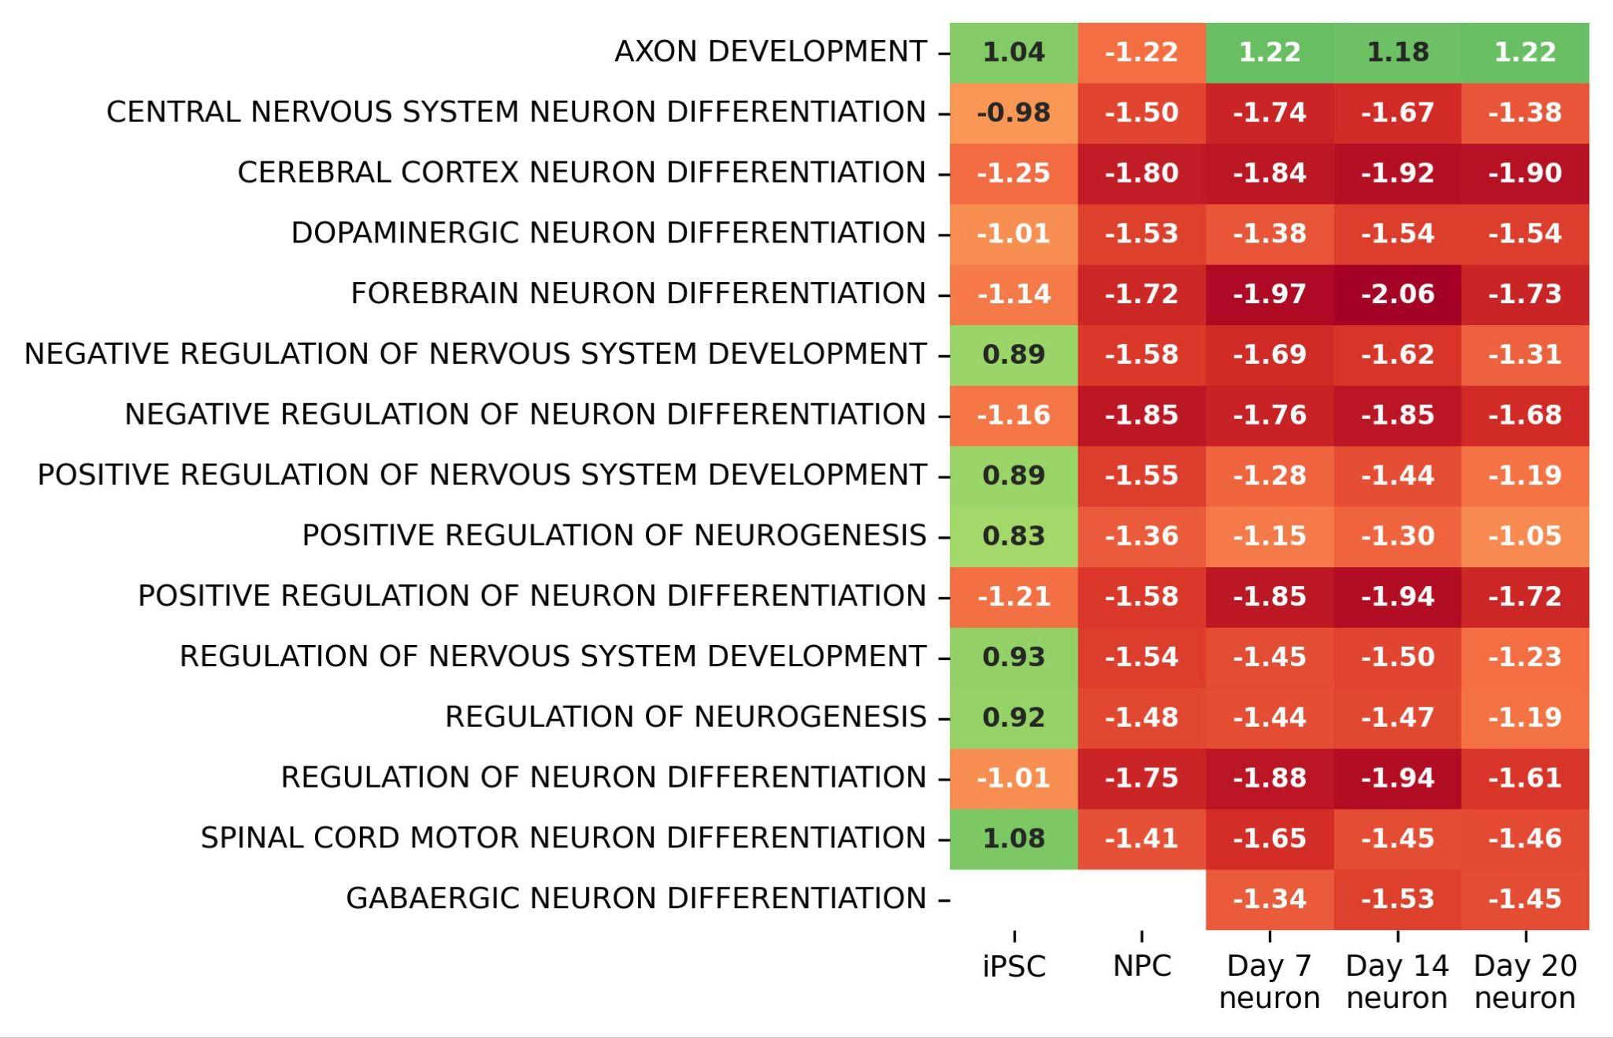

Figure S3
Volcano plots showing regulation of key genes in neurogenesis pathways in patient-derived (A) iPSC cells (B) day 7 and (C) day 14 neurons compared to a parental control line. Purple and orange points show non-significant and significant fold changes, respectively.
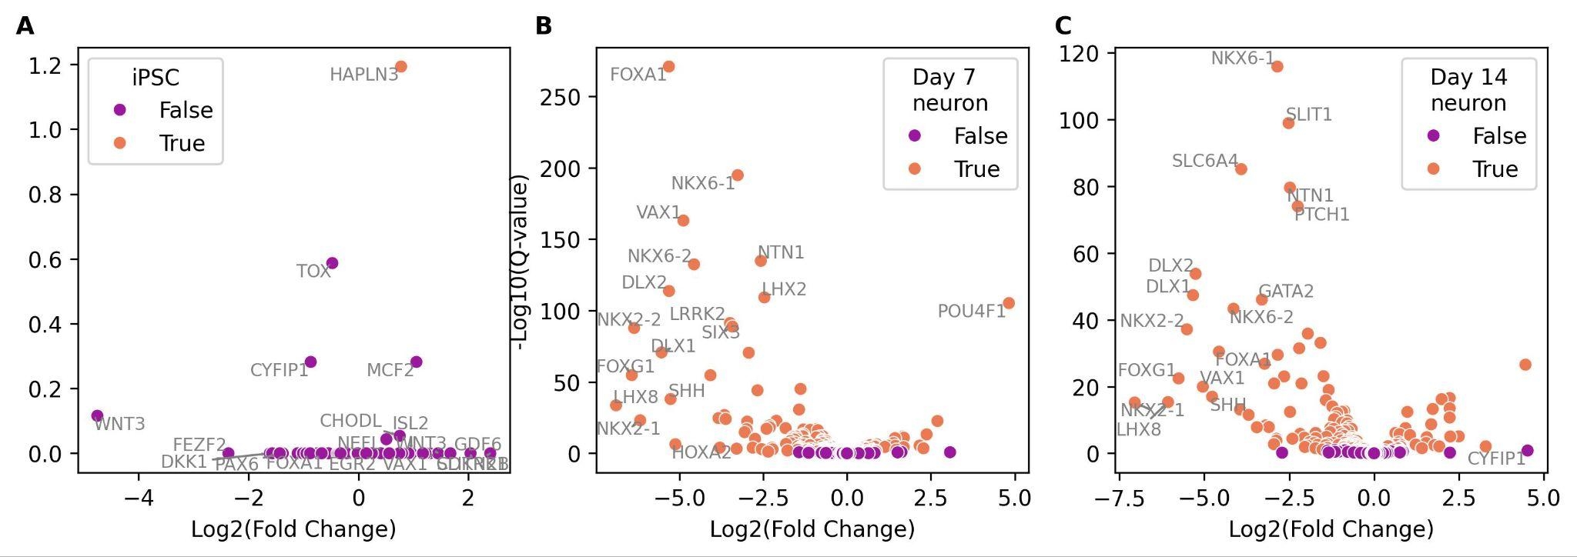

Figure S4
Regulation of relevant pathway sets associated with disease signature and neuronal phenotype of 19q12 autism spectrum disorder as a function of neuron maturation stage. Inset numbers show the magnitude of regulation. Redder and greener colors show lower and higher activity, respectively, in patient-derived compared to a parental control line for (A) neurotransmitter export and trafficking associated with key glutamatergic marker gene SLC17A6 and (B) synapse transmission and organization. A combined p-value for each pathway across timepoints was calculated using the Fisher Test for the individual p-values. Pathways associated with SLC17A6 and synapse transmission all have p-values < 0.05.
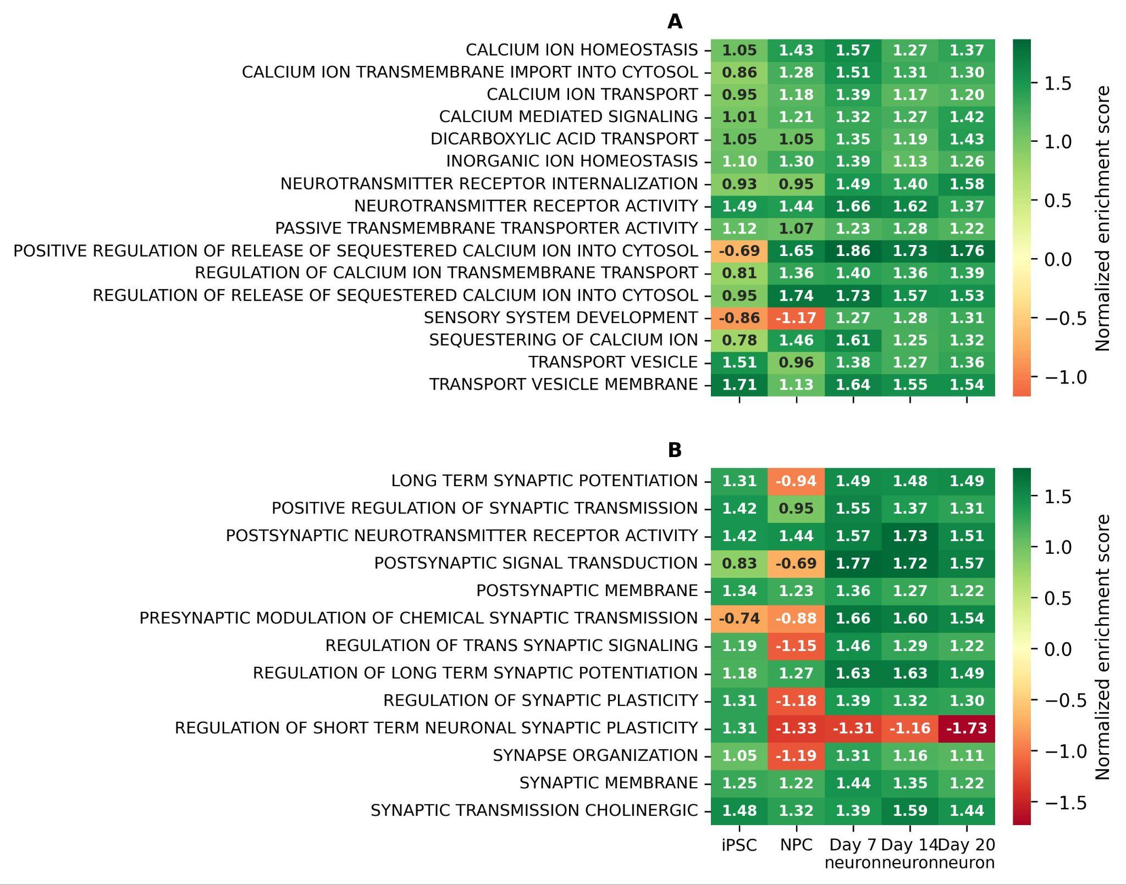

Figure S5
(A-D) Stepwise analysis of randomly selected vehicle control well section using PerkinElmer Harmony Image Analysis Software; comparison of vehicle control cells to compound treated cells. (A) Live cell imaging of control well demonstrating characteristic staining of nuclei with DAPI (blue) and neurites with NeuO (green) staining at 20x magnification. (B) Live/Dead cell mask trained manually to identify nuclei of live and dead cells using metrics such as nuclear roundness, fluorescence intensity and nuclear area using 5 randomly selected well regions. Color is an artificial mask overlay added post imaging by Harmony software. Nuclei highlighted in green have been identified as live, red identified as dead. Live Cell Fraction (LCF) determined by calculating fraction of live to dead cells as identified by Live/Dead cell mask. (C-D) Randomly selected vehicle control well section (C) and compound treated well (D) showing live neuron staining of nuclei with DAPI (blue) and neurites with NeuO (green) at 20x magnification.
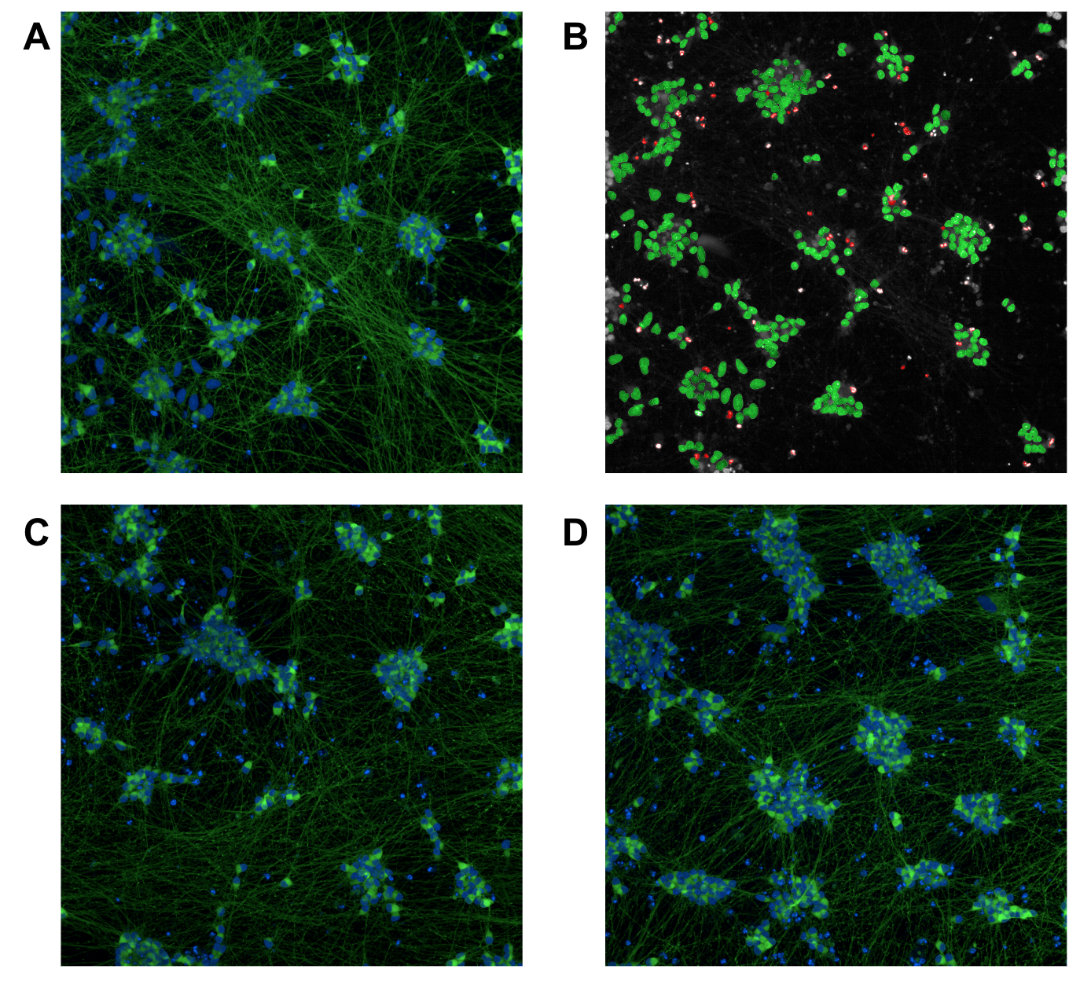

Figure S6
(A) Heatmap showing the Bray-Curtis dissimilarity score of all pairwise well combinations for DMSO treated wells. (B) Kernel density estimation of all mean Bray-Curtis dissimilarity score for each well. Scores closer to 1 signify wells that are more dissimilar to the other DMSO control wells for the batch. Dashed black line shows two standard deviations from the mean of the Gaussian distribution fit used as a cutoff to identify the most similar DMSO wells (mean = 0.229, deviation = 0.014). A total of 24 wells pass having mean Bray-Curtis dissimilarity score < cutoff. Orange line shows the Gaussian fit to the distribution.
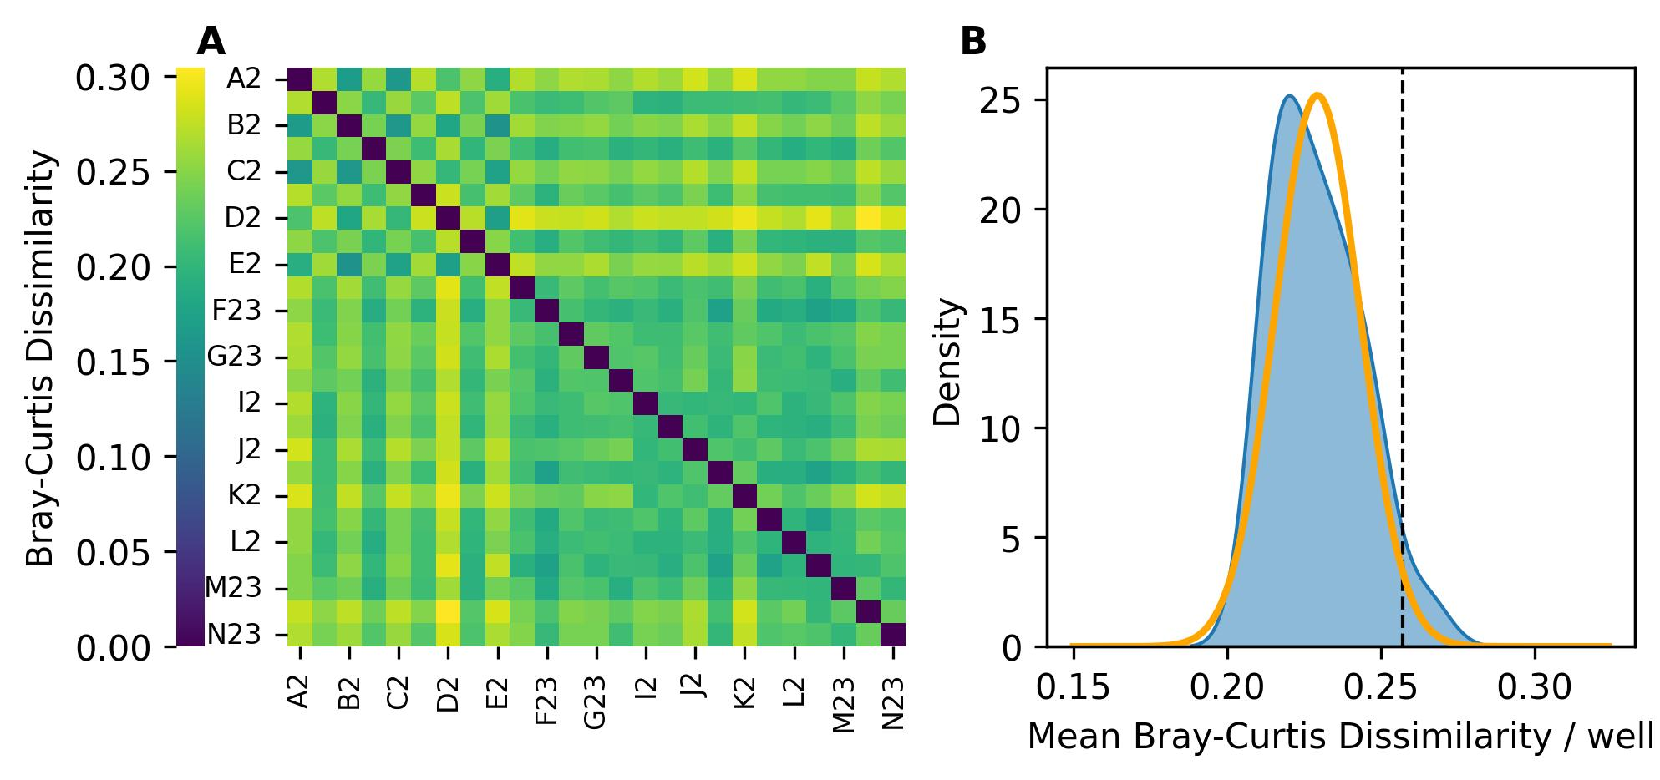

Figure S7
An example histogram showing the distribution of genes as a function of sparsity (Fraction of wells where the gene was undetected on a plate) for a single compound/concentration and DMSO pair. The distribution of genes follows a trimodal distribution. A Gaussian mixture of 3 separate Gaussian functions was used to fit the distribution. The leftmost Gaussian fit explains genes with very low sparsity (green curve), i.e. genes that are consistently expressed across all wells. The rightmost Gaussian fit explains genes with very high sparsity (red curve), i.e. genes that are sparsely expressed across the wells. The middle magenta curve represents genes with sparsity between 0.1-0.9. The cutoff (black dashed line) for sparsity is calculated as the mean + standard deviation of the magenta Gaussian function. Genes with sparsity > cutoff are removed from DEA. ~15000 out of a total ~25000 detected genes passed the cutoff.
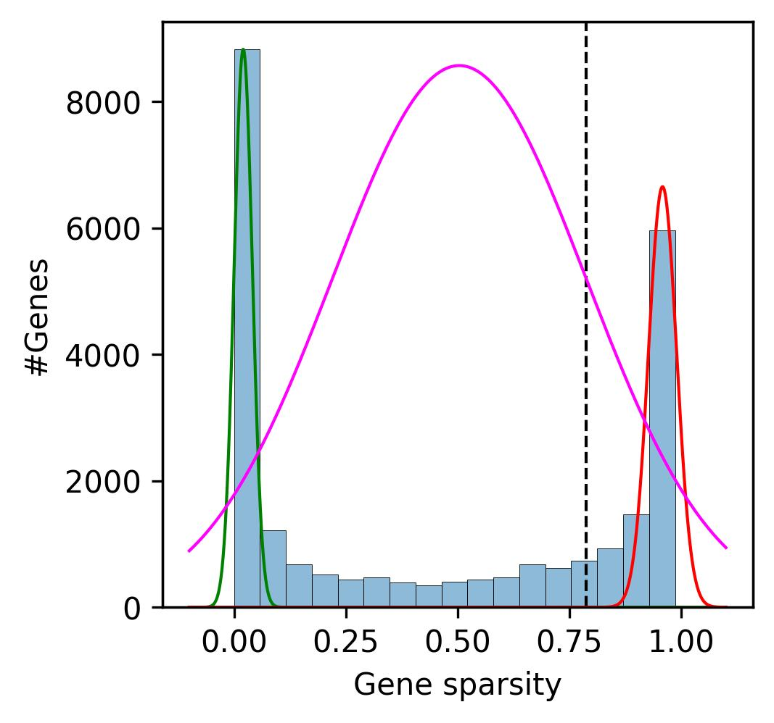

Figure S8
Cytotoxicity profile of Entrectinib in NGN2-derived neurons as a function of compound concentration measured using (A) %dead cells via the lactate dehydrogenase (LDH) assay and (B) live cell fraction using high-content imaging. Dashed line shows baseline values for DMSO-vehicle control treated cells. Entrectinib was only mildly cytotoxic to the cells at concentrations between 14 nM to 3.33 µM and caused almost complete cell death at concentrations above that.
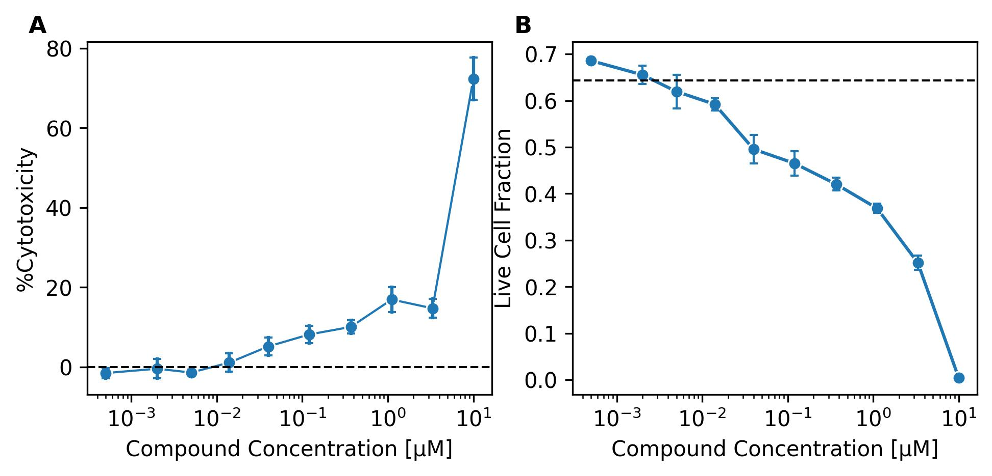

Figure S9
Response on y-axis shows cosine correlation coefficient between the normalized enrichment scores of signature pathways from patient neurons and normalized enrichment scores of the same pathways in NGN2-derived neurons treated with Entrectinib compared to DMSO vehicle control.

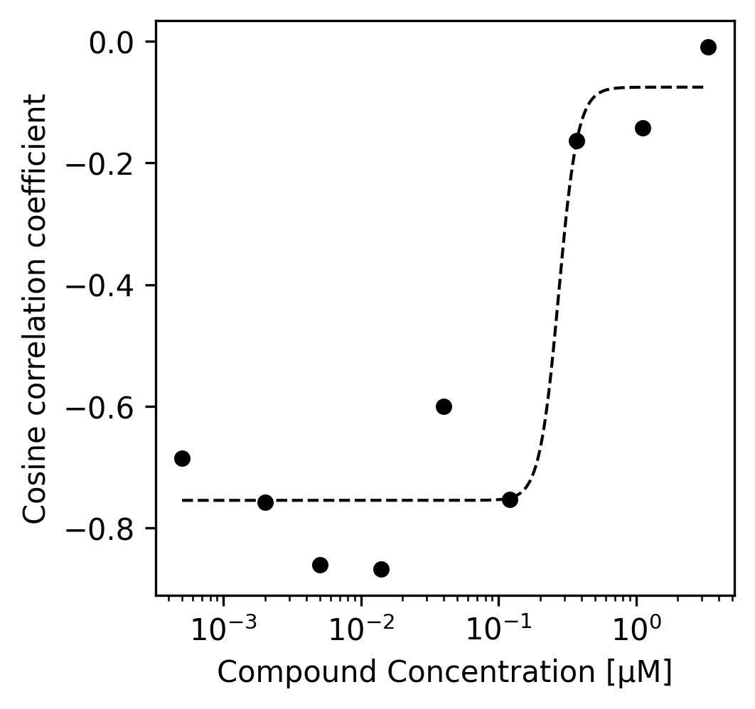

Figure S10
Heatmaps showing normalized enrichment score of (A) neurotransmitter transport and (B) Synaptic transmission/plasticity as a function of compound concentration in nM measured using DRUG-seq. Inset numbers show the magnitude of enrichment scores. Redder and greener colors show lower and higher activity, respectively, in Entrectinib treated vs. DMSO-vehicle control treated NGN2-derived neurons. Individual dose-response curves for each pathway is shown in Figure S11.
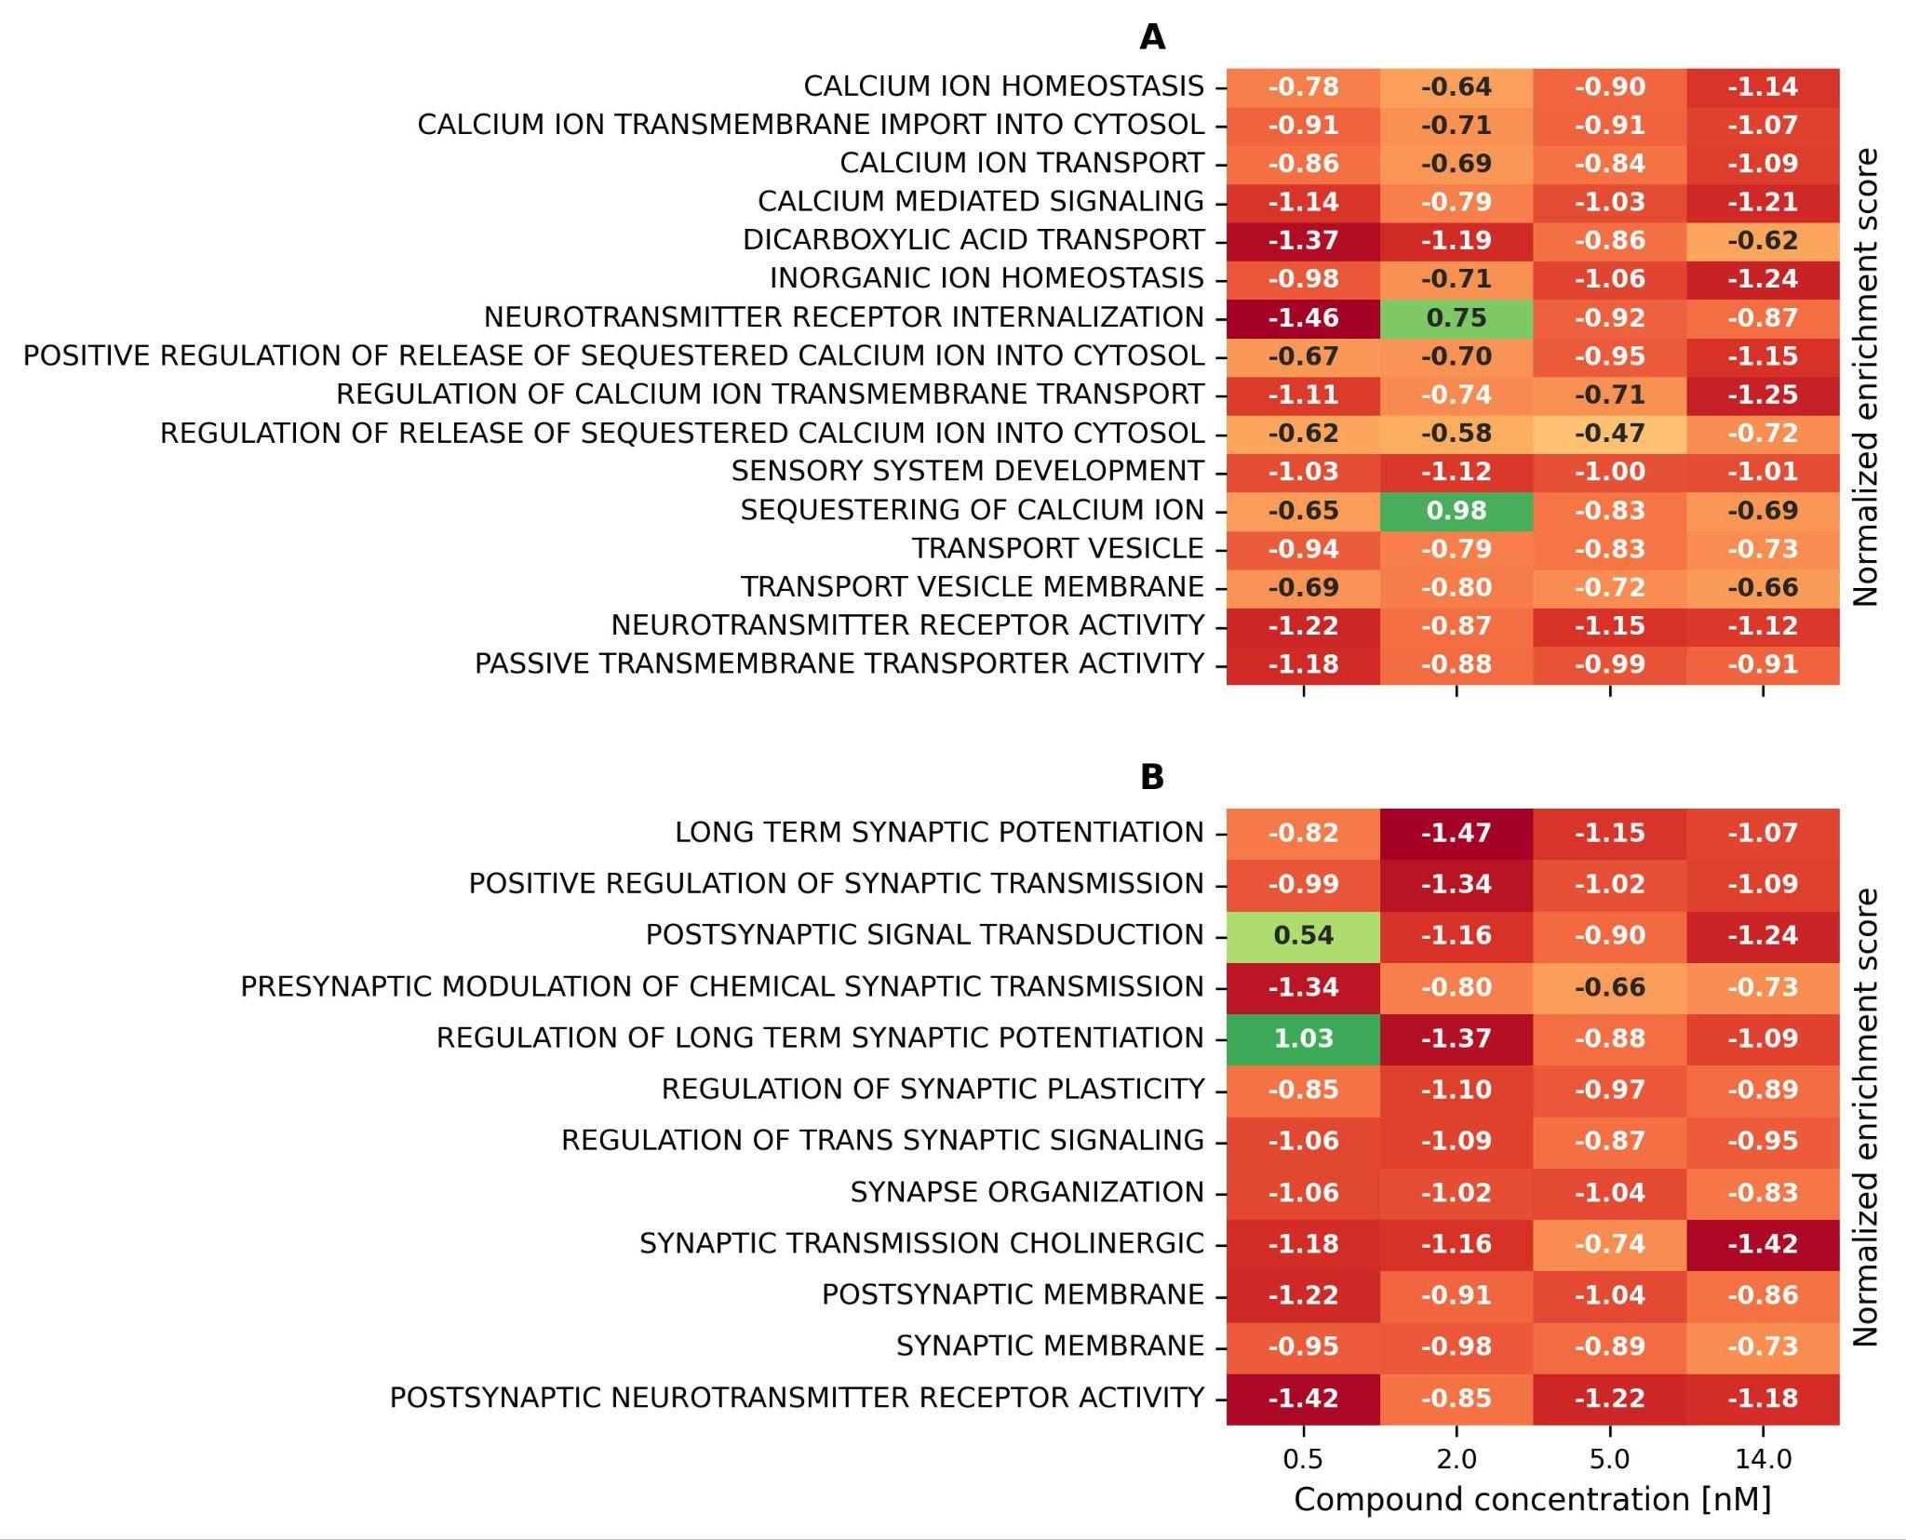

Figure S11
Individual dose response curves of pathway NES during Entrectinib treatment of wild-type neurons in the drug screen. Markers show experimental data and dotted lines show fits to experimental data. Data was fit using either a linear function or a Hill function. 19 out of the 28 signature pathways had a fit r-squared > 0.9 when fit using the Hill equation showing measurable dose response of the pathway activity.
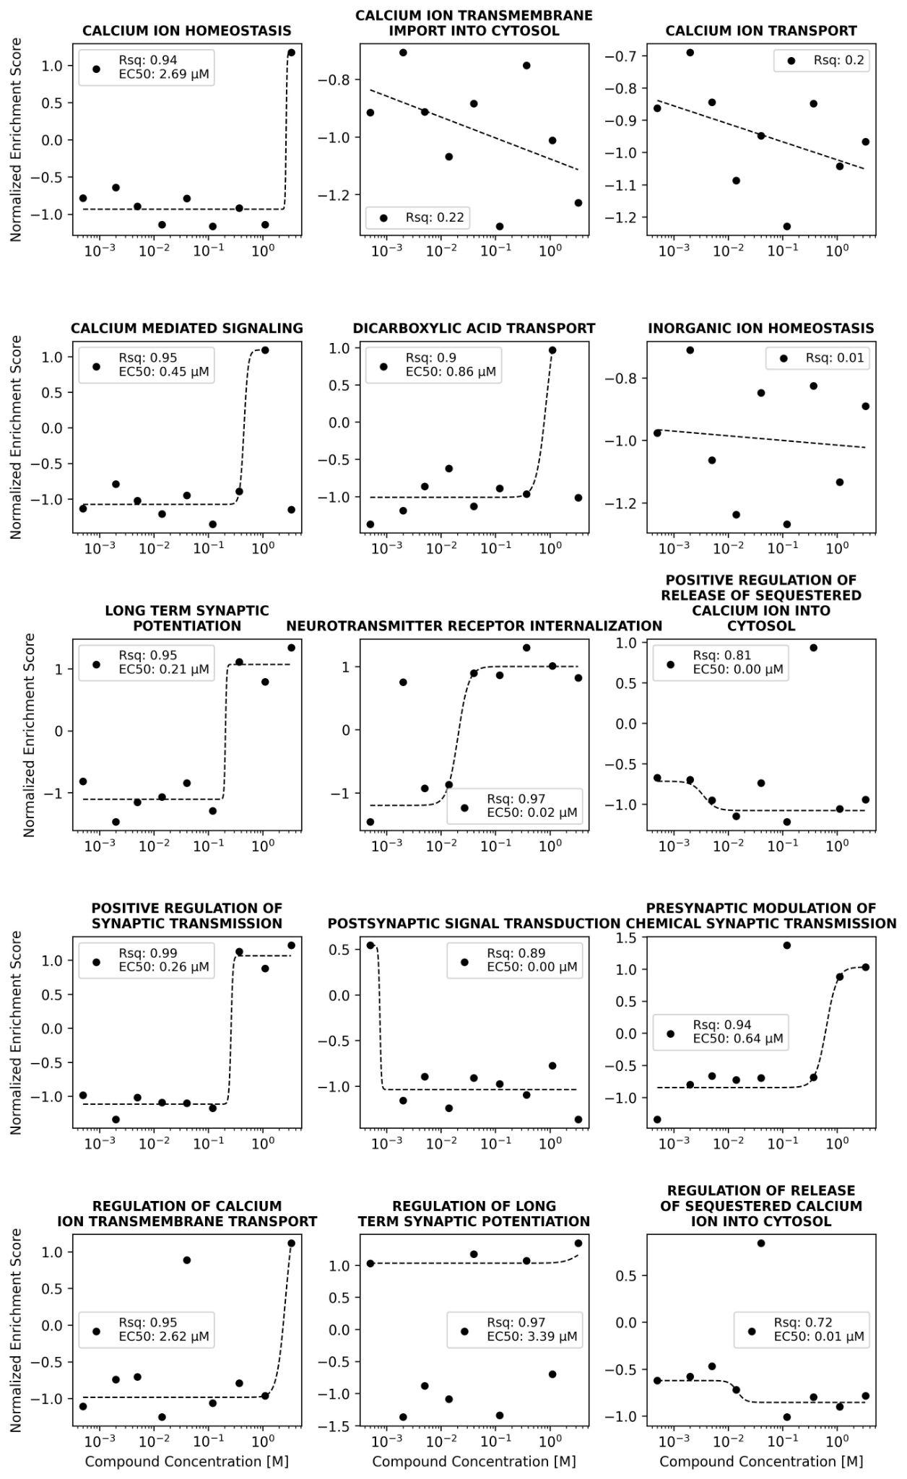
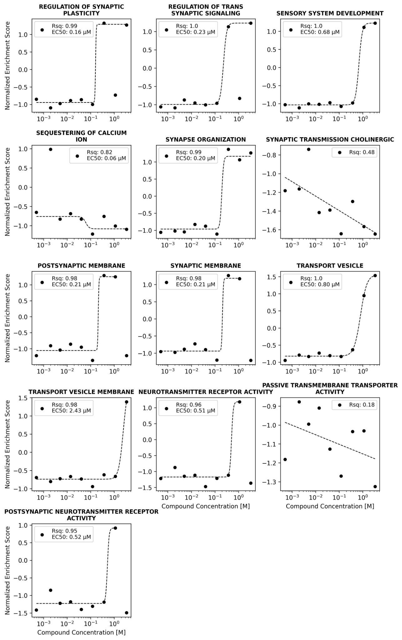

Figure S12
Compound-response curves showing log2(Fold Change) of genes (A) HTR3A, (B) VAMP2, (C) STX4, (D) STXBP3 and (E) STX8. Orange points show significant fold changes and blue points show non-significant fold changes. Error bars represent standard error of log2(Fold Change). (F) SNARE complex GO pathway normalized enrichment score as a function of Entrectinib concentration. Points show experimental data and dashed lines show Hill fits to experimental data.
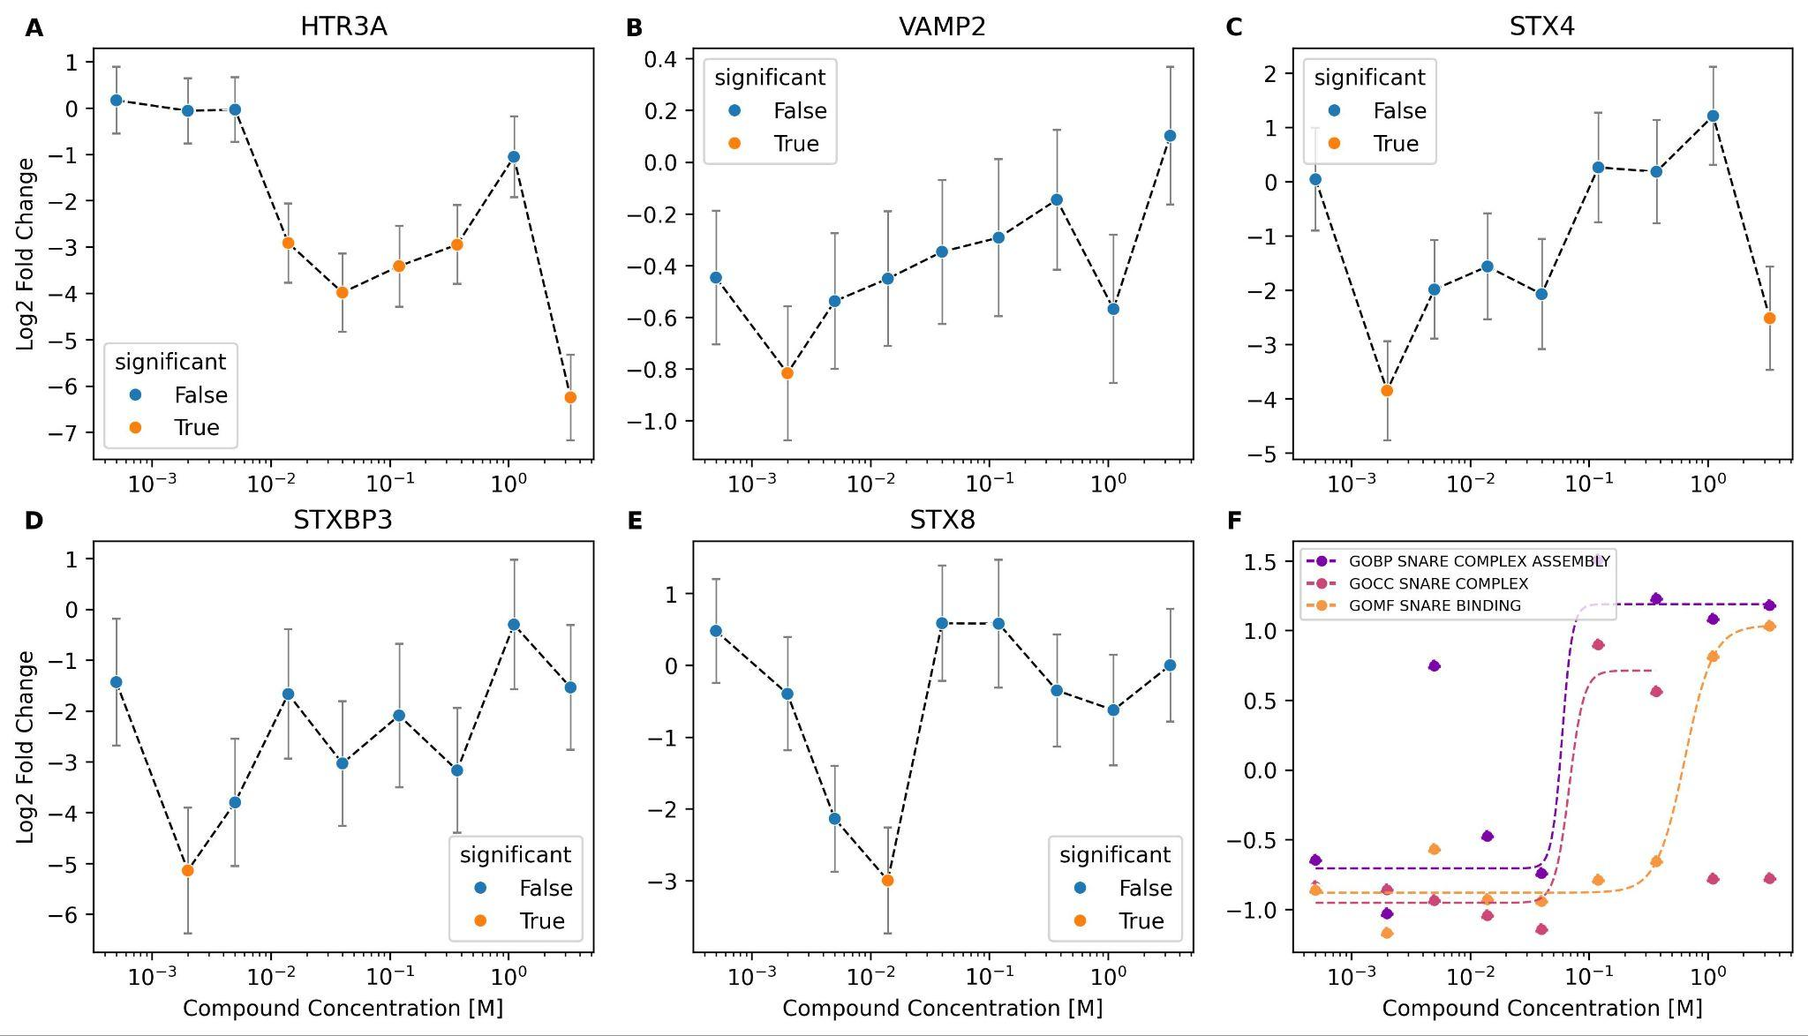

Figure S13
RARA expression profile in RNA-seq of whole blood from patient and unaffected sibling control pre- and post-treatment with Entrectinib. Entrectinib normalized both RARA levels and retinoic acid signaling activity in the patient when compared to a sibling control. (A) RARA TPM in sibling (yellow), patient pre-treatment (magenta), 3 and 6 months post-treatment (purple and salmon, respectively). (B) Heatmap showing change in RARA expression in a pre-treated sample compared to sibling and post-treatment samples compared to pre-treated. All fold changes are significant with q-values < 1E-8. (C) Activity of pathways associated with retinoic acid (RA) signaling in a pre-treated sample compared to sibling and post-treatment samples compared to pre-treated. Pathways NES are significant in patient vs. sibling control and in 3 month treated vs untreated samples. Significance was lost at the 6 month mark. Leading edge genes of these pathways are shown in figure S13. Activity of AMPA receptor signaling pathways (D-E) and BDNF-TrkB signaling pathways (F-G) from (D, F) patient pre-treated whole blood compared to a sibling control, (E, G) 3 (purple) and 6 month post-treatment with Entrectinib compared to a pre-treated control. Hatched and solid lines are non-significant and significant enrichment scores, respectively.
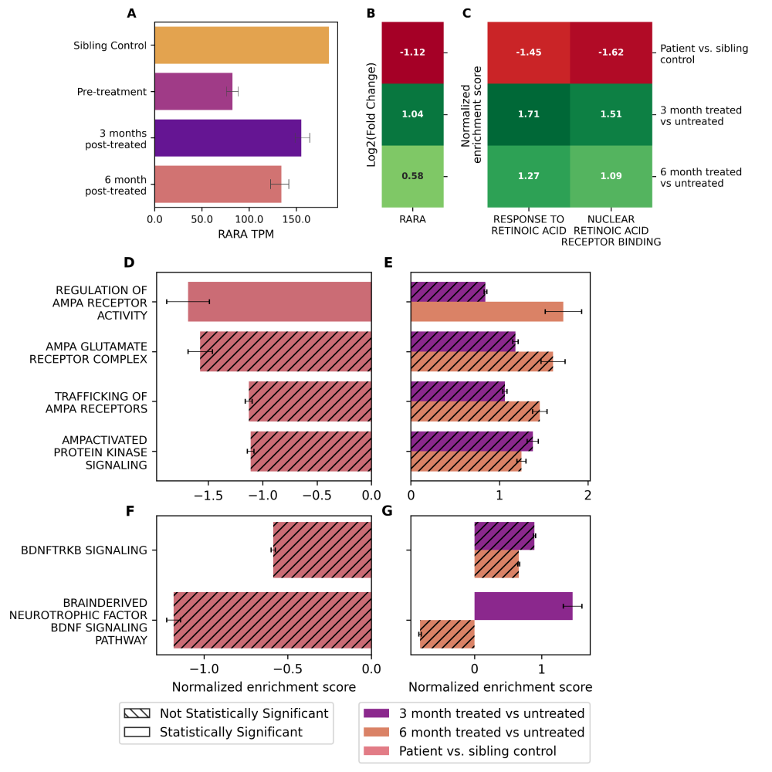

Figure S14
Volcano plots showing regulation of genes in retinoic acid pathways in (A) patient pre-treated vs. sibling control, (B) patient 3 month post-treated vs. pre-treated and (C) patient 6 month post-treated vs. pre-treated. Purple and orange points show non-significant and significant fold changes, respectively.
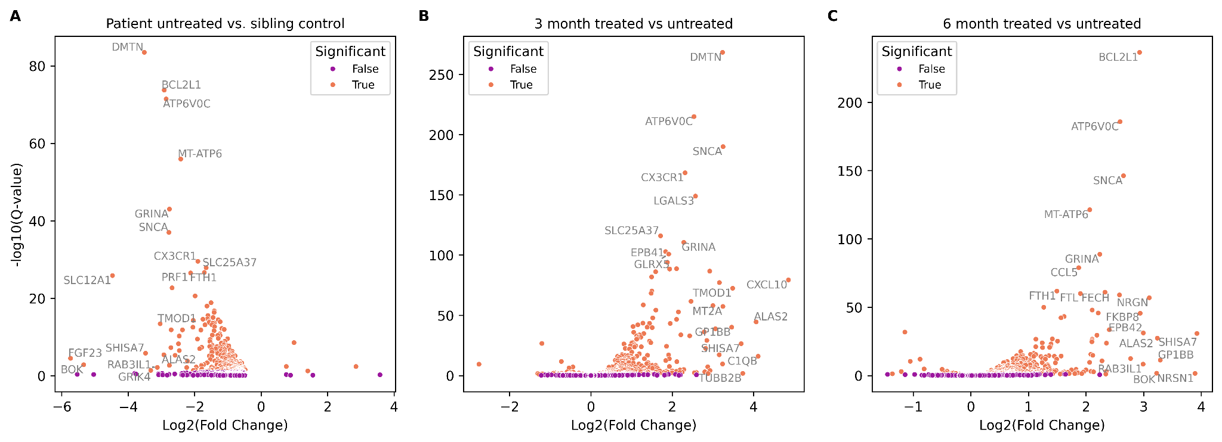

Tables

Table S1
Results from optical genome mapping of the 19q12 region in patient. Gene-level fold changes are based on RNA extracted from frozen lymphocytes from patient vs. sibling. Only ZNF536 and TSHZ3 expression levels were compromised in patient vs. sibling.
HGNC Symbol | Structural Change | Gene Start | Gene End | Copy # | Fold Change | Genomic Segment #
AC005394.2 | Deleted | 28435388 | 28727680 | 1 | 1.02 | 1
UQCRFS1 | Inverted and duplicated | 29205320 | 29213151 | 3 | 1.24 | 2 and 3
POP4 | Duplicated | 29606283 | 29617237 | 3 | 1.35 | 4
C19orf12 | Duplicated | 29698886 | 29715789 | 3 | 1.46 | 4
CCNE1 | Duplicated | 29811991 | 29824312 | 3 | 1.9 | 4
URI1 | Inverted and duplicated | 29923644 | 30016612 | 3 | 1.51 | 5
ZNF536 | 5 is inverted duplicated, 6 is deleted | 30224235 | 30713585 | 1 | NA | 5 and 6
TSHZ3 | Deleted | 31149979 | 31349436 | 1 | 0.33 | 10

Table S2
Q-values of neurogenesis pathways implicated by root cause genes ZNF536 and TSHZ3 in patient neurons compared to control. Combined p-value for pathway enrichment scores were calculated using the Fisher test for the individual p-values across multiple timepoints. P-values were corrected for false discovery rate using the Benjamini-Hochberg procedure.
Pathway | q-value
Regulation of neuron differentiation | 5.729E-13
Positive regulation of neuron differentiation | 1.139E-08
Regulation of nervous system development | 2.588E-08
Negative regulation of neuron differentiation | 1.132E-07
Forebrain neuron differentiation | 1.343E-07
Central nervous system neuron differentiation | 3.085E-07
Cerebral cortex neuron differentiation | 1.549E-06
Hedgehog signaling | 2.074E-06
Regulation of neurogenesis | 3.805E-06
Negative regulation of nervous system development | 6.910E-06
Negative regulation of notch signaling pathway | 1.066E-05
Positive regulation of nervous system development | 9.507E-05
Regulation of notch signaling pathway | 2.470E-03
Dopaminergic neuron differentiation | 1.242E-02
Spinal cord motor neuron differentiation | 2.054E-02
Axon development | 2.597E-02
Positive regulation of neurogenesis | 5.179E-02
Gabaergic neuron differentiation | 8.067E-02

Table S3
Q-values of neurotransmitter transport pathways implicated by up-regulation of glutamatergic marker gene SLC17A6 in patient neurons compared to control. Combined p-value for pathway enrichment scores were calculated using the Fisher test for the individual p-values across multiple timepoints. P-values were corrected for false discovery rate using the Benjamini-Hochberg procedure.
Pathway | q-value
Transport vesicle membrane | 4.792E-09
Positive regulation of release of sequestered calcium ion into cytosol | 1.634E-05
Calcium ion homeostasis | 2.836E-05
Regulation of release of sequestered calcium ion into cytosol | 3.083E-05
Transport vesicle | 3.876E-05
Neurotransmitter receptor activity | 6.400E-05
Inorganic ion homeostasis | 1.877E-03
Sequestering of calcium ion | 6.488E-03
Regulation of calcium ion transmembrane transport | 9.388E-03
Calcium ion transmembrane import into cytosol | 1.418E-02
Calcium mediated signaling | 1.543E-02
Sensory system development | 1.904E-02
Calcium ion transport | 1.966E-02
Passive transmembrane transporter activity | 2.040E-02
Neurotransmitter receptor internalization | 6.169E-02
Dicarboxylic acid transport | 1.149E-01

Table S4
Q-values of synaptic transmission and organization pathways implicated by up-regulation of glutamatergic marker gene SLC17A6 and acceleration of neurogenesis in patient neurons compared to control. Combined p-value for pathway enrichment scores were calculated using the Fisher test for the individual p-values across multiple timepoints.
Pathway | q-value
Postsynaptic neurotransmitter receptor activity | 1.861E-04
Synaptic membrane | 2.442E-04
Regulation of trans synaptic signaling | 3.977E-04
Postsynaptic signal transduction | 2.415E-03
Regulation of long term synaptic potentiation | 2.787E-03
Positive regulation of synaptic transmission | 2.971E-03
Postsynaptic membrane | 3.486E-03
Regulation of synaptic plasticity | 4.302E-03
Long term synaptic potentiation | 6.370E-03
Synaptic transmission cholinergic | 1.157E-02
Presynaptic modulation of chemical synaptic transmission | 1.863E-02
Synapse organization | 3.522E-02
Regulation of short term neuronal synaptic plasticity | 4.494E-02

Table S5
DAYC-2 scores at pre- and post-treatment evaluations conducted in 2023 and 2025, respectively.

Treatment date | Domain | Raw Score | Standard Score | Age Equivalent | Description
06/2023 | Cognitive | 29 | <50 | 17 month | Extremely Low
01/2025 | Cognitive | 33 | N/A | 23 month | Extremely Low

