Appendix A. Six-Year GNSS Observation File QC Records (2010–2015)
Table A1 presents the annual GNSS observation file quality control (QC) results for the KSEJ station over the 2010–2015 period. The reported metrics include the mean and standard deviation of the utilization rate, the total number of observation days, the mean and standard deviation of multipath errors (MP1 and MP2), and the mean and standard deviation of the cycle slip rate (CSR). The CSR parameter quantifies the frequency of phase discontinuities in carrier-phase measurements, expressed both as the average number of epochs between cycle slips and as a percentage of total observations. In this analysis, CSR was derived from 30-second interval, 24-hour observation files, corresponding to 2880 epochs per day. For example, a CSR_mean of 1000 epochs indicates that, on average, one cycle slip occurred every 1000 observation epochs, equivalent to a cycle slip rate of 0.10%. Lower CSR values (in percentage terms) reflect more stable carrier-phase tracking and higher data integrity.
Figure A1 illustrates the corresponding annual variations in mean utilization rate, mean multipath (MP1 and MP2), and mean CSR, providing a visual comparison of station performance across the six-year period. The combination of tabular and graphical results enables an integrated assessment of temporal trends in signal quality, data availability, and susceptibility to cycle slips at the KSEJ station.
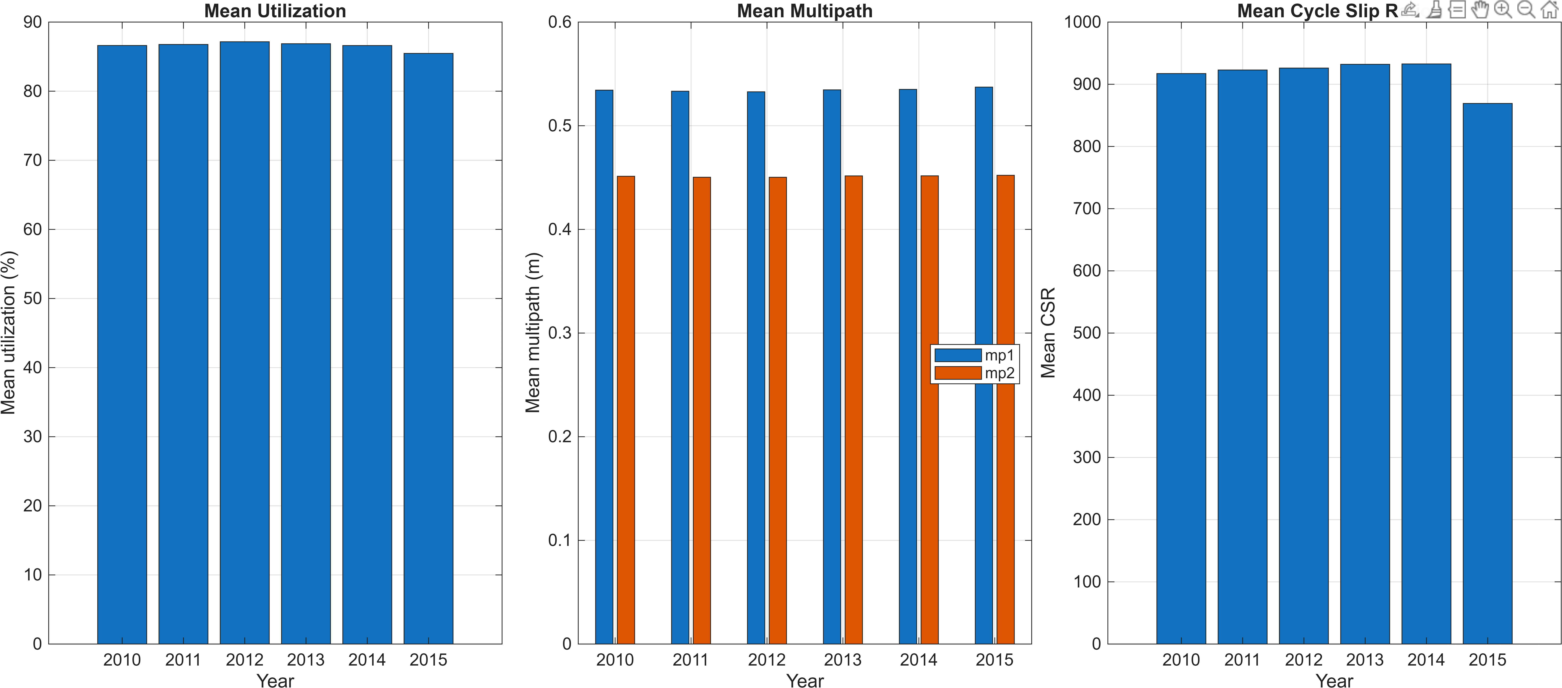
Figure A 1 Annual variations in GNSS observation file quality control (QC) metrics for the KSEJ station from 2010 to 2015. (a) Mean utilization rate, expressed as the percentage of successfully processed observation epochs relative to the total available epochs per year, reflecting overall data availability. (b) Mean multipath values (MP1 and MP2) in meters, representing code multipath effects on the L1 and L2 frequencies, respectively; higher values indicate greater signal degradation due to reflective interference. (c) Mean cycle slip rate (CSR) expressed as the average number of epochs between cycle slips, computed from 30-second interval, 24-hour observation files (2880 epochs/day). The CSR metric quantifies carrier-phase continuity, where higher values denote fewer cycle slips and better phase tracking performance. Together, these plots enable assessment of temporal stability, signal quality, and tracking robustness over the six-year monitoring period.
Table A1 summarizes the annual quality control (QC) statistics derived from 30-second interval, 24-hour GNSS observation files collected at the KSEJ station over the period 2010–2015. The reported metrics include the mean and standard deviation of utilization rate (percentage of valid observation epochs), the total number of observation days (N), mean and standard deviation of multipath on L1 and L2 frequencies (MP1 and MP2), and the mean cycle slip rate (CSR). In this study, CSR is expressed in two forms: the mean number of epochs between consecutive cycle slips (CSR_mean) and the equivalent percentage of cycle slip occurrences relative to total daily epochs (CSR_mean %). The latter provides a normalized measure for comparing phase continuity performance across different observation periods.
Table A1 Annual GNSS observation file quality control (QC) results for the KSEJ station from 2010 to 2015. Util_mean and Util_std represent the average and variability of daily data utilization, N denotes the number of valid observation days per year, and MP1/MP2 refer to the mean and standard deviation of multipath on L1 and L2 signals, respectively. CSR_mean represents the average number of epochs between cycle slips (higher values indicate better carrier-phase continuity), while CSR_mean % expresses the proportion of cycle slip occurrences relative to the total number of daily.
Year | Util_mean (%) | Util_std | N (days) | MP1_mean (m) | MP1_std (m) | MP2_mean (m) | MP2_std (m) | CSR_mean | CSR_mean (%)
2010 | 86.61 | 13.61 | 284 | 0.53 | 0.08 | 0.45 | 0.08 | 917.2 | 0.08
2011 | 86.76 | 13.63 | 287 | 0.53 | 0.07 | 0.45 | 0.08 | 922.96 | 0.1
2012 | 87.15 | 13.80 | 242 | 0.53 | 0.08 | 0.45 | 0.08 | 926.03 | 0.11
2013 | 86.87 | 13.83 | 230 | 0.53 | 0.07 | 0.45 | 0.07 | 932.09 | 0.09
2014 | 86.6 | 14.01 | 262 | 0.54 | 0.08 | 0.45 | 0.08 | 932.69 | 0.12
2015 | 85.47 | 13.67 | 264 | 0.54 | 0.07 | 0.45 | 0.08 | 869.15 | 0.09

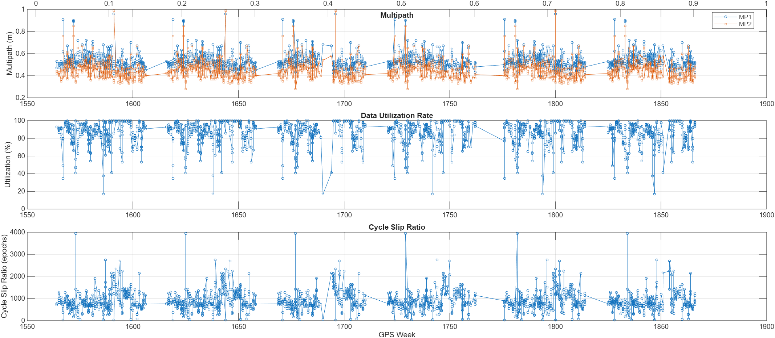
Figure A 2 Time series of GNSS data quality indicators at King Sejong Station. The top panel shows multipath metrics (MP1 and MP2, in meters), the middle panel illustrates the data utilization rate (percentage of usable observations), and the bottom panel presents the cycle slip ratio (number of slips per 1000 epochs). The horizontal axis represents GPS Week, covering the 1550–1900 interval. These diagnostics highlight temporal variability in multipath effects, data completeness, and signal continuity, and provide complementary information for evaluating site-specific observational conditions.

