Appendix B. Tide-Gauge Operations, QA/QC, and Reference Surfaces at KSEJ

B.1 Instrument maintenance and diagnostics
Prior to analysis, the tide-gauge installation was inspected for sensor malfunctions and consumable wear. Routine actions included cleaning of the instruments, replacement of consumables, and reinforcement of data cables and the housing enclosure. To diagnose scale and offset errors, a Van de Casteele (VdC) analysis was performed against repeated staff-gauge readings.

B.2 Staff-gauge intercomparison
Three staff-gauge sessions were conducted between 28 Dec 2021 and 25 Jan 2022. Linear regression between staff readings and tide-gauge measurements showed a strong positive correlation (typical R²≈0.996) with small mean offsets (order of centimeters). These checks confirmed normal operation of the primary PLS sensor; the backup unit showed scale bias and required servicing (per VdC results).

B.3 Data processing and quality control
Observed pressure was corrected for atmospheric pressure (local sea-level pressure) and seawater density (from in-situ temperature/salinity; representative salinity 35 psu). Staff-gauge scale checks were applied before harmonic analysis. Ten-minute WL series (WLS) were thinned to hourly values and decomposed with TASK-2000/TIRA to obtain tidal constituents. From Jan 2021–Mar 2022, the overall availability of normal tide levels was 96.6 %; missing data peaks (e.g., Feb 2022) were due to power interruptions during maintenance or personnel turnover. All streams passed a nine-class QC filter; 53,711 records were flagged and handled accordingly.

B.4 Seasonal tidal statistics
Monthly/seasonal constituents were computed to assess stability. The combined amplitude of the four major constituents showed year-to-year differences of ≤1 mm, indicating stable instrument behavior. Seasonal summaries of form number, mean high/low-water intervals, and ranges are provided below. Figure B1 illustrates the agreement between in situ staff-gauge observations and the tide-gauge records, as well as the corresponding temporal variability during the verification period.
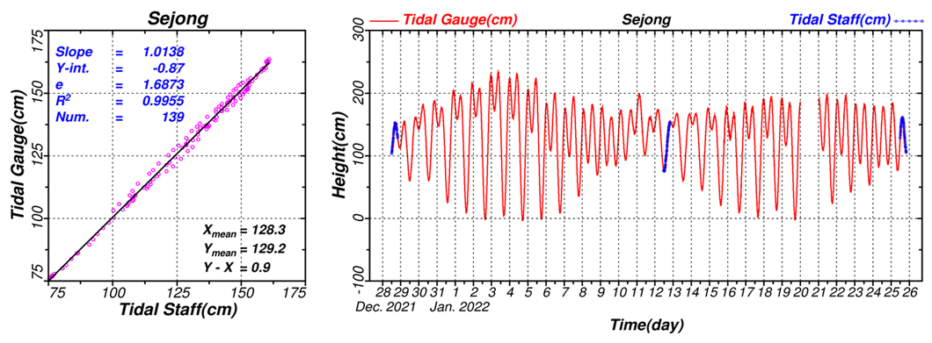
Figure B 4 Staff-gauge intercomparison and hourly water-level time series at King Sejong Station.
(Left) Scatter plot showing the relationship between manual staff-gauge readings and simultaneous tide-gauge water-level measurements, including best-fit linear regression with slope, intercept, and coefficient of determination (R²) values, demonstrating the high consistency between the two measurement methods. (Right) Hourly water-level time series from December 2021 to January 2022, with tide-gauge observations shown in red and periodic staff-gauge validation measurements shown in blue, illustrating agreement and stability during the verification period.
To ensure the reliability of tidal observations at the KSEJ tide-gauge station, a detailed assessment of data acquisition quality and seasonal tidal characteristics was conducted. Table A1 presents monthly statistics of data acquisition from January 2021 to March 2022, including the total number of samples, counts and percentages of valid and abnormal readings, and instances of missing data. Table A2 summarizes the seasonal tidal parameters computed from the quality-controlled dataset, including the tidal form number, mean high- and low-water intervals, spring tidal range, approximate highest astronomical tide (HAT), and mean sea level (Zo). These datasets provide the basis for evaluating both the operational stability of the tide-gauge system and the seasonal variability of tidal behavior at the site.
Table A1 Seasonal tidal statistics at King Sejong Station, including form number, mean high-water interval, mean low-water interval, and tidal range, derived from the 12-month tide-gauge record (January 2020–January 2021).
Year | Month | Total samples | Normal levels (count) | Normal (%) | Abnormal (count) | Abnormal (%) | Missing (count) | Missing (%)
2021 | 1 | 44,640 | 44,091 | 98.8 | 546 | 1.2 | 3 | 0
2021 | 2 | 40,320 | 38,806 | 96.2 | 1,495 | 3.7 | 19 | 0
2021 | 3 | 44,640 | 43,828 | 98.2 | 802 | 1.8 | 10 | 0
2021 | 4 | 43,200 | 42,732 | 98.9 | 468 | 1.1 | 0 | 0
2021 | 5 | 44,640 | 44,202 | 99 | 435 | 1 | 3 | 0
2021 | 6 | 43,200 | 42,757 | 99 | 432 | 1 | 11 | 0
2021 | 7 | 44,640 | 44,257 | 99.1 | 383 | 0.9 | 0 | 0
2021 | 8 | 44,640 | 44,276 | 99.2 | 357 | 0.8 | 7 | 0
2021 | 9 | 43,200 | 34,821 | 80.6 | 8,379 | 19.4 | 0 | 0
2021 | 10 | 44,640 | 44,177 | 99 | 447 | 1 | 16 | 0
2021 | 11 | 43,200 | 42,783 | 99 | 417 | 1 | 0 | 0
2021 | 12 | 44,640 | 42,834 | 96 | 1,767 | 4 | 39 | 0.1
2022 | 1 | 44,640 | 44,194 | 99 | 446 | 1 | 0 | 0
2022 | 2 | 40,320 | 37,325 | 92.6 | 635 | 1.6 | 2,360 | 5.9
2022 | 3 | 44,640 | 42,146 | 94.4 | 2,482 | 5.6 | 12 | 0
Total |  | 655,200 | 633,229 | 96.6 | 19,491 | 3 | 2,480 | 0.4

Table A2 Seasonal tidal statistics at King Sejong Station, including form number, mean high-water interval, mean low-water interval, and tidal range, derived from the 12-month tide-gauge record (January 2020–January 2021).
Season | Tidal form number | Mean HW interval (hh:mm) | Mean LW interval (hh:mm) | Spring range (mm) | Approx. HAT (mm) | Zo (mm)
Summer | 0.93 | 9:43 | 3:30 | 1365 | 2547 | 1274
Autumn | 0.7 | 9:44 | 3:31 | 1521 | 2577 | 1288
Winter | 0.97 | 9:42 | 3:29 | 1299 | 2553 | 1267
Spring | 0.75 | 9:45 | 3:31 | 1433 | 2501 | 1250
Notes: HAT—Highest Astronomical Tide; Zo—zonal mean astronomical MSL. Seasonal differences in constituent amplitudes/phases were modest; the September anomaly in availability corresponds to the month with elevated abnormal levels.

