Supplementary Figures
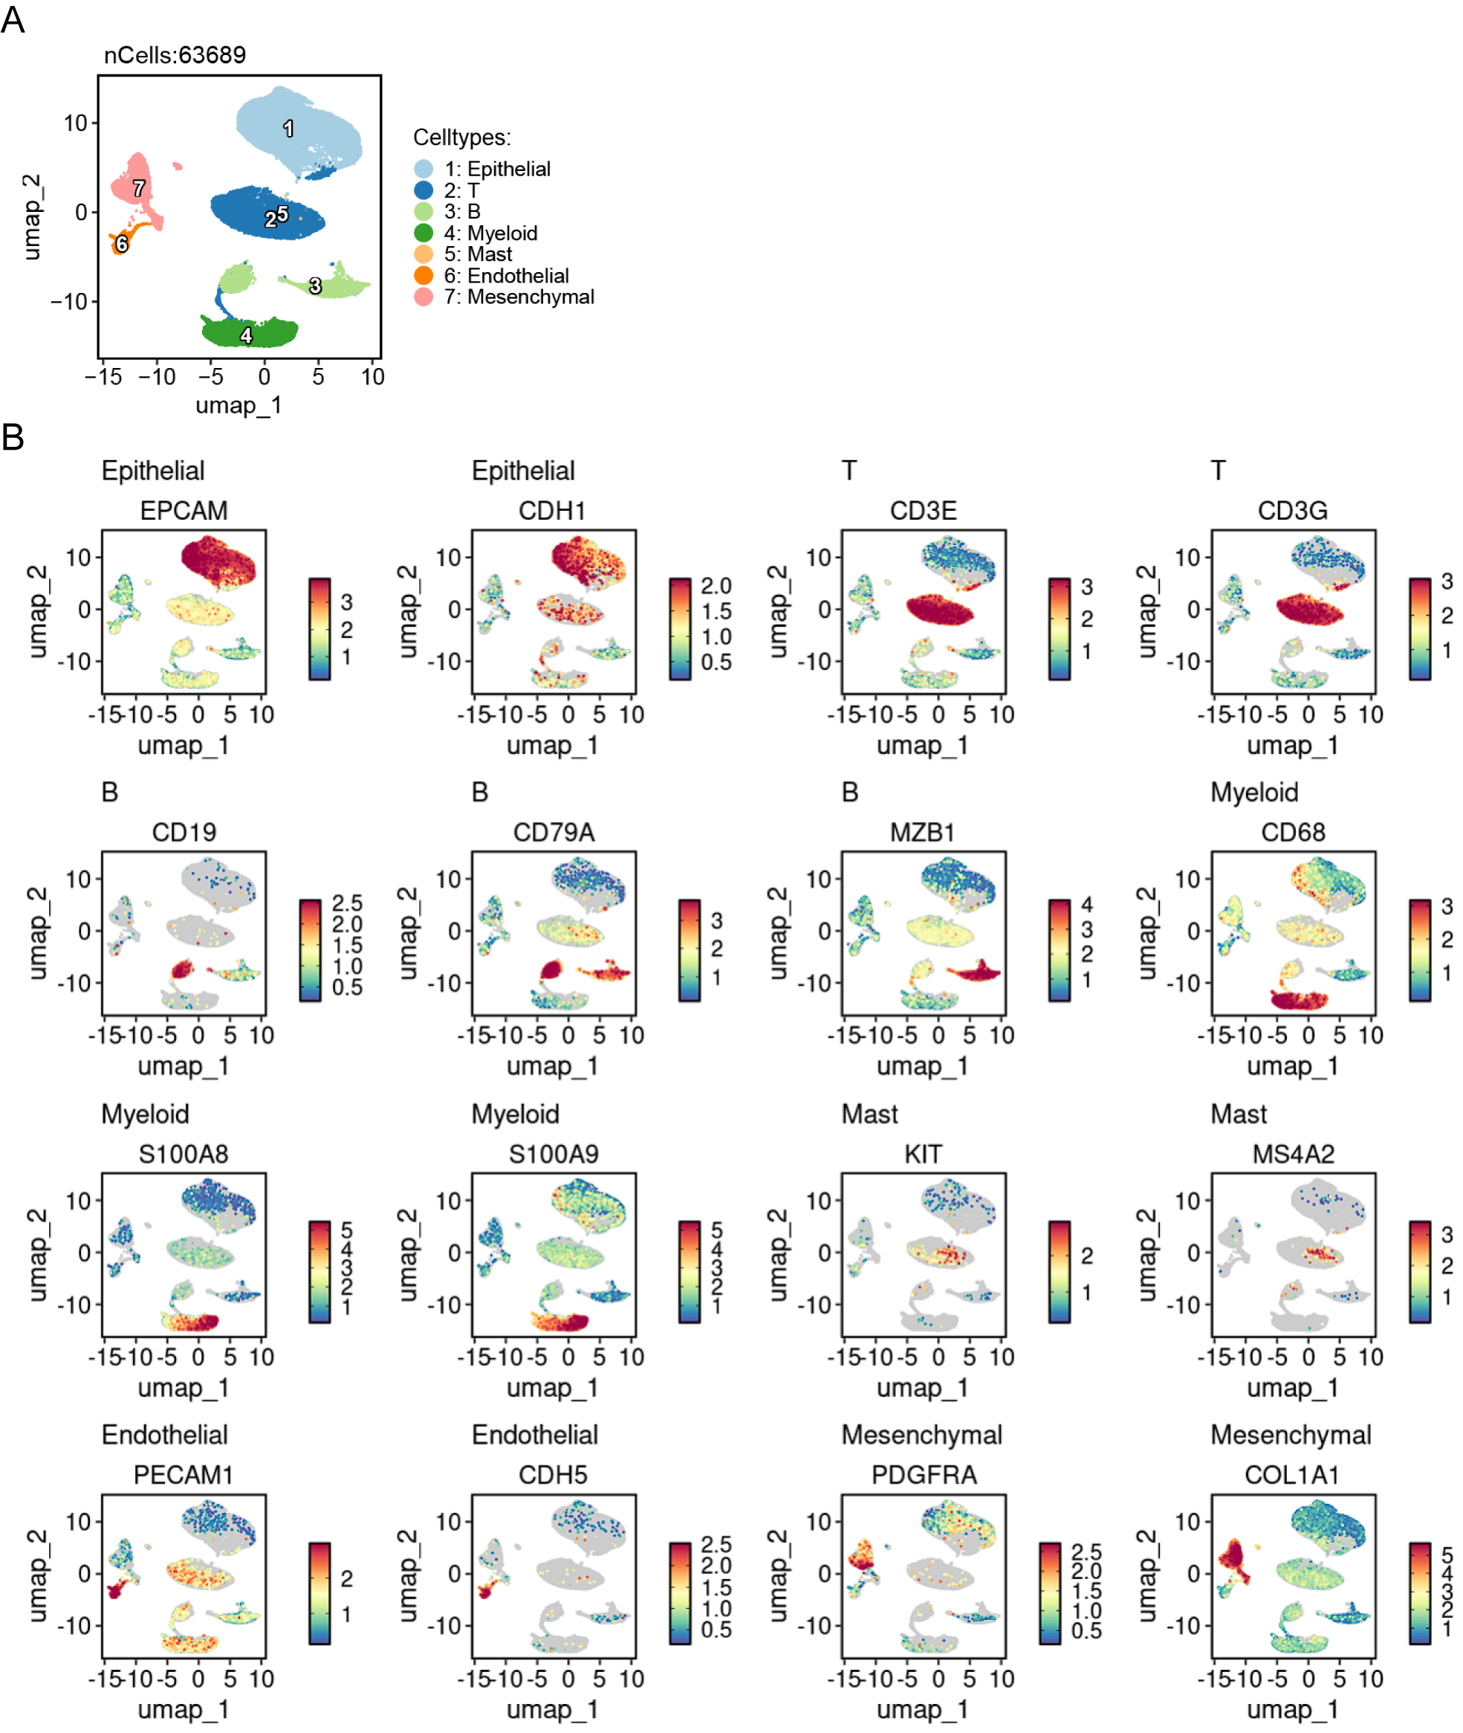
Supplementary Figure 1
(A) UMAP Plot showing the major celltypes, including T, B, myeloid, mast, epithelial, endothelial, and mesenchymal cells. (B) FeaturePlots of specific markers in different celltypes, including epithelial cells (EPCAM, CDH1), T cells (CD3D, CD3G), B cells (CD19, CD79A, MZB1), myeloid cells (CD68, S100A8, S100A9), mast (KIT, MS4A2), endothelial cells (PECAM1, CDH5), and mesenchymal cells (PDGFRA, COL1A1).
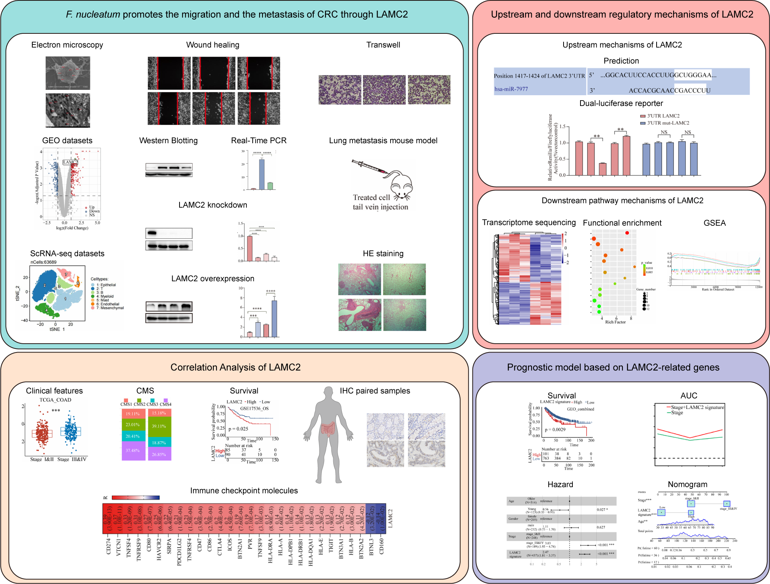
Supplementary Figure 2
The flow chart shows all the procedures done within the current study.
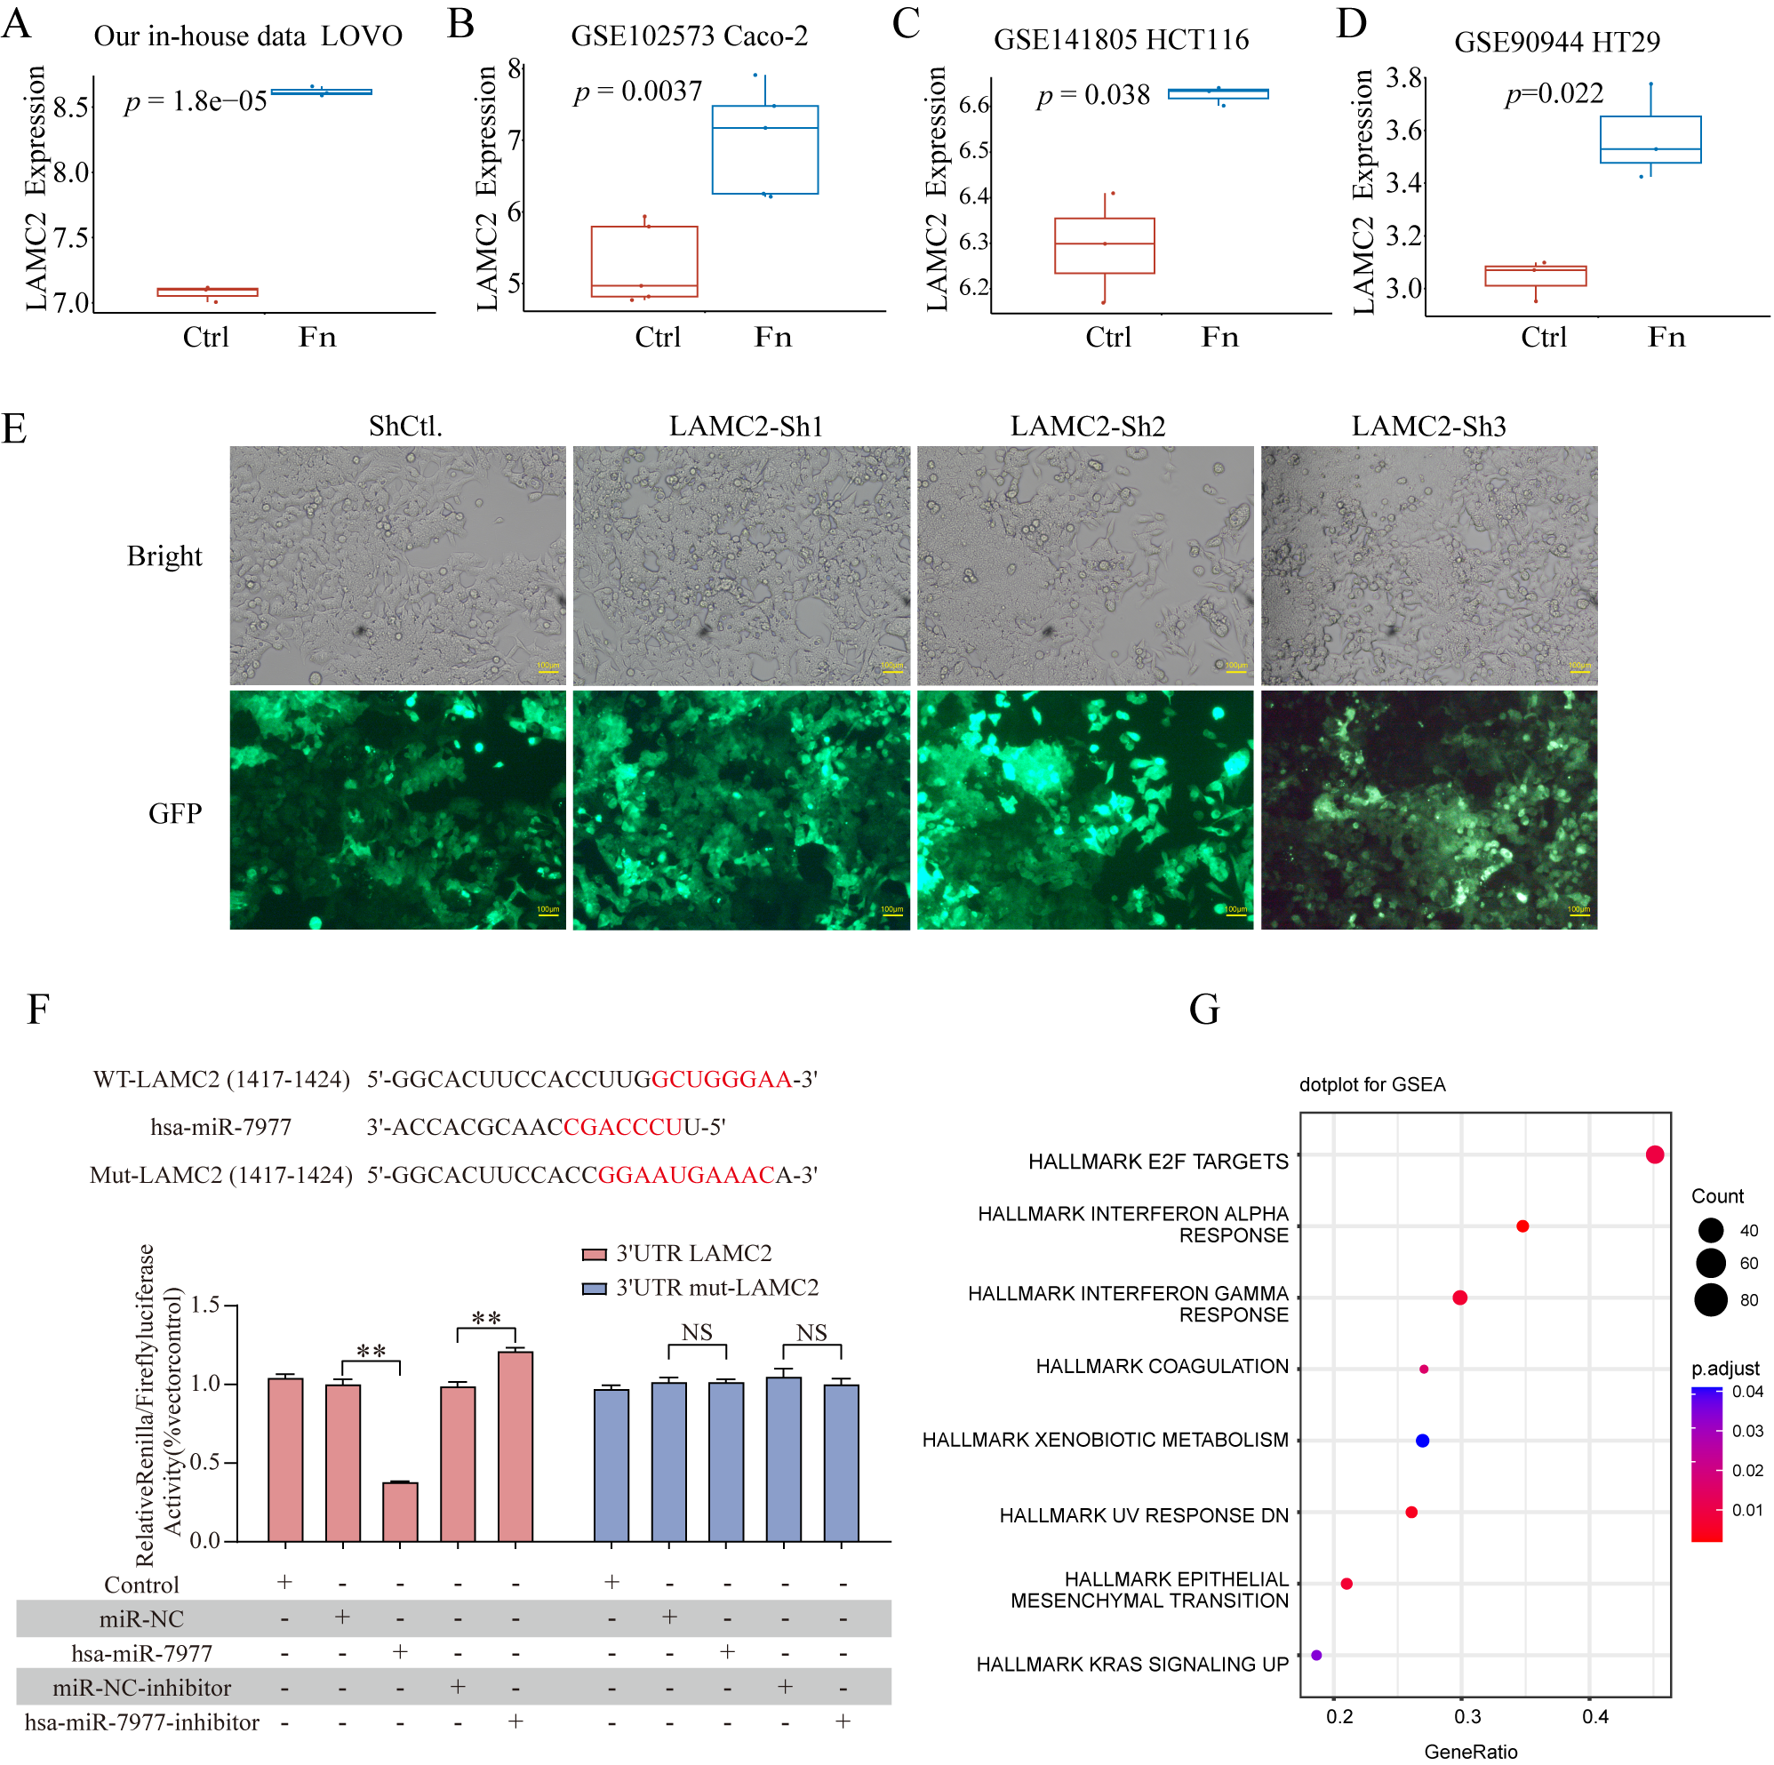
Supplementary Figure 3
(A-D) The expression of LAMC2 in different CRC cells infected by F. nucleatum (t test). (E) The represent images of LAMC2 knockdown by lentivirus in LOVO cells under fluorescence microscope. (F) The luciferase reporter assay validates LAMC2 as a direct target of hsa-miR-7977. (G) GSEA enrichment analysis of DEGs after LAMC2 knockdown.
Supplementary Figure 4
- The correlation between LAMC2 and immune checkpoint molecules was analyzed by GEPIA 2 database. (B-H) qPCR was used to verify the correlation between LAMC2 and different immune checkpoint molecules after LAMC2 knockdown in LOVO cells. (n = 4 per group, One-way ANOVA test). (I-L) KM plots of LAMC2 in multiple CRC cohorts (log-rank test, time unit: month). DFS: disease-free survival, DSS: disease-specific survival, RFS: recurrence-free survival, PFS: progression-free survival.
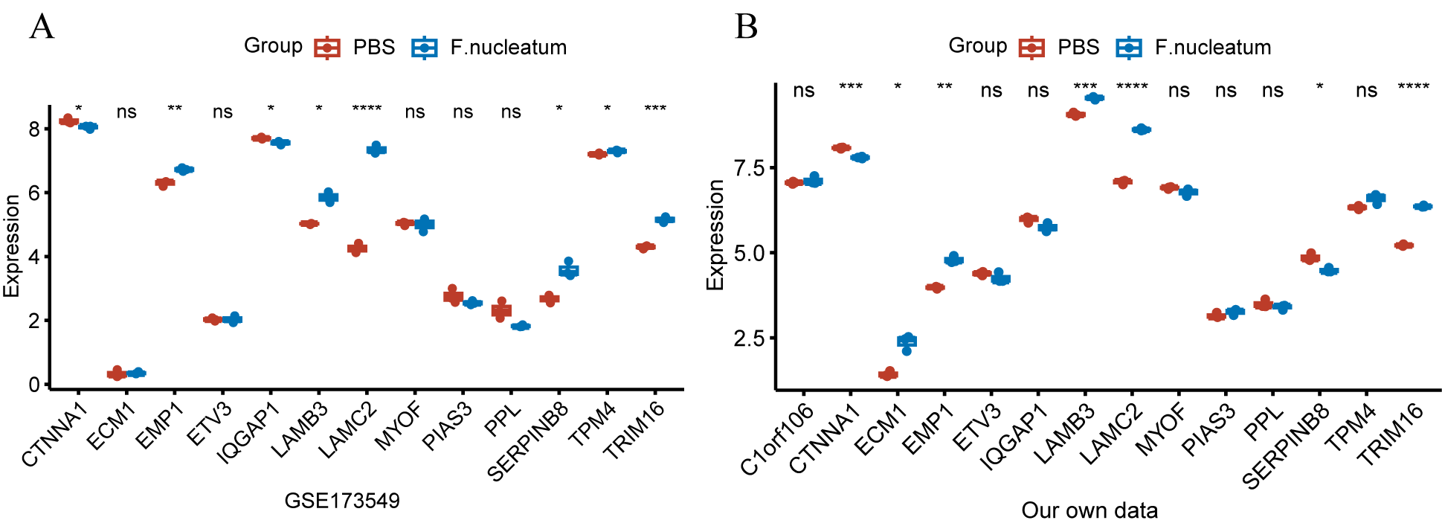
Supplementary Figure 5
(A) The expression levels of LAMC2-associated genes between PBS and F. nucleatum treated LOVO cells in GSE173549 dataset. (B) The expression levels of LAMC2-associated genes between PBS and F. nucleatum treated LOVO cells in the transcriptomic data from our own laboratory. The statistical significance between two groups was evaluated by t.test. * represents p <0 .05, ** represents p <0 .01, *** represents p < 0.001, and **** represents p < 0.0001, ns represents no statistical significant.
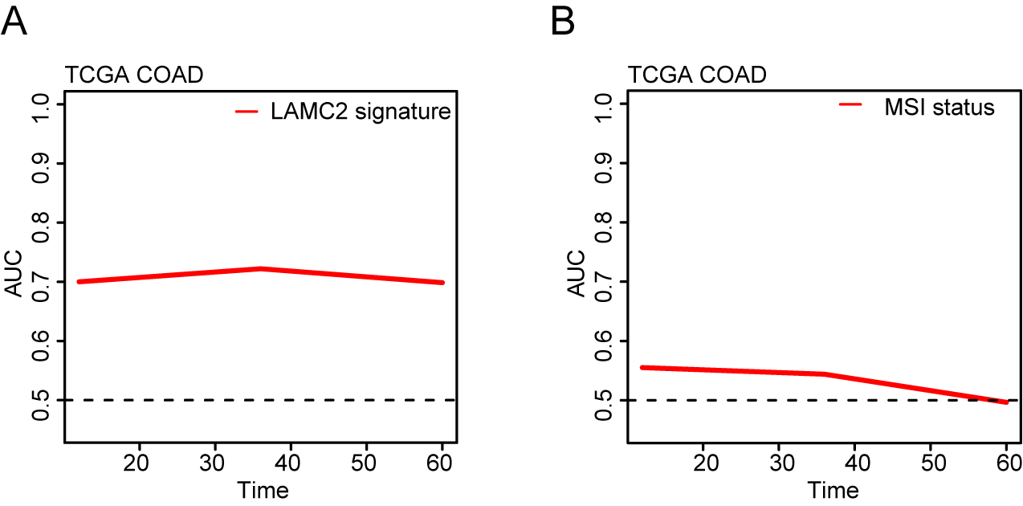
Supplementary Figure 6
(A, B) ROC curve assessing the predictive efficacy of LAMC2-related signature and MSI status for overall survival.

