Widely targeted metabolomics study of flower buds of Styphnolobium japonicum from different producing areas
Leilei Zuo†^{a,b}, Rundong Meng†ª, Xiaofeng Liª, Xiao Mengª, Ying Zhangª, Dayi Chen*ª, Waralee Watcharin*^{b}

Supplementary Information
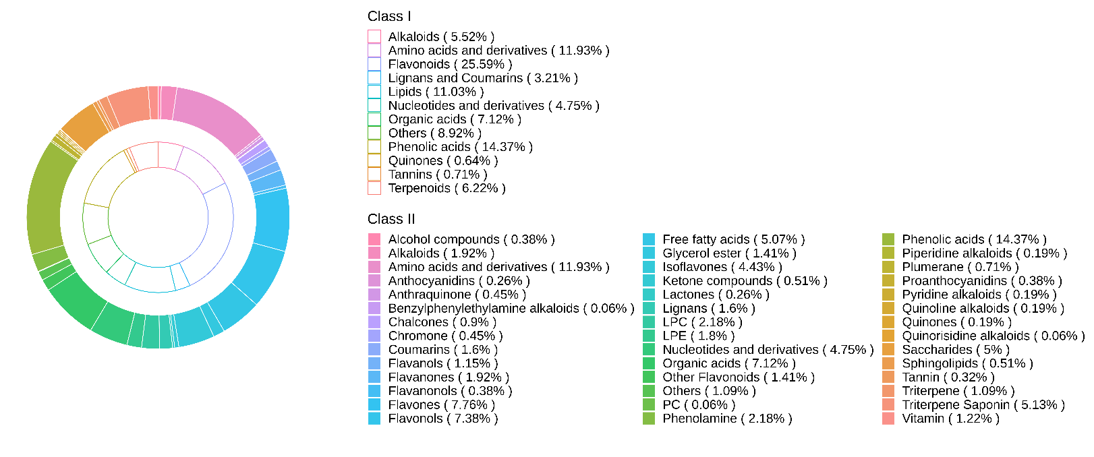
Supplementary Fig. S1 Ring chart of a total of 1559 metabolites derived from FBSJ

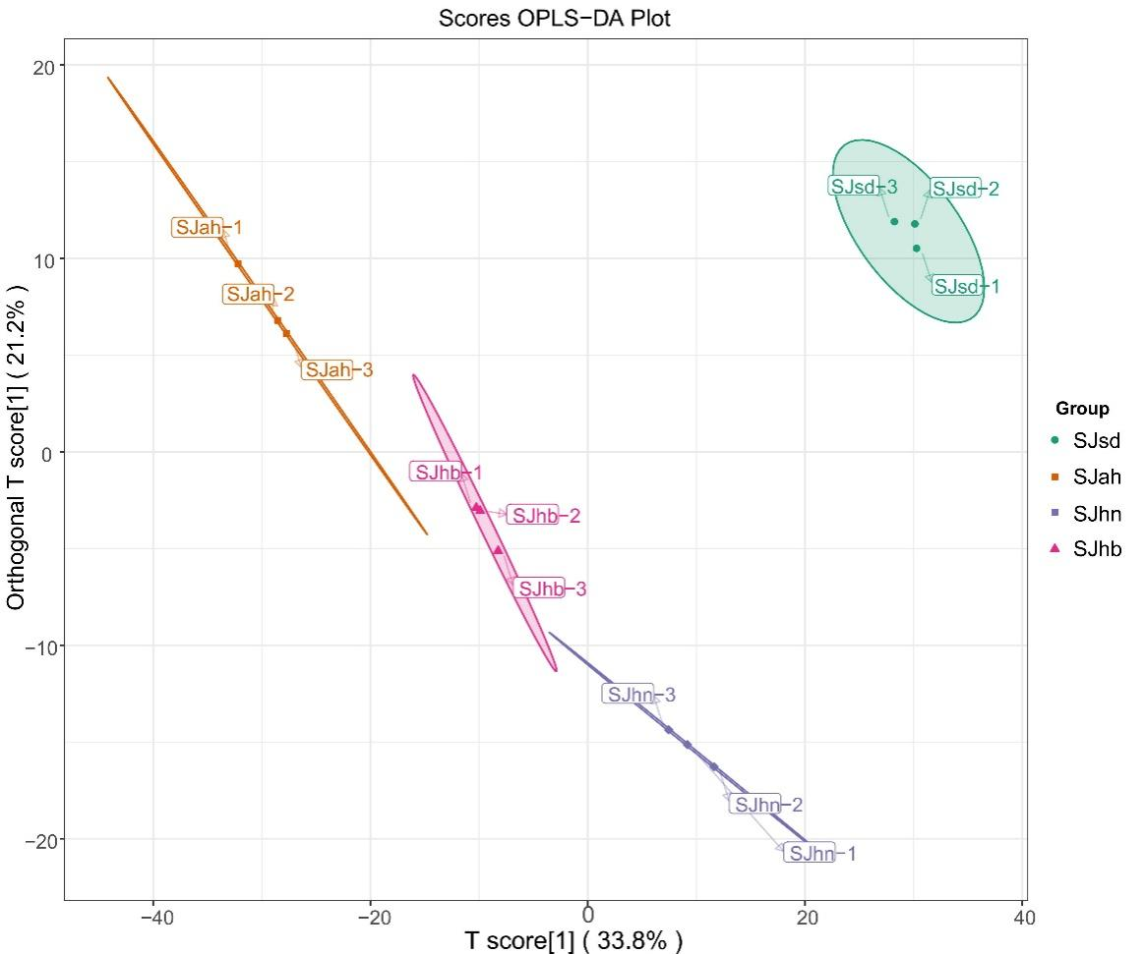
Supplementary Fig. S2 OPLS-DA score plot of the four groups of FBSJ from four different origins
Supplementary Tab. S1 Summary of active pharmaceutical ingredients of FBSJ against these 11 human diseases as reported in CancerHSP and TCMSP database
Cancer/tumor | Diabetes | Hypertension | Cardiovascular Disease | Atherosclerosis | Thrombotic Diseases | Osteoporosis | Liver Ischemic Injury | Inflammation | Infectious Diseases | Hemorrhage
Salidroside  Chlorogenic acid (3-O-Caffeoylquinic acid)*  Sinapinaldehyde  Vanillic acid  Caffeic acid  Gallic acid  Vanillin; 4-Hydroxy-3-Methoxybenzaldehyde  p-Coumaric acid  3,4-Dihydroxybenzoic acid (Protocatechuic acid)*  Methyl caffeate  Cordycepin (3'-Deoxyadenosine)  Phloretin  Naringenin (5,7,4'-Trihydroxyflavanone)  Liquiritigenin  Naringenin-7-O-Neohesperidoside(Naringin)  Isobavachin  Liquiritigenin-4'-O-Glucoside (Liquiritin)  Aromadendrin (Dihydrokaempferol)  Taxifolin-3-O-rhamnoside (Astilbin)  Hispidulin (5,7,4'-Trihydroxy-6-methoxyflavone)  Wogonin (5,7-Dihydroxy-8-Methoxyflavone)  Acacetin  Apigenin-8-C-Glucoside (Vitexin)  Diosmetin (5,7,3'-Trihydroxy-4'-methoxyflavone)  Apigenin; 4',5,7-Trihydroxyflavone  Cirsimaritin (4',5-dihydroxy-6,7-dimethoxyflavone)*  Apigenin-7-O-glucoside(Cosmosiin)  Quercetin  Morin  Kaempferol (3,5,7,4'-Tetrahydroxyflavone)  Quercetin-3-O-rutinoside (Rutin)*  Quercetin-3-O-galactoside (Hyperin)  Quercetin-3-O-rhamnoside(Quercitrin)  Catechin  7-O-Methyleriodictyol  Claussequinone  Biochanin A  Tectorigenin  Formononetin (7-Hydroxy-4'-methoxyisoflavone)  Medicarpin  7,4'-Di-O-methyldaidzein  Genistein  Pterocarpine  Embelin  Coumarin  Procyanidin B1  Procyanidin B2*  cis-Citral  3,23-Dihydroxylup-20(29)-en-28-oic acid (23-Hydroxybetulinic acid)  3-Hydroxylup-20(29)-en-28-oic acid (Betulinic acid)  3-Hydroxyurs-12-en-28-oic acid (Ursolic acid) | Neochlorogenic acid (5-O-Caffeoylquinic acid)*  Digallic Acid  Dihydroferulic Acid  Benzamide  Gallic acid  Hydrocinnamic acid  3,4-Dihydroxybenzoic acid (Protocatechuic acid)*  4,4'-Dihydroxy-2-methoxychalcone; Echinatin  4,4'-Dihydroxy-2-methoxychalcone; Echinatin  Sophoraflavanone G  Taxifolin(Dihydroquercetin)  Hispidulin (5,7,4'-Trihydroxy-6-methoxyflavone)  Pectolinarigenin  Wogonin (5,7-Dihydroxy-8-Methoxyflavone)  Luteolin (5,7,3',4'-Tetrahydroxyflavone)  Acacetin  5,2'-Dihydroxy-7,8-dimethoxyflavone  5-Hydroxy-4',6,7-trimethoxyflavone (Salvigenin)  Eupatilin (5,7-Dihydroxy-3',4',6-Trimethoxyflavone)  4',5,7-Trihydroxy-3',6-dimethoxyflavone (Jaceosidin)  Luteolin-6-C-glucoside (Isoorientin)  Pectolinarigenin  Cirsimaritin (4',5-dihydroxy-6,7-dimethoxyflavone)*  Isorhamnetin; 3'-Methoxy-3,4',5,7-Tetrahydroxyflavone  Quercetin  Morin  Kaempferol (3,5,7,4'-Tetrahydroxyflavone)  Sexangularetin  3,5,6,7,8,3',4'-Heptamethoxyflavone  Limocitrin (5,7,4'-trihydroxy-8,3'-dimethoxyflavone)  Kaempferide (3,5,7-Trihydroxy-4'-methoxyflavone)  Rhamnetin-3-O-rhamnoside  Kaempferol-3-O-glucuronide  Vestitol  Claussequinone  Formononetin-7-O-glucoside (Ononin)  Afrormosin (6,4'-Dimethoxy-7-Hydroxyisoflavone)  Biochanin A  3'-Methoxydaidzein  5,7,4'-Trihydroxy-3'-methoxyisoflavone; 3'-O-Methylorobol  Tectorigenin  Glycitein  pseudobaptigenin  Irisolidone  8-O-methylretusin  Formononetin (7-Hydroxy-4'-methoxyisoflavone)  Genistein-8-C-glucoside  Medicarpin  Genistein  Daidzein-7-O-glucoside(Daidzin)  6''-O-Acetylglycitin  Dehydrodiconiferyl alcohol  Esculetin (6,7-Dihydroxycoumarin)  stevenin  Scopoletin-7-O-glucoside (Scopolin)  Capillarisin  5,7-Dihydroxychromone  beta-D-Galactose  α-Linolenic Acid*  DL-Glyceric Acid  Succinic acid  L-Malic acid  Citric Acid  cis-Citral  L-Tartaric acid  DL-3-Phenyllactic acid*  Creatine  Indole-3-acetic acid (IAA) | Cryptochlorogenic acid (4-O-Caffeoylquinic acid)*  Androsin  Digallic Acid  Chlorogenic acid (3-O-Caffeoylquinic acid)*  Dimethyl phthalate  Isovanillin  Dihydroferulic Acid  Methyl 2,4-dihydroxyphenylacetate  3-Hydroxy-4-methoxybenzoic acid; Isovanillic Acid  Salicylic acid  Sinapinaldehyde  Protocatechuic Acid Methyl Ester  Vanillic acid  Methyl gallate  Caffeic acid  Diisobutyl phthalate  Gallic acid  Hydrocinnamic acid  Vanillin; 4-Hydroxy-3-Methoxybenzaldehyde  3,4-Dihydroxybenzoic acid (Protocatechuic acid)*  Syringaldehyde; 4-Hydroxy-3,5-Dimethoxybenzaldehyde  2-Hydroxycinnamic acid*  Sinapic acid  3,4-Dimethoxycinnamic acid  2,6-Dimethoxybenzoic acid  2,5-Dihydroxybenzoic acid; Gentisic Acid*  Ferulic acid  Ethylparaben  Methyl 4-hydroxybenzoate  Syringic acid  Methyl caffeate  2'-Deoxyadenosine  Guanosine  Cordycepin (3'-Deoxyadenosine)  4,4'-Dihydroxy-2-methoxychalcone; Echinatin  4,4'-Dihydroxy-2-methoxychalcone; Echinatin  Naringenin (5,7,4'-Trihydroxyflavanone)  Glabranine  Liquiritigenin  Naringenin-7-O-Neohesperidoside(Naringin)  Sophoraflavanone G  Eriodictyol (5,7,3',4'-Tetrahydroxyflavanone)  Naringenin-7-O-glucoside (Prunin)  Choerospondin  Isobavachin  Liquiritigenin-4'-O-Glucoside (Liquiritin)  Taxifolin(Dihydroquercetin)  Aromadendrin (Dihydrokaempferol)  Taxifolin-3-O-rhamnoside (Astilbin)  Hispidulin (5,7,4'-Trihydroxy-6-methoxyflavone)  Pectolinarigenin  Wogonin (5,7-Dihydroxy-8-Methoxyflavone)  Luteolin (5,7,3',4'-Tetrahydroxyflavone)  Acacetin  5,2'-Dihydroxy-7,8-dimethoxyflavone  Apigenin-8-C-Glucoside (Vitexin)  5-Hydroxy-4',6,7-trimethoxyflavone (Salvigenin)  Eupatilin (5,7-Dihydroxy-3',4',6-Trimethoxyflavone)  4',5,7-Trihydroxy-3',6-dimethoxyflavone (Jaceosidin)  Pectolinarigenin  Cirsimaritin (4',5-dihydroxy-6,7-dimethoxyflavone)*  Apigenin-7,4'-dimethyl ether  6-Hydroxyluteolin  Apigenin-7-O-glucoside(Cosmosiin)  Isorhamnetin; 3'-Methoxy-3,4',5,7-Tetrahydroxyflavone  Quercetin  Morin  Kaempferol (3,5,7,4'-Tetrahydroxyflavone)  Sexangularetin  3,5,6,7,8,3',4'-Heptamethoxyflavone  Garbanzol  Limocitrin (5,7,4'-trihydroxy-8,3'-dimethoxyflavone)  Quercetin-3-O-rutinoside (Rutin)*  Kaempferide (3,5,7-Trihydroxy-4'-methoxyflavone)  Kaempferol-7-O-glucoside  Kaempferol-3-O-arabinoside (Juglanin)  Catechin  7-O-Methyleriodictyol  Vestitol  Astrapterocarpan  Claussequinone  Formononetin-7-O-glucoside (Ononin)  Afrormosin (6,4'-Dimethoxy-7-Hydroxyisoflavone)  Biochanin A  3'-Methoxydaidzein  5,7,4'-Trihydroxy-3'-methoxyisoflavone; 3'-O-Methylorobol  Tectorigenin  Glycitein  pseudobaptigenin  Irisolidone  Glycitin  8-O-methylretusin  Formononetin (7-Hydroxy-4'-methoxyisoflavone)  Medicarpin  Trifolirhizin (Maackiain-3-O-glucoside)  Sophoricoside  Calycosin-7-O-glucoside  Maackiain  Genistein  Genistein-7-O-Glucoside (Genistin)  Pterocarpine  Daidzein-7-O-glucoside(Daidzin)  Embelin  Dehydrodiconiferyl alcohol  Epipinoresinol  3,4-Dihydrocoumarin  Coumarin  Esculin (6,7-Dihydroxycoumarin-6-O-glucoside)  stevenin  Scopoletin-7-O-glucoside (Scopolin)  Eucommiol  Capillarisin  5,7-Dihydroxychromone  Riboflavin (Vitamin B2)  Nicotinamide  Pyridoxine  beta-D-Galactose  Stachyose  Procyanidin B1  Procyanidin B2*  Dodecanoic acid (Lauric acid)  Ricinoleic acid  9-Hydroxy-10,12,15-octadecatrienoic acid  Punicic acid (9Z,11E,13Z-octadecatrienoic acid)  α-Linolenic Acid*  Methyl linolenate  4-Guanidinobutyric acid  Shikimic acid  L-Pipecolic Acid  Quinic Acid  Citric Acid  Abscisic acid  L-Tartaric acid  DL-3-Phenyllactic acid*  Mono-Methyl Glutarate  2,3-Dihydroxyurs-12-en-28-oic acid methyl ester (Corosolic acid methyl ester)  Soyasaponin βg (Soyasaponin VI)  Abrine  Indole-3-acetic acid (IAA)  3-Hydroxypyridine  L-Citrulline  L-Homocitrulline  L-Leucine  L-Tyrosine | Isovanillin  Dihydroferulic Acid  Benzamide  3-Hydroxy-4-methoxybenzoic acid; Isovanillic Acid  Salicylic acid  Sinapinaldehyde  Protocatechuic Acid Methyl Ester  Vanillic acid  Methyl gallate  Caffeic acid  Gallic acid  3,4-Dihydroxybenzoic acid (Protocatechuic acid)*  Syringaldehyde; 4-Hydroxy-3,5-Dimethoxybenzaldehyde  2-Hydroxycinnamic acid*  Sinapic acid  3,4-Dimethoxycinnamic acid  2,6-Dimethoxybenzoic acid  2,5-Dihydroxybenzoic acid; Gentisic Acid*  Ferulic acid  Ethylparaben  Methyl 4-hydroxybenzoate  Methyl caffeate  2'-Deoxyadenosine  Guanosine  Isoliquiritin  4,4'-Dihydroxy-2-methoxychalcone; Echinatin  4,4'-Dihydroxy-2-methoxychalcone; Echinatin  Naringenin (5,7,4'-Trihydroxyflavanone)  Glabranine  Liquiritigenin  Naringenin-7-O-Neohesperidoside(Naringin)  Sophoraflavanone G  Eriodictyol (5,7,3',4'-Tetrahydroxyflavanone)  Isobavachin  Liquiritigenin-4'-O-Glucoside (Liquiritin)  Taxifolin(Dihydroquercetin)  Aromadendrin (Dihydrokaempferol)  Taxifolin-3-O-rhamnoside (Astilbin)  Hispidulin (5,7,4'-Trihydroxy-6-methoxyflavone)  Pectolinarigenin  Wogonin (5,7-Dihydroxy-8-Methoxyflavone)  Luteolin (5,7,3',4'-Tetrahydroxyflavone)  Acacetin  5,2'-Dihydroxy-7,8-dimethoxyflavone  5-Hydroxy-4',6,7-trimethoxyflavone (Salvigenin)  Eupatilin (5,7-Dihydroxy-3',4',6-Trimethoxyflavone)  4',5,7-Trihydroxy-3',6-dimethoxyflavone (Jaceosidin)  Pectolinarigenin  Cirsimaritin (4',5-dihydroxy-6,7-dimethoxyflavone)*  Apigenin-7,4'-dimethyl ether  6-Hydroxyluteolin  Nepetin-7-O-glucoside(Nepitrin)  Isorhamnetin; 3'-Methoxy-3,4',5,7-Tetrahydroxyflavone  Quercetin  Morin  Kaempferol (3,5,7,4'-Tetrahydroxyflavone)  Sexangularetin  3,5,6,7,8,3',4'-Heptamethoxyflavone  Garbanzol  Limocitrin (5,7,4'-trihydroxy-8,3'-dimethoxyflavone)  Quercetin-3-O-rutinoside (Rutin)*  Kaempferide (3,5,7-Trihydroxy-4'-methoxyflavone)  Kaempferol-3-O-glucuronide  Kaempferol-3-O-arabinoside (Juglanin)  Quercetin-3-O-rhamnoside(Quercitrin)  Catechin  7-O-Methyleriodictyol  Vestitol  Astrapterocarpan  Claussequinone  Formononetin-7-O-glucoside (Ononin)  Afrormosin (6,4'-Dimethoxy-7-Hydroxyisoflavone)  Biochanin A  3'-Methoxydaidzein  5,7,4'-Trihydroxy-3'-methoxyisoflavone; 3'-O-Methylorobol  Tectorigenin  Glycitein  pseudobaptigenin  Irisolidone  8-O-methylretusin  Formononetin (7-Hydroxy-4'-methoxyisoflavone)  Medicarpin  Maackiain  Genistein  Pterocarpine  Daidzein-7-O-glucoside(Daidzin)  Dehydrodiconiferyl alcohol  Epipinoresinol  3,4-Dihydrocoumarin  stevenin  Capillarisin  5-O-Methylvisammioside  5,7-Dihydroxychromone  Nicotinamide  Pyridoxine  beta-D-Galactose  Stachyose  Procyanidin B1  Palmitoleic Acid  Dodecanoic acid (Lauric acid)  Ricinoleic acid  9-Hydroxy-10,12,15-octadecatrienoic acid  Punicic acid (9Z,11E,13Z-octadecatrienoic acid)  α-Linolenic Acid*  11-Octadecanoic acid(Vaccenic acid)*  Petroselinic acid*  Methyl linolenate  1-Linoleoylglycerol*  4-Guanidinobutyric acid  DL-Glyceric Acid  L-Pipecolic Acid  Citric Acid  L-Tartaric acid  Malonic acid  DL-3-Phenyllactic acid*  2,3-Dihydroxyurs-12-en-28-oic acid methyl ester (Corosolic acid methyl ester)  Soyasaponin βg (Soyasaponin VI)  Abrine  Indole-3-acetic acid (IAA)  L-Leucine | Dihydroferulic Acid  Benzamide  Isoliquiritin  4,4'-Dihydroxy-2-methoxychalcone; Echinatin  4,4'-Dihydroxy-2-methoxychalcone; Echinatin  Naringenin (5,7,4'-Trihydroxyflavanone)  Glabranine  Liquiritigenin  Naringenin-7-O-Neohesperidoside(Naringin)  Sophoraflavanone G  Isobavachin  Hispidulin (5,7,4'-Trihydroxy-6-methoxyflavone)  Wogonin (5,7-Dihydroxy-8-Methoxyflavone)  5-Hydroxy-4',6,7-trimethoxyflavone (Salvigenin)  Eupatilin (5,7-Dihydroxy-3',4',6-Trimethoxyflavone)  4',5,7-Trihydroxy-3',6-dimethoxyflavone (Jaceosidin)  Isorhamnetin; 3'-Methoxy-3,4',5,7-Tetrahydroxyflavone  Quercetin  Morin  Kaempferol (3,5,7,4'-Tetrahydroxyflavone)  3,5,6,7,8,3',4'-Heptamethoxyflavone  Limocitrin (5,7,4'-trihydroxy-8,3'-dimethoxyflavone)  Kaempferide (3,5,7-Trihydroxy-4'-methoxyflavone)  Kaempferol-7-O-glucoside  Catechin  Vestitol  Astrapterocarpan  Formononetin-7-O-glucoside (Ononin)  Afrormosin (6,4'-Dimethoxy-7-Hydroxyisoflavone)  Biochanin A  3'-Methoxydaidzein  5,7,4'-Trihydroxy-3'-methoxyisoflavone; 3'-O-Methylorobol  Tectorigenin  Glycitein  pseudobaptigenin  Irisolidone  Glycitin  8-O-methylretusin  Formononetin (7-Hydroxy-4'-methoxyisoflavone)  Medicarpin  Calycosin-7-O-glucoside  Genistein  Genistein-7-O-Glucoside (Genistin)  Daidzein-7-O-glucoside(Daidzin)  6''-O-Acetylglycitin  Embelin  Dehydrodiconiferyl alcohol  Coumarin  5,7-Dihydroxychromone  DL-3-Phenyllactic acid*  2,3-Dihydroxyurs-12-en-28-oic acid methyl ester (Corosolic acid methyl ester) | Dihydroferulic Acid  Diisobutyl phthalate  4,4'-Dihydroxy-2-methoxychalcone; Echinatin  4,4'-Dihydroxy-2-methoxychalcone; Echinatin  Glabranine  Sophoraflavanone G  Isobavachin  Liquiritigenin-4'-O-Glucoside (Liquiritin)  Hispidulin (5,7,4'-Trihydroxy-6-methoxyflavone)  Wogonin (5,7-Dihydroxy-8-Methoxyflavone)  5-Hydroxy-4',6,7-trimethoxyflavone (Salvigenin)  Eupatilin (5,7-Dihydroxy-3',4',6-Trimethoxyflavone)  4',5,7-Trihydroxy-3',6-dimethoxyflavone (Jaceosidin)  Nepetin-7-O-glucoside(Nepitrin)  Quercetin  Kaempferol (3,5,7,4'-Tetrahydroxyflavone)  3,5,6,7,8,3',4'-Heptamethoxyflavone  Limocitrin (5,7,4'-trihydroxy-8,3'-dimethoxyflavone)  Kaempferide (3,5,7-Trihydroxy-4'-methoxyflavone)  Kaempferol-7-O-glucoside  Kaempferol-3-O-glucuronide  Kaempferol-3-O-arabinoside (Juglanin)  Quercetin-3-O-rhamnoside(Quercitrin)  Vestitol  Astrapterocarpan  Formononetin-7-O-glucoside (Ononin)  Afrormosin (6,4'-Dimethoxy-7-Hydroxyisoflavone)  Biochanin A  3'-Methoxydaidzein  5,7,4'-Trihydroxy-3'-methoxyisoflavone; 3'-O-Methylorobol  Tectorigenin  Glycitein  pseudobaptigenin  Irisolidone  Glycitin  8-O-methylretusin  Formononetin (7-Hydroxy-4'-methoxyisoflavone)  Medicarpin  Calycosin-7-O-glucoside  Genistein  Genistein-7-O-Glucoside (Genistin)  Daidzein-7-O-glucoside(Daidzin)  6''-O-Acetylglycitin  Embelin  Dehydrodiconiferyl alcohol  Epipinoresinol  Coumarin  Capillarisin  5-O-Methylvisammioside  4-Guanidinobutyric acid  Citric Acid  DL-3-Phenyllactic acid*  2,3-Dihydroxyurs-12-en-28-oic acid methyl ester (Corosolic acid methyl ester) | Benzamide  Salicylic acid  Isoliquiritin  4,4'-Dihydroxy-2-methoxychalcone; Echinatin  4,4'-Dihydroxy-2-methoxychalcone; Echinatin  Naringenin (5,7,4'-Trihydroxyflavanone)  Glabranine  Liquiritigenin  Naringenin-7-O-Neohesperidoside(Naringin)  Sophoraflavanone G  Isobavachin  Wogonin (5,7-Dihydroxy-8-Methoxyflavone)  Luteolin (5,7,3',4'-Tetrahydroxyflavone)  Eupatilin (5,7-Dihydroxy-3',4',6-Trimethoxyflavone)  4',5,7-Trihydroxy-3',6-dimethoxyflavone (Jaceosidin)  Quercetin  3,5,6,7,8,3',4'-Heptamethoxyflavone  Limocitrin (5,7,4'-trihydroxy-8,3'-dimethoxyflavone)  Kaempferide (3,5,7-Trihydroxy-4'-methoxyflavone)  Catechin  Vestitol  Astrapterocarpan  Formononetin-7-O-glucoside (Ononin)  Afrormosin (6,4'-Dimethoxy-7-Hydroxyisoflavone)  Biochanin A  3'-Methoxydaidzein  5,7,4'-Trihydroxy-3'-methoxyisoflavone; 3'-O-Methylorobol  Tectorigenin  Glycitein  pseudobaptigenin  Irisolidone  8-O-methylretusin  Formononetin (7-Hydroxy-4'-methoxyisoflavone)  Medicarpin  Genistein  Daidzein-7-O-glucoside(Daidzin)  Dehydrodiconiferyl alcohol  5,7-Dihydroxychromone  beta-D-Galactose  Dodecanoic acid (Lauric acid)  DL-Glyceric Acid  Succinic acid  L-Malic acid  Citric Acid  Malonic acid  2,3-Dihydroxyurs-12-en-28-oic acid methyl ester (Corosolic acid methyl ester) | Salicylic acid  Liquiritigenin-4'-O-Glucoside (Liquiritin)  Quercetin | Cryptochlorogenic acid (4-O-Caffeoylquinic acid)*  Androsin  Digallic Acid  Chlorogenic acid (3-O-Caffeoylquinic acid)*  Dimethyl phthalate  Isovanillin  4-Hydroxybenzoic acid  Dihydroferulic Acid  Methyl 2,4-dihydroxyphenylacetate  3-Hydroxy-4-methoxybenzoic acid; Isovanillic Acid  Salicylic acid  Sinapinaldehyde  Protocatechuic Acid Methyl Ester  Vanillic acid  Protocatechualdehyde  Methyl gallate  Caffeic acid  Diisobutyl phthalate  Gallic acid  Hydrocinnamic acid  Vanillin; 4-Hydroxy-3-Methoxybenzaldehyde  3,4-Dihydroxybenzoic acid (Protocatechuic acid)*  Syringaldehyde; 4-Hydroxy-3,5-Dimethoxybenzaldehyde  2-Hydroxycinnamic acid*  Sinapic acid  3,4-Dimethoxycinnamic acid  2,6-Dimethoxybenzoic acid  2,5-Dihydroxybenzoic acid; Gentisic Acid*  Ferulic acid  Ethylparaben  Methyl 4-hydroxybenzoate  Methyl caffeate  2'-Deoxyadenosine  Guanosine  Cordycepin (3'-Deoxyadenosine)  4,4'-Dihydroxy-2-methoxychalcone; Echinatin  4,4'-Dihydroxy-2-methoxychalcone; Echinatin  Naringenin (5,7,4'-Trihydroxyflavanone)  Glabranine  Liquiritigenin  Naringenin-7-O-Neohesperidoside(Naringin)  Sophoraflavanone G  Eriodictyol (5,7,3',4'-Tetrahydroxyflavanone)  Naringenin-7-O-glucoside (Prunin)  Choerospondin  Isobavachin  Liquiritigenin-4'-O-Glucoside (Liquiritin)  Taxifolin(Dihydroquercetin)  Aromadendrin (Dihydrokaempferol)  Taxifolin-3-O-rhamnoside (Astilbin)  Hispidulin (5,7,4'-Trihydroxy-6-methoxyflavone)  Pectolinarigenin  Wogonin (5,7-Dihydroxy-8-Methoxyflavone)  Luteolin (5,7,3',4'-Tetrahydroxyflavone)  Acacetin  5,2'-Dihydroxy-7,8-dimethoxyflavone  Apigenin-8-C-Glucoside (Vitexin)  5-Hydroxy-4',6,7-trimethoxyflavone (Salvigenin)  Eupatilin (5,7-Dihydroxy-3',4',6-Trimethoxyflavone)  4',5,7-Trihydroxy-3',6-dimethoxyflavone (Jaceosidin)  Pectolinarigenin  Cirsimaritin (4',5-dihydroxy-6,7-dimethoxyflavone)*  Apigenin-7,4'-dimethyl ether  6-Hydroxyluteolin  Apigenin-7-O-glucoside(Cosmosiin)  Isorhamnetin; 3'-Methoxy-3,4',5,7-Tetrahydroxyflavone  Quercetin  Morin  Kaempferol (3,5,7,4'-Tetrahydroxyflavone)  Sexangularetin  3,5,6,7,8,3',4'-Heptamethoxyflavone  Garbanzol  Limocitrin (5,7,4'-trihydroxy-8,3'-dimethoxyflavone)  Quercetin-3-O-rutinoside (Rutin)*  Kaempferide (3,5,7-Trihydroxy-4'-methoxyflavone)  Kaempferol-7-O-glucoside  Kaempferol-3-O-arabinoside (Juglanin)  Catechin  7-O-Methyleriodictyol  Vestitol  Astrapterocarpan  Claussequinone  Formononetin-7-O-glucoside (Ononin)  Afrormosin (6,4'-Dimethoxy-7-Hydroxyisoflavone)  Biochanin A  3'-Methoxydaidzein  5,7,4'-Trihydroxy-3'-methoxyisoflavone; 3'-O-Methylorobol  Tectorigenin  Glycitein  pseudobaptigenin  Irisolidone  Glycitin  8-O-methylretusin  Formononetin (7-Hydroxy-4'-methoxyisoflavone)  Medicarpin  Trifolirhizin (Maackiain-3-O-glucoside)  Sophoricoside  Calycosin-7-O-glucoside  Maackiain  Genistein  Genistein-7-O-Glucoside (Genistin)  Pterocarpine  Daidzein-7-O-glucoside(Daidzin)  Embelin  Dehydrodiconiferyl alcohol  Epipinoresinol  3,4-Dihydrocoumarin  Coumarin  Esculin (6,7-Dihydroxycoumarin-6-O-glucoside)  stevenin  Scopoletin-7-O-glucoside (Scopolin)  Eucommiol  Capillarisin  5,7-Dihydroxychromone  Riboflavin (Vitamin B2)  Nicotinamide  Pyridoxine  beta-D-Galactose  Stachyose  Procyanidin B1  Procyanidin B2*  Undecylic Acid  Dodecanoic acid (Lauric acid)  Ricinoleic acid  9-Hydroxy-10,12,15-octadecatrienoic acid  Punicic acid (9Z,11E,13Z-octadecatrienoic acid)  α-Linolenic Acid*  Methyl linolenate  4-Guanidinobutyric acid  Shikimic acid  L-Pipecolic Acid  Quinic Acid  Citric Acid  Abscisic acid  L-Tartaric acid  DL-3-Phenyllactic acid*  Mono-Methyl Glutarate  Soyasaponin βg (Soyasaponin VI)  Abrine  Indole-3-acetic acid (IAA)  3-Hydroxypyridine  L-Citrulline  L-Homocitrulline  L-Leucine  L-Tyrosine | Dihydroferulic Acid  Benzamide  Gallic acid  Hydrocinnamic acid  Syringaldehyde; 4-Hydroxy-3,5-Dimethoxybenzaldehyde  Sinapic acid  3,4-Dimethoxycinnamic acid  Ferulic acid  2'-Deoxyadenosine  Guanosine  4,4'-Dihydroxy-2-methoxychalcone; Echinatin  4,4'-Dihydroxy-2-methoxychalcone; Echinatin  Naringenin (5,7,4'-Trihydroxyflavanone)  Glabranine  Liquiritigenin  Hispidulin (5,7,4'-Trihydroxy-6-methoxyflavone)  Wogonin (5,7-Dihydroxy-8-Methoxyflavone)  Luteolin (5,7,3',4'-Tetrahydroxyflavone)  Acacetin  Chrysoeriol-7-O-glucoside  5,2'-Dihydroxy-7,8-dimethoxyflavone  Apigenin-8-C-Glucoside (Vitexin)  5-Hydroxy-4',6,7-trimethoxyflavone (Salvigenin)  Eupatilin (5,7-Dihydroxy-3',4',6-Trimethoxyflavone)  Vitexin-2''-O-rhamnoside  Apigenin-6,8-di-C-glucoside (Vicenin-2)  4',5,7-Trihydroxy-3',6-dimethoxyflavone (Jaceosidin)  Neoeriocitrin  Quercetin  Kaempferol (3,5,7,4'-Tetrahydroxyflavone)  Sexangularetin  Quercetin-3-O-glucoside (Isoquercitrin)*  3,5,6,7,8,3',4'-Heptamethoxyflavone  Limocitrin (5,7,4'-trihydroxy-8,3'-dimethoxyflavone)  Quercetin-3-O-(2''-O-galactosyl)glucoside  Kaempferol-3,7-O-diglucoside  Isorhamnetin-3,7-O-diglucoside  Quercetin-3-O-rutinoside (Rutin)*  Kaempferide (3,5,7-Trihydroxy-4'-methoxyflavone)  Quercetin-3-O-sambubioside*  Rhamnetin-3-O-rhamnoside  Kaempferol-3-O-glucuronide  Kaempferol-3-O-arabinoside (Juglanin)  Quercetin-3-O-rhamnoside(Quercitrin)  Quercetin-3-O-sophoroside (Baimaside)  Catechin  Vestitol  Claussequinone  Formononetin-7-O-glucoside (Ononin)  Afrormosin (6,4'-Dimethoxy-7-Hydroxyisoflavone)  Biochanin A  3'-Methoxydaidzein  5,7,4'-Trihydroxy-3'-methoxyisoflavone; 3'-O-Methylorobol  Tectorigenin  Isoluteolin (Orobol)(5,7,3',4'-tetrahydroxyisoflavone)  Glycitein  pseudobaptigenin  Irisolidone  Glycitin  8-O-methylretusin  Formononetin (7-Hydroxy-4'-methoxyisoflavone)  Genistein-8-C-glucoside  Medicarpin  Genistein  Syringaresinol-4'-O-glucoside; Acanthoside B  3,4-Dihydrocoumarin  Capillarisin  5-O-Methylvisammioside  Icariside E5  Riboflavin (Vitamin B2)  beta-D-Galactose  Procyanidin B1  4-Guanidinobutyric acid  DL-Glyceric Acid  Succinic acid  Citric Acid  L-Tartaric acid  DL-3-Phenyllactic acid*  Kaikasaponin III  L-Citrulline  L-Homocitrulline
 |  |  |  |  |  |  |  |  |  | Salicylic acid

