Supplement Fig. 1 The correlation between HGI and HbA1c.

A B

Supplementary Fig. 2 Distribution of HGI ad GV. A distribution of HGI, B distribution of GV.

A
B
C
F
E
D
I
H
G
A

Supplement Fig. 3 Kaplan-Meier curves of HGI, GV, and their combination for 365-day mortality. (A, D, and G) Overall population; (B, E, and H) patients without diabetes; (C, F, and I) patients with diabetes. Abbreviations: GV, glycemic variability; HGI, hemoglobin glycation index.

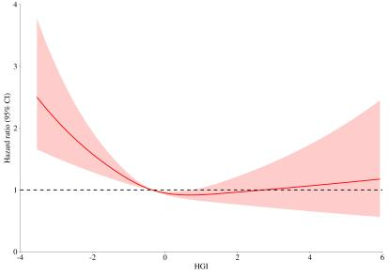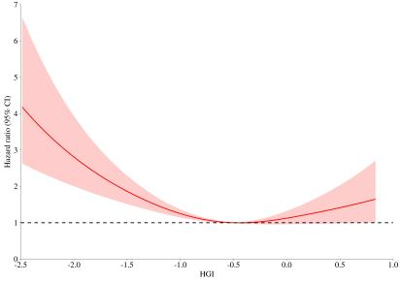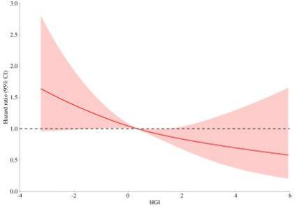
A B C

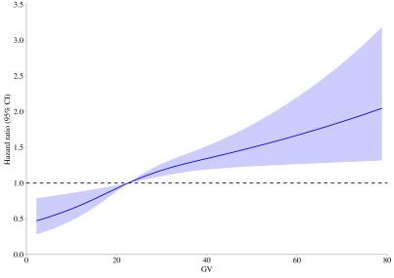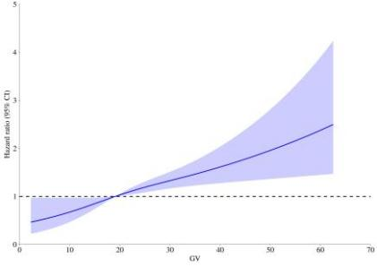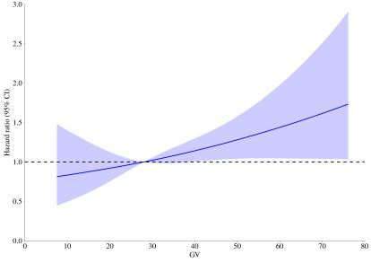
D E F

Supplement Fig. 4 Dose-response relationship between HGI and GV and 365-day mortality in the (A and D) overall population, (B and E) individuals without diabetes, and (C and F) individuals with diabetes according to multivariable-adjusted restricted cubic spline analysis. Adjusted for Model 3 in the Cox regression analysis.

B
A
Supplement Fig. 5 Forest plots for subgroup analyses of (A) HGI and (B) GV with 365-day mortality.

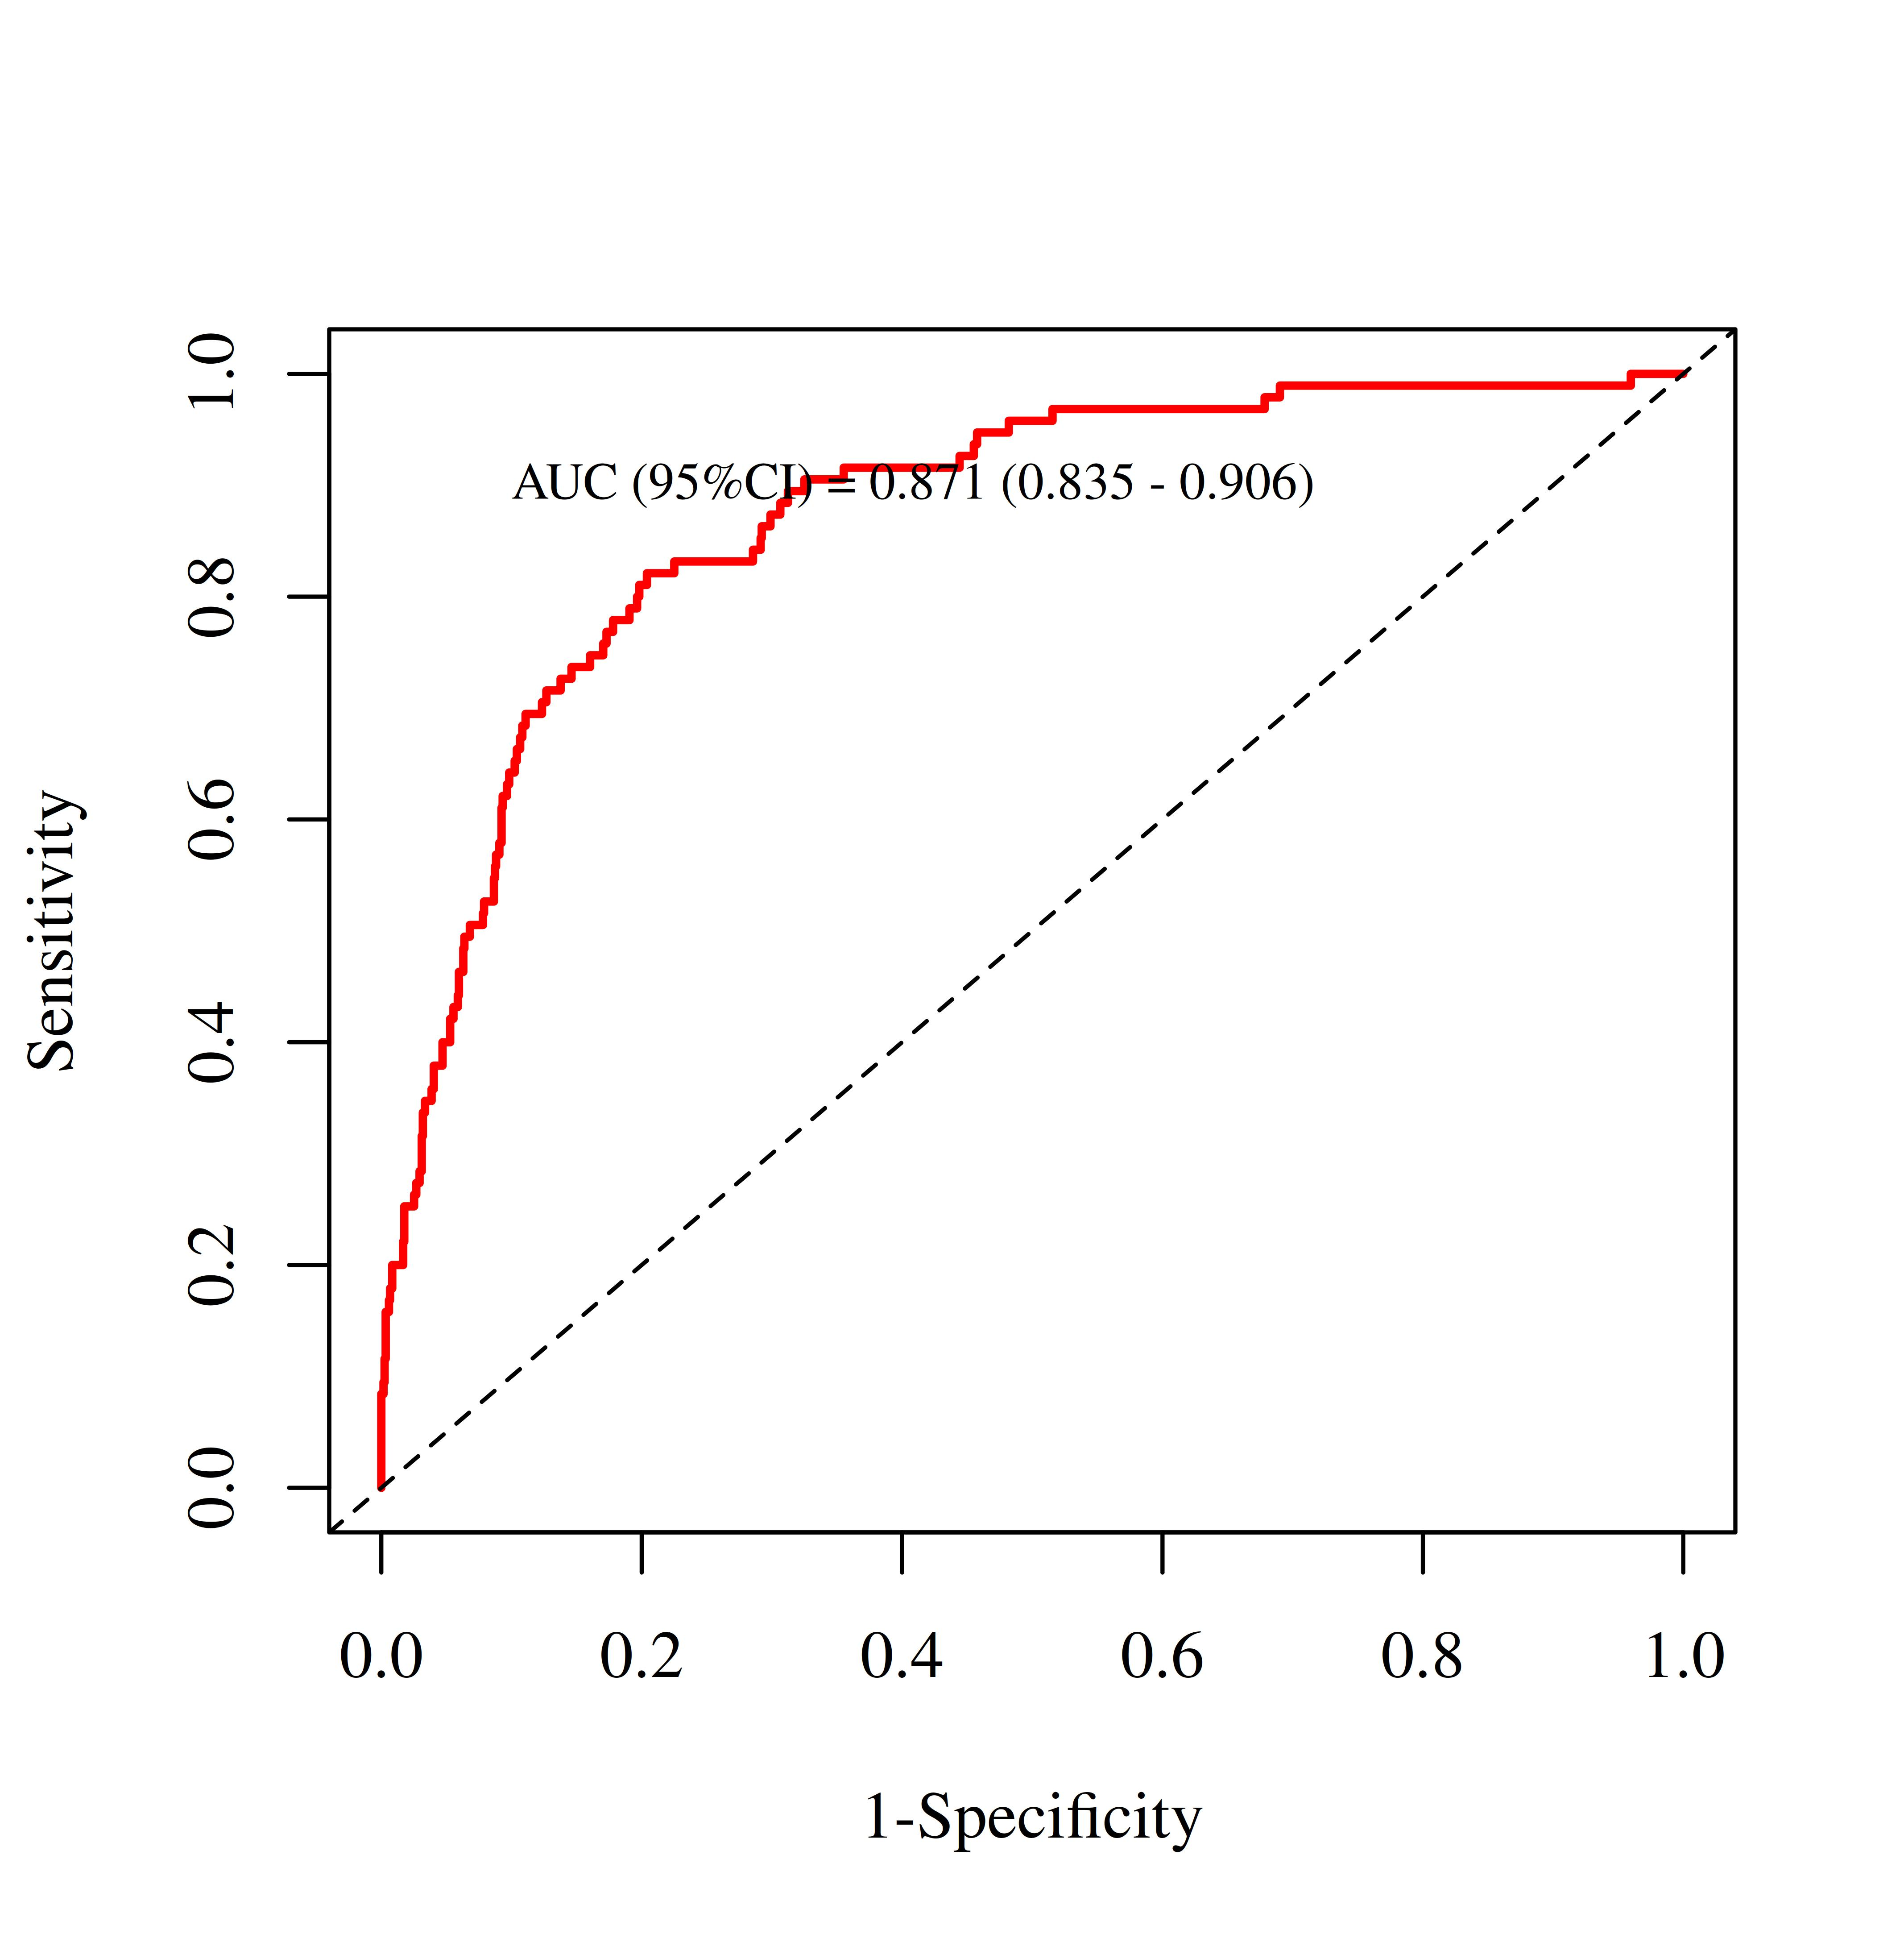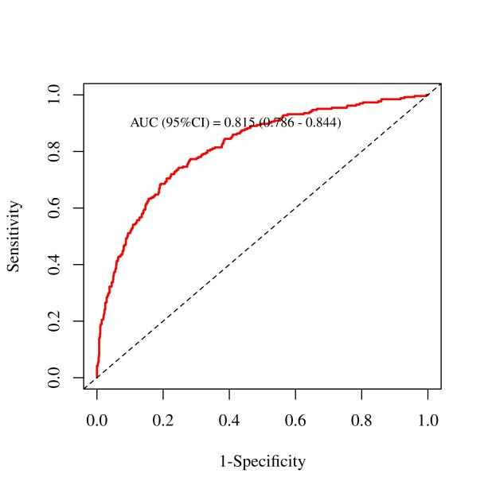
B
A
Supplement Fig. 6 ROC curve for bootstrap validation. (A) 28-day mortality; (B) 365-day mortality.

