The efficacy of bone marrow-derived mesenchymal stem cells in restoring limbal stem cell deficiency in rat model
Mohamed A. El-Desouky ¹, Nadia S. Mahmoud ^{2,3}, Fayek M. Ghaleb ⁴, Fatma B. Rashidi ¹, Iman M.A.Zaki ⁵, Marwa A. Fouly ⁶, Ahmed M. Ata ^{7*}, Hanaa H. Ahmed ^{2,3}
¹ Biochemistry Division, Chemistry Department, Faculty of Science, Cairo University, Giza, Egypt
² Hormones Department, Medical Research and Clinical Studies Institute, National Research Centre, Dokki, Giza, Egypt
³ Stem Cells Lab, Center of Excellence for Advanced Sciences, National Research Centre, Dokki, Giza, Egypt
⁴ Clinical Pathology Department, Research Institute of Ophthalmology, Giza, Egypt.
⁵ Pathology Department, Research Institute of Ophthalmology, Giza, Egypt.
⁶ Ophthalmology Department, Research Institute of Ophthalmology, Giza, Egypt.
⁷ Biochemistry Department, Research Institute of Ophthalmology, Giza, Egypt.
*Corresponding Author: Ahmed M. Ata
Email: ahmed.mostafa@rio.sci.eg, ORCID: 0000-0003-1969-9707

Emails and ORCID of authors:
Prof. Dr. Mohamed A El-Desouky, E-mail: meldesouky@sci.cu.edu.eg, ORCID: 0000-0001-5007-5455
Dr. Nadia Samy Mahmoud, E-mail: nadiasamy@sci.asu.edu.eg , ORCID: 0000-0002-9085-4063.
Prof. Dr. Fayek M. Ghaleb, E-mail: fayek.ghaleb@gmail.com
Ass. Prof. Fatma B. Rashidi, Email: fabdallah@sci.cu.edu.eg, ORCID: 0000-0003-1646-0856
Prof. Dr. Iman M.A.Zaki, Email: imanmz45@gmail.com
Ass. Prof. Marwa A. Fouly, Email: marwa.rio2014@gmail.com
Prof. Dr. Hanaa Hamdy Ahmed, E-mail: hh.ahmed@nrc.sci.eg, ORCID: 0000-0001-8642-9251
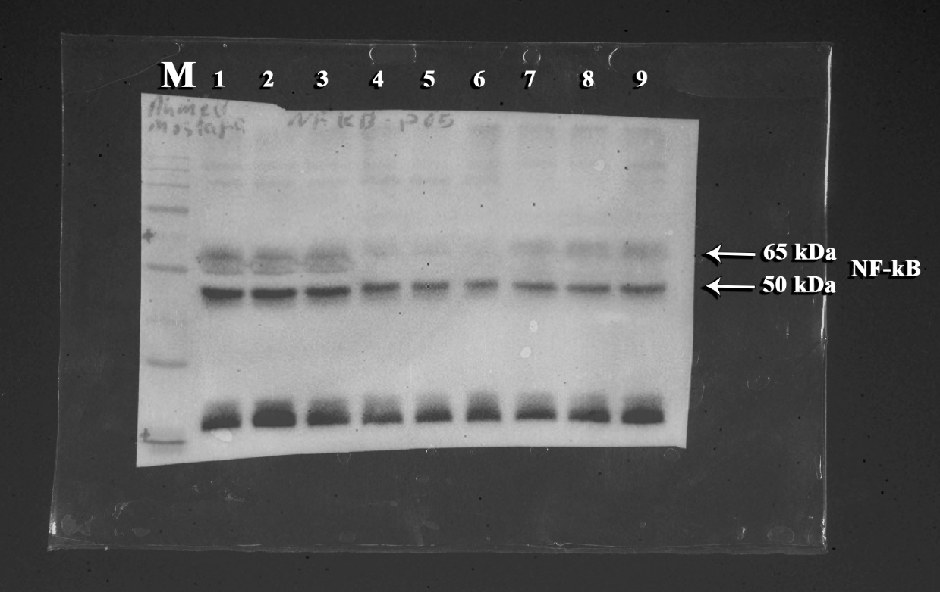
Figure S1: Original uncropped blot of protein expression patterns of NF-kB in the different studied groups. M: Molecular weight marker, bands (1-3): control group, bands (4-6): stem cells group, bands (7-9): alkali burn group

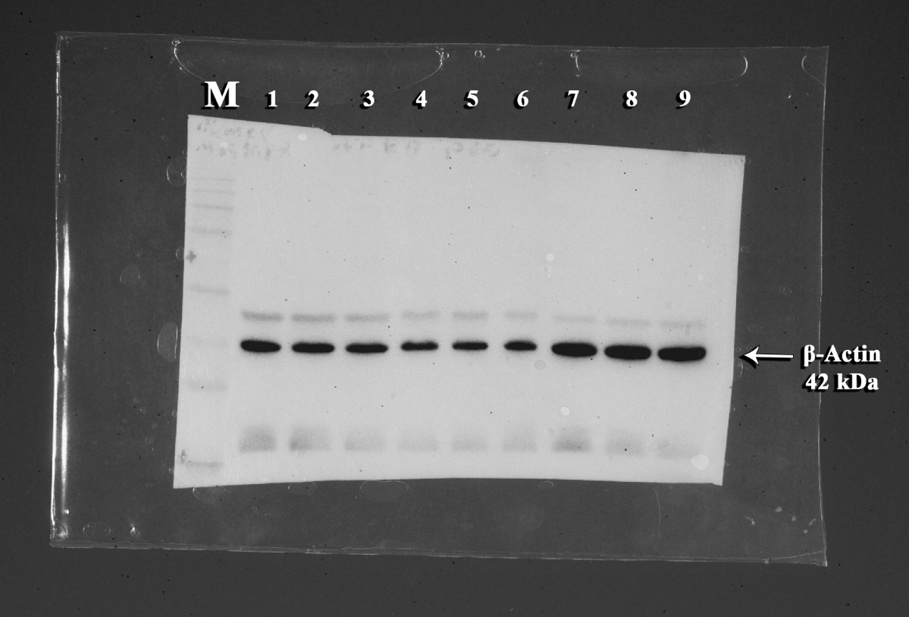
Figure S2: Original uncropped blot of protein expression patterns of β-actin in the different studied groups. M: Molecular weight marker, bands (1-3): control group, bands (4-6): stem cells group, bands (7-9): alkali burn group

