Supplementary information.
One Section, Two Worlds: Single-Cell Integration of MALDI-MSI and Spatial Transcriptomics on the Same Single Tissue Section
Tim F.E. Hendriks¹, Gert B. Eijkel¹, Theodoros Visvikis¹, Benjamin Balluff¹, Ron M.A. Heeren¹, Eva Cuypers^{1*}
¹The Maastricht MultiModal Molecular Imaging (M4I) Institute, Division of Imaging Mass Spectrometry (IMS), Maastricht University, 6229 ER Maastricht, The Netherlands
*Corresponding author: e.cuypers@maastrichtuniversity.nl
BioRxiv DOI: https://doi.org/10.1101/2025.07.16.665110

Table of Contents:
Supplementary table 1: List of gene markers per cell type used for cell identification and identified cells. 3
Supplementary text 1: Lipidomics LC-MS/MS and lipid identification 4
Supplementary figure 1: Per-gene RNA abundance comparison between MALDI-MSI measured and control regions (mouse brain). 5
Supplementary figure 2: ESCDAT Software GUI and explanation. 6
Supplementary figure 3: Distribution of gene counts and gene features per cell type. 7
Supplementary figure 4: Score distribution per cell type. 8
Supplementary figure 5: Score distribution of individual marker‐gene specificity across predicted cell types. 9
Supplementary figure 6: Heatmap of top RNA markers across predicted cell types in human GBM. 10
Supplementary figure 7: Heatmap of top m/z markers across predicted cell types in human GBM. 11
Supplementary figure 8: Intra-lineage metabolic variation within astrocytes in human GBM. 12
Supplementary figure 9: RNA vs MALDI-MSI embeddings and astrocyte-focused spatial structure. 13
Supplementary Figure 10. Global gene – MALDI-MSI correlation heatmap of human GBM tissue. 14
Supplementary figure 11: Spatial illustration of a gene-ion pair in GBM. 15
d

Supplementary table 1: List of gene markers per cell type used for cell identification and identified cells.
Cell type | Gene markers | Identified cells
Astrocytes | AQP4, GJA1, FGFR3 | 2009
Endothelial cells | PECAM1, FLT1, NRP1 | 530
Excitatory neurons | CRYM, SLC17A7, SLC17A6 | 253
GSCs | PAX6, SOX2 | 594
Inhibitory neurons | GAD1, SST, WIF1 | 189
MES | TGBF1, MGST1, NCSTN | 365
Oligodendrocytes | CAPN3, MOBP, MOG, OPALIN | 2174
OPC | PDGFRA, SOX10, OLIG2 | 653
T-cells | CD4 | 686
TAMs | CD163, CD68, P2RY12, CX3CR1, TREM2 | 865

Supplementary text 1: Lipidomics LC-MS/MS and lipid identification
Lipids and proteins were extracted as follows. To 5 mg of GBM dissected material, 400 µL MTBE was added, the sample was vortexed for 1 minute and then incubated in a thermoshaker at 20 °C and 950 rpm for 1 hour. Next, 100 µL water was added, the tube was vortexed for 1 min, and centrifuged at 1,000 g for 10 min (Eppendorf 5353). The upper organic (lipid) layer was transferred to a new 2 mL tube. Lipids remaining in the lower aqueous phase were re-extracted by adding 300 µL MTBE, 40 µL MeOH, and 30 µL water, vortexing for 1 min, and centrifuging again for 10 min at 1,000 g. The upper organic layers from both extractions were combined per sample, dried completely in a vacuum centrifuge (Heto Lab), reconstituted in 50 µL 1:1 ACN:IPA, and analyzed by LC-MS/MS (Vanquish UHPLC, Hypersil GOLD 100 × 2.1 mm, Orbitrap Exploris 480; Thermo Fisher) using a generic lipidomics protocol ¹.
Lipid identification was performed on an Orbitrap Exploris 480 mass spectrometer (Thermo Fisher Scientific, USA) in data-dependent acquisition (DDA) positive mode. MS¹ data (m/z 200-1450) were acquired at 60.000 resolution with a 65 ms injection time. In parallel, MS² spectra were acquired in the ion trap using collision-induced dissociation (CID) with a 1.7 Da isolation window at 30,000 resolution. LC-MS/MS lipid species were assigned from DDA MS¹ and MS² spectra in Lipostar2 v2.1.2. MALDI-MSI lipid identifications were assigned by linking MALDI-MSI MS¹ precursor ions to the corresponding LC-MS/MS MS¹ + MS² m/z values, and finalized in LipostarMSI v2.0.1 using the LIPID MAPS database (3- and 4-star ratings; Molecular Horizon, Bettona, PG, Italy) ².

Supplementary figure 1: Per-gene RNA abundance comparison between MALDI-MSI measured and control regions (mouse brain).
Bars show the average transcripts per area, normalized by the number of segmented cells (control: 7763 cells, MALDI-MSI: 7963 cells) in the ROI. Dotted bars: MALDI-MSI; striped bars: control. Genes are listed along the x-axis; two matched ROI are shown. This analysis assesses per-gene expression between conditions.
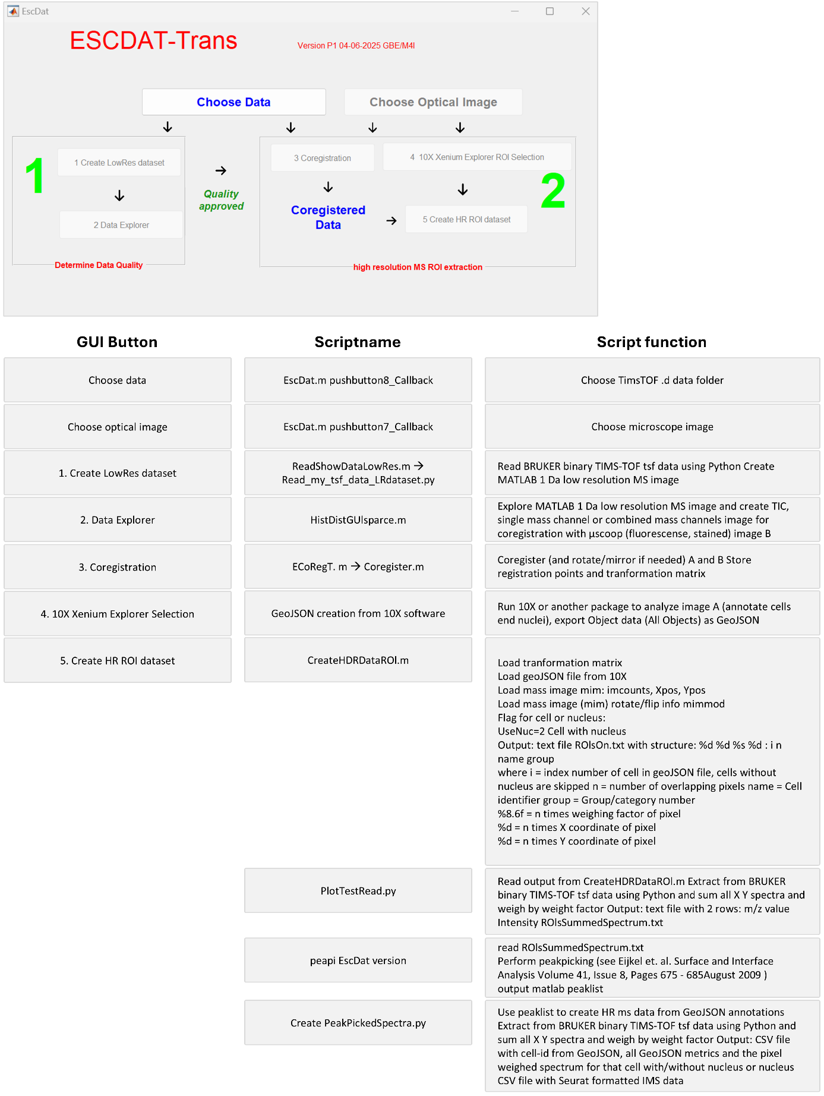

Supplementary figure 2: ESCDAT Software GUI and explanation.

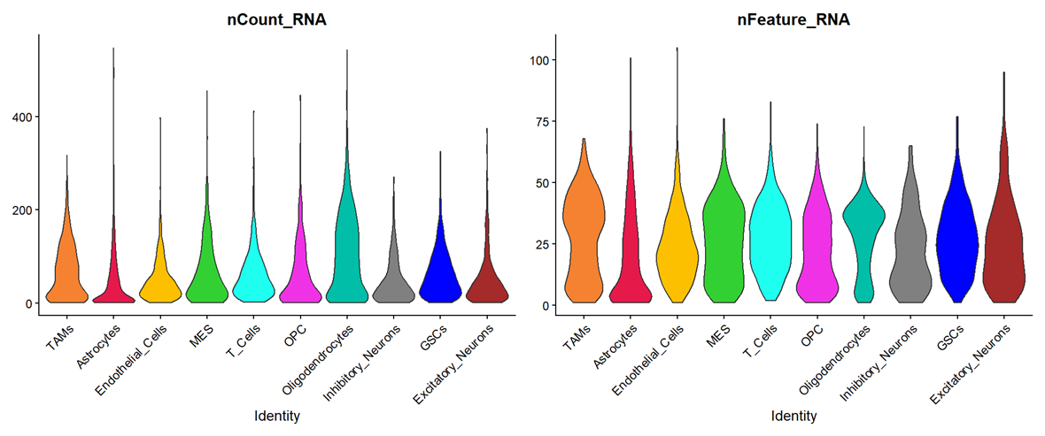
Supplementary figure 3: Distribution of gene counts and gene features per cell type. Human glioblastoma tissue. Violin plots of total UMI counts per cell (nCount_RNA) and number of detected genes per cell (nFeature_RNA) are shown for each predicted cell‐type cluster; TAMs, astrocytes, endothelial cells, MES, t-cells, OPC, oligodendrocytes, inhibitory neurons, GSCs, excitatory neurons. Comparable distributions across all groups demonstrate uniform sequencing depth and gene‐detection efficiency, with no cluster‐specific biases affecting downstream analyses.

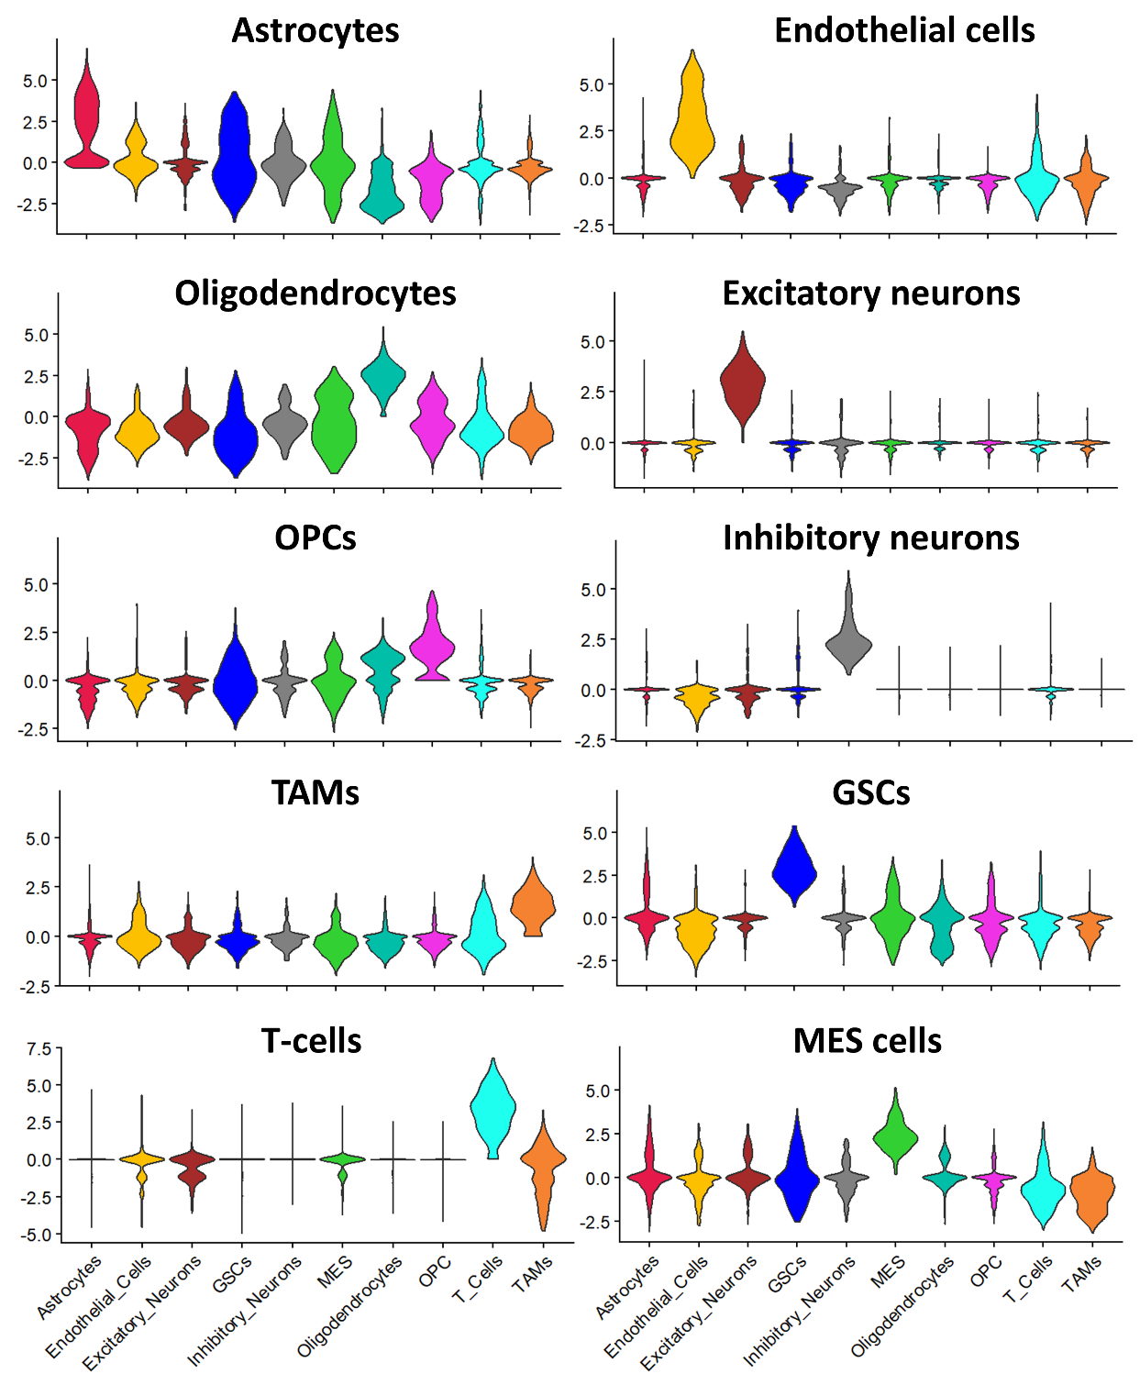
Supplementary figure 4: Score distribution per cell type. For each of the ten selected cell-type signatures in human glioblastoma tissue we calculated an AddModuleScore per cell and then assigned each cell to the signature with its highest score. In every violin plot, the y-axis shows the range of module scores for that signature, and the x-axis groups cells by their assigned cell type. The signature score is sharply enriched in its matching cell-type cohort while remaining near zero in all other groups. However, low background signatures can be seen in cell types, possibly reflecting baseline expression.

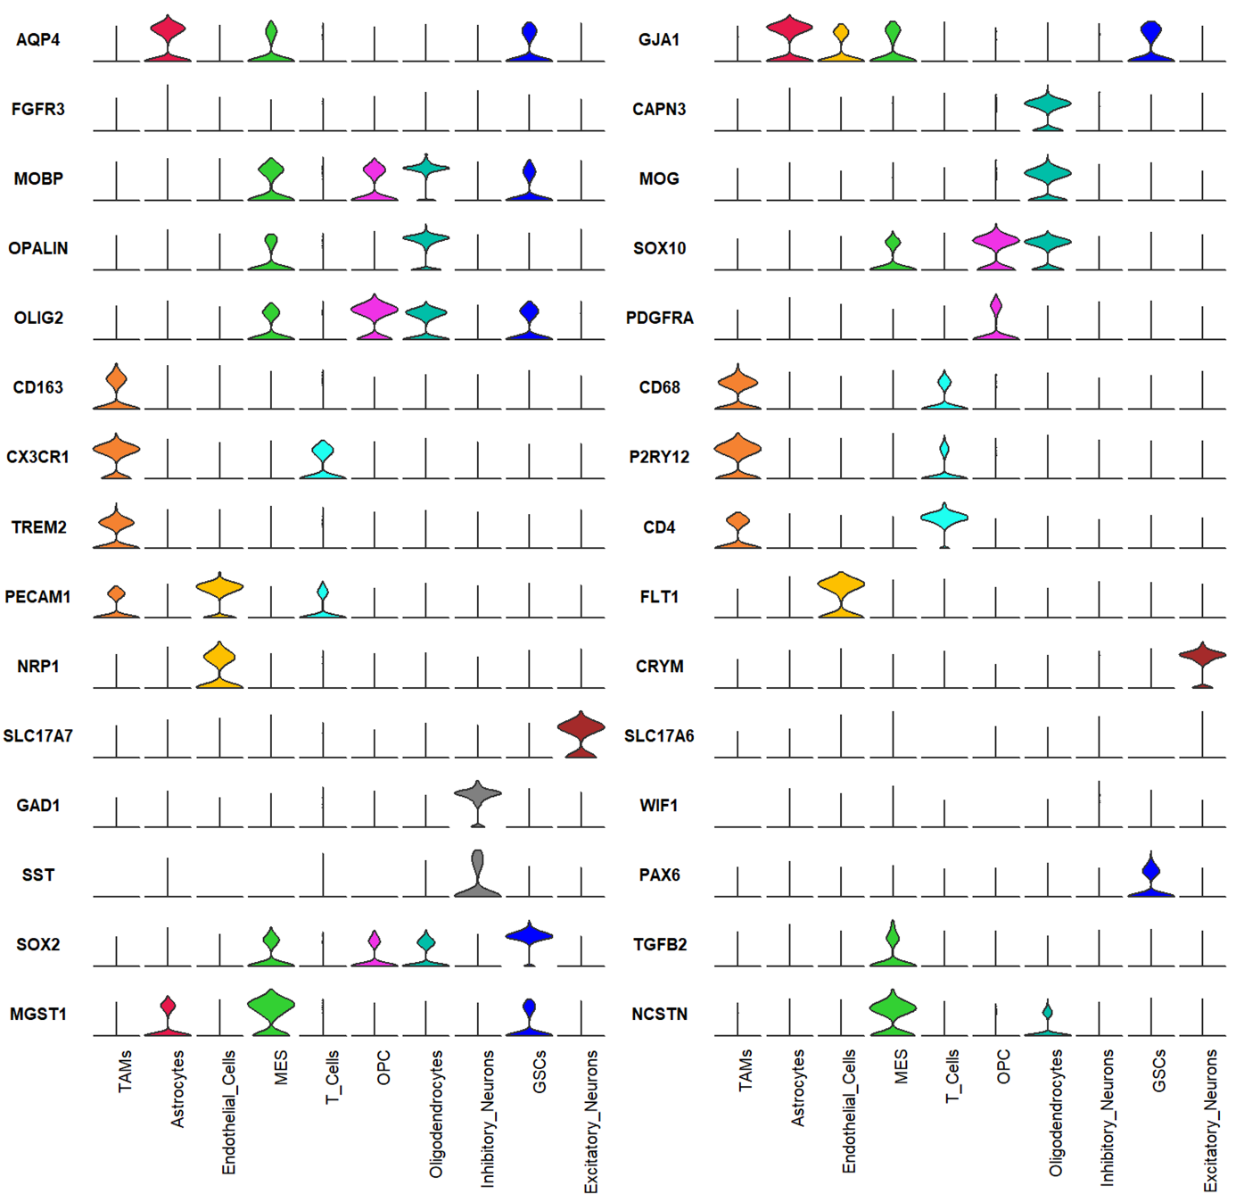
Supplementary figure 5: Score distribution of individual marker‐gene specificity across predicted cell types. For each marker gene, normalized Xenium RNA expression is shown as a violin density plot across all cells, grouped by their predicted cell type.

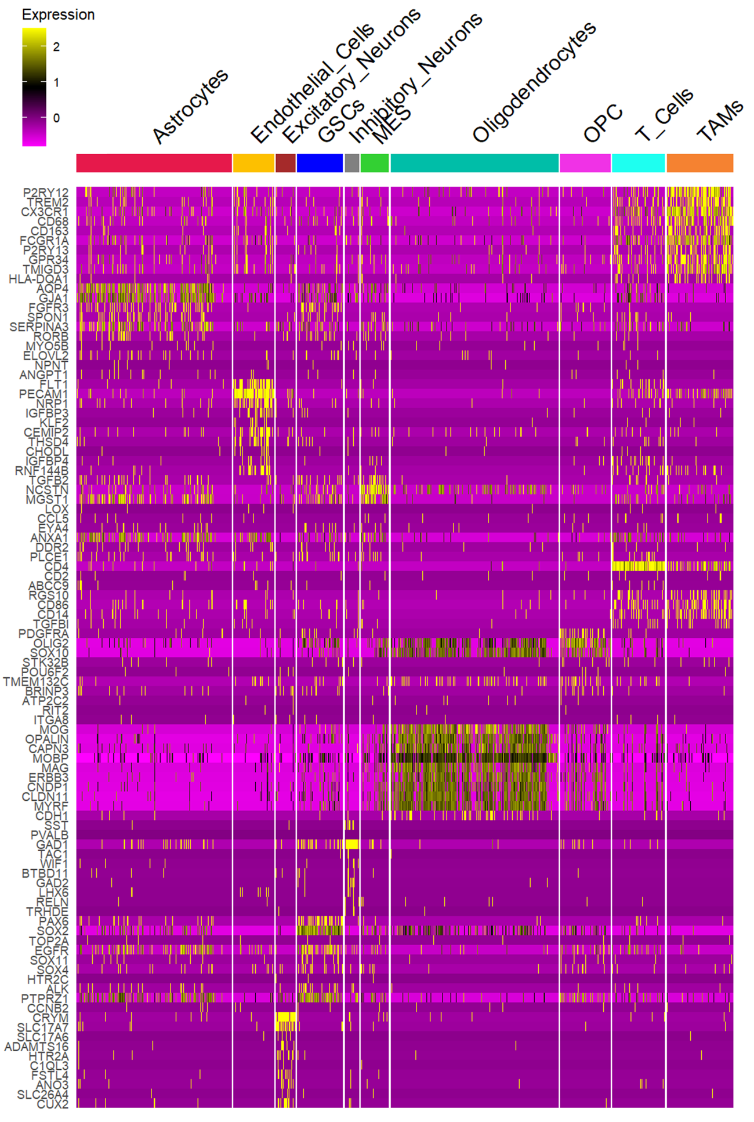
Supplementary figure 6: Heatmap of top RNA markers across predicted cell types in human GBM. Normalized RNA expression of the top ten positive marker genes for each predicted cell‐type cluster identified via Seurat displayed in a heatmap.
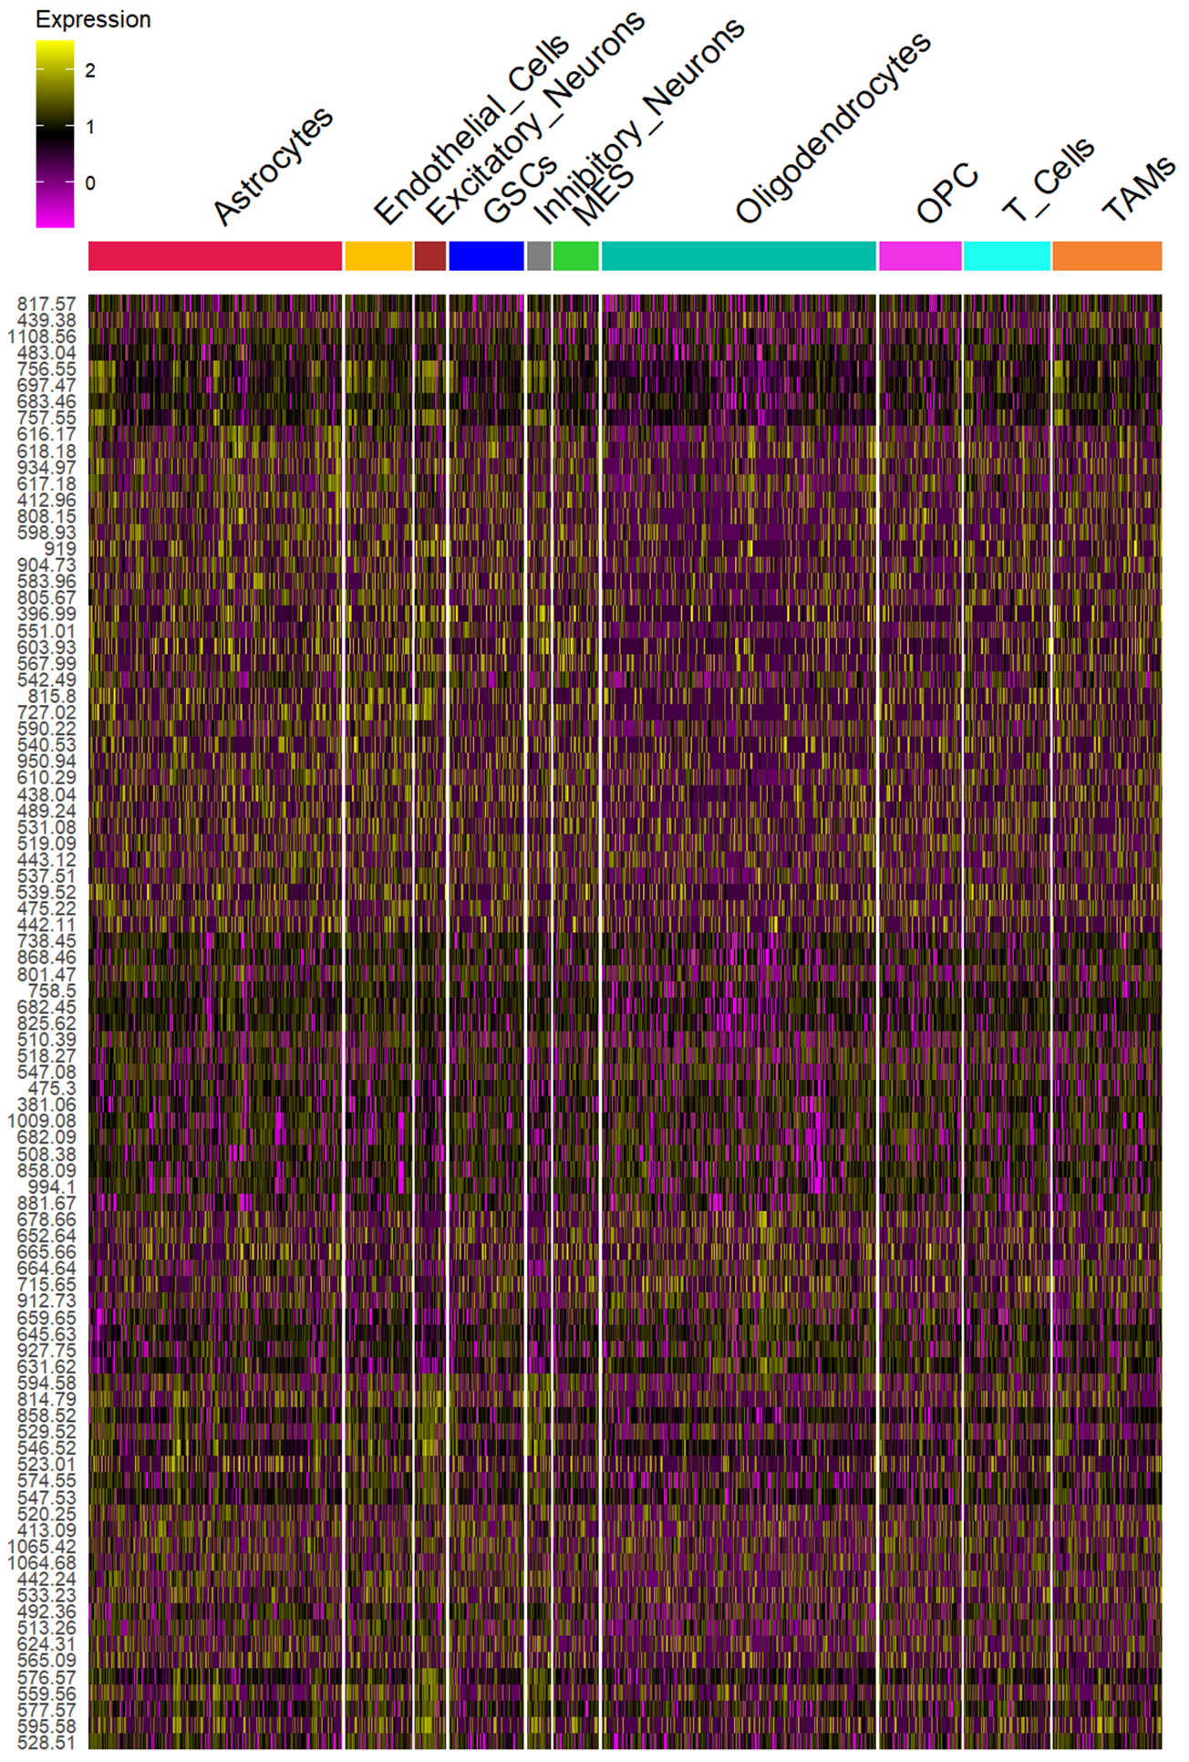
Supplementary figure 7: Heatmap of top m/z markers across predicted cell types in human GBM. Normalized m/z expression of the top ten positive marker m/z values for each predicted cell‐type cluster identified via Seurat displayed in a heatmap.
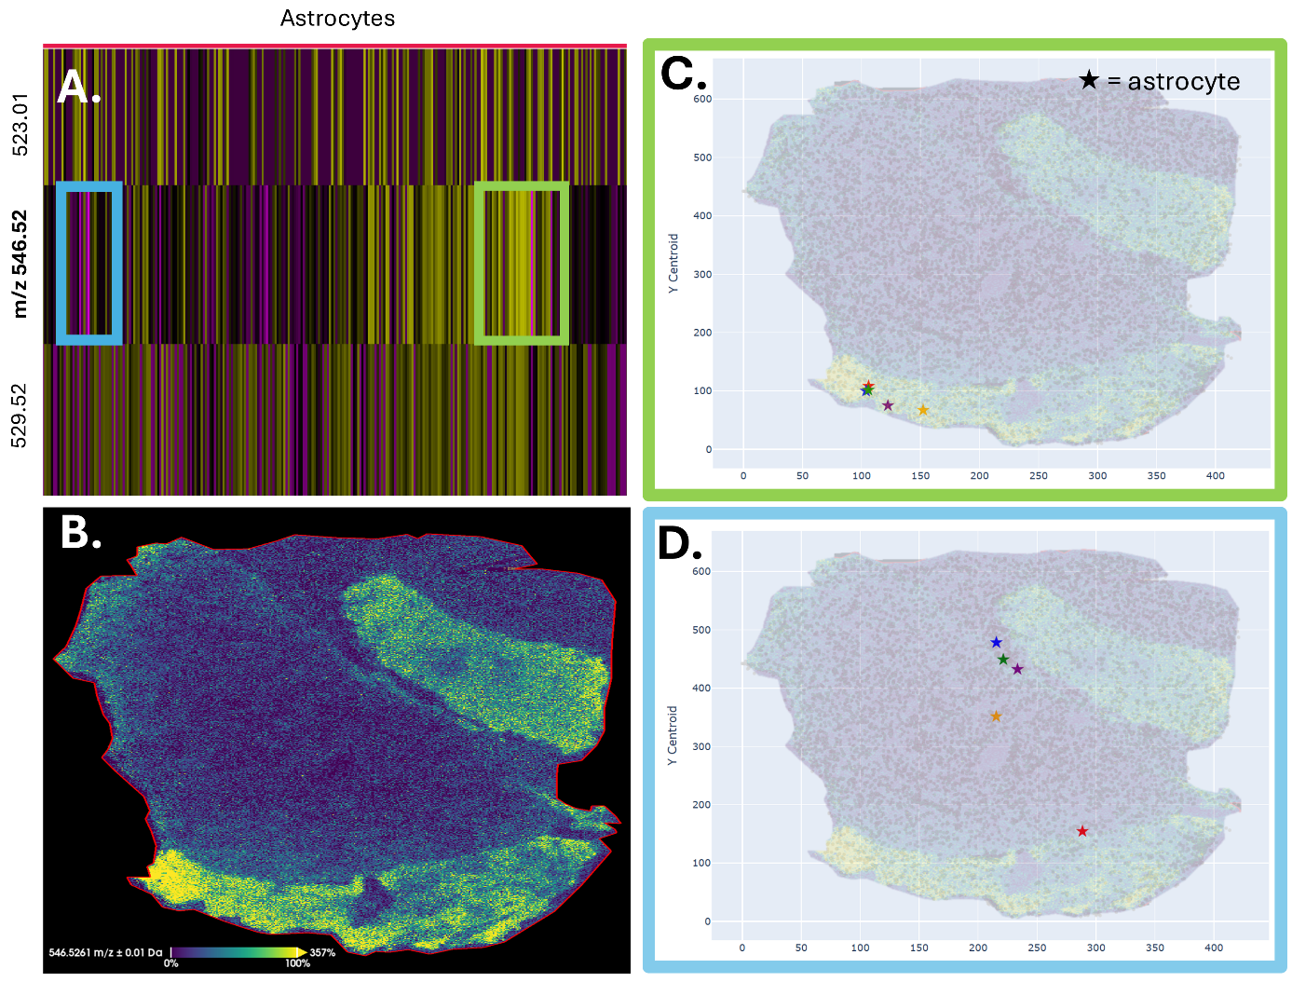
Supplementary figure 8: Intra-lineage metabolic variation within astrocytes in human GBM. (A) Heatmap selection (astrocytes only) from the TIC-normalized MALDI assay; rows are ions, columns are cells ordered by RNA identity. Boxes mark astrocyte cells in the upper (green) and lower (blue) quartiles of m/z 546.52 intensity. (B) MALDI-MSI ion image (m/z 546.52); same field of view as C–D. (C–D) Tissue-coordinate maps showing sampled astrocyte cells (★) from panel A. (C), high-intensity (upper quartile); (D), low-intensity (lower quartile). Background in C–D is the m/z 546.52 ion image.

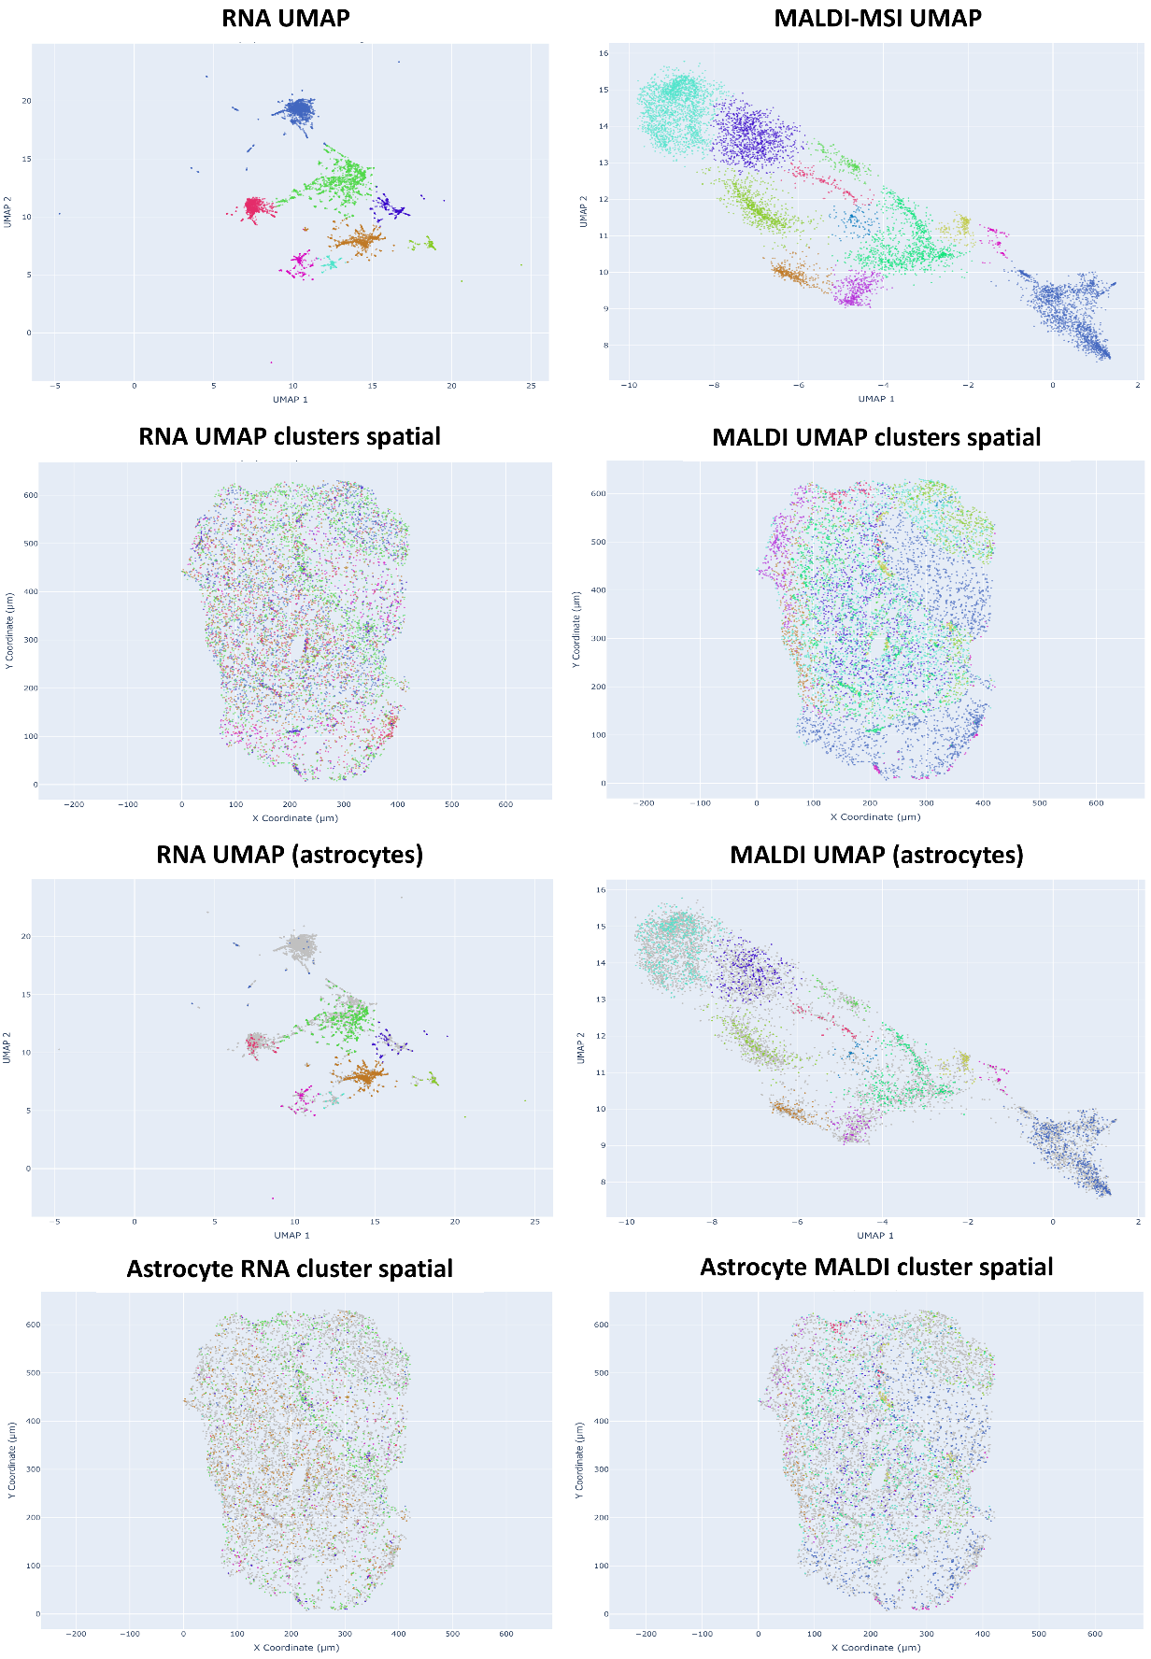
Supplementary figure 9: RNA vs MALDI-MSI embeddings and astrocyte-focused spatial structure. Top row: RNA UMAP (left) and MALDI-only UMAP (right), points are colored by de novo clusters. Second row: spatial projections of the same clusters in tissue coordinates. RNA clusters are intermixed across the section, whereas MALDI clusters segregate into distinct regions. Third row: astrocyte-focused view. astrocytes colored, all other cell types in gray. In the MALDI UMAP, astrocytes occupy both metabolomic clusters. Bottom row: astrocytes in space. RNA-defined astrocyte clusters are spread throughout the section. The astrocytes in MALDI-defined UMAP shows intra-lineage metabolic heterogeneity, which is defined by tissue context.
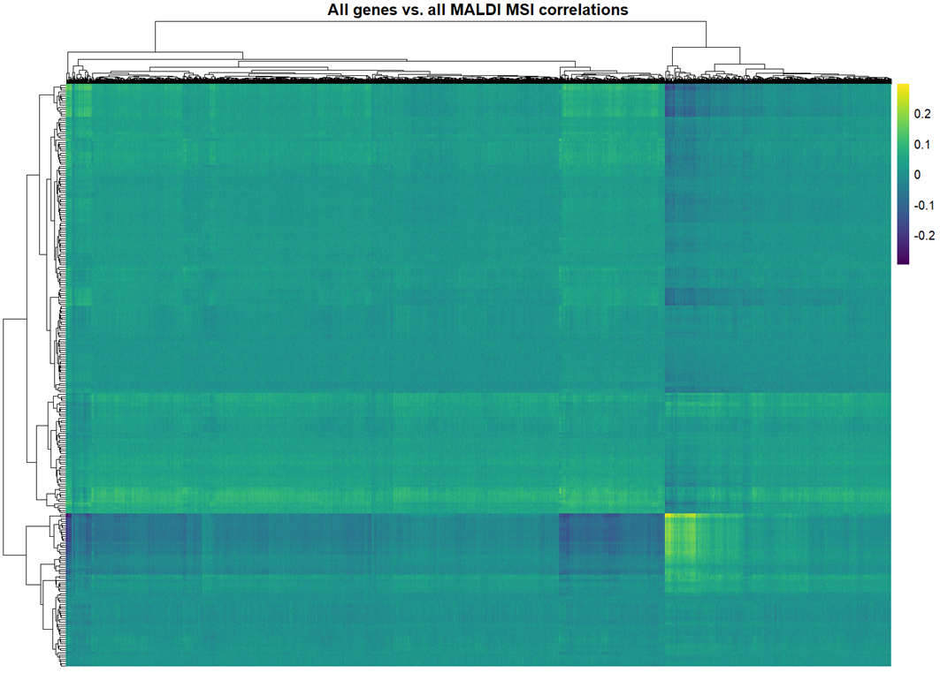
Supplementary Figure 10. Global gene – MALDI-MSI correlation heatmap of human GBM tissue. Pearson correlation coefficients between normalized expression of all genes (horizontal) and intensities of all MALDI-MSI m/z features (vertical) across all single‐cell profiles. Both rows and columns are hierarchically clustered (dendrograms at top and left) to reveal co-varying modules. This map shows distinct gene-metabolite/lipid clusters.

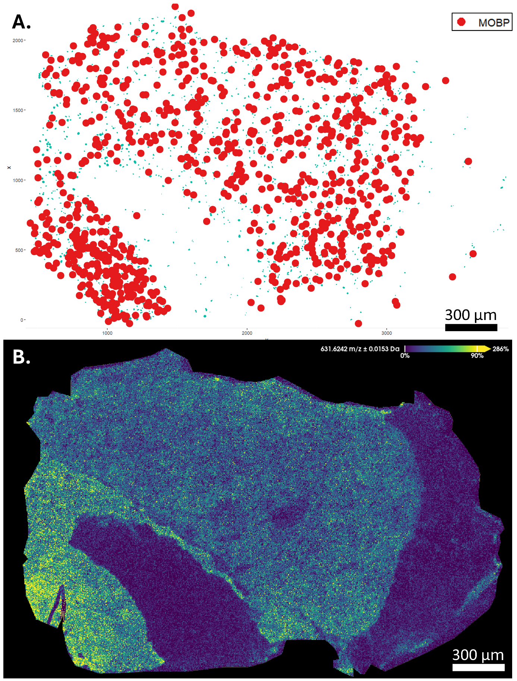
Supplementary figure 11: Spatial illustration of a gene-ion pair in GBM. (A) Cells plotted in tissue coordinates; red dots indicate MOBP rich regions, turquoise dots mark oligodendrocyte-labeled cells (RNA-based identities); other cells omitted for clarity. (B) MALDI-MSI ion image for m/z 631.62 (± 0.0153 Da) (CE (18:2)) acquired at 5 µm pixel pitch. Images are shown in the same field of view and coordinate system.

(1) Breitkopf, S. B.; Ricoult, S. J. H.; Yuan, M.; Xu, Y.; Peake, D. A.; Manning, B. D.; Asara, J. M. A relative quantitative positive/negative ion switching method for untargeted lipidomics via high resolution LC-MS/MS from any biological source. Metabolomics 2017, 13 (3). DOI: 10.1007/s11306-016-1157-8 From NLM PubMed-not-MEDLINE.
(2) Tortorella, S.; Tiberi, P.; Bowman, A. P.; Claes, B. S. R.; Scupakova, K.; Heeren, R. M. A.; Ellis, S. R.; Cruciani, G. LipostarMSI: Comprehensive, Vendor-Neutral Software for Visualization, Data Analysis, and Automated Molecular Identification in Mass Spectrometry Imaging. J Am Soc Mass Spectrom 2020, 31 (1), 155-163. DOI: 10.1021/jasms.9b00034 From NLM PubMed-not-MEDLINE.

