Table S2. Partial correlation between IKS and CT controlling for other AI literacy dimensions
Controlled variables | Partial correlation  (r) | Sig. (2-tailed) | N
Intelligent Responsibility, Intelligent Thinking, Human–Machine Collaboration | −0.078 | 0.003 | 1463

Figure S1. Partial regression plot between Intelligent Knowledge and Skills and Computational Thinking
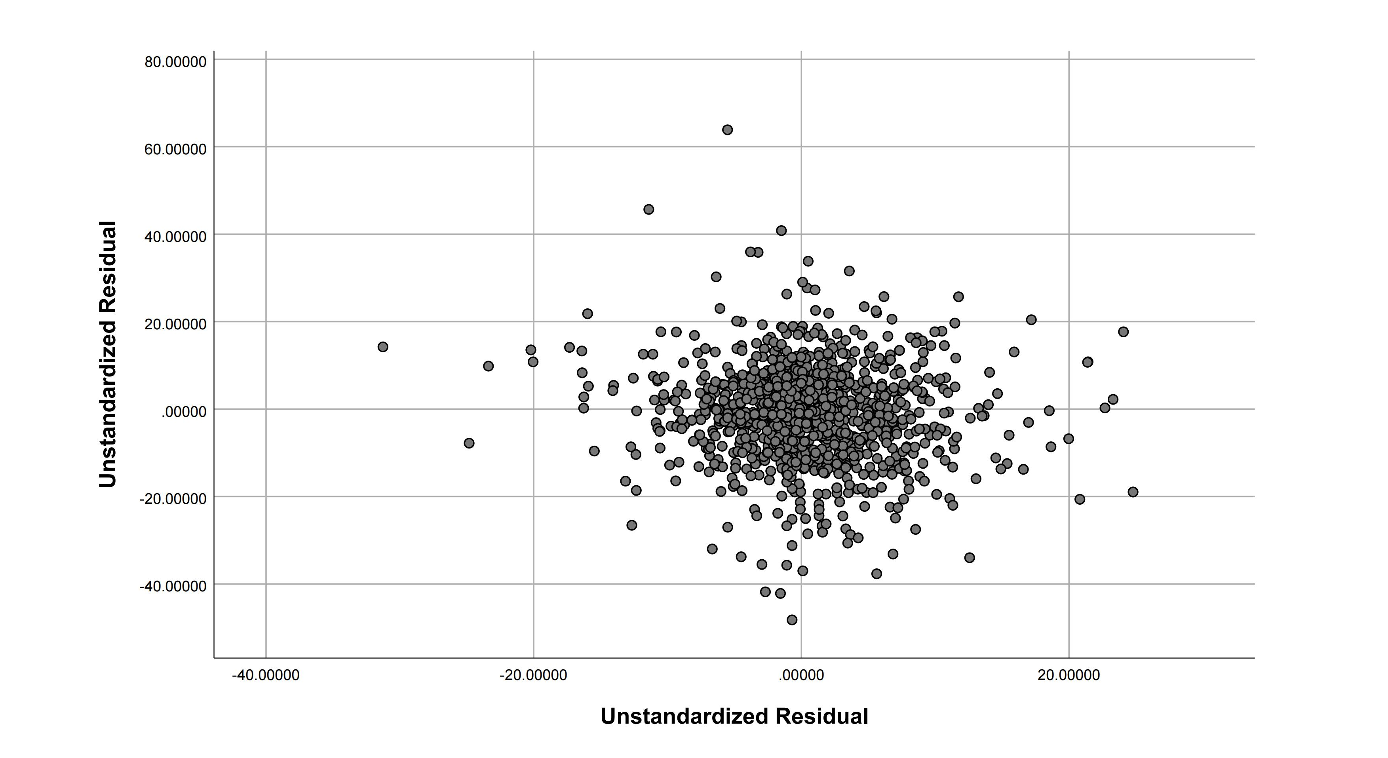
Note. This figure presents the residual relationship between Intelligent Knowledge and Skills (IKS) and Computational Thinking (CT) after controlling for Intelligent Responsibility, Intelligent Thinking, and Human–Machine Collaborative Hybrid Innovation. Each point represents the residuals of CT regressed on the control variables (y-axis) against the residuals of IKS regressed on the same controls (x-axis). The distribution shows a slight downward tendency, confirming a weak negative residual association (partial r = −0.078, p = .003). This pattern supports the interpretation that the negative standardized coefficient of IKS reflects a statistical suppression effect, not a true negative causal relationship.

