Supplementary Table 1. Detailed technical data for wastewater treatment plants (WWTPs) during investigation in the Warsaw capital districts (Mazovian Voivodship Poland)

WTPs | Technological data | Sample collection and sampling intervals
WTP1  the left inflow  to the Northern WWTP  and  WTP1a  the right inflow  to the Northern WWTP | The average standard throughput for the greatest WTP1 and WTP1a in combined oscillates around 435,000 m3/d. The area of the whole treatment plant is 53ha and is in the northern part of Warsaw (FIG S1). This is one of the largest and most modern sewage treatment plants in Poland, operating for the right-bank Vistula districts of Warsaw (left inflow approx. 180,000 m3/d) and the central and northern part of the left-bank Vistula districts of Warsaw (right inflow approx. 240,000 m3/d). Mechanical-biological treatment with increased removal of biogenic compounds from sewage contains 10 technological lines of biological wastewater treatment: a biological reactor with activated sludge of the BIODENIPHO type, ten secondary clarifiers, and biogas production. The fermented sludge is dewatered and directly disposed in the incineration plant. The sludge is disposed in fluidised bed furnaces. Treated wastes are discharged directly into the Vistula River [17]. | flow-proportional mode  (150ml/30 minutes)
WTP2  main inflow  to the Southern WWTP | Wastewater is in the southern part of the city. Since 2006, it has received approximately 60,000 m³/d of sewage from the southern part of the Vistula left bank of Warsaw. The treatment plant is a fully hermetic facility based on mechanical facilities and bioreactors with anaerobic-anoxic-aerobic zones for the biological removal of nitrogen and phosphorus using activated sludge microorganisms. | 320ml of raw sewages taken every hour up to 24 h/day from three collection points then mixed and one 750ml/24h on local catchment station. All samples were mixed as representative and proportional 500 ml.
WTP3  the main inflow  to the Western WWTP | Wastewater is in the western part of the city. The plant receives approximately 40,000 m³ (max 97,000) of daily sewage. The technological line includes bioreactors with anaerobic-anoxic-aerobic zones for the biological removal of nitrogen and phosphorus using activated sludge microorganisms supported by secondary clarifiers. This sewage treatment plant serves approximately 174,000 residents. | flow-proportional mode  (150ml/30 minutes)
WTP4  the main to the  to the control WWTP | The fourth wastewater is based on activated sludge technology, adapted to mechanical-biological-chemical treatment, with a 4,500-10,000 m³/day capacity. During a present study, approximately 5,000 m³ of sewage flowed into the treatment plant daily. WTP4 station was used in this study as an "external background | time-proportional mode 100ml/30min
OF1 | Outflow of treated wastewater from WTP1 directly to the Vistula River | time-proportional mode 150 ml/500m³.
OF2 | Outflow of treated wastewater from WTP2 directly to the Vistula River | flow- proportional mode (120ml/1000m³).
OF3 | Outflow of treated wastewater from WTP3 directly to the Utrata River | flow- proportional mode (100ml/100m³).
OF4 | Outflow of treated wastewater from WTP4 directly to the Narew River (background) | flow- proportional mode (100ml/100m³).

Supplementary Table 2. Basic technological parameters assessed for raw and treated sewage during picks of COVID-wave 2023 and 2024 for the biggest Northern wastewater treatment plant in the capital city of Warsaw.

Parameter  (amount per day) | COVID-19 Wave in 2023@ |  |  | COVID-19 Wave in 2024#
Parameter  (amount per day) | Raw left inflow | Raw right inflow | Treated outflow | Raw left inflow | Raw right inflow | Treated outflow
Average daily sewage flow [m3/d] | 302559 | 160090 | 472402 | 253210 | 145071 | 420017
BOD5 [mgO₂/l] | 290.0 | 380 | 9.8 | 237.1 | 270 | 8.3
COD [mgO₂/l] | 657.9 | 672.9 | 44.1 | 582.6 | 613.0 | 42.8
Suspended solids [mg/l] | 344.3 | 334.3 | 16.0 | 351.4 | 334.3 | 13.5
Mineral suspended matter [mg/l] | 53.7 | 53.7 | 3.2 | 48.2 | 27.4 | 12.0
Total nitrogen (TN) [mg-N/l] | 51.9 | 50.8 | 5.8 | 52.1 | 56.0 | 4.3
Ammonical nitrogen [mg-NH₄⁺/l] | 35.3 | 33.4 | 1.5 | 37.9 | 39.6 | 1.9
Total phosphorus (TP) [mg-P/l] | 7.1 | 5.9 | 0.7 | 5.9 | 6.4 | 0.5

@ for period 23.10.2023 – 11.12.2023
# - for period 12.08.2024 – 23.09.2024

Supplementary Table 3. Supportive technological parameters assessed for treated sewage during picks of COVID-wave 2023 and 2024 for the biggest Northern wastewater treatment plant in the capital city of Warsaw.

Parameter [mg/l] per day | Polish standard | Wave 2023@ | Wave 2024#
Boron (B) | ≤ 1,0 | 0,111 | 0,152
Chlorides (CL⁻) | ≤ 1000 | 228 | 211,5
Sulfates (SO₄²⁻) | ≤ 500 | 86,5 | 110
Nitrate nitrogen (N-NO₃⁻) | ≤ 10 | 1,1 | 1,0
Nitrite nitrogen (N-NO₂⁻) | ≤ 10 | 1,2 | 0,4
Iron (Fe) | ≤ 0,3 | 0,299 | 0,269
Zinc (Zn) | ≤ 2,5 | 0,05 | 0,0375
Chromium (Cr⁺⁶) | ≤ 0,1 | 0,05 | 0,05
Total chromium (TCr) | ≤ 1,0 | 0,05 | 0,055
Copper (Cu) | ≤ 1,0 | 0,051 | 0,0605
Nickel (Ni) | ≤ 0,5 | 0,05 | 0,05
Lead (Pb) | ≤ 0,5 | 0,1 | 0,075
Mrcury (Hg) | ≤ 0,06 | 0.001 | 0.001
Phenols (Ar-OH) | ≤ 15 | 0,0155 | 0,01
Surface-active anionic (anionics; R-X⁻-M⁺) | ≤ 15 | 0,21 | 0,26
Non-ionic surfactants (NIO) | ≤ 20 | 0,3 | 0,3
Fluorides (F⁻) | ≤ 20 | 0,115 | 0,11
Cadmium (Cd) | ≤ 0,4 | 0,01 | 0,015
Compounds extracted with light petroleum (LCO) | ≤ 100 | 18 | 10
Petroleum hydrocarbons (PHC) | ≤ 15 | 0,1 | 0,1
Free cyanide (CN-) | ≤ 0,5 | 0,005 | 0,005
Total cyanide (associated) | ≤ 5,0 | 0,026 | 0,014
Total organic carbon (TOC) | ≤ 200 | 10,2 | 12
Ethylene dichloride (EDC) | ≤ 0,2 | 0,0002 | 0,0002
Trichloromethane (TCM) | ≤ 1,5 | 0,00006 | 0,00006
Organochlorine pesticides (OCs) incl. aldrin | ≤0,01  or none | 0,000008 | 0,000008

@ for period: 23.10.2023 – 11.12.2023
# - for period: 12.08.2024 – 23.09.2024

Supplementary Figure 1. Sampling locations and their technical meaning in Warsaw capital districts, Mazovian Voivodship, Poland.

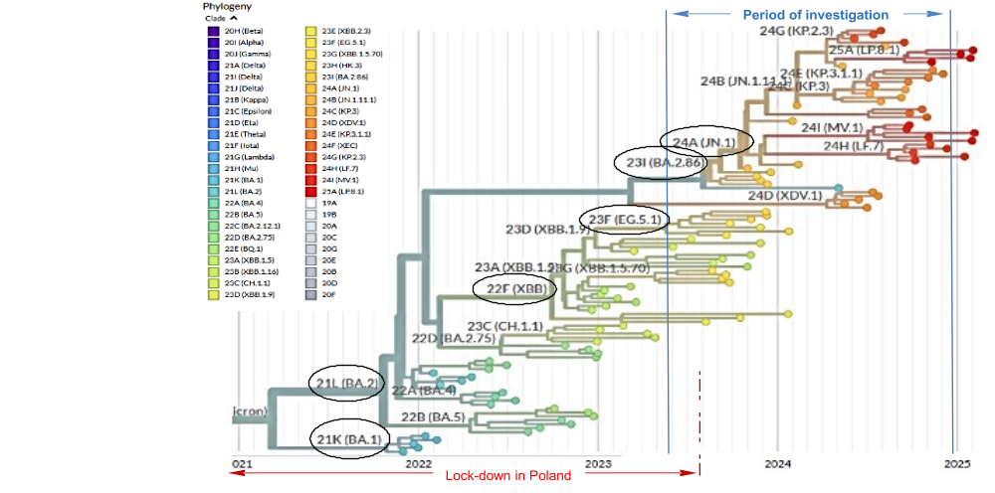
Supplementary Figure 2. Genomic epidemiology of SARS-CoV-2 in Europe based on phylogenetic tree interface (The Nextstrain tools⁶⁴) with lockdown information and research range for “2023 wave”, including variants of interest (with own modifications).

Supplementary Figure 3. Proportion of variants in Poland between the 16th week of 2023 and the 51st week of 2024 during two epidemic waves of COVID-19 (a), and distribution with median for selected coronavirus over the world (b), according to ECDC⁶⁶, with own modifications.
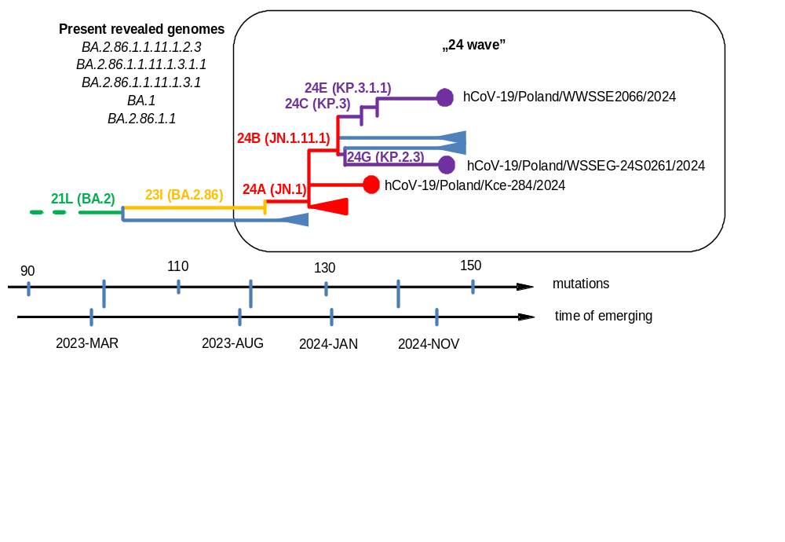
Supplementary Figure 4. Clades represented variants isolated in sewers of Warsaw Capital City during the second wave of COVID-19 in 2024 (“2024 Wave”), based on phylogenetic tree interface – The Nextstrain⁶⁴ on the background of variants abundance in Poland.

