Figures S45 to S61 show the initial and final atomic structures of 17 protein-ligand complexes:
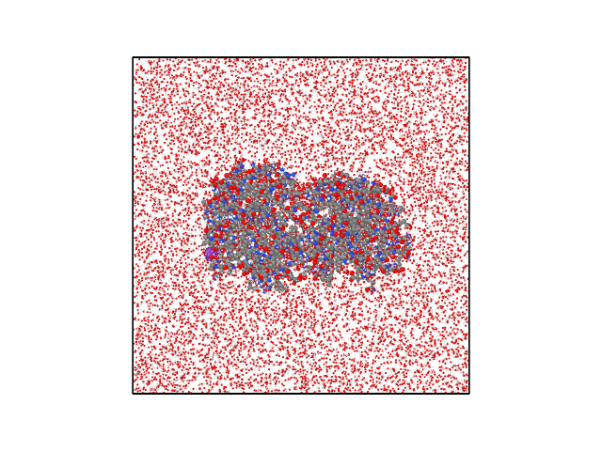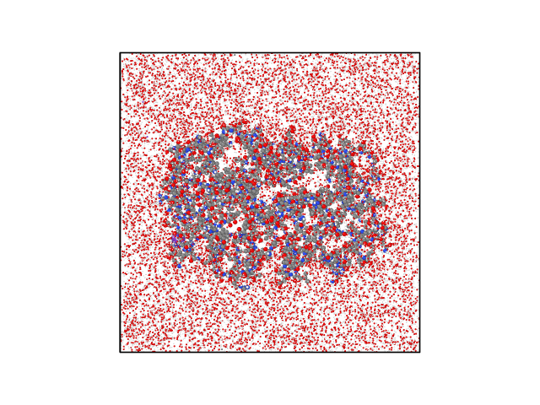
(a)

(b)
Figure S45: Complex 01 – Initial and final atomic structure of the Moracin P–GPD2 complex. (a) Initial atomic structure and (b) final atomic structure after 500 ns MD simulation.
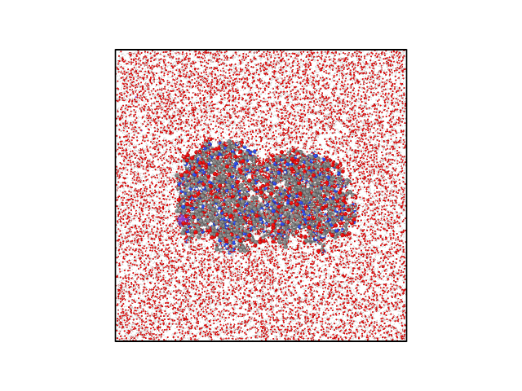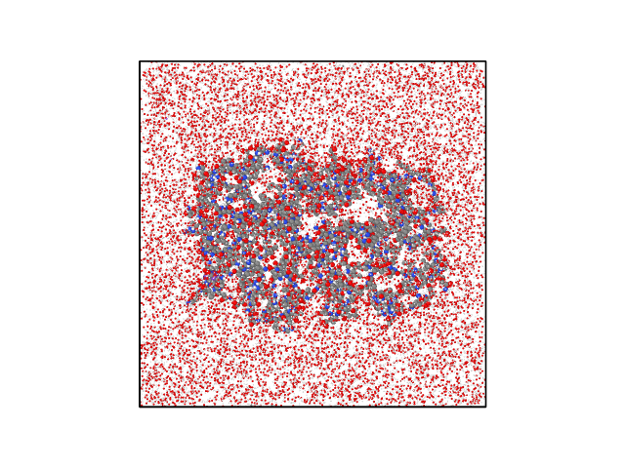
(a)

(b)

Figure S46: Complex 02 – Initial and final atomic structure of the Moracin D–GPD2 complex. (a) Initial atomic structure and (b) final atomic structure after 500 ns MD simulation.
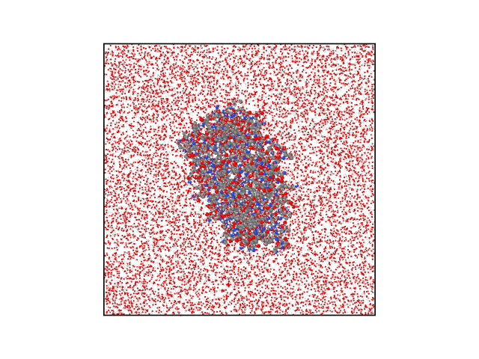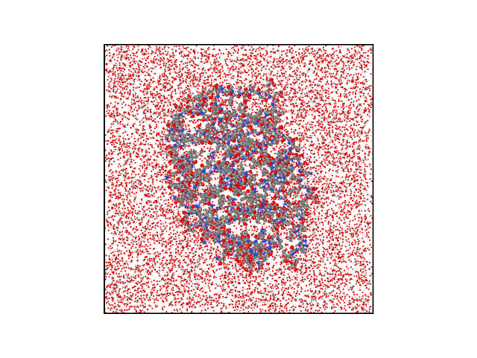
(a)

(b)
Figure S47: Complex 03 – Initial and final atomic structure of the Plantagineoside A–PPARG complex. (a) Initial atomic structure and (b) final atomic structure after 500 ns MD simulation.
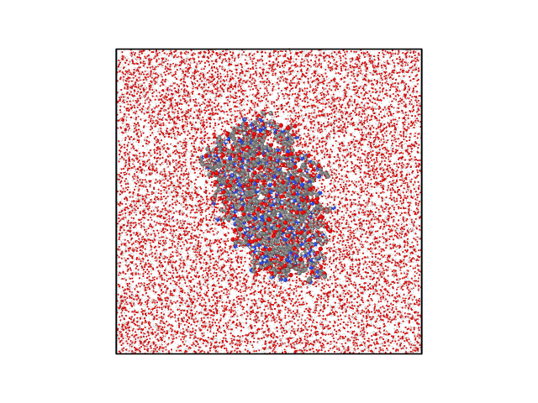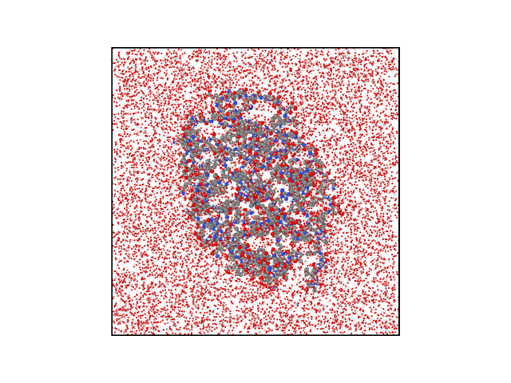
(a)

(b)

Figure S48: Complex 04 – Initial and final atomic structure of the Pyrene–PPARG complex. (a) Initial atomic structure and (b) final atomic structure after 500 ns MD simulation.
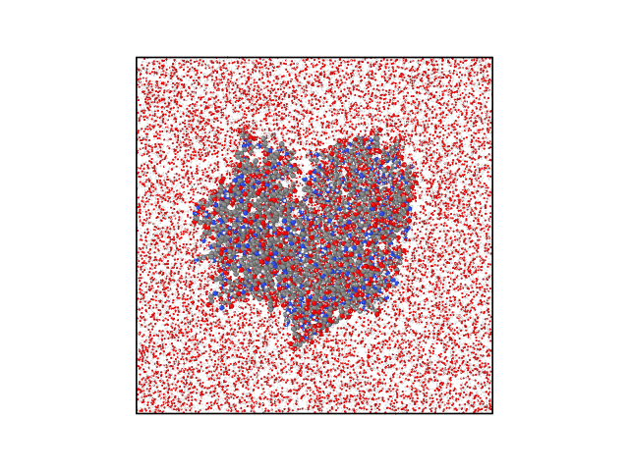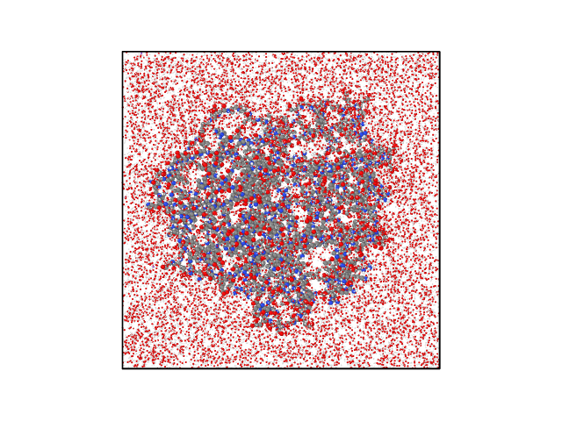
(a)

(b)

Figure S49: Complex 06 – Initial and final atomic structure of the Rohitukine–GCK complex. (a) Initial atomic structure and (b) final atomic structure after 500 ns MD simulation.
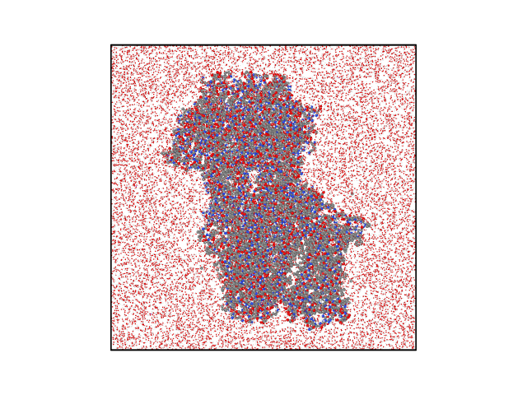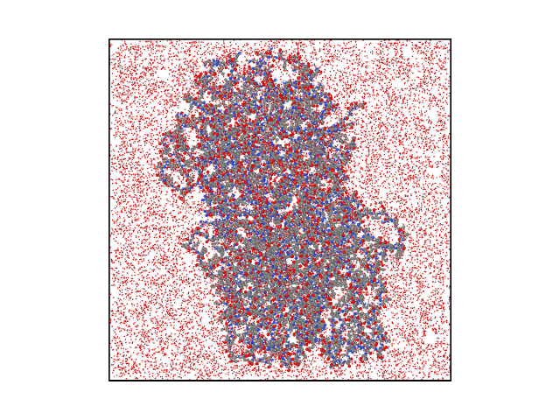
(a)

(b)

Figure S50: Complex 07 – Initial and final atomic structure of the Berberrubine–ABCC8 complex. (a) Initial atomic structure and (b) final atomic structure after 500 ns MD simulation.
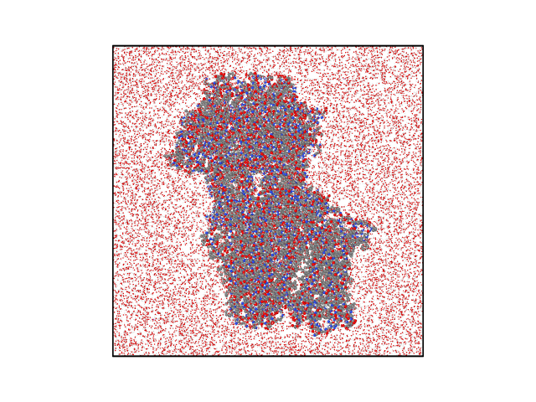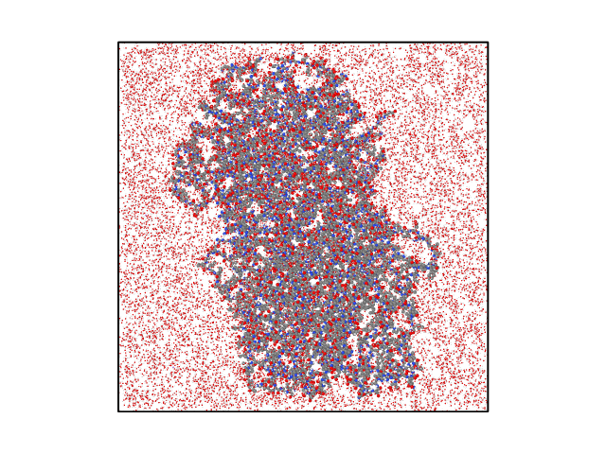
(a)

(b)

Figure S51: Complex 08 – Initial and final atomic structure of the Berberine Chloride–ABCC8 complex. (a) Initial atomic structure and (b) final atomic structure after 500 ns MD simulation.
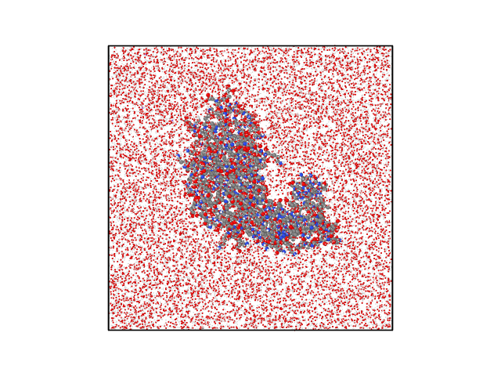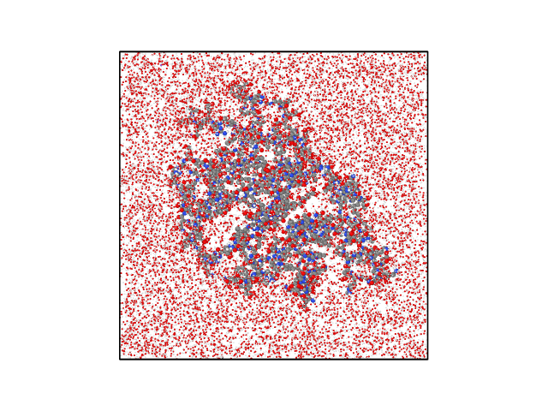
(a)

(b)

Figure S52: Complex 09 – Initial and final atomic structure of the Apigenin–MAPK8 complex. (a) Initial atomic structure and (b) final atomic structure after 500 ns MD simulation.
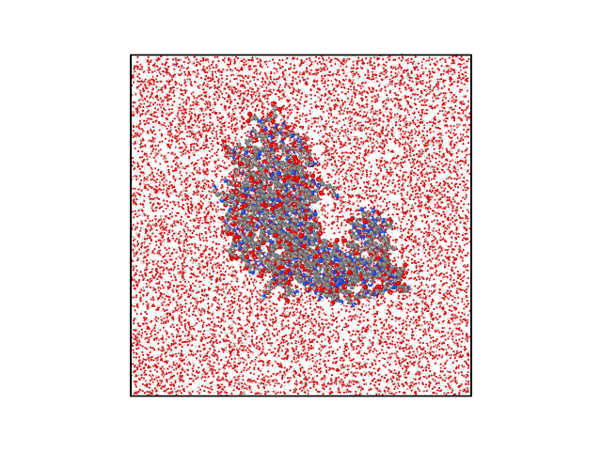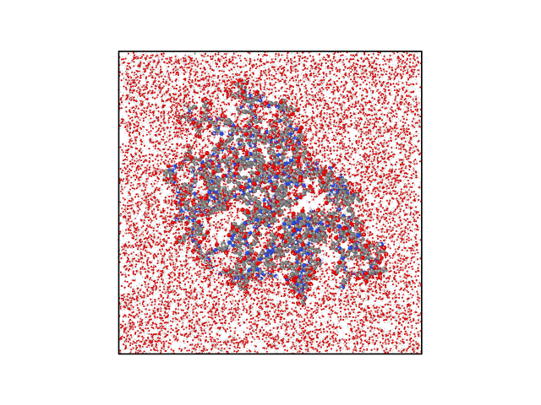
(a)

(b)

Figure S53: Complex 10 – Initial and final atomic structure of the Emodin–MAPK8 complex. (a) Initial atomic structure and (b) final atomic structure after 500 ns MD simulation.
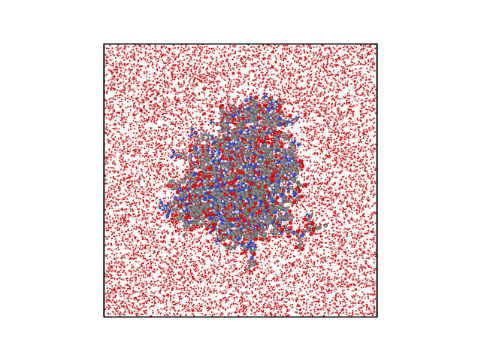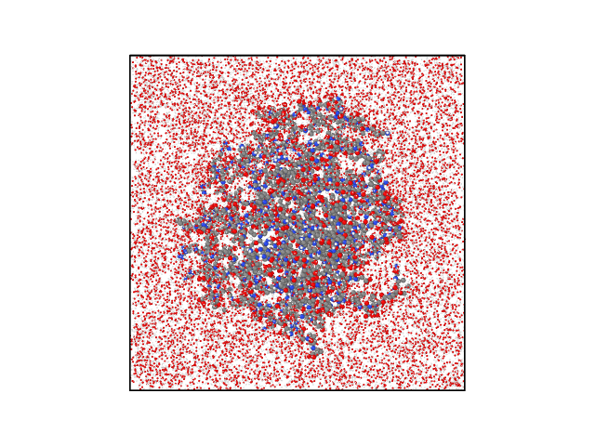
(a)

(b)

Figure S54: Complex 11 – Initial and final atomic structure of the Chelerythrine–AKT2 complex. (a) Initial atomic structure and (b) final atomic structure after 500 ns MD simulation.
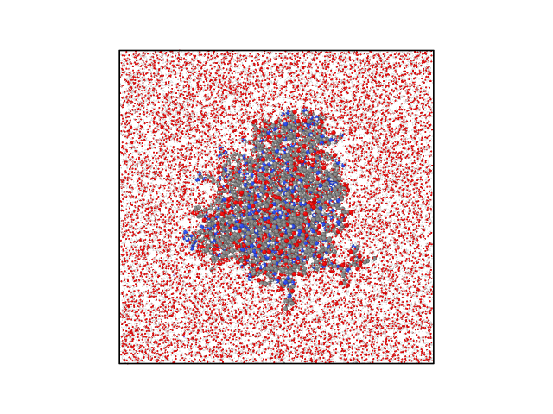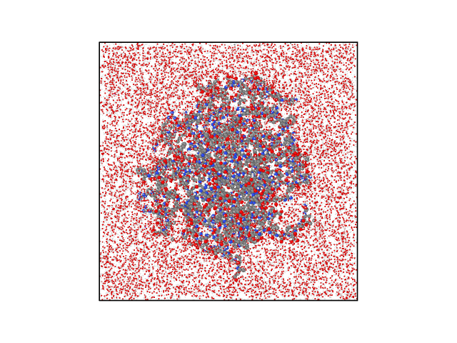
(a)

(b)

Figure S55: Complex 12 – Initial and final atomic structure of the Alvocidib–AKT2 complex. (a) Initial atomic structure and (b) final atomic structure after 500 ns MD simulation.
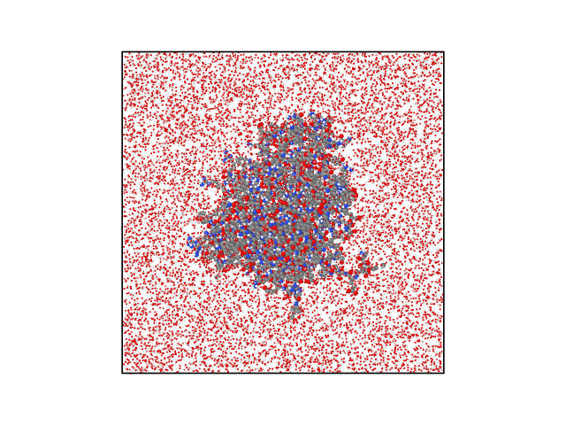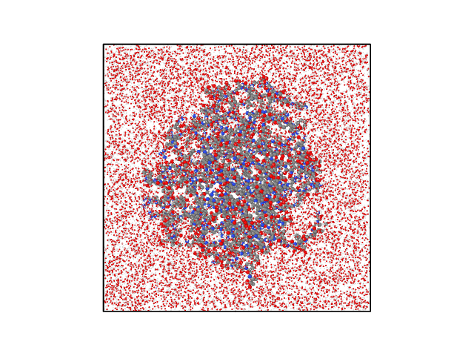
(a)

(b)

Figure S56: Complex 13 – Initial and final atomic structure of the A-443654–AKT2 complex. (a) Initial atomic structure and (b) final atomic structure after 500 ns MD simulation.
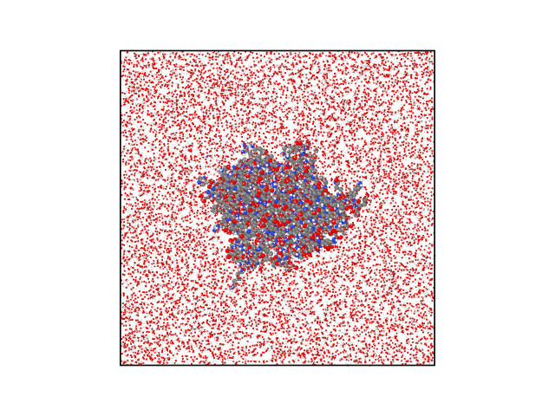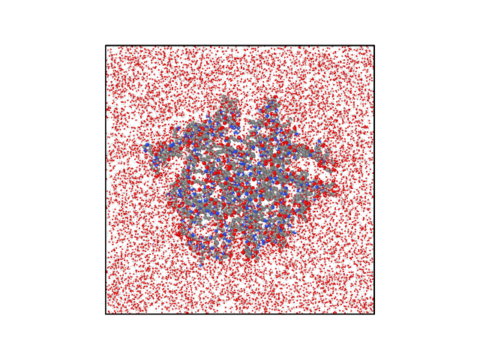
(a)

(b)

Figure S57: Complex 14 – Initial and final atomic structure of the Xambioona–PTPN1 complex. (a) Initial atomic structure and (b) final atomic structure after 500 ns MD simulation.
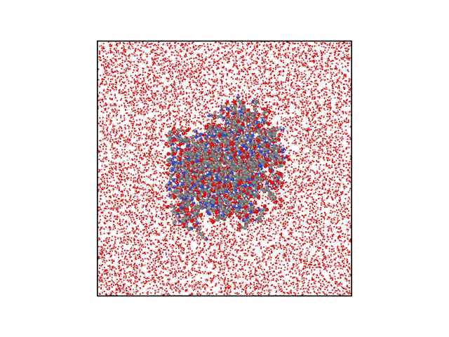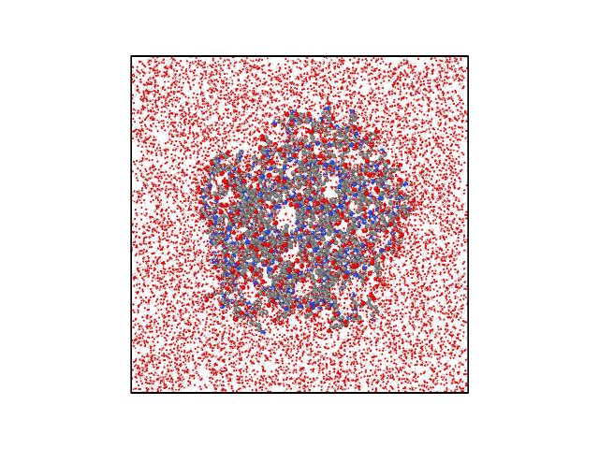
(a)

(b)

Figure S58: Complex 15 – Initial and final atomic structure of the Altertoxin I–INSR complex. (a) Initial atomic structure and (b) final atomic structure after 500 ns MD simulation.
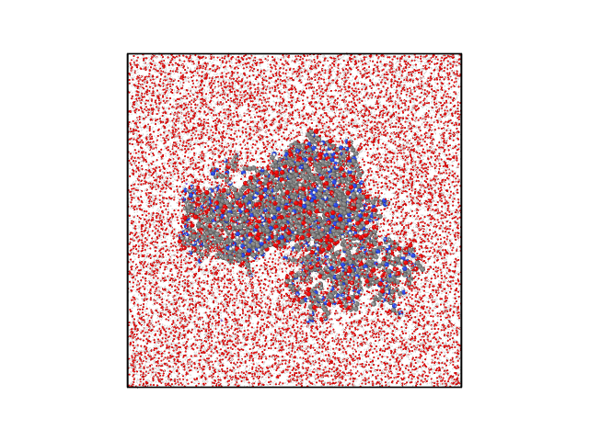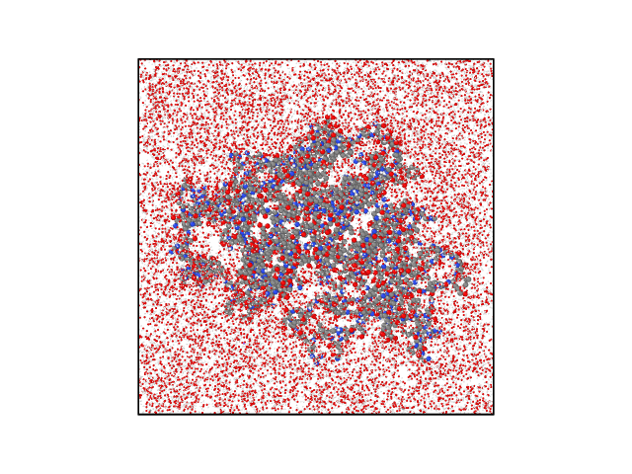
(a)

(b)

Figure S59: Complex 16 – Initial and final atomic structure of the Chelerythrine–AMPK complex. (a) Initial atomic structure and (b) final atomic structure after 500 ns MD simulation.
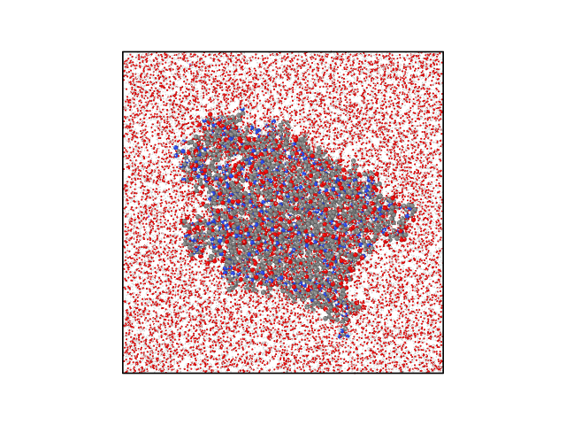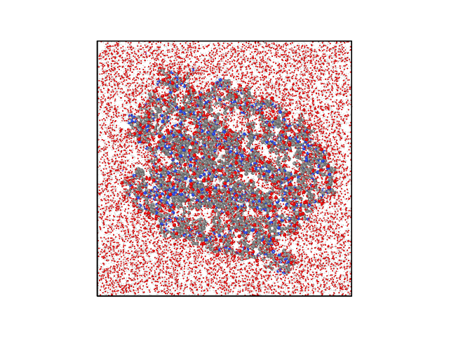
(a)

(b)

Figure S60: Complex 17 – Initial and final atomic structure of the Ursolic Acid–SLC2A4 complex. (a) Initial atomic structure and (b) final atomic structure after 500 ns MD simulation.
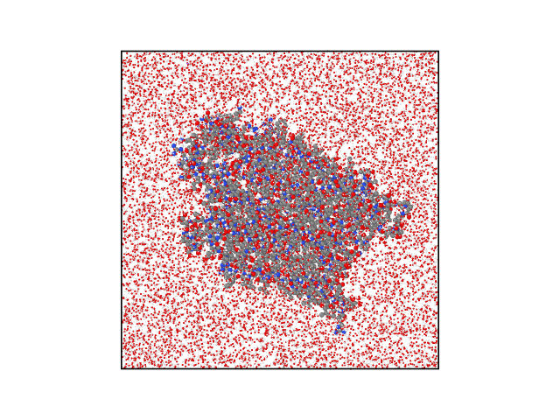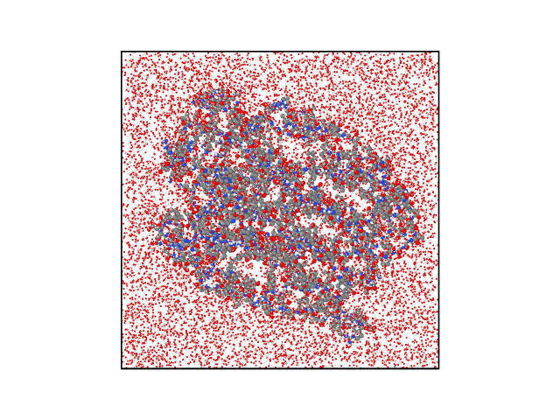
(a)

(b)

Figure S61: Complex 18 – Initial and final atomic structure of the Oleanolic Acid–SLC2A4 complex. (a) Initial atomic structure and (b) final atomic structure after 500 ns MD simulation.

